Simple Texture Sample (DX12)

*This sample is compatible with the August 2016 Xbox One XDK or later*

# Description

This sample demonstrates how to render a simple textured quad using Direct3D 12.

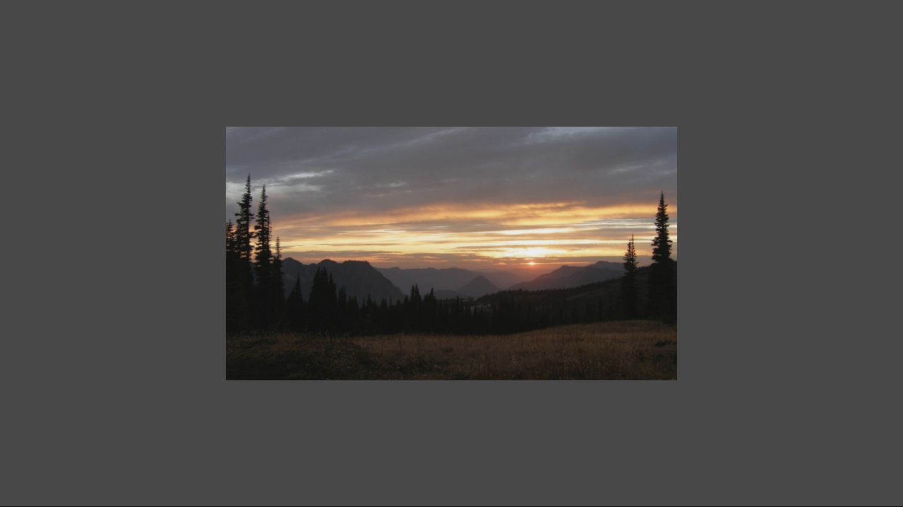

# Using the sample

The sample has no controls other than exiting.

# Implementation notes

The texture is loaded here using a simple helper that uses the Windows Imaging Component (WIC) and is designed for simplicity of learning. For production use, you should look at the DirectX Tool Kit’s [DDSTextureLoader](https://github.com/Microsoft/DirectXTK12/wiki/DDSTextureLoader) and [WICTextureLoader](https://github.com/Microsoft/DirectXTK12/wiki/WICTextureLoader).

# Update history

Initial release April 2016. In April 2017, it was updated to support 4k swap chains when run on Xbox One X.

# Privacy Statement

When compiling and running a sample, the file name of the sample executable will be sent to Microsoft to help track sample usage. To opt-out of this data collection, you can remove the block of code in Main.cpp labeled “Sample Usage Telemetry”.

For more information about Microsoft’s privacy policies in general, see the [Microsoft Privacy Statement](https://privacy.microsoft.com/en-us/privacystatement/).