

FrontPanelDemo Sample

# *\*This sample is compatible with the Xbox One XDK (June 2017)*

# 

# Description

FrontPanelDemo combines several samples into one executable and then ties together the functionality with a menu system all hosted entirely on the Xbox One X DevKit front panel. As the name implies, it is intended as a demonstration of some of the capabilities of the front panel. For more detailed explanations of the various parts of the demo, the reader is encouraged to explore the other front panel samples.

# Using the sample

The FrontPanelDemo sample renders a simple dolphin scene on the main display and hosts a menu-driven demo on the Xbox One X DevKit front panel. Note that the FrontPanelDemo is intended for the Xbox One X DevKit with the integrated front panel (the sample will compile and run on an Xbox One or Xbox One S however will not be very interesting without the physical front panel.)

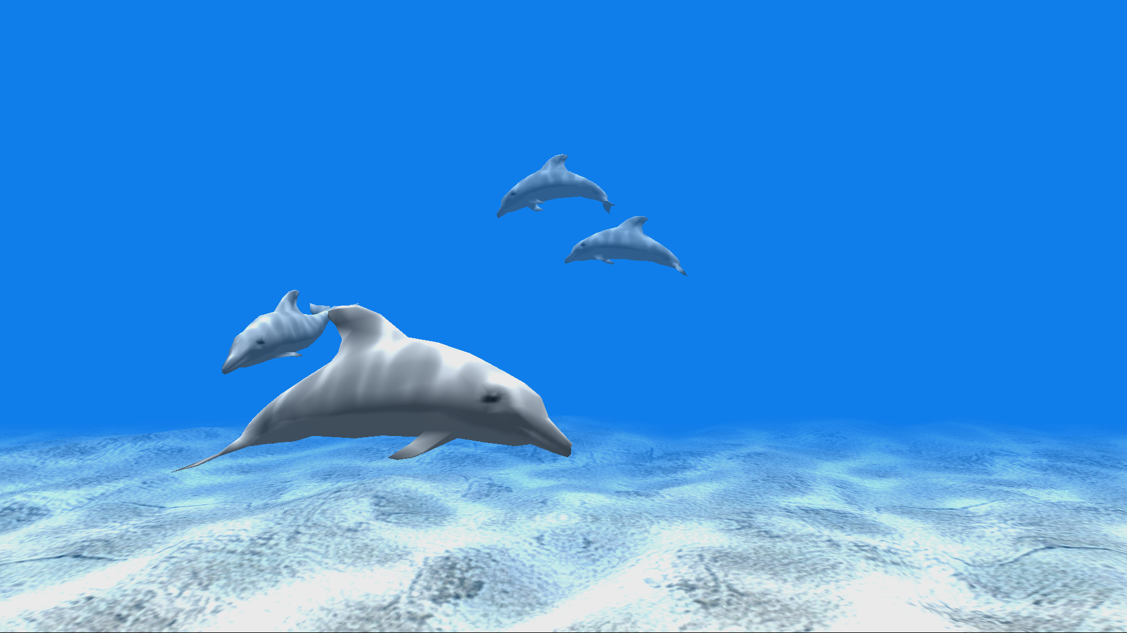

The Xbox One X DevKit Front Panel provides 5 toggle buttons, 5 LED lights, an LCD display, and a DPAD input. Each of the 5 LEDs are physically associated each of the 5 toggle buttons. The LCD display, is 256 pixels wide by 64 pixels high and supports 16 shades of gray. The DPAD supports input for up, down, left, and right and can also be pressed in for select.

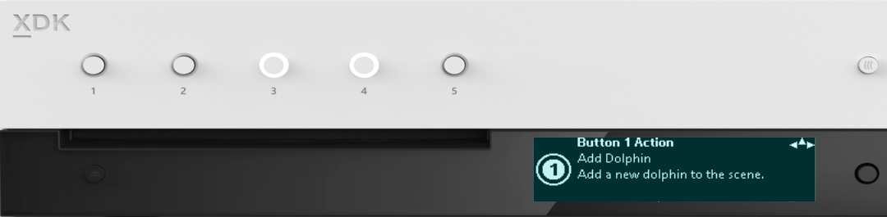

1 LED per Button

5x Programmable buttons

256 x 64 x 4bpp OLED display

DPAD + Select

## Top Level Menus

The menu system consists of four top level menus and each menu prints a simple description of the functionality that you can access from the menu. Use the DPAD (down) to “scroll down” and access the functionality for each of the menus:

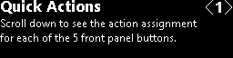The sample has several actions that can be mapped dynamically to any of the 5 toggle buttons on the front panel. The Quick Actions menu allows the user to inspect the mappings for each button.

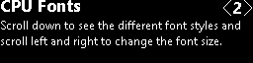The sub-menus of CPU Fonts show a variety of fonts rendered on the front panel display. For a more detailed look at rendering text see the FrontPanelText sample.

GPU to 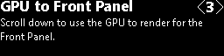Front Panel demonstrates how to use the GPU to render a scene that can then be displayed on the front panel. For a more detailed example

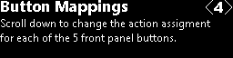The sub-menus of Button Mappings allow the user to dynamically remap the buttons to different actions.

## Quick Action Sub-Menus

From the Quick Actions <1> menu, use DPAD down to go to the Quick Actions sub-menus. Each sub-menu explains what action is currently mapped to the corresponding toggle button on the Front Panel. Also, the LED associated with the toggle button with blink when you navigate to the sub-menu corresponding to that toggle button.

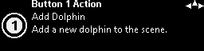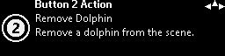

…

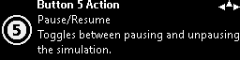

Each of the sub-menus also has a glyph with a number on it to indicated the associated toggle button.

Also notice the “compass rose” on the upper-right corner of every sub-menu. This provides a navigation “hint” to the user. In the example above, the user can use DPAD Left, Right, and Up. This convention is used throughout the demo.



DPAD Navigation

Toggle Button

## CPU Fonts

There are too-many CPU font screens to show them all here. Here is an example for one font:

This shows the Segoe UI Bold font generated at a height of 32 pixels using the RasterFontGen tool. The user can use DPAD Left, Right to change the font height and DPAD Up, Down to browse different font faces. Note that by going up multiple times the user eventually returns to the top-level menu (CPU Fonts <2>.) For more details on how to use the CPU to render text to the Xbox One X DevKit Front Panel, please see the RasterFontGen, RasterFontViewer, and FrontPanelText samples.

## GPU to Front Panel

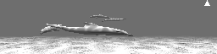The GPU to Front Panel <3> has one sub-menu. This is just a simple screen that captures whatever is rendering on the main display and then copies it to the front panel in real time. The user can use DPAD Up to return to the top-level menu (GPU to Front Panel <3>.) For a more detailed example of how to use the GPU to render graphics that can then be used on the Front Panel display, please see the FrontPanelDolphin sample.

## Button Mappings

The Button Mappings screens resemble the Quick Actions screens, but have a slightly different interpretation. Each button mapping screen corresponds to an action that can be mapped to a button. There are more actions available than there are buttons. So there will always be at least one action that is not mapped to a button. On the Button Mapping screen, the icon therefore indicates what button, if any is currently the “owner” of the action.

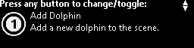

Owning Toggle Button

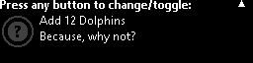In this example, the button icon is dimmed and there is a question mark indicating that no button owns the action. If the user presses any toggle button, then that button becomes the new owner of the action. Furthermore, whatever action that the button previously owned, if any, will no-longer have an owner. For example, here’s what the same Add 12 Dolphins action screen looks like after pressing Button 1:

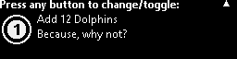

Here’s a summary of how the Button Mapping screens work:

* If the action has no owner then pressing any button will cause that button to be the new owner.
* If the action already has an owner then the user can change the owner by pressing a different toggle button.
* If the action already has an owner and the user presses the owning toggle button, then the action will no longer have an owner
* In order to actually perform the action, the user will have to scroll back to the top level using DPAD Up.

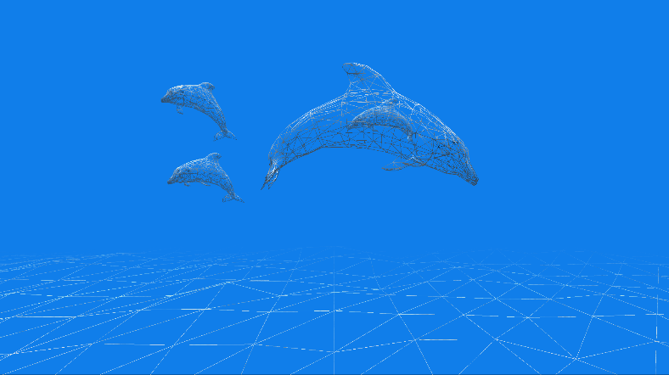The sample currently has 6 map-able actions:

1. Add Dolphin
2. Remove Dolphin
3. Clear All Dolphins
4. Toggle Wireframe
5. Pause/Resume Simulation
6. Add 12 Dolphins

E.g. the image on the left shows the scene rendered in wireframe mode after executing the Toggle Wireframe action via a Front Panel Button press.

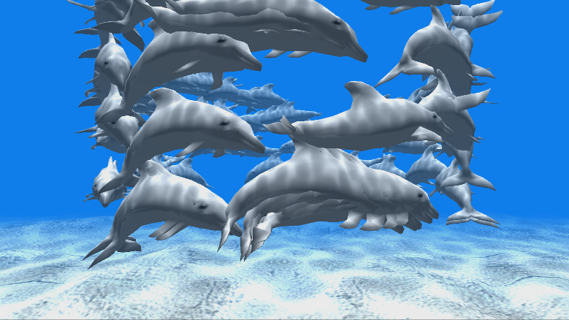

Here we see the results of adding lots of dolphins using the Add 12 Dolphins action.

# Update history

April 2017, first release of the sample.

# Privacy Statement

When compiling and running a sample, the file name of the sample executable will be sent to Microsoft to help track sample usage. To opt-out of this data collection, you can remove the block of code in Main.cpp labeled “Sample Usage Telemetry”.

For more information about Microsoft’s privacy policies in general, see the [Microsoft Privacy Statement](https://privacy.microsoft.com/en-us/privacystatement/).