

FrontPanelGame Sample

# *\*This sample is compatible with the Xbox One XDK (June 2017)*

# Description

FrontPanelGame is the classic “snake game” implemented completely on the Xbox One X DevKit Front Panel. The sample is mainly provided for fun but nonetheless does demonstrate some important aspects of the front panel control:

* The front panel is completely programmable from title code
* The buttons and DPAD APIs are analogous to the familiar Gamepad APIs
* The sample showcases some utility code that you can use in your own front panel project
  + Text rendering using RasterFont (see also: the FrontPanelText sample)
  + FrontPanelInput provides a reusable input class much like DirectXTK::GamePad
  + FrontPanelDisplay provides a simple class for managing the front panel buffer
  + Code for drawing basic shapes such as lines and rectangles

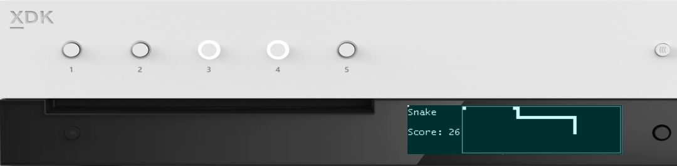

Press to start

256 x 64 x 4bpp OLED display

DPAD + Select

* Move the snake
* Take e a screenshot

# Using the sample

|  |  |
| --- | --- |
| Action | Front Panel |
| Start a new game | Button 1 |
| Move the snake | DPAD (Left, Right, Up, Down) |
| Take a screenshot | DPAD Select |
| Toggle between game mode and system mode | Press and hold DPAD Select |

# Update history

April 2017, first release of the sample.

# Privacy Statement

When compiling and running a sample, the file name of the sample executable will be sent to Microsoft to help track sample usage. To opt-out of this data collection, you can remove the block of code in Main.cpp labeled “Sample Usage Telemetry”.

For more information about Microsoft’s privacy policies in general, see the [Microsoft Privacy Statement](https://privacy.microsoft.com/en-us/privacystatement/).