Gamepad Sample

*This sample is compatible with the November 2015 Xbox One XDK or later*

# Description

This sample demonstrates how to read inputs from a gamepad one the Xbox One

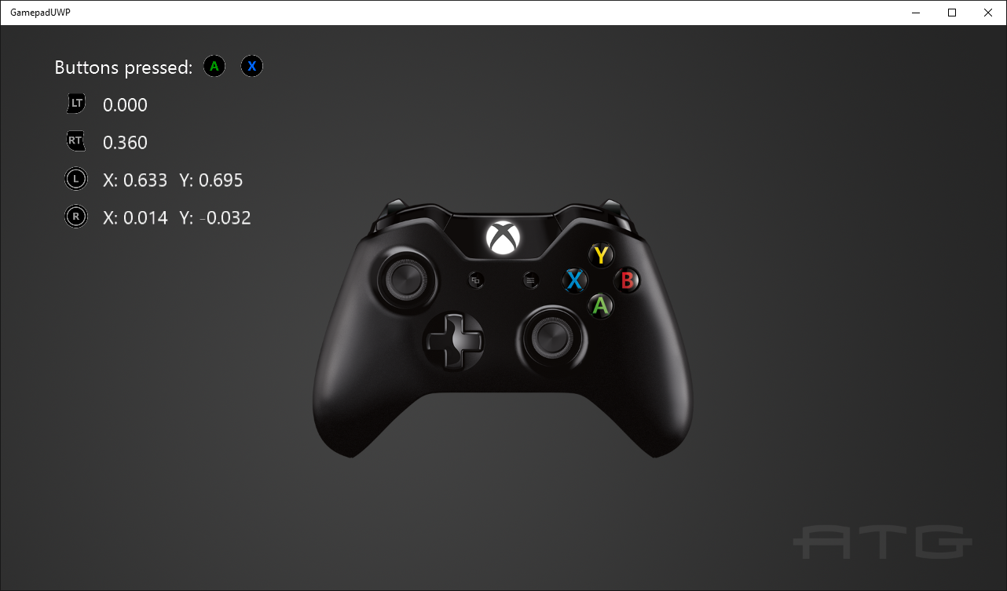

# Using the sample

Press buttons to see them displayed and move the thumbsticks and triggers to see their readings.

# Implementation notes

This sample demonstrates how to use Windows.Xbox.Input to read input from a gamepad, including thumbsticks and triggers.

For more information on Windows.Xbox.Input, see [GDNP](https://developer.xboxlive.com/en-us/platform/development/documentation/software/Pages/durangocontroller_overview_mar16.aspx).

# Update history

Initial release May 2016

Added IsTrusted support April 2018

# Privacy statement

When compiling and running a sample, the file name of the sample executable will be sent to Microsoft to help track sample usage. To opt-out of this data collection, you can remove the block of code in Main.cpp labeled “Sample Usage Telemetry”.

For more information about Microsoft’s privacy policies in general, see the [Microsoft Privacy Statement](https://privacy.microsoft.com/en-us/privacystatement/).