Gamepad Vibration Sample

*This sample is compatible with the November 2015 Xbox One XDK or later*

# Description

This sample demonstrates how to use vibration with a gamepad on an Xbox One.

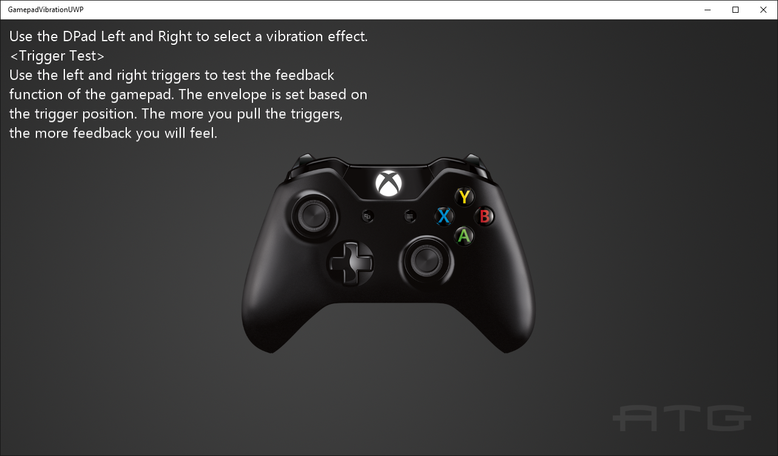

# Using the sample

Use left and right on the DPad to cycle between different vibration examples. Use the triggers in most of these examples to increase the amount of vibration.

# Implementation notes

This sample demonstrates how to use Windows.Xbox.Input to set vibration levels on an Xbox One gamepad.

For more information on Windows.Xbox.Input, see [GDNP](https://developer.xboxlive.com/en-us/platform/development/documentation/software/Pages/impulsetriggers_overview_mar16.aspx).

# Update history

Initial release May 2016