Lamp Array Sample

*This sample is compatible with the July 2018 QFE 3 Xbox One XDK or later*

# Description

This sample demonstrates how to use LampArray to create RGB lighting effects for peripherals

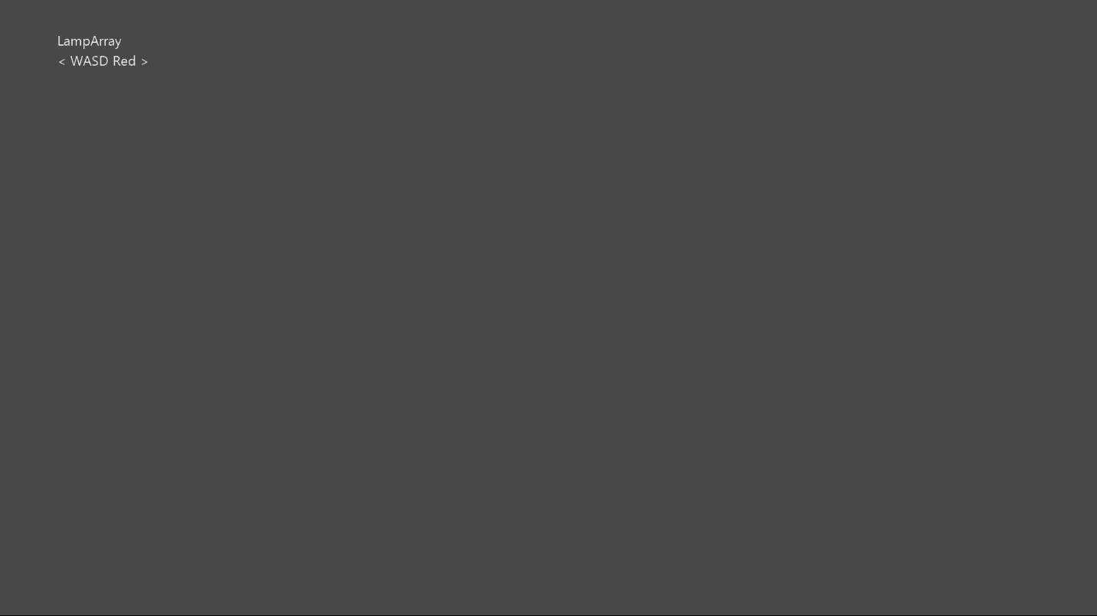

# Using the sample

Use the left or right arrow keys on the keyboard to select what effect to display

# Implementation notes

This sample demonstrates how to use LampArray to create RGB lighting effects in a variety of ways

For more information on Windows.Devices.Lights, see [Windows](https://docs.microsoft.com/en-us/uwp/api/windows.devices.lights) Dev Center.

# Update history

Initial release December 2018

# Privacy statement

When compiling and running a sample, the file name of the sample executable will be sent to Microsoft to help track sample usage. To opt-out of this data collection, you can remove the block of code in Main.cpp labeled “Sample Usage Telemetry”.

For more information about Microsoft’s privacy policies in general, see the [Microsoft Privacy Statement](https://privacy.microsoft.com/en-us/privacystatement/).