SystemInfo Sample

# *This sample is compatible with the August 2016 Xbox One XDK or later*

# Description

This sample demonstrates a number of Xbox One APIs for querying system information and hardware capabilities.

# Using the sample

This sample displays a series of text pages with technical information.

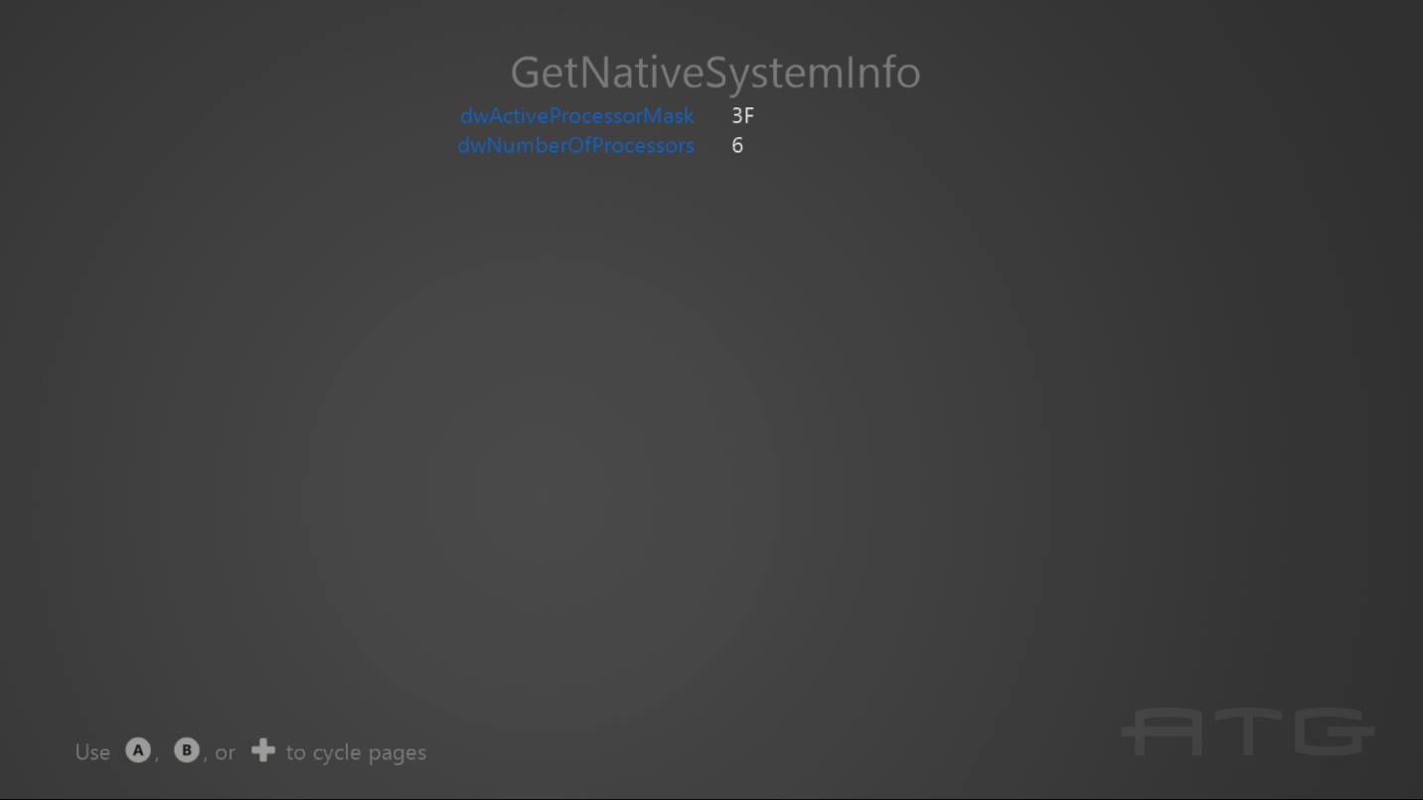

To switch between pages with the gamepad controller, use A or DPad Right / B or DPad Left.

# Implementation notes

The important code is in the switch case within the **Render** function.

# Update history

Initial release for October 2016. Updated for the June 2017 release and the GetConsoleType API.

# Privacy statement

When compiling and running a sample, the file name of the sample executable will be sent to Microsoft to help track sample usage. To opt-out of this data collection, you can remove the block of code in Main.cpp labeled “Sample Usage Telemetry”.

For more information about Microsoft’s privacy policies in general, see the [Microsoft Privacy Statement](https://privacy.microsoft.com/en-us/privacystatement/).