

RasterFontViewer

# Description

RasterFontViewer is a tool for viewing .rasterfont files created using the RasterFontGen tool. RasterFontViewer will allow you to perform a quick visual validation of the font. For small fonts, you will be able to visually inspect every supported glyph.

# Building RasterFontViewer

RasterFontViewer is provided as source code. To build the tool, simply open RasterfontViewer.sln and build from Visual Studio.

# Using RasterFontGen

Syntax:

>RasterFontGen.exe <filename>

The following image is taken from a screenshot of RasterFontViewer and shows a rendering of a .rasterfont file:

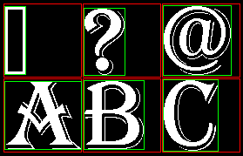

* The .rasterfont file was generated using the following command line:

>RasterFontGen.exe -h 128 -tf "Algerian" -ow -cr:?-h -of AR.rasterfont

* Each red rectangle is the same size. The height of each red rectangle is the height of the font in logical units (pixels.) When considering all glyphs supported by the original True Type font, the glyph with the tallest ascender will just touch the top of the red rectangle, whereas the glyph with the deepest descender will just touch the bottom.
* The green rectangles are the respective bounding boxes for each glyph.

# Implementation notes

.rasterfont files can be rendered using the APIs in Rasterfont.h/cpp found in the ATG Tool Kit.