Supplementary Figure 1
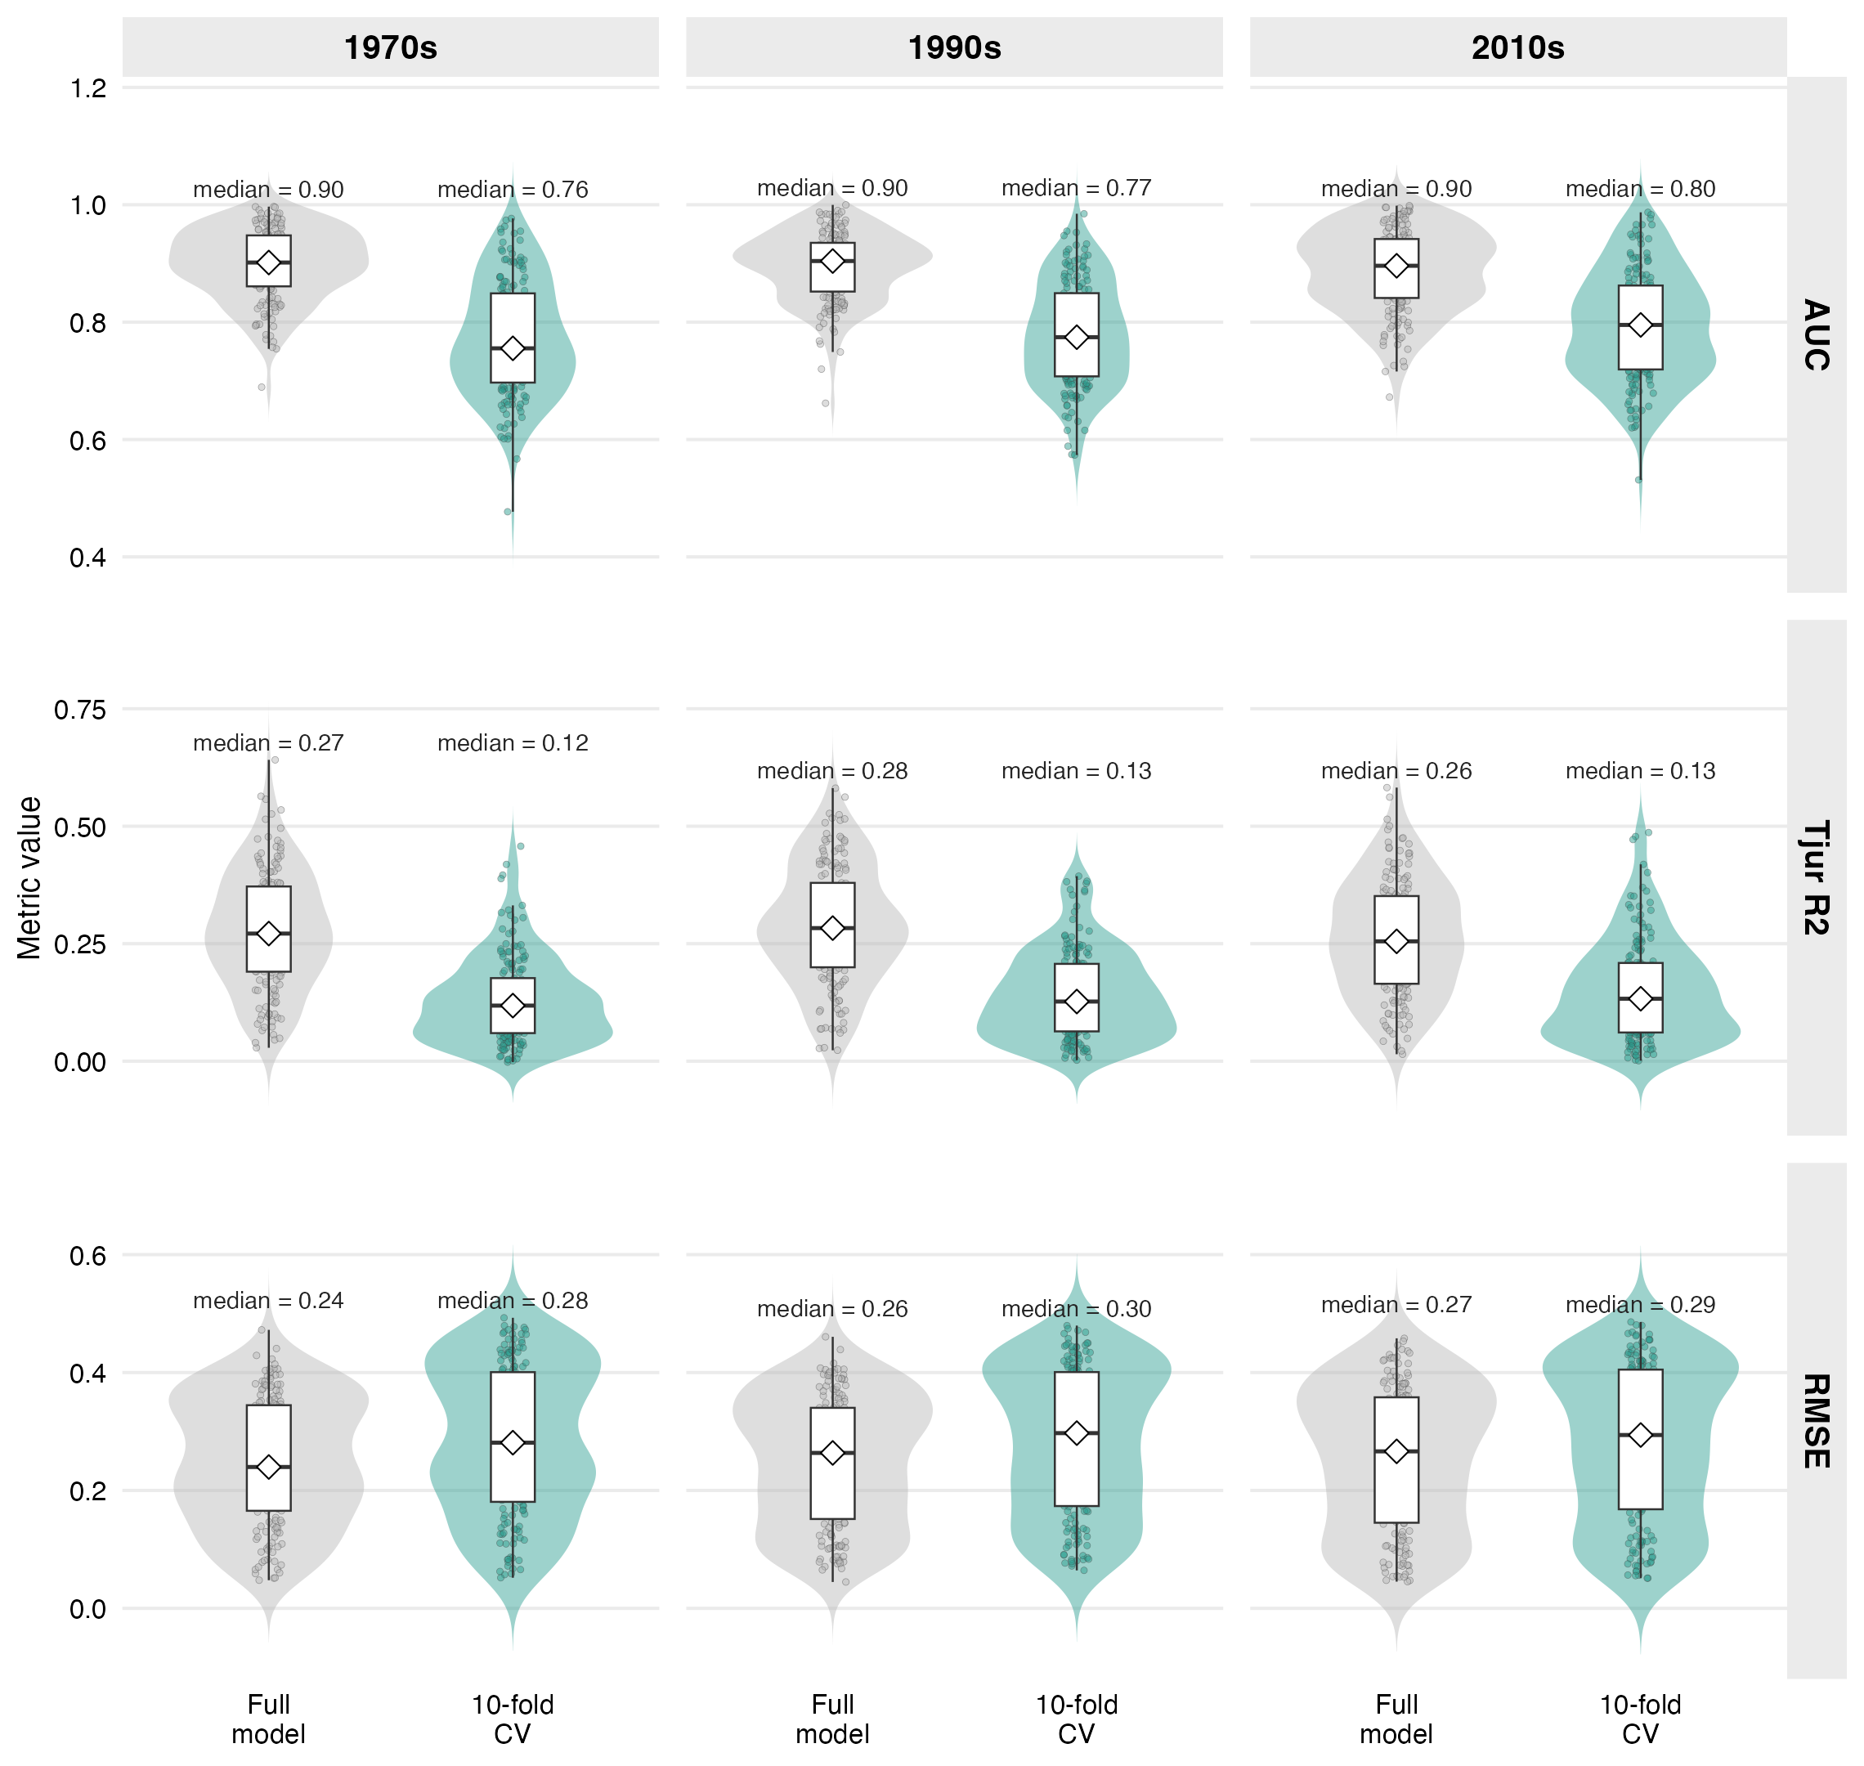
Supplementary Figure 1. Full-model and 10-fold cross-validated model accuracy across atlas periods. Each panel shows species-level accuracy values for AUC, Tjur R2, and RMSE; diamonds and text labels indicate median values.

Supplementary Figure 2
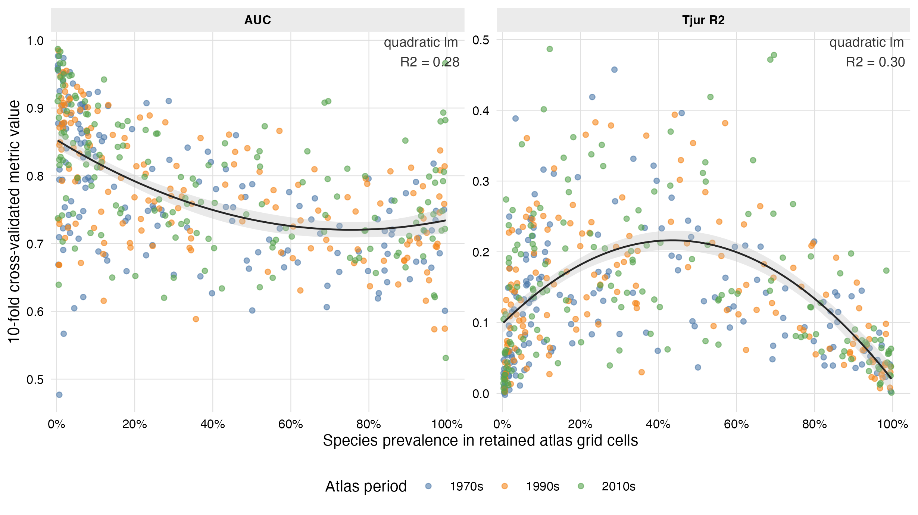
Supplementary Figure 2. Species prevalence and 10-fold cross-validated AUC and Tjur R2. Points are species-period combinations coloured by atlas period. Black curves show quadratic linear-model fits, with facet-specific R2 values printed in each panel.

Supplementary Figure 3
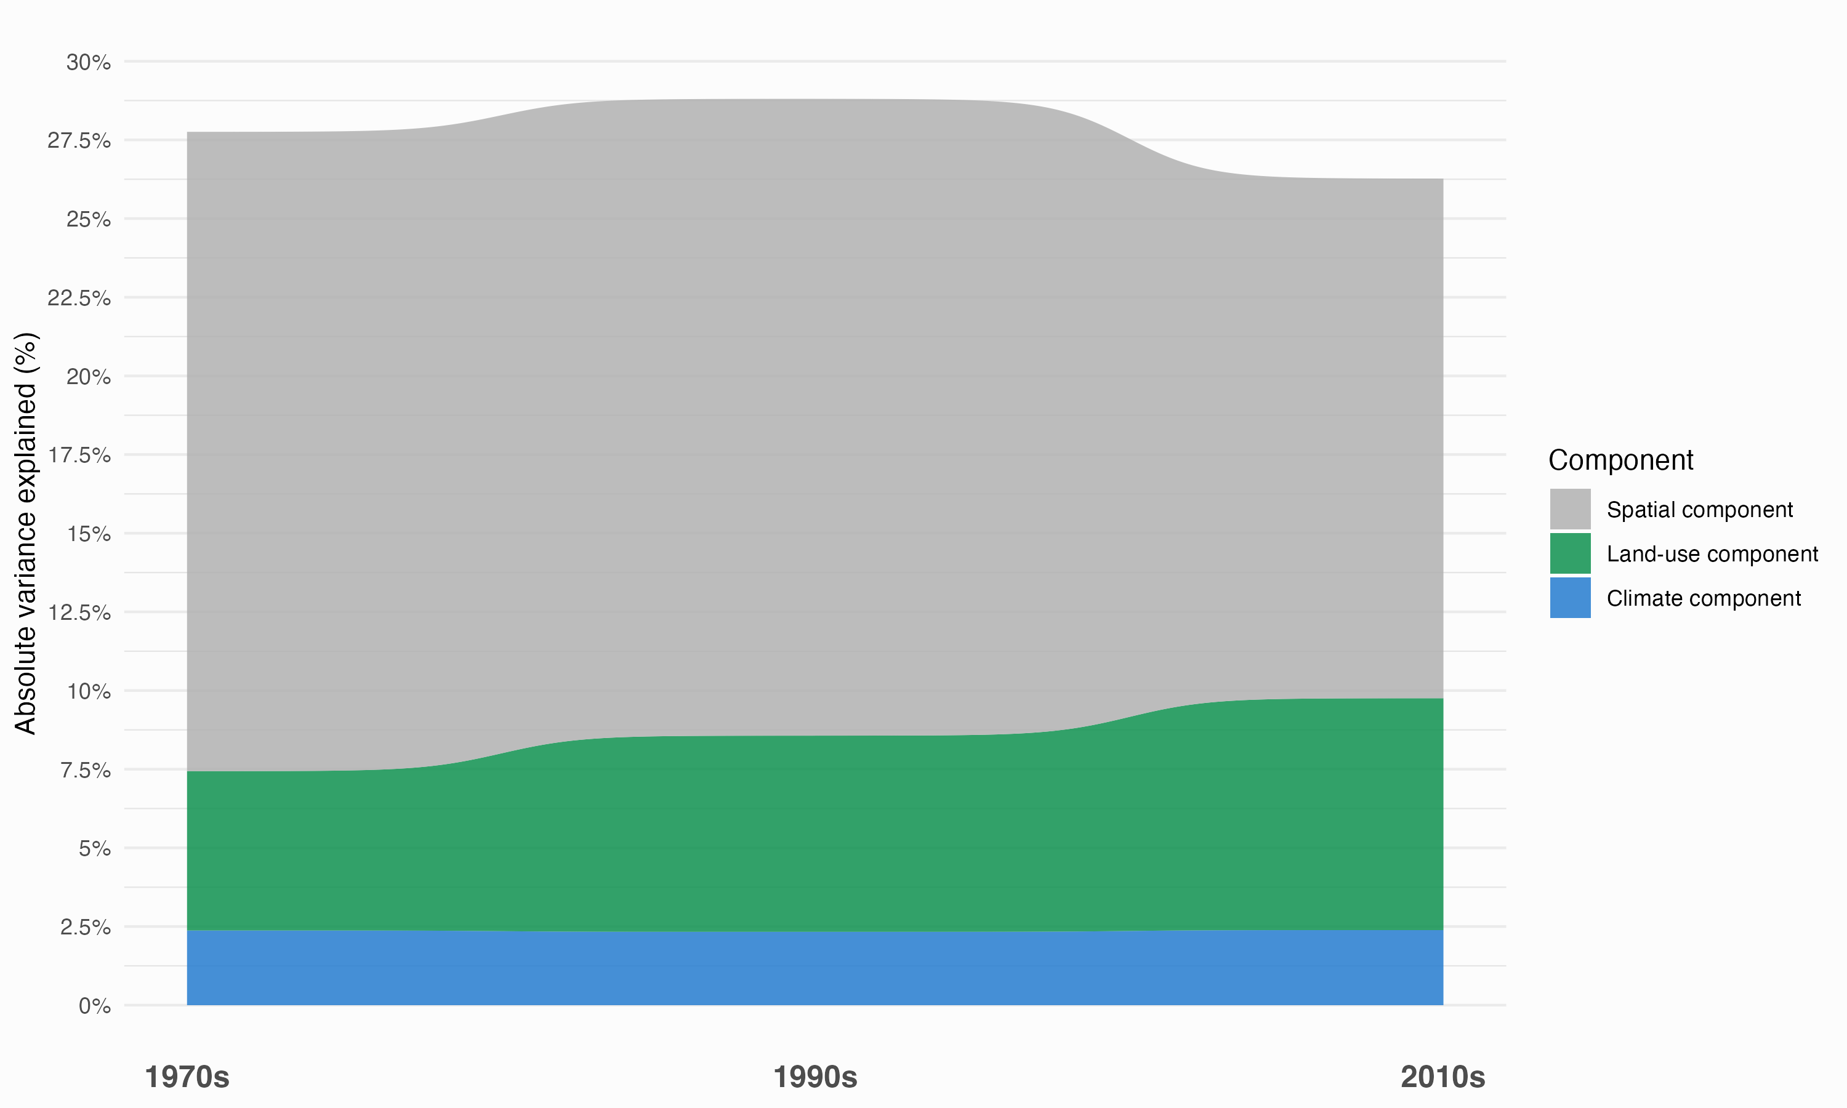
Supplementary Figure 3. Temporal change in the mean absolute variance explained by three aggregated components. The spatial component is the site-level random effect; the land-use component combines land-use heterogeneity and urban, cropland, pasture, forest, and grass/shrubland coverage; and the climate component combines breeding-season temperature and precipitation. Values are based on Tjur R2-scaled variance partitioning across the 157 modelled species.

