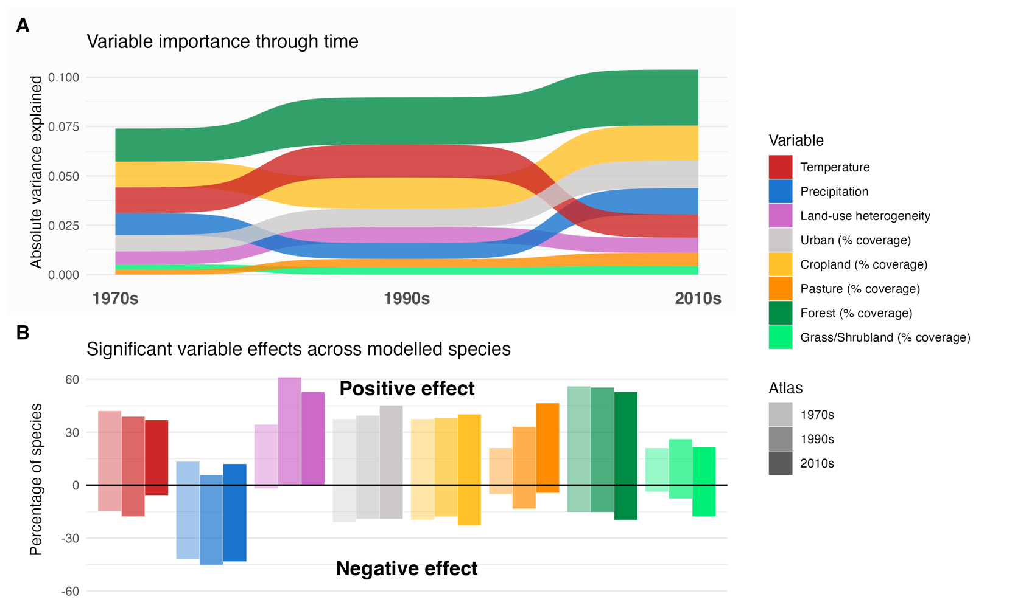
Temporal variation in environmental drivers
Importance and direction of environmental variables on Danish breeding bird distributions across three atlas periods. (A) Absolute variance explained by each predictor variable across atlas periods. Variables are reordered in each period from most to least variance explained. (B) Percentage of modelled species for which each variable had a significant positive (above zero) or negative (below zero) effect.

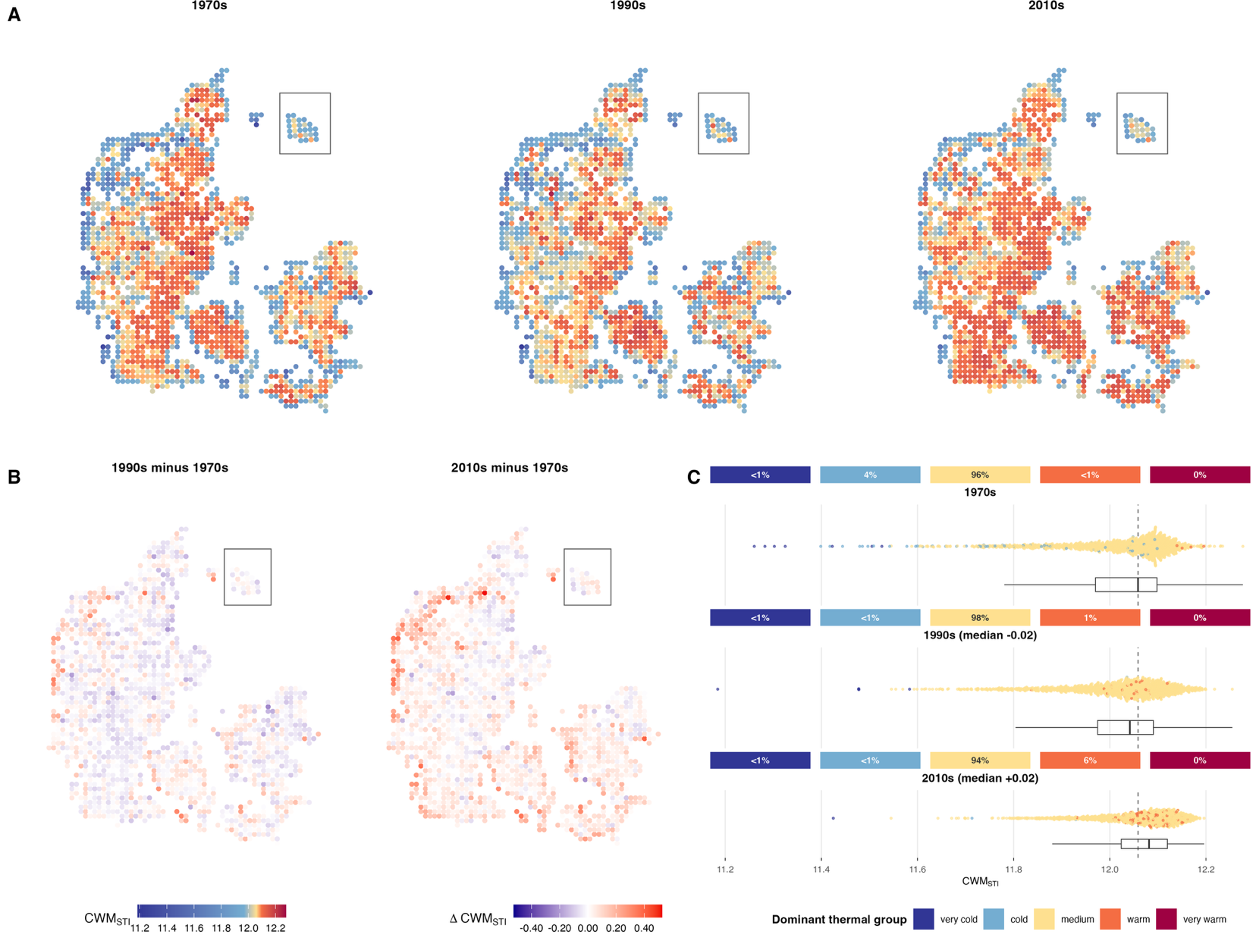
Avian community warming driven by loss of ‘cold’ species and expansions of ‘warm’ species
(A) Spatial distribution of CMW-STI across three Danish breeding bird atlas periods: 1970s, 1990s, and 2010s. CMW-STI represents the average breeding season temperatures across each species’ range, weighted by their grid-level predicted probability of occurrence, with higher values indicating communities dominated by species with warmer species thermal indices. CWM-STI colours use a common nonlinear scale, with internal colour stops anchored to equal, 1970s CWM-STI quantiles and applied consistently across the other atlas periods. (B) Spatial distribution of communities in 1990s and 2010s that are warming or cooling relative to the reference period in the 1970s. (C) Distribution of CMW-STI across three Danish breeding bird atlas periods and increasing prevalence of warm-affinity dominated communities. Beeswarm plots show the full distribution of CWM-STI values across grid cells, with individual points coloured according to the dominant thermal affinity class in said grid cell. Box plots indicate the median and interquartile range, compared to the median from the from 1970s (dotted line).

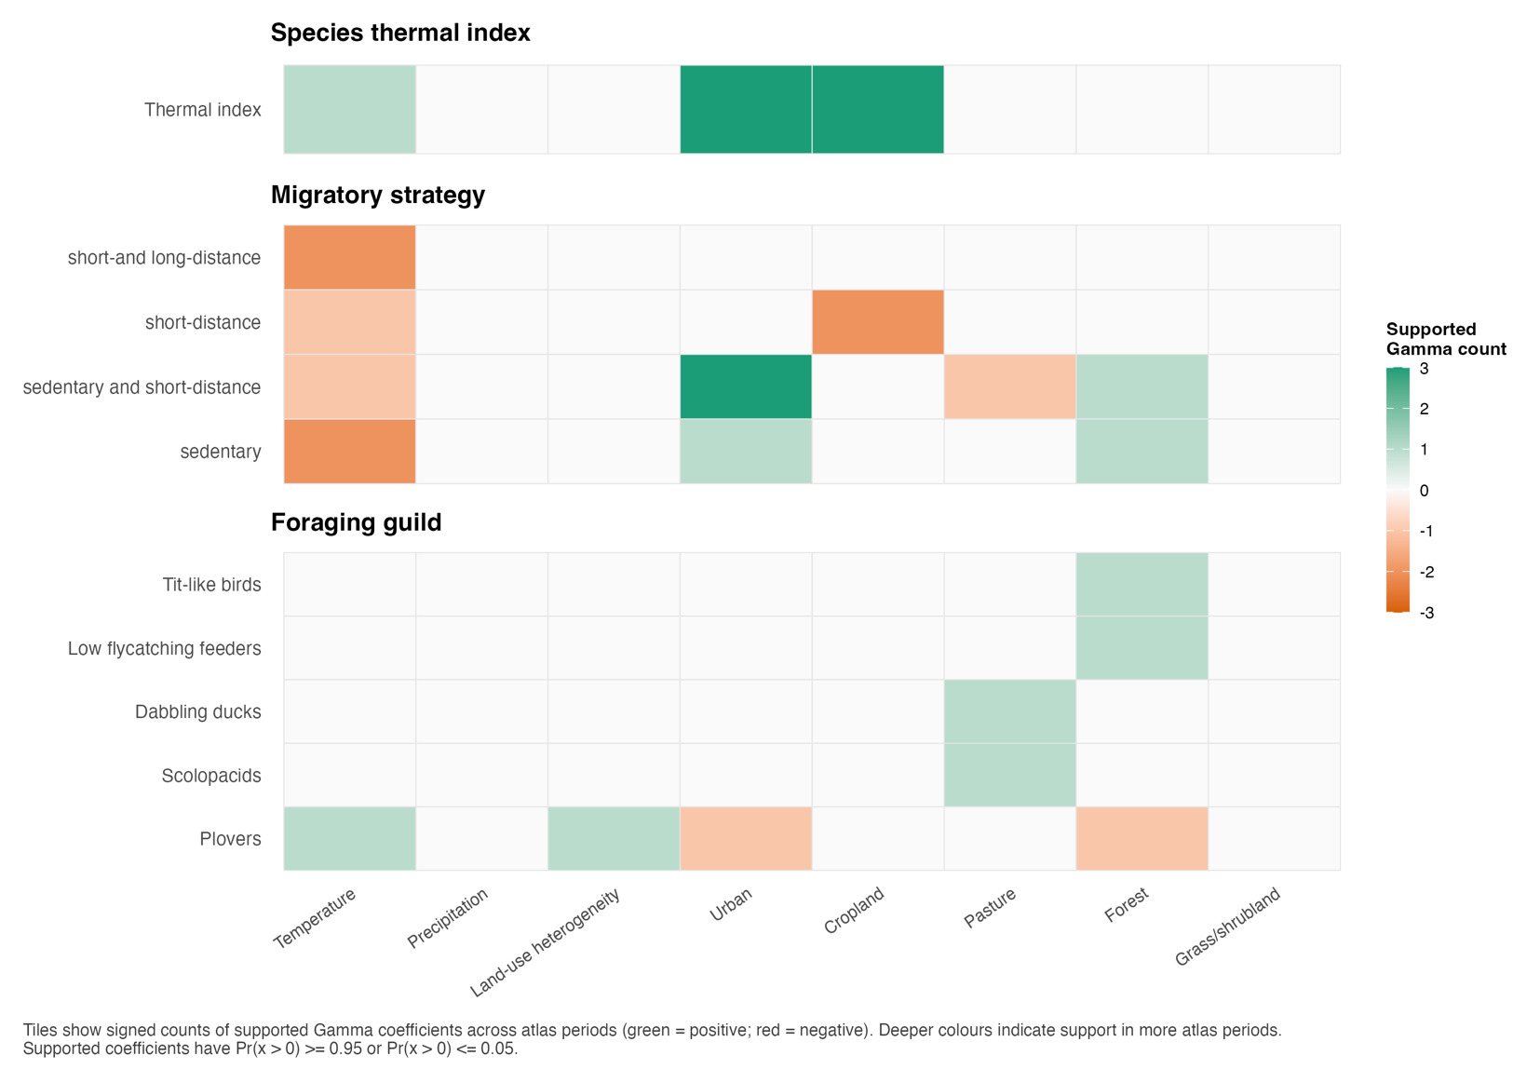
Temporal consistency in avian characteristic x environment relationships
Trait moderation of species-environment relationships across atlas periods. Tiles show the number of atlas-period HMSC models in which a trait had a supported Gamma coefficient for each environmental variable. Green tiles indicate positive trait moderation and red tiles indicate negative trait moderation; darker shades indicate support in more atlas periods. Near-white tiles indicate no supported effect. Panels separate species thermal index, migratory strategy, and foraging guild. For categorical traits, effects are interpreted relative to the model reference levels: long-distance migrants for migratory strategy and aerial insectivores for foraging guild. Trait-variable pairs with conflicting supported signs across atlas periods were checked before plotting.

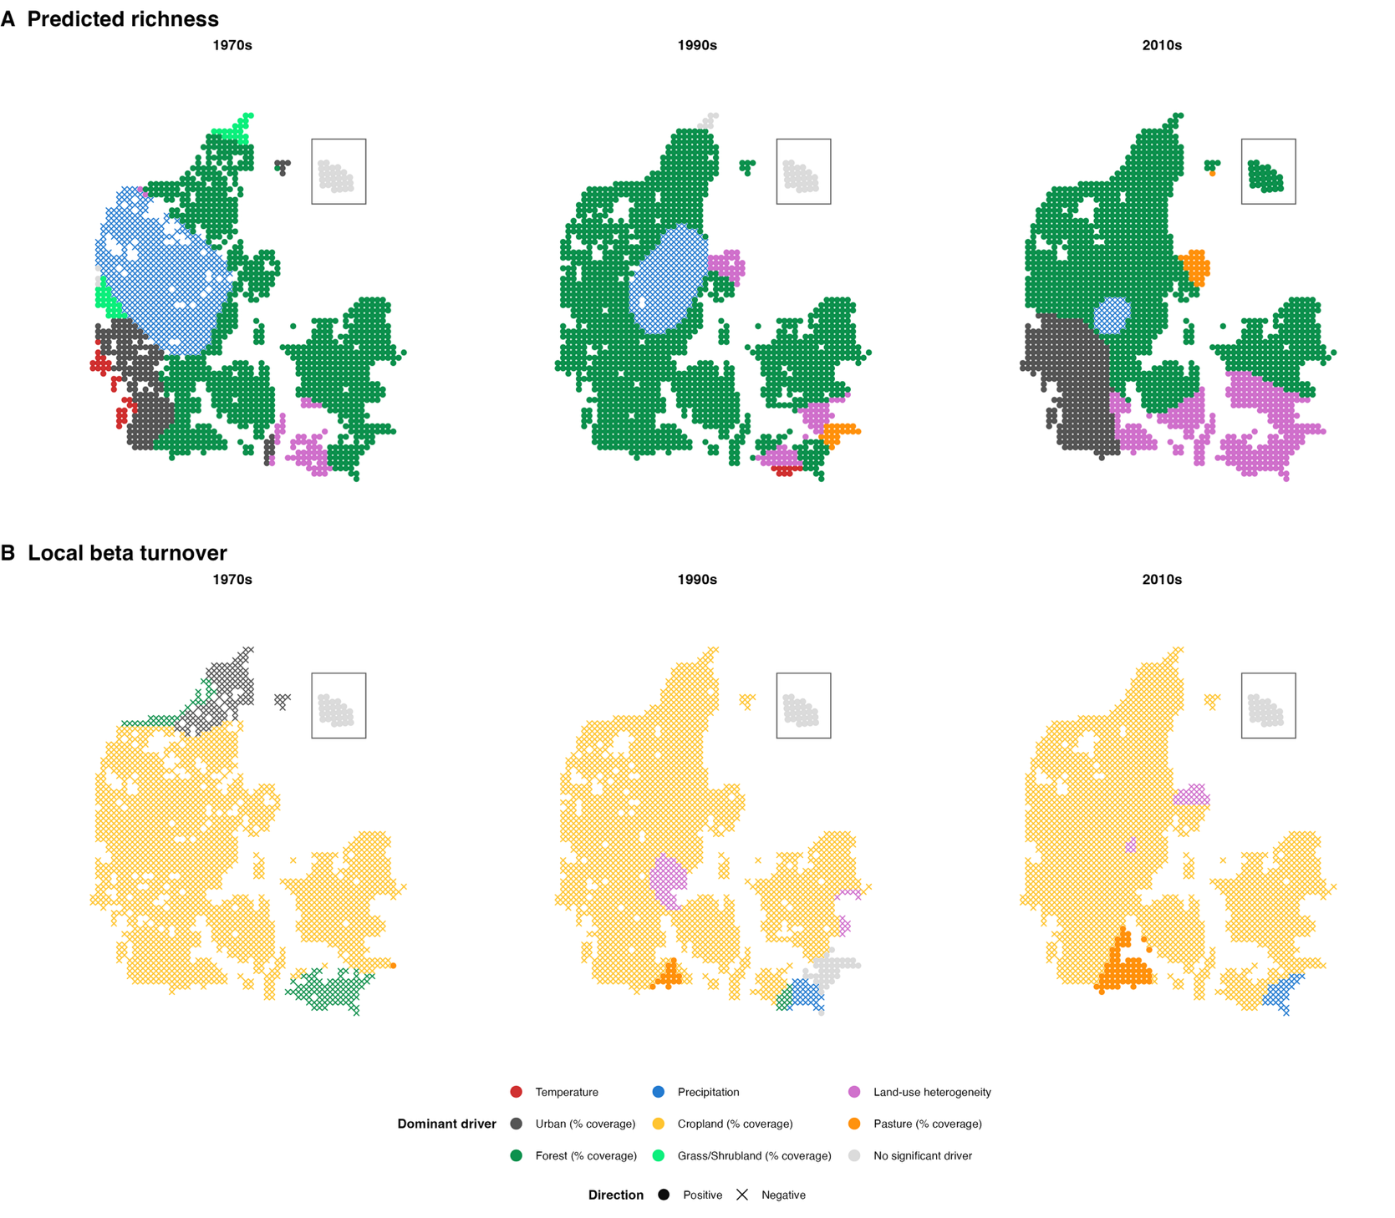
Local predictors of avian richness and community dissimilarity
Dominant drivers of avian species richness and beta turnover across Denmark for the three breeding bird atlas periods. Each point represents a survey site, coloured by the variable with the highest significant local t-value (|t| > 1.96) from Geographicaly Weighted Regression (GWR). Cross symbols indicate a significant negative effect, filled circles indicate a significant positive effect. Light grey points indicate no significant drivers at that site.

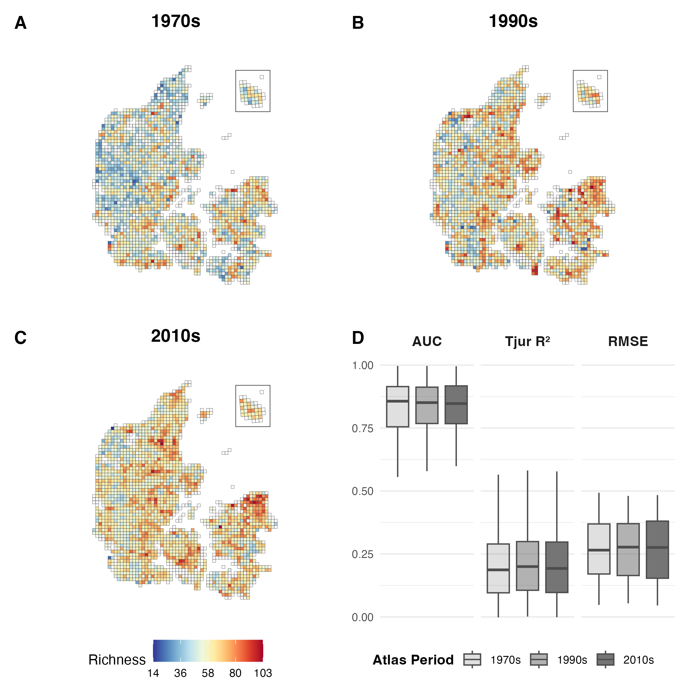
Avian species richness across the three atlas surveys
Predicted avian species richness from joint species distribution models fitted to three resurveys of Danish breeding birds in the (A) 1970s, (B) 1990s, and (C) 2010s. Species richness was estimated as the sum of predicted occurrence probabilities across species. Species-level model performance metrics derived from 10-fold cross-validation are shown in panel D. Predictions in panels A–C are based on models trained on the complete dataset.

