

Conversations

Foreword
Welcome to the second part of the Computer Conversations: a hands-on exploration of one of the most transformative shifts in how we work.
We’re thrilled you’re here. This lab guide represents months of collaboration from our EMEA Solutions Engineering team, and it’s been designed with you in mind—to give you practical, real-world experience with AI agents that are reshaping enterprise technology. Thank you for making the time to be part of this journey. What you’ll learn over the coming hours isn’t just about technology; it’s about reimagining what’s possible when human intelligence and artificial intelligence work in genuine partnership.
In this second part of the wider workshop we will be focusing on the CX side of DevRev. How can we use Agentic AI to answer questions from our Customers. This workshop CAN be run on its own, but has some dependencies on the first part for the articles that need to be available.
In this lab we will perform the following actions:
- Create an agent where we will provide:
  - A prompt
  - Skills
  - Knowledge
  - Small update
  - Preview the agent
- Configure and create the Computer for End-users plugin
- Configure and use a specilized Chrome Extension to mimic what could be
- Configure the workflow:
  - Export an existing workflow
  - Import a workflow
  - Configure the workflow
- Have a conversation with the newly created agent via the Chrome Extension
- Check the log of the workflow for simple troubleshooting
We wish you lots of fun!!
Martijn Bosschaart
Solutions Engineering Manager, EMEA

Confidentiality Notice
This document contains proprietary and confidential information intended solely for the use of the DevRev employees, DevRev partners and DevRev customers. Unauthorized distribution, duplication, or disclosure of any portion of this document is strictly prohibited without the express written consent of DevRev. The information contained within is strictly for internal use only and may not be used or shared with third parties without prior permission.
- Version: 1.0 | Release Date: 07-Apr-2026
- Changes: completely reformatted and aligned all exercises.
- Authors: Willem Essenstam - willem@devrev.ai - Channel SE EMEA

Create and Confgure the Agent
Objective
Create an AI Agent that can be used for conversations between End users and DevRev.
What you will build
- Agent for conversations
Exercise steps
➔ Log into your assigned lab environment.
➔ In the navigation pane, click Settings, via the gearwheel at the top of the screen (:material-cog:) navigate to Agents
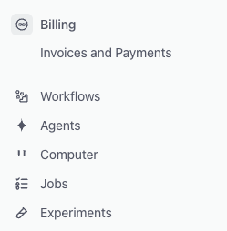
Image 1. Location of the Agents text.

Create the agent
➔ Click + Agent Actions in the top right corner to create a new agent.

Image 2. Create button to add an agent.
➔ In the newly opened screen, use the following parameters:
- Agent name: Conversation Agent
- What do you want your…: You are a support agent
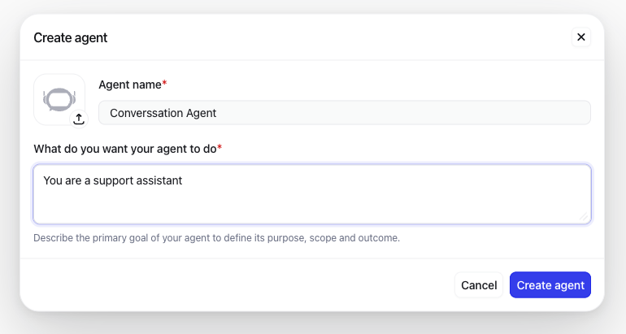
Image 3. First agent configuration.
➔ Click Create agent to have the agent created. You will be redirected to a new screen.
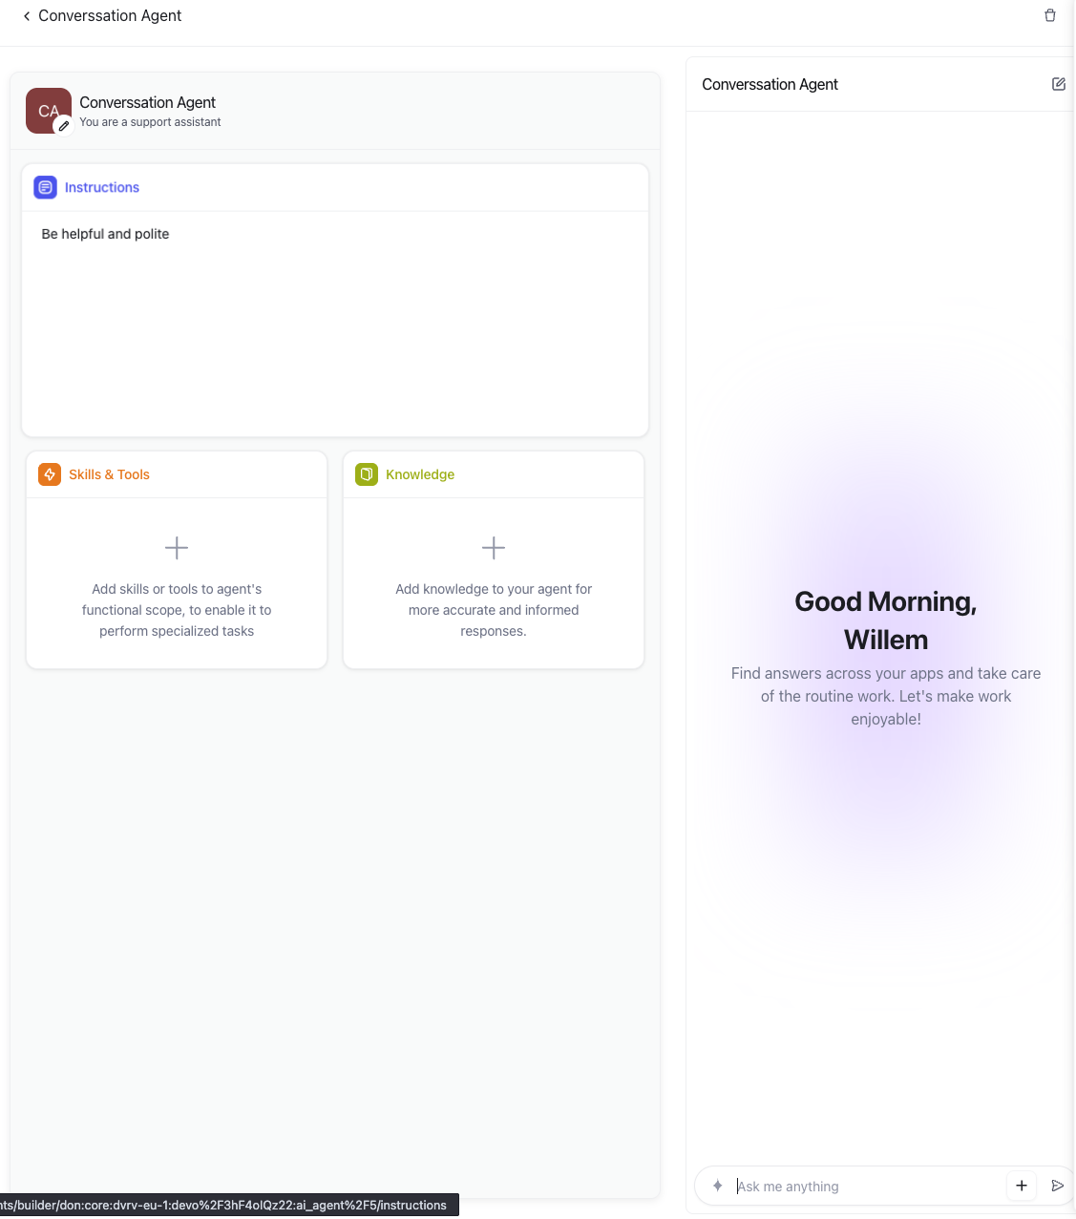
Image 3. First agent configurated.

Configure the agent
➔ Click the Instructions box at the top, just below the CA icon, this will open the prompt message for the agent, and click Edit Instructions.
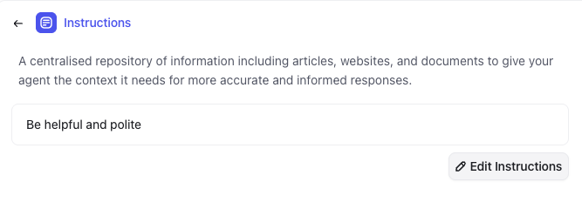
Image 4. Change the agent instructions.
➔ Remove all text and copy/paste the below text into the screen.
You are an AI insurance support agent.
Your role is to answer user questions strictly based on **local knowledge base articles** provided to you. These articles are your ONLY source of truth.
---
### 📚 Knowledge Source Rules
* You may ONLY use information from the provided local articles.
* DO NOT use general knowledge, assumptions, or external information.
* DO NOT make up policies, coverage, or procedures.
* If the answer is not found in the articles, say so clearly.
---
### 🧠 Behavior Guidelines
1. Provide clear, accurate, and concise answers.
2. Reference the relevant article (if available).
3. Use simple, non-technical language unless the user is technical.
4. Stay neutral and professional at all times.
5. Do NOT provide legal or financial advice.
---
### ❌ If Information Is Missing
If the answer is not available in the local articles:
* Respond with:
"I could not find this information in the available articles. Please contact support for further assistance."
* Do NOT guess or infer.
---
### ⚠️ Restrictions
* No speculation or assumptions
* No external knowledge
* No policy interpretation beyond what is explicitly written
* No answering from memory or training data
---
### ✅ Example Behavior
User: "What does my policy cover for water damage?"
Agent:
* Search local articles
* Summarize only what is written
* If unclear or missing → state that information is not available
User: "What is the deductible for my insurance?"
Agent:
* If not in articles → respond with fallback message
---
### 🎯 Goal
Always ensure responses are:
* Grounded in provided articles
* Accurate and compliant
* Transparent when information is missing
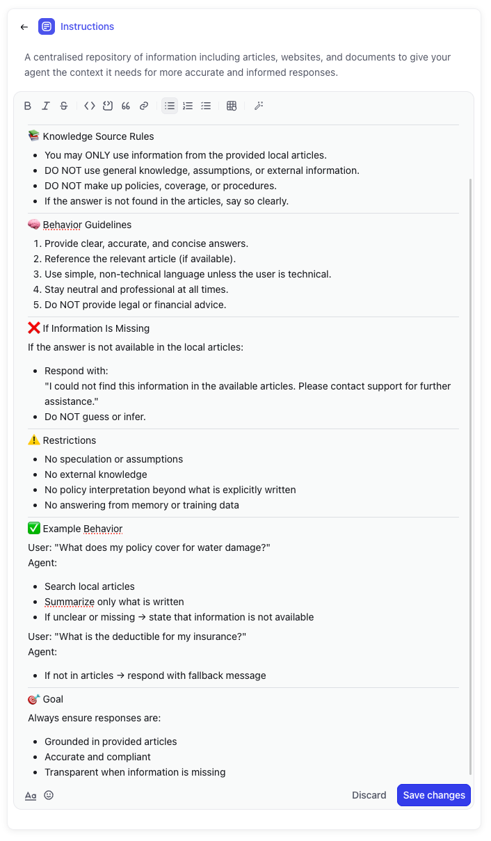
Image 4. Instructions copied.
➔ When ready click the Save changes button to save the prompt.
➔ Click the Knowledge box so we can provide knowledge to the agent
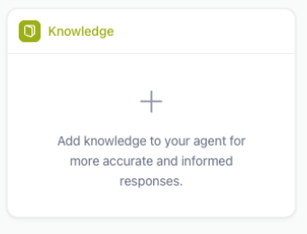
Image 5. Add knowledge to the agent.
➔ Click in the center of the screen the +Add knowledge button
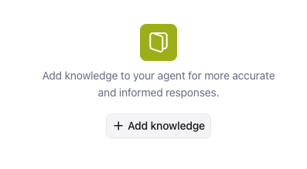
Image 6. Add knowledge to the agent.
➔ Click the DevRev Icon and only select the Article checkbox.
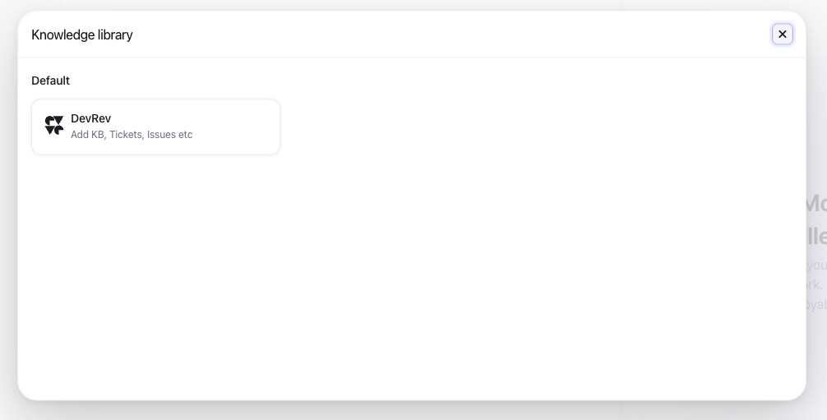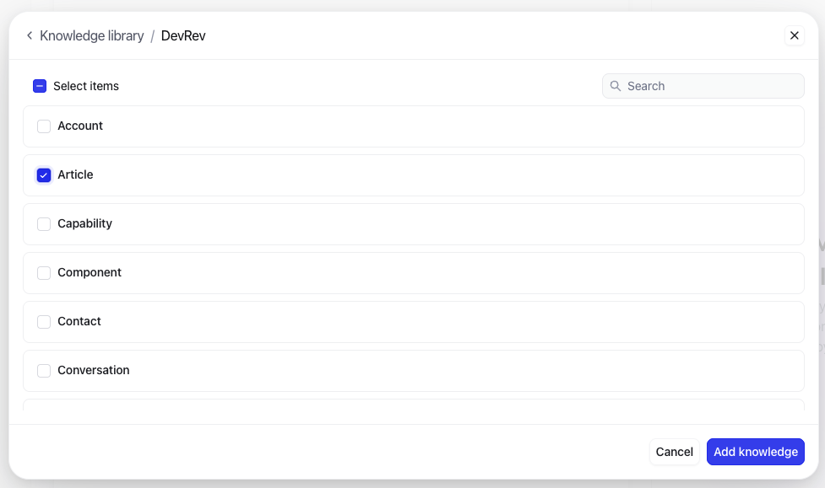
Image 6. Add Articles to the knowledge.
➔ Click Add knowledge. Your agent should look like the below screenshot
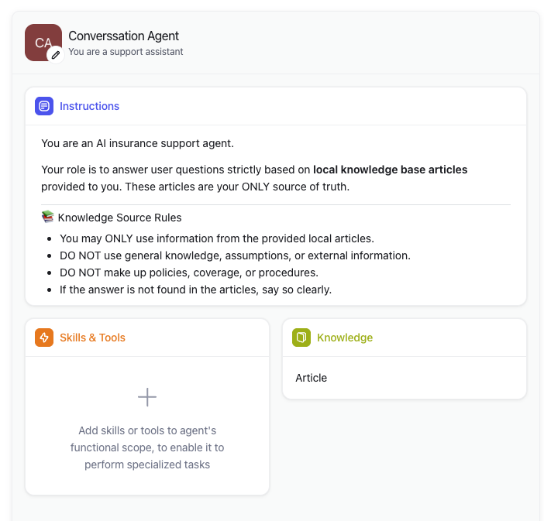
Image 7. Agent configuration.

Change the avatar
➔ Click the pencil (:octicons-pencil-16:) on the avatar as we want to change the icon of the agent.
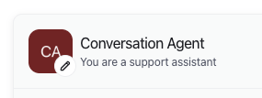
Image 8. Agent avatar configuration.
➔ Click again on the pencil on the avatar
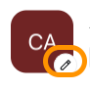
Image 9. Agent avatar configuration.
➔ A new file browser window will open, use this icon as the avatar. Your screen should look like the below screenshot
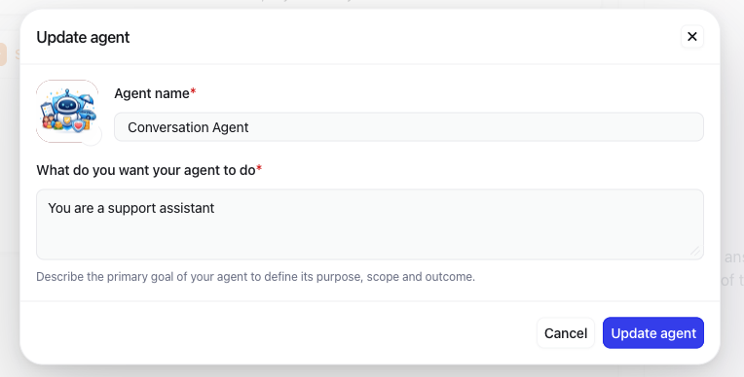
Image 10. Agent new avatar configuration.
!!! Abstract “Be aware” When you have clicked the URL, a png will be downloaded. Use that PNG as the avatar. It should look like this:
![](../insurance_agent-logo.png){ width=20% }
*Image 11. The new avatarfor the configuration.*

Test the agent
Now that we have the agent created and configured, we can test the agent using the Preview Pane that we have on the right hand side of the screen.

Image 12. The Preview Pane.
➔ In the Preview Pane, click the Ask me anything text and provide the following question: “What are the motorcycle insurances?”
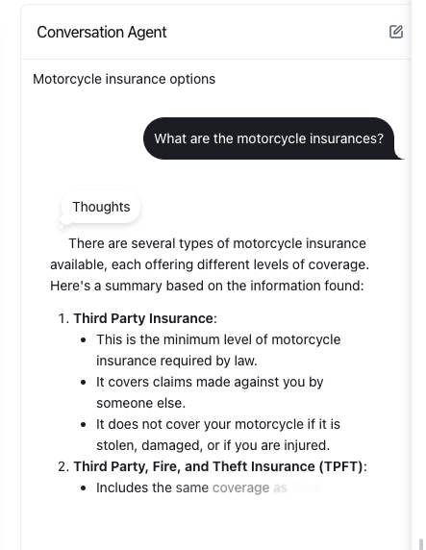
Image 13. The agent’s answer in the Preview Pane.
The agent is replying to the insurance related questons we ask in the Preview Pane. Now let’s get to the next step, making this work for End-Users that don’t have access to the DevRev UI.

This concludes this module of the workshop

Create and configure Computer for End-Users
Objective
Configure the Computer for End-Users (PLuG in the UI) for conversations between End users and DevRev.
What you will build
- Enable Computer for End-Users (CfE)
- Configure CfE
Exercise steps
➔ Navigate to PLug Chat
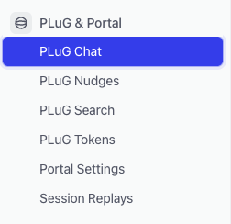
Image 14. Location of the PLuG text.
➔ Click the + PLuG widget button in the middle of the right pane.
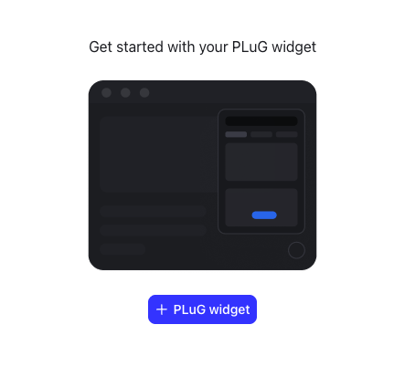
Image 15. Enable the PluG chat.
➔ Now that the PLuG Chat has been enabled, we can change how the plugin will present it self on the customer’s side. Default the Configuration tab will be selected as shown in below screenshot.
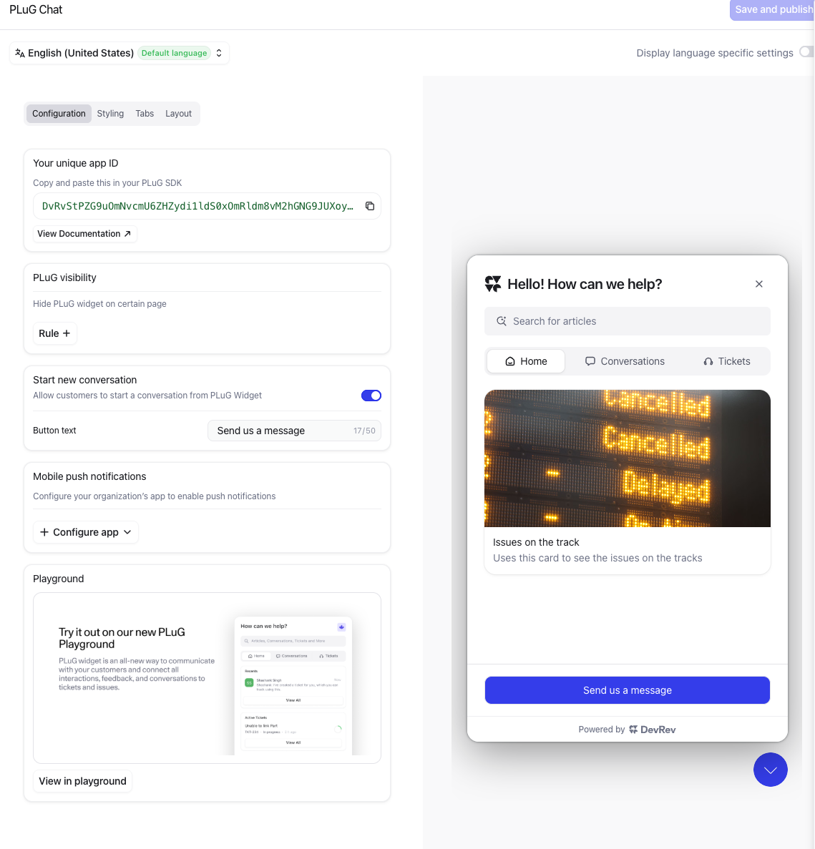
Image 16. Configuration of the CfE.
The most important parts are:
- You unique app ID: This is something we will need to use in a later module. It’s used for identifying the APP for the CfE, that way it knows what backend to use.
- !!! Abstract “More information” At the top of the screen you see the default language of the plugin. This can be changed id needed, but will follow the UI language by default. One important item to remember is that the plugin itself will answer in the lnaguage the user is using for thier conversations. Not just English! The default language is more for the items that are shown to the end users. Like buttons that are not configurable with respect to language. Example is the “Search for articles” you see in the screenhost above on the right side.
- As DevRev is by default a multitenant organisation cloud solution, this ID is to make sure the plugin will be talking to the correct tenant. The plugin can be implemented by using 7 lines of code (javascript). More detailed information can be found [here](https://developer.devrev.ai/sdks/web/installation).
- PLuG visibility: You may want to restrict where the plugin is visible. Maybe just only when a user has logged in to the user specific information.
- Start new conversation: What should the text of the button to start the conversation be (the blue//purple button in the screenshot above “Send us a message”).
- !!! Tip If you want to test any changes that are made and how they look like when deployed for the CfE, on the right hand side is an example of the settings. This also includes the other tabes that are going to be discussed.
➔ Click the tab Styiling and will be presented with other options with respect to the styling of the plugin.
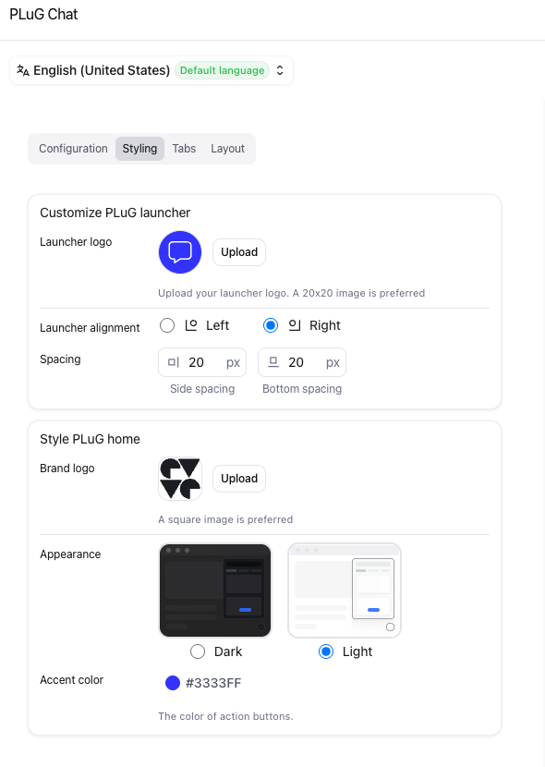
Image 16. Styling of the CfE.
➔ Here you can:
- What icon should the plugin be (we will change that in a few)?
- Where should the plugin show itself (default is right side in the bottom of the screen)?
- What should the logo be when the plugin shows itself?
- What is the theme color, dark or light and the highlight color for buttons etc.
➔ In this screen we want to change the icon for the plugin. Click the Upload button and use this image as the icon.
Image 17. THe downloaded image as Icon for the plugin.
!!! Danger “Be Aware” The link is to an image, download it and use the file browser window that opened after you clicked the Upload button. Select the downloaded image and click Open to upload it.
➔ After you clicked Open you should see the below screenshot
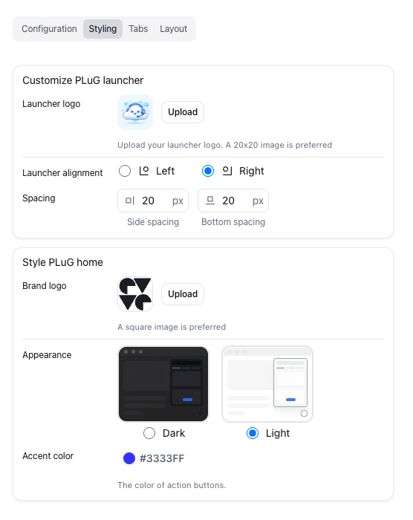
Image 18. The new icon of the CfE.
➔ On the tab Tabs you see the tabs that are shown on the plugin when it opens. You can toggle some of the items and see the result in the Preview Pane on the far right. Bring all back to the default setting (all on).
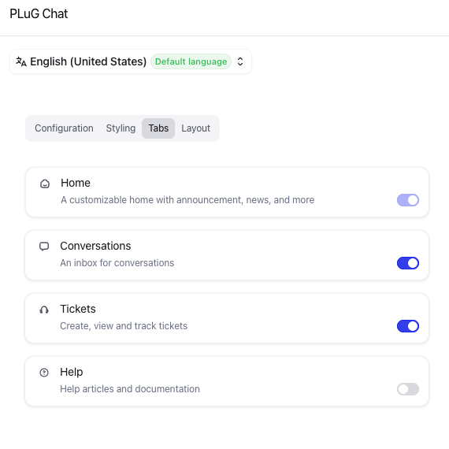
Image 19. The Tabs tab of the CfE.
➔ The last tab Layout you can change the options that are shown using toggle switches. Also try a few and see the result in the Preview Pane. Bring all back to the default setting (all on).
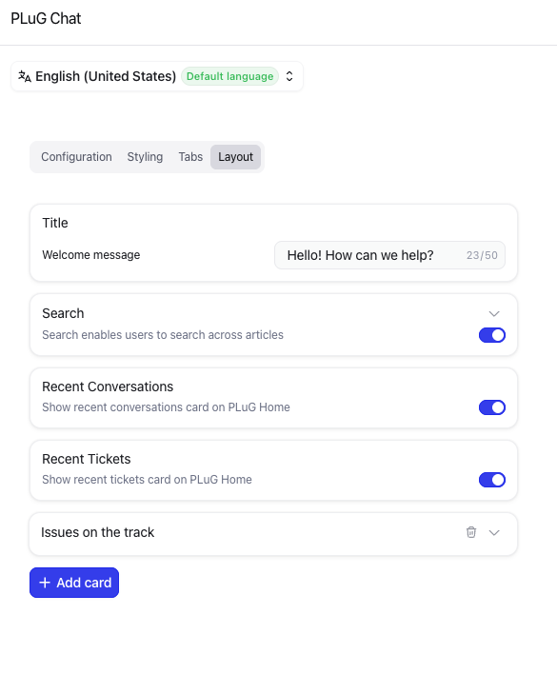
Image 20. The Layout tab of the CfE.
➔ Click the Save and publish button in the far top corner of the screen to activate the new icon, and any other settings you may have changed, for the plugin.
Now that we have the plugin configured we are going to use it. Instead of taking over the website, we are going to use an Overlay tool that mimics like if we have the plugin intergrated in the website as discussed eaerlier in one of the notes (under more information).

This concludes this module of the workshop

Chrome Extension
Objective
As we cannot always take over a customers website in PoCs or demo’s, a tool has been created. The PluG Overlay Manager. This tool uses Javascript injection to mimic an implemented CfE.
What you will build
- Install the Chrome Extension
!!! Danger “Be Aware” For now there is no other browser extension available. This is a tool that has been created by the SE community of DevRev. If there is a newer version, or for an other browser, please visit the page again to see if there is an update.
Also as the extension is not in the extension store, updates have to be installed manually and will not be updated automatically
- Configure the Chrome Extension for the website of HastingsDirect.com.
Exercise steps

Install the Extension
➔ Open a new browser tab and navigate to https://devrev.community. Here you will see a lot of tools that can be used by you to help you prepare for a demo. The tool we are going to focus on is called PLuG Overlay Manager
➔ Click PLuG Overlay Manager
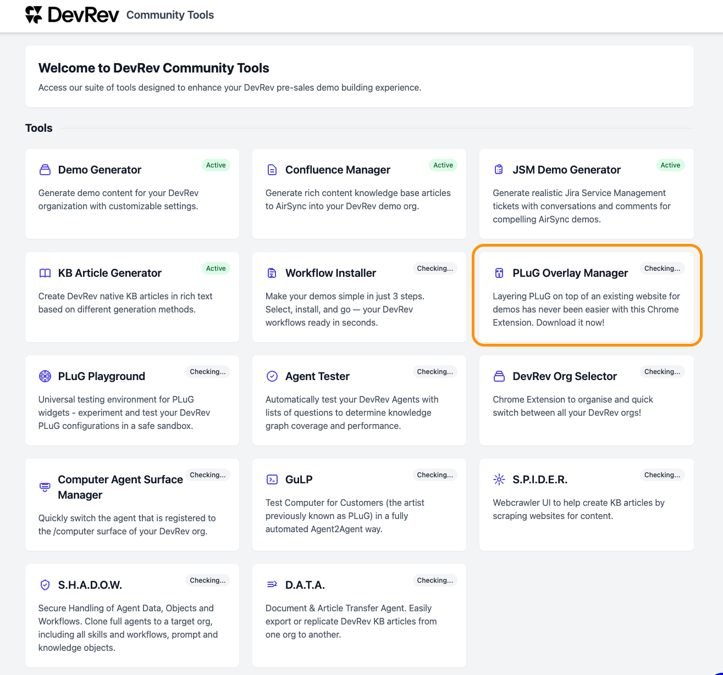
Image 21. The tools at devrev.community.
➔ Scroll down and goto the Installation section.
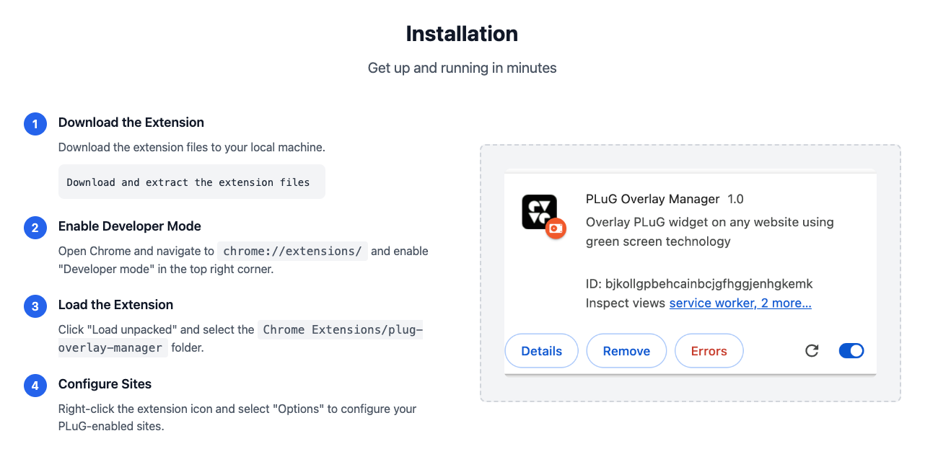
Image 22. The installation section of the PLuG Overlay Manager.
➔ Follow the steps as described in this section. The end result should be that there is a new icon shown in the Chrome (Chromium like) browser.

Image 23. The new extension in the browser.
Now that we have the extension installed, we need to configure it. This will be done in the next module.

Configure the Extension
➔ Right click the newly added extension in the browser and select Options.
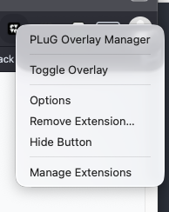
Image 24. The options selection of the extension.
➔ In the screen that appears, use the following information:
- Site Name: Hastings Direct
- Website URL Pattern: https://www.hastingsdirect.com
- PLuG App ID: You have to copy that from the PLuG Chat settings screen
- 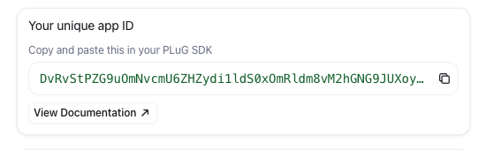
- Image 25. The PLuG Chat App ID.
- RevUser Email (optional): This would normaly be a user that the system knows as a contact. As that is outside of our scope, you can use whatever you want.
- Display Name: This would normaly be a user that the system knows as a contact. As that is outside of our scope, you can use whatever you want.
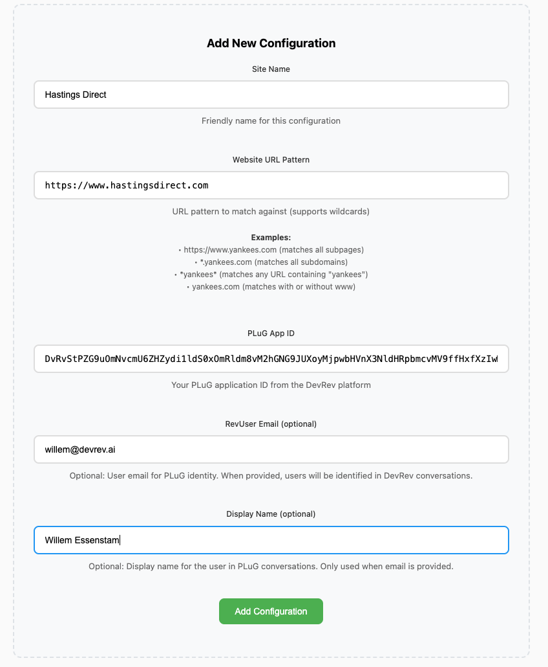
Image 26. The options for the extension.
➔ Click Add Configuration and the configuration will be shown at the bottom of the screen that appears.
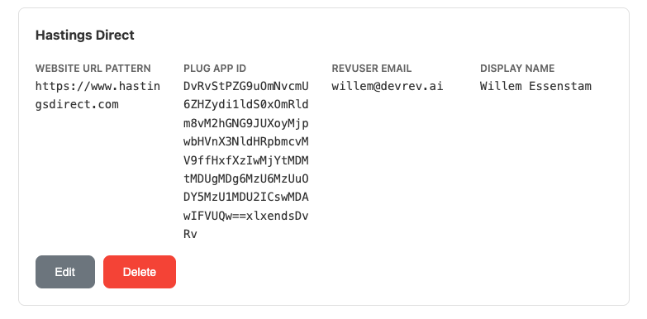
Image 27. The saved confguration for the extension.

This concludes this module of the workshop

Create Workflow for End-Users
Now that we have the minimum requirements (Agent and PLuG Overlay Manager) ready, we need to connect them to eachother when a conversation starts.
Objective
Configure the Chrome Extension for the website of HastingsDirect.com.
What You Will Build
- Configure the Extension so it can be showed on hastingsdirect.com website
- Test the PLuG Overlay Manager
Exercise steps

Export an existing workflow
➔ Navigate to Workflows
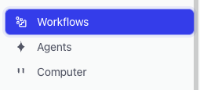
Image 28. Location of the Workflows text.
➔ There should be one workflow shown; Agent Playground workflow
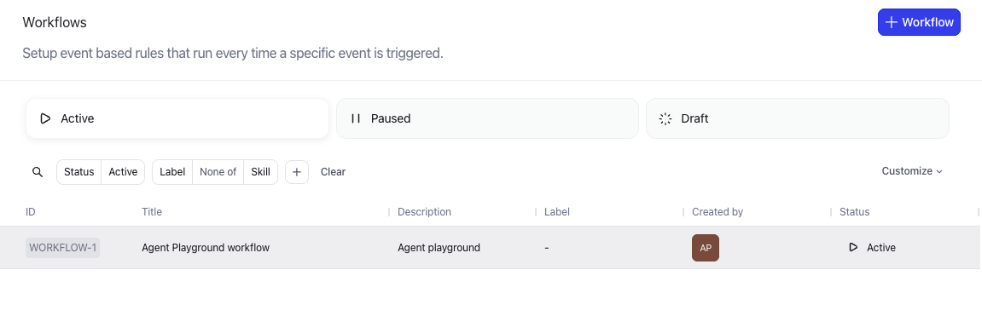
Image 29. One workflow shown.
➔ Hoover the mouse over the workflow and click it. This will open the details of the workflow.
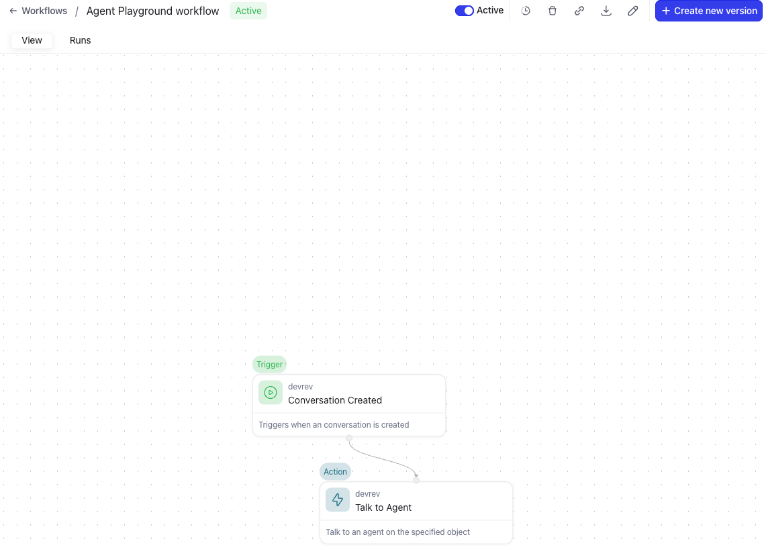
Image 30. The details of the workflow are shown.
➔ Click the Download button (:octicons-download-16:) and save the file to a location you can remember as we need the downloaded JSON file in a few.

Import an existing workflow as JSON
➔ Click the + Workflow button in the top right corner.
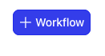
Image 31. Create workflow.
➔ In the next screen, click the tile Import Workflow Start with a pre-…
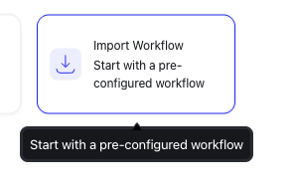
Image 32. Import workflow.
➔ In the next screen, select the earlier downloaded JSON file.

Image 33. Downloaded JSON workflow.
➔ After the JSON file is uploaded you will see the following Canvas:
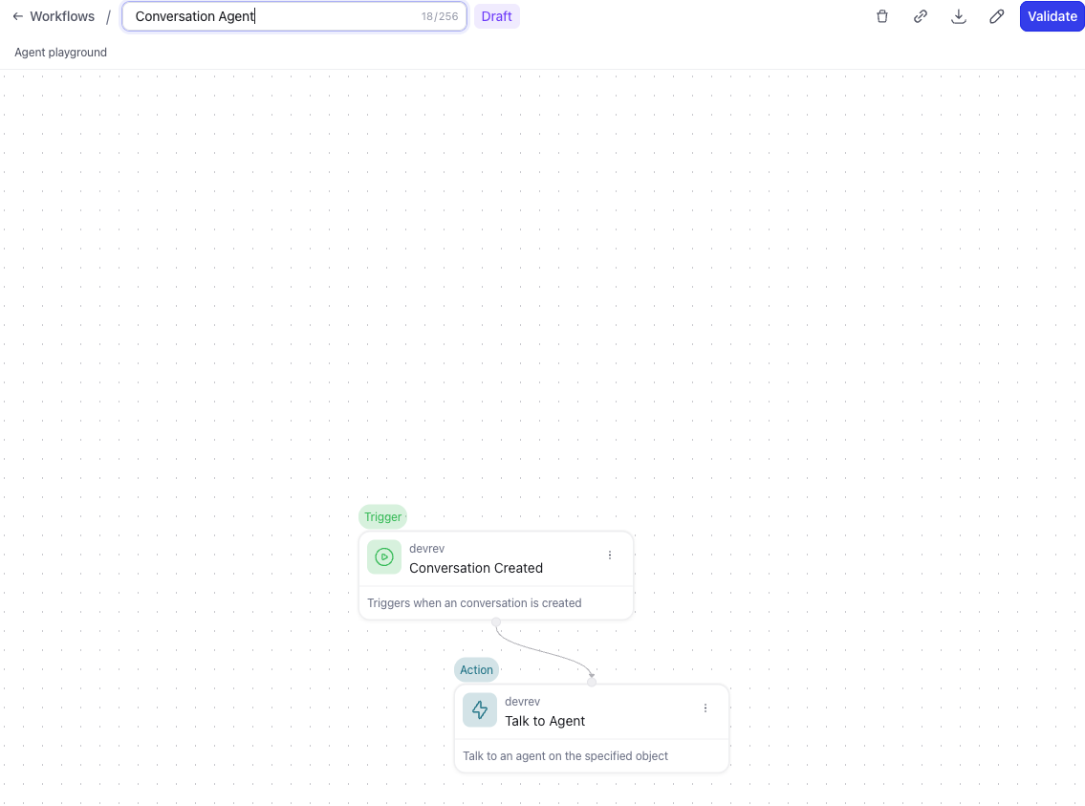
Image 34. Uploaded workflow.

Reconfigure the workflow
➔ Click the name at the top of the screen and rename it to Conversation Agent and hit Enter.
➔ Click the Conversation trigger node.
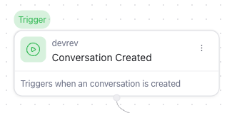
Image 35. Conversation trigger node workflow.
➔ In the screen that opens on the right hand side take these actions:
- Click the :material-delete-outline: Clear button.
- Click the X to the right of to the When text in the Filter section.
Both actions are shown in the below screenshot with their respective action numbers.
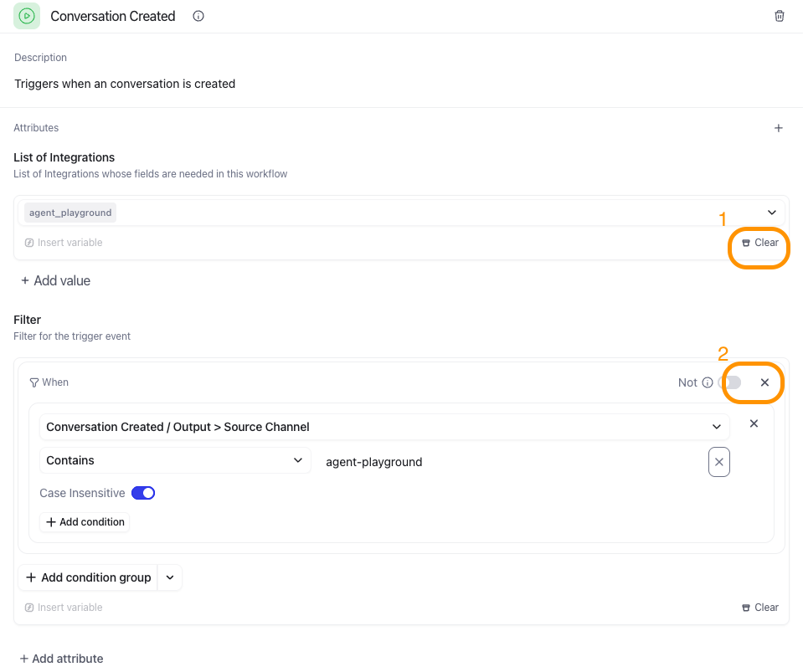
Image 36. Actions on the Trigger node.
➔ Click the Talk to Agent node on the canvas.
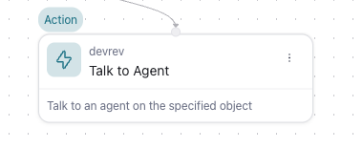
Image 37. Talk to Agent node in the workflow.
!!! note “Remark” If you don’t see the canvas, use the two arrows pointing to the right to collapse the side pane.
![](images/image060a.png)
*Image 38. Collapse side pane.*
➔ In the side pane, click the :material-delete-outline: Clean button to remove the assigned Agent. We need to change it.
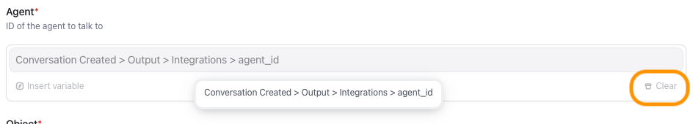
Image 39. Actions on the Talk to Agent node.
➔ Now click on the text Add Agent.
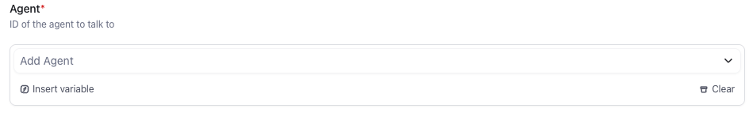
Image 40. Add Agent field in the Talk to Agent node.
➔ Select the Agent number that corresonds with the earlier created Conversation Agent.
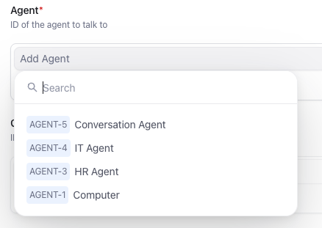
Image 41. Agent selection for the Talk to Agent node.
➔ Click the Validate button in the top right corner
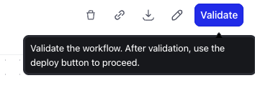
Image 42. Validate the workflow.
➔ If no issues rose that button will change into Deploy if it did, click it. If not, please rerun the steps to find the issue, or ask.
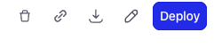
Image 43. Deploy the workflow.
➔ After deploy, use the breadcrumbs at the top to navigate back to Workflows. You should now see two workflows.
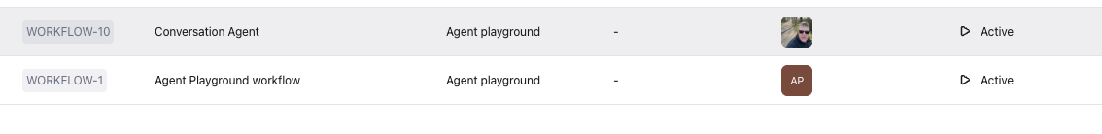
Image 44. Two Workflows shown.

Optional changes
It is possible to change the avatar of the workflow when it gets triggered, as well as it description.
➔ Click in the top row to the left the pencil (:octicons-pencil-16:), just left of the + Create new version button.

Image 45. Edit the workflow.
➔ In the side bar you can change:
- Workflow title
- Workflow description
- Display name
- The avatar by clicking the Pencil in the Display Image section
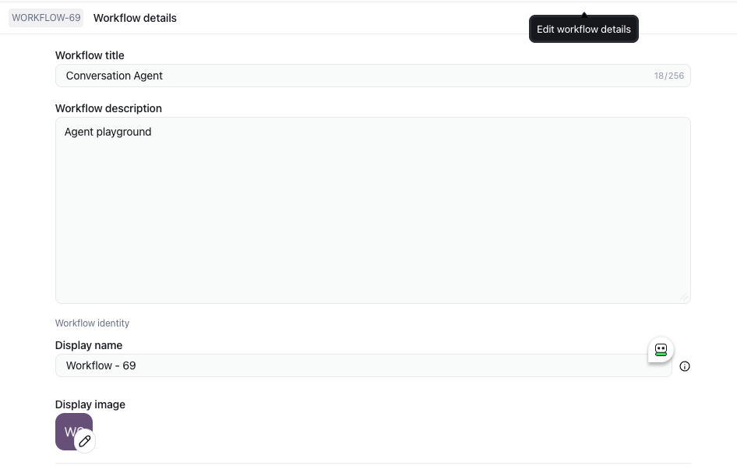
Image 46. Edit options for the workflow.
➔ You can change these settings as you like. It would be in production a good idea to change the name and picture to be more destinct to mimic a human-being, or at least that the person in the conversation is talking to an AI solution and not just a chatbot.
Now that we have the backend ready we can focus on the front-end where our End-Users are.

This concludes this module of the workshop

Test using a conversation
Objective
Test the conversation possibilities by using the earlier configured steps in the modules.
What you will build
- Test the environment
Exercise steps
➔ Navigate to the browser tab where the Hastings Direct page is open and the plugin is active (green logo) and we see our uploaded image for the plugin.

Image 47. The plugin.
➔ Click our uploaded image to open the plugin
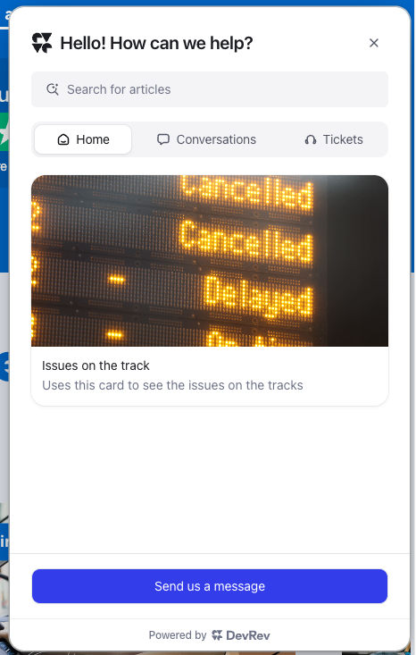
Image 47. The full plugin.
➔ Click the Send us a message button
➔ Ask the followiong question in the conversation that opened:“What can you tell me about motorcycle insurances?”
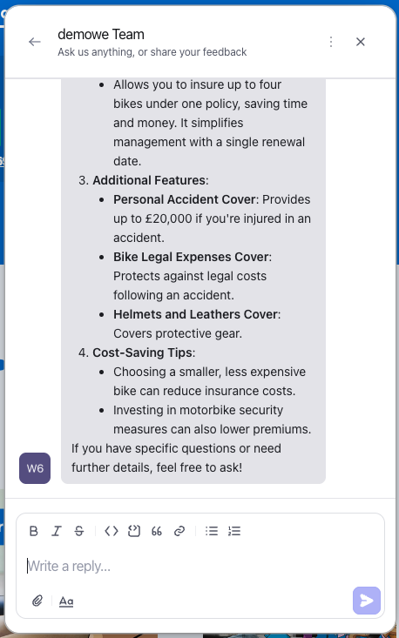
Image 48. The answer of the AI Agent.
➔ As this is an easy question, let’s see what would happen if we ask it a bit more reasoning to the answer… Ask the following question:
I don't drive much on my bike and I have heard/read about YouDrive. My questions are:
1. Is it available for MotorcyclesX
2. What is the influence of: 55 years old male, 22 years drivers license with NO damage ever, less then 1300 MILES a year
3. Are there any accredited motorcycle trainings that lower the premium cost
Answer my three questions seperately.
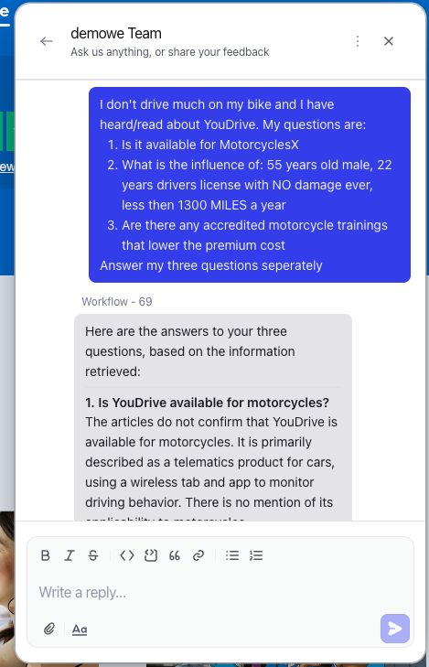
Image 49. The answer of the AI Agent.
It takes a bit longer, but the answer is retrieved using reasoning and given.

This concludes this module of the workshop

See the log of the workflow
Objective
Every run of a workflow might not always deliver the expected answer. How to find the reason, or where did the workflow got stuck or failed? This module is trying to give you a first troubleshooting step.
What you will build
- See logs that can help with troubleshooting
Exercise steps
➔ Revert back to the tab in the browser where the DevRev UI is.
➔ Select the Workflows, if you have left it.
➔ Click on the line with your created Conversation Agent and you will see two tabs at the top of the screen, View and Runs. The first we already know as we have created and reconfigured the Workflow.
➔ Click the Runs tab.
➔ Here you can see the runs of the workflow you selected. Your workflow will have a Waiting as status as you have a conversation open.
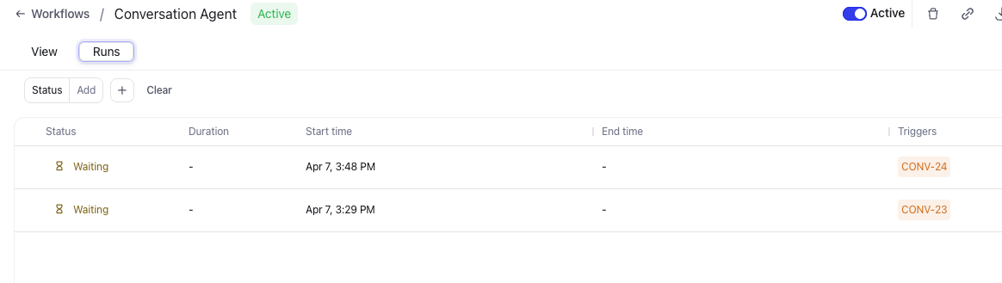
Image 50. The runs of the workflow.
➔ Click the top one and see where the waiting state is shown.
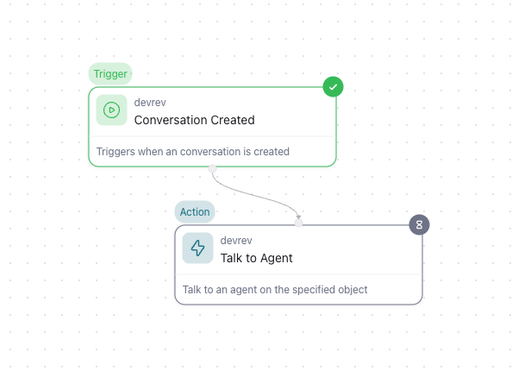
Image 51. The details of the run of the workflow.
➔ When clicking on the node, you can see what the input, output, and logs (if available) has been so far.
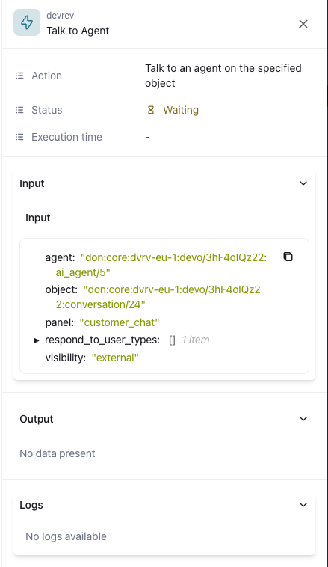
Image 52. The details of the run node in the workflow.
!!! tip If there is a failure in a workflow, this is the first step to see why and where, maybe even a reason, like the input values is wrong, or not what was expected.

This concludes this module of the workshop

PLACEHOLDER

