My First R Markdown File

Ryan Wesslen

September 28, 2017

## Loading Data

Let's get started. First, we can write text to describe what we're doing next.

For example, let's load tidyverse.

library(tidyverse)

## Loading tidyverse: ggplot2  
## Loading tidyverse: tibble  
## Loading tidyverse: tidyr  
## Loading tidyverse: readr  
## Loading tidyverse: purrr  
## Loading tidyverse: dplyr

## Conflicts with tidy packages ----------------------------------------------

## filter(): dplyr, stats  
## lag(): dplyr, stats

Next, let's use the read_csv() function load our dataset.

tweets <- read_csv("../data/CharlotteTweets20Sample.csv")

## Parsed with column specification:  
## cols(  
## body = col_character(),  
## postedTime = col_datetime(format = ""),  
## actor.id = col_double(),  
## displayName = col_character(),  
## actor.postedTime = col_datetime(format = ""),  
## summary = col_character(),  
## friendsCount = col_integer(),  
## followersCount = col_integer(),  
## statusesCount = col_integer(),  
## actor.location.displayName = col_character(),  
## generator.displayName = col_character(),  
## geo.type = col_character(),  
## point_long = col_double(),  
## point_lat = col_double(),  
## urls.0.expanded_url = col_character(),  
## klout_score = col_integer(),  
## hashtags = col_character(),  
## user_mention_screen_names = col_character()  
## )

Recall -- what's going on with the path?

Why have we not needed to set our working directory?

### View Data

We can use the ### parameter to specify a new section. For example, in this section, let's consider looking at the first five tweets.

head(tweets$body, n = 3)

## [1] "Treon to WR is a really good move by Mac, very familiar with playbook. Very good runner in open space too"   
## [2] "primus #vsco #vscocam #primus #primussucks #charlotte #bojanglescoliseum #livemusic… https://t.co/IqI6BIPVqn"  
## [3] "WOAH!!!!!!"

## Getting a time series of the Tweets

Next, let's convert the date to allow us to plot our data.

# converts YYYY-MM-DD HH:MM:SS to string of YYYY-MM-DD  
tweets$day <- as.Date(tweets$postedTime)  
  
# recall from dplyr  
dayCount <- tweets %>%  
 group_by(day) %>%  
 summarise(Count=n())

Next, we're going to use ggplot2 to plot our time series. We'll formally introduce ggplot more next week.

ggplot(dayCount, aes(x = day, y = Count)) +  
 geom_line()

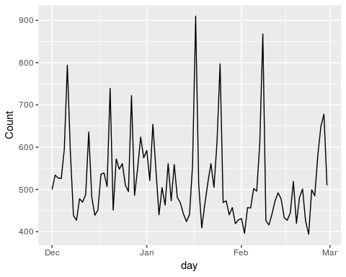

Not bad. We can add a few parameters to this plot to make it pretty.

ggplot(dayCount, aes(x = day, y = Count)) +  
 geom_line() +  
 labs(x = "Posted Day", y = "Tweet Count", title = "Charlotte Geo Tweets per Day") +  
 expand_limits(y = 0) # set y axis to start at zero

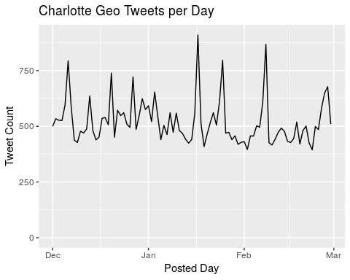

What the heck are those spikes?

## Hashtag & Mentions

One way we can check is to look at the most prominent hashtags and mentions.

To do this, we can run a pre-specified function ([regular expression](https://www.rstudio.com/wp-content/uploads/2016/09/RegExCheatsheet.pdf)) that will keep only hashtags or handles from the body of our tweet.

getCommonHashtags <- function(text, n=20){  
 hashtags <- regmatches(text, gregexpr("#(\\d|\\w)+",text))  
 hashtags <- unlist(hashtags)  
 tab <- table(hashtags)  
 return(head(sort(tab, dec=TRUE), n=n))  
}  
  
getCommonHandles <- function(text, n=20){  
 handles <- regmatches(text, gregexpr('@([0-9_A-Za-z]+)',text, perl=TRUE))  
 handles <- unlist(handles)  
 tab <- table(handles)  
 return(head(sort(tab, dec=TRUE), n=n))  
}

For example, now we can run:

getCommonHashtags(tweets$body)

## hashtags  
## #KeepPounding #Charlotte #NC #realestate #charlotte   
## 487 458 443 429 256   
## #keeppounding #traffic #trndnl #photo #listing   
## 234 212 205 185 159   
## #clt #Repost #realtor #CIAA #SB50   
## 154 144 133 123 109   
## #Panthers #CIAA2016 #Concord #CLT #panthers   
## 95 89 88 86 86

or ...

getCommonHandles(tweets$body)

## handles  
## @cltairport @Panthers @midnight @panthers   
## 218 212 180 130   
## @EthanDolan @ness @hornets @GraysonDolan   
## 117 80 78 77   
## @SportsCenter @F3theFort @realDonaldTrump @nodabrewing   
## 69 64 64 63   
## @CampersHaven @marcuslemonis @F3Isotope @marielawtf   
## 58 52 48 43   
## @oakley @LifeTimeFitness @ChickenNGreens @wcnc   
## 39 38 36 36

Ah... maybe they're Carolina Panther related!

## Searching for Panther Tweets

Let's use a different regular expression and save only the tweets that include three keywords...

panthers <- c("#keeppounding", "#panthers", "@panthers")  
  
# find only the Tweets that contain words in the first list  
hit <- grepl(paste(panthers, collapse = "|"), tolower(tweets$body))  
  
# create a column to separate panther tweets and non-Panther tweets  
tweets$pantherFlag <- ifelse(hit, "Panther Tweet", "Non-Panther Tweet")

With our new flag, let's rerun our time series but differentiate between Panther and non-Panther tweets.

dayCount <- tweets %>%  
 group_by(day, pantherFlag) %>%  
 summarise(Count=n())

Next, we're going to use ggplot2 to plot our time series. We'll formally introduce ggplot more next week.

ggplot(dayCount, aes(x = day, y = Count, color = pantherFlag)) +  
 geom_line() +  
 labs(x = "Posted Day", y = "Tweet Count", title = "Charlotte Geo Tweets per Day") +  
 expand_limits(y = 0) # set y axis to start at zero

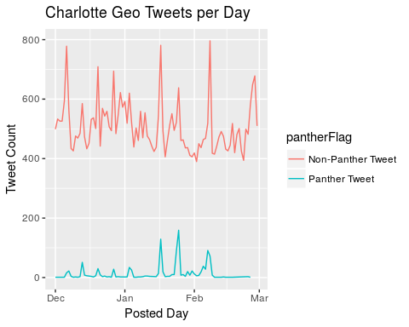

This is a good start, but it still looks like we may have missed some Tweets.

Querying Twitter data is an incredibly hard problem (much harder than many researchers realize!).

For example, [King, Lam and Roberts (2017)](https://gking.harvard.edu/publications/computer-assisted-keyword-and-document-set-discovery-fromunstructured-text) investigates this problem and finds that the choice of keywords can drastically affect results.

For a deeper analysis, see my [Fall 2016 Twitter Workshop Day 1](https://cdn.rawgit.com/wesslen/fall-2016-pm-twitter-text/44b3a896/Day1/exercise1.html) Exercise.