**Treatment: Bar Chart (repeat of Round 1)**

### **Round 2 Instructions**

* **You'll repeat the same task for new funds: C and D.**
* **You will use the same bar chart as round 1.**

**------**

### **Round 2 Instructions**

* **Like Round 1, you will be provided returns across different evaluation periods.**
* **And you will make your allocation decision based on a 30 year investment period.**
* **Press Next to proceed to Round 2**

**Treatment: Table**

### **Round 2 Instructions**

* **You'll repeat the same task for new funds: C and D.**
* **Now you will view a table of the rates of returns.**
* **The table provides possible rates of returns.**

### **Example**

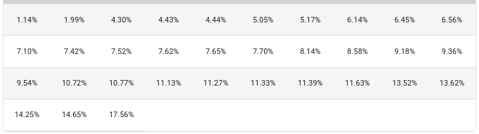

**------**

### **Example**



##### **1. In this table, what does each cell value? \***

**The allocation options between two assets**

**The guaranteed rate of return for investing**

**A possible rate of return for the asset**

**A break even rate of return**

**Treatment: Dotplot**

### **Round 2 Instructions**

* **You'll repeat the same task for new funds: C and D.**
* **Now you will view a new visualization of the rates of return.**
* **Each dot represents a possible rate of return.**

### **Example**

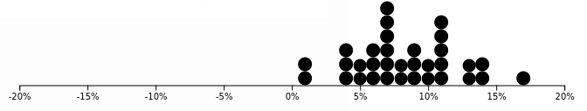

**----**

### **Example**



##### **1. In this plot, what does each dot stand for? \***

**An investment year**

**An investable asset**

**A possible rate of return**

**The maximum rate of a return for the asset**

**Treatment: Density**

### **Round 2 Instructions**

* **You'll repeat the same task for new funds: C and D.**
* **Now you will view a new visualization of the rates of return.**
* **The line shows the distribution of possible rates of returns.**

### **Example**

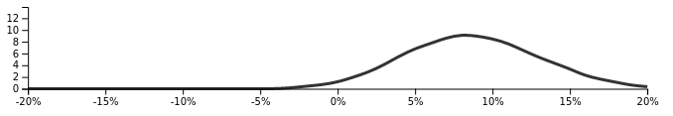

**----**

### **Example**



##### **1. In this plot, what does the line stand for? \***

**The number of years to invest**

**The maximum values of guaranteed**

**The distribution of possible rates of return**

**The range of allocation options**

**Treatment: Interval**

### **Round 2 Instructions**

* **You'll repeat the same task for new funds: C and D.**
* **Now you will view a new visualization of the rates of return.**
* **The intervals represents the range for 95% (light green) and 66% (dark green) of possible rates of return.**

### **Example**

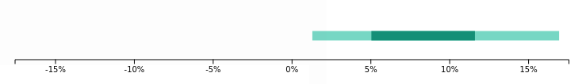

**-----**

### **Example**



##### **1. What does the light green interval represent? \***

**The range of 50% of possible rates of return**

**The minimum and maximum possible investment returns**

**The range of 95% of possible rates of return**

**The range of feasible allocation mixes**

**Treatment: Point + Interval**

### **Round 2 Instructions**

* **You'll repeat the same task for new funds: C and D.**
* **Now you will view a new visualization of the rates of return.**
* **The intervals represent the range for 95% (light green) and 66% (dark green) of possible rates of return.**
* **The point represents the average rate of return.**

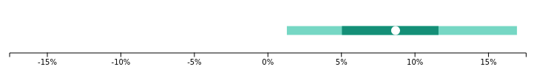

**-----**

### **Example**



##### **1. What does the point represent? \***

**An investable asset**

**The optimal allocation mix**

**The average rate of return**

**The minimum investment rate**

**Treatment: HOPs**

### **Round 2 Instructions**

* **You'll repeat the same task for new funds: C and D.**
* **Now you will view a new visualization of the rates of return.**
* **Each line represents a possible rate of rate.**

### **Example**



**----**

### **Example**



##### **1. What does each orange line stand for? \***

**An investment year**

**An investable asset**

**A possible rate of return**

**The maximum rate of a return for the fund**

**Treatment: HOPs + Strip Plot**

### **Round 2 Instructions**

* **You'll repeat the same task for new funds: C and D.**
* **Now you will view a new visualization of the rates of return.**
* **Each line represents a possible rate of rate.**
* **The grey lines show the distribution of possible rates of return.**

### **Example**



**-----**

### **Example**



##### **1. What does each orange line stand for? \***

**An investment year**

**An investable asset**

**A possible rate of return**

**The maximum rate of a return for the fund**