Outline of study: retirement-study-1.herokuapp.com/

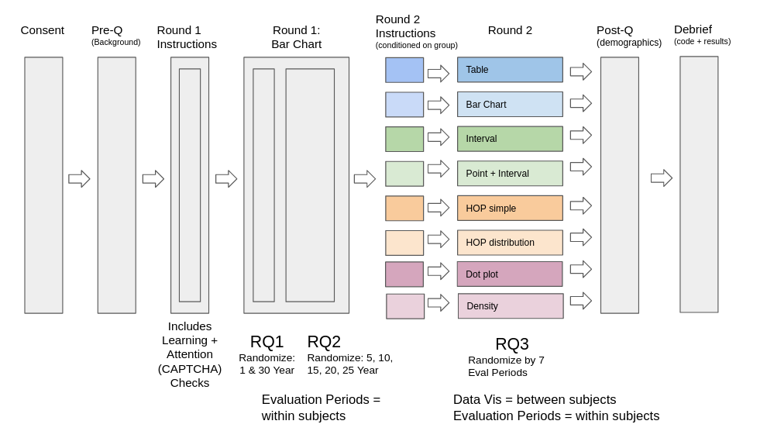

Consent Form:

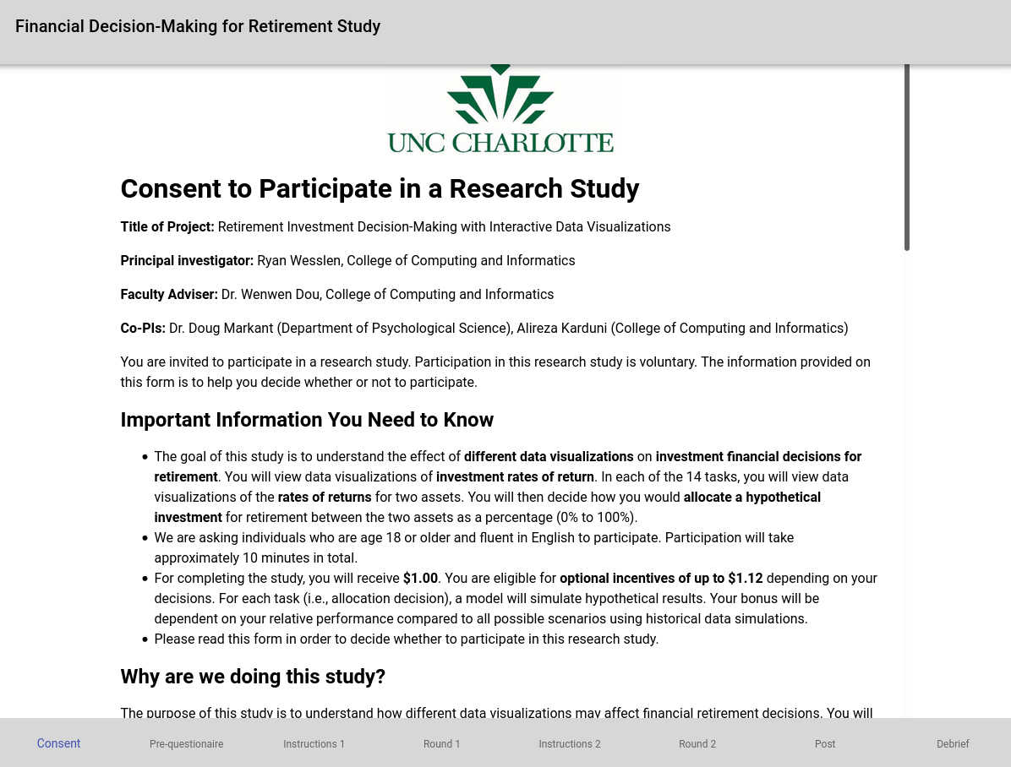

User scrolls and must click Consent to proceed (can print to pdf).

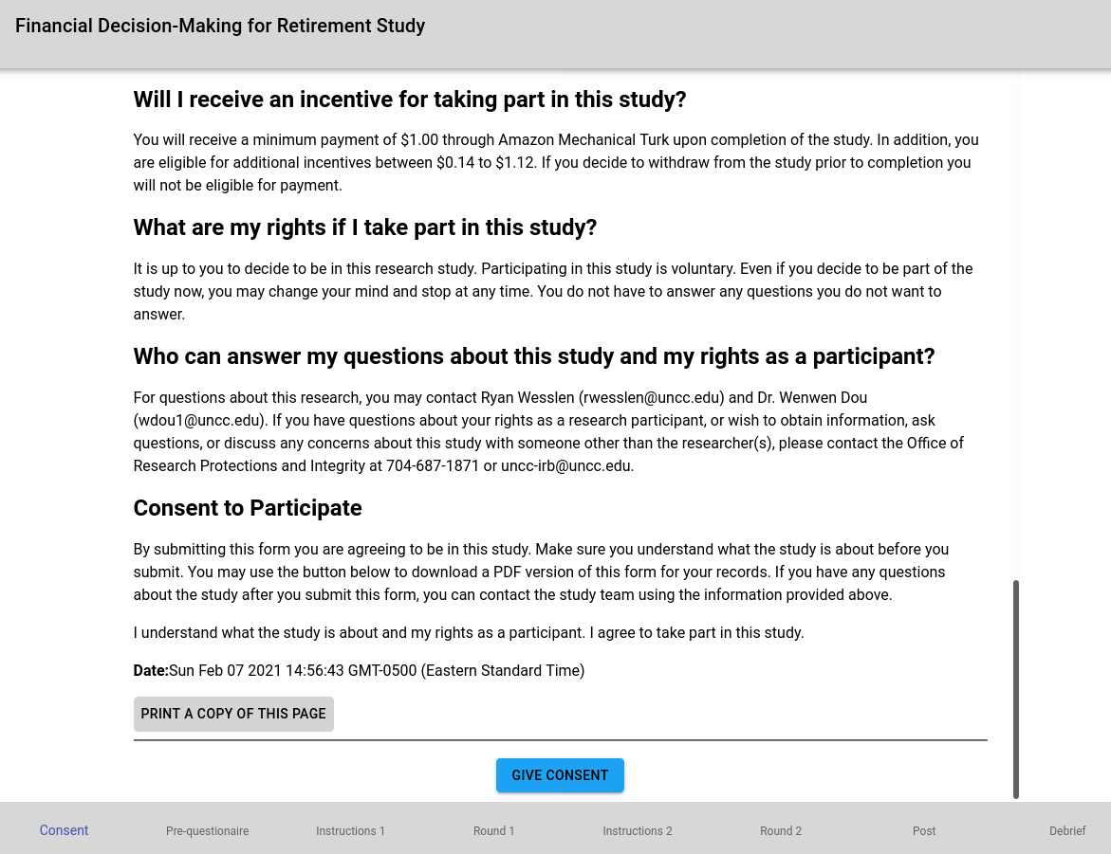

Pre-questionnaire:

* Five questions that measure risk aversion (e.g., Samuelson’s bet, classic Prospect Theory, and Measure CRRA)
* All are required.

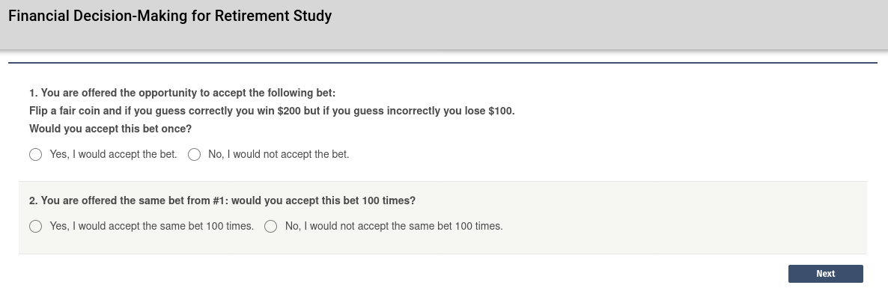

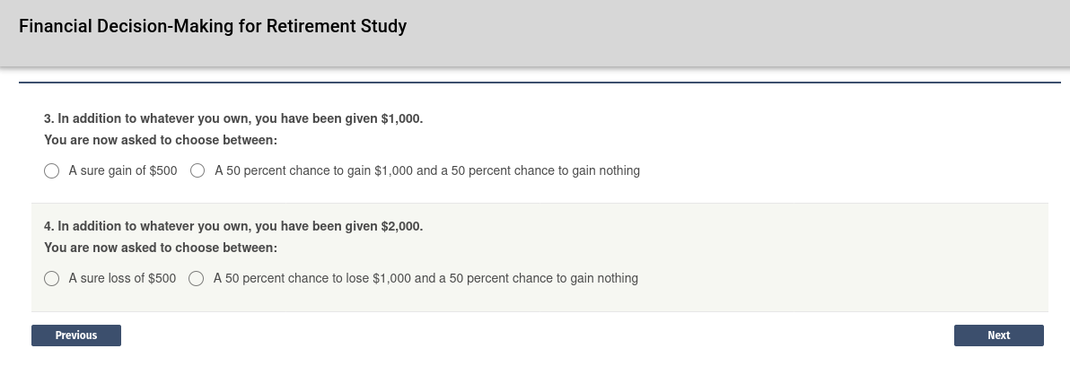

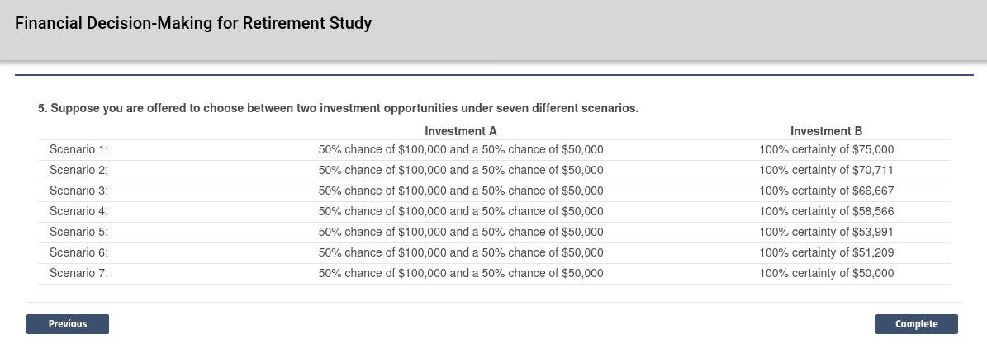

Round 1 Instructions:

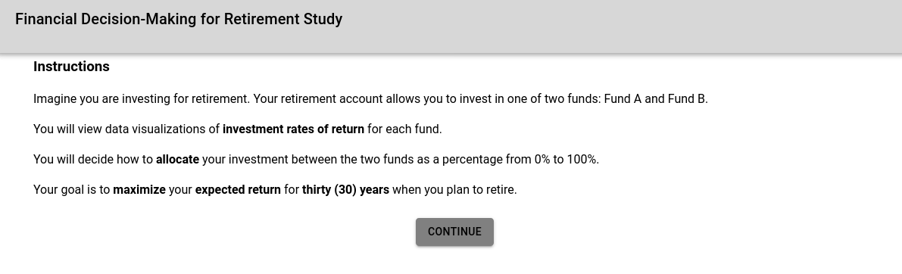

Includes comprehension check (user must complete correctly to move on)

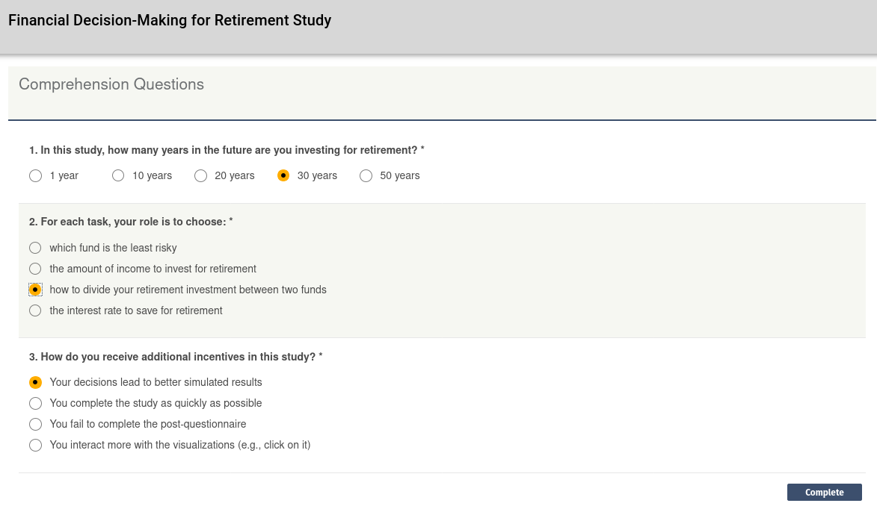

Example/practice 1

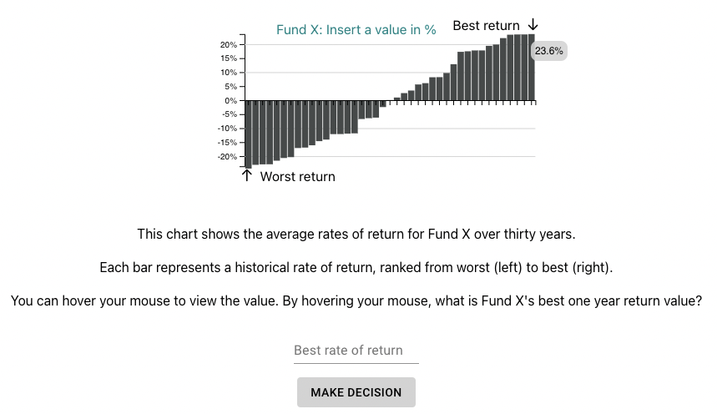

Learning/control check: user must use mouse to hover over the largest bar which will have a tooltip pop-up. To move forward, the user must put in 23.6% into the box.

Data is randomly sampled from uniform distribution

Example/practice 1

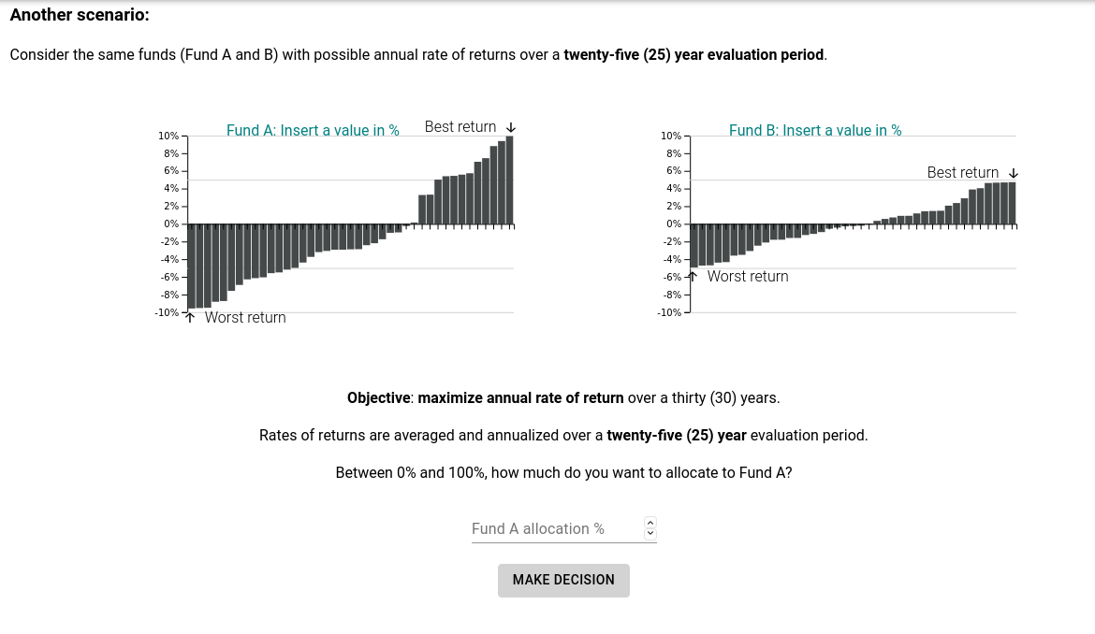

Uniform sampled as well.

Also includes attention/captcha check to remove bots

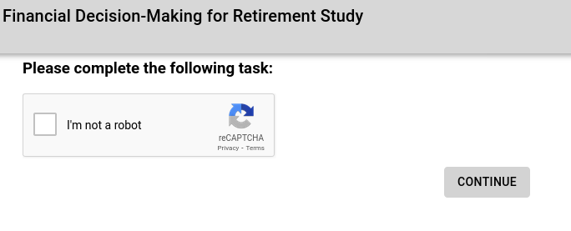

Round 1 Task:

Users will provide allocation for 7 tasks comparing simulated returns between two hypothetical funds. Each task is different by the “evaluation period” (framing) of the returns. First two options are randomized between 1 and 30 year evaluation period (Benartzi & Thaler replication). Then trials 3-7 are randomly selected between 5, 10, 15, 20, and 25 year evaluation periods. To control for order, the order of the funds are randomized (left/right).

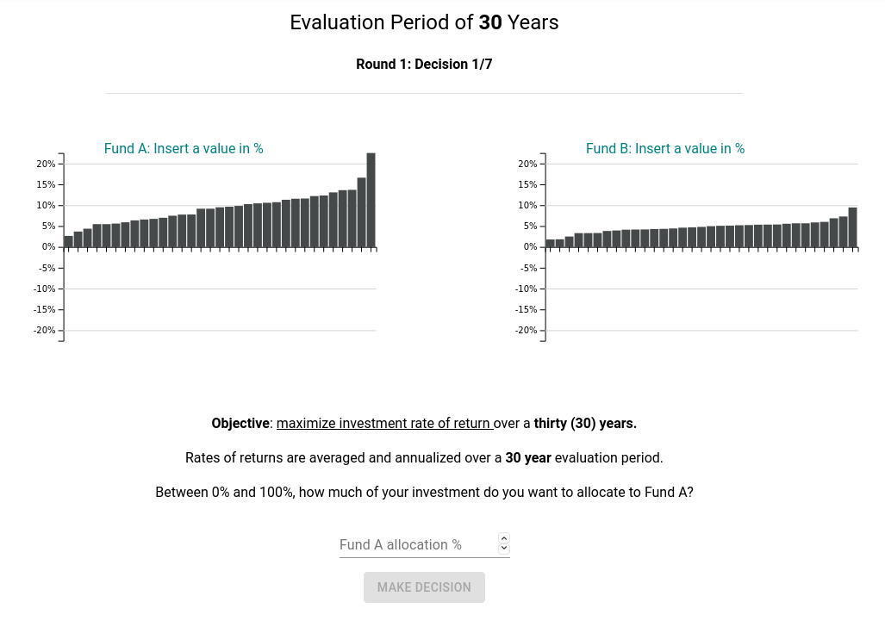

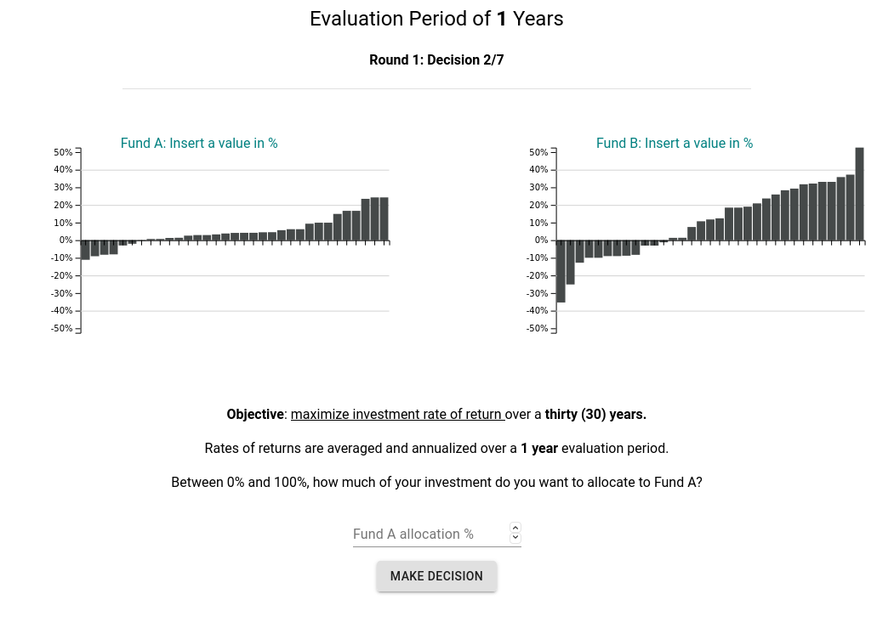

Similar is shown for next 5 (5, 10, 15, 20, 25 evaluation periods)

Round 2 Instructions:

Instructions will be provided similar to Round 1, but unique to the treatment (visualization) they are assigned. Similar to Round 1, each user will answer 7 allocation questions. Different than Round 1 is that they’ll be assigned a different visualization (between subjects treatment).



For each treatment, Round 2 instructions will include

Page 1: Instructions for round 2 (text only)

Page 2: Image of visualization + text

Page 3: Comprehension question - multiple choice to understand what each point is (e.g., 1 out of 33 sampled draw or interval/point/density

Treatment 1: Table

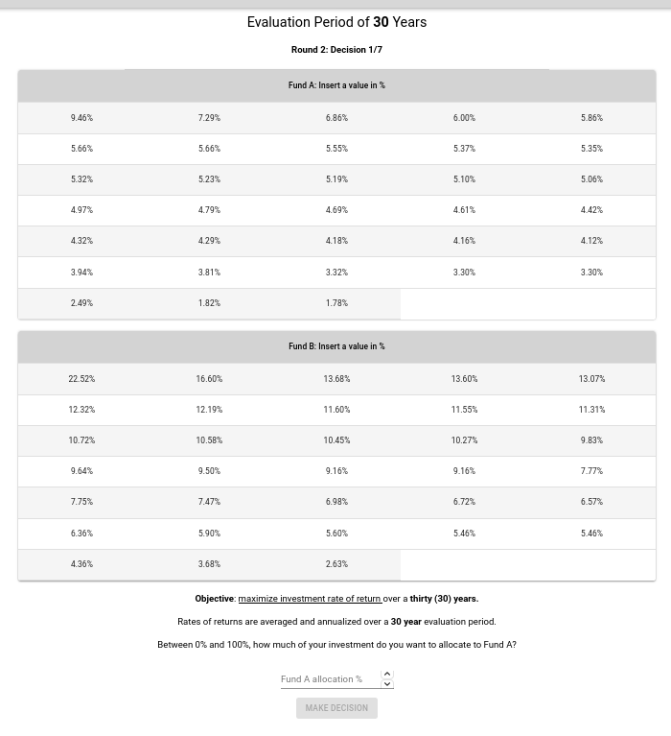

Treatment 2: Dotplot

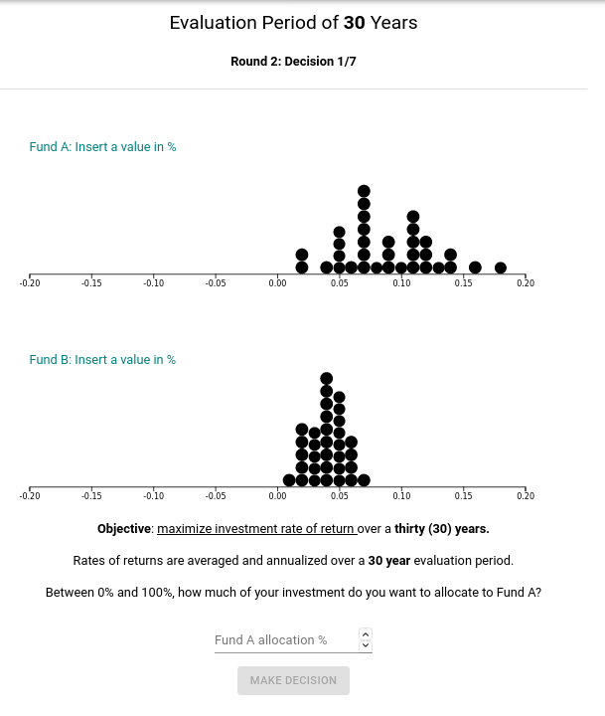

Treatment 3: Density

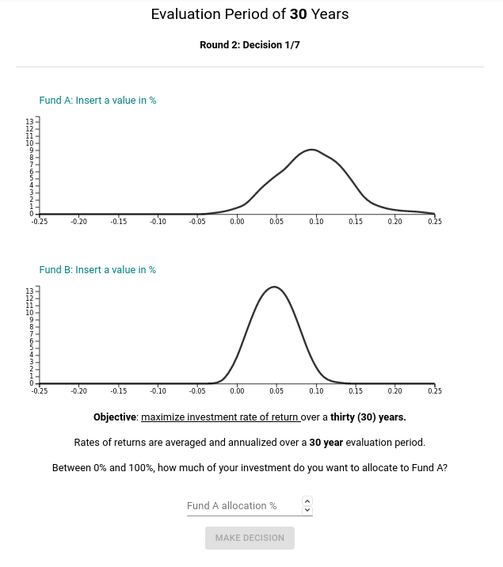

Treatment 4: Point + Interval

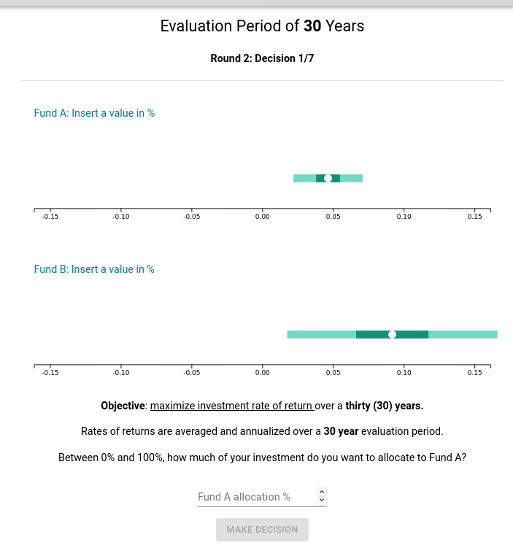

Treatment 5: Interval

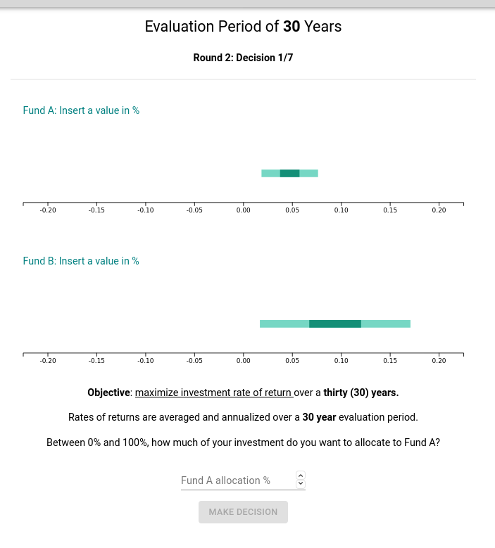

Treatment 6: HOP (simple)



Treatment 7: HOP (distribution)



Treatment 8: Bar chart - identical to Round 1

* Reason we use this is to get a clean between subjects performance in Round 2 of how the bar chart performance is relative to the other 7 graphs.



Post-questionnaire:

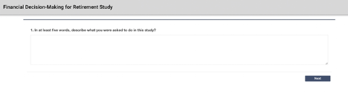

This first question is to remove out participants that exclude from the analysis participants that do not provide a legitimate response. In such cases, participants will still receive the same payment and incentives but results will not be used. This will be recorded in pre-registration.

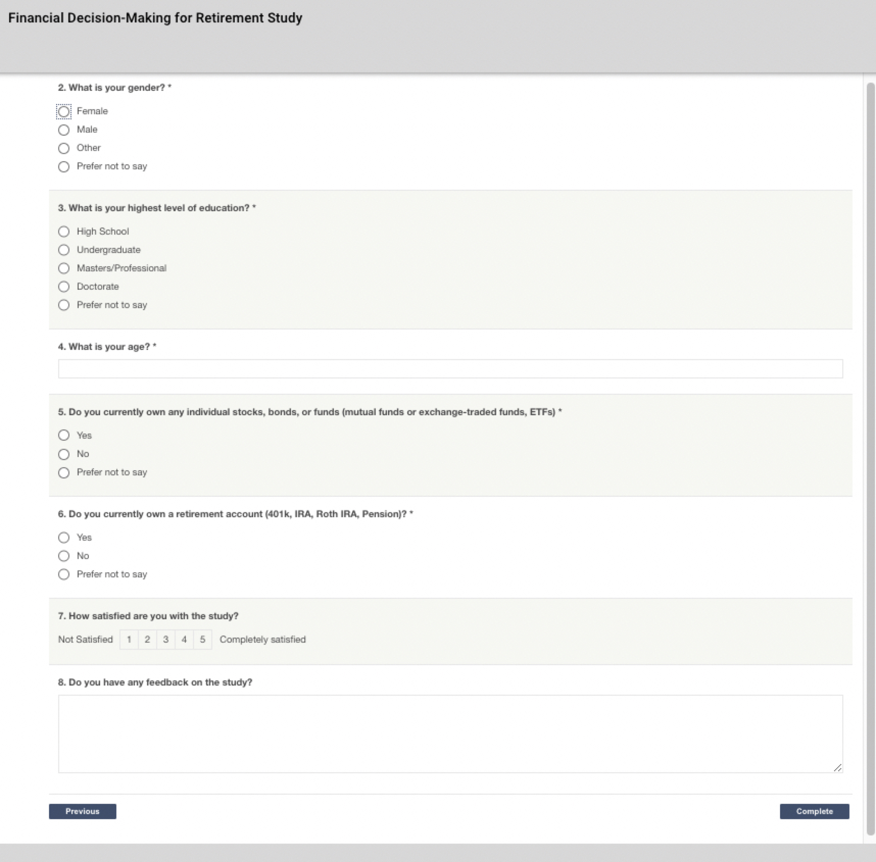

Debrief:

