Wes Porter

PGEO6050

4/10/2017

Python Mini Project Report

Description of requirements and outcomes:

The task of this mini project is to use Python scripting in order to analyze data generated from a channel-widdening experiment performed by the National Sedimentation Lab. Specifically, the Python script must measure channel-width across the length of the channel in 10 second increments. This requires utilizing arcpy to generate cross section lines spaced 3cm apart across the length of the channel. Then an intersect analysis can be performed between the cross section polylines and the channel boundary polygon for a particular time increment.

A search cursor can be used to search across the results of the intersect analysis and gather the lengths of the lines between channel edges for every increment of time. The lengths and any additonal attribute information can then be writen to a csv file. The summary statistics tool can be used in conjunction with a search cursor to write summary inforation about the channel data to a csv as well.

Pseudo code:

import arcpy

define the workspace

determine the rectangular boundaries of where cross section lines will extend

create an empty feature class for our cross section polylines

add a field for distance to outlet

create an insert cursor

use a for loop to generate cross section lines along our channel boundaries and measure distance to outlet

use a for loop to perform an intersect analysis for selected time increments and then merge them together

create a search cursor to gather channel width measurments

add a field for channel width to intersect merged results

create an update cursor to populate channel width field with collected data

create a search cursor to write attribute table to csv

use statistics analysis to calculate summary statistics for intersect results

use search cursor to write results to csv

Examples of generated datasets:

Cross Section Polylines

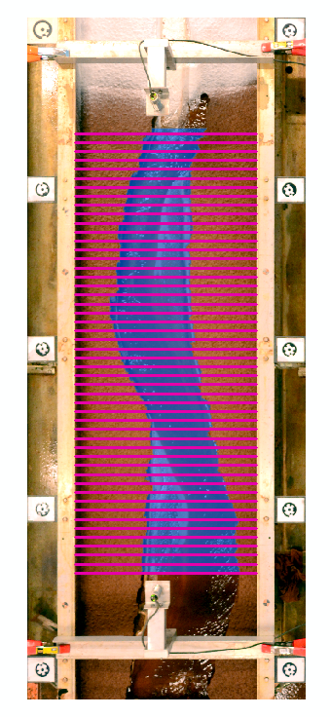

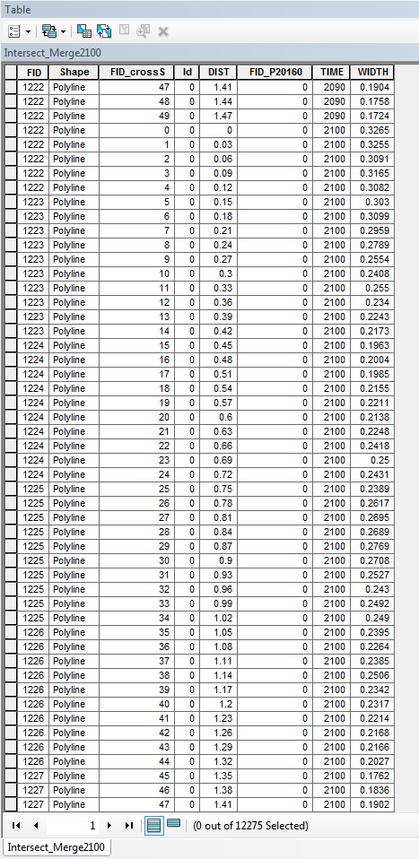Merged Intersect Results - Attribute Table

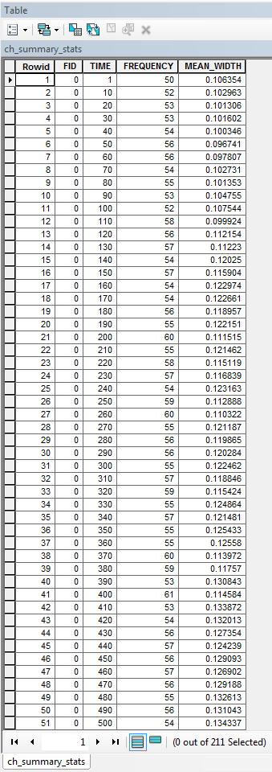Summary Statistics Table

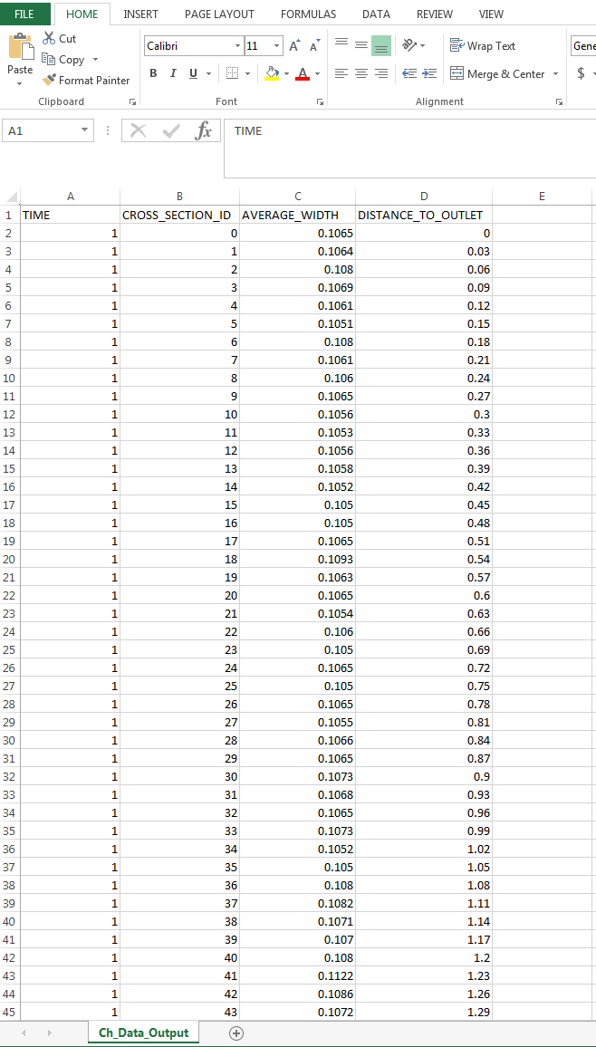Channel Data Output – CSV

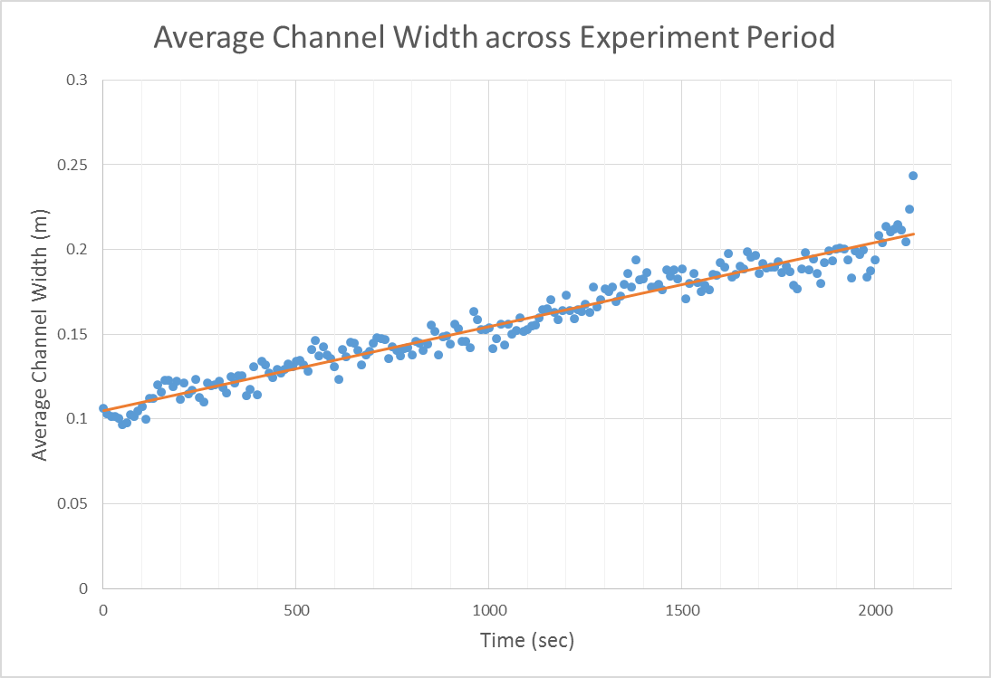Graph of elapsed time and average channel width: