# **Introduction**

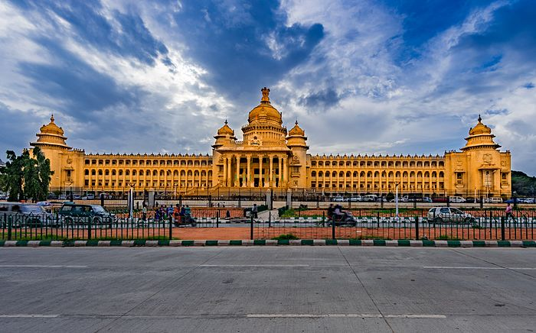

**Bangalore** is the capital city of the state of Karnataka.

**Bangalore** consists of the closely built old town, together with a number of modern outlying areas (former suburbs) laid out in a gridiron pattern to the north and south, with many parks and wide streets. A large military area is situated just southeast of central Bengaluru. Outlying areas incorporated into the city in 2007 include large green spaces as well as farmland and are sites of population and ICT-related growth.

In today’s technology driven world people move from one place to another on account of new jobs, better amenities, schooling facilities, better work life balance etc. In a city like Bangalore the lives of people revolve around traffic which the city is known for. Whenever people move on account of any of the reasons mentioned above, they try to explore the place they like about and try to dig as much information as possible about it. It can be about the neighborhood, locality, market, price of the place and many more factors including neighborhood analysis.

In such a scenario it would be good to have as much data analysis which could make a person’s life easy by considering a comparative analysis between the neighborhoods with a host of predetermined factors.

# **Problem Description**

The objective of this project would be to help the end user or anyone who wishes to

1. Choosing a rental apartment/house
2. Buy a house/apartment
3. Start a Super market
4. Start a Playschool
5. Start a gymnasium

These could be based on the distribution of various facilities available around the neighborhood.

As an example, this project would compare 2 randomly picked neighborhoods and analyze the top 10 most common venues in each of those two neighborhoods

The project proposes to use K-mean clustering unsupervised machine learning algorithm to cluster the venues based on the place category such as restaurants, park, coffee shop, gym, clubs etc.

This would give a better understanding of the pros and cons between the two chosen neighborhoods and present the much wanted insights into the neighborhoods and conclude which one is better and which has the edge over the other.

Target Audience

Target audiences for this are not limited to an individual or a group of people who are looking for the information. It could be anyone who wishes to rent a place, buy a house or anyone who wishes to open a new business.