CERTIFICATION PROGRAM IN APPLIED GENERATIVE AI AND AGENTIC AI
Customer Review Insights & Response Generator
Final Project Report
A multilingual pipeline that collects product reviews in six languages, translates them, measures sentiment, finds the issues customers complain about, spots sudden spikes, and drafts on-brand replies for a human to approve.
Group 5
TalentSprint capstone project, final presentation on Sunday 11 October 2026
Code repository: github.com/west01srinivas-hue/Capstone_Project_Group_5

Team
Group 5 has seven members. Srinivasan K and Jyothi Kawalli are the group coordinators.
Member
Srinivasan K
Jyothi Kawalli
Shishir Rai
Shyam
Sai Vamsi Krishna Posani
Vinay Bommireddy
Bandi Shivani

How this report is organised
The sections follow the order of the final presentation so the two documents can be read side by side: problem, proposed solution, components, methods tried and challenges, demo plan, limitations, future scope and the business view. Section 10 explains how to run the application and Section 8 holds the test cases and results. Every number in the report comes from the experiment log in the repository (docs/experiment_log.md); where a result is weaker than the proposal’s target, the report says so.

Contents
Team 2
How this report is organised 2
1. Executive summary 5
Results against the targets 5
2. Problem statement 5
Current methods and where they fail 6
3. Objectives and success metrics 6
4. Proposed solution and architecture 7
Design principles 7
Tools and technology 8
5. Data and pipeline design 8
5.1 Dataset 8
5.2 Unified schema 8
5.3 Samples and splits 8
5.4 Ground truth and its limits 8
6. Components in detail 10
6.1 Ingestion (n8n workflow 01) 10
6.2 Translation (n8n workflow 02) 10
6.3 Sentiment, topic and estimated stars 10
6.4 Issue clustering 11
6.5 Trend detection and alerts 12
6.6 Response generation and quality checks 13
6.7 Dashboard and Slack alerts 14
6.8 API service and LLMOps 14
6.9 The full pipeline in n8n (workflow 03) 15
7. Methods tried, challenges and how we overcame them 15
8. Test cases, results and experiment log 16
8.1 Automated tests 16
8.2 Functional test cases 16
8.3 Experiment log summary 17
8.4 Claude spend 17
9. Demo plan 18
10. How to run the application 19
10.1 Setup (Windows) 19
10.2 n8n workflows 19
10.3 Analysis scripts 19
10.4 API service and tests 19
10.5 Repository map 20
11. Limitations 20
12. Future scope and scaling 20
13. Business perspective 21
Illustration of the saving 21
14. Conclusion 21
References 22
Appendix A. Prompts and versions 23
Appendix B. Dashboard screenshots 23

1. Executive summary
Companies that sell in several countries receive reviews in many languages. Reading them by hand is slow, so problems such as late deliveries or damaged packaging are found after many customers have already been upset, and replies are late, inconsistent or missing. Our project builds an automated pipeline that reads reviews in English, German, Spanish, French, Japanese and Chinese, translates them, scores sentiment, groups negative reviews into named issue categories, alerts the team when one issue suddenly grows, and drafts a reply in the customer’s own language.
We built and tested every stage with Claude Haiku 4.5 as the only language model for the pipeline and Claude Sonnet 5 as an independent judge of reply quality. The workflow runs in n8n, the analysis code and the API service run in Python, results are shown in a Google Sheets dashboard, and spike alerts go to Slack. The whole project used about $2.5 to $3.7 of the $5 Claude budget.

Results against the targets
Target (from the brief and proposal) | What we measured | Status
1,000+ reviews per day | n8n Cloud processed 120 reviews in 81 s (0.68 s per review), so about 11 minutes per 1,000 reviews. Cost about $2.50 per 1,000 reviews. Measured on 120 reviews and extrapolated. | Met on speed
85%+ sentiment accuracy | Positive vs negative: 88.4% on 960 held-out reviews. Three-way (positive, neutral, negative): 78.1%. | Two-way met, three-way not met
Response in 3 hours instead of 24 | A draft is ready about a minute after a batch starts. Negative replies then wait for a human, and that waiting time was not measured. | Automation met, human time not measured
Star rating error (MAE) at most 0.15 | MAE 0.47; 95.6% of estimates are within one star. The target is not realistic for this data (Section 6.3). | Not met
80% of drafts accepted | 79.2% accepted by the Sonnet 5 judge (v2 prompt). No human acceptance test was run. | Close, on a proxy measure
Trend spikes found early | On simulated weekly data: precision 88.6%, recall 94.3%, about 0.5 false alarms per 12 weeks. Slack alert verified end to end. | Met on simulated dates
Issue clustering | 13 readable issue categories; silhouette 0.07 (0.04 when clustering native text). | Working, low absolute score

What the results mean. The pipeline works end to end and is cheap and fast enough for the target volume. Its weak point is the neutral, three-star class, where even a strong language model agrees with the star rating only about a third of the time, because a three-star review is often genuinely mixed. We report this honestly instead of tuning until the number looked better.

2. Problem statement
An online seller with customers in several countries gets thousands of reviews a week in different languages. The team that has to act on them faces four connected problems:
- Language barrier. Reviews in Japanese, Chinese or German are skipped or copied one by one into a translator.
- Stars hide the reason. An average of 3.8 stars does not say whether customers are unhappy with delivery, price or quality.
- Spikes are found late. A week of damaged parcels shows up in a monthly report, after hundreds of customers have complained.
- Replies are slow and generic. Support answers in about a day, with template text that ignores what the customer actually wrote.

Current methods and where they fail
Situation (example) | How it is handled today | Where it fails
A three-star English review: “I love the sound but it turns itself back on.” | Counted as a neutral star rating in an average. | The review contains a clear product fault (the device restarts itself) that nobody sees in the average.
A review saying the parcel “arrived late and the box was crushed”. | A support agent reads it and replies by hand, or it is ignored. | Two separate issues (delivery and packaging) are lumped together, and the reply is late and generic.
A Japanese review of a product that is fine but has one annoying flaw. | Pasted into a translator by someone who happens to read the language, or skipped. | Slow, not repeatable, and the reply is written in the wrong language or not at all.
A week in which many customers report delayed shipments. | Discovered in a monthly summary or when the volume of complaints becomes obvious. | The alert comes weeks late; nobody compares this week with the recent baseline.

These four situations are the ones our demo (Section 9) goes back to, so that the audience can see each problem and the pipeline’s answer to it.

3. Objectives and success metrics
The project brief asks for a working prototype of the workflow (aggregation, translation, analysis, response generation), a detailed report, and dashboard screenshots with a business-impact summary. Our objectives and how we check them:
Objective | How we measure it | Target
Aggregate reviews from several languages into one schema | 1,200-review sample: 200 per language, 240 per star rating, unique ids | All six languages
Translate non-English reviews | Valid JSON, ids match, language detected correctly, no failed reviews | No failures
Classify sentiment and topic | Accuracy and macro-F1 against star-derived labels on 960 held-out reviews | 85%+
Group negative reviews into issues | Readable cluster labels; silhouette score; agreement with Claude labels | Coherent, cross-language clusters
Detect sudden spikes | Precision, recall and false alarms on planted spikes over 200 simulated timelines | High precision, few false alarms
Draft replies safely | Judge scores (empathy, specificity, correctness, tone), guardrail flags, share accepted | 80% accepted, no promises or wrong language
Show results and alert the team | Google Sheets dashboard; Slack message posted for each spike | Working end to end
Stay within budget and be repeatable | Cost per 1,000 reviews, spend cap, every call logged | Within $5 total

4. Proposed solution and architecture
The solution is a pipeline of small steps. Each step reads the output of the one before it, records what it did, and marks a review as failed instead of stopping the whole run when something goes wrong.
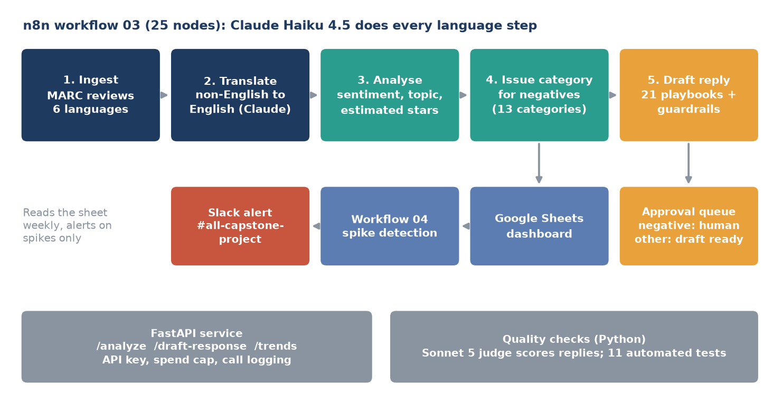
Figure 1. Architecture: the n8n pipeline (top), outputs (middle) and supporting services (bottom).

Design principles
- One model family. Claude Haiku 4.5 does translation, classification, issue labelling and drafting because it is fast and cheap ($1 per million input tokens, $5 per million output). A different, stronger model (Sonnet 5) judges the drafts so that a model does not grade its own work.
- Human in the loop. A reply to a negative review is never sent automatically. It always goes to a human approval queue. Neutral and positive replies are marked ready only if the judge accepts them.
- Guardrails in the prompt. Replies must be in the reviewer’s language, use only facts from the review, promise no refund, replacement, discount or date, make no legal admissions, request no personal data and stay within 40 to 90 words.
- Versioned prompts and honest measurement. Every prompt is a file in prompts/ with a version number. Settings are chosen on a development split and reported once on a held-out test split.
- Cost control. The API service has a hard spend cap and logs every call with tokens, cost and latency.

Tools and technology
Purpose | Tool | Why
Workflow automation | n8n Cloud (workflows exported as JSON) | Visual workflow, retries, easy to demo; required by the brief
Language model | Claude Haiku 4.5 (pipeline), Claude Sonnet 5 (judge) | Strong multilingual quality at low cost
Data | Multilingual Amazon Reviews Corpus (Kaggle copy) | Real reviews in six languages with star ratings
Embeddings and clustering | sentence-transformers, k-means (scikit-learn) | Free, runs locally, multilingual
Baseline model | TF-IDF character n-grams + logistic regression | Shows what an LLM adds over a classic model
Service and tests | FastAPI, pytest | Three endpoints plus 11 automated tests
Dashboard and alerts | Google Sheets, Slack incoming webhook | Free, familiar to business users

5. Data and pipeline design

5.1 Dataset
We use the Multilingual Amazon Reviews Corpus (MARC, Keung et al., EMNLP 2020): real Amazon product reviews in English, German, Spanish, French, Japanese and Chinese, with a 1 to 5 star rating, a product category and a review text (title and body). The team downloaded the Kaggle copy (mexwell/amazon-reviews-multi). We checked it against the Hugging Face copy used by the n8n Cloud workflows: all 1,200 sample reviews have identical ids, star ratings and text, so results from either copy are interchangeable.

5.2 Unified schema
review_id, source, product_category, rating, review_text,
detected_language, translated_text, review_date

5.3 Samples and splits
Set | Size | Use
Main sample | 1,200 reviews (40 per star per language) | All evaluation; stratified because the source files are sorted by star rating
Development split | 240 reviews | Choosing prompts (prompt v1 vs v2)
Test split | 960 reviews | Reported once; never used for tuning or training
Stacker training sample | 600 reviews from the MARC train split (100 per language) | Training the optional stacking model; the baseline never saw it
Baseline training data | 30,000 reviews from the validation file | TF-IDF + logistic regression, one model per language
Dashboard set | 1,560 analysed reviews (test split plus train sample) | Google Sheets dashboard and trend workflow

5.4 Ground truth and its limits
MARC has no human sentiment labels, so we derive them from stars: 1 to 2 stars is negative, 3 is neutral, 4 to 5 is positive. This is a noisy proxy, and it limits how high any text model can score (Section 6.3). The dataset also has no review dates, so the trend stage uses simulated dates (12 weeks from 6 July 2026) with planted spikes. Trend results therefore show that the detector works, not how real customers behave.

6. Components in detail

6.1 Ingestion (n8n workflow 01)
The workflow downloads the MARC review files, takes an even sample per star rating and language, and outputs the unified schema. It was verified by a headless run: 1,200 items, 200 per language, 240 per star, unique ids, no encoding damage in any language. The default run uses 4 reviews per star per language (about 100 translations) so that test runs cost pennies; a setting scales it up.

6.2 Translation (n8n workflow 02)
Non-English reviews are translated to English in batches of eight with Claude. The prompt returns JSON with the detected language and translation for each id. Each call is retried three times; a failed batch marks its reviews failed with the error and the run continues.
 | Groq Qwen 27B | Claude Haiku 4.5
Valid JSON, ids match, language correct (40 reviews) | 40/40 | 40/40
Latency per batch | 1.5 s to 58 s (erratic) | 5.6 s to 21.7 s
Cost | Free tier | $0.0218 for 40 reviews (about $0.54 per 1,000)

We chose Claude only. Both models translated all 40 test reviews correctly, but Groq’s latency was unpredictable and Groq no longer offers the Llama chat models that our early plan assumed. Cloud and local runs of the workflow agree: 120 reviews, 100 translated, 20 English (not needed), 0 failed, about $0.06. With an invalid API key the run still finishes and records all 100 as failed with the error message.

6.3 Sentiment, topic and estimated stars
One Claude call per review returns the sentiment, a topic (quality, features, shipping, price, ux, support or other), a confidence and an estimated star rating from 1 to 5. Three prompt versions were tried; version 3 adds the star estimate and is used in production, with the label taken from the estimated stars. We compared it with a classic baseline.
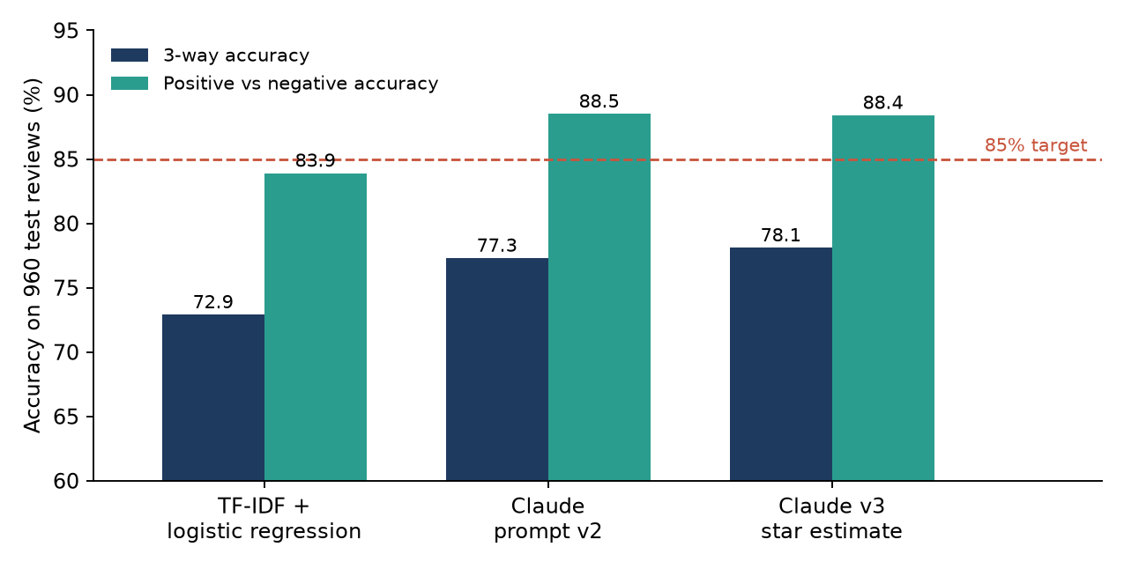
Figure 2. Sentiment accuracy on the 960 held-out test reviews.
Model (test, 960 reviews) | 3-way accuracy | Macro-F1 | Neutral recall | Positive vs negative
TF-IDF baseline | 72.9% | 0.654 | 29.2% | 83.9%
Claude prompt v2 | 77.3% | 0.697 | 32.3% | 88.5%
Claude prompt v3, label | 77.7% | 0.707 | 35.4% | 88.3%
Claude v3, star estimate to label (production) | 78.1% | 0.714 | 37.0% | 88.4%
Stacker, Claude + baseline | 78.1% | 0.708 | 34.4% | 89.1%
Stacker, balanced (optional mode) | 75.4% | 0.720 | 57.8% | 79.8%

Confusion matrix for prompt v2 (rows are the star-derived truth):
Truth \ predicted | Negative | Neutral | Positive
Negative (384) | 357 | 22 | 5
Neutral (192) | 101 | 62 | 29
Positive (384) | 17 | 44 | 323

Positive vs negative accuracy by language (prompt v2): English 89.1%, German 89.1%, Spanish 87.5%, French 95.3%, Japanese 89.1%, Chinese 81.2%. Chinese is the weakest language for Claude; the baseline is stronger there (84.4%).

Why three-way accuracy stays near 78%
- The gap is almost entirely the neutral class: 101 of 192 three-star reviews were called negative. Negative recall is 93% and positive 84%.
- A three-star review is often genuinely mixed (“I love the sound but it turns itself back on”). Star ratings are a noisy proxy for text sentiment, and the published fine-grained MARC results also stop at about 59 to 70% exact-star accuracy.
- We tried to lift the neutral class with a small logistic-regression stacker over Claude’s label, confidence, star estimate and the baseline’s probabilities. Everything landed at 75 to 78%. A “balanced” stacker finds more neutrals (recall up to 58%) but pushes borderline reviews out of the positive and negative classes, and positive-vs-negative accuracy falls from 88% to 80%, below the target. We therefore kept the simple, cheaper classifier and offer the balanced stacker only as an optional “flag borderline reviews” mode.
- Star estimate versus true stars: MAE 0.47, exact match 58.0%, within one star 95.6% (Chinese weakest, MAE 0.63). The proposal’s MAE target of 0.15 is not realistic for this data.
Topic labels were produced for every review but could not be checked against ground truth, because the data has none. The distribution on the test set was quality 536, features 199, shipping 104, price 49, other 37, ux 19, support 16.

6.4 Issue clustering
For the 765 reviews classified negative in the 1,560-review dashboard set, we compared two ways of grouping them. Method A embeds the native review text with a multilingual sentence model and clusters it. Method B first asks Claude for a short English “issue phrase” (what went wrong, in a few words), then embeds and clusters those phrases. This is the proposal’s “translate-then-analyze versus native” comparison.
Text that is embedded | k-means silhouette (k = 6 to 14) | HDBSCAN | Share of one topic within a cluster
Native review text, six languages | 0.037 to 0.044 | 0 clusters, all noise | 42 to 86%
Claude’s English issue phrase | 0.056 to 0.071 (best k = 13: 0.0706) | 3 clusters, 86% noise | 42 to 96%

Translate-then-analyze wins: the silhouette rises about 1.6 times and clusters mix languages evenly, which is the goal of grouping across languages. The absolute score (0.07) is low, as is normal for short phrases about very different products, so we treat it as a coarse measure and rely on the fact that the clusters read clearly. HDBSCAN produced almost only noise, so we use k-means with k = 13.
The 13 categories, named by Claude from the cluster contents: delayed or missing shipments and poor support; damaged packaging and product during shipping; wrong item received or non-functional; missing parts and assembly defects; product fails or breaks shortly after purchase; defective or malfunctioning components; poor overall quality and durability; connectivity and performance issues; design flaws and uncomfortable fit; wrong size sent or undersized; poor content quality and printing errors; product does not work as advertised; overpriced and rapid price drops.
n8n Cloud cannot run the embedding model, so inside n8n a Claude call assigns each negative review to one of these 13 categories. On 100 negatives its choice matched the k-means cluster 43% of the time. That is not an accuracy figure, since k-means is not ground truth; the disagreements were mostly reasonable re-assignments (for example, “misleading description” going to “does not work as advertised”). Only 2% of reviews got “none fits”.

6.5 Trend detection and alerts
The detector counts negative reviews per issue category per week and compares each week with the trailing four weeks. A week is flagged when its z-score is at least 3.5 and it has at least 8 reviews. The spread is floored at the Poisson value (the square root of the mean) so that quiet categories do not flag on noise. An EWMA control chart is available as an alternative.
Because the data has no dates, we assigned each review a simulated week and planted three spikes: delayed shipments five times normal in week 8, damaged packaging four times in week 10 and price complaints three times in week 11 (weeks counted from 1). Results are averaged over 200 random timelines.
Rule | Precision | Recall | Precision@3 | False alarms per 12 weeks
z-score (chosen) | 88.6% | 94.3% | 91.3% | 0.47
EWMA | 90.6% | 86.0% | 91.3% | 0.34

Threshold sweep for the z-score rule: z 3.0 gives recall 97% but precision 77% and 1.07 false alarms; z 4.0 gives recall 90.7%, precision 91.6% and 0.32 false alarms; z 5.0 gives recall 75% and precision 97%. These numbers are optimistic because the threshold was tuned on the same simulation. Precision@5, the proposal’s metric, cannot exceed 0.6 with three planted spikes, so Precision@3 is reported.
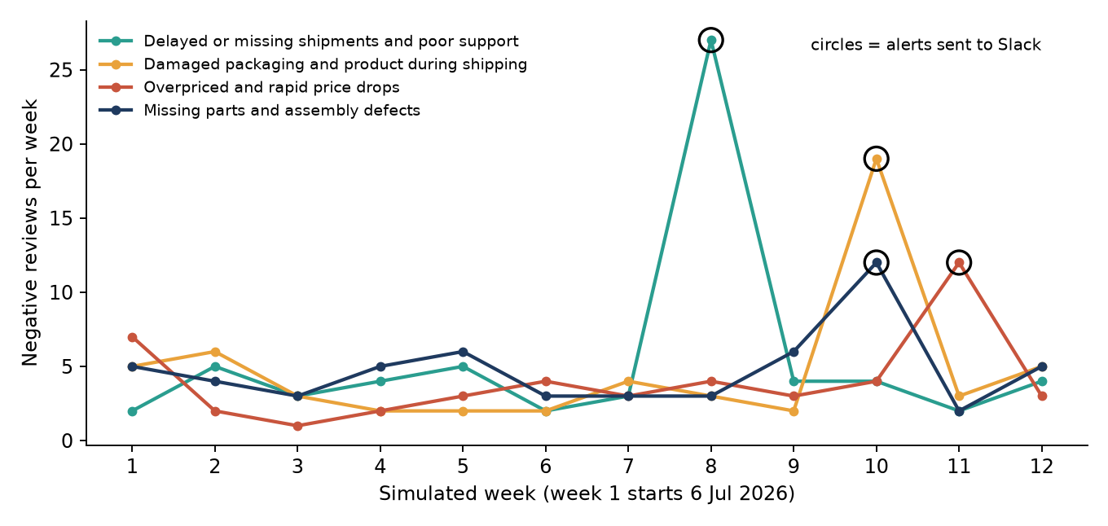
Figure 3. Weekly negative reviews for four issue categories in the dashboard data. Circles mark the four alerts sent to Slack.
The dashboard data produced four alerts: delayed shipments (27 reviews in the week of 24 August, baseline 3.5, z 12.56), damaged packaging (19 in the week of 7 September, z 9.80), price complaints (12 in the week of 14 September, z 4.54) and missing parts (12 in the week of 7 September, z 4.26). The first three are planted spikes. The fourth was not planted, so it is a false alarm produced by ordinary variation in a small category, which is consistent with the roughly 0.5 false alarms per 12 weeks measured above.

6.6 Response generation and quality checks
A library of 21 playbooks, one for every combination of sentiment (three) and issue type (seven), gives the drafting model the right tone and structure. A system prompt adds the brand voice and the hard guardrails listed in Section 4. One Claude Haiku call drafts each reply. The brand (“Acme Store”) and its support address are placeholders, and MARC has no reviewer names, so four synthetic first names per language test personalisation.
Quality is checked by Claude Sonnet 5 as an independent judge. It scores empathy, specificity, correctness and tone from 1 to 5 and flags promised outcomes, invented facts, wrong language and reviews a human must handle. A draft counts as judge-acceptable when all four scores are at least 4 and no flag is raised. We tested on 48 held-out reviews (8 per language: 4 negative, 2 neutral, 2 positive).
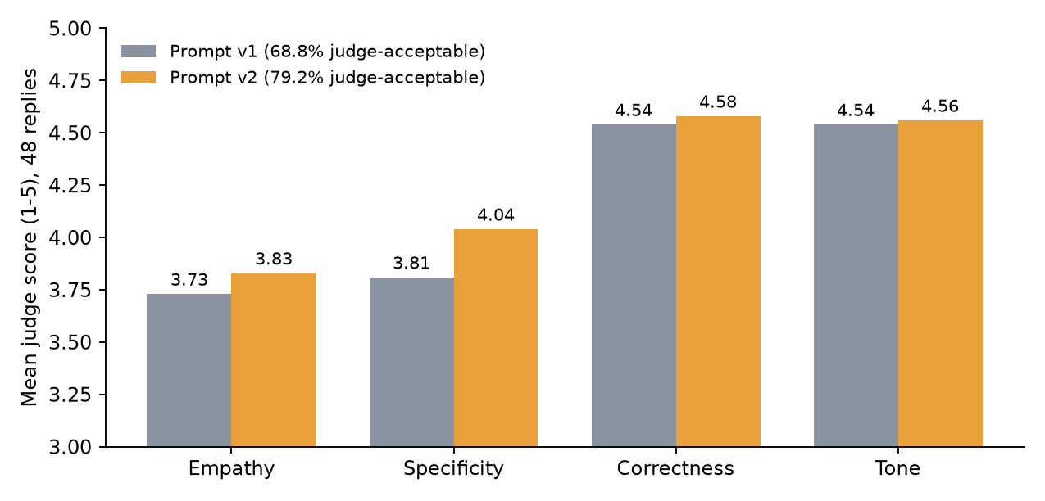
Figure 4. Reply quality, prompt v1 versus v2, scored by the Sonnet 5 judge on 48 replies.
Prompt | Promised outcome | Invented facts | Wrong language | Judge-acceptable
response v1 | 1 | 4 | 0 | 68.8% (33/48)
response v2 | 0 | 4 | 0 | 79.2% (38/48)

Prompt v2 adds “be specific, not stock” rules: mention at least two concrete details from the review, avoid stock phrases, match the emotional weight and make no assumptions. It improved acceptance from 68.8% to 79.2%. By sentiment (v2): negative 88%, positive 83%, neutral 58%. By language: German, English and Spanish 88%; French and Chinese 75%; Japanese 62%.
Important: the proposal asked for an 80% human-acceptance test. The team decided to skip it, so the 79.2% figure is a model’s opinion, not human approval. It is a useful signal (the judge caught, for example, replies that assumed the product worked), but human review remains the real test. The judge also made mistakes: it once flagged the customer’s supplied first name as an “invented fact” until we told it that the name is system-provided.
Guardrails held: no reply was in the wrong language, and prompt v2 produced no promised outcomes. Typical remaining failures are replies that assume something the review never said and empathy lines that could be pasted anywhere. The approval queue works as designed: of 48 v2 replies, 24 negative plus 7 others waited for a human and 17 were auto-approved.

6.7 Dashboard and Slack alerts
The Google Sheets dashboard has four tabs. Reviews holds the 1,560 analysed reviews; Alerts holds the detected spikes; Data holds formula tables for weekly sentiment, topic counts, issue categories and spike trends; Dashboard shows the summary figures and charts (issue-category bar chart, sentiment by week, topic share and a weekly spike line chart; see Appendix B). Review dates are simulated, so the trend charts demonstrate the detector, not real market behaviour.
Workflow 04 (nine nodes) reads the Reviews tab through the sheet’s CSV export, counts negative reviews per issue category per week, applies the same z-score rule in JavaScript and posts one summary message to a Slack incoming webhook. It found the same four spikes with identical z-scores as the Python detector (12.56, 9.80, 4.54, 4.26) and needs no Claude calls, so it costs nothing to run.
Lesson learned: the first version reported sent even though nothing had reached Slack. With the placeholder webhook URL still in place, Slack’s documentation website answered the POST with an HTML page and HTTP 200. The check now requires the exact reply ok that a real Slack webhook returns; an HTML page or an error status is recorded as failed with a hint. Judge success on the response content, not only the HTTP status.

6.8 API service and LLMOps
A FastAPI service exposes the three endpoints from the proposal plus a health check:
Endpoint | What it does
GET /health | Service status
POST /analyze | Up to 20 reviews; returns sentiment (from estimated stars), topic and confidence
POST /draft-response | Classifies if needed, writes an issue phrase for negatives, drafts the reply, optionally judges it and returns a status: negatives are always pending_human_review; others are auto_approved only if the judge accepts
POST /trends | Takes (cluster, date) events; returns spikes and the latest week-over-week table (needs at least 5 weeks)

LLMOps features: every Claude call is logged with prompt version, model, tokens, cost and latency to data/processed/llm_calls.jsonl; a hard spend cap (MAX_SPEND_USD, default $1) makes the service answer HTTP 429 instead of spending more; and SERVICE_API_KEY makes callers send an X-API-Key header. A live check with real Claude calls classified four multilingual reviews correctly, drafted and judged a negative English reply (issue phrase “arrived late and box was crushed”, scores 4/5/5/5, queued for a human) and auto-approved a positive Spanish reply (5/5/5/5), for a total cost of $0.0115.

6.9 The full pipeline in n8n (workflow 03)
Workflow 03 has 25 nodes and covers the brief’s first deliverable: ingest, simulated dates, translation, sentiment and topic, issue category for negatives, reply drafting, per-review status and a summary of counts, accuracy, tokens, cost and timing. Each Claude stage retries three times and continues on error. It was run locally and on the team’s n8n Cloud with the same result.
Measure (120 reviews) | Local run | n8n Cloud run
Translation | 100 ok, 20 not needed, 0 failed | 100 ok, 20 not needed
Classification | 120 ok | 120 ok
Issue category | 62 ok | 60 ok, 59 not needed, 1 failed
Replies | 58 draft ready + 62 pending human review | 59 draft ready + 61 pending human review
3-way accuracy / positive vs negative | 76.7% / 87.5% | 75.8% / 87.5%
Cost | about $0.30 | $0.2987
Wall time | about 80 s | 81.3 s (0.68 s per review)

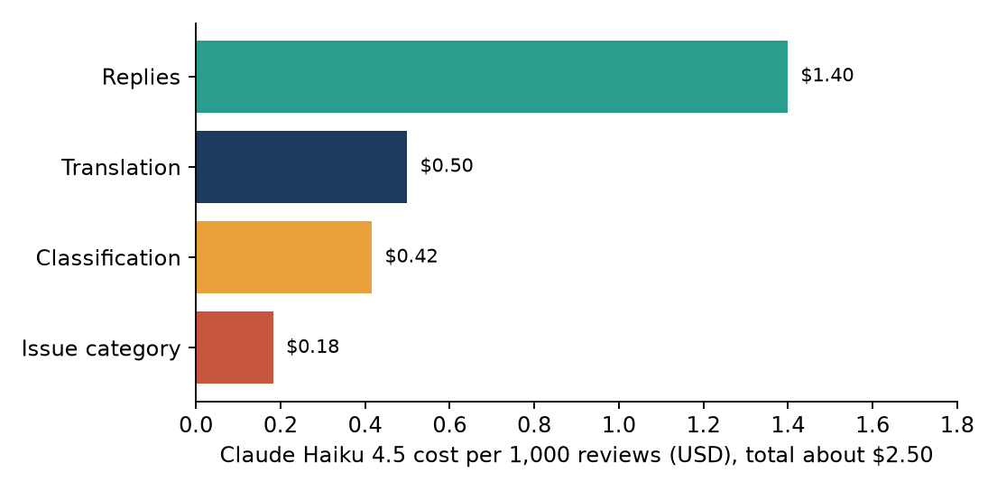
Figure 5. Where the money goes: about $2.50 per 1,000 reviews, by stage.

7. Methods tried, challenges and how we overcame them
Challenge | What happened | How we overcame it
Dataset loading | The Hugging Face copy uses a legacy loading script that the current datasets library refuses. | Read the per-language .jsonl files directly; later switched to the team’s Kaggle copy and verified it is identical.
Sorted data | Files are sorted by star rating, so the first N rows were all one-star reviews. | Stratified sampling: 40 reviews per star per language.
No dates or categories | MARC (HF copy) has no review date; the Kaggle copy adds category but still no date. | Joined product categories from Kaggle; simulated dates with planted spikes and said so everywhere.
Model choice | Groq’s free tier had latency of 1.5 to 58 s and no Llama chat models. | Compared on 40 reviews, then chose Claude only.
Three-way sentiment stuck near 78% | Neutral (three-star) reviews are truly mixed; labels are noisy. | Tried prompt v2/v3 and a stacker; reported the ceiling honestly and explained the star proxy.
Clusters too diffuse | HDBSCAN gave mostly noise; native-text silhouette was 0.04. | Embedded Claude’s English issue phrase and used k-means (silhouette 0.07).
Judge failures | Sonnet 5 returns a thinking block first and can run out of tokens; it flagged a supplied name as invented. | Read the first text block, raised max tokens to 2,000, told the judge the name is system-provided, re-judged all runs.
Silent n8n failures | “Continue on error” shows green even when calls fail; the execution view can show empty output for the last nodes. | Always read the summary node’s counts; run from the editor to see node output.
False “sent” in Slack workflow | Placeholder URL returned an HTML page with HTTP 200. | Require the reply body to be exactly ok; test the HTML, error and success cases locally.
Cloud limits | n8n Cloud cannot run the embedding model or read local files; the free trial is time-limited (our current account runs to about 16 October, after the final presentation). | Claude classifies into the 13 named categories inside n8n; workflows are kept as JSON in the repository so they import into any n8n.
Budget | Only $5 of Claude credit. | Small samples, Haiku for volume, cached calls, spend cap in the API, cost per stage recorded.

8. Test cases, results and experiment log

8.1 Automated tests
pytest tests -q runs 11 tests and makes no Claude calls, so it costs nothing. They cover spike detection (including the week arithmetic of /trends), API-key authentication, input validation and the spend cap.

8.2 Functional test cases
ID | Test | Expected | Observed
T1 | Workflow 01: ingest MARC sample | 1,200 items, 200 per language, unique ids | Passed
T2 | Workflow 02: translate 120 reviews | 100 translated, 20 skipped, 0 failed | Passed locally and in n8n Cloud
T3 | Workflows 02 and 03 with an invalid API key | Run finishes; every review marked failed with the error | Passed; no crash
T4 | Workflow 03: full pipeline, 120 reviews | No hard failures; accuracy in line with Section 6.3 | Passed; 0 hard failures, 75.8% / 87.5%
T5 | Workflow 04 with a fake Slack endpoint | Same four spikes and z-scores as the Python detector; one message | Passed
T6 | Workflow 04, Slack endpoint returns HTTP 500 | Run completes; status failed | Passed
T7 | Workflow 04, placeholder URL (HTML page with HTTP 200) | Status failed, not sent | Failed at first, fixed, passed
T8 | Workflow 04 against real Slack | Message appears in the channel; status sent | Passed (four alerts posted)
T9 | API: request without the API key, invalid input, spend cap reached | Rejected; validation error; HTTP 429 | Passed (automated tests)
T10 | API live check: 4 multilingual reviews, 2 drafts | Correct labels; negative queued for a human | Passed, cost $0.0115

8.3 Experiment log summary
The full log with tables and reasoning is docs/experiment_log.md in the repository. In brief:
No. | Experiment | Main finding
E1 | Data source and sampling | Stratified 1,200-review sample; Kaggle and Hugging Face copies identical
E2 | Ingestion workflow | 1,200 items, balanced by language and star
E3 | Translation model comparison | Groq and Claude both 40/40; Claude chosen; $0.54 per 1,000
E4 | Translation workflow | 0 failures; failure path handled
E5 | Sentiment classification | Claude 77.3% 3-way, 88.5% two-way vs baseline 72.9% / 83.9%
E6 | Lifting the neutral class | Best 78.1%; stacker adds nothing; star MAE 0.47
E7 | Issue clustering | k = 13; issue phrases beat native text (0.07 vs 0.04)
E8 | Trend detection | Precision 88.6%, recall 94.3%, about 0.5 false alarms per 12 weeks
E9 | Response generation | Judge-acceptable 68.8% to 79.2% (v1 to v2); human acceptance not measured
E10 | API service and LLMOps | 3 endpoints, 11 tests, spend cap, call logging
E11 | Full pipeline in n8n | $0.30 per 120 reviews, 81 s, no hard failures
E12 | Dashboard and Slack alert | Four spikes posted; success check fixed

8.4 Claude spend
Item | Cost (USD)
Translation tests | 0.14
Sentiment experiments (E5 and E6) | 1.18
Issue phrases and cluster labels | 0.23
Response generation and judging | 0.61
API test, issue-category check, workflow 03 local test | 0.34
Total recorded | about 2.51 of 5.00

Runs of workflow 03 on n8n Cloud, and three earlier cloud executions whose cost was not recorded, add roughly $0.3 to $1.2, so total spend is about $2.8 to $3.7. The Anthropic Console usage page has the exact figure.

9. Demo plan
The demo goes back to the four situations in Section 2. Tasks get harder, so the audience sees the easy case work and then the cases that used to be a problem.
Level | Task | What the audience sees | Problem it answers
1 Easy | Classify one English review: “arrived late and the box was crushed”. | Negative, topic shipping, issue phrase and estimated stars, in a few seconds. | Late, generic handling of one review
2 Medium | Send a Japanese neutral review through translation, classification and drafting. | English translation, mixed label, reply written in Japanese within the guardrails. | Language barrier
3 Hard | Run n8n workflow 03 on a mixed batch of reviews in all six languages. | Summary node: counts per stage, accuracy, cost, time; negatives waiting in the approval queue. | Manual reading at volume
4 Hard | Show the mixed three-star review “I love the sound but it turns itself back on”. | Estimated stars and label, a specific reply that names the fault (run it before the demo to confirm the output), and a note on why three-way accuracy is limited. | Stars hide the reason
5 Hardest | Run workflow 04 on the dashboard sheet. | Detected spikes, week-over-week delta and a live Slack message linking to the dashboard. | Spikes found late

Backup plan: keep recorded outputs and the exported n8n workflow JSON files in case the network or the n8n trial fails on the day. Our current n8n Cloud trial runs to about 16 October, after the presentation, and the workflows are also kept as JSON so they can be imported into another n8n (or run locally with npx n8n) beforehand.

10. How to run the application

10.1 Setup (Windows)
python -m venv .venv
.venv\Scripts\activate
pip install -r requirements.txt
copy .env.example .env # then fill in ANTHROPIC_API_KEY
python scripts/check_keys.py # tests the Claude key

Set KAGGLE_MARC_DIR in .env to the folder that holds train.csv, validation.csv and test.csv from the Kaggle dataset mexwell/amazon-reviews-multi. The sample CSVs in data/samples/ are already in the repository.

10.2 n8n workflows
- In n8n choose Workflows, Create workflow, the ... menu, then Import from file, and pick a file from the n8n/ folder.
- Create the Claude credential once: Credentials, Create, Header Auth, Name x-api-key, Value = your Anthropic API key. Open each Claude HTTP node and select that credential.
- For workflow 04, share the dashboard sheet as “Anyone with the link can view” and paste your Slack incoming-webhook URL into the Post to Slack node, then save.
- Click Execute workflow. Read the summary node (Pipeline summary or Alert result) rather than trusting the green ticks.
File | Purpose | Approximate cost
01_ingestion_marc_to_unified_schema.json | Ingest and sample reviews | Free
02_ingestion_and_translation.json | Adds Claude translation | About $0.06 at the default size
03_full_pipeline.json | Full pipeline; perStar in Config sets the size | About $0.30 for 120 reviews; $3 at 40 per star
04_trend_detection_slack_alert.json | Spike detection and Slack alert | Free

10.3 Analysis scripts
python scripts/eval_sentiment.py # sentiment experiments (cached calls)
python scripts/run_stage4.py issues # issue phrases
python scripts/run_stage4.py cluster issue # k-means clustering
python scripts/run_stage4.py label issue # cluster labels
python scripts/run_stage4.py trends issue # trend detection
python scripts/eval_responses.py # replies + judge (RESPONSE_VERSION=v1|v2)

10.4 API service and tests
set SERVICE_API_KEY=choose-a-key # optional; callers then send X-API-Key
set MAX_SPEND_USD=1.0 # hard cap on Claude spend
uvicorn src.api.main:app --port 8000
# interactive docs: http://localhost:8000/docs
pytest tests -q # 11 tests, no Claude calls

10.5 Repository map
Path | Contents
src/analysis, src/response, src/api, src/llmops | Clustering and trend detection; reply generation and judge; FastAPI service; call tracking and spend cap
prompts/ | Versioned prompts: translate, classify v1 to v3, issue phrase, issue category and taxonomy, judge, reply prompts and 21 playbooks
n8n/ | The four exported workflows
scripts/ | Data sampling, evaluation and stage scripts
data/samples/ | Review samples, dashboard data and alert list
docs/experiment_log.md | The full experiment log
tests/ | The 11 pytest tests

11. Limitations
- Simulated dates. The dataset has no review dates, so trend detection was tested on simulated weeks with planted spikes, and the threshold was tuned on the same simulation. Real data may behave differently.
- Star-derived labels. Sentiment accuracy is measured against a noisy proxy. Three-way accuracy is 78.1%, below the 85% target, and the neutral class is recognised only about a third of the time.
- No human acceptance test. Reply quality is judged by a model. The 79.2% figure is not human approval.
- Weak spots in replies. Neutral reviews (58% accepted) and Japanese (62%) are the weakest; the reply signature stays in English in other languages; some replies assume facts the review did not state.
- Issue categories in n8n. A Claude classifier over 13 fixed categories replaces the embedding step, and it agrees with k-means only 43% of the time. The categories come from one sample and would need refreshing on a real feed.
- Small evaluation sets. 48 replies and 960 test reviews are enough to show trends, but small differences (for example between prompt v1 and v2 on the development split) are within noise.
- Not yet automatic. Results reach the Google Sheet by paste or import. The service is not deployed publicly.
- Trial and budget. The n8n Cloud trial is time-limited (we moved to a new account on 2 October, valid to about 16 October), and Claude credit limits how many full runs we can afford. We measured throughput on 120 reviews and extrapolated to 1,000.
- Placeholders. The brand “Acme Store”, its support address and the reviewer names are placeholders.

12. Future scope and scaling
- Real data feed. Connect live review sources (marketplace exports, app-store and social feeds) with real timestamps, then retune the spike threshold on genuine weeks.
- Human evaluation. Run the reply acceptance test with support staff (the review sheet and scoring script already exist) and use the results to improve the playbooks.
- Better neutral handling. Ask for a 1 to 5 rating plus a separate “mixed” flag, or fine-tune a multilingual model on labelled neutral reviews.
- Self-updating dashboard. Append pipeline results to Google Sheets or a database from workflow 03 and build Looker Studio pages on top.
- Scaling. Use batch and prompt-caching features of the model API to cut the $2.50 per 1,000 reviews, run the embedding step in a small service, and move the API to a hosted environment with proper tracing (for example Langfuse).
- More languages and channels. Extend beyond six languages, add Slack or email delivery of approved replies, and track how long human approval takes to measure the 3-hour goal properly.
- Closed loop. Feed approved and edited replies back as examples, and report which issues shrink after a fix.

13. Business perspective
Cost. The measured cost is about $2.50 per 1,000 reviews with Claude Haiku 4.5 (replies $1.40, translation $0.50, classification $0.42, issue category $0.18). At 1,000 reviews per day this is about $75 per month of model usage. Trend detection and the Slack alert cost nothing to run.
Speed. The automated part takes about 11 minutes per 1,000 reviews, so a day’s feed is analysed in one short run instead of a working day of reading. A draft reply exists about a minute after a batch starts; the remaining time to reply is the human approval of negative drafts, which we did not measure.

Illustration of the saving
The table below is an illustration, not a measurement. The manual time per review is an assumption that the team should replace with its own figure.
 | Manual handling | With the pipeline
Reading, translating and drafting a reply for 1,000 reviews | About 33 staff hours if a review takes 2 minutes (assumption) | About 11 minutes of automated processing
Human effort remaining | All of it | Approving and editing drafts, mainly for negative reviews (our balanced sample is about 49% negative; a real feed usually has fewer)
Cost per 1,000 reviews | Staff time | About $2.50 of model usage plus approval time
Spike discovery | In the next periodic report | Next scheduled run of workflow 04, with a Slack message

Business value. Faster and more consistent replies in the customer’s language, earlier warning about delivery, packaging or price problems, and a shared view of the reasons behind ratings. The human approval queue keeps a person in charge of anything sensitive, and the spend cap and call log make the cost predictable.
Risks and how we handle them. Wrong or over-promising replies (guardrails, judge, mandatory human approval for negatives); privacy (the pipeline asks for no personal data and drafts use first names only); model changes or price changes (versioned prompts, model name in configuration); overreliance on the automated sentiment (report the neutral-class weakness, offer a borderline-review flag).

14. Conclusion
We built a complete, working pipeline for multilingual review analysis and reply drafting, verified it on real reviews in six languages, and connected it to a dashboard and Slack. Positive-versus-negative accuracy of 88.4% and a cost of about $2.50 per 1,000 reviews show that the approach is practical. The results that fall short of the proposal (three-way accuracy of 78.1%, star error of 0.47 and reply acceptance measured by a model) are explained rather than hidden. The most valuable next steps are testing on a real dated feed and asking people to review the drafts.

References
- Keung, P., Lu, Y., Szarvas, G., & Smith, N. A. (2020). The Multilingual Amazon Reviews Corpus. Proceedings of EMNLP 2020.
- Reimers, N., & Gurevych, I. (2019). Sentence-BERT: Sentence Embeddings using Siamese BERT-Networks. EMNLP 2019. (Model used: paraphrase-multilingual-MiniLM-L12-v2.)
- Rahman et al. (2025), Scientific Reports, multilingual sentiment with XLM-RoBERTa-style models, as cited in the team’s project proposal.
- Anthropic. Claude API documentation and model pricing (Haiku 4.5 and Sonnet 5).
- n8n documentation: HTTP Request node, Code node, error handling. Slack documentation: Incoming Webhooks.

Appendix A. Prompts and versions
File | Purpose | Status
translate_v1.txt | Batch translation and language detection | Used
classify_v1.txt, classify_v2.txt | Sentiment and topic | Compared on the dev split; v2 better on two-way accuracy
classify_v3.txt | Adds estimated stars | Production choice (stars mapped to label)
issue_v1.txt | Short English issue phrase for negatives | Used for clustering
issue_cluster_v1.txt, issue_taxonomy_v1.json | Assign a negative review to one of 13 categories | Used in n8n
response/system_v1.txt, system_v2.txt | Reply drafting with guardrails | v2 better (79.2% vs 68.8% judge-acceptable)
response/playbooks_v1.json | 21 playbooks (3 sentiments x 7 topics) | Used
judge_v1.txt | Sonnet 5 scoring rubric and flags | Used

Appendix B. Dashboard screenshots
The Dashboard tab of the Google Sheet holds the summary figures and four charts: the issue-category bar chart, sentiment by week, topic share, and the weekly spike line chart. The Alerts tab lists the four spikes reported in Section 6.5. Review dates are simulated.
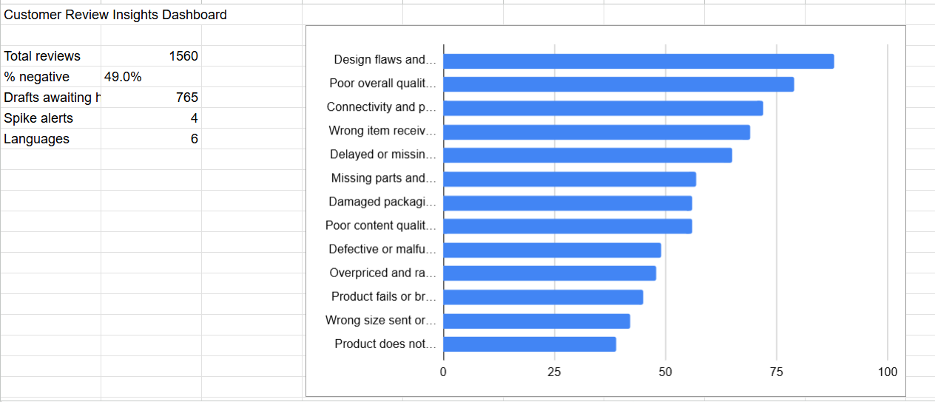
Figure B1. Dashboard summary figures (1,560 reviews, 49.0% negative, 765 drafts awaiting human review, 4 spike alerts, 6 languages) and negative reviews per issue category.
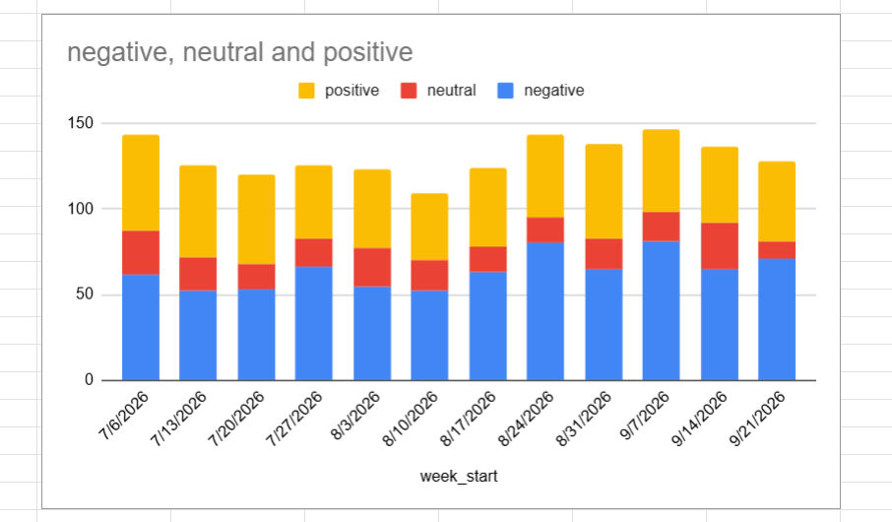
Figure B2. Reviews per week by sentiment (positive, neutral, negative) for the 12 simulated weeks.
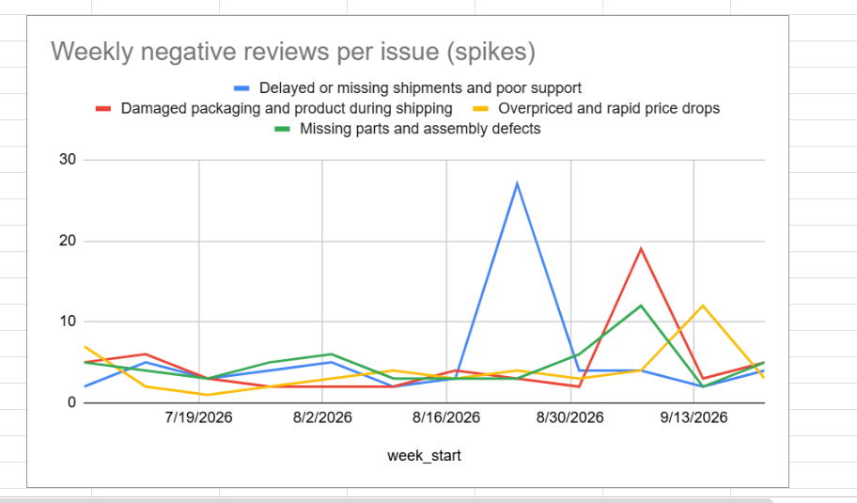
Figure B3. Weekly negative reviews for the four issue categories that raised alerts (Data tab range L1:P13).
The delayed-shipments spike (27 reviews) is in the week of 24 August, damaged packaging (19) and missing parts (12) in the week of 7 September, and price complaints (12) in the week of 14 September.
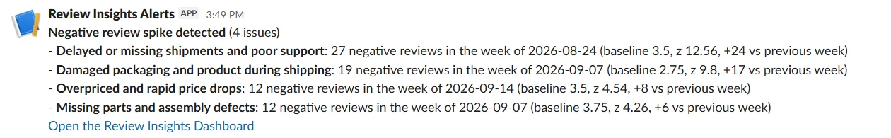
Figure B4. The Slack alert posted to #all-capstone-project by workflow 04, listing the four detected spikes with counts, baseline and z-score.
Optional: add the topic-share pie chart from the Dashboard tab.

