**Date Submitted:**

**Task 01:**

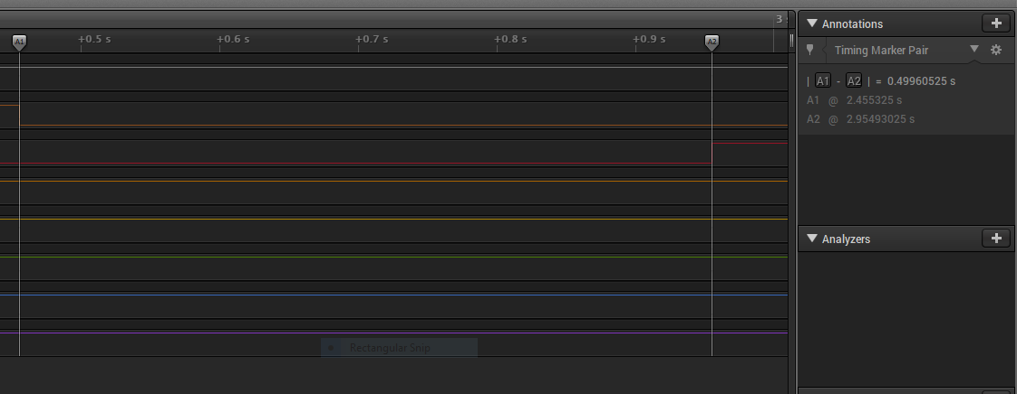

**Modified Code:**

**//Lab 3 Task01**

**#include <stdint.h>**

**#include <stdbool.h>**

**#include "inc/hw_memmap.h"**

**#include "inc/hw_types.h"**

**#include "driverlib/sysctl.h"**

**#include "driverlib/gpio.h"**

**uint8_t ui8PinData=8;**

**int main(void)**

**{**

**SysCtlClockSet(SYSCTL_SYSDIV_16|SYSCTL_USE_PLL|SYSCTL_XTAL_16MHZ|SYSCTL_OSC_MAIN);**

**SysCtlPeripheralEnable(SYSCTL_PERIPH_GPIOF);**

**GPIOPinTypeGPIOOutput(GPIO_PORTF_BASE, GPIO_PIN_1|GPIO_PIN_2|GPIO_PIN_3);**

**while(1)**

**{**

**GPIOPinWrite(GPIO_PORTF_BASE, GPIO_PIN_1|GPIO_PIN_2|GPIO_PIN_3, ui8PinData);**

**SysCtlDelay(2083333);**

**GPIOPinWrite(GPIO_PORTF_BASE, GPIO_PIN_1|GPIO_PIN_2|GPIO_PIN_3, 0x00);**

**SysCtlDelay(2083333);**

**if(ui8PinData==2) {**

**ui8PinData=8;**

**}**

**else{**

**ui8PinData=ui8PinData/2;**

**}**

**}**

**}**

**------------------------------------------------------------------------------------**

**Task 02A:**

Youtube Link: <https://youtu.be/B909bGGcByk>

**Modified Code:**

**//Lab3 Task02A**

**#include <stdint.h>**

**#include <stdbool.h>**

**#include "inc/hw_memmap.h"**

**#include "inc/hw_types.h"**

**#include "driverlib/sysctl.h"**

**#include "driverlib/gpio.h"**

**//uint8_t ui8PinData=8;**

**int main(void)**

**{**

**SysCtlClockSet(SYSCTL_SYSDIV_16|SYSCTL_USE_PLL|SYSCTL_XTAL_16MHZ|SYSCTL_OSC_MAIN);**

**SysCtlPeripheralEnable(SYSCTL_PERIPH_GPIOF);**

**GPIOPinTypeGPIOOutput(GPIO_PORTF_BASE, GPIO_PIN_1|GPIO_PIN_2|GPIO_PIN_3);**

**while(1)**

**{**

**//Blue**

**GPIOPinWrite(GPIO_PORTF_BASE, GPIO_PIN_1|GPIO_PIN_2|GPIO_PIN_3, 4);**

**SysCtlDelay(2083333);**

**GPIOPinWrite(GPIO_PORTF_BASE, GPIO_PIN_1|GPIO_PIN_2|GPIO_PIN_3, 0x00);**

**SysCtlDelay(2083333);**

**//Green**

**GPIOPinWrite(GPIO_PORTF_BASE, GPIO_PIN_1|GPIO_PIN_2|GPIO_PIN_3, 8);**

**SysCtlDelay(2083333);**

**GPIOPinWrite(GPIO_PORTF_BASE, GPIO_PIN_1|GPIO_PIN_2|GPIO_PIN_3, 0x00);**

**SysCtlDelay(2083333);**

**//Red**

**GPIOPinWrite(GPIO_PORTF_BASE, GPIO_PIN_1|GPIO_PIN_2|GPIO_PIN_3, 2);**

**SysCtlDelay(2083333);**

**GPIOPinWrite(GPIO_PORTF_BASE, GPIO_PIN_1|GPIO_PIN_2|GPIO_PIN_3, 0x00);**

**SysCtlDelay(2083333);**

**}**

**}**

**------------------------------------------------------------------------------------**

**Task 02B:**

Youtube Link: <https://youtu.be/X4JM0myQido>

**Modified Code:**

**#include <stdint.h>**

**#include <stdbool.h>**

**#include "inc/hw_memmap.h"**

**#include "inc/hw_types.h"**

**#include "driverlib/sysctl.h"**

**#include "driverlib/gpio.h"**

**uint8_t ui8PinData[7]={2,8,4,10,6,12,14};**

**int main(void)**

**{**

**SysCtlClockSet(SYSCTL_SYSDIV_16|SYSCTL_USE_PLL|SYSCTL_XTAL_16MHZ|SYSCTL_OSC_MAIN);**

**SysCtlPeripheralEnable(SYSCTL_PERIPH_GPIOF);**

**GPIOPinTypeGPIOOutput(GPIO_PORTF_BASE, GPIO_PIN_1|GPIO_PIN_2|GPIO_PIN_3);**

**int i = 0; //array index c**

**while(1)**

**{**

**//Red**

**GPIOPinWrite(GPIO_PORTF_BASE, GPIO_PIN_1|GPIO_PIN_2|GPIO_PIN_3, ui8PinData[i]);**

**if(i==6){**

**i=0;**

**}**

**else{**

**i++;**

**}**

**SysCtlDelay(2083333);**

**GPIOPinWrite(GPIO_PORTF_BASE, GPIO_PIN_1|GPIO_PIN_2|GPIO_PIN_3, 0x00);**

**SysCtlDelay(2083333);**

**//Green**

**}**

**}**

**------------------------------------------------------------------------------------**