**Date Submitted:10/25/2019**

**Task 01:**

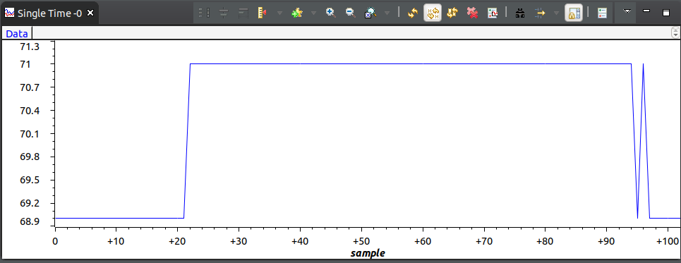

**Modified Code:**

#include <stdint.h>

#include <stdbool.h>

#include "inc/hw_memmap.h"

#include "inc/hw_types.h"

#include "driverlib/debug.h"

#include "driverlib/sysctl.h"

#include "driverlib/adc.h"

#include "driverlib/gpio.h"

#define TARGET_IS_BLIZZARD_RB1

#include "driverlib/rom.h"

int main(void)

{

uint32_t ui32ADC0Value[4];

volatile uint32_t ui32TempAvg;

volatile uint32_t ui32TempValueC;

volatile uint32_t ui32TempValueF;

ROM_SysCtlClockSet(SYSCTL_SYSDIV_5|SYSCTL_USE_PLL|SYSCTL_OSC_MAIN|SYSCTL_XTAL_16MHZ);

//Configuring LED

ROM_SysCtlPeripheralEnable(SYSCTL_PERIPH_GPIOF);

ROM_GPIOPinTypeGPIOOutput(GPIO_PORTF_BASE,GPIO_PIN_2);

ROM_SysCtlPeripheralEnable(SYSCTL_PERIPH_ADC0);

ROM_ADCHardwareOversampleConfigure(ADC0_BASE, 64);

ROM_ADCSequenceConfigure(ADC0_BASE, 1, ADC_TRIGGER_PROCESSOR, 0);

ROM_ADCSequenceStepConfigure(ADC0_BASE, 1, 0, ADC_CTL_TS);

ROM_ADCSequenceStepConfigure(ADC0_BASE, 1, 1, ADC_CTL_TS);

ROM_ADCSequenceStepConfigure(ADC0_BASE, 1, 2, ADC_CTL_TS);

ROM_ADCSequenceStepConfigure(ADC0_BASE,1,3,ADC_CTL_TS|ADC_CTL_IE|ADC_CTL_END);

ROM_ADCSequenceEnable(ADC0_BASE, 1);

while(1)

{

ROM_ADCIntClear(ADC0_BASE, 1);

ROM_ADCProcessorTrigger(ADC0_BASE, 1);

while(!ROM_ADCIntStatus(ADC0_BASE, 1, false))

{

}

ROM_ADCSequenceDataGet(ADC0_BASE, 1, ui32ADC0Value);

ui32TempAvg = (ui32ADC0Value[0] + ui32ADC0Value[1] + ui32ADC0Value[2] + ui32ADC0Value[3] + 2)/4;

ui32TempValueC = (1475 - ((2475 * ui32TempAvg)) / 4096)/10;

ui32TempValueF = ((ui32TempValueC * 9) + 160) / 5;

if(ui32TempValueF>72){

GPIOPinWrite(GPIO_PORTF_BASE,GPIO_PIN_2,4);

}

else{

GPIOPinWrite(GPIO_PORTF_BASE,GPIO_PIN_2,0);

}

}

}

**------------------------------------------------------------------------------------**

**Task 02:**

Youtube Link: <https://youtu.be/WYWZZcQ7GyM>

**#include <stdint.h>**

**#include <stdbool.h>**

**#include "inc/tm4c123gh6pm.h"**

**#include "inc/hw_memmap.h"**

**#include "inc/hw_types.h"**

**#include "driverlib/debug.h"**

**#include "driverlib/sysctl.h"**

**#include "driverlib/adc.h"**

**#include "driverlib/gpio.h"**

**#include "driverlib/timer.h"**

**#include "driverlib/interrupt.h"**

**#define TARGET_IS_BLIZZARD_RB1**

**#include "driverlib/rom.h"**

**//uint32_t ui32period;**

**void configureTimer1A(void){**

**SysCtlPeripheralEnable(SYSCTL_PERIPH_TIMER1);**

**IntMasterEnable();**

**TimerConfigure(TIMER1_BASE, TIMER_CFG_PERIODIC);**

**//ui32period = (SysCtlClockGet()/2);**

**TimerLoadSet(TIMER1_BASE, TIMER_A, 20000000-1);**

**IntEnable(INT_TIMER1A);**

**TimerIntEnable(TIMER1_BASE,TIMER_TIMA_TIMEOUT);**

**TimerEnable(TIMER1_BASE, TIMER_A);**

**}**

**int main(void)**

**{**

**ROM_SysCtlClockSet(SYSCTL_SYSDIV_5|SYSCTL_USE_PLL|SYSCTL_OSC_MAIN|SYSCTL_XTAL_16MHZ);**

**//Configuring LED**

**ROM_SysCtlPeripheralEnable(SYSCTL_PERIPH_GPIOF);**

**ROM_GPIOPinTypeGPIOOutput(GPIO_PORTF_BASE,GPIO_PIN_2);**

**configureTimer1A();**

**ROM_SysCtlPeripheralEnable(SYSCTL_PERIPH_ADC0);**

**ROM_ADCHardwareOversampleConfigure(ADC0_BASE, 32);**

**ROM_ADCSequenceConfigure(ADC0_BASE, 1, ADC_TRIGGER_PROCESSOR, 0);**

**ROM_ADCSequenceStepConfigure(ADC0_BASE, 1, 0, ADC_CTL_TS);**

**ROM_ADCSequenceStepConfigure(ADC0_BASE, 1, 1, ADC_CTL_TS);**

**ROM_ADCSequenceStepConfigure(ADC0_BASE, 1, 2, ADC_CTL_TS);**

**ROM_ADCSequenceStepConfigure(ADC0_BASE,1,3,ADC_CTL_TS|ADC_CTL_IE|ADC_CTL_END);**

**ROM_ADCSequenceEnable(ADC0_BASE, 1);**

**while(1){**

**}**

**}**

**void Timer1IntHandler(void){**

**TimerIntClear(TIMER1_BASE, TIMER_TIMA_TIMEOUT);**

**uint32_t ui32ADC0Value[4];**

**volatile uint32_t ui32TempAvg;**

**volatile uint32_t ui32TempValueC;**

**volatile uint32_t ui32TempValueF;**

**ROM_ADCIntClear(ADC0_BASE, 1);**

**ROM_ADCProcessorTrigger(ADC0_BASE, 1);**

**while(!ROM_ADCIntStatus(ADC0_BASE, 1, false)){**

**}**

**ROM_ADCSequenceDataGet(ADC0_BASE, 1, ui32ADC0Value);**

**ui32TempAvg = (ui32ADC0Value[0] + ui32ADC0Value[1] + ui32ADC0Value[2] + ui32ADC0Value[3] + 2)/4;**

**ui32TempValueC = (1475 - ((2475 * ui32TempAvg)) / 4096)/10;**

**ui32TempValueF = ((ui32TempValueC * 9) + 160) / 5;**

**if(ui32TempValueF>72){**

**GPIOPinWrite(GPIO_PORTF_BASE,GPIO_PIN_2,4);**

**}**

**else{**

**GPIOPinWrite(GPIO_PORTF_BASE,GPIO_PIN_2,0);**

**}**

**}**