Design Assignment 1

Brian West

5003032874

[Westb2@unlv.nevada.edu](mailto:Westb2@unlv.nevada.edu)

Primary Github: https://github.com/westbrian2/Spring2019

Directory: Spring2019/DesignAssignments/DA1_submission

start:

ldi r25,0xFF ; high 8 of M

ldi r24,0xFF ; low 8 of M

ldi r22,0xAA ; multiplier (m)

ldi r18,0; [7:0] answer

ldi r19,0;[15:8] answer

ldi r20,0;[23:16]answer

ldi r16,0; Carry trasfer register(0+carry=carry)

multiply:

cp r22,r15; compares multiplier with 0, if not 0 continue

breq end ; jumps to end if 0

add r18,r24 ;adding low of M into answer [7:0]

adc r19,r25 ;adding high of M into answer [15:8] with carry from low

adc r20,r16 ; placing carry bit into answer[23:16]

dec r22 ; dec m (acts as counter)

jmp multiply

end:

jmp end

Registers after the multiplicand and multiplier have been loaded.

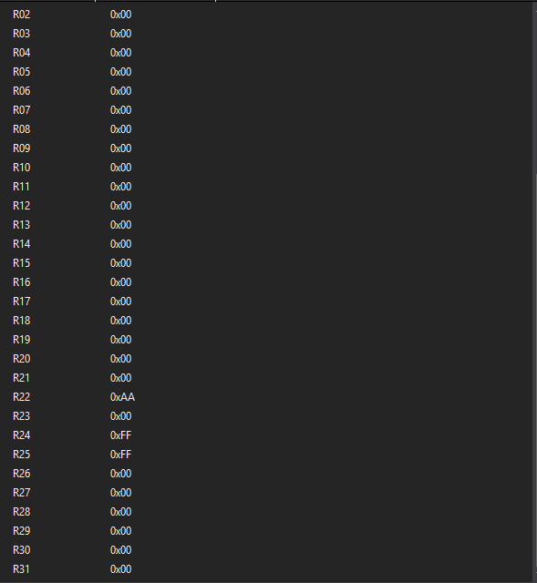

Registers after program has finished running.

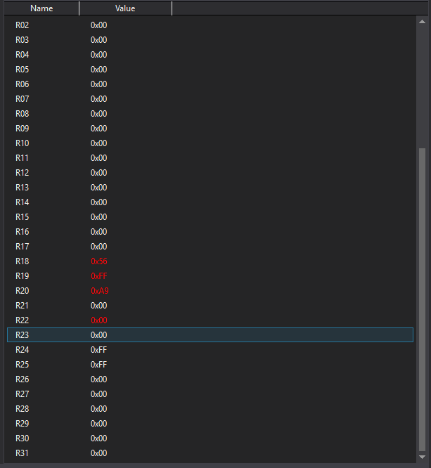

Cycle counter and execution time.

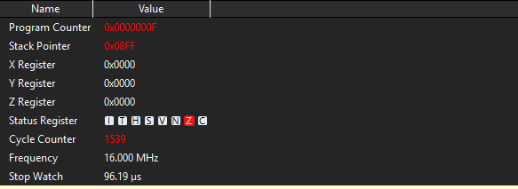

1539 Cycles/16Mhz = 96.1875us.