CPE301 – SPRING 2019

Design Assignment 3A

Student Name: Brian West

Student #: 5003032874

Student Email: [westb2@unlv.edu](mailto:westb2@unlv.edu)

Primary Github address: https://github.com/westbrian2/Spring2019

Directory: Spring2019/DesignAssignments/DA3A_submission

Submit the following for all Labs:

1. In the document, for each task submit the modified or included code (only) with highlights and justifications of the modifications. Also, include the comments.
2. Use the previously create a Github repository with a random name (no CPE/301, Lastname, Firstname). Place all labs under the root folder ESD301/DA, sub-folder named LABXX, with one document and one video link file for each lab, place modified asm/c files named as LabXX-TYY.asm/c.
3. If multiple asm/c files or other libraries are used, create a folder LabXX-TYY and place these files inside the folder.
4. The folder should have a) Word document (see template), b) source code file(s) and other include files, c) text file with youtube video links (see template).

1. **COMPONENTS LIST AND CONNECTION BLOCK DIAGRAM w/ PINS**

I did not directly use any pins rather I read the output via the USB connection on the Xplained Mini board. However, PinD1 was used for transmission.

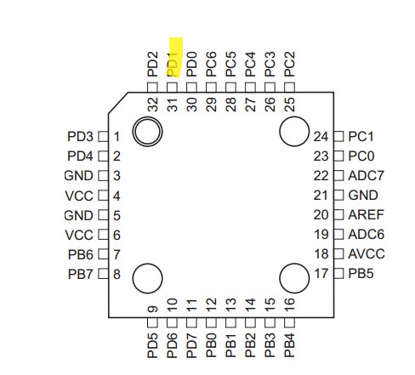

1. **INITIAL/MODIFIED/DEVELOPED CODE OF TASK 1/A**

#define F_CPU 16000000UL

#define UBRR_9600 103 //Baud rate for 16MHz

#include <avr/io.h>

#include <util/delay.h>

#include <stdio.h>

#include <avr/interrupt.h>

void USART_init( unsigned int ubrr ); //Sets up usart for use

void USART_tx_string( char *data ); //function that outputs data (usart)

char outint[10]; //for integer

char outfloat[10]; //for float

int num1=66;

float num2=1.75;

int main(void){

sei(); //enable interrupt

USART_init(UBRR_9600); //set up usart

OCR1A = 15625; //setting compare value

TIMSK1=2; //enables match interrupt

TCCR1B=(1<<WGM12)|(1<<CS12)|(1<<CS10); //setting for CTC and prescaler of 1024

snprintf(outint,sizeof(outint),"%d\r\n",num1); //coverts decimal to string to send

snprintf(outfloat,sizeof(outfloat),"%f\r\n",num2); //converts float to string to send

while(1){

}

}

ISR(TIMER1_COMPA_vect){

USART_tx_string("String\r\n");

_delay_ms(50);

USART_tx_string(outint);

_delay_ms(50);

USART_tx_string(outfloat);

_delay_ms(50);

TCNT1=0;

}

void USART_init(unsigned int ubrr){

UBRR0H=(unsigned char)(ubrr>>8); //Setting up

UBRR0L=(unsigned char)(ubrr);

UCSR0B=(1<<TXEN0);//Enabling reciever, transmitter, and rx interrupt

UCSR0C=(1<<UCSZ01)|(1<<UCSZ00); //async 8 n 1

}

void USART_tx_string(char *data){ //sends string

while((*data!= '\0')){

while(!(UCSR0A&(1<<UDRE0)));

UDR0=*data;

data++; //gets next part of data

}

}

1. **DEVELOPED MODIFIED CODE OF TASK 2/A from TASK 1/A**

Only one Task

1. **SCHEMATICS**

No schematic, Xplained mini was plugged in

1. **SCREENSHOTS OF EACH TASK OUTPUT (ATMEL STUDIO OUTPUT)**

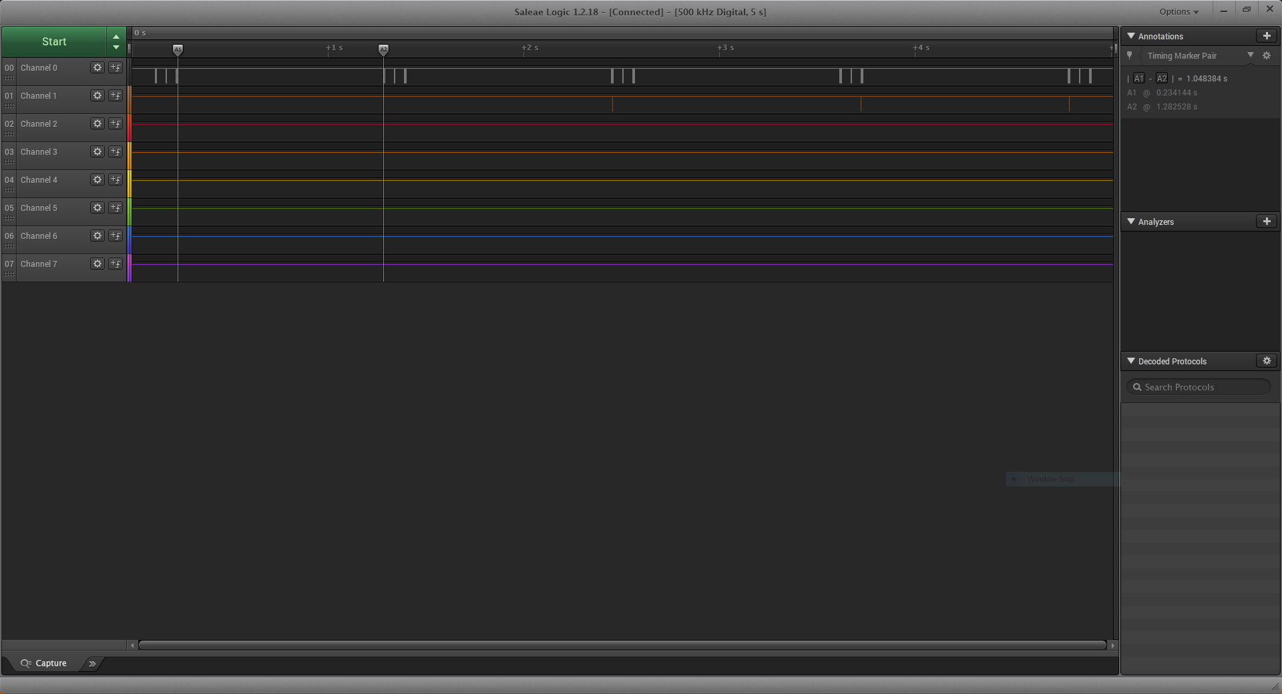



I did two implementations and this was my favorite, the values are updated after ~1sec of waiting. I did it this way because I am working on a project that needs a similar sampling of input from a load cell. I figured this would be a good way to test the implementation I had in mind.

1. **SCREENSHOT OF EACH DEMO (BOARD SETUP)**

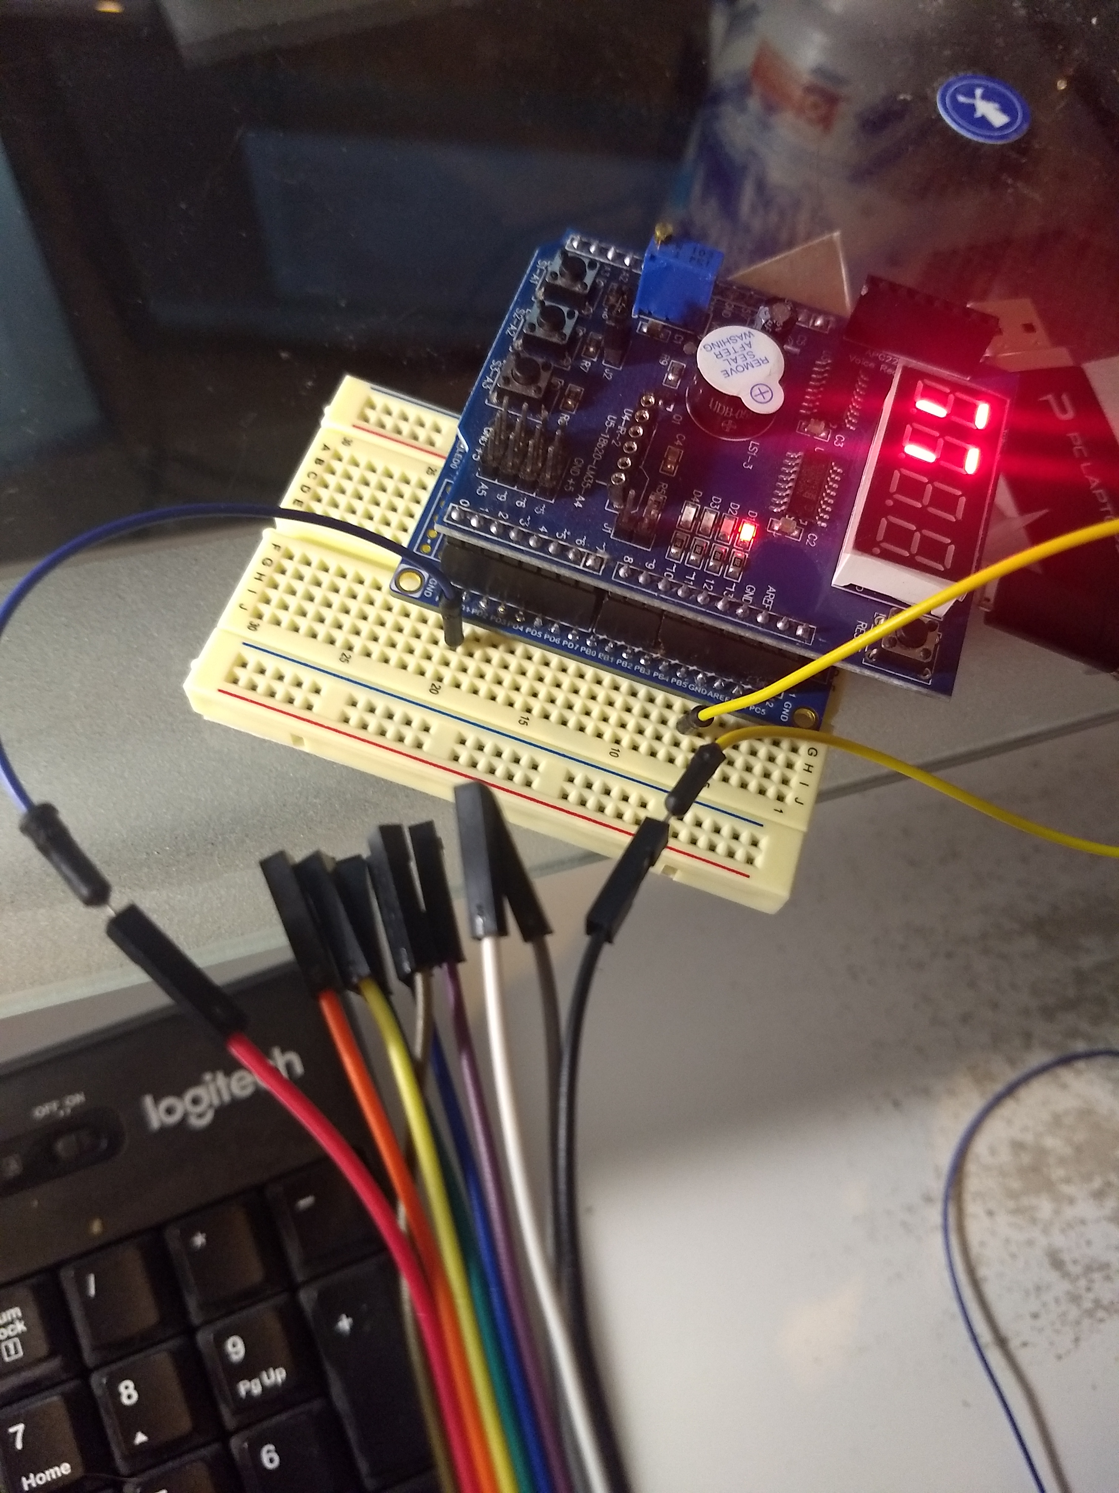

1. **VIDEO LINKS OF EACH DEMO**

<https://www.youtube.com/watch?v=xIMbkIHwa8s&feature=youtu.be>

1. **GITHUB LINK OF THIS DA**

https://github.com/westbrian2/Spring2019/DesignAssignments/DA3A_submission

**Student Academic Misconduct Policy**

<http://studentconduct.unlv.edu/misconduct/policy.html>

“This assignment submission is my own, original work”.

Brian West