Welcome, Dragons, to R-DAVIS 2020!

What’s your name? Jonas

What do you study (or hope to study)? Toxicology of chemical threat agents

What’s one interesting fact about you? I love studying mushrooms

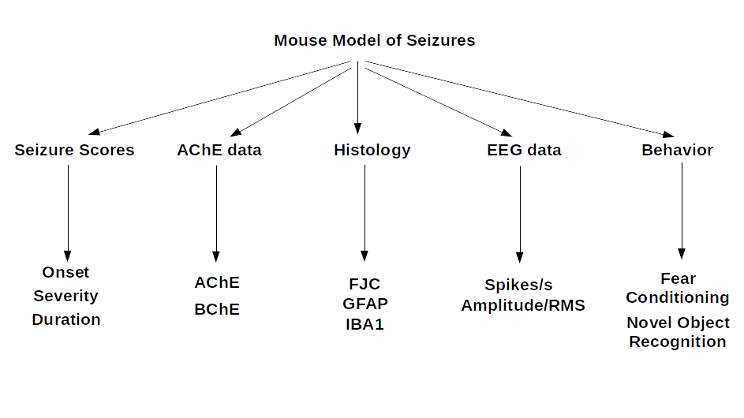

Mouse Model of DFP-induced SE