DIGITAL FORENSIC
INVESTIGATION REPORT
Deleted data recovery and activity timeframe review
CASE DETAILS | VALUE
Organization | Apex Integrated Technologies Ltd.
Case ID | AIT-DF-2026-009
Investigation type | Digital forensics / deleted data recovery
Evidence provided | D:\Evidence.E01; Autopsy screenshots
Prepared | 27 September 2026
Investigator | [PLACEHOLDER — name]
Team | [PLACEHOLDER — team]
Status | Preliminary — image not analyzable; findings limited to supplied material

I prepared this report from the project brief, my read-only intake examination of the supplied file, and the Autopsy screenshots you provided. Based on those materials, I cannot reach a conclusion about deletion, recovery, user activity, or actor identity.
CONFIDENTIAL — INVESTIGATION WORK PRODUCT

1. Executive Summary
The project brief assigns me to examine a workstation forensic image for six target folders, assess deleted and recoverable files, and establish the most defensible timeframe for deletion activity. I checked the supplied image file, D:\Evidence.E01: it was present and measured 10,341,301 bytes. I calculated its SHA-256 as DFE7BEC71F4DBB757761885B3C3EC2940983DD77D27E48D919F31EF0400AC40E. In a read-only byte scan, I found that every byte was 0xFF. I therefore could not use it as a disk image; you also reported that FTK Imager rejected it as invalid evidence.
I reviewed the Autopsy screenshots you supplied. They show a case titled Project01 running Autopsy 4.23.1, with a data source labeled LogicalFileSet1. One discovery warning states that Hash Lookup, File Type Identification, and Picture Analyzer were not run on that data source. The displayed deleted-file and file-type views show zero results, and the displayed Score view shows zero bad and suspicious items. I treat these only as observations from the screens; they do not establish that the workstation contained no relevant evidence.
I could not resolve the forensic objectives. The screenshots do not show that anyone examined the rejected E01 image or establish that the Autopsy data source represents the same evidence. I cannot report a supported deletion timeframe, folder status, recovery result, user attribution, or finding about intent. I recommend resuming the examination only after obtaining a valid image and its acquisition and integrity records.

2. Case Background and Objectives
The assignment brief says the organization noticed that folders previously present on a workstation were no longer visible. I was asked to examine SSH, My pic, Our pic, ADDS Project, Corel, and Corel Draw Work. The brief calls for me to use FTK Imager and Autopsy, document appropriate use or non-applicability of DD and R-Drive Image, attempt deleted-file recovery, analyze a timeline, validate findings across tools, and write an evidence-based report.

I was assigned to answer these questions:
- Determine for each target folder whether it is present, deleted, partially deleted, recoverable, partially recoverable, or unrecoverable.
- Identify relevant files, metadata, artifacts, and timestamps.
- Assess the most defensible timeframe for deletion activity and explain what each timestamp represents.
- State what I can and cannot conclude about who acted, intent, and possible copying before deletion.

3. Scope and Materials Reviewed
Material | What was available | Scope limitation
Project brief | Forensic Project.docx; Case ID AIT-DF-2026-009 and required objectives/tools. | Assignment requirements only; contains no case findings.
Evidence image | D:\Evidence.E01; 10,341,301 bytes; filesystem timestamp shown as 24 Sep 2026 1:18 PM. | Byte scan showed all bytes were 0xFF; no disk structure could be examined.
Autopsy screenshots | 15 PNG screenshots, numbered 26–40; visible Windows date 25 Sep 2026; Autopsy 4.23.1. | Screenshots are partial views; no native case database, ingest logs, or original data source provided.
Other tool records | None supplied for R-Drive Image, FTK Imager, or DD. | No independent verification, cross-tool comparison, or processing records available.

I visually reviewed the screenshot files. I selected five relevant screenshots and reproduced them as cropped exhibits in Appendix A. I cropped only the application window for readability and left the original screenshots unchanged.

4. Evidence Intake and Integrity

4.1 Supplied E01 file
Item | Recorded value
Path | D:\Evidence.E01
Length | 10,341,301 bytes
SHA-256 | DFE7BEC71F4DBB757761885B3C3EC2940983DD77D27E48D919F31EF0400AC40E
Read-only byte check | 10,341,301 bytes read; 1 distinct byte value; 0 bytes differed from 0xFF.
FTK Imager status | User reports FTK Imager displayed “the file does not contain valid evidence.” Exact dialog/screenshot was not supplied.
Original/acquisition hash | [NOT PROVIDED — request from evidence provider]
Chain of custody | [NOT PROVIDED — complete transfer and handling history]

The SHA-256 I recorded identifies the file I examined during intake; it is not an acquisition-time hash and does not validate the file as an E01 image. Because every byte was 0xFF and you reported FTK Imager rejected the file, I could not examine partitions, file systems, or target-folder content. I did not treat this file as the workstation image or attempt to repair it in place.

4.2 Handling record
Date/time | Action | Result / record | Operator
24 Sep 2026 1:18 PM* | Filesystem timestamp observed for D:\Evidence.E01. | Timestamp as reported by the file system; not an acquisition timestamp. | [PLACEHOLDER]
[PLACEHOLDER] | Read-only file size and SHA-256 intake check. | 10,341,301 bytes; SHA-256 recorded above. | [PLACEHOLDER]
[PLACEHOLDER] | Read-only byte content check. | All bytes observed as 0xFF. | [PLACEHOLDER]
[PLACEHOLDER] | FTK Imager attempted to open file (reported by user). | Rejected as not containing valid evidence; exact version/log unavailable. | [PLACEHOLDER]

I could not independently verify the local time zone for the file-system timestamp. I record it only as an observed file property.

5. Autopsy Screenshot Observations
In the screenshots I reviewed, Autopsy 4.23.1 and a case named Project01 are visible. The data source tree is labeled “LogicalFileSet_1 Host” and “LogicalFileSet1 (1).” I cannot determine from these screenshots which files populated this logical file set or whether it is linked to D:\Evidence.E01.
Displayed view | Visible observation | Interpretation limit
Discovery warning (Screenshot 26) | Hash Lookup, File Type Identification, and Picture Analyzer were not run on LogicalFileSet1. | Results for these analysis functions may be incomplete.
Data Sources (Screenshot 27) | One data source is listed: LogicalFileSet_1 Host. | Does not identify an E01, physical image, or partition.
File Types (Screenshots 29, 31–33) | Displayed type/extension categories report zero items, including image and document categories. | Only the displayed categories/state; not proof that the source has no such content.
Deleted Files (Screenshots 26, 34) | Displayed File System and All counts are zero. | Not a reliable absence finding while data source and ingest completeness are unverified.
Score (Screenshot 40) | Bad Items (0) and Suspicious Items (0). | Scoring view is not a complete forensic examination or proof of no suspicious content.

6. Target Folder Findings
I could not determine the status of any target folder from the available evidence. I cannot use a zero-result view in Autopsy to classify a folder as absent, deleted, or unrecoverable, particularly because I could not verify the displayed data source and some ingest modules did not run.
Target folder | Finding status | Reason
SSH | Not determined | No verified image examination or path-level results supplied.
My pic | Not determined | No image inventory, deleted entry, or recovery evidence supplied.
Our pic | Not determined | No path-level or related-artifact results supplied.
ADDS Project | Not determined | No project-file or metadata evidence supplied.
Corel | Not determined | No Corel-related file or recovery evidence supplied.
Corel Draw Work | Not determined | No design-file, preview, or recovery evidence supplied.

7. Timeline Analysis
I cannot state a deletion timeframe. The only dates I can see in the materials are file and screenshot timestamps and the screenshot taskbar date. They may indicate when a file was modified or a screen was captured; they do not show when a target folder was deleted.
Time/date shown | Source | What it may represent | Deletion evidence?
24 Sep 2026 1:18 PM | Filesystem LastWriteTime for D:\Evidence.E01. | Timestamp associated with the image file on the host system. | No.
25 Sep 2026, about 7:28–7:35 PM | Windows taskbar visible in screenshots 26–40. | Screenshots appear to have been captured during this period; system clock accuracy is unknown. | No.
Deletion event time | No underlying file-system artifacts available. | Cannot be assessed. | Not established.

To build a defensible timeline, I would need artifact-level timestamps from a verified image and corroborating records (for example, file-system metadata, operating-system artifacts, and relevant user-activity artifacts). I would document the source and meaning of each timestamp.

8. Tool Use and Cross-Tool Validation
Tool | Status in this matter | Report treatment
FTK Imager | User reports rejection of D:\Evidence.E01 as invalid evidence. | No image examination findings can be attributed to FTK. Exact tool version and error screenshot are outstanding.
Autopsy 4.23.1 | Screenshots supplied; one logical-file-set source shown. Three ingest modules are reported as not run. | Limited screenshot observations recorded above; native case and ingest logs are outstanding.
R-Drive Image | No results or screenshots supplied. | Use for appropriate image verification/handling after a valid image is received; document version and result.
DD | User reports DD is unavailable; an E01 copy had already been supplied. | No acquisition/copy operation was performed. State non-use and reason; do not invent a DD result.

The assignment requires me to compare at least five important findings across tools. I could not complete that comparison: you reported that FTK rejected the file, no R-Drive results were supplied, and I cannot link the Autopsy screenshots to a verified image. I therefore report no cross-tool-confirmed forensic finding.

9. Limitations
- I found that the supplied E01 file consists entirely of 0xFF bytes. You reported that FTK Imager rejected it. I could not analyze the disk image.
- I was not provided an acquisition-time hash, image verification report, evidence source details, or chain-of-custody record.
- The Autopsy screenshots show a logical file set, but I cannot establish that it represents the rejected E01 or the workstation image described in the brief.
- The warning visible in the screenshots says Hash Lookup, File Type Identification, and Picture Analyzer did not run on the displayed Autopsy data source.
- I have only partial screenshots, not the native Autopsy case, source image, ingest configuration, or processing logs needed to validate the displayed results.
- I was not provided tool versions or result logs for FTK Imager, R-Drive Image, or DD. You told me DD is unavailable.
- I was not provided target-folder contents, deleted-file artifacts, recovered exports, file hashes, user-activity artifacts, or reliable timeline artifacts.
- I still need the investigator and team names, authorization details, evidence custodian, chain-of-custody information, and the relevant time zone.

10. Conclusions
From the material available to me, I cannot conclude whether any of the six target folders existed on the workstation, whether they were deleted, whether their contents can be recovered, when any deletion occurred, who performed an action, whether an action was intentional, or whether files were copied beforehand.
The only technical conclusion I can support is that the file currently present at D:\Evidence.E01 measured 10,341,301 bytes, had the SHA-256 recorded above, and contained only 0xFF bytes when I checked it. The screenshots you supplied show selected Autopsy interface states, including incomplete discovery processing and zero counts in particular views. Those observations do not resolve the assignment.

11. Actions Required to Resume
- To resume my examination, I need a new copy of the actual forensic image from its custodian. I will request all split segments and the acquisition-time hash or verification record, and I will preserve the current file without overwriting it.
- I will record who supplied the replacement, when and how it was transferred, and its chain of custody. Before analysis, I will compare its hash with the provider’s acquisition record.
- I will verify the image in FTK Imager and, where appropriate, R-Drive Image. I will record tool versions, verification outcomes, image format and size, partitions, and screenshots.
- I will add the verified image to Autopsy as a disk image, retain the case and logs, configure appropriate ingest modules, and investigate all six target folders and related artifacts.
- I will attempt relevant file recovery to a separate evidence export location. For each item, I will record its original path and metadata, the recovery tool, export hash, and screenshots.
- I will build and explain a timeline from source artifacts, compare at least five findings across tools, and fill report placeholders only with verified information.

Appendix A. Cropped Autopsy Screenshots
I selected each exhibit from the screenshots you supplied and cropped it for legibility. I left the originals unchanged in the supplied folder. I report UI labels and counts as they appear on screen; I have not independently validated them against the underlying case database.
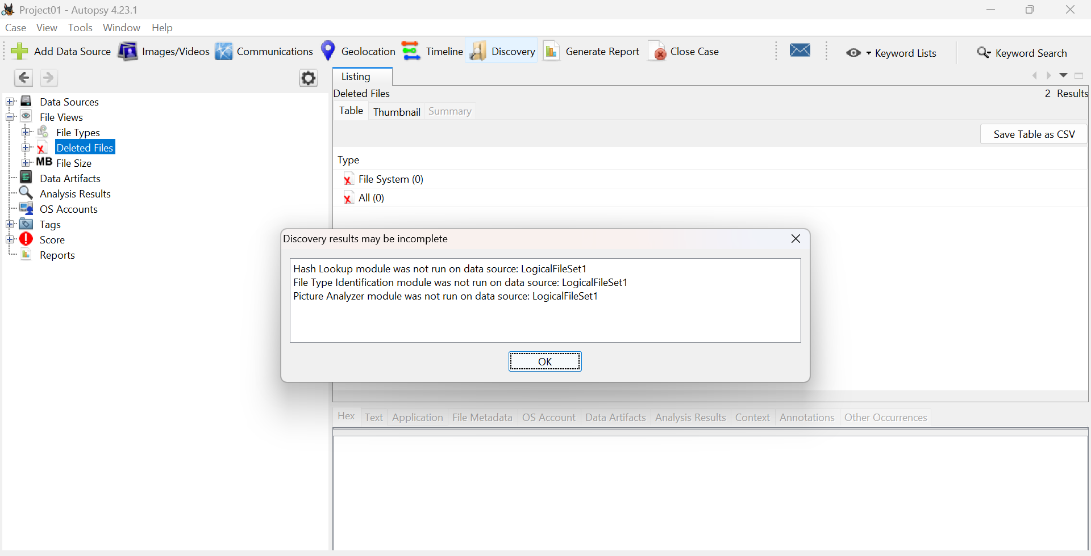
Exhibit 26 | I observed a discovery warning stating that three ingest modules were not run on LogicalFileSet1.
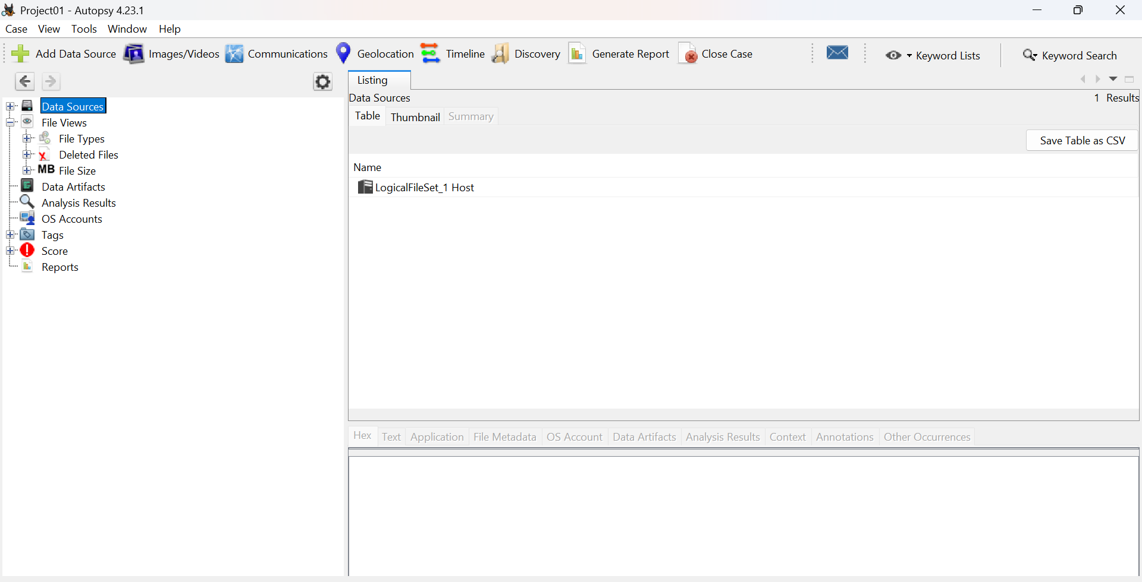
Exhibit 27 | I observed one source labeled LogicalFileSet_1 Host in the Autopsy Data Sources view.
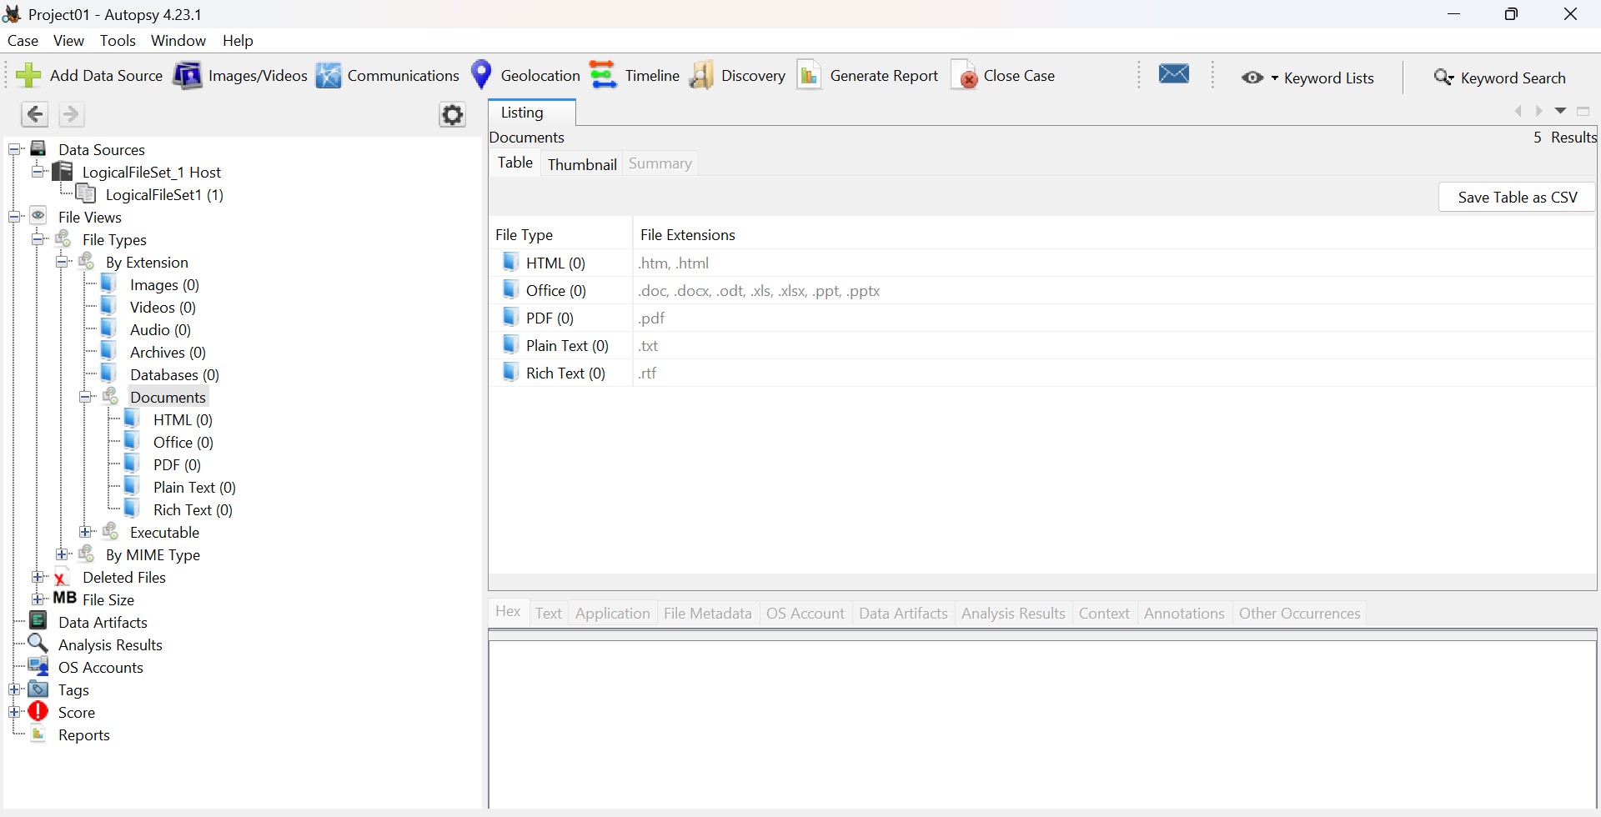
Exhibit 32 | I observed zero counts for the displayed image, video, audio, archive, database, and document categories.
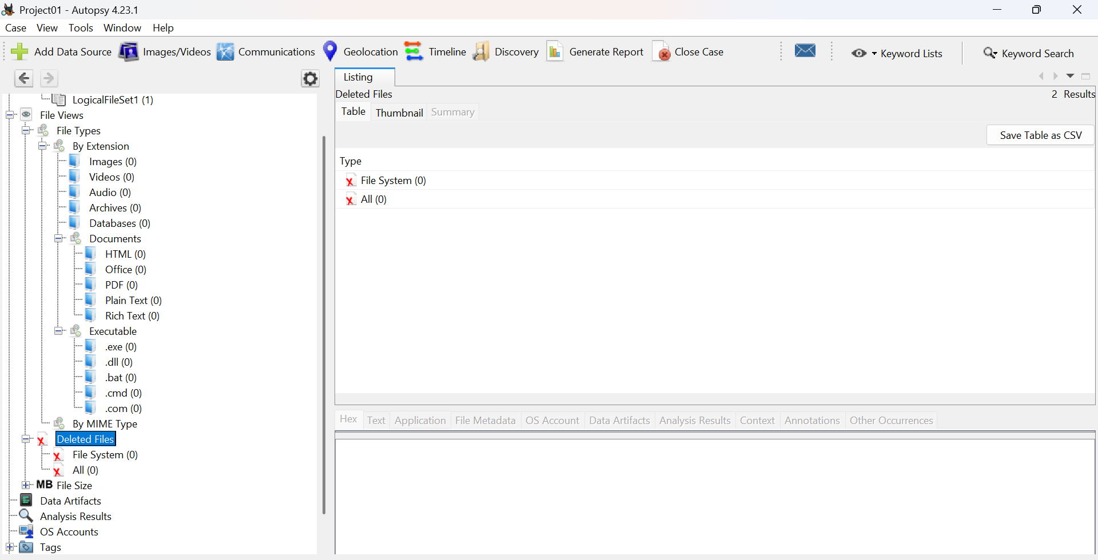
Exhibit 34 | I observed zero counts for File System and All in the Deleted Files view.
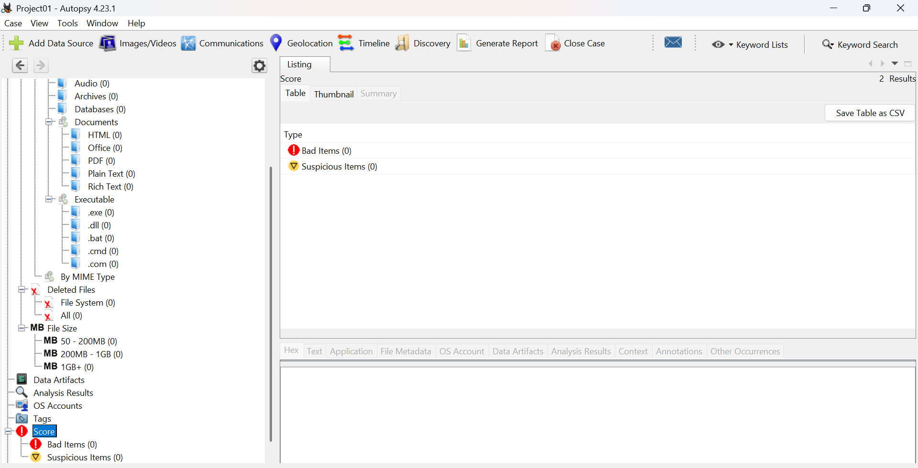
Exhibit 40 | I observed zero Bad Items and zero Suspicious Items in the Score view.

Appendix B. Evidence Register and Pending Fields
Record / item | Current value or status
Case ID | AIT-DF-2026-009
Evidence item | D:\Evidence.E01 — invalid/unusable as received
Current SHA-256 | DFE7BEC71F4DBB757761885B3C3EC2940983DD77D27E48D919F31EF0400AC40E
Autopsy screenshot set | 15 PNG files, Screenshot (26).png through Screenshot (40).png
Acquisition hash | [PENDING]
Custodian / provider | [PENDING]
Transfer history / chain of custody | [PENDING]
Investigator / team | [PENDING]
FTK version and exact error | [PENDING]
R-Drive Image version and result | [PENDING]
Replacement image details | [PENDING]
Autopsy native case and ingest log | [PENDING]

Appendix C. Source Material
I reviewed the assignment brief, Forensic Project.docx. I performed the read-only intake checks described in this report on D:\Evidence.E01. I reviewed the screenshots you provided in C:\Users\HP-PC\OneDrive\Autopsy Screenshots\Screenshot (26).png through Screenshot (40).png.

