Contextual Research & Diagnostic Usability Audit
System Selection & Problem Statement Formulation
Weber Instructure Portal, sometimes known as Weber Canvas, a common tool in the hands of students and teachers at weber state university. Students use this system to connect and learn from the teachers, using the layout designed by our teachers from the options available with the portal. One of the biggest issues is that not all teachers know how to use this system, creating friction between the system and the students’ need to complete schoolwork. For some the portal seems straight forward, for others you need to move between 3 pages to find what you are looking for, be it the next currently due assignment or the recourses they need to learn. The system is in between two different classes of users without enough directions to communicate clearly. These mismatches between the system cause friction between teachers and students, frustration, loss of time that could be used completing assignments, and sometimes dropped classes.
Qualitative Contextual Research
To research I used semi-structured user interview with 2 people. I chose people who are users of Weber Canvas, one is student with average experience, and one is a tenured teacher with above average experience, to get a full picture of the system. I used the base questions from the User Research Protocol I developed as a guide for the interview. I also observed them for a short time, with their permission, using Weber Canvas before starting the interview.
The Good
- The Calendar is the best way to keep track your classes.
- Customizable
- Lots of users
- Allow students and teachers to connect
- Teacher Sand Box
- Grading Rubrics
- Immersive Reader
The Bad
- Teacher Guided
- Inconstant notification
- Formatting
- Requires Searching
- Unsorted Resources
- Incomplete information
- Difficult to customize
- Hard to notice notifications
- Lack of guarantied feedback.
  - If the teacher doesn’t set it up, it doesn’t happen
- Doesn’t work well with connected applications
- Requires work to sort
- Imported files are mixed with existing files
- Self-Taught Users
  - Lack of Training in Capability’s and Use, Especial with Teachers.
  - Special Features require unique knowledge to use
- Glitches
- Reinput information repeatedly
- No communication between pages
- Little feedback on page status.
- No adaptable requirements
- Poor Defaults.

When users’ needs to take a class to understand how to use a system and remember how to do complicated tasks over a long period there is bound to be moments when reality fails to match expectations. Users noted that their system relies heavily on the skill of the teacher in setting up their canvas for the students. Many of the most common issues come from system mismatches between the expectations of the teacher setting up their canvas pages and reality. Students demonstrate frustration with ambiguous guidance, pages that appear or unlock late, unopenable links or files. They are forced to work around a menu of pages they never use to find the requirements of the work they need to do. When a teacher sets up an assignment the default in the system it for it to have no submission. Each action they take requires knowledge and time to set up from uploaded assignments that appear anywhere on the assignment page, a modules page that requires time and practice to set up in an organized fashion, and grading that requires repeated tedious preparation. Students are left to the mercy of the ability of a teacher to manage the system that works against them if the teacher bothers at all. When it came to the teachers learning how to use the system “it was blind teaching the blind”, it was self-taught teachers trying to help others the best they could.
The most common way to set up the canvas seems to have the home page default to the modules page and have a long list of lessons and assignments in groups. This seems practical in the context of a in person class, but when a user needs to work between many pages the repeated sameness of the pages causes time delays and misunderstandings. This is not even counting what happens when a teacher doesn’t put in the time and effort to organize their class into groups, which is not uncommon leaving the only sign for students to start being the ever-useful Calander. Getting notified on assignments being posted comes down to having your system set up to assist the user by the user, the location and process being hidden within layers of menus of same looking options. The few simple systems of getting attention are small and unintrusive, leading to them easily being missed. Many of the useful tools meant to assist the user are left quietly alone because no guide or explanation of how to use them is natively given.
It is an ever-improving experience as the system adapts to the needs of a more accessible world, but it is often slow and unnoticed. System feedback relies on customization and the understanding and foresight of one user for another.
Heuristic Evaluation & Accessibility Audit
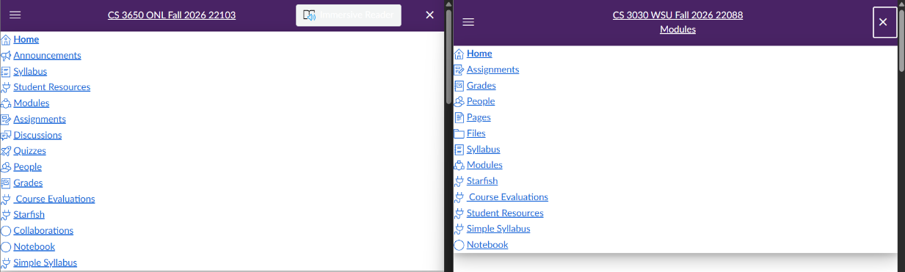
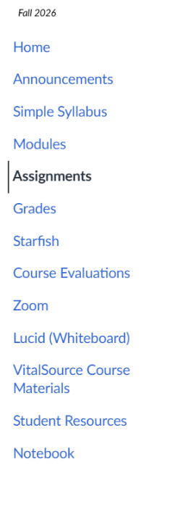
- Nielsen’s 10 Usability Heuristic Audit
Individual Evaluation

Inconsistent Structure of the sidebar. Resources that the user doesn’t know what does.
Aesthetic & Minimalist Design,
Severity Rating: 1
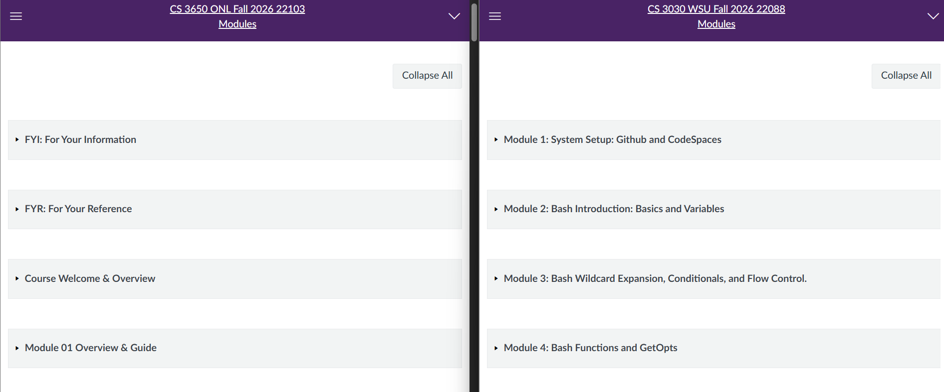
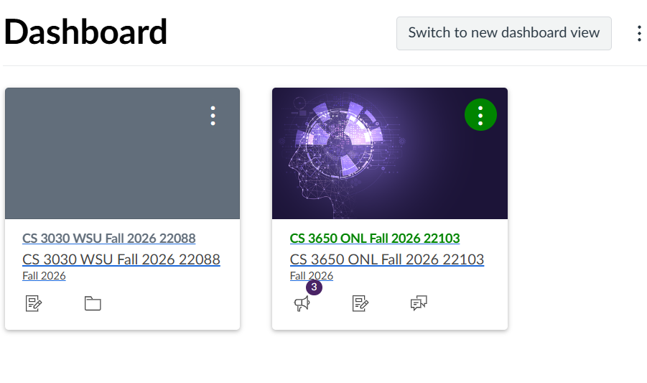
All Dashboards Look the same. The User needs to remember what the number means, especially if the teacher doesn’t add a unique picture, to make them differentiate.
Severity Rating: 1
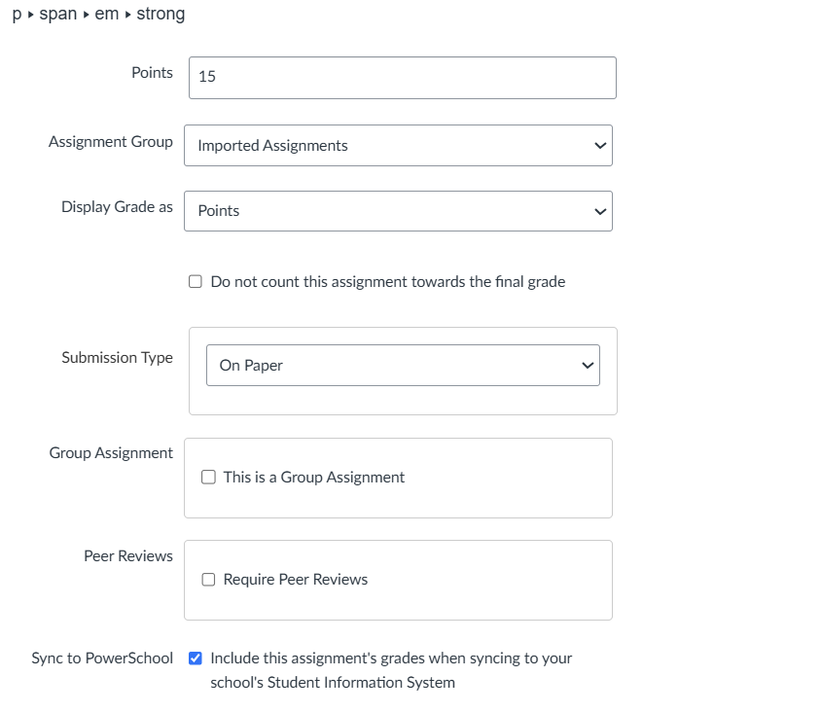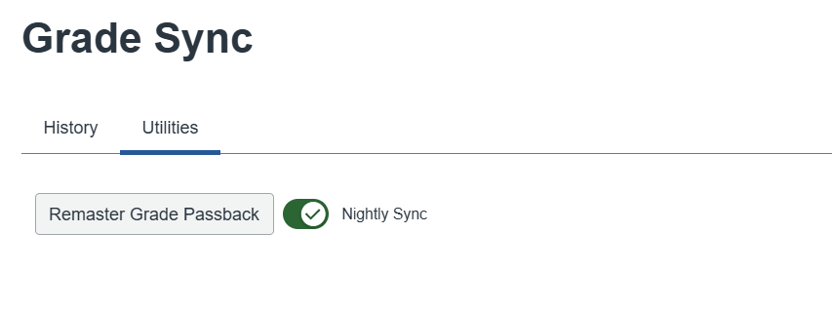Lots of information is required all at once, and it will not be remembered if you move away from the page. For example, Grade Sync requires an option on another page to be set for it to function, it does not tell you this. Has a button that can accidentally reset everything on the sister program.
Help & Documentation, Help Users Recognize & Recover from Errors, Recognition Rather than Recall.
Severity Rating: 3

Baseline Accessibility (WCAG 2.1 AA) Audit
- Visual Color Contrast Ratios
  - Dashboard: 8.59:1 – Pass
  - Modules: 8.59:1 – Pass
  - Syllabus: 8.59:1 – Pass
  - I noticed that all buttons and indicators use visually distinct contrasts so even when in desaturated mode all parts were distinct.
- Keyboard Navigation
  - During my manual inspection I was able to use a combination of tab, the arrow keys and enter to move focus through and access any part of the page.
  - This was confirmed by inspecting the page using the Order tab.
- Semantic Document structure and aria-* attribute support
  - All pages show some amount of aria support.
  - Announcements and student resources have the least but still have some especially on any button or link.
  - Most screens where the user is expected to read information, such as in an assignment or on a custom home page, have integrated screen readers to allow for blind or reading impaired accessibility. Pages like Modules, Assignments, Grades, Calander, and inbox don’t.

Post-Mortem Reflection (Metacognition)
- How did combining qualitative user observations with an expert heuristic evaluation reveal usability flaws that a developer testing their own code would likely overlook?
Using qualitative user observation with an expert heuristic evaluation revealed flaws that only showed up when two users were forced to communicate. A developer testing would make sure each small piece works without realizing that they were designing a system that can have two users fail to communicate. It allows for the post reflection of the function and use based on actual users and their experiences working with the system and each other.
- Identify one heuristic violation that directly creates a legal or ethical accessibility barrier under WCAG 2.1 AA and explain how resolving that violation improves the user experience for both disabled users and the public.
The only consistent violation I found was a broken ARIA reference for the link back to the main page and for the current page. To fix it the link to the current page still be pressable. For example, if you are in the modules page you can click the modules link at the top to reload the page. This improves the user experience by letting screen readers know what the current page is through other methods than having the title elsewhere.

