CST8915
Full-Stack Cloud-Native Development
Complete Study Guide — All Diagrams | All Modules | Quiz | Glossary | Interview Prep
Jaswant Singh | 41287569 | Algonquin College | Summer 2026

Module | Topic
1 | Cloud-Native Applications — Introduction & 6 Pillars
2 | Modern Design — Monolith vs Cloud-Native & CNCF
3 | The Twelve-Factor Application Methodology (All 12 + 3 Additional)
4 | Microservices — Principles, Advantages & Challenges
5 | Containers — Docker, Virtualization & Containerization
6 | Container Orchestration — Kubernetes Architecture
7 | Backing Services & Database as a Service (DBaaS)
8 | Automation, CI/CD, DevOps & Infrastructure as Code

MODULE 1 | Cloud-Native Applications — Introduction & 6 Pillars

🎯 Learning Objectives
01 Examine cloud-native applications | 02 State the pillars of cloud-native | 03 Discuss candidate applications for cloud-native

1.1 What is Cloud-Native?
Cloud-native application development is an approach to designing, building, deploying, and maintaining services that leverage the resiliency and efficiency of cloud computing technologies to deliver real-time, cost-effective, and secure applications to end users.

📖 CNCF Official Definition
Cloud-native technologies empower organizations to build and run scalable applications in modern, dynamic environments (public, private, hybrid clouds).
Containers, service meshes, microservices, immutable infrastructure, and declarative APIs exemplify this approach.
These techniques enable loosely coupled systems that are resilient, manageable, and observable. Combined with robust automation, they allow engineers to make high-impact changes frequently and predictably with minimal toil.
Cloud native is about SPEED and AGILITY.

Industry Examples
Company | Services in Production | Deployment Frequency
Netflix | 600+ services | 100 deployments per day
Uber | 1,000+ services | Several thousand per week
WeChat | 3,000+ services | 1,000 deployments per day

1.2 Candidate Apps for Cloud-Native
Good candidates for cloud-native:
Indicator | Why It Fits Cloud-Native
Needs constant feature evolution | Microservices allow independent updates without full redeployment
Requires high release velocity | CI/CD pipelines and autonomous microservices enable fast releases
Individual features must release independently | Each microservice has its own deployment lifecycle
Teams with different tech stacks | Each service can use the most appropriate language/framework
Components must scale independently | Scale only the services under load, not the entire application

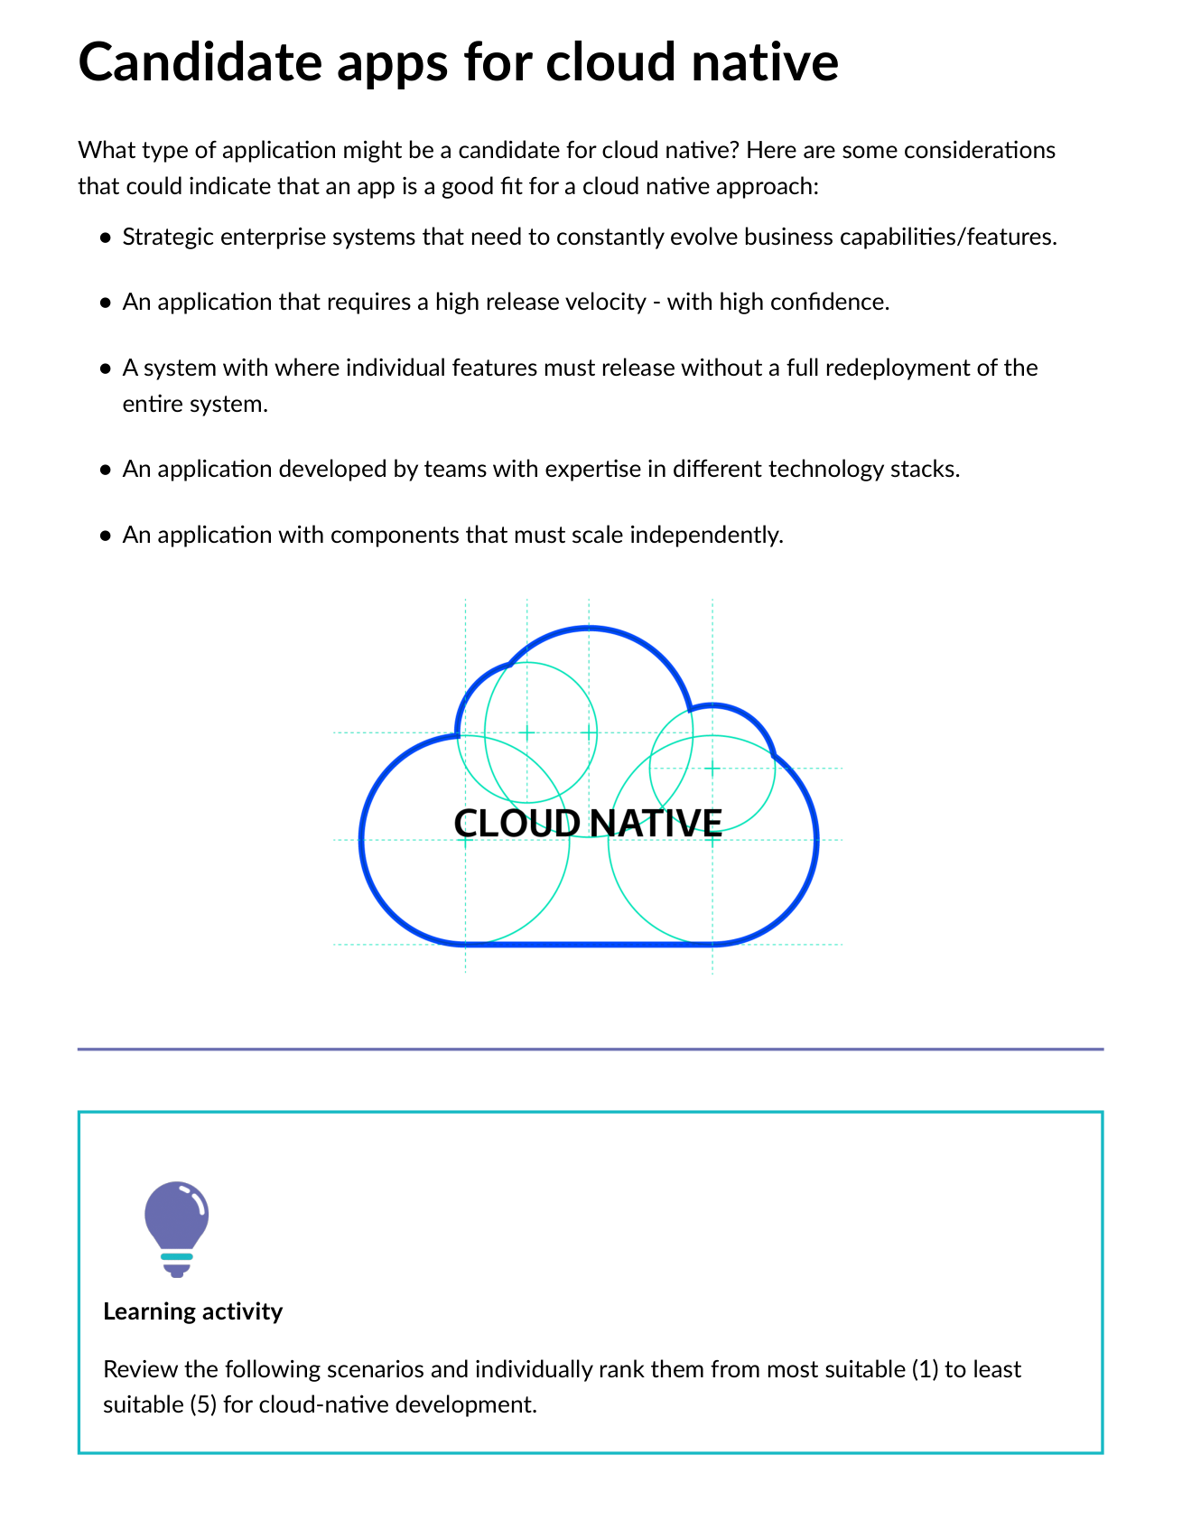
Fig 1.1 — Learning Activity: Ranking apps most→least suitable for cloud-native (Video streaming, Banking, E-commerce, Weather app, Small blog)

1.3 The 6 Pillars of Cloud-Native
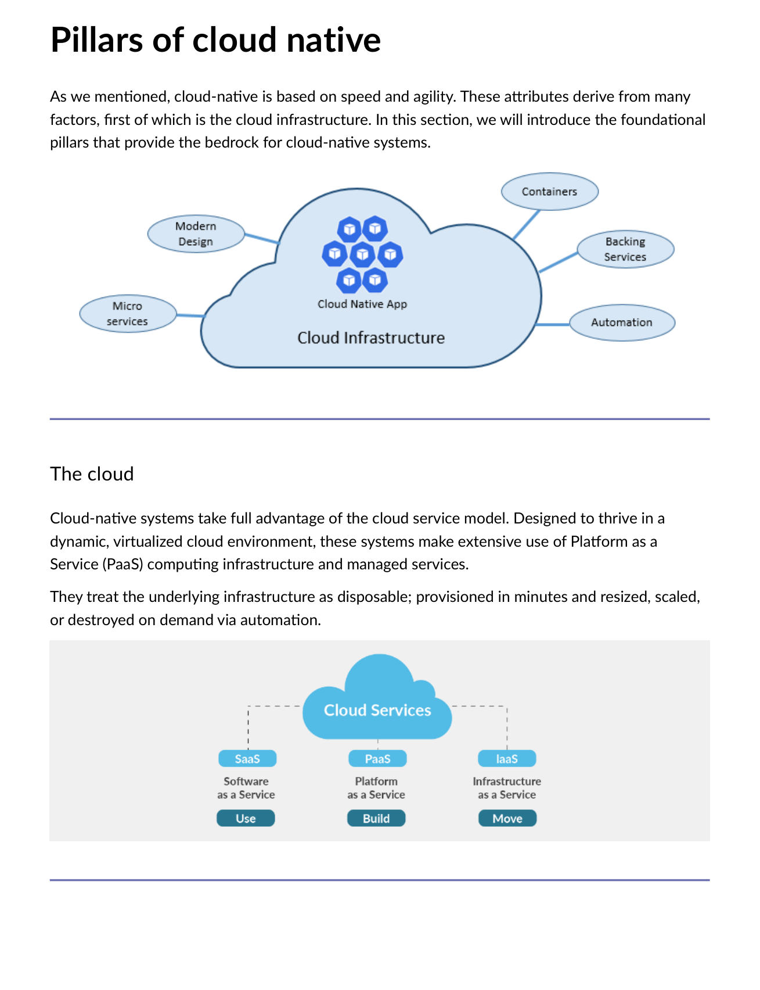
Fig 1.2 — The 6 Pillars: The Cloud, Modern Design, Microservices, Containerization, Backing Services, Automation

Pillar | Key Concept
The Cloud | Use PaaS and managed services. Treat infrastructure as disposable — provisioned/destroyed on demand via automation.
Modern Design | Twelve-Factor Application methodology — principles for portable, scalable cloud apps.
Microservices | Independent services each performing a specific business function, communicating via APIs.
Containerization | Package app + all dependencies into a container image — runs consistently anywhere.
Backing Services | External services (databases, queues, caches) consumed over the network as attached resources.
Automation | IaC + CI/CD pipelines — automate provisioning, building, testing, and deployment.

1.4 Pets vs. Cattle Analogy
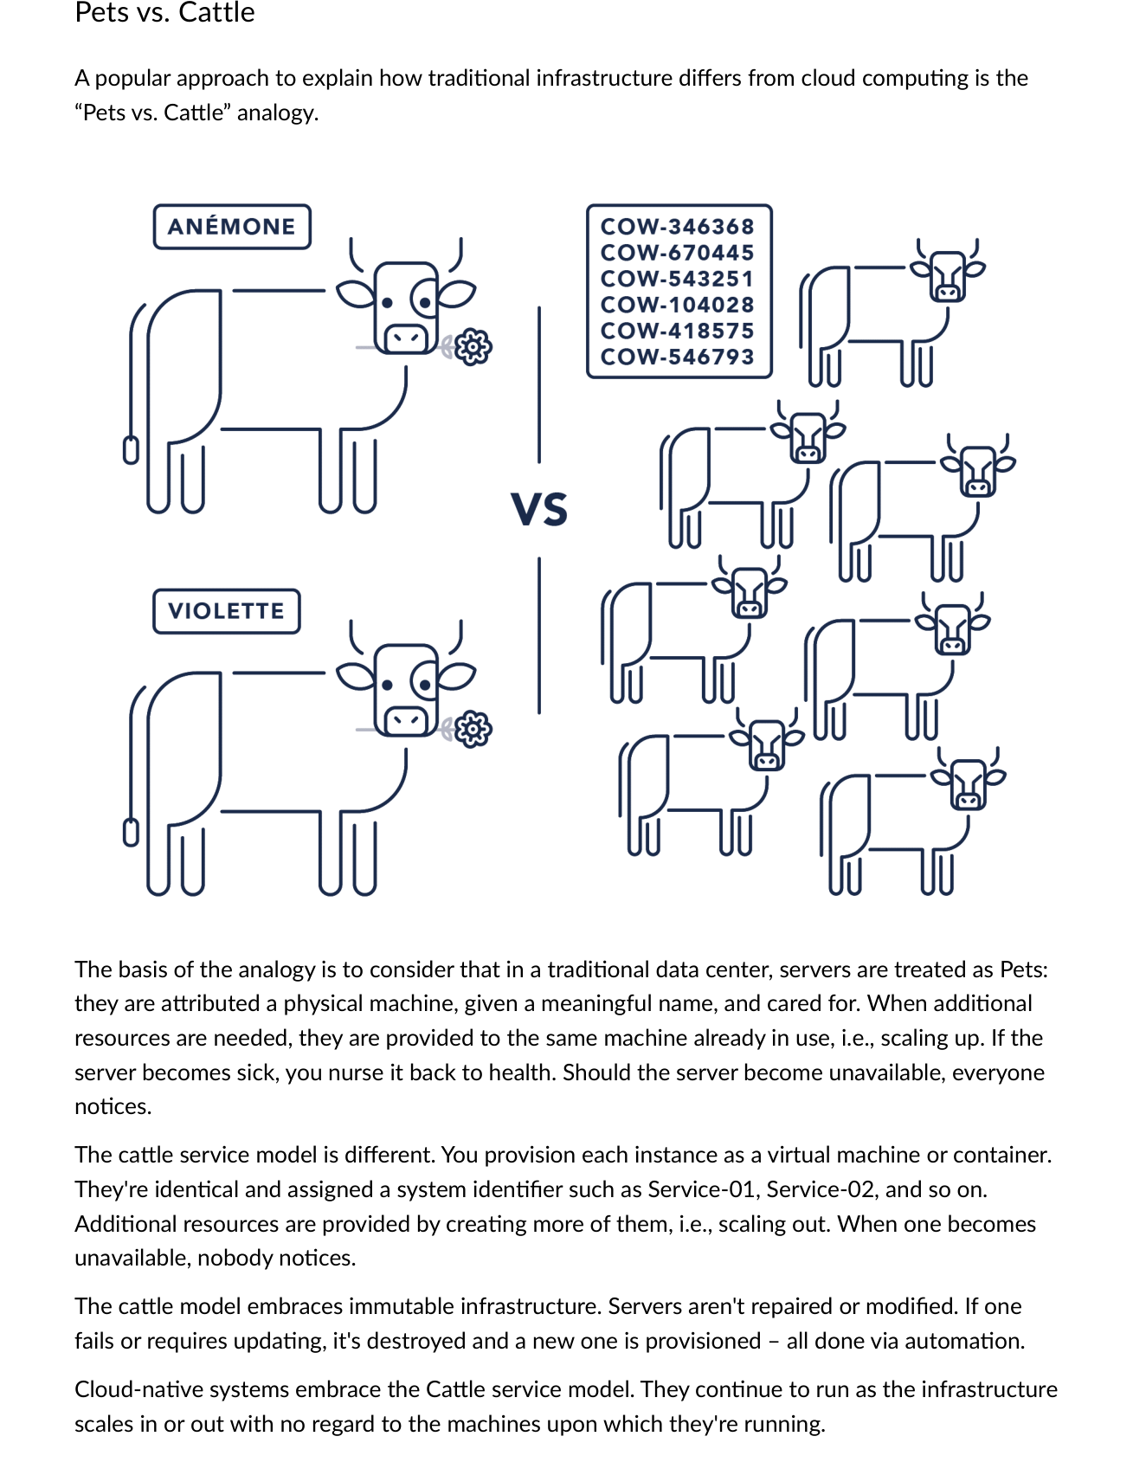
Fig 1.3 — Pets vs. Cattle: Traditional servers treated as Pets (named, cared for, scaled up, irreplaceable). Cloud servers treated as Cattle (numbered, disposable, auto-replaced, immutable).

Dimension | Pets (Traditional) | Cattle (Cloud-Native)
Naming | Named machines (WebServer01) | System IDs (Service-01, Service-02)
Scaling | Scale UP — more resources to same machine | Scale OUT — more identical instances
Failure response | Nurse it back to health | Destroy and provision a new one automatically
Visibility | Everyone notices if it goes down | Nobody notices — auto-replaced by orchestrator
Infrastructure | Mutable — updated in place | Immutable — never modified, always replaced

1.5 Key Diagrams — Microservices & Containers Overview
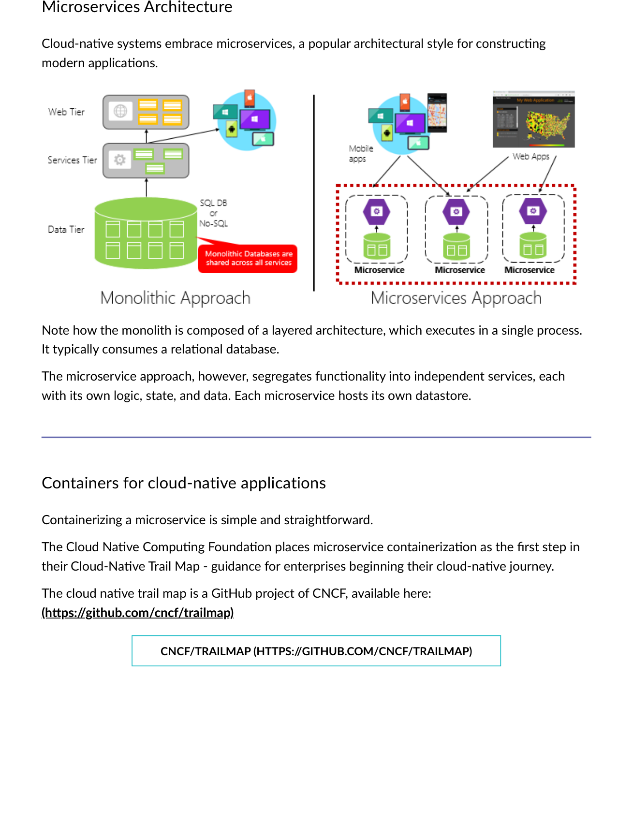
Fig 1.4 — Monolith (single process, shared relational DB) vs. Microservices (independent services each with own data store)
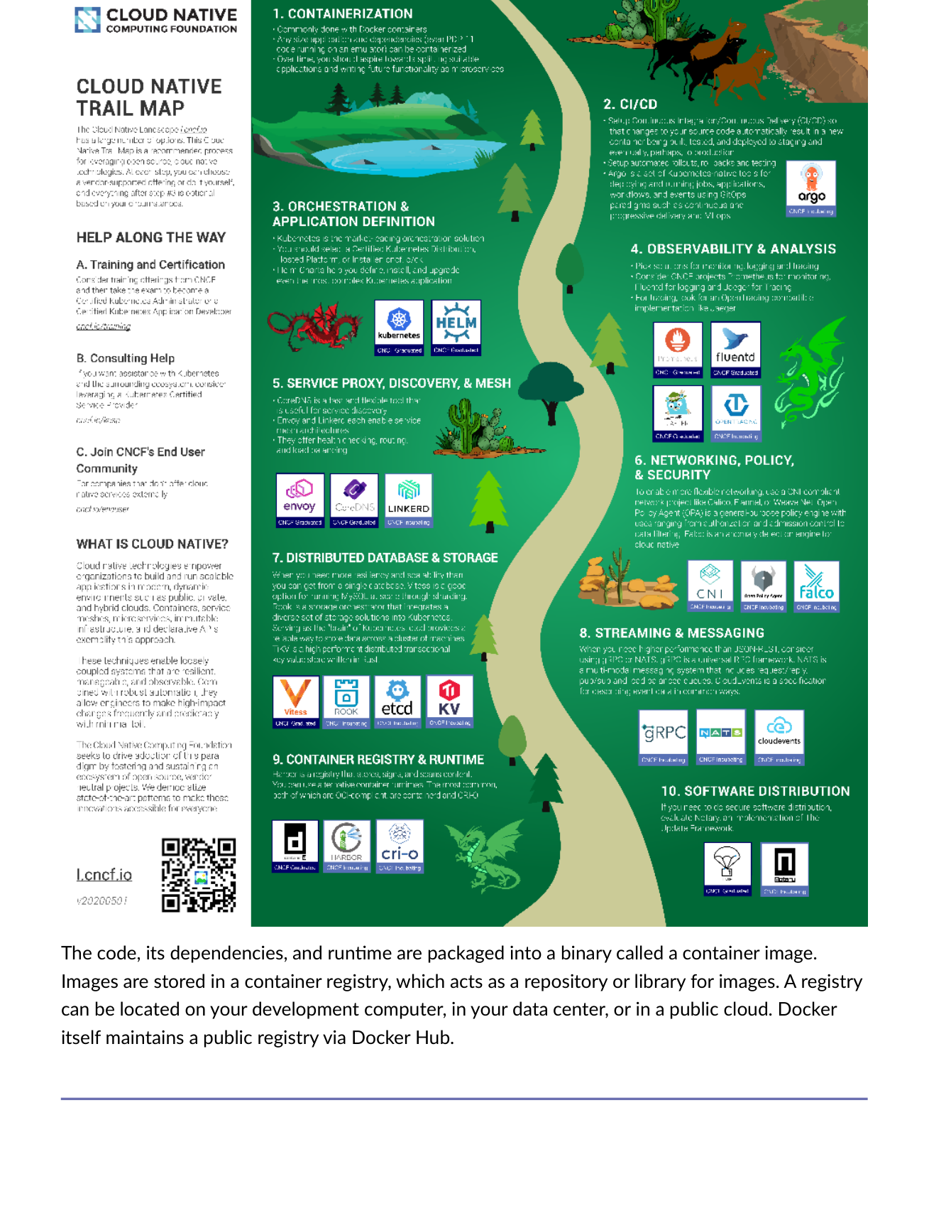
Fig 1.5 — Container model: Code+Dependencies+Runtime → Container Image → Registry → Running Container Instances
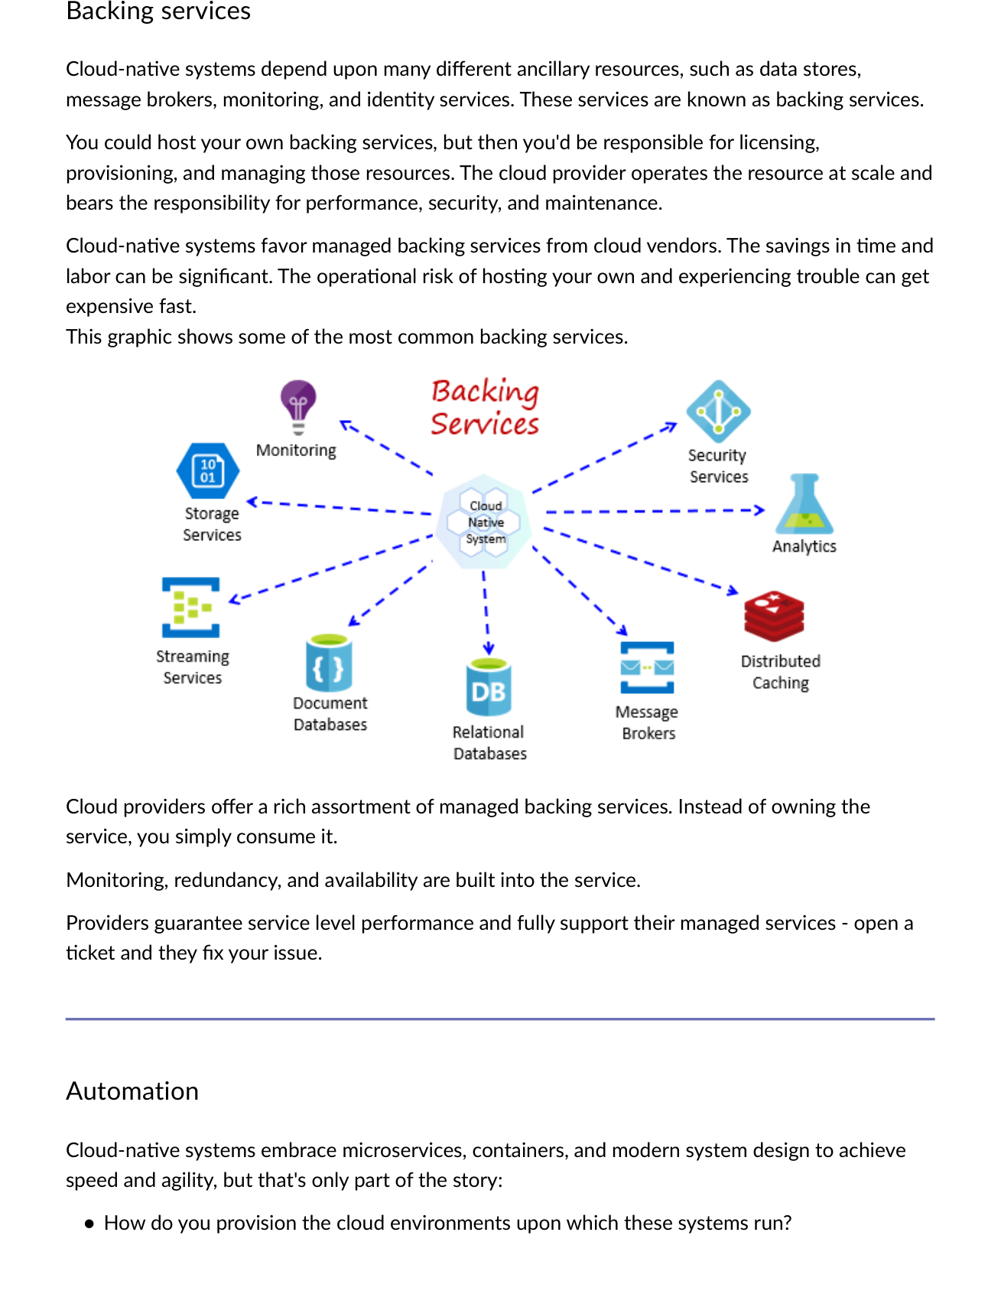
Fig 1.6 — Common Backing Services consumed by cloud-native systems: data stores, message brokers, monitoring, identity services

Module 1 — Key Terms
Term | Definition
Cloud-Native | Approach leveraging cloud for real-time, cost-effective, secure delivery using microservices, containers, automation.
CNCF | Cloud Native Computing Foundation — 400+ member consortium hosting Kubernetes, Prometheus, Envoy.
Immutable Infrastructure | Servers replaced entirely when changes needed — never modified in place.
Pets vs. Cattle | Pets=traditional named servers; Cattle=disposable, identical, auto-replaced cloud instances.
API | Application Programming Interface — way for two programs to communicate.
Legacy Application | Outdated system unable to adopt new tech due to compatibility issues; unreliable and hard to maintain.
Vertical Scaling | Adding more resources (CPU, RAM) to the same machine. Contrast: Horizontal = add more instances.

MODULE 2 | Modern Design — Monolith vs Cloud-Native & CNCF

2.1 Monolithic Application Design
Traditional approach: a single executable running the entire system. Web apps use 3-tier architecture: Database tier + Business Logic (web server) + Presentation tier (browser). Everything runs in a single process.
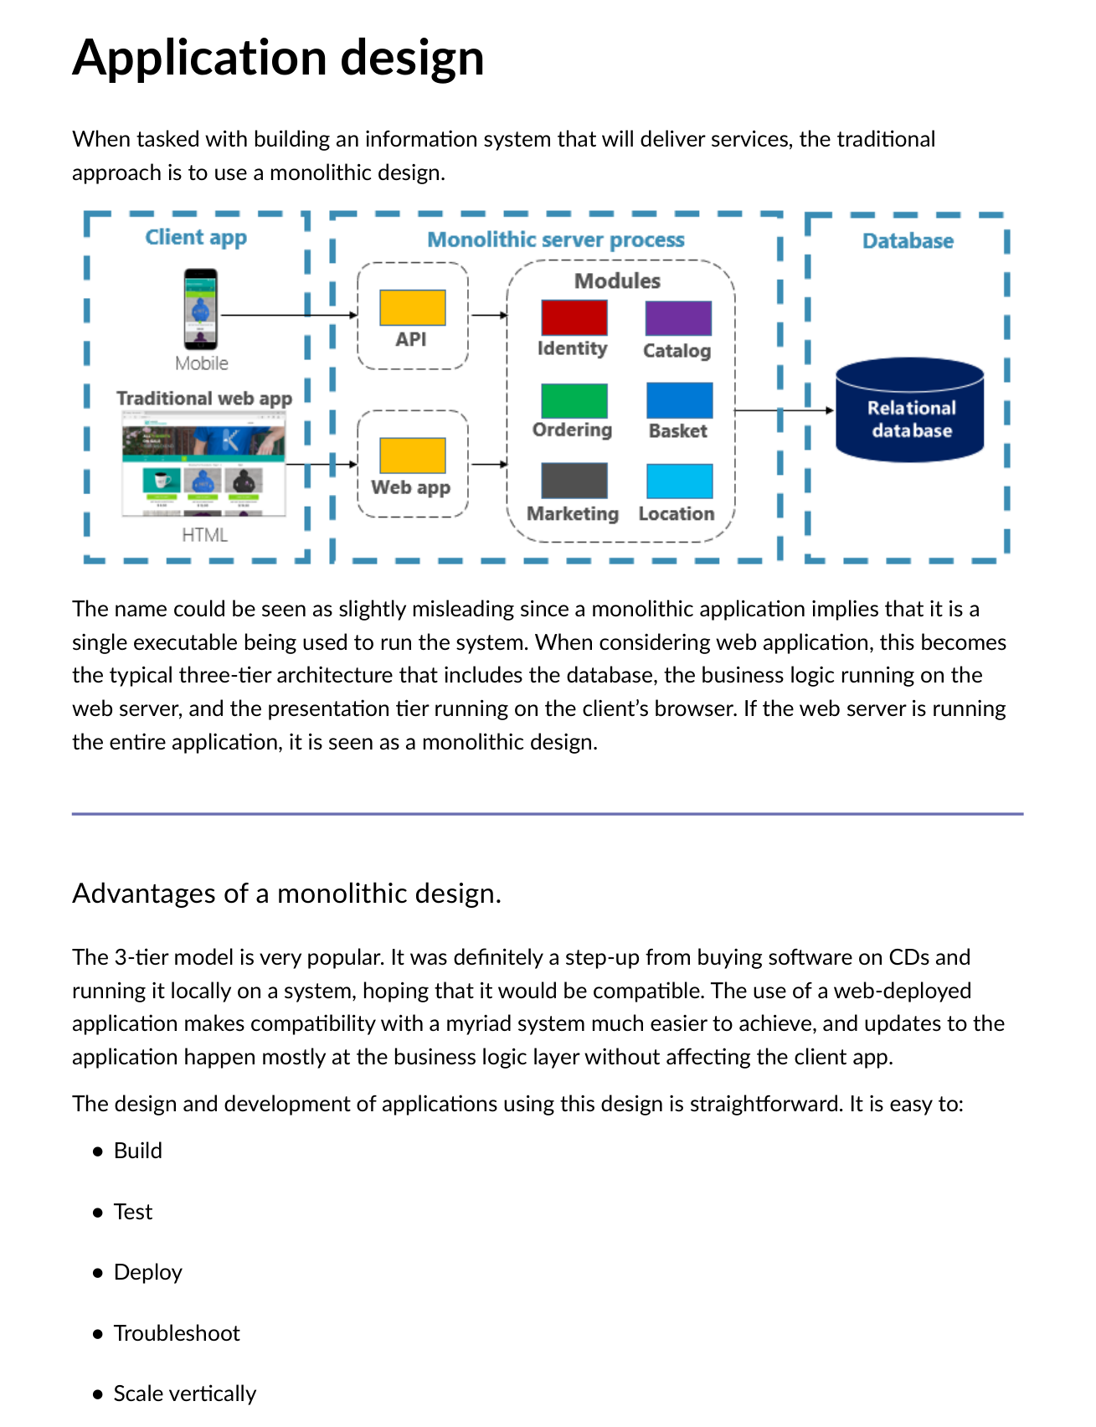
Fig 2.1 — Traditional 3-Tier Monolithic Architecture: DB → Business Logic (Web Server) → Presentation (Browser). Single process execution.

Monolith Advantages | Monolith Disadvantages / Fear Cycle
Easy to build, test, deploy, troubleshoot | As app grows, changes have unexpected consequences — side effects costly
Scale vertically straightforward | No one understands the full application anymore
Updates to business logic don't break client | New features become time-consuming and expensive
Wide compatibility across clients | Each release requires FULL redeployment of entire application

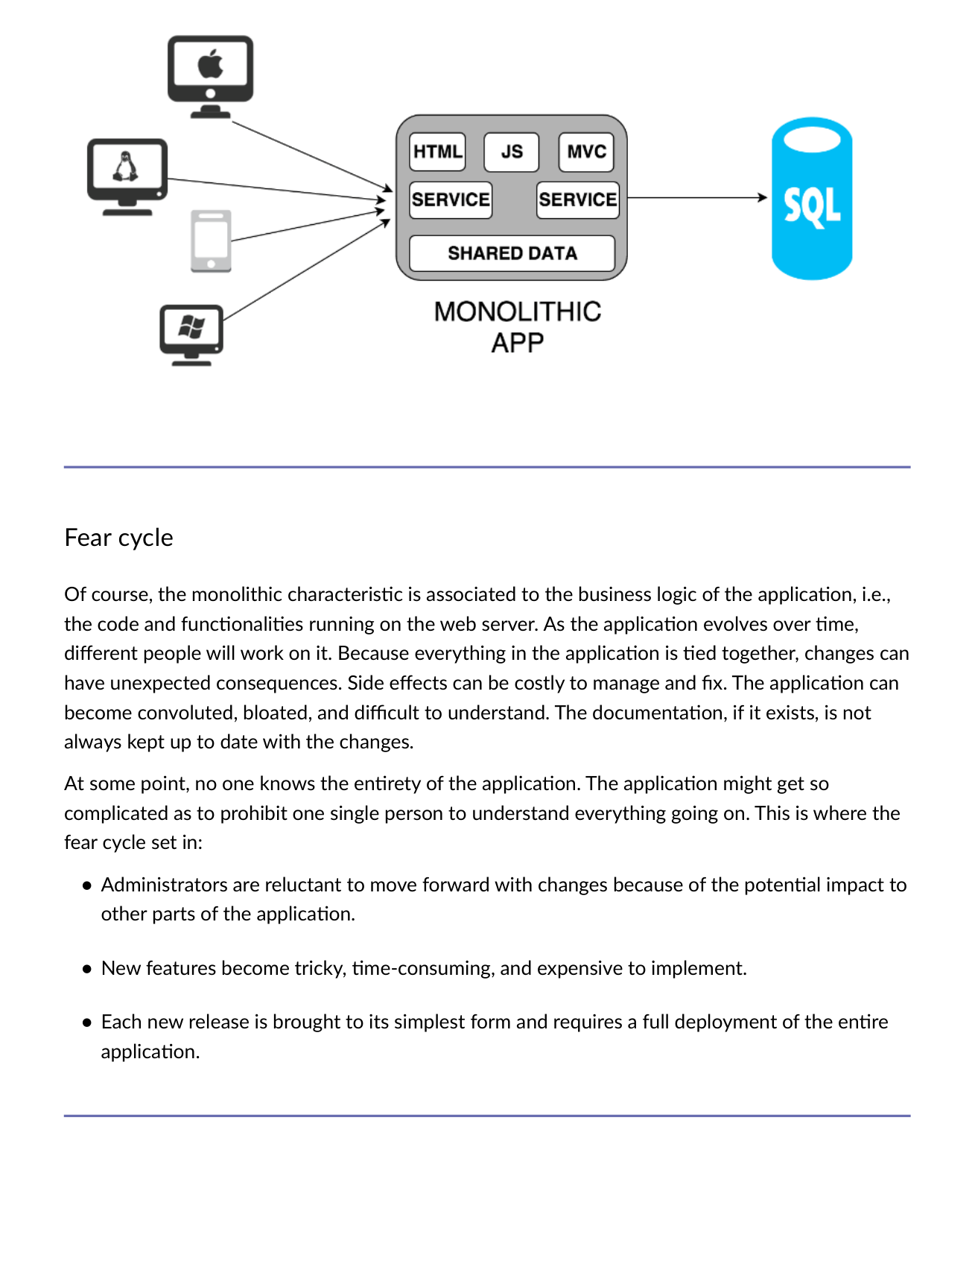
Fig 2.2 — The Fear Cycle: Application becomes so complex that administrators are afraid to change anything. Kills velocity.

📖 Real-World: Phoenix Pay System (Canada, 2016)
Government payroll system failed because the previous legacy system had become so customized and convoluted that reverse engineering it was nearly impossible. Still causing issues years later. Classic legacy monolith risk — the longer you wait, the worse it gets.

2.2 Cloud-Native Solution
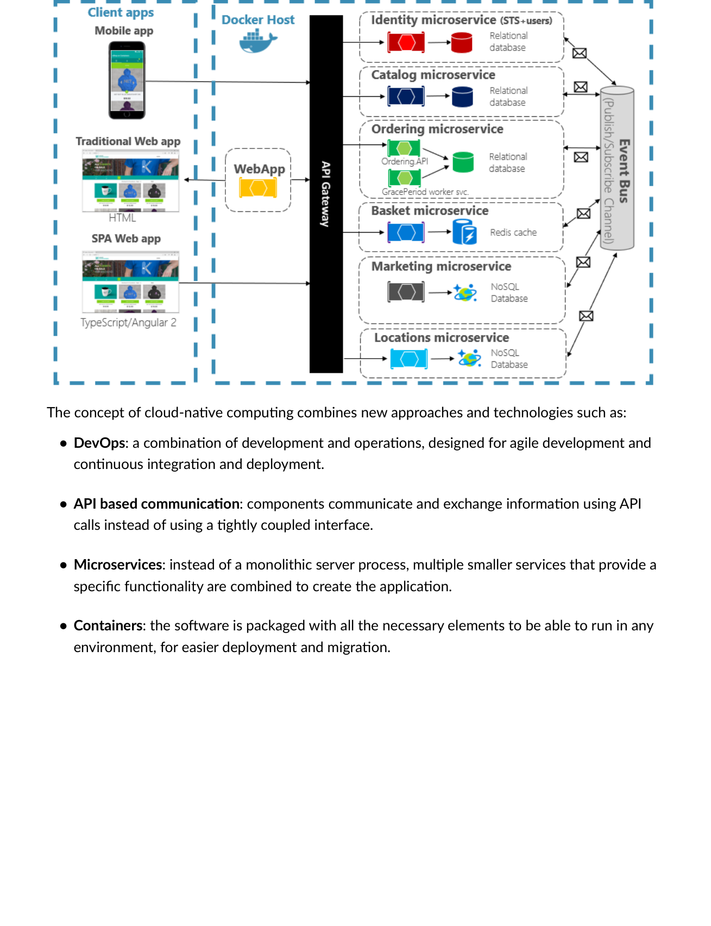
Fig 2.3 — Cloud-Native combines: DevOps + API-based communication + Microservices + Containers

Technology | Role in Cloud-Native
DevOps | Combination of development + operations. Agile development with CI/CD.
API-based communication | Components exchange info via API calls — loosely coupled, not tightly bound interfaces.
Microservices | Multiple smaller services each providing specific functionality, combined to form the app.
Containers | Software packaged with all necessary elements to run in any environment.

2.3 Cloud Native Computing Foundation (CNCF)
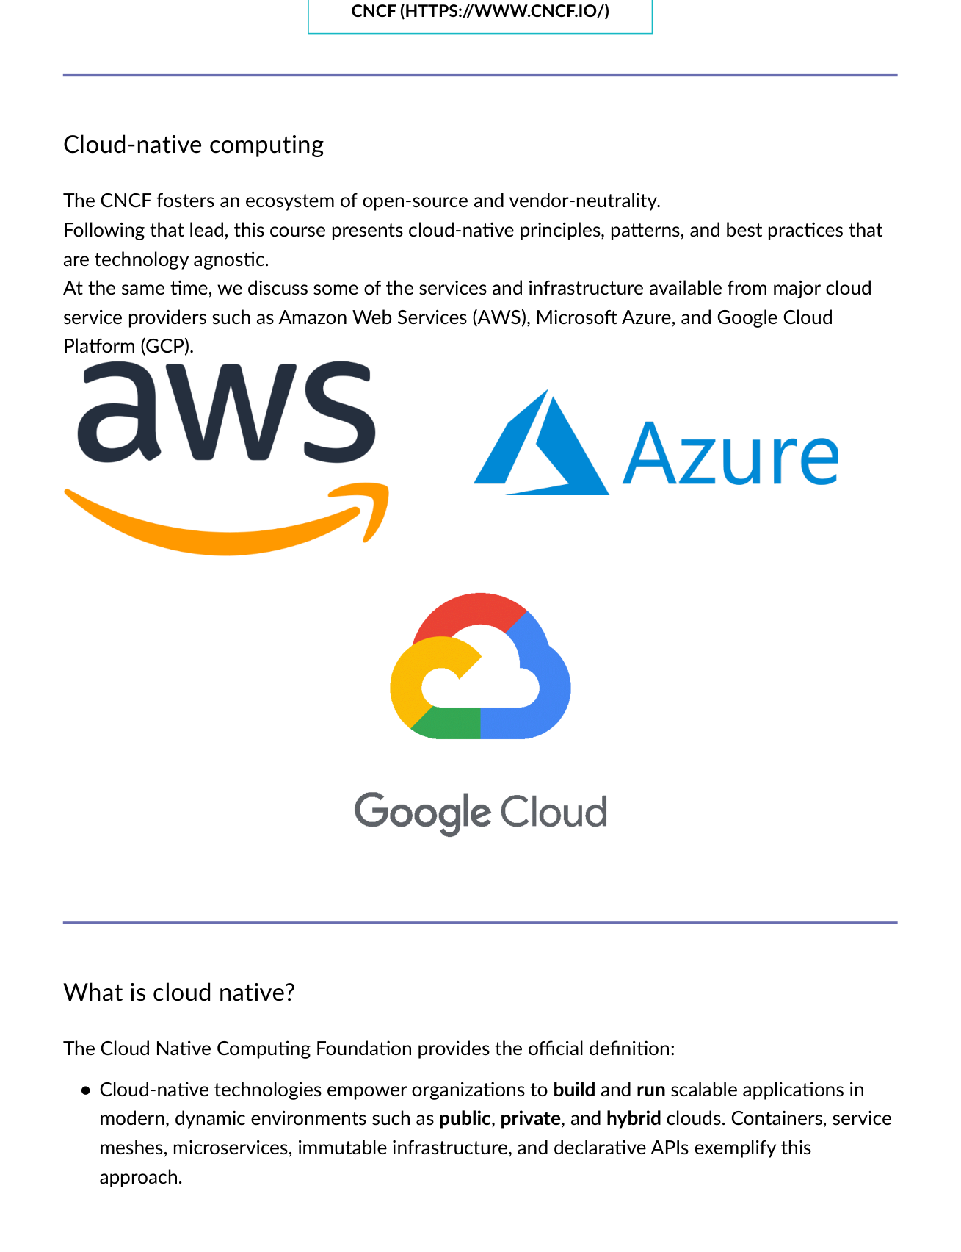
Fig 2.4 — CNCF ecosystem: 400+ member corporations. Vendor-neutral open-source projects. Fastest-growing GitHub projects.
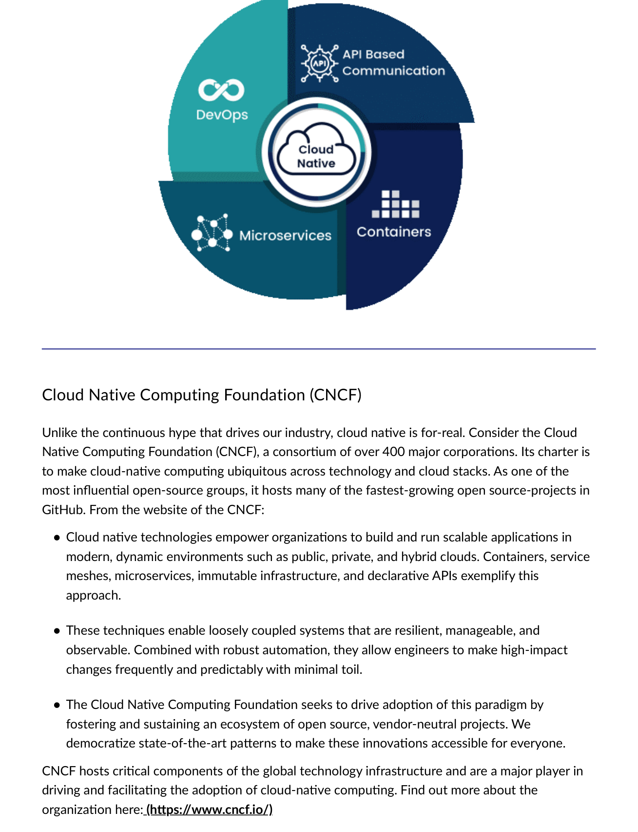
Fig 2.5 — CNCF hosts critical components of global tech infrastructure driving cloud-native adoption.

- 400+ major corporations: AWS, Azure, Google, IBM, RedHat, and more.
- Charter: make cloud-native computing ubiquitous across technology and cloud stacks.
- Hosts: Kubernetes, Prometheus, Envoy, Fluentd, gRPC, CoreDNS, containerd, and more.
- Vendor-neutral — cloud-native principles not locked to any one provider.

Module 2 — Key Terms
Term | Definition
Monolithic App | Self-contained single unified software app — all components in one large application.
3-Tier Architecture | DB tier + Business logic tier + Presentation tier. Classic monolithic web app structure.
Fear Cycle | Paralysis when monolith becomes too complex to change — fear of unintended side effects.
Legacy Application | Application so outdated it cannot be updated with new frameworks/tech and needs replacement.
DevOps | Culture combining development and operations enabling agile development and CI/CD.
CNCF | Cloud Native Computing Foundation — 400+ member consortium driving cloud-native globally.
CI/CD Pipeline | Continuous Integration and Continuous Deployment — automated steps to deliver software.
RBAC | Role-Based Access Control — restricting access to authorized users based on their role.

MODULE 3 | The Twelve-Factor Application Methodology

🎯 Learning Objectives
01 Describe Twelve-Factor methodology | 02 Explain factors reflecting modern cloud app design | 03 Identify principles, patterns, best practices | 04 Discuss infrastructure and operational concerns

3.1 What is the Twelve-Factor App?
A widely accepted methodology for building cloud-native SaaS apps. Systems built on these principles deploy and scale rapidly and react quickly to market changes.

Twelve-Factor Apps... | Detail
Use declarative formats | Minimize time/cost for new developers joining the project.
Clean OS contract | Maximum portability between execution environments.
Cloud platform ready | No need for servers and systems administration.
Dev/prod parity | Continuous deployment for maximum agility.
Scale without changes | No tooling, architecture, or dev practice changes to scale.

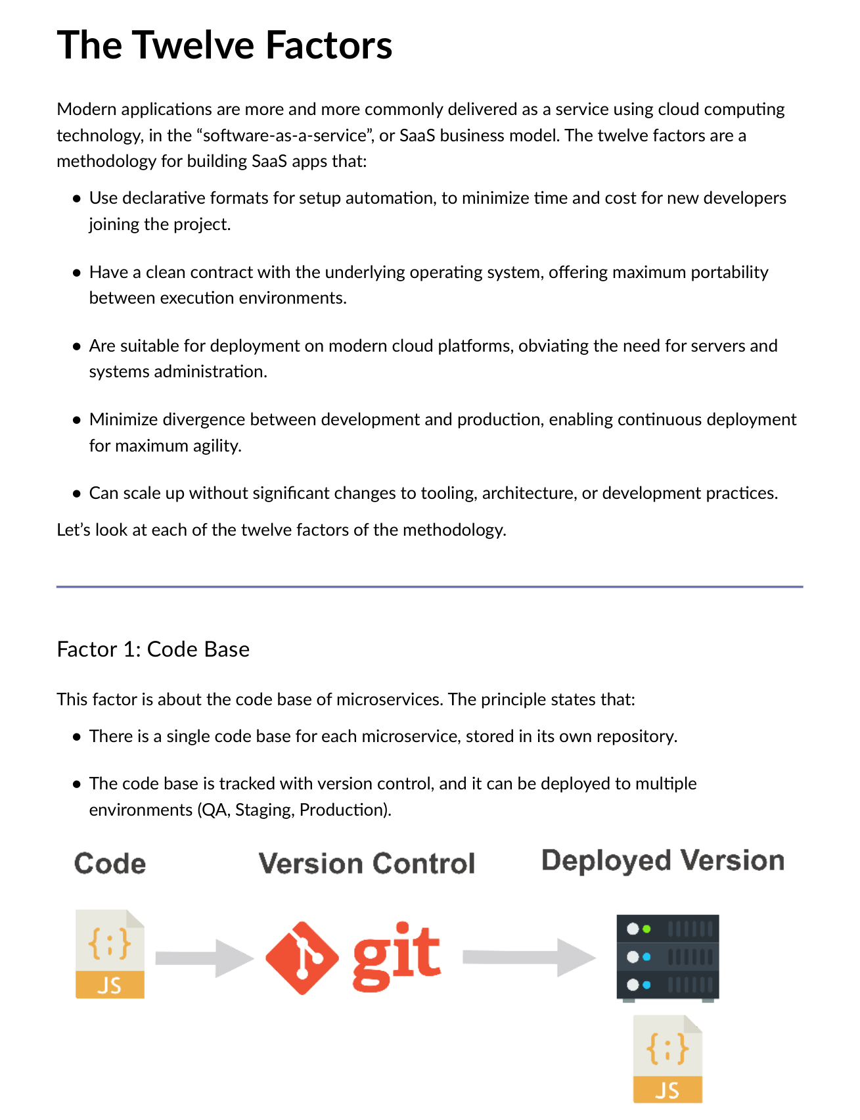
Fig 3.1 — Factor 1: Codebase. One repo per microservice tracked in version control, deployed to multiple environments (QA/Staging/Production).
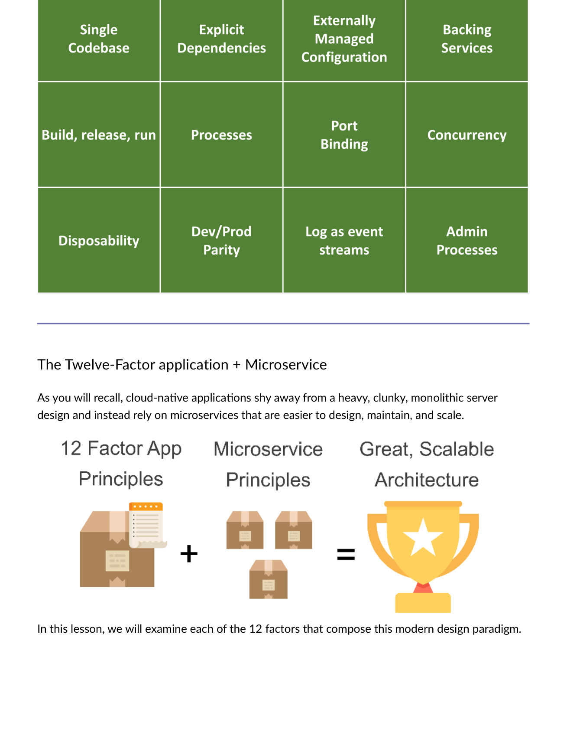
Fig 3.2 — Twelve-Factor + Microservices: Cloud-native apps rely on microservices that are each themselves a 12-factor app.

3.2 All 12 Factors — Quick Reference
# | Factor | Principle
1 | Codebase | One repo per microservice; same code deployed to QA, Staging, Production.
2 | Dependencies | Explicitly declare and isolate all dependencies — NEVER rely on the host.
3 | Configurations | Store config in ENVIRONMENT VARIABLES, not in code. Same container, different configs per environment.
4 | Backing Services | Treat backing services as attached resources via URL. Local MySQL = Amazon RDS (only config changes, not code).
5 | Build/Release/Run | Strict separation: Build (artifact) → Release (artifact+config, immutable, unique ID) → Run.
6 | Processes | Execute as STATELESS processes. Externalize state to backing services (cache, DB).
7 | Port Binding | Each microservice self-contained, exposed on its own port. Network-level isolation.
8 | Concurrency | Scale OUT via multiple identical processes — NOT scale up a single large instance.
9 | Disposability | Fast startup, graceful shutdown. Instances disposable and auto-replaced.
10 | Dev/Prod Parity | Keep all environments as similar as possible. Containers help achieve this.
11 | Logging | Treat logs as EVENT STREAMS. Aggregate with Azure Monitor/Splunk → long-term archival.
12 | Admin Processes | Admin tasks run as one-off processes using independent tools in the same environment.

3.3 Factor Diagrams
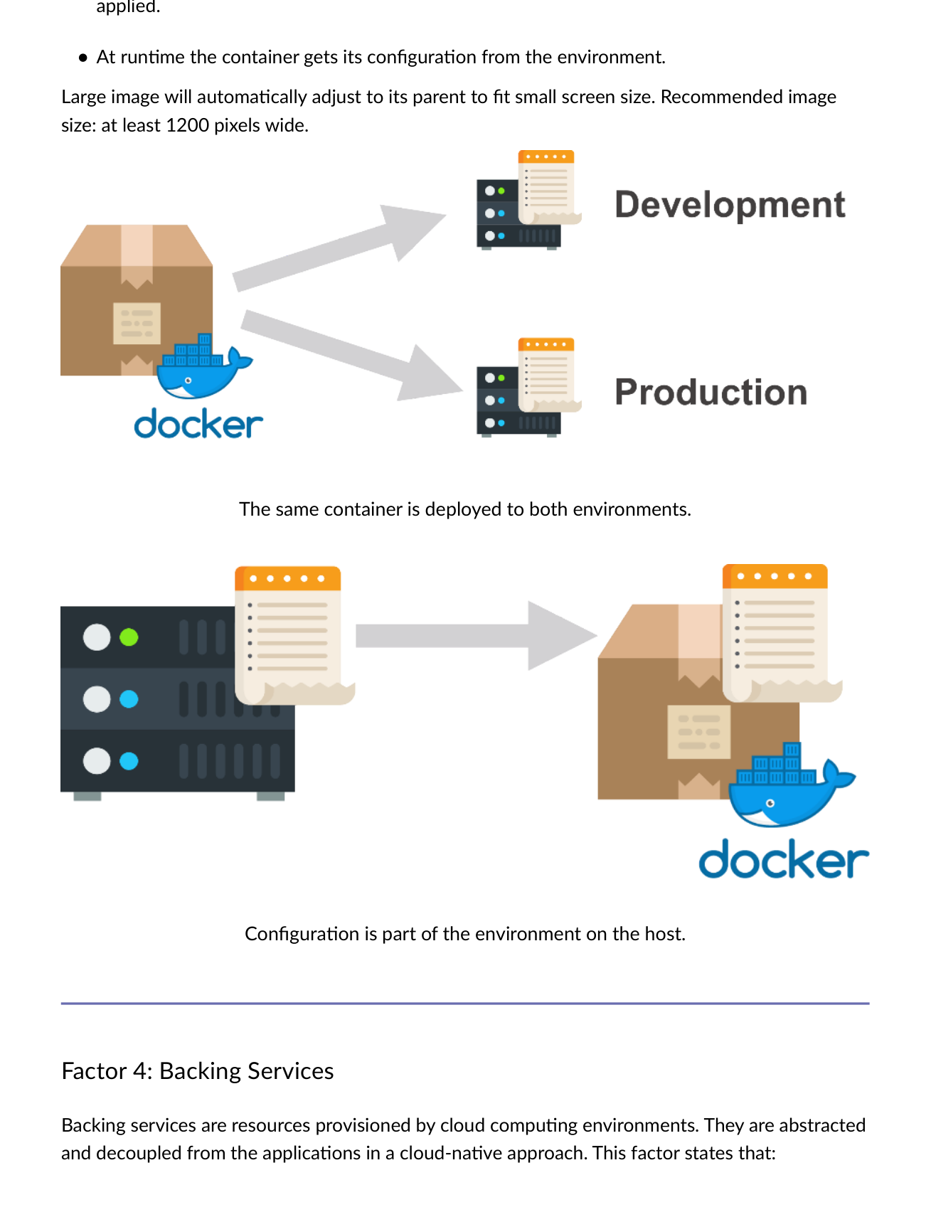
Fig 3.3 — Factor 3: Same container deployed to Dev and Prod. Configuration from environment, not baked into container image.
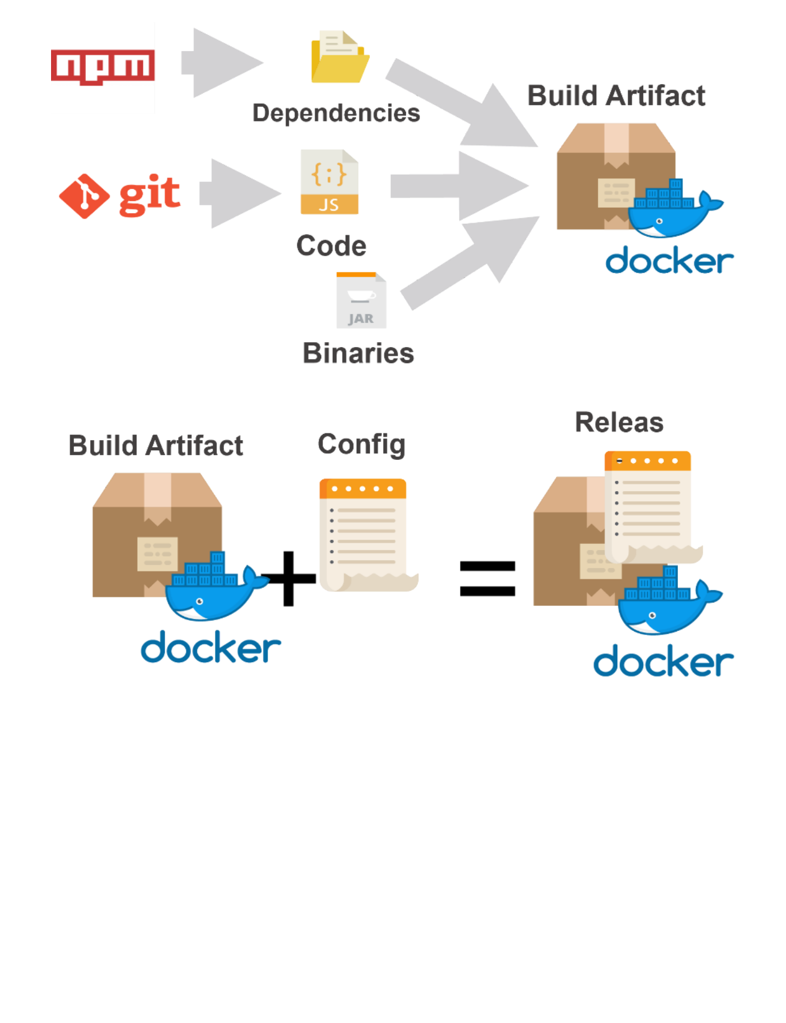
Fig 3.4 — Factor 5: Build → Release (immutable, unique ID) → Run. Each stage strictly separated. Rollback via releasing a previous version.
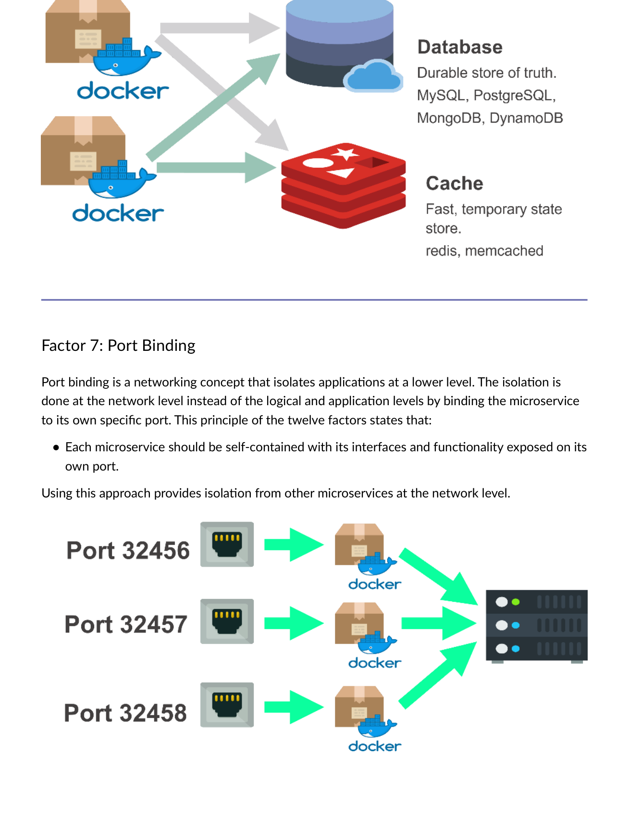
Fig 3.5 — Factor 7: Each microservice exposed on its own port (Service A:3000, B:4000, C:5000). Network-level isolation.
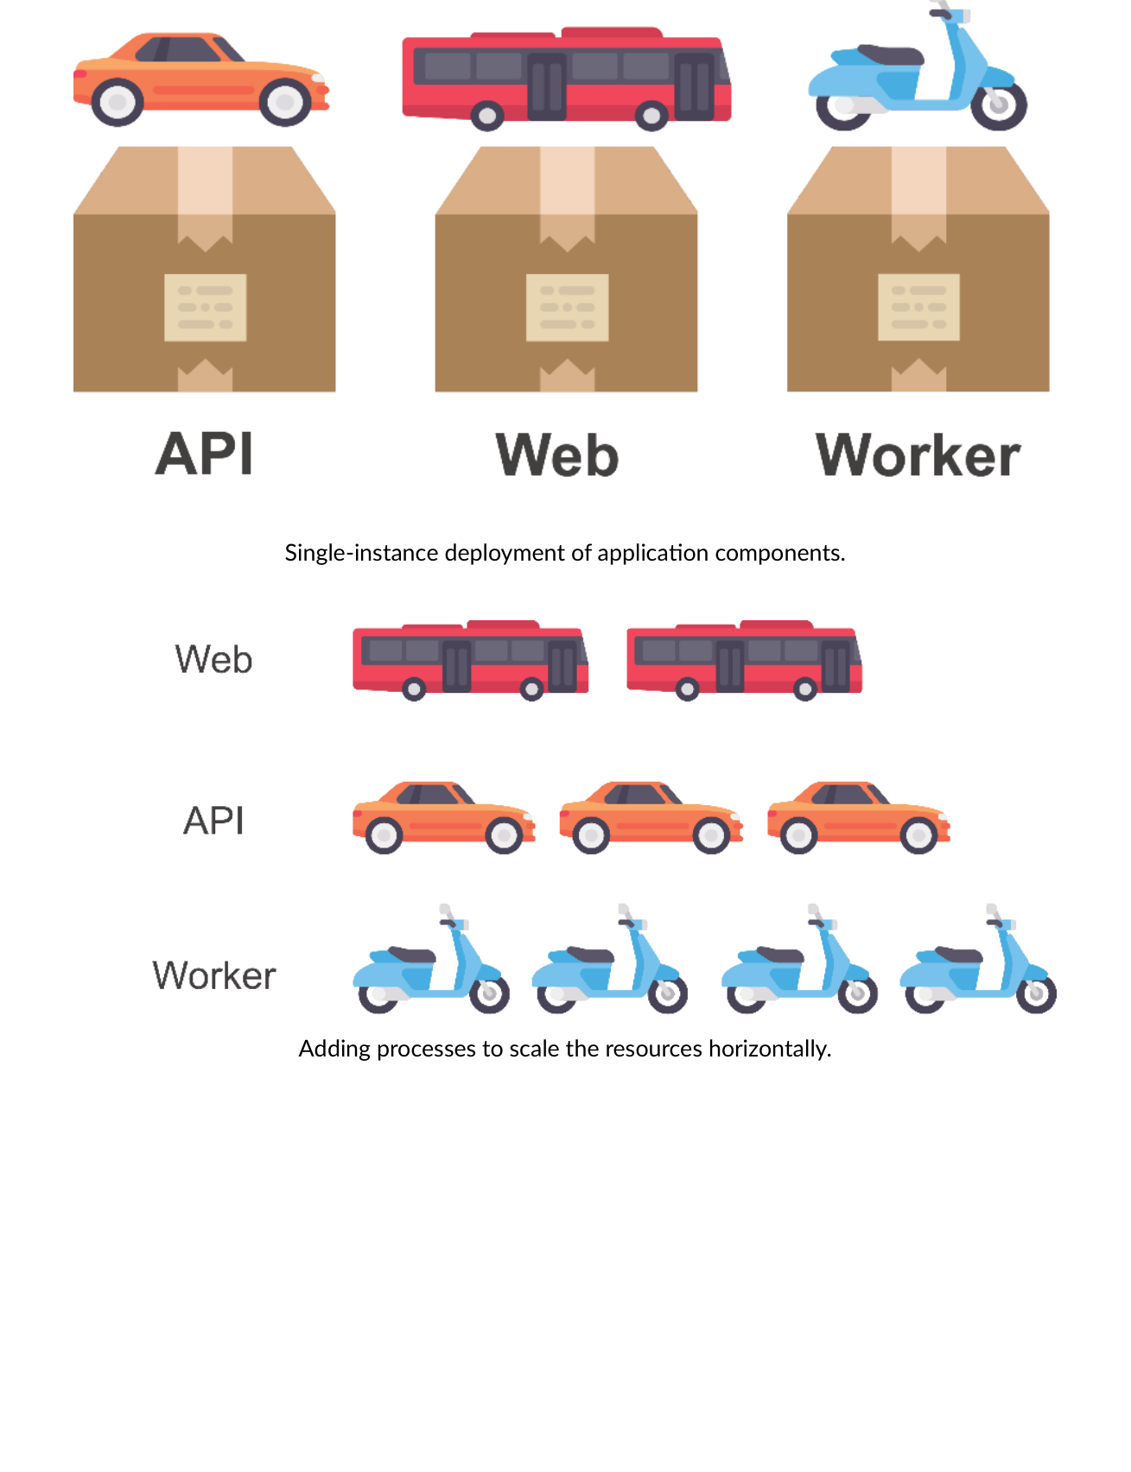
Fig 3.6 — Factor 8: Single instance (left) → Scale OUT by adding identical processes (right). Horizontal not vertical.
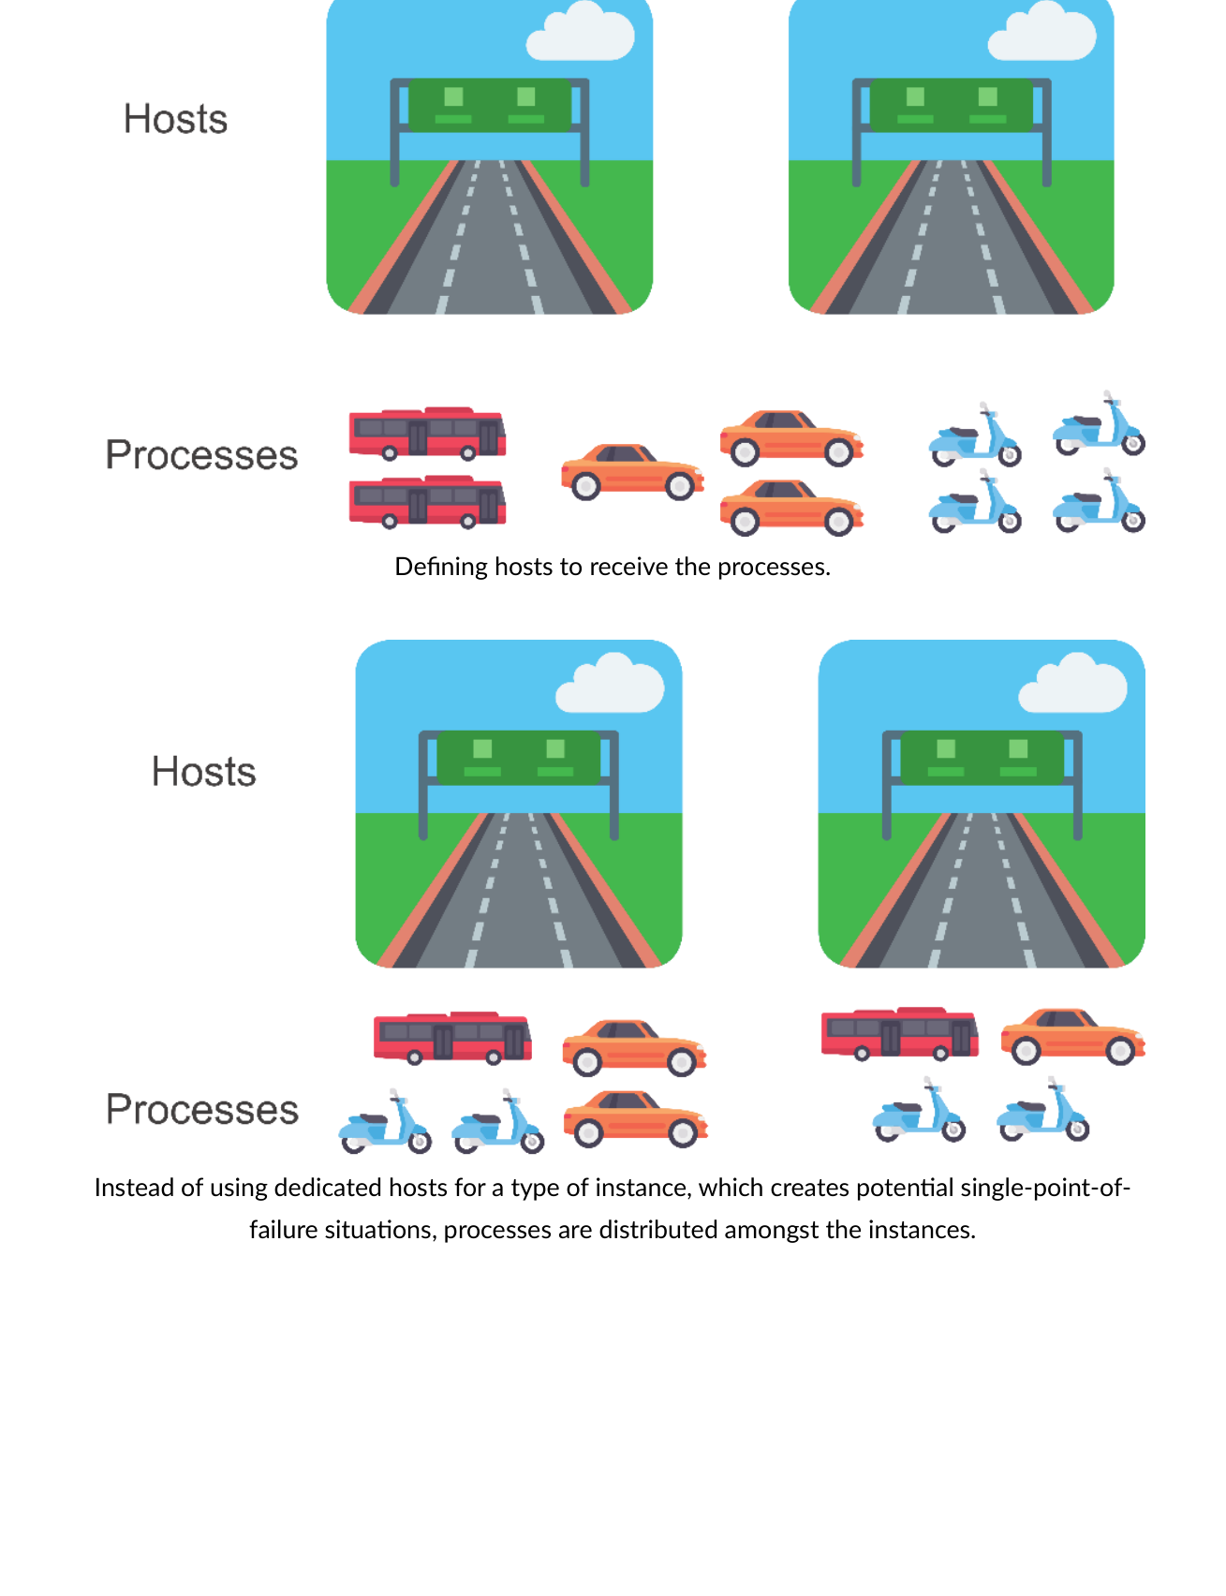
Fig 3.7 — Factor 8: Processes distributed across hosts. No dedicated host per instance type — avoids single point of failure.
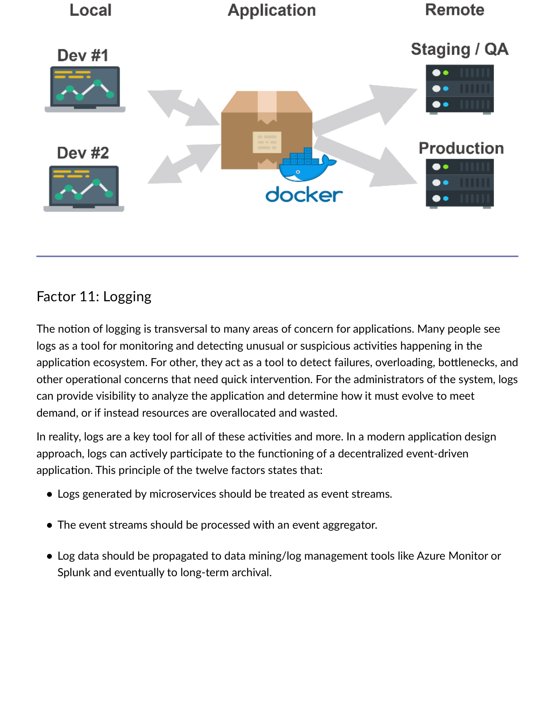
Fig 3.8 — Factor 11: Logs as event streams → Event aggregator → Azure Monitor/Splunk → Long-term archival.
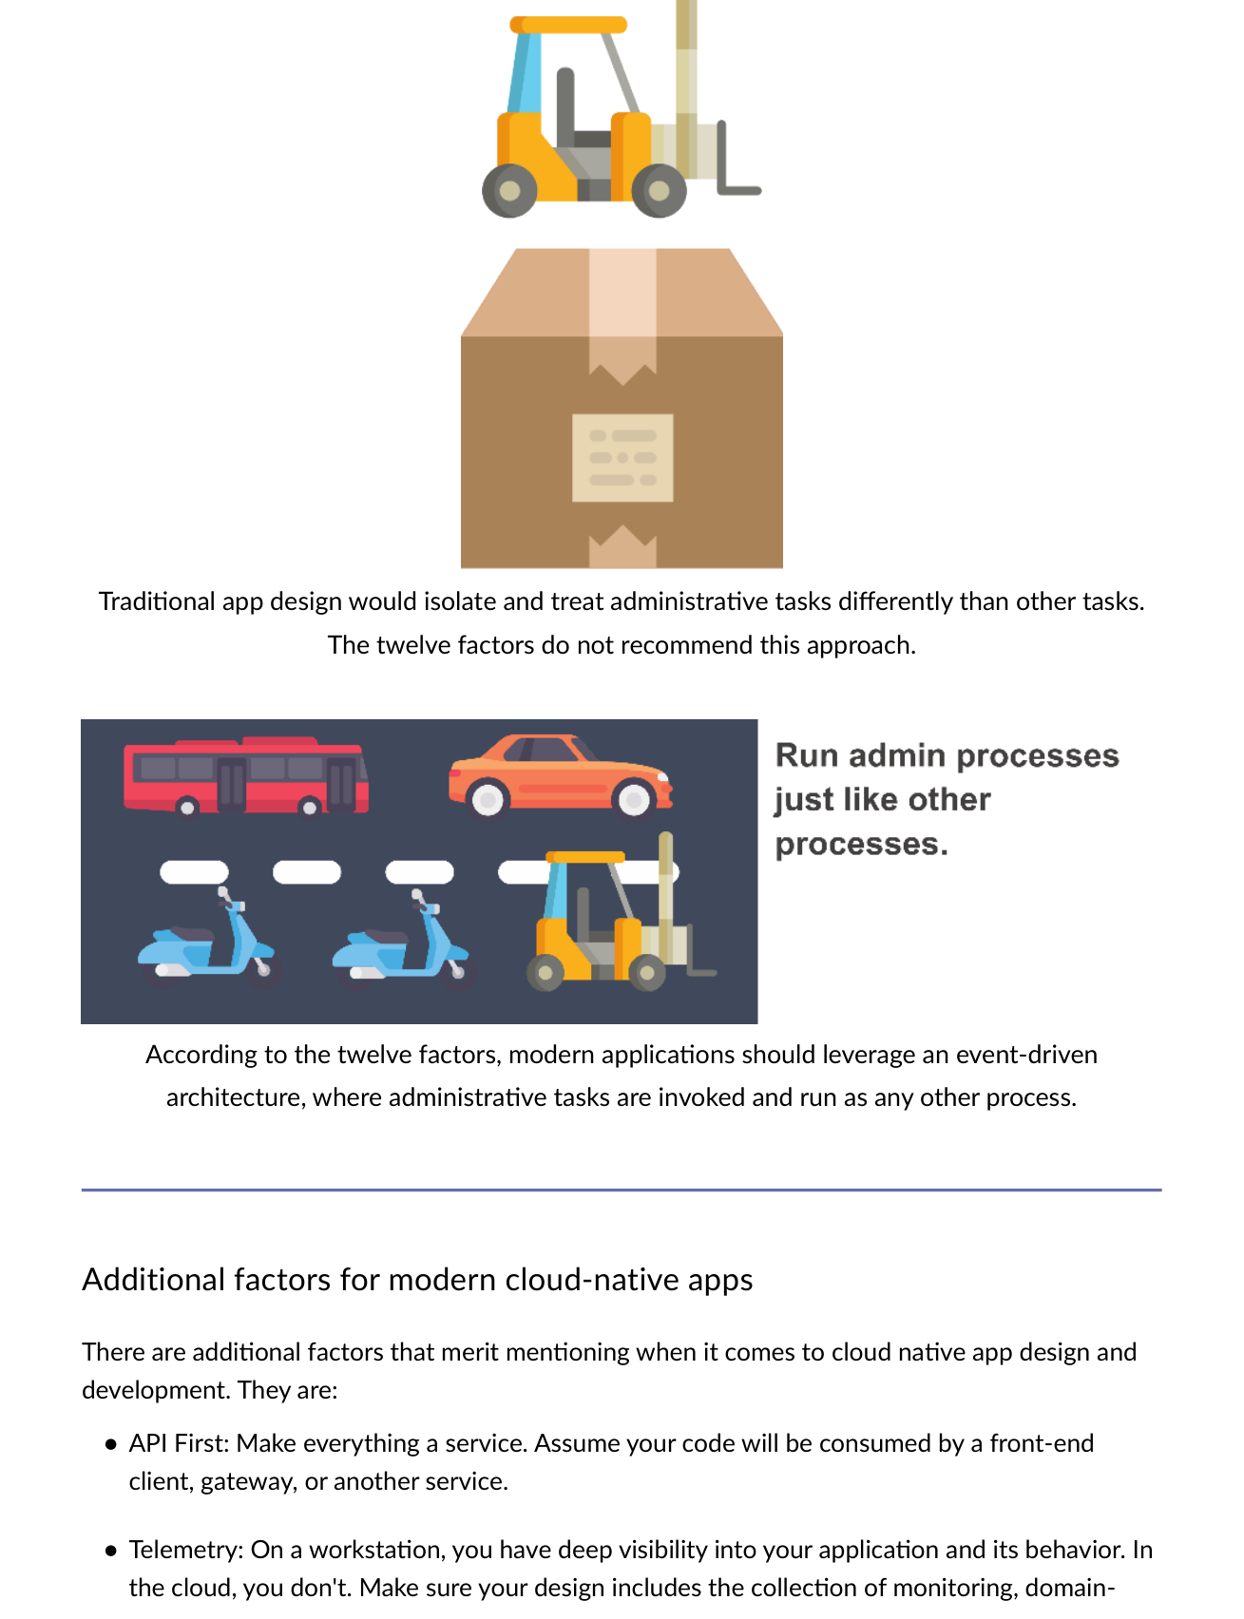
Fig 3.9 — Factor 12: Admin tasks invoked via event-driven architecture as any other process — not treated separately.

3.4 Additional Factors (Beyond the Original 12)
Additional Factor | Description
API First | Make everything a service. Assume code will be consumed by a front-end client, gateway, or another service.
Telemetry | Include collection of monitoring, domain-specific, and health/system data in your design from the start.
Authentication/Authorization | Implement identity (Azure AD) and RBAC from the beginning — not as an afterthought.

MODULE 4 | Microservices — Principles, Advantages & Challenges

4.1 Microservice Definition
A microservice implements a set of distinct features or functionality. Each is a mini-application with its own architecture and business logic, deployed independently.
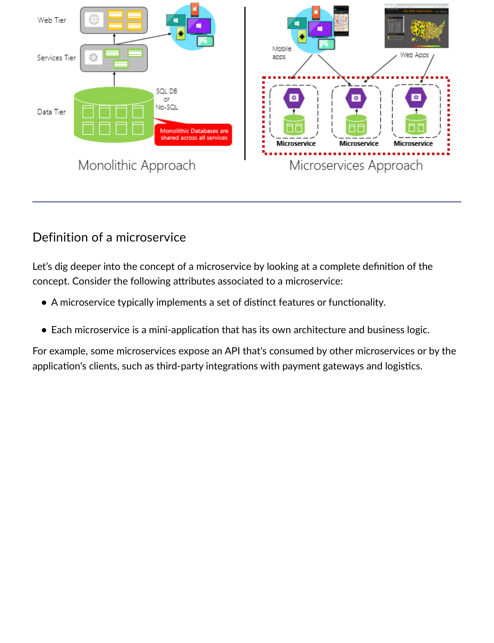
Fig 4.1 — Microservice: mini-app with own architecture and business logic. Exposes API consumed by other services or clients (payment gateway, logistics API).

Characteristic | Detail
Autonomy | Developed autonomously and deployed independently.
Self-Contained | Encapsulates own data storage, dependencies, and programming platform.
Process Isolation | Runs in its own process; communicates via HTTP/HTTPS, gRPC, WebSockets, or AMQP.
Composition | Microservices compose together to form an application.

4.2 Four Microservices Principles
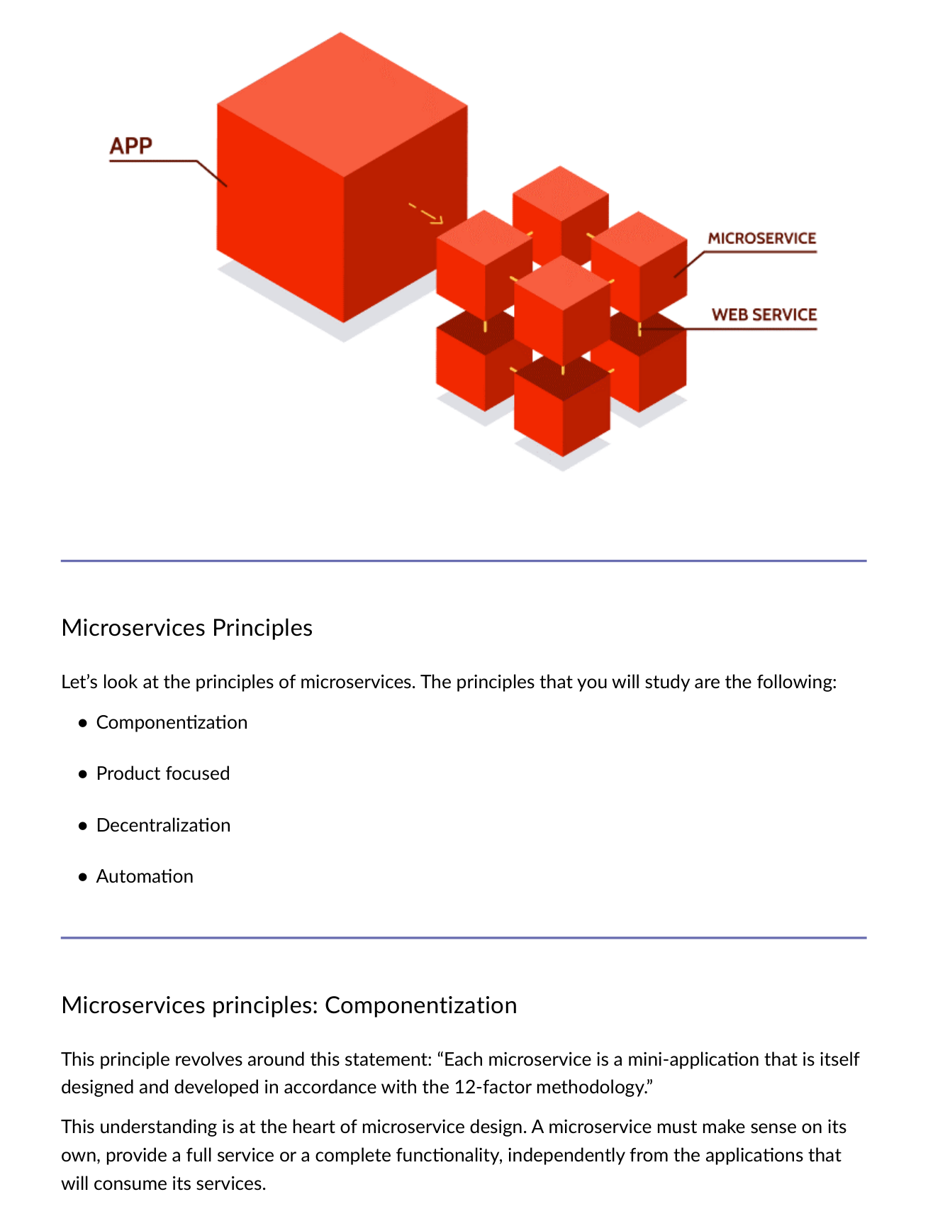
Fig 4.2 — Four Microservices Principles: Componentization, Product Focused, Decentralization, Automation

Principle | Key Statement | Implication
Componentization | Each microservice is a 12-factor mini-app — complete functionality independent of consumers. | Each major capability = its own 12-factor app.
Product Focused | Microservices are PRODUCTS not projects. Products grow over time. | Don't create throwaway microservices — all must be maintained or they corrupt data.
Decentralization | Cloud-native favours distributed architecture — no central bus/single-point-of-failure. | Microservices consume each other directly. Central bus = vertical scaling only.
Automation | Automation reduces time to test, deploy, configure. IaC + container orchestration. | IaC: Terraform, Ansible, ARM. Orchestration: Kubernetes, Docker Swarm, ECS.

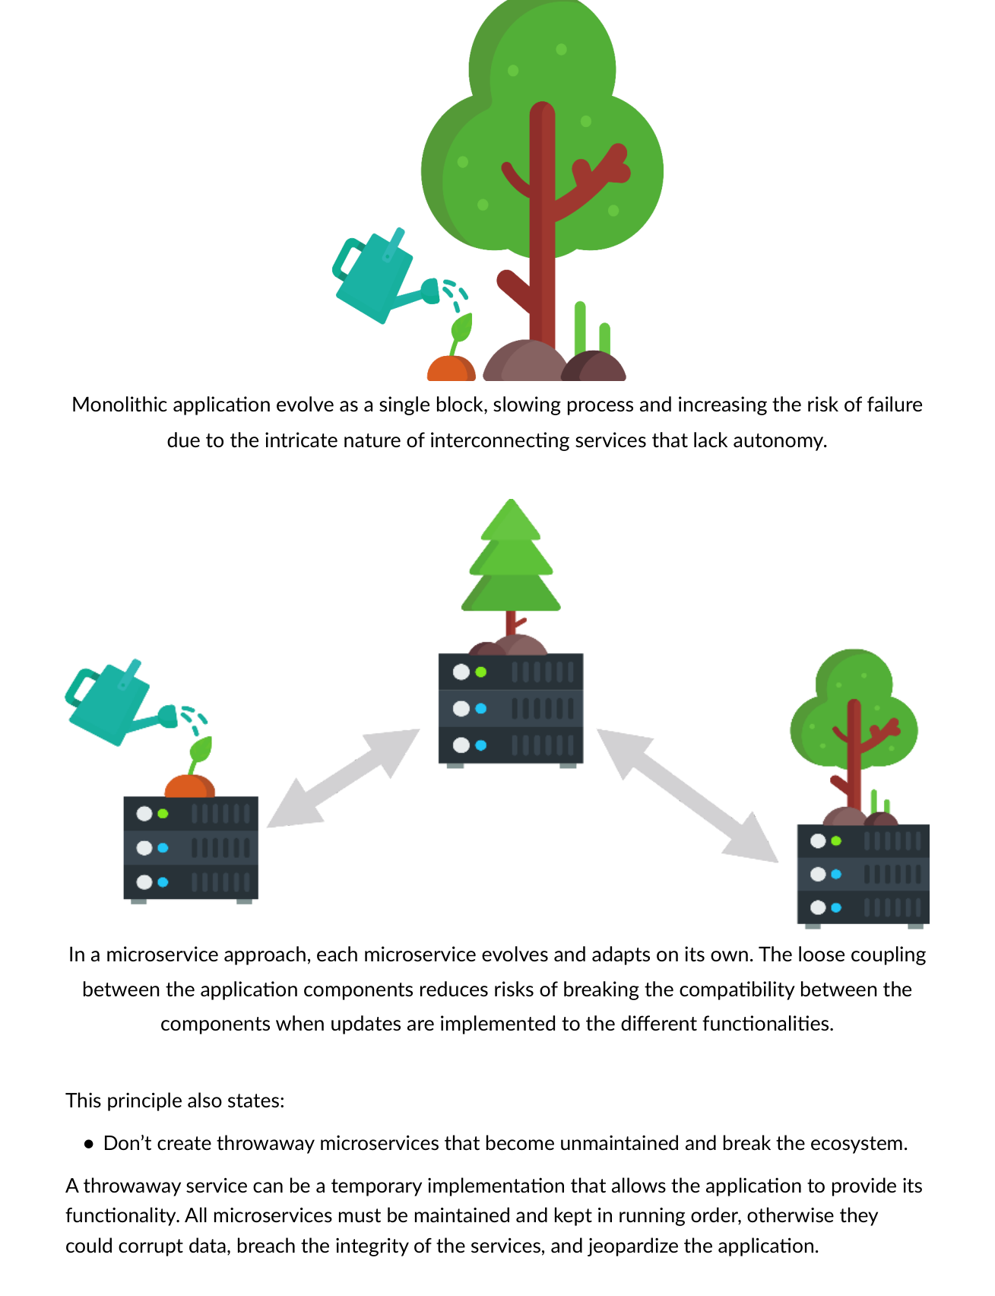
Fig 4.3 — Monolith evolves as single block (slow, risky). Microservices evolve independently — loose coupling reduces risk.
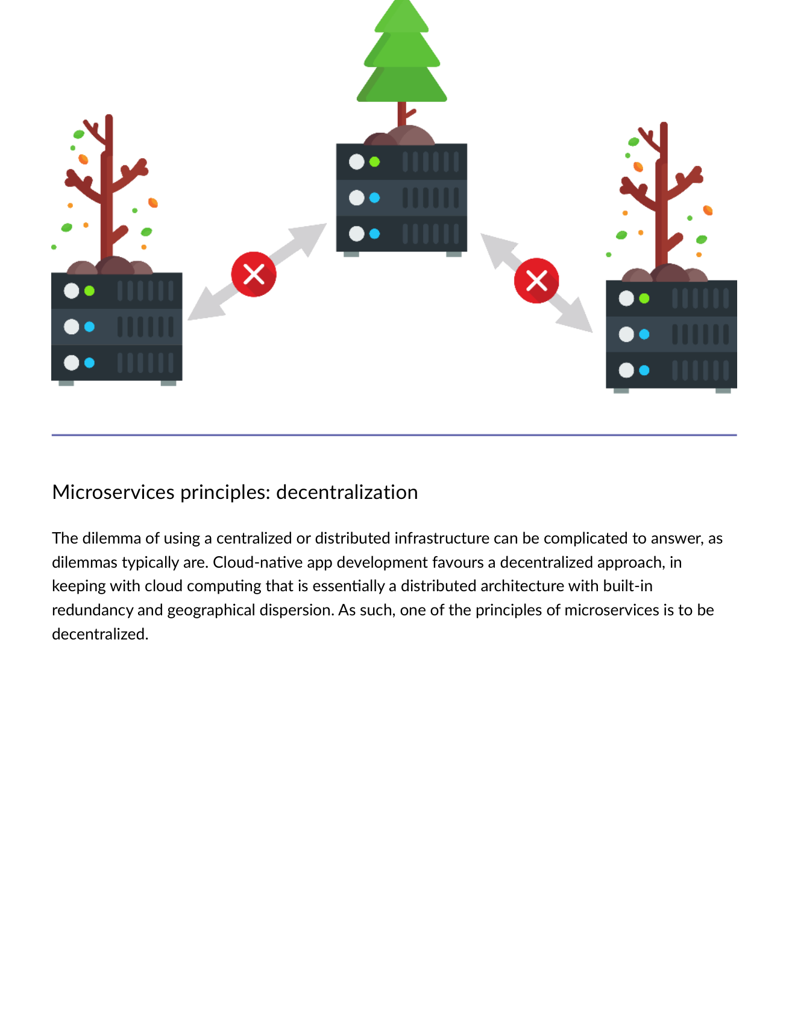
Fig 4.4 — Decentralization: No central bus. Microservices consume each other directly. Supports horizontal scaling.
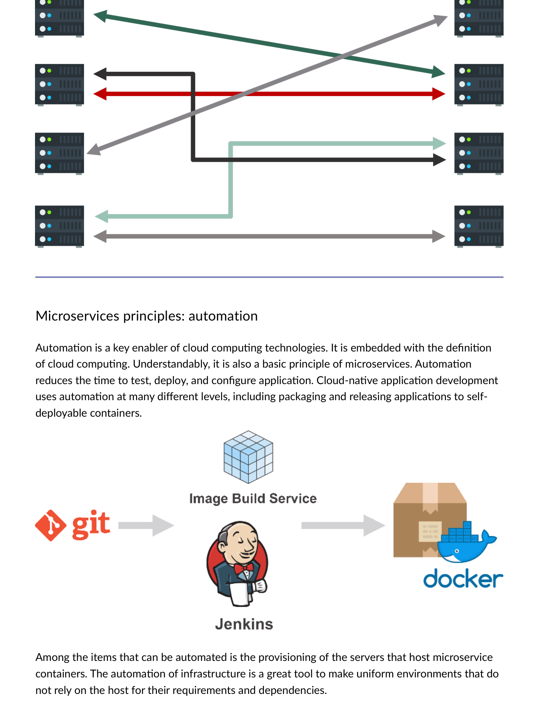
Fig 4.5 — Automation: IaC tools provision infrastructure. Orchestration tools place containers on hosts automatically.
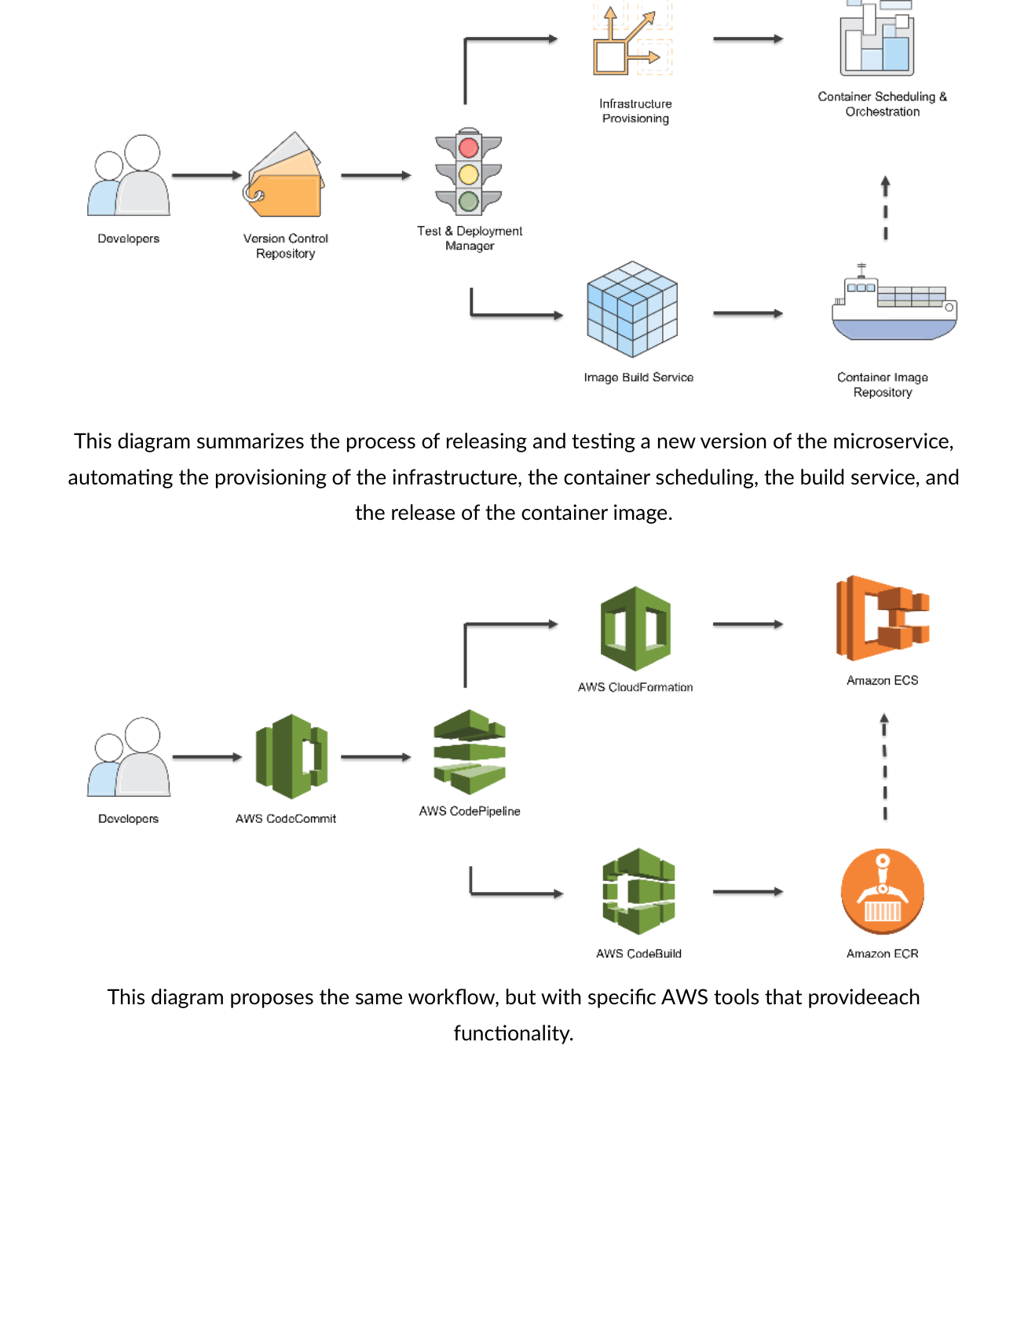
Fig 4.6 — Automation pipeline: Source → Build → Container image → Registry → IaC provisions infra → Orchestrator schedules containers.
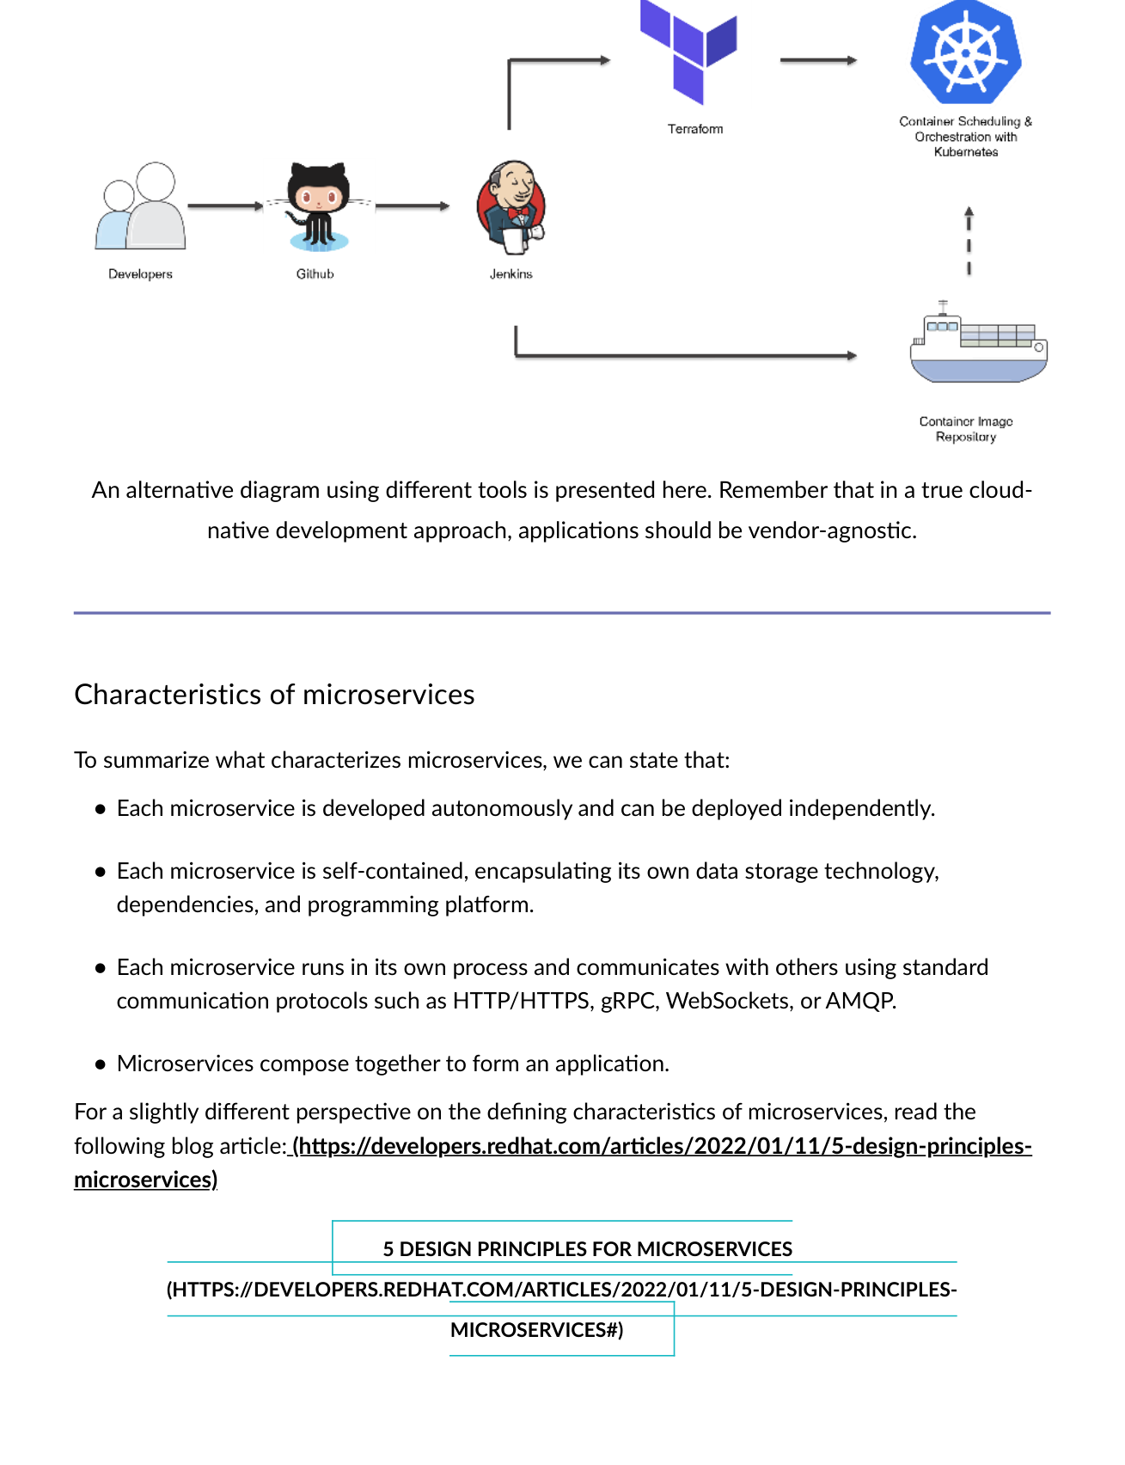
Fig 4.7 — Alternative CI/CD pipeline (vendor-agnostic). In true cloud-native development, apps should not be locked to one vendor.

4.3 Advantages & Challenges
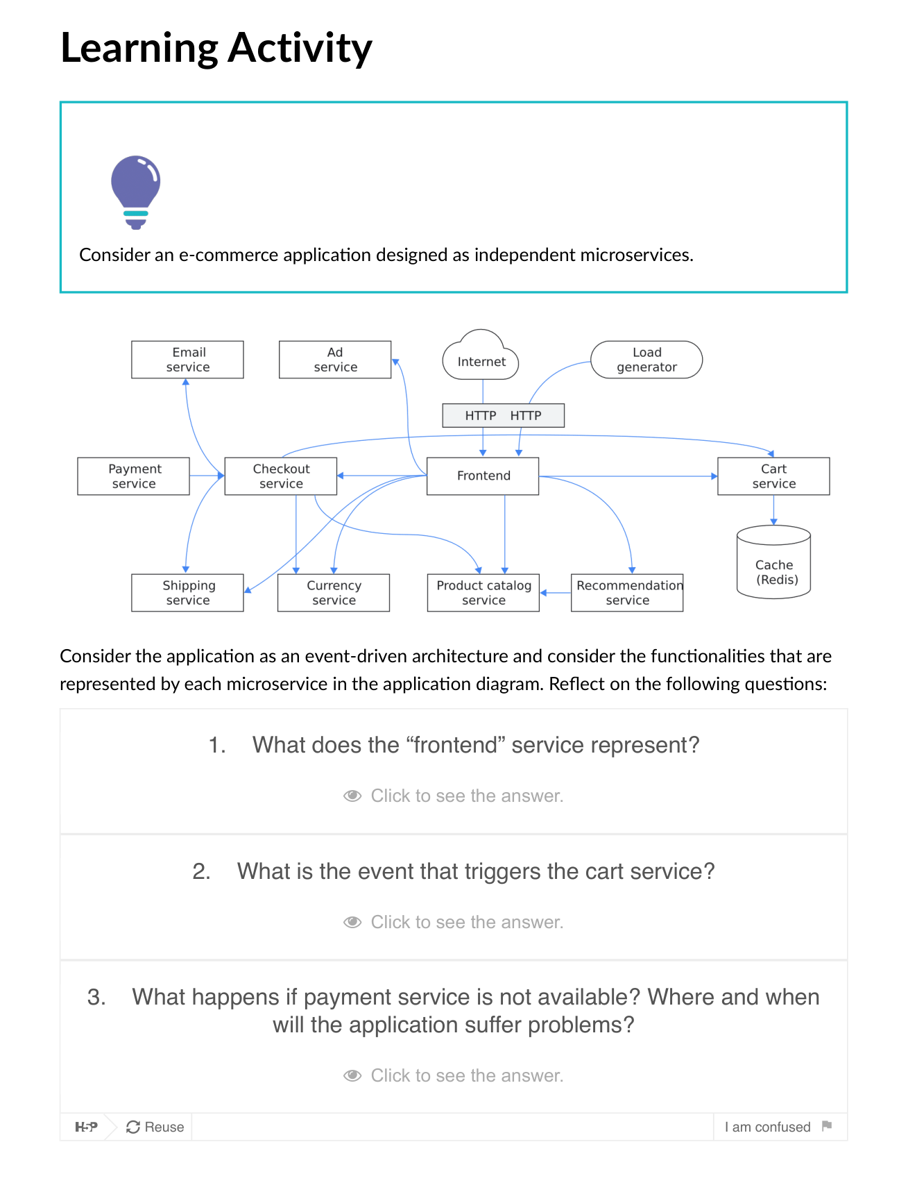
Fig 4.8 — E-Commerce as event-driven microservices: Frontend, Cart, Product, Payment, Shipping — each independently deployable.

Advantages | Challenges
Update small area of live app — less risk of disrupting whole system | Communication: direct HTTP (coupling risk) vs. decoupled messaging via queues
Update without full redeployment | Resiliency: what happens when Service B stops responding to Service A?
Fine-grained scaling — scale only services under load | Distributed Data: each service has own DB — cross-service queries/transactions are complex
Each service has autonomous lifecycle — deploy without waiting for quarterly release | Secrets: how do distributed microservices securely store credentials and sensitive config?
Teams use different tech stacks for different services | Management overhead: monitoring, logging, and debugging across dozens of services

4.4 Microservices Characteristics Summary
Characteristic | Detail
Developed autonomously | Can be deployed independently — no coordination with other services.
Self-contained | Encapsulates own data storage technology, dependencies, and programming platform.
Process-isolated | Runs in own process; uses standard protocols: HTTP/HTTPS, gRPC, WebSockets, AMQP.
Composable | Multiple microservices compose together to form a complete application.

MODULE 5 | Containers — Docker, Virtualization & Containerization

5.1 Historical Limitations → Virtualization → Containers
Era | Approach | Problem
Dedicated Servers | 1 app per physical server | Wasted resources, vendor lock-in, slow deployment, hard to scale
VMs (Hypervisor) | Multiple VMs per physical server, each with full guest OS | Each VM has its own OS — gigabytes, minutes to start, portability not guaranteed
Containers | Share host OS kernel — only app + dependencies packaged | Megabytes, seconds to start, truly portable, optimal resource use

5.2 Hypervisor-Based Virtualization (VMs)
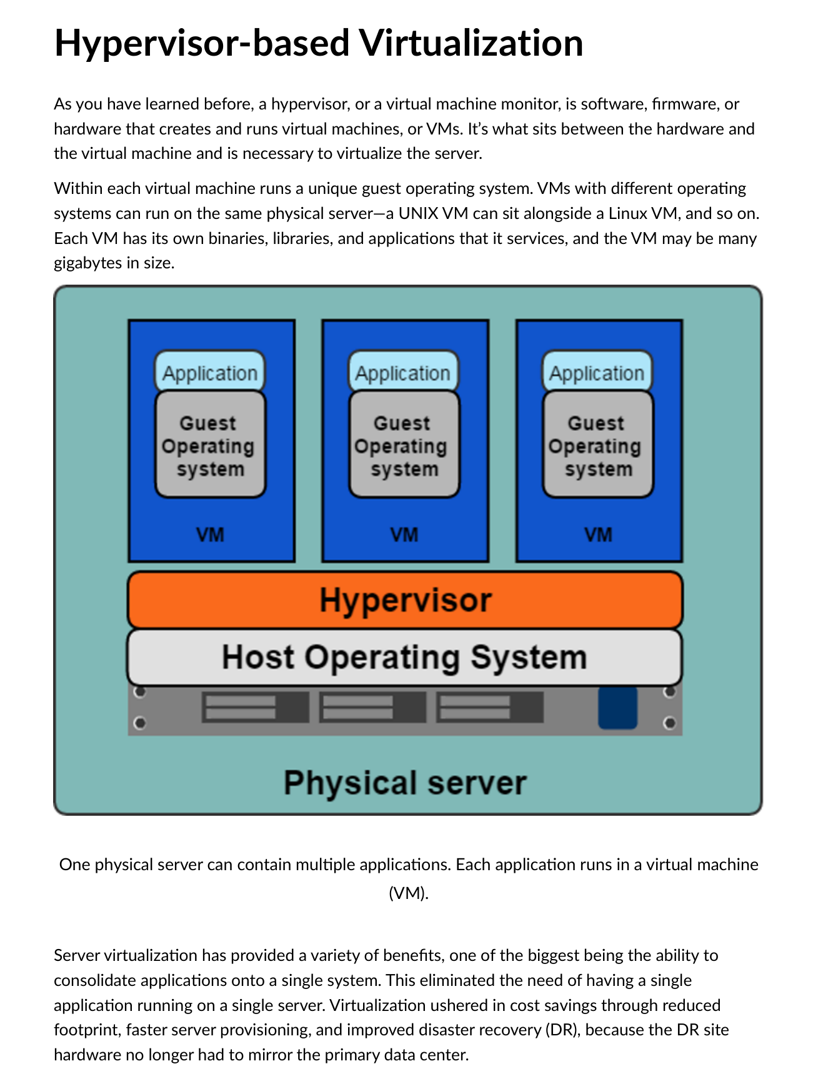
Fig 5.1 — Hypervisor virtualization: Physical server → Hypervisor → Multiple VMs each with own guest OS, binaries, libraries, applications.
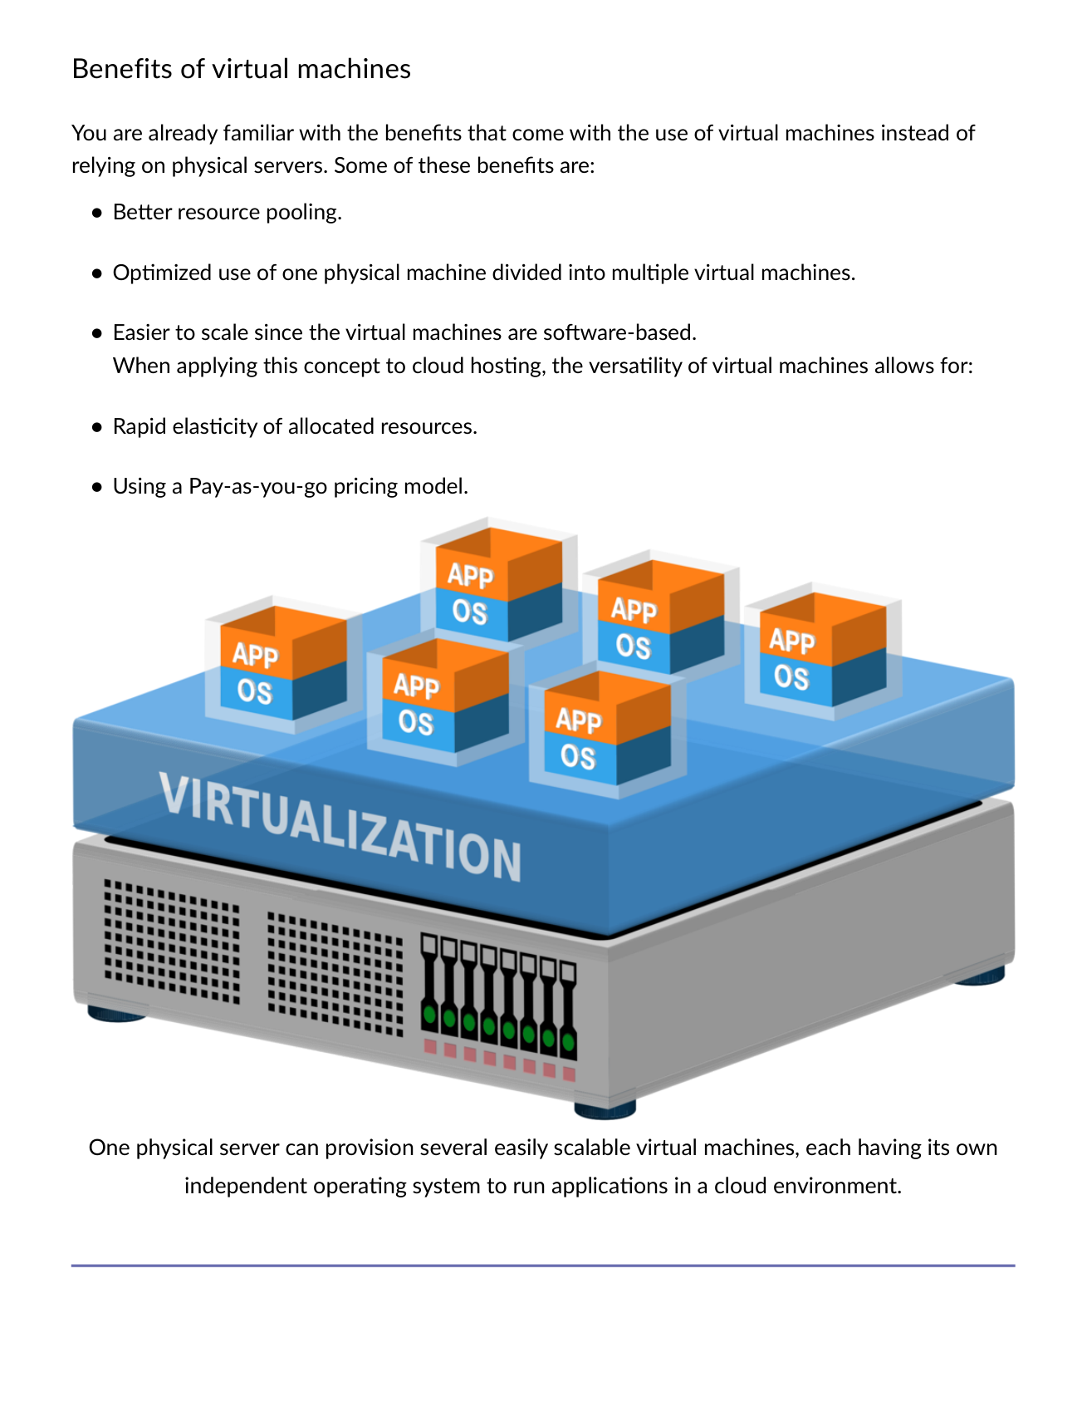
Fig 5.2 — VM benefits: Better resource pooling, rapid elasticity, pay-as-you-go, easier to scale than physical servers.
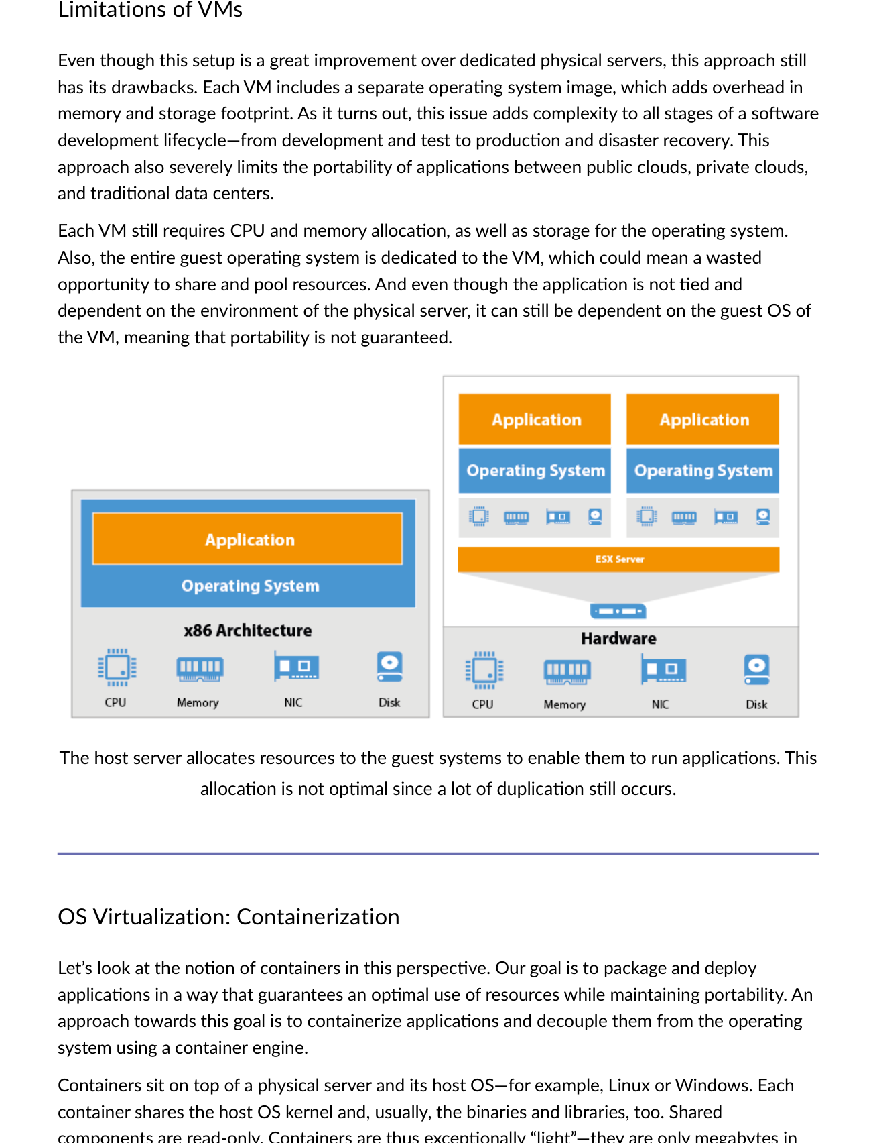
Fig 5.3 — VM limitations: Separate OS per VM adds memory/storage overhead. Portability not guaranteed. Resources allocated but not optimally shared.

Feature | VMs | Containers
Virtualizes | Hardware (full guest OS per VM) | OS (shares host kernel)
Size | Gigabytes | Megabytes
Startup time | Minutes | Seconds
Portability | Limited by guest OS | Truly portable anywhere with container engine
Resource use | Duplicated OS overhead | Optimal — only what app needs
Isolation level | Hardware level | OS level (kernel shared)

5.3 OS Virtualization — Containerization
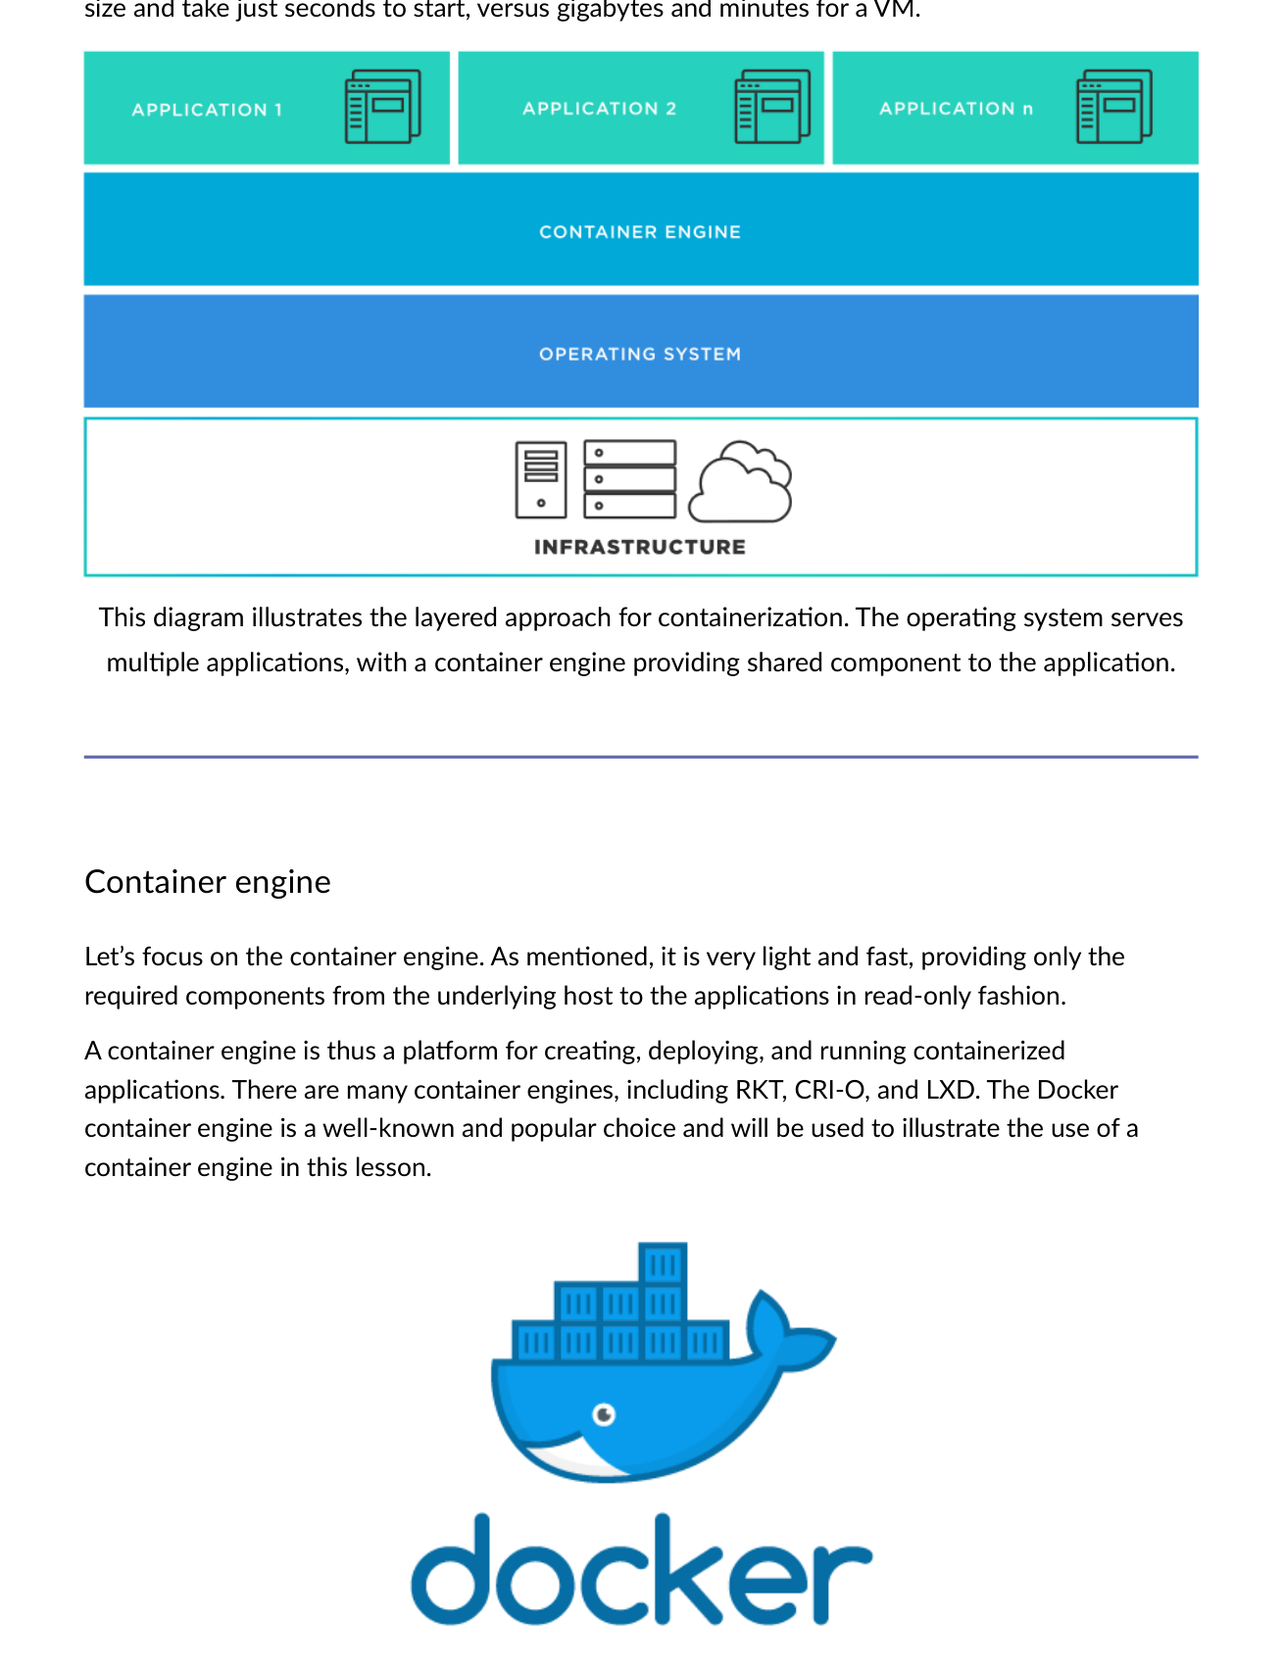
Fig 5.4 — Containerization layers: Physical server → Host OS → Container Engine (shared read-only) → Multiple containers (app-specific layers only).
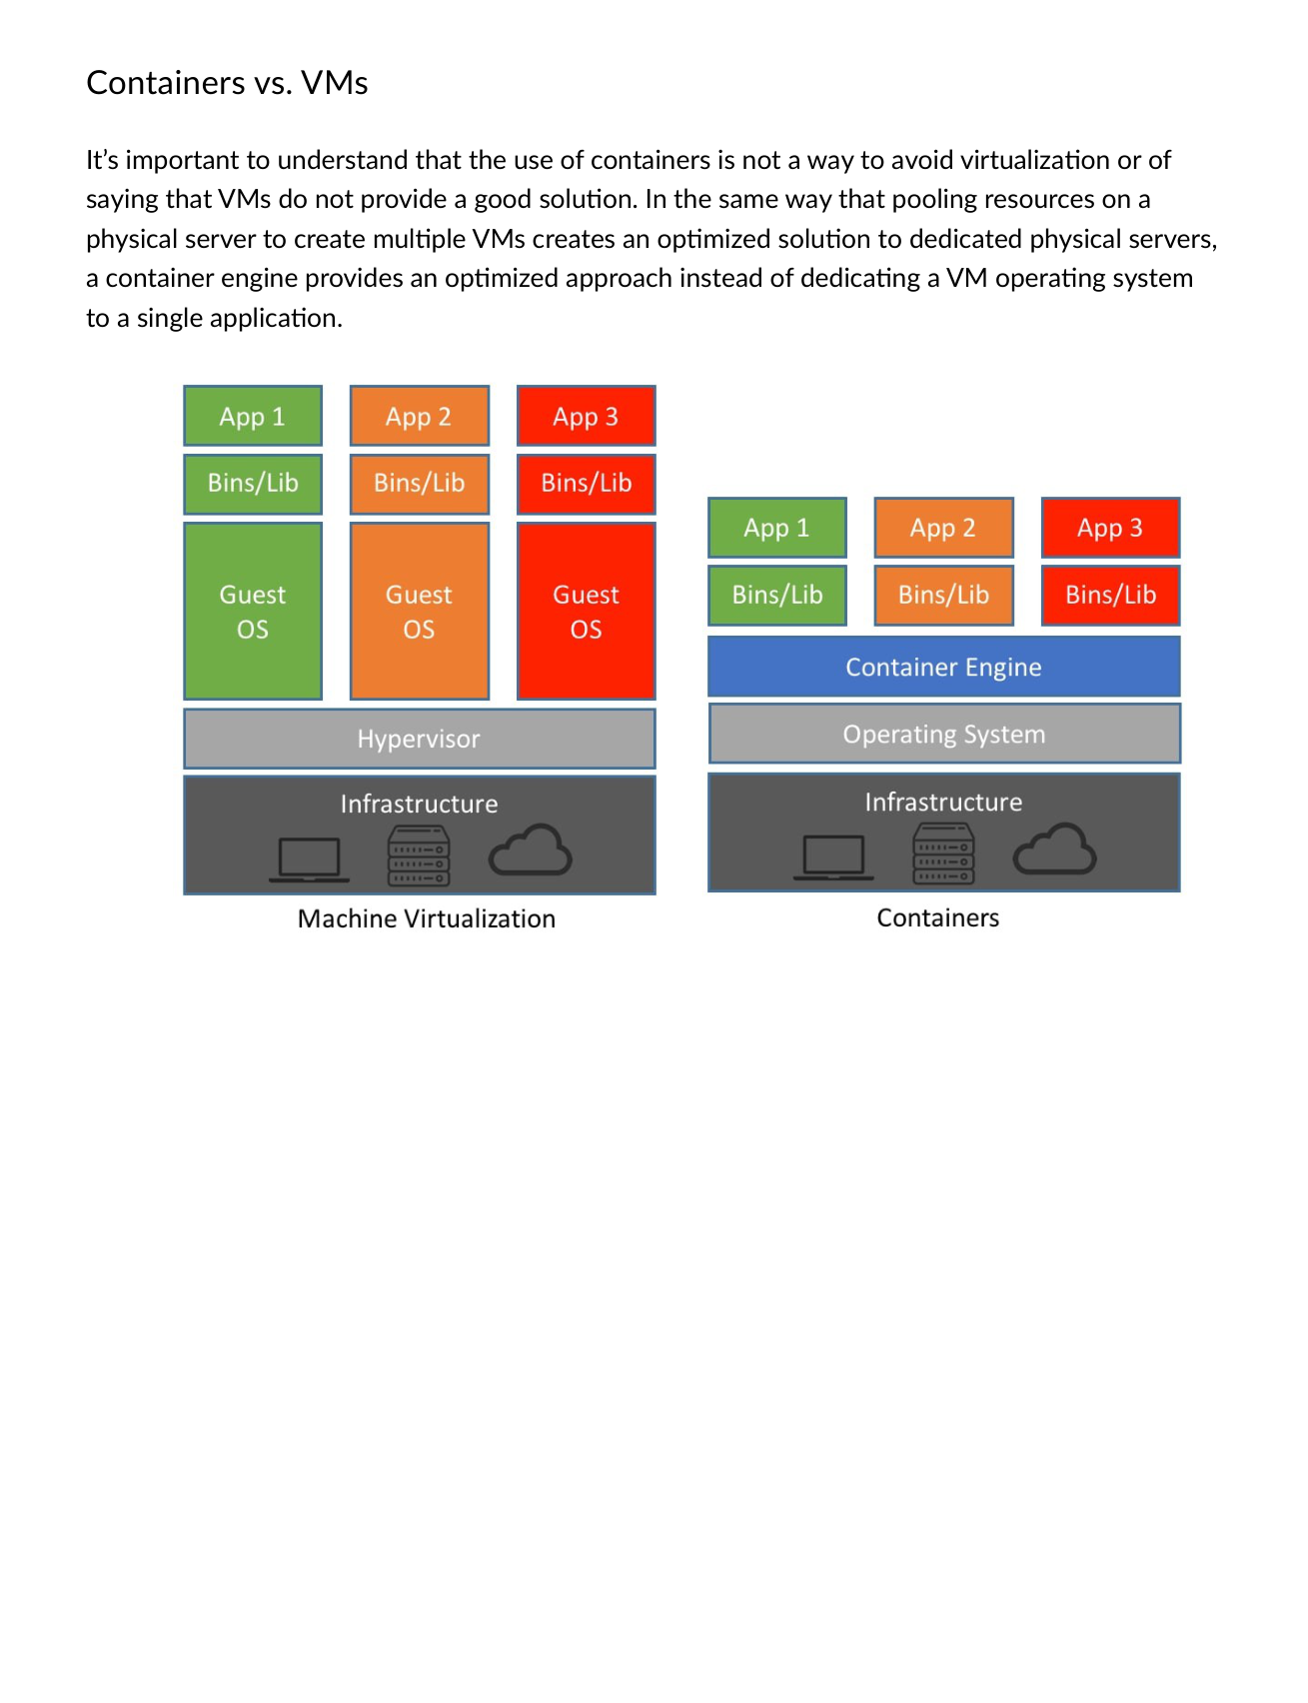
Fig 5.5 — Containers vs. VMs: Containers are not a way to avoid virtualization — they provide an optimized approach vs. dedicating a VM OS to a single application.

5.4 Docker & Container Engine
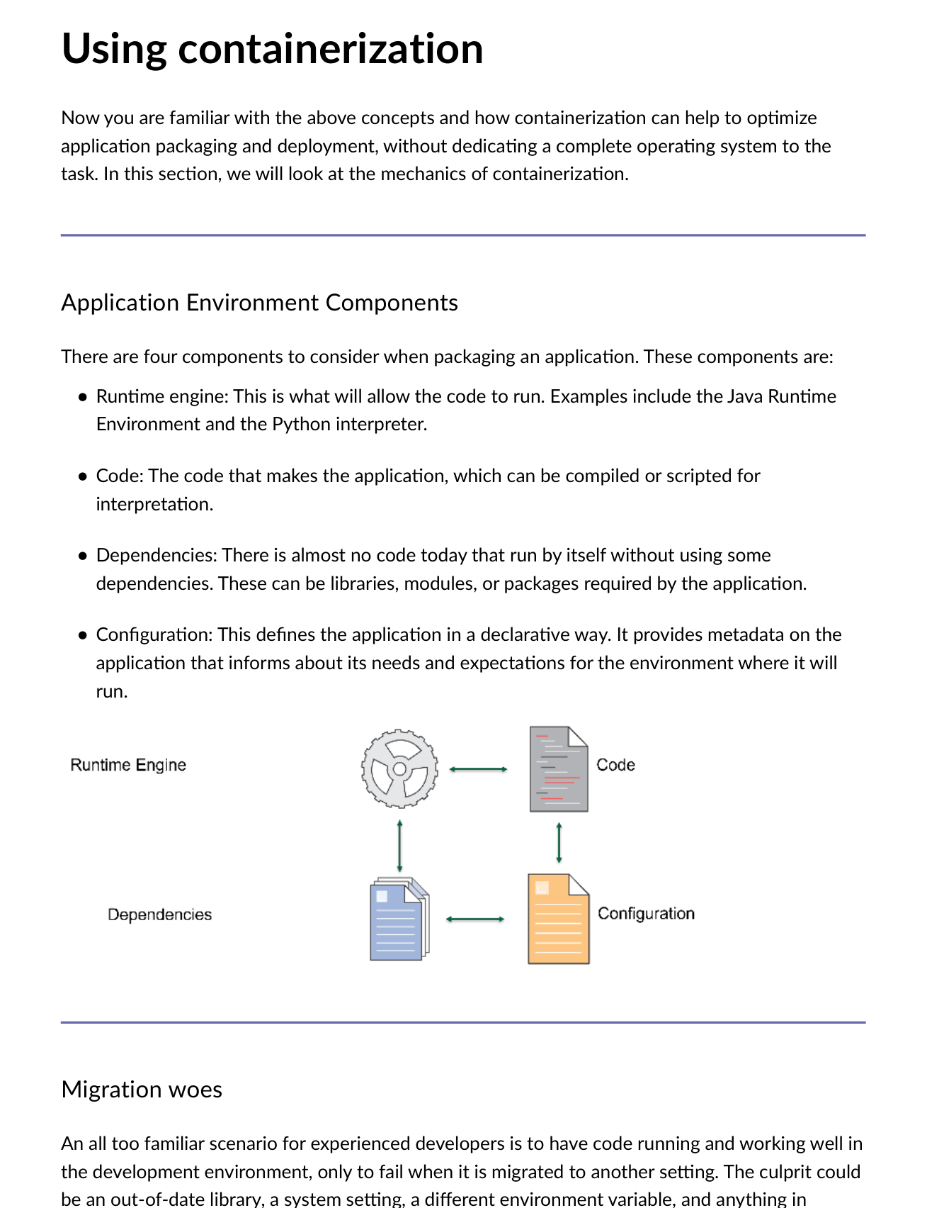
Fig 5.6 — 4 components to package: Runtime Engine (JRE, Python interpreter), Code, Dependencies (libraries, packages), Configuration (declarative metadata).
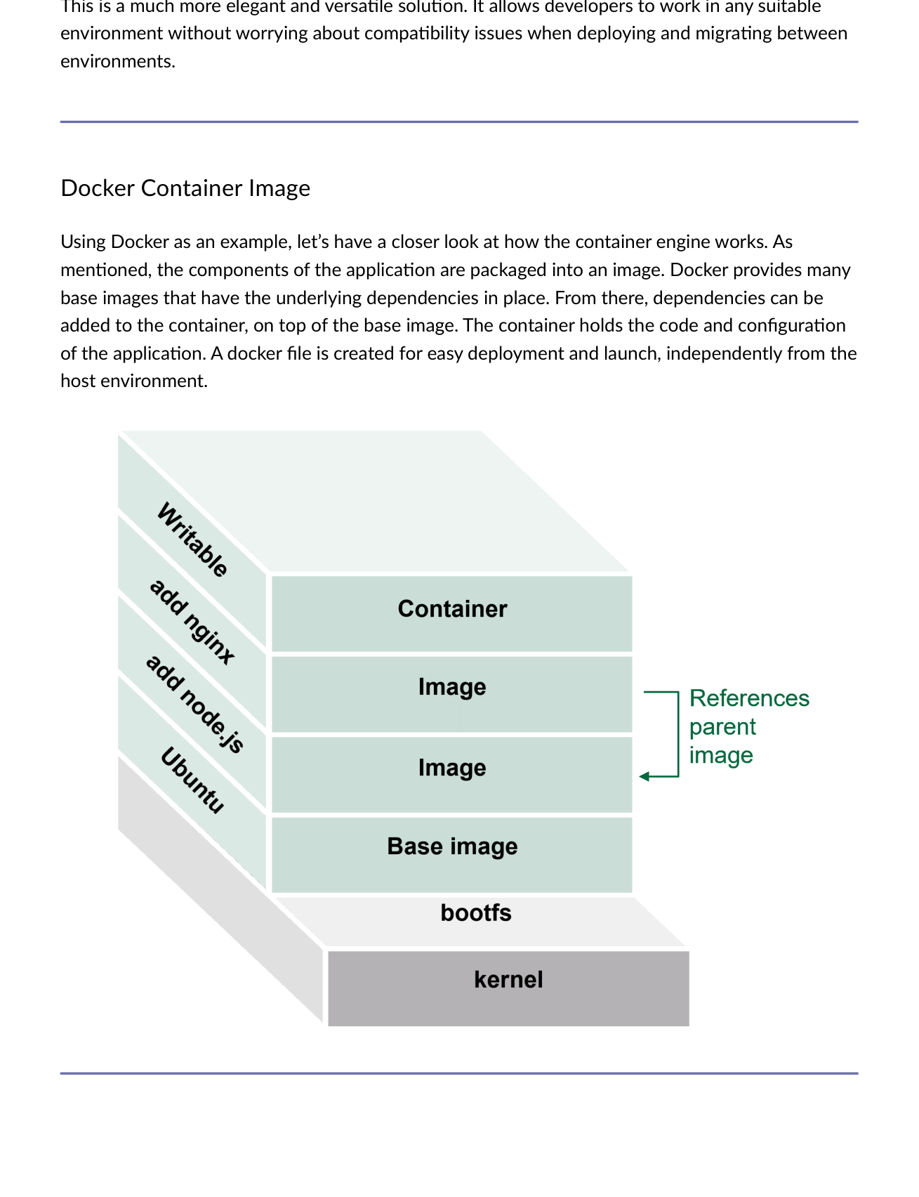
Fig 5.7 — Docker image layers: Base image → Dependencies → App code → Config. All layers read-only except top writable container layer.
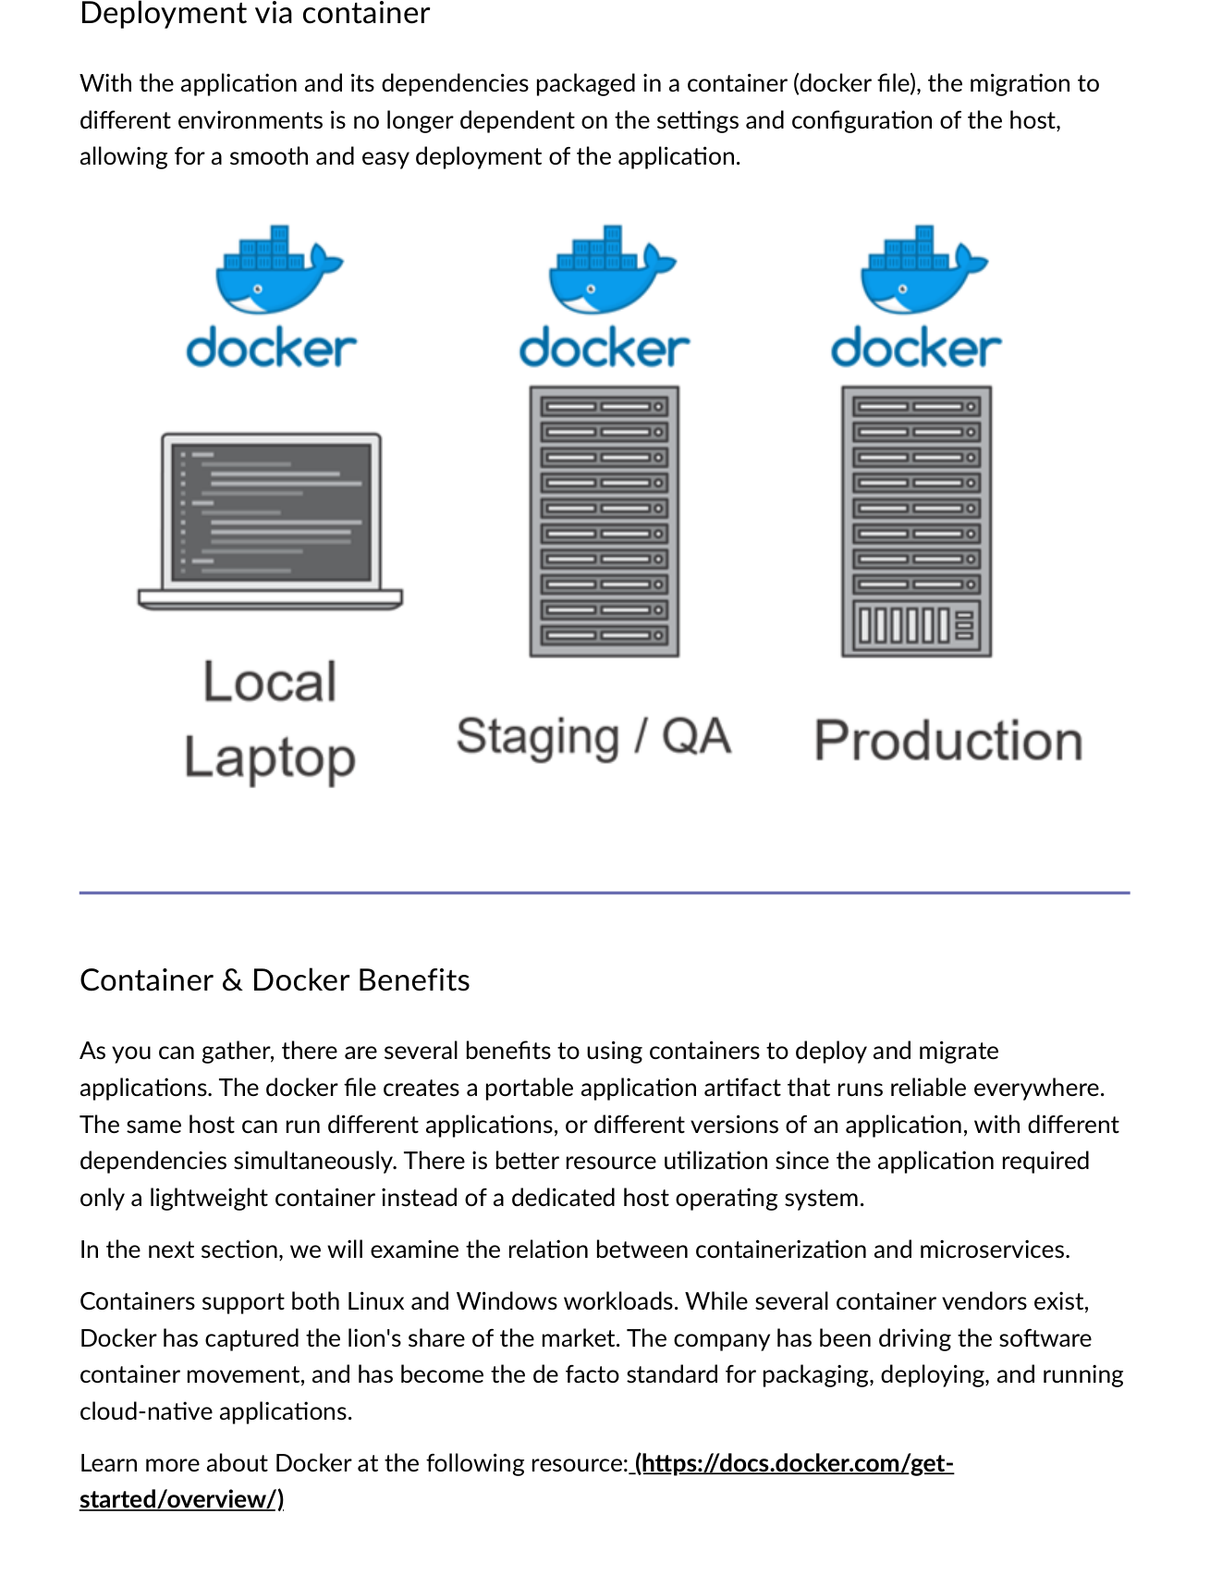
Fig 5.8 — Deployment via container: App + dependencies in Dockerfile → smooth migration to any environment independent of host settings.

Docker Term | Definition
Image | The basis of a Docker container. Content at rest. Blueprint.
Container | The image when it is 'running.' Standard unit for app service.
Engine | Software executing commands for containers. Networking and volumes included.
Registry | Stores, distributes, manages Docker images (Docker Hub, ECR, ACR).
Dockerfile | Config file with instructions for building a container image.
Control Plane | Management plane for container and cluster orchestration.
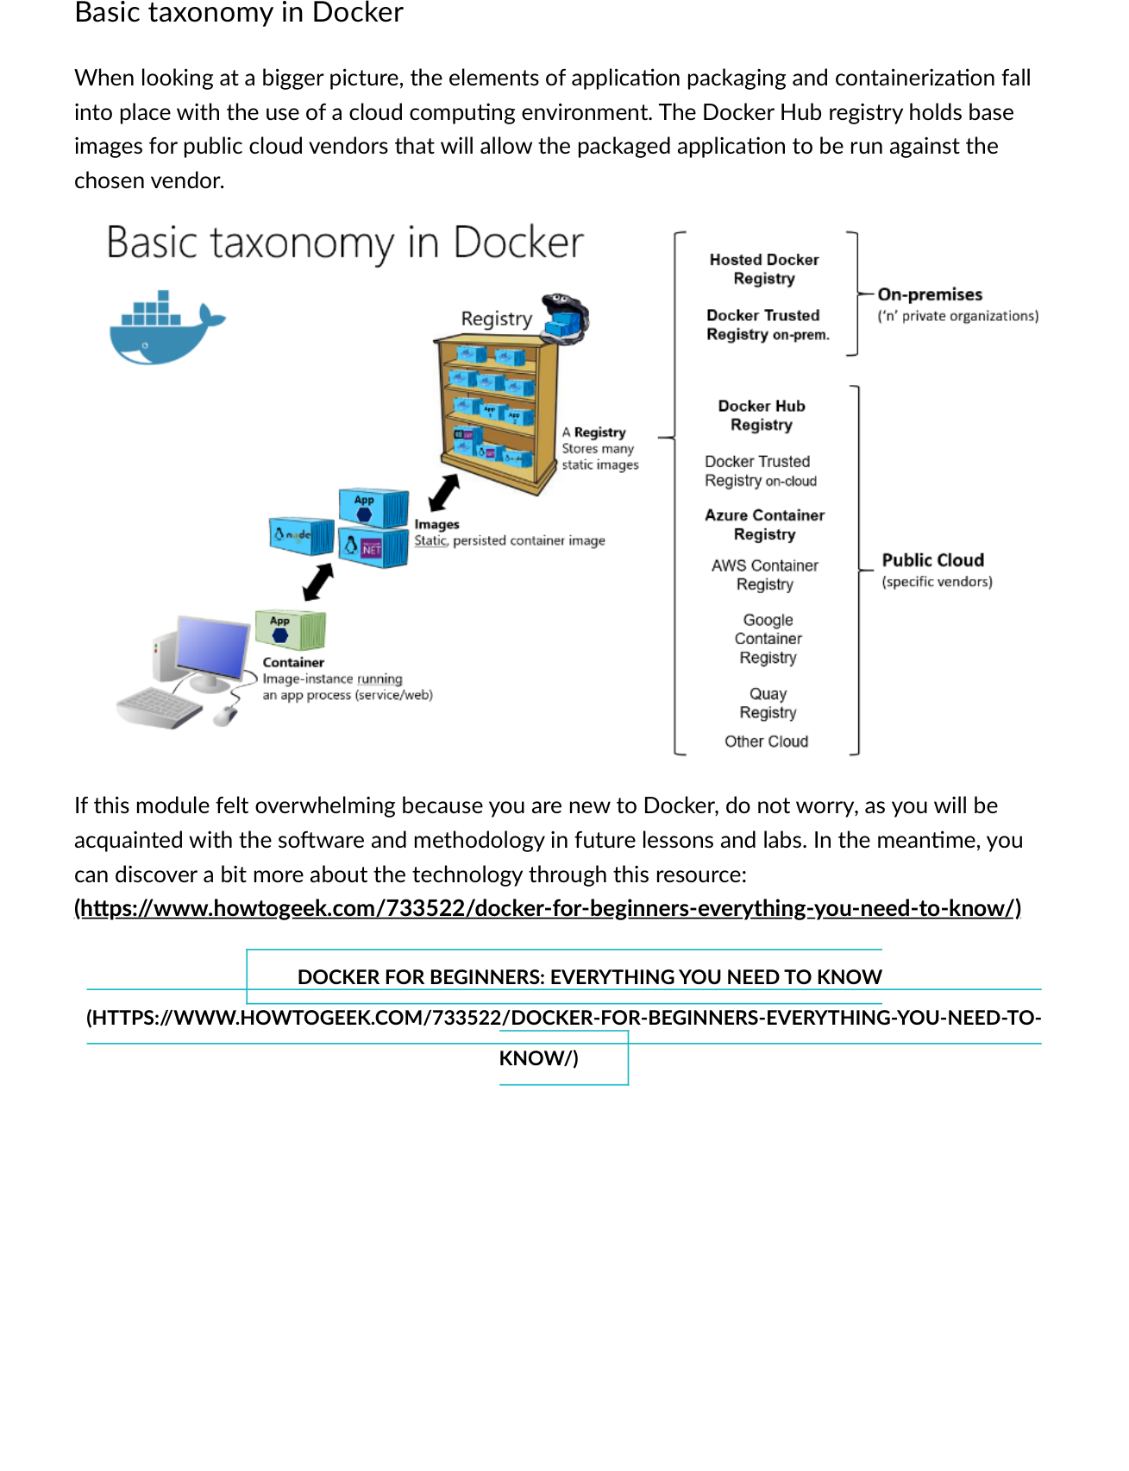
Fig 5.9 — Docker taxonomy: Docker Hub holds base images for public cloud vendors. Packaged app deployed against chosen vendor.

5.5 Containerizing a Microservice
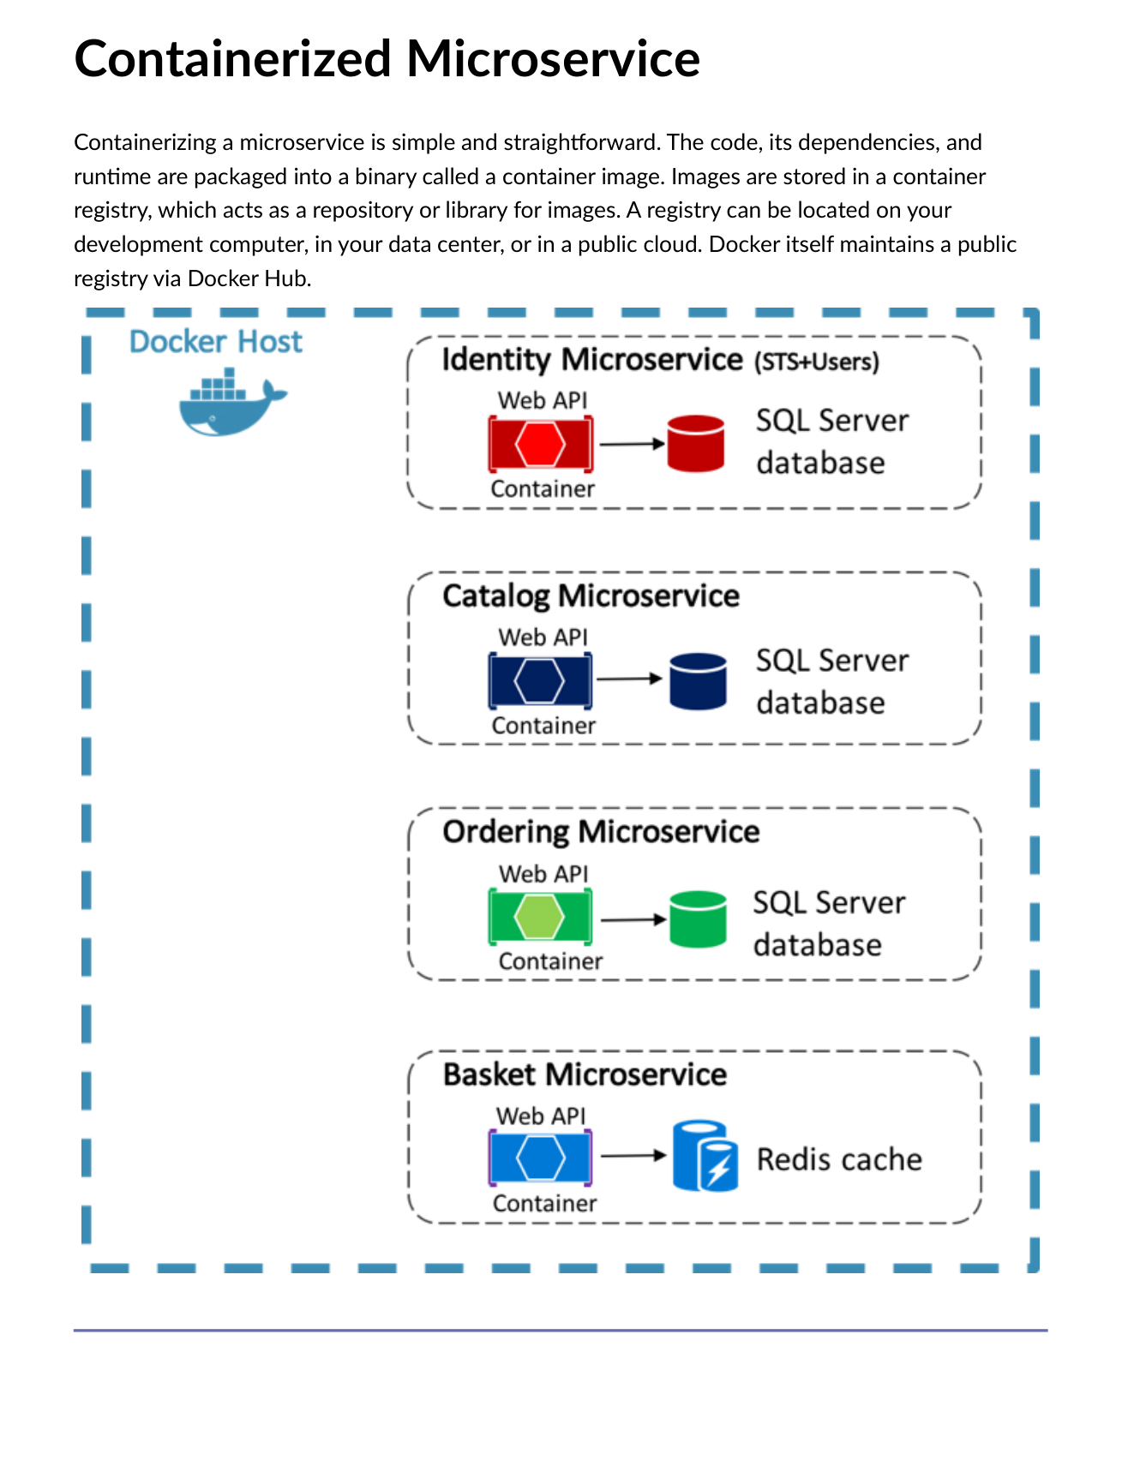
Fig 5.10 — Containerized microservice: Code+Dependencies+Runtime → Container Image → Registry → Running Instances.
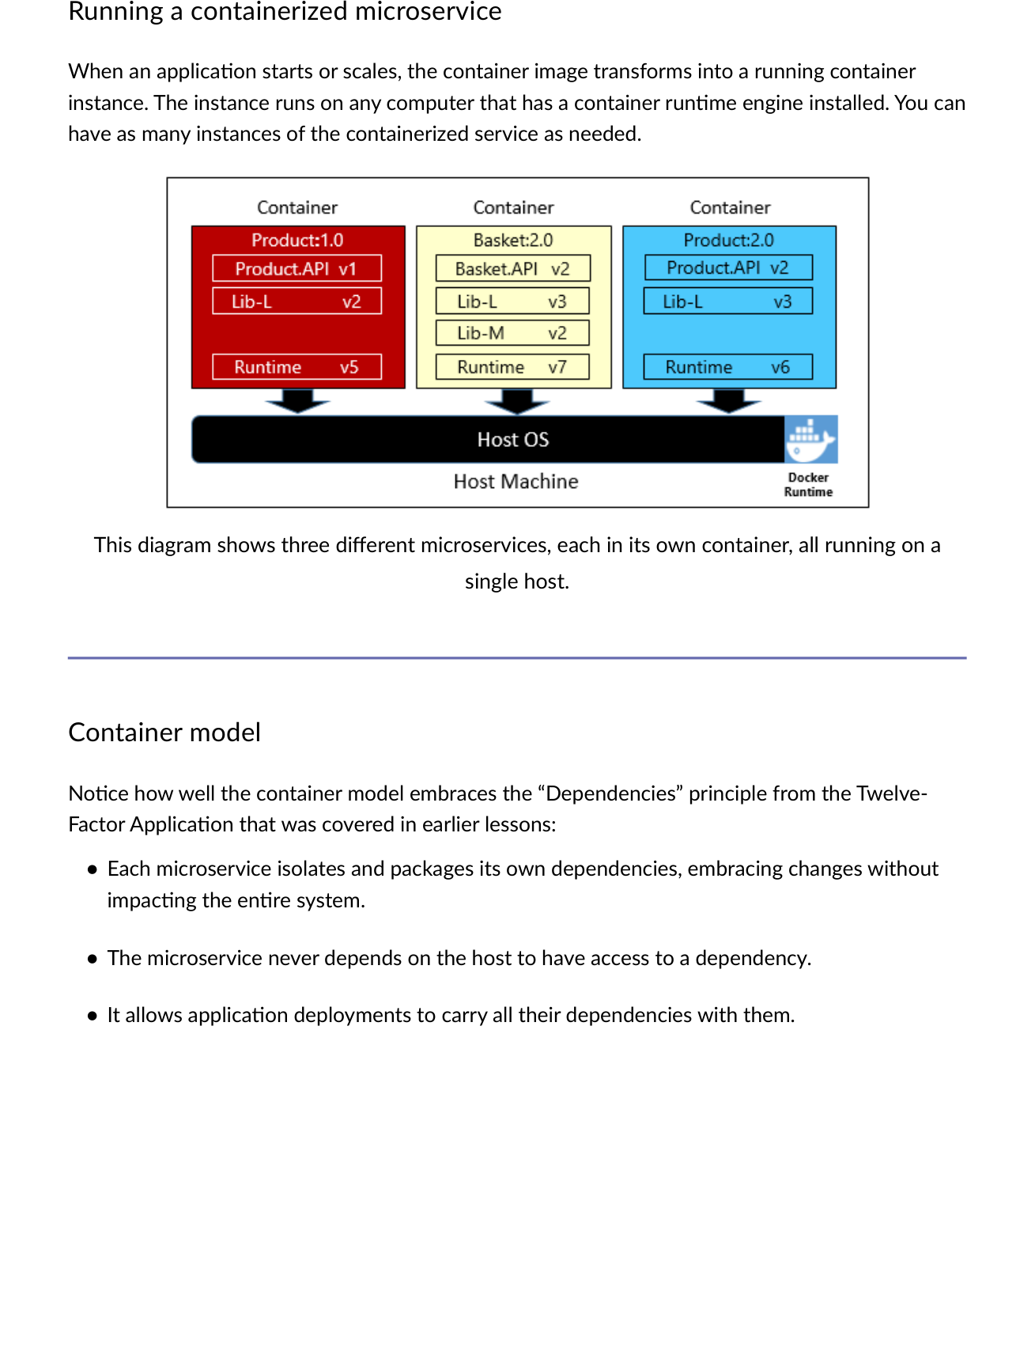
Fig 5.11 — Three microservices each in own container, all running on a single host. Each container isolates its own dependencies.
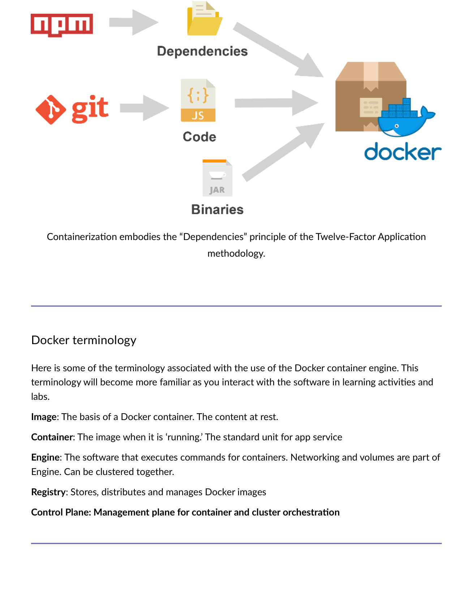
Fig 5.12 — Containerization embodies Factor 2 (Dependencies): each microservice isolates own deps, never relies on host, carries all deps in deployment.

Container Benefit | Detail
Portable artifact | Dockerfile creates portable artifact that runs reliably everywhere.
Multiple apps per host | Same host runs different apps or different versions simultaneously with different dependencies.
Better resource utilization | Lightweight container vs. dedicated host OS — uses only what it needs.
Cross-platform | Supports Linux and Windows workloads.
Docker dominance | De facto standard — captured lion's share of container market.

MODULE 6 | Container Orchestration — Kubernetes

6.1 Why Orchestration?
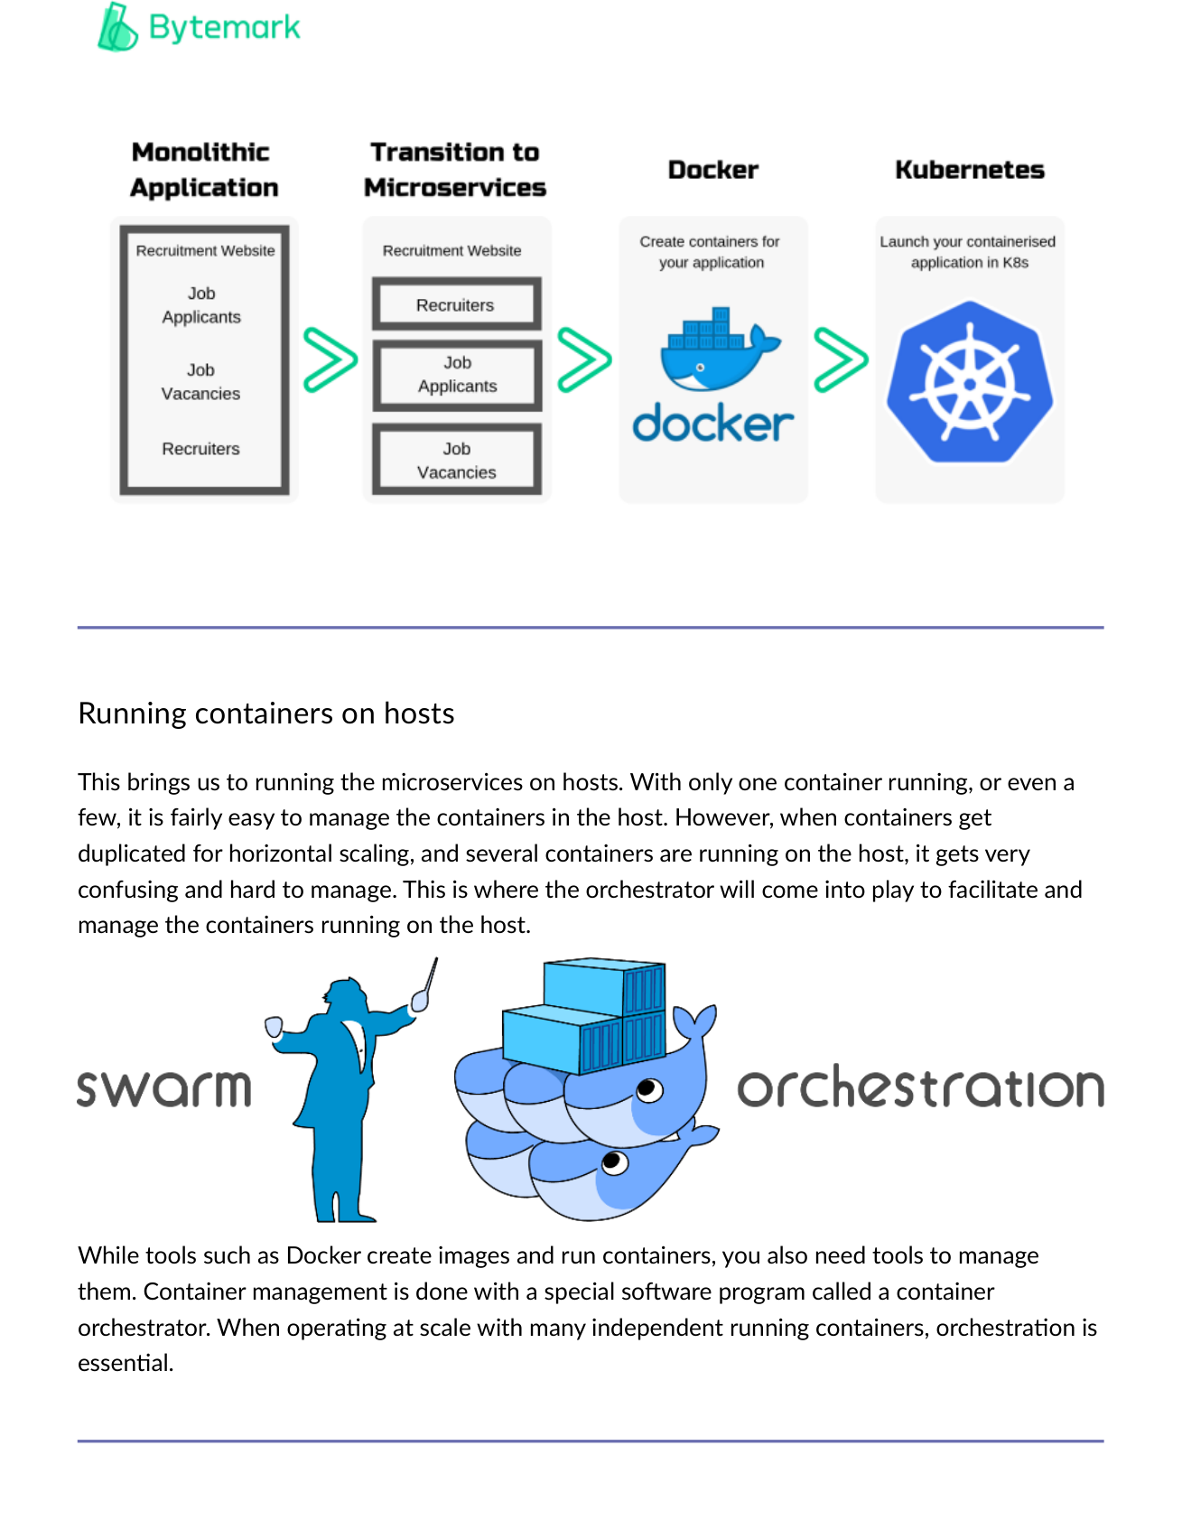
Fig 6.1 — With one container, management is simple. When containers are duplicated for horizontal scaling across hosts, an orchestrator is essential.

With only a few containers, management is easy. When containers get duplicated for horizontal scaling and many containers run on the host, it becomes very confusing and hard to manage. This is where a container orchestrator comes in.

6.2 Orchestration Tasks
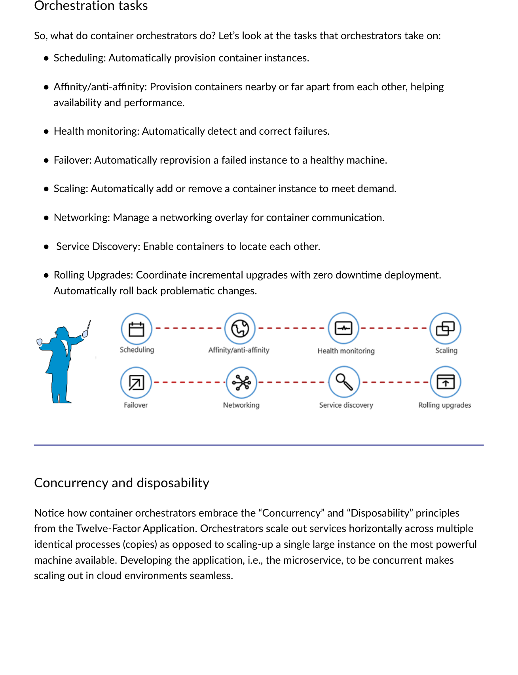
Fig 6.2 — Container Orchestration Tasks: Scheduling, Affinity/Anti-affinity, Health Monitoring, Failover, Scaling, Networking, Service Discovery, Rolling Upgrades.

Task | Description
Scheduling | Automatically provision container instances on available nodes.
Affinity/Anti-affinity | Provision containers nearby or far apart for availability and performance.
Health Monitoring | Automatically detect and correct failures.
Failover | Automatically reprovision a failed instance to a healthy machine.
Scaling | Automatically add or remove container instances to meet demand.
Networking | Manage a networking overlay for container communication.
Service Discovery | Enable containers to locate each other.
Rolling Upgrades | Coordinate incremental upgrades with zero downtime. Auto rollback if problems.
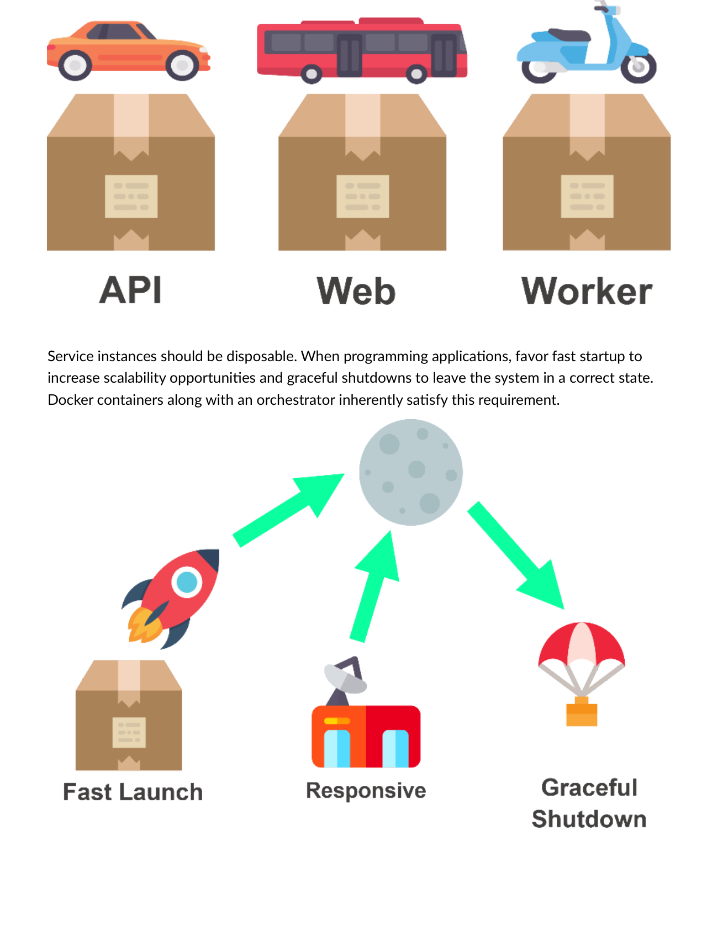
Fig 6.3 — Disposability: Docker containers with orchestrator satisfy Factor 9 (Disposability) and Factor 8 (Concurrency) inherently.

6.3 Kubernetes
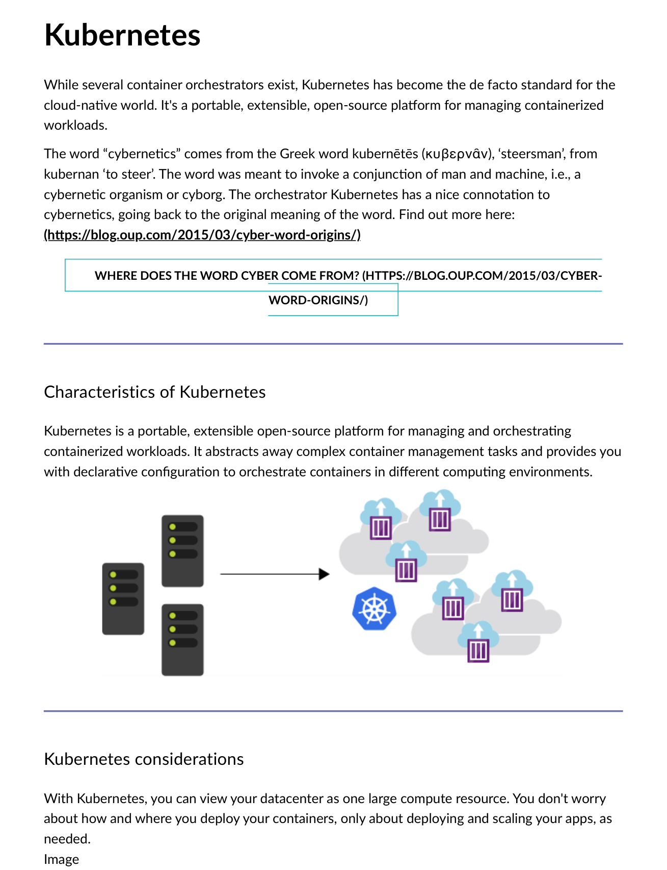
Fig 6.4 — Kubernetes: Portable, extensible, open-source platform. Treats your datacenter as one large compute resource. De facto cloud-native standard.
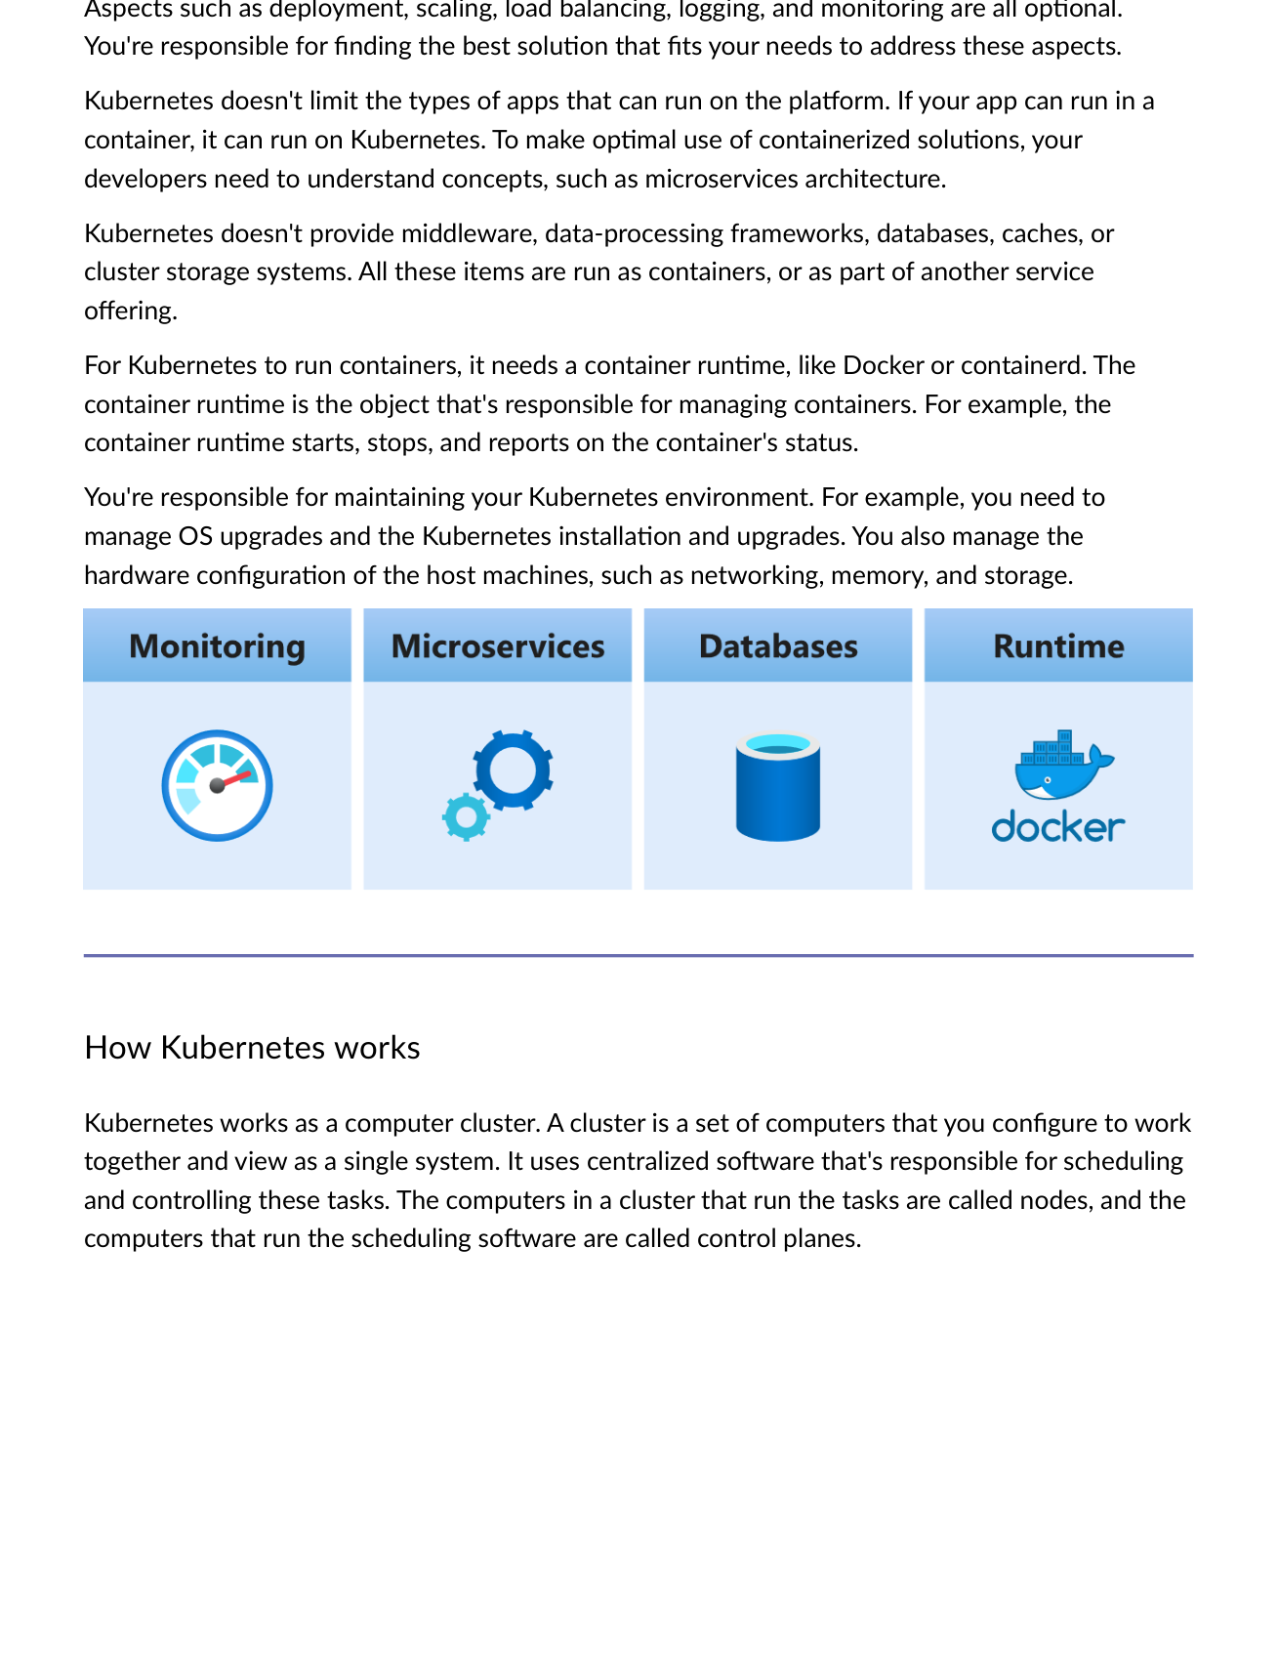
Fig 6.5 — Kubernetes: You don't worry about HOW/WHERE containers deploy — only about deploying and scaling apps. Abstracts infrastructure complexity.

⚠️ What Kubernetes Does NOT Provide
Does NOT provide middleware, databases, caches, or cluster storage (run these as containers or separate services).
Does NOT limit which types of apps run (if it runs in a container, it runs on K8s).
YOU are responsible for: OS upgrades, K8s installation/upgrades, host hardware config (networking, memory, storage).

6.4 Kubernetes Architecture
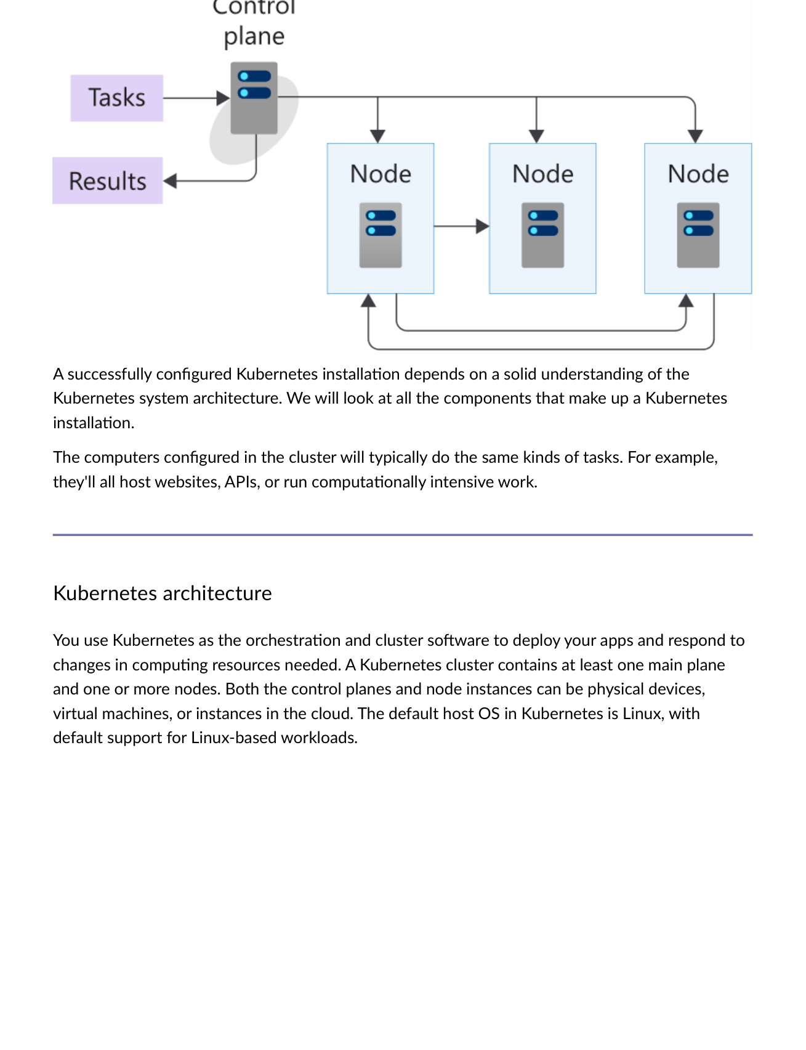
Fig 6.6 — K8s cluster: At least one Control Plane + one or more worker Nodes. Can be physical, virtual, or cloud instances. Default host OS: Linux.
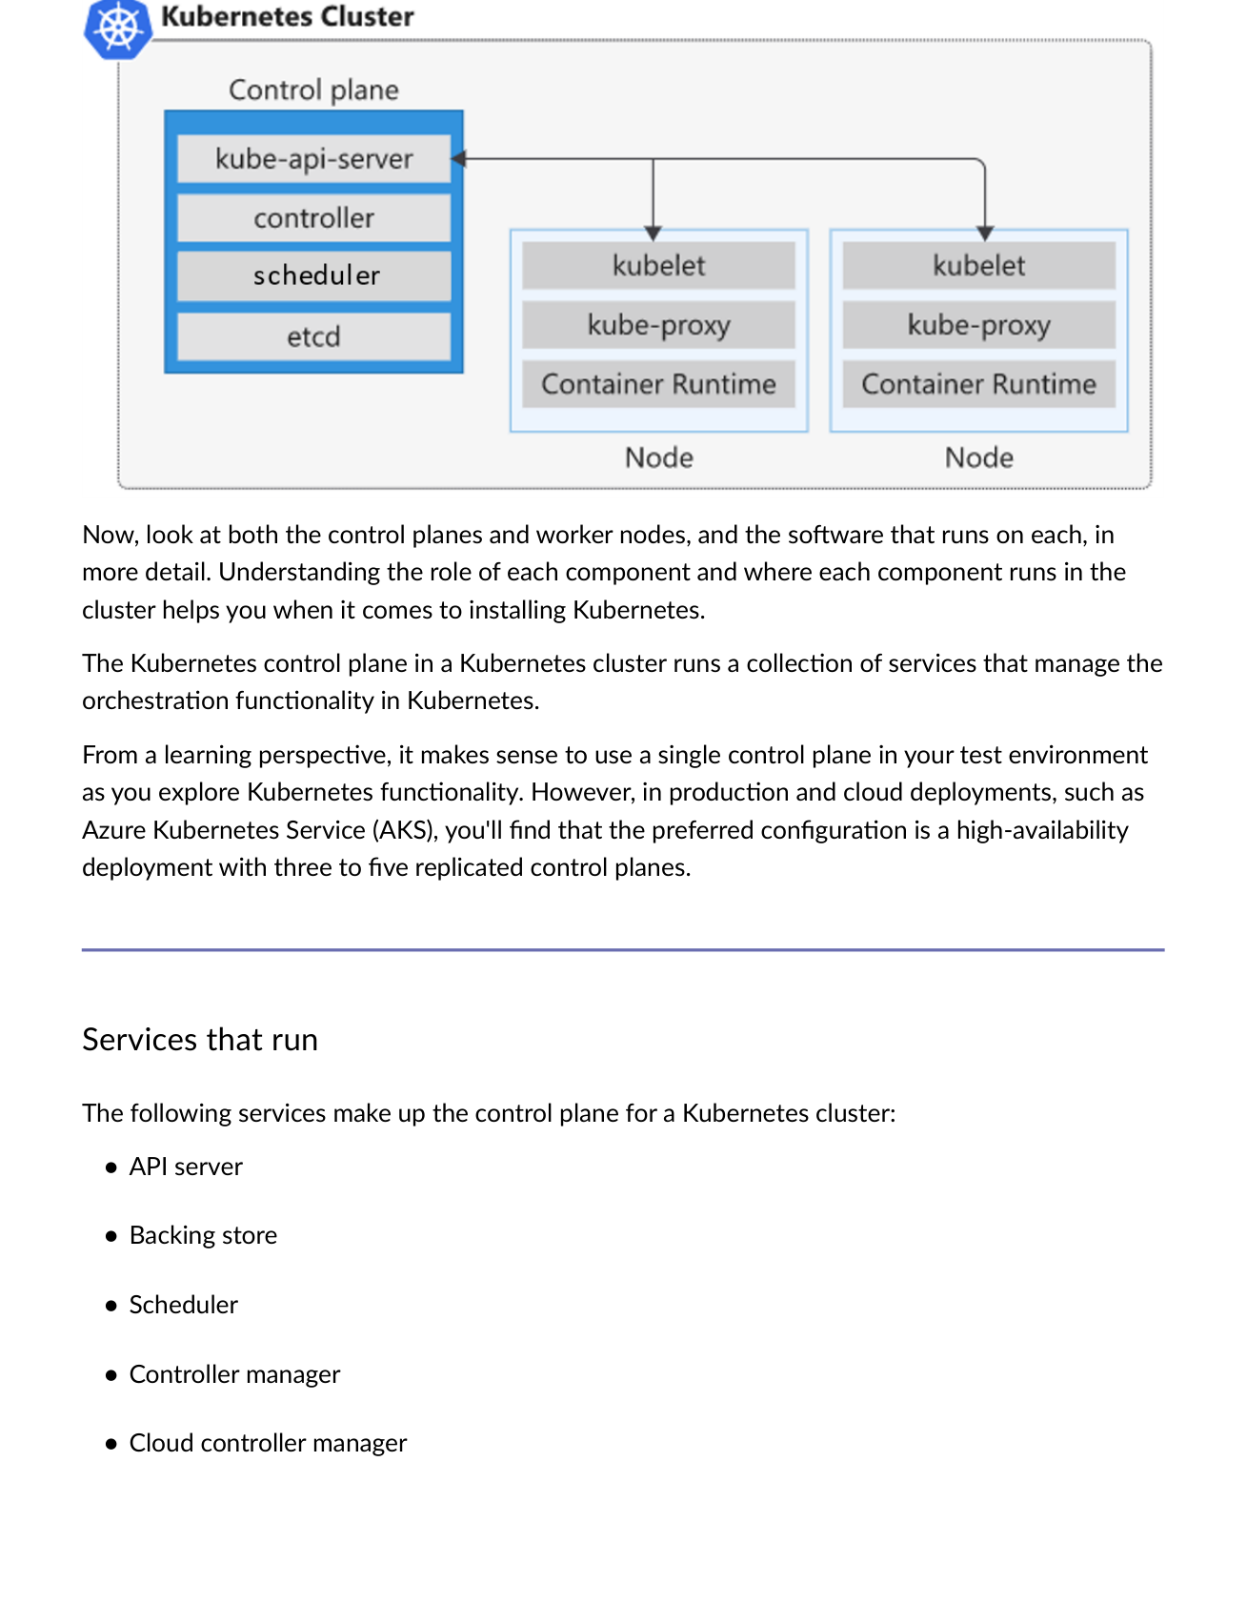
Fig 6.7 — Control Plane services vs. Node services.

Component | Location | Role
API Server | Control Plane | Front-end for control plane — receives all kubectl commands.
etcd (Backing Store) | Control Plane | Distributed key-value store holding all cluster state/config.
Scheduler | Control Plane | Assigns pods to nodes based on resource requirements.
Controller Manager | Control Plane | Runs control loops to maintain desired cluster state.
Cloud Controller Manager | Control Plane | Integrates with cloud provider APIs (AKS, EKS, GKE).
Kubelet | Node | Agent ensuring containers in pods are running and healthy.
Kube-proxy | Node | Maintains network rules; enables pod-to-pod communication.
Container Runtime | Node | Software running containers (Docker, containerd, CRI-O).

6.5 Kubernetes Pods & kubectl
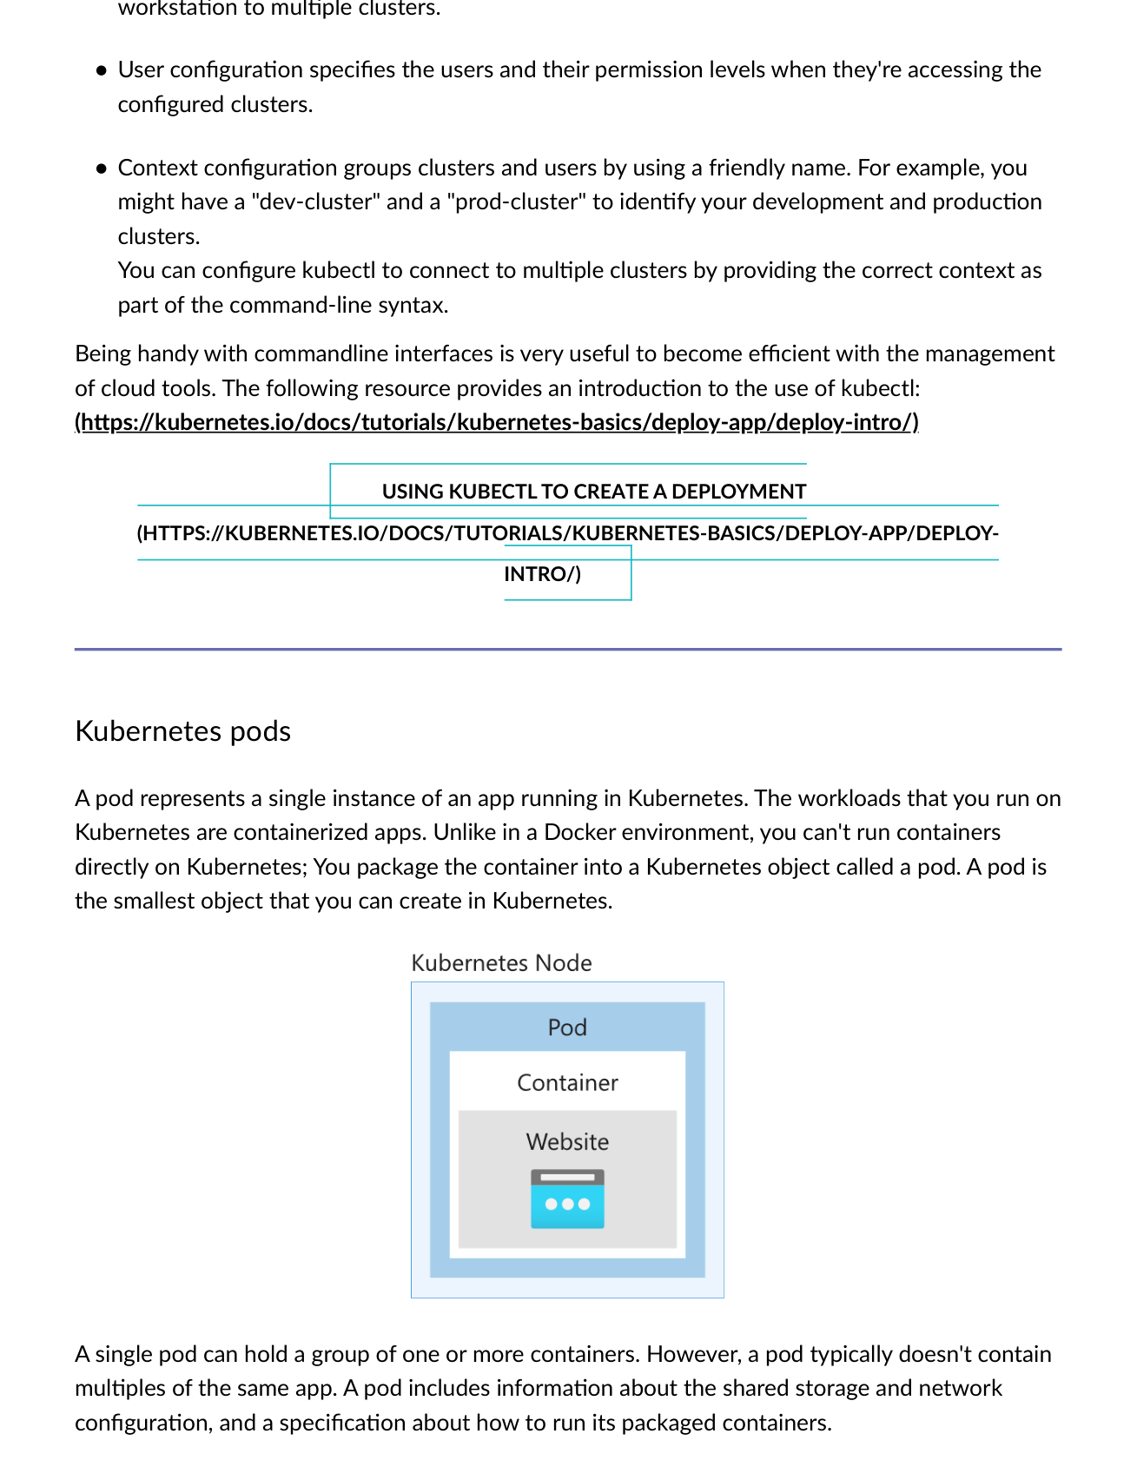
Fig 6.8 — kubectl config: Cluster (name, certs, API endpoint), User (permissions), Context (friendly name grouping e.g. 'dev-cluster', 'prod-cluster').
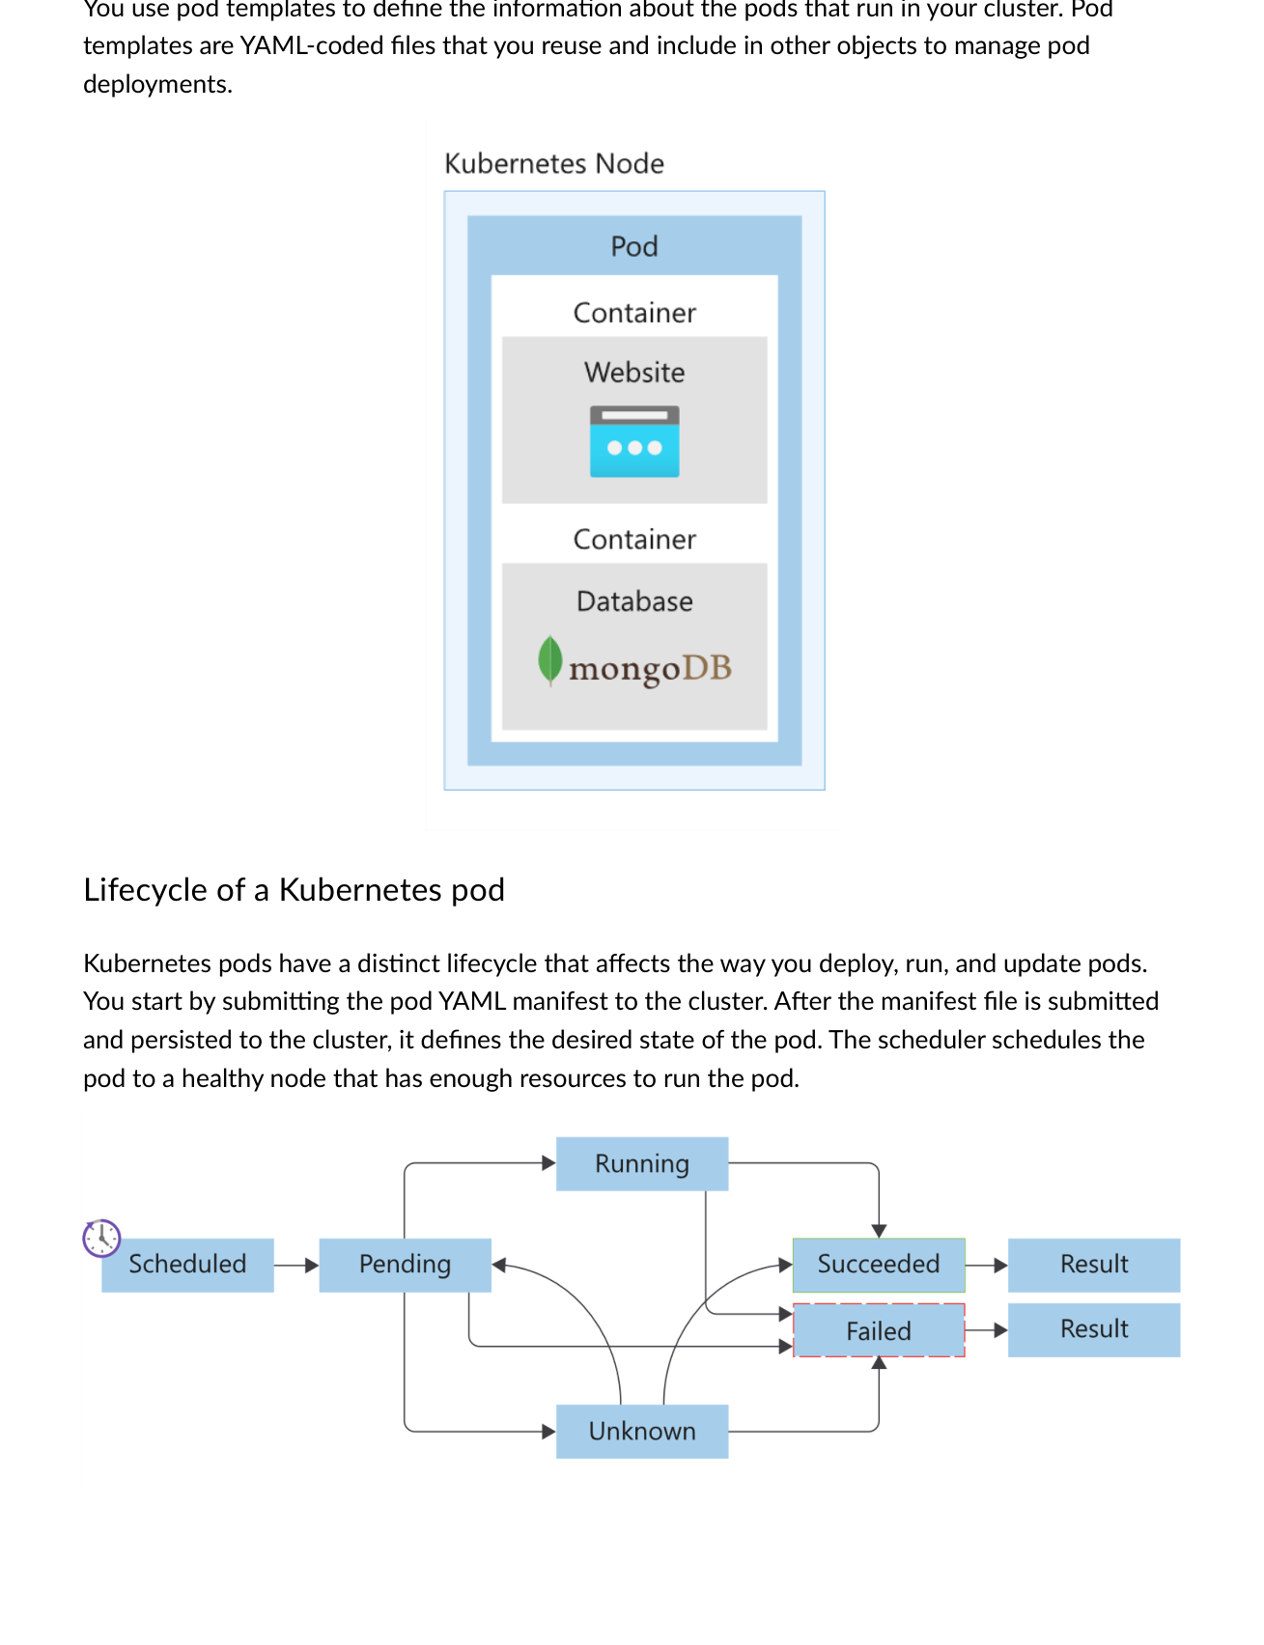
Fig 6.9 — Pod lifecycle: Submit YAML → Desired state → Scheduler assigns to healthy node → Pending → Running → Succeeded/Failed.

Pod Concept | Detail
Definition | Smallest deployable object in Kubernetes. Wraps one or more containers.
Relationship to containers | Cannot run containers directly in K8s — must wrap in a pod.
Contents | Shared storage/network config + specification for running packaged containers.
Pod templates | YAML-coded files defining pod specs — reusable across deployments.
Typical usage | A single pod typically doesn't contain multiples of the same app.

6.6 Managed Container Orchestration
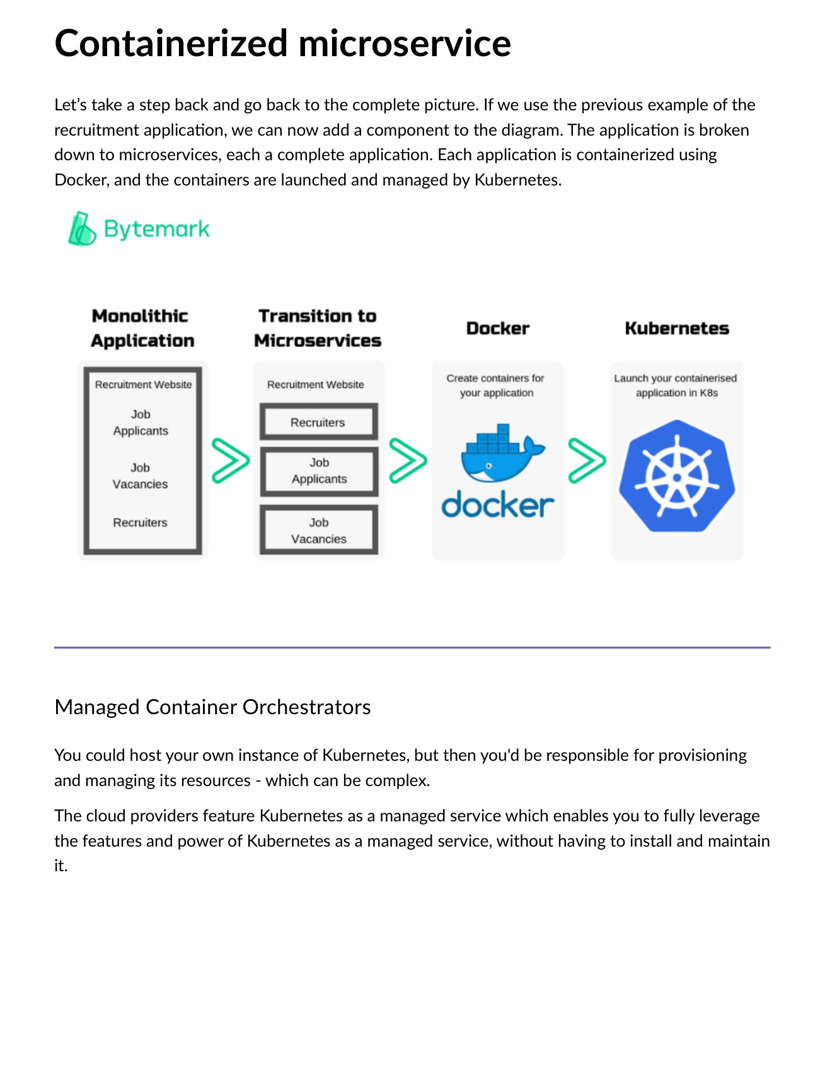
Fig 6.10 — Complete picture: App broken into microservices → each containerized with Docker → all managed by Kubernetes.
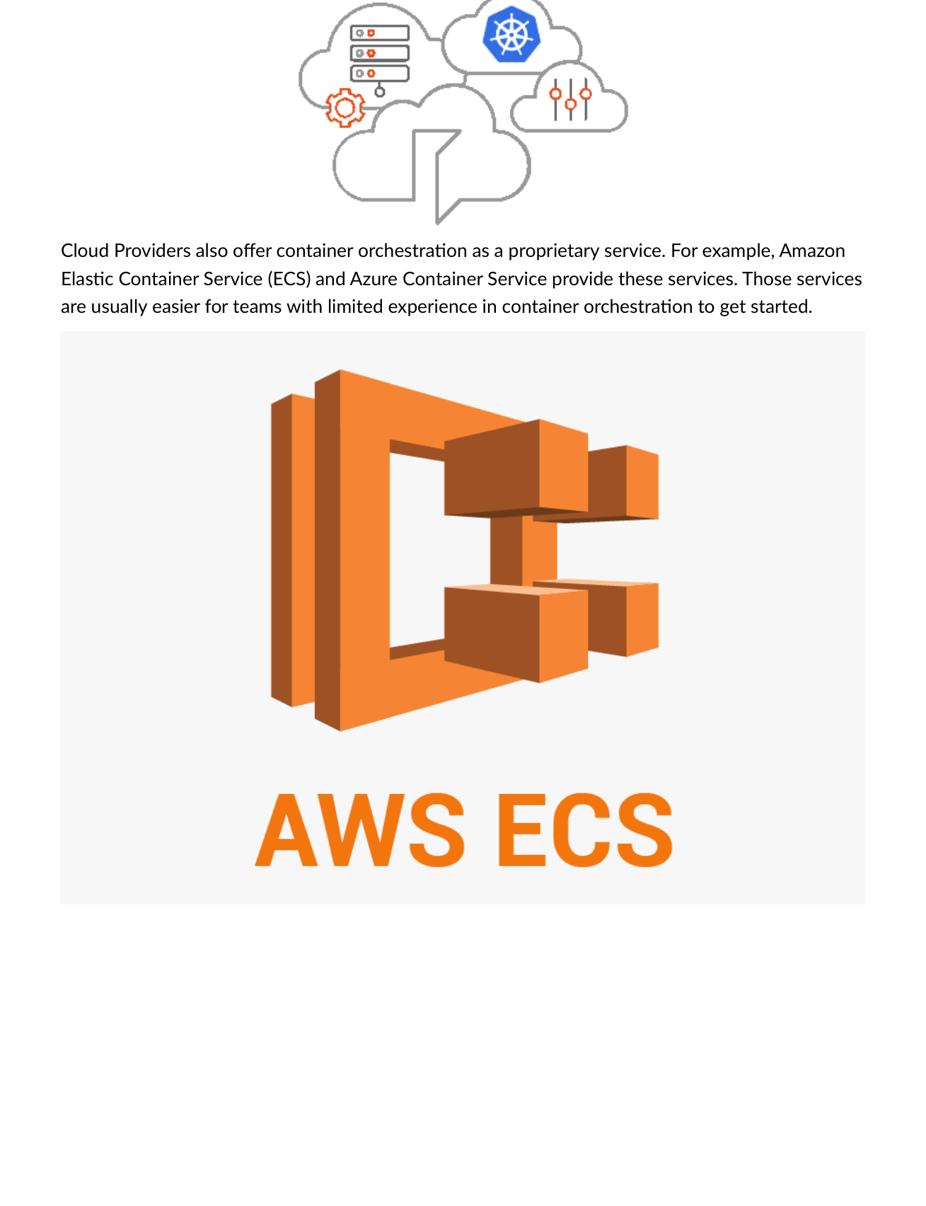
Fig 6.11 — Cloud providers offer Kubernetes as managed service (AKS, EKS, GKE). Also proprietary: Amazon ECS, Azure Container Apps.

💡 Production Kubernetes
In production and cloud deployments (like AKS), preferred config is high-availability with 3 to 5 replicated control planes. Test environments can use single control plane.

Term | Definition
Kubernetes | Open-source container orchestration — de facto standard for cloud-native.
Pod | Smallest K8s unit — wraps containers with shared storage/network.
Node | Worker machine running pods (VM or physical).
Control Plane | API Server + etcd + Scheduler + Controller Manager — manages cluster.
kubectl | Kubernetes CLI for sending commands to control plane.
etcd | Distributed key-value store — K8s cluster state/config.
YAML | Human-readable config language for K8s manifests.
Rolling Upgrade | Zero-downtime update — gradually replaces old pods with new ones.
Containerd | Container backend extracted from Docker — standard container runtime.

MODULE 7 | Backing Services & Database as a Service (DBaaS)

7.1 What is a Backing Service?
Formal definition: A backing service is any service the app consumes OVER THE NETWORK as part of its normal operation.
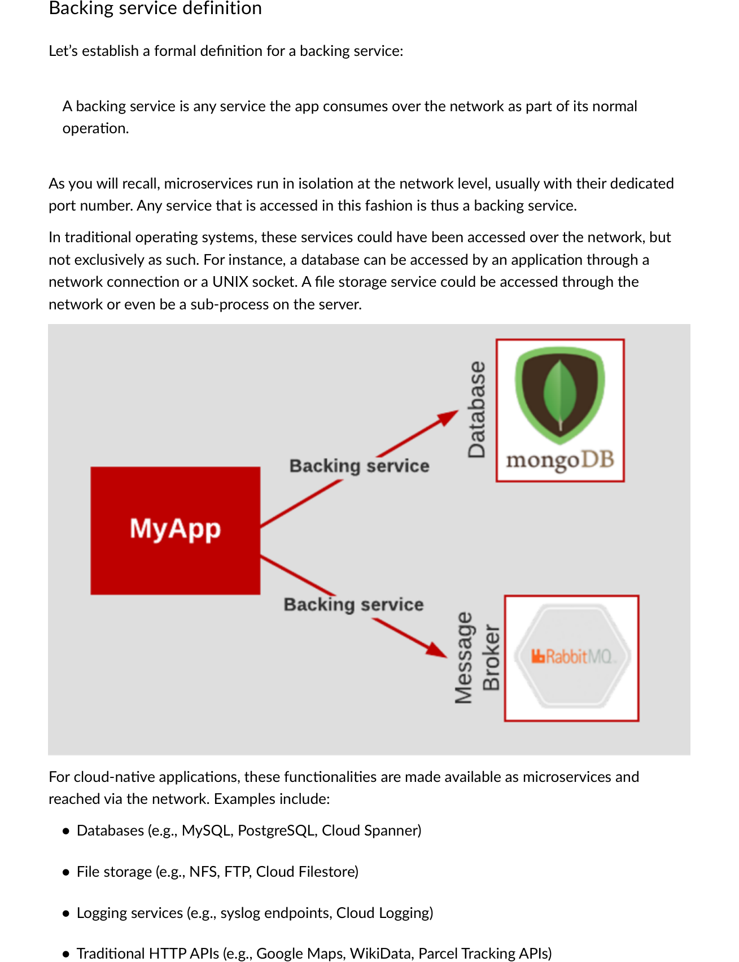
Fig 7.1 — Backing service: accessed via URL over network. Any service reached this way (database, file storage, logging, HTTP API) is a backing service.

Type | Examples
Relational databases | MySQL, PostgreSQL, Microsoft SQL Server
NoSQL databases | MongoDB, Cassandra, Amazon DynamoDB
Object storage | Amazon S3, Azure Blob Storage
File storage | Microsoft OneDrive, Google Drive, Dropbox
Message queues | RabbitMQ, Apache Kafka, Amazon SQS
Cache services | Redis, Memcached
Big data services | Apache Hadoop, Apache Spark, Amazon EMR
Backup & recovery | AWS Backup, Veeam, Azure Backup

7.2 From 3-Tier to Microservices — Why Backing Services Matter
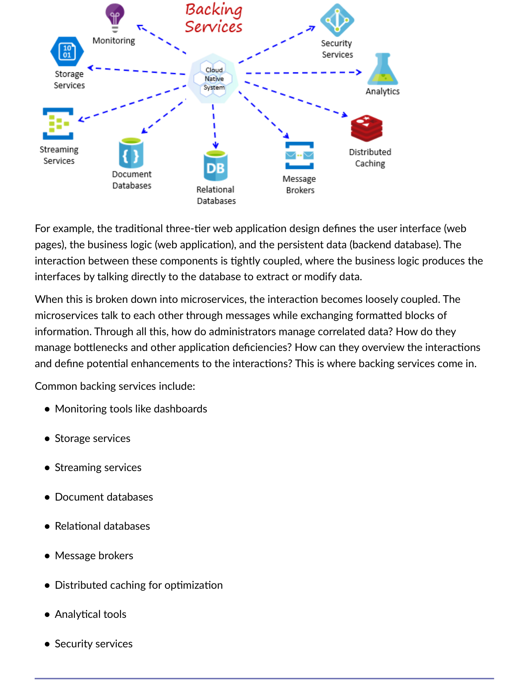
Fig 7.2 — Traditional 3-tier: tightly coupled (direct DB calls). Microservices: loosely coupled via messages. Backing services provide secondary services (monitoring, storage, messaging).
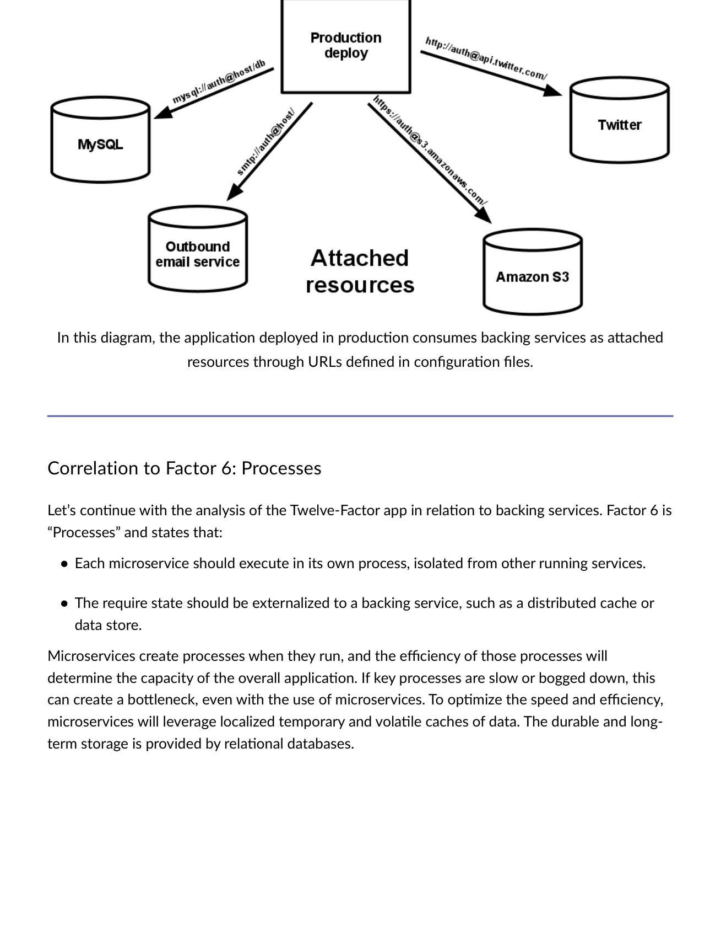
Fig 7.3 — Application consumes backing services as attached resources through URLs in config files. Any URL-accessed service = attached resource.

7.3 Twelve-Factor Correlations
Factor | Correlation to Backing Services
Factor 3: Config | Connecting to backing services should NOT be hardcoded. Define via environment variable in config file. Promote QA→Staging by updating config — same container image.
Factor 4: Backing Services | Local MySQL = Amazon RDS. Local SMTP = Postmark. ONLY the config handle changes, not the code. Treat all backing services as attached resources via URL.
Factor 6: Processes | Externalize state to backing services (distributed cache or data store). Microservices use localized volatile caches; durable storage uses relational databases.

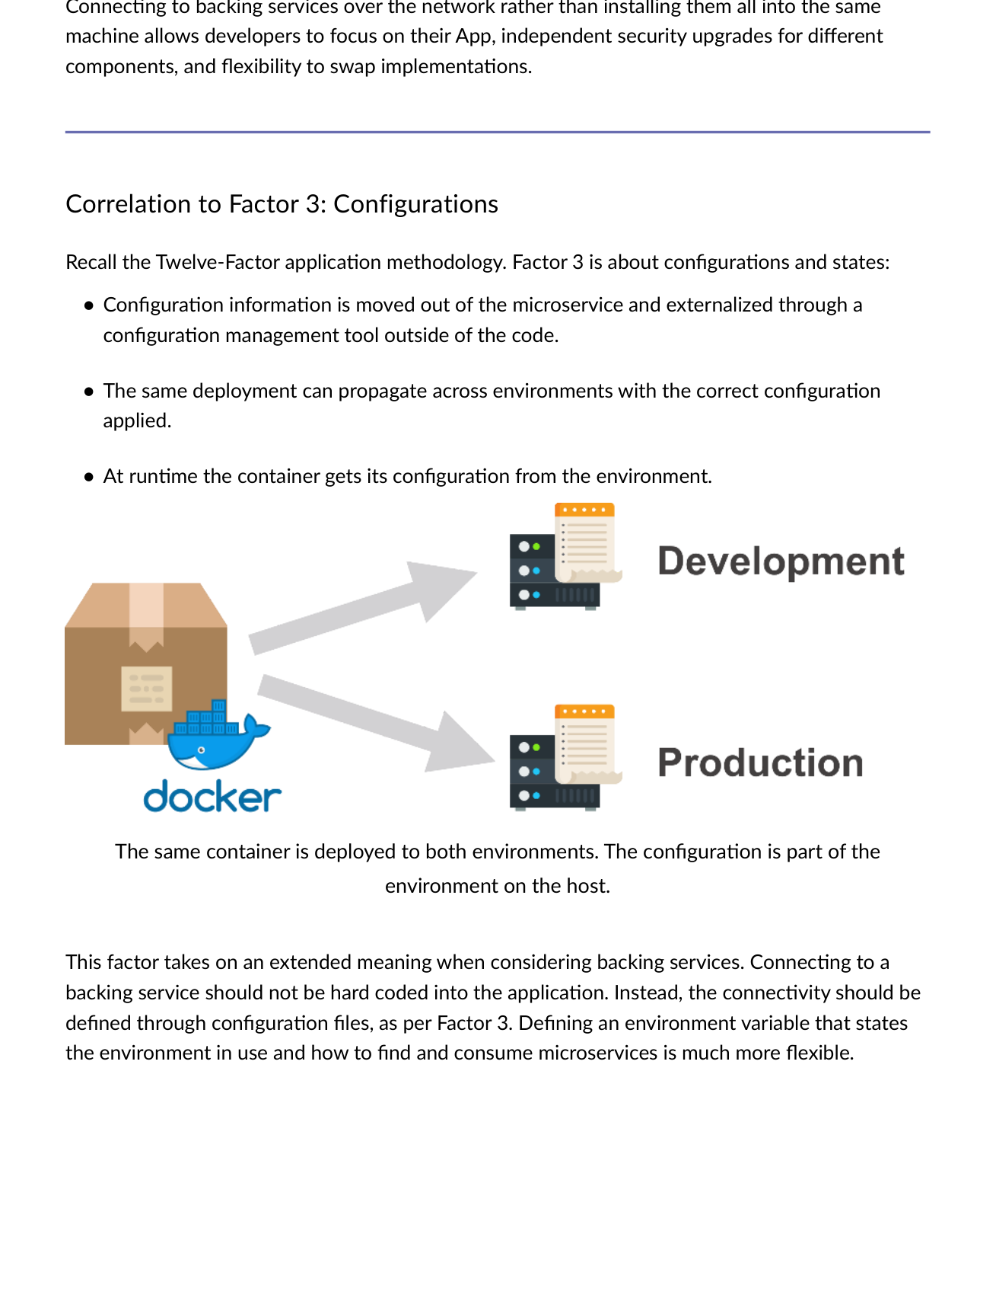
Fig 7.4 — Factor 3 correlation: Define backing service connection via env var in config, not hardcoded. Same container, different config per environment.
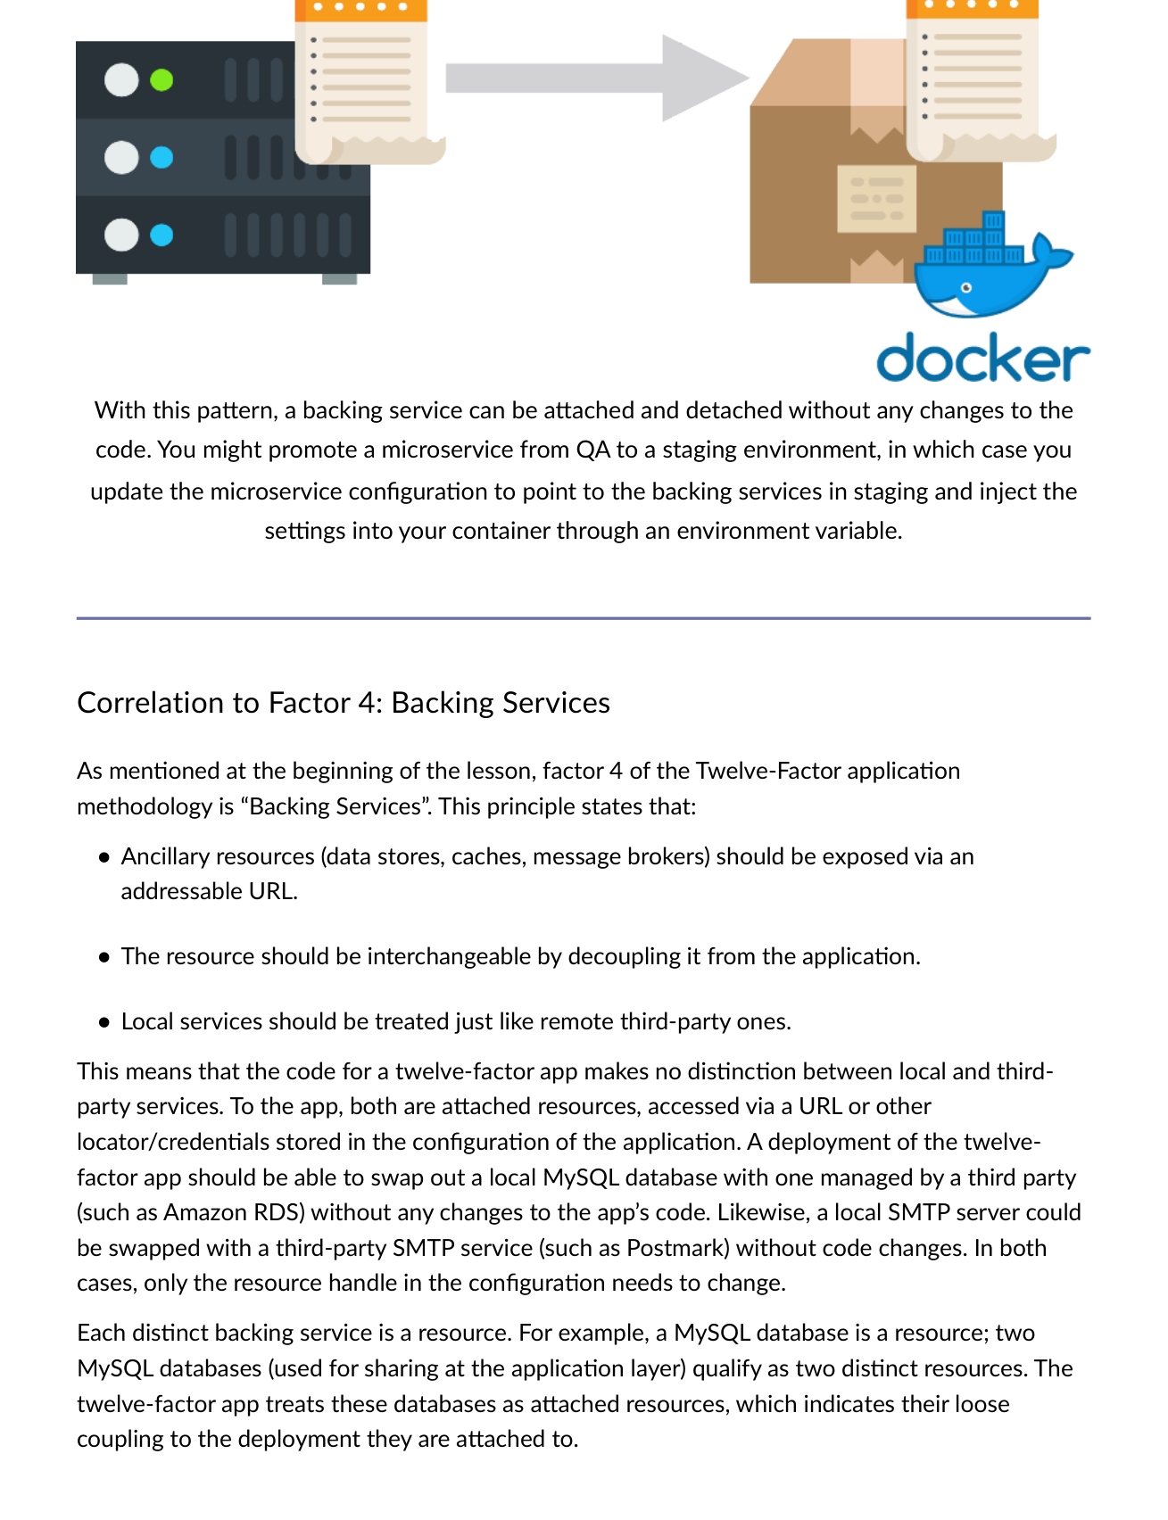
Fig 7.5 — Factor 4: Backing services as attached resources. Swap local MySQL for Amazon RDS — only config changes. No code changes.
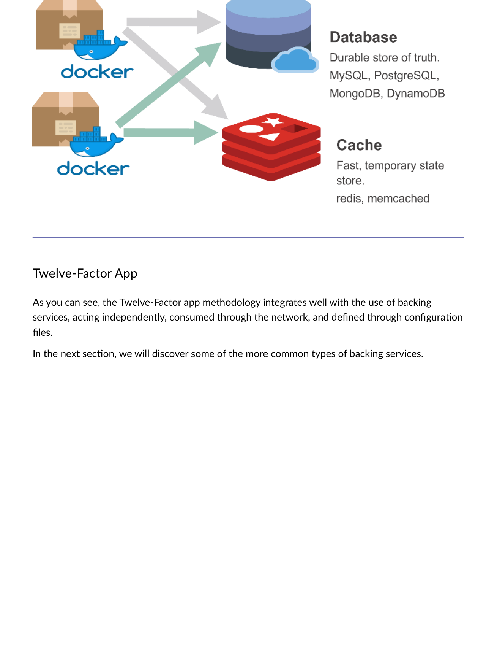
Fig 7.6 — Twelve-Factor app integrates with backing services: acting independently, consumed through network, defined through config files.

7.4 Owned vs. Managed Backing Services
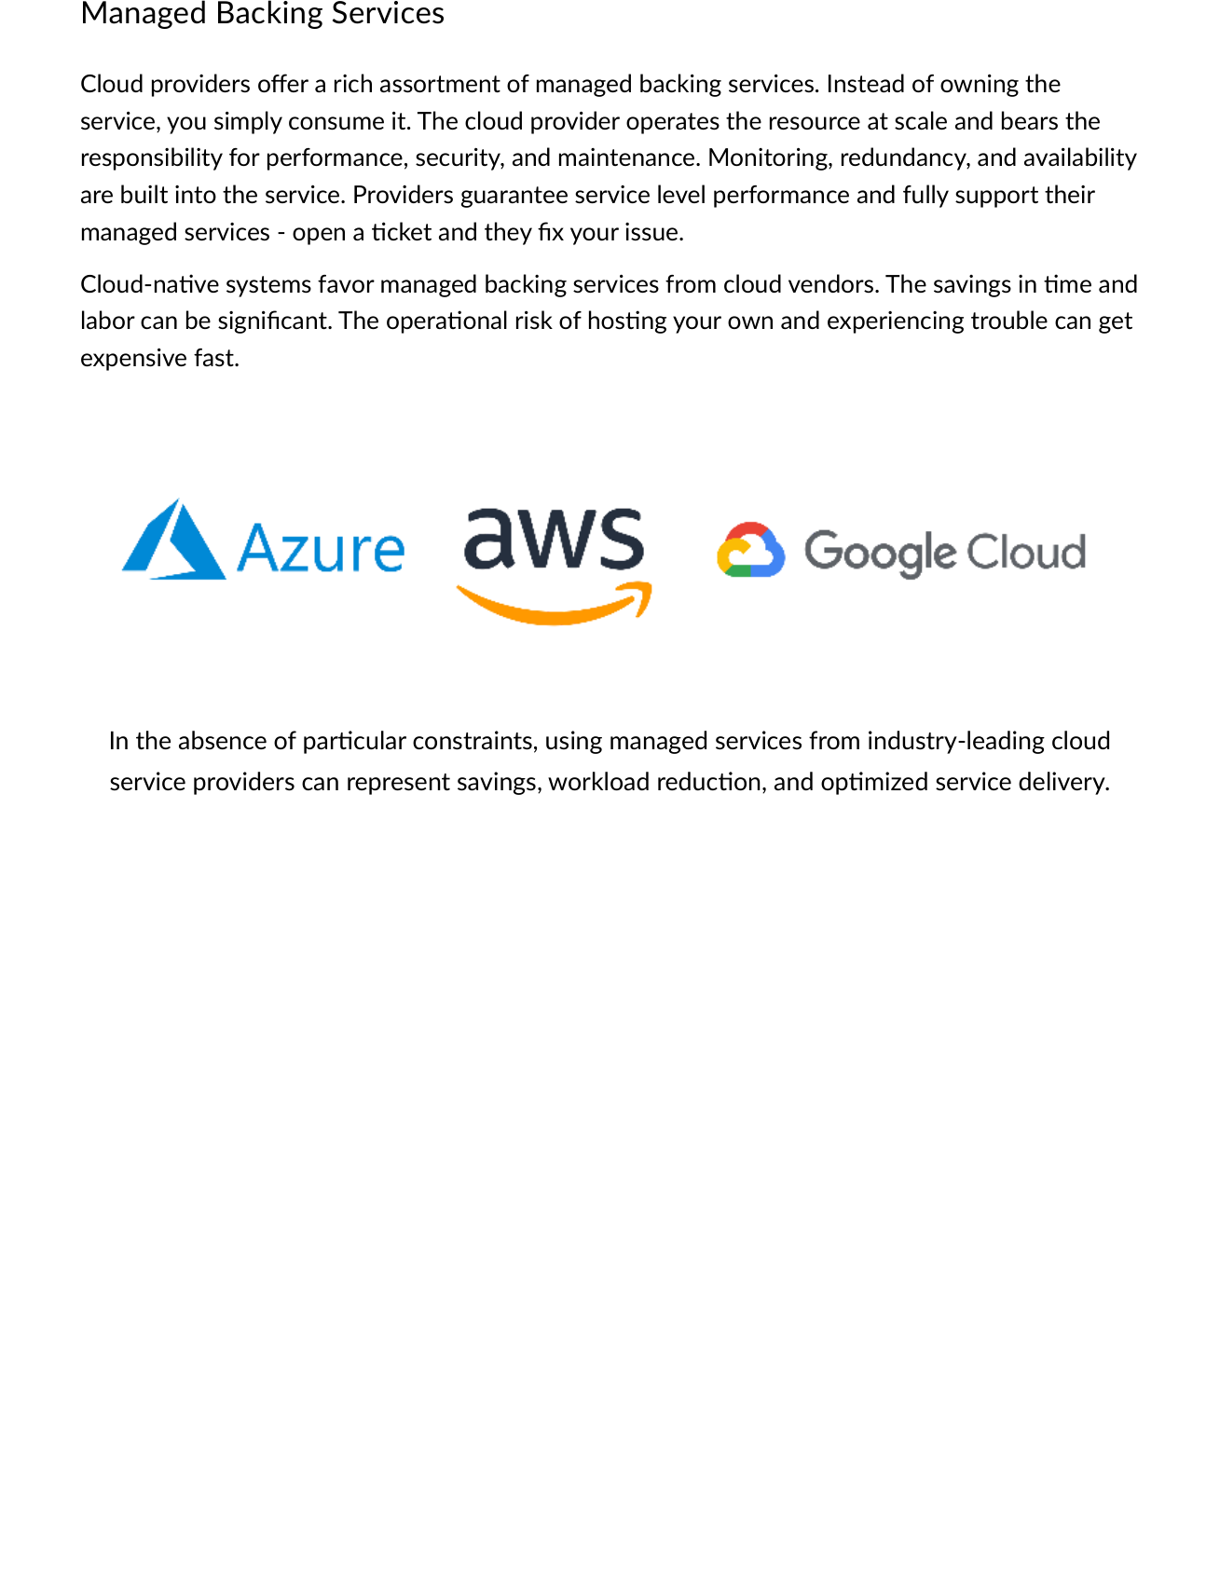
Fig 7.7 — Managed backing services: cloud provider operates at scale. Monitoring, redundancy, availability built-in. SLA-backed. Open ticket → provider fixes issue.

Owned (Self-Hosted) | Managed (Cloud Provider)
You provision, license, and manage resources | Provider operates resource at scale
You handle performance, security, maintenance | Provider responsible for all operational concerns
No built-in monitoring or redundancy | Monitoring, redundancy, availability built-in
Full control over environment | Consume as service — no infrastructure management
Can be expensive and time-consuming | Significant savings in time and labor

💡 Cloud-Native Preference
Cloud-native systems FAVOUR managed backing services from cloud vendors. The savings in time and labor can be significant. The operational risk of hosting your own and experiencing trouble can get expensive fast.

7.5 Database as a Service (DBaaS)
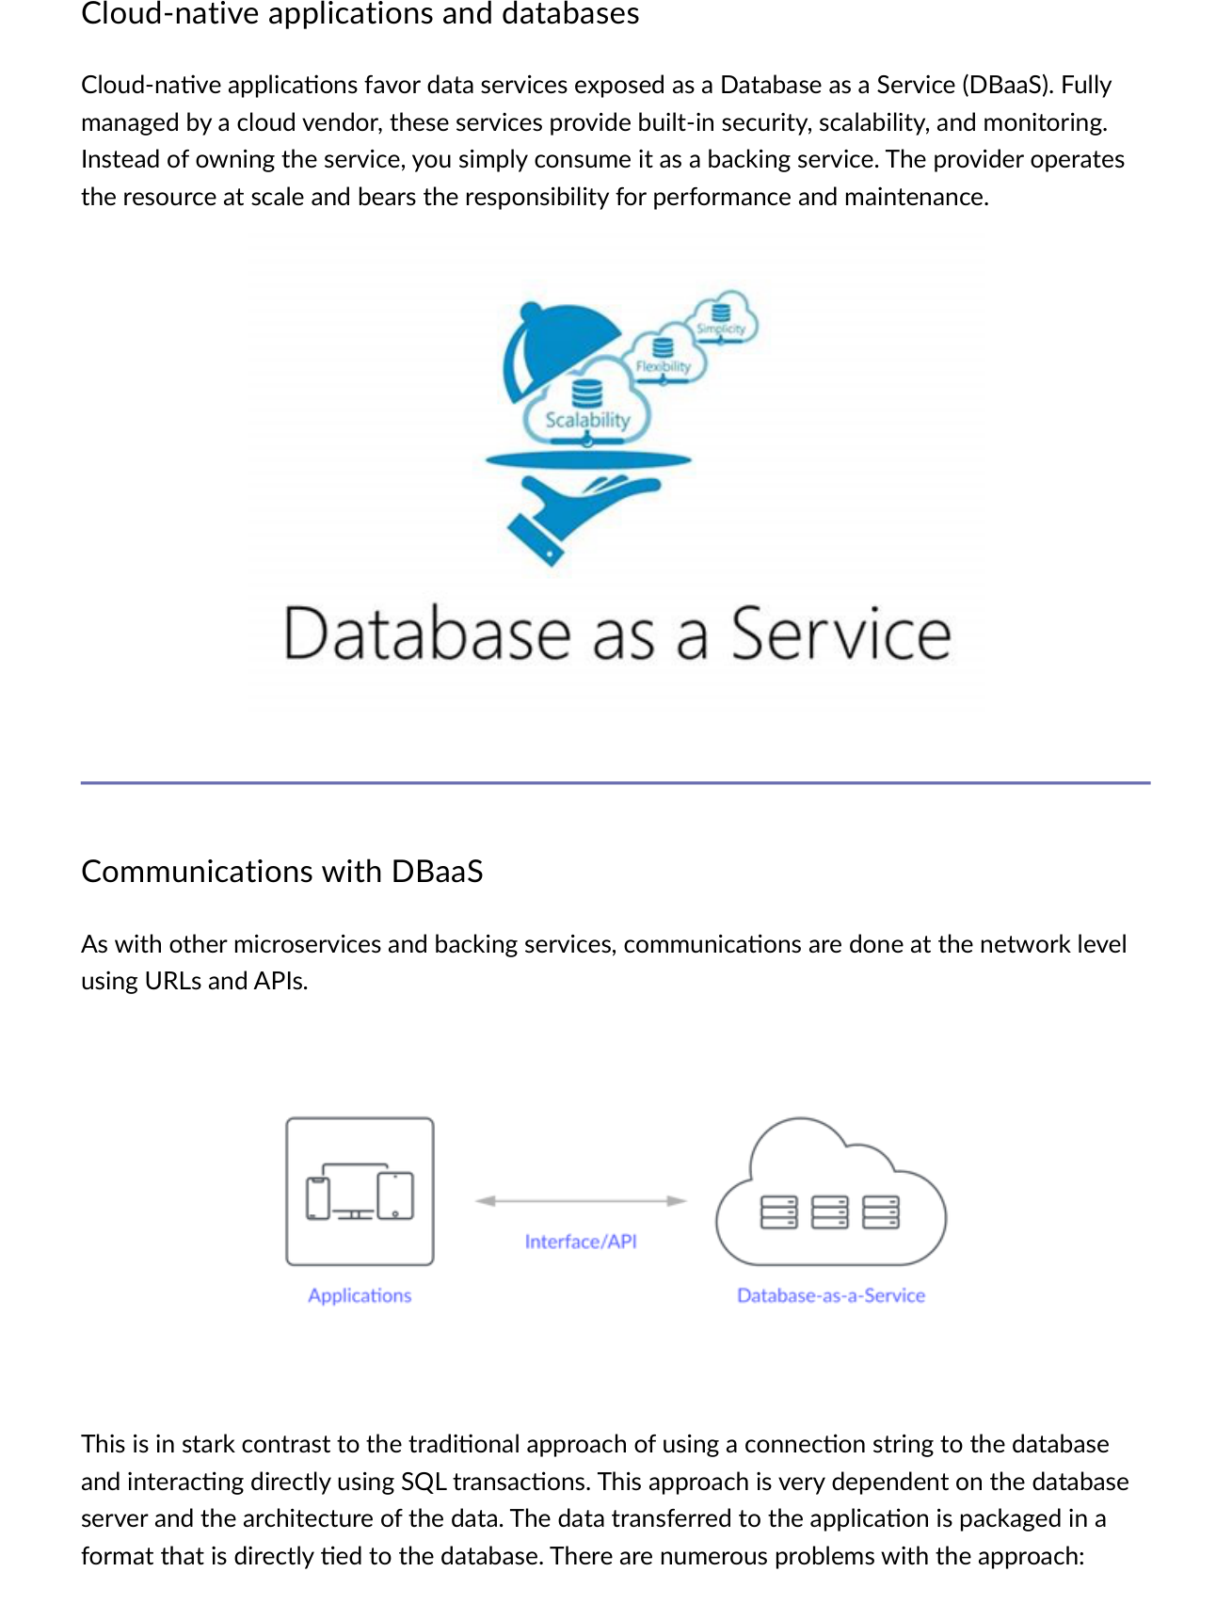
Fig 7.8 — Cloud-native apps favour DBaaS: communications via URL/API not direct SQL connection strings. Decouples app from DB architecture.

DBaaS Benefit | Detail
Cost savings | Predictable periodic charge based on resources consumed — no upfront capacity purchase.
Scalability up/down | Provision additional storage/compute at runtime; scale down during non-peak.
Simpler management | Provider manages everything — lightens IT staff burden; focus on applications.
Rapid development | Developers spin up database in minutes, not days/weeks through IT requests.
Security | Enterprise-grade — encryption at rest/in transit, IAM controls, compliance standards.
Reduced risk | SLA guarantees uptime; compensation for excess downtime if SLA not met.
Software quality | Wide variety of highly configurable, pre-selected quality database options.

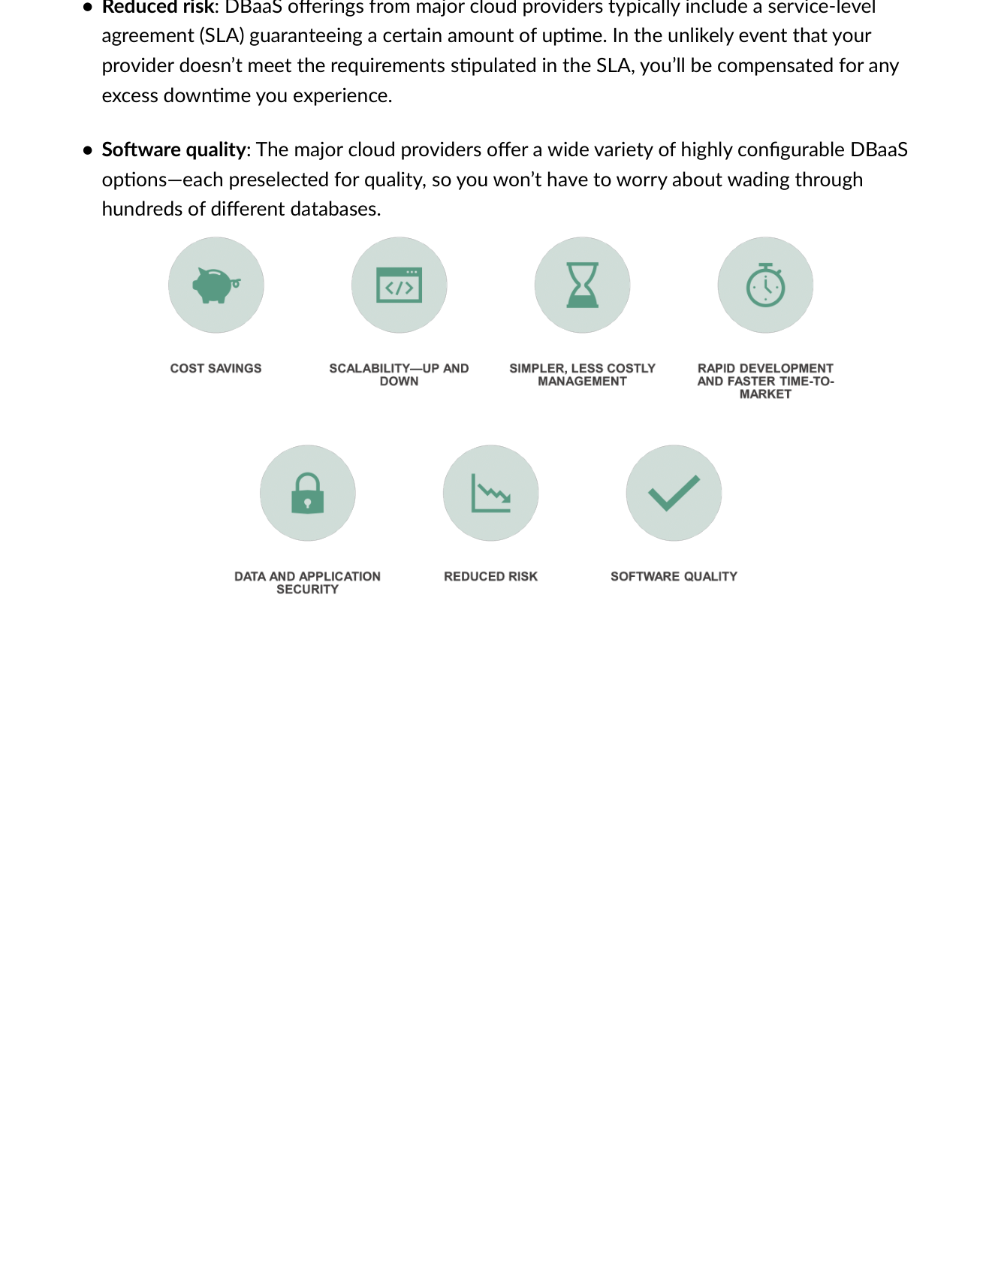
Fig 7.9 — DBaaS benefits summary: Reduced risk, Software quality, Cost savings, Scalability, Simpler management, Rapid development, Data security.

7.6 How to Choose a Backing Service
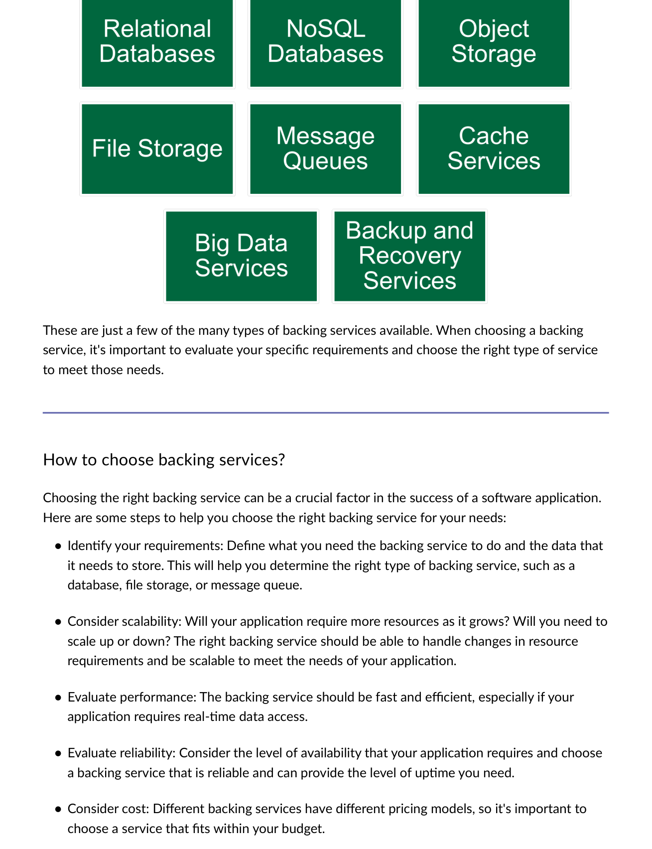
Fig 7.10 — Choosing backing services: Requirements → Scalability → Performance → Reliability → Cost → Ease of use → Security → Vendor support → Test.

Step | Question to Answer
1. Identify requirements | What does the service need to do? What data must it store?
2. Consider scalability | Can it handle resource changes as your application grows?
3. Evaluate performance | Is it fast and efficient for real-time data access if required?
4. Evaluate reliability | Does it provide the level of uptime your application needs?
5. Consider cost | Does it fit within your budget and pricing model?
6. Ease of use | Is it well-documented with good support?
7. Security | Does it protect sensitive data with robust security features?
8. Vendor support | Strong reputation? Responsive support team?
9. Test | Confirm it meets all requirements before final decision.

MODULE 8 | Automation, CI/CD, DevOps & Infrastructure as Code

8.1 The Automation Pillar
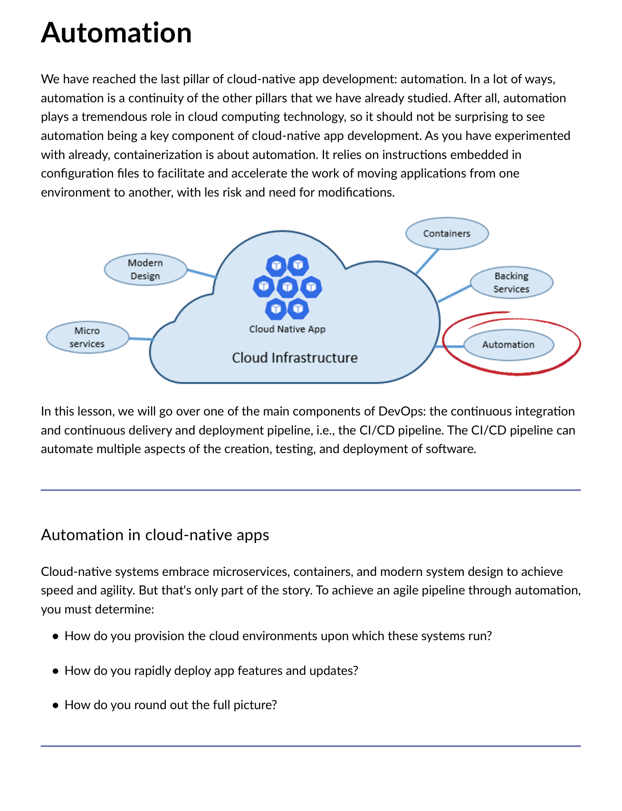
Fig 8.1 — Automation Pillar: How do you provision cloud environments? How do you rapidly deploy features? Answer: IaC + CI/CD pipeline.

Automation is the final and in many ways most important pillar of cloud-native. Containerization relies on configuration files to accelerate moving applications between environments. Three questions must be answered:
Question | Answer
How do you provision cloud environments? | Infrastructure as Code (IaC) — Terraform, Ansible, ARM templates.
How do you rapidly deploy app features and updates? | CI/CD pipeline — automated build, test, and deploy on every commit.
How do you round out the full picture? | Automated container placement — Kubernetes, ECS, Docker Swarm.

8.2 Infrastructure as Code (IaC)
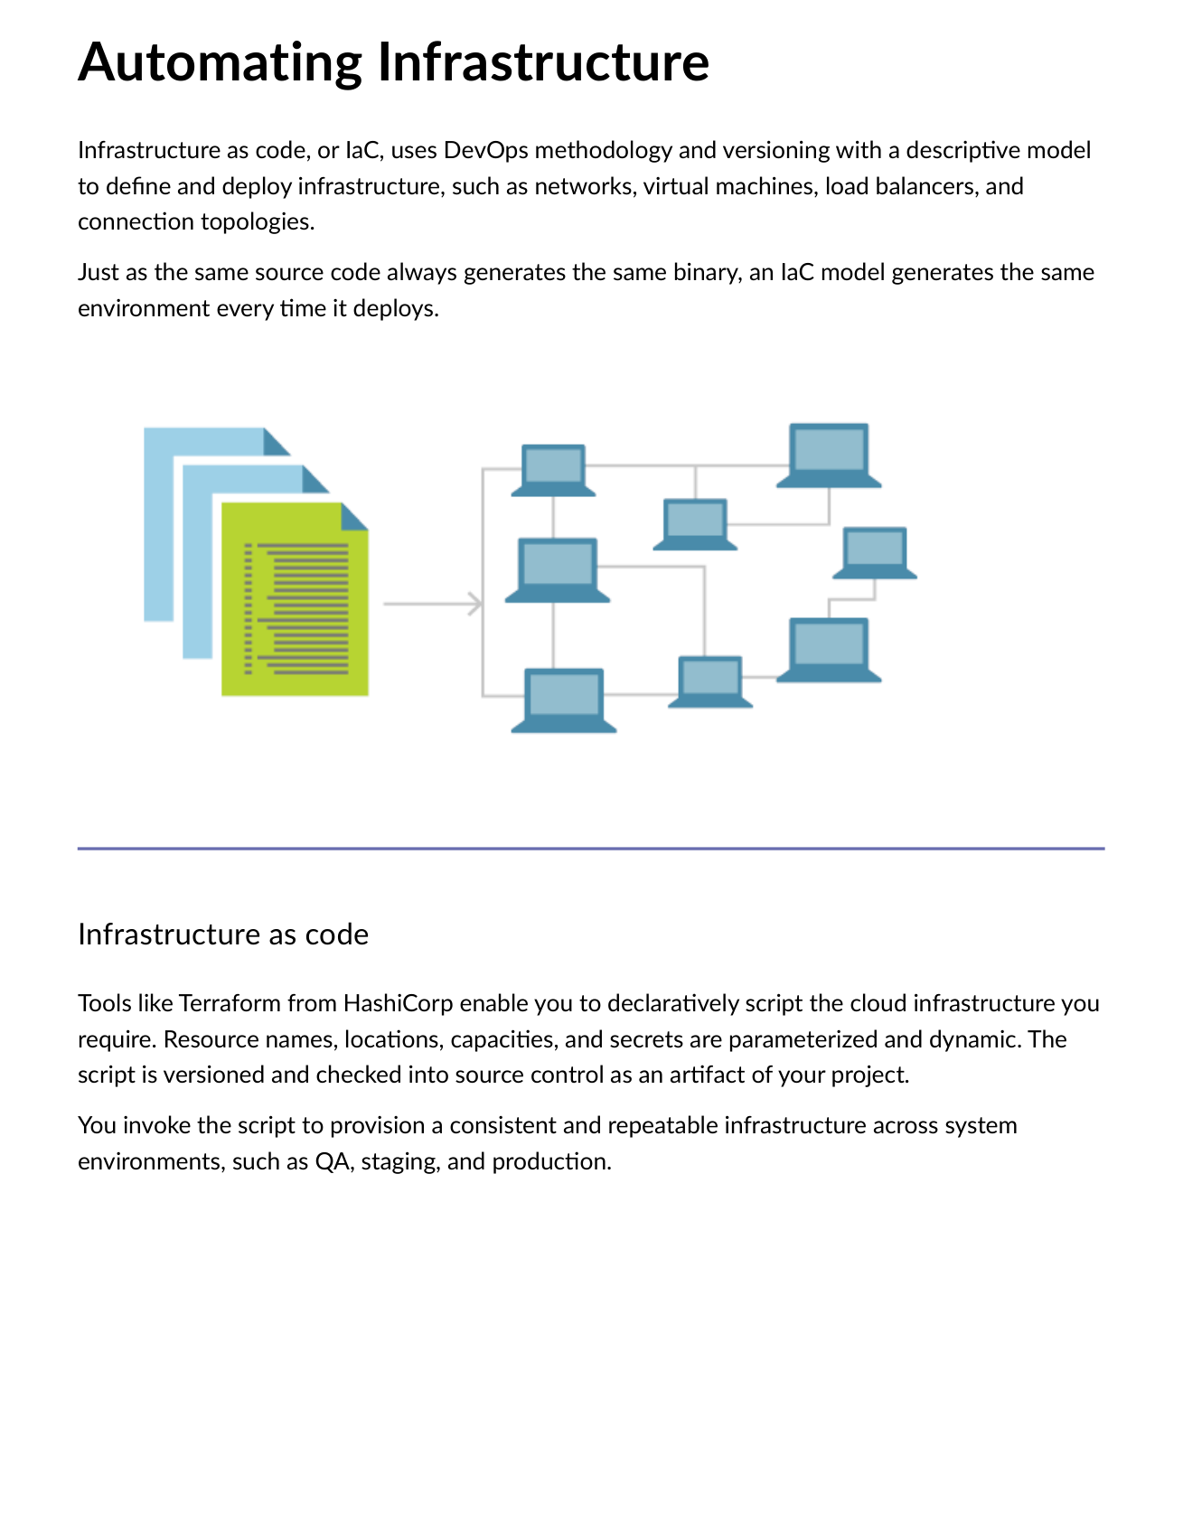
Fig 8.2 — IaC: Uses DevOps methodology and versioning with descriptive model. Same IaC script = same environment every time it deploys.
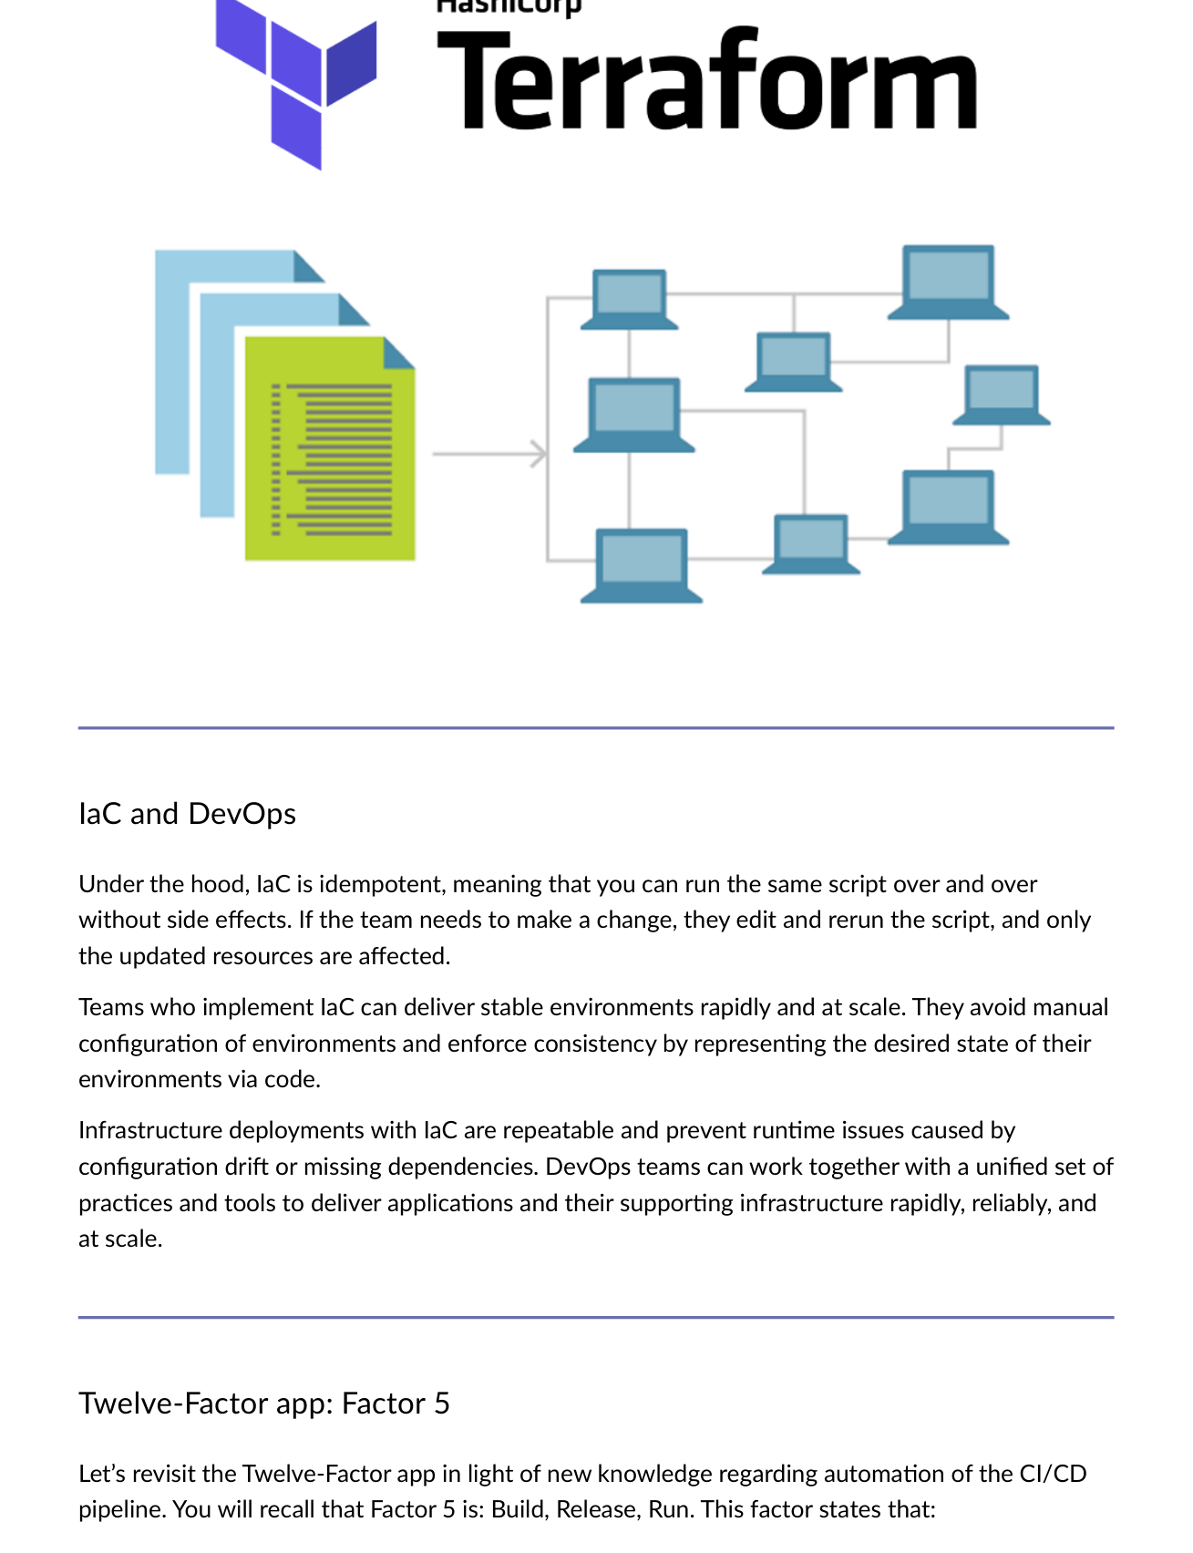
Fig 8.3 — IaC is idempotent: run same script repeatedly without side effects. Only updated resources are affected. Consistent, stable environments at scale.

IaC Property | Meaning
Idempotent | Run same script repeatedly without side effects — only updated resources affected.
Consistent | Avoid manual configuration drift between environments.
Repeatable | Same infrastructure every time — eliminates 'works on my machine' issues.
Version-controlled | Track infrastructure changes in source control like application code.

IaC Tool | Use Case
Terraform (HashiCorp) | Cloud-agnostic declarative IaC. Supports Azure, AWS, GCP and 100+ providers.
Ansible | Agentless configuration management and provisioning.
Azure Resource Manager (ARM/Bicep) | Azure-native IaC — JSON/Bicep templates for Azure resources.
Amazon CloudFormation | AWS-native IaC — JSON/YAML templates for AWS resources.

8.3 Build, Release, Run (Factor 5 Revisited)
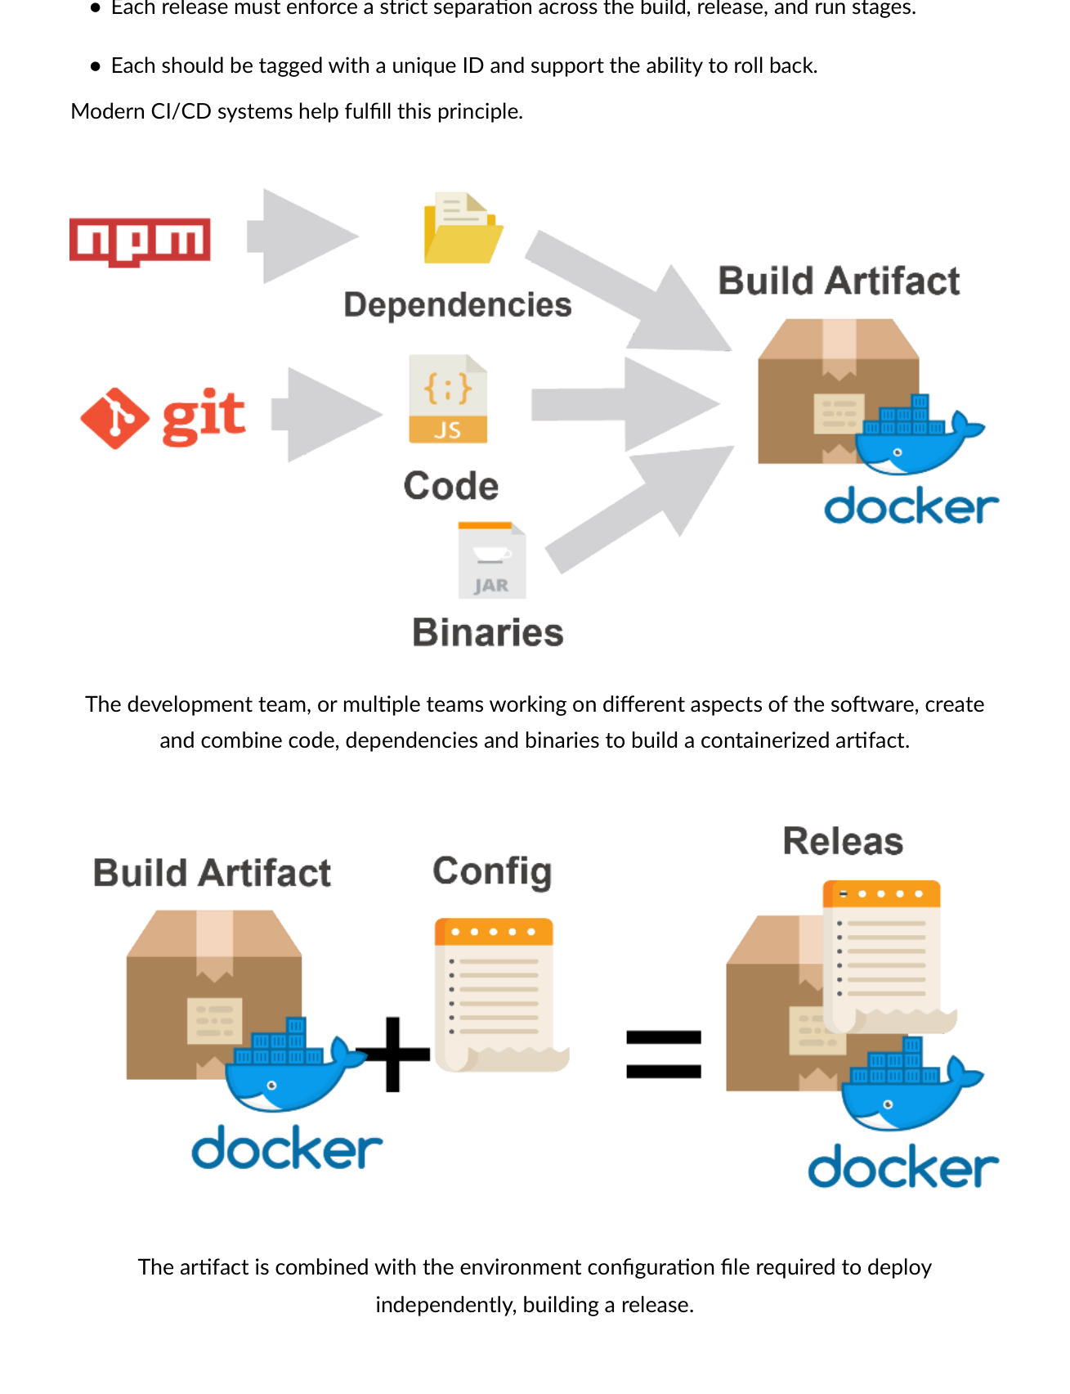
Fig 8.4 — Factor 5: Build = code + dependencies → containerized artifact. Release = artifact + environment config → immutable release.
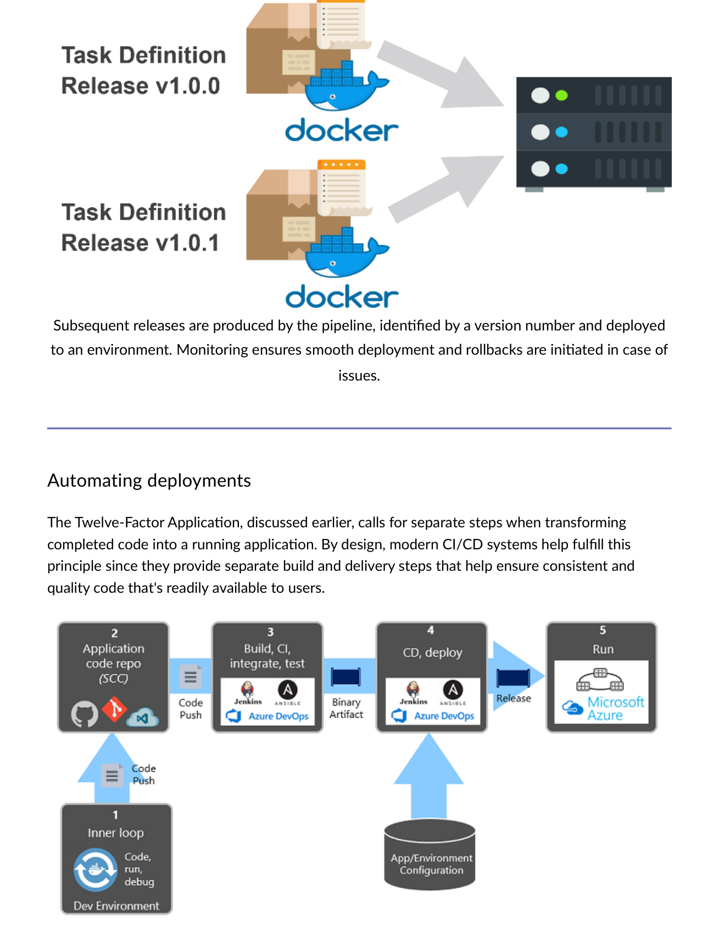
Fig 8.5 — Releases produced by pipeline, identified by version number, deployed to environment. Monitoring ensures smooth deployment; rollbacks if issues arise.

Step | Action
1. Developer builds feature | Code → run → debug (inner loop) in development environment.
2. Push to code repository | Git push to GitHub, Azure DevOps, or BitBucket.
3. CI pipeline triggered | Automatically builds, tests, packages into binary artifact.
4. CD pipeline triggered | Picks up artifact + applies environment config → produces immutable release → deploys.
5. Feature runs in production | Releases are IMMUTABLE — any change must create a new release.

8.4 Software Development Lifecycle Evolution
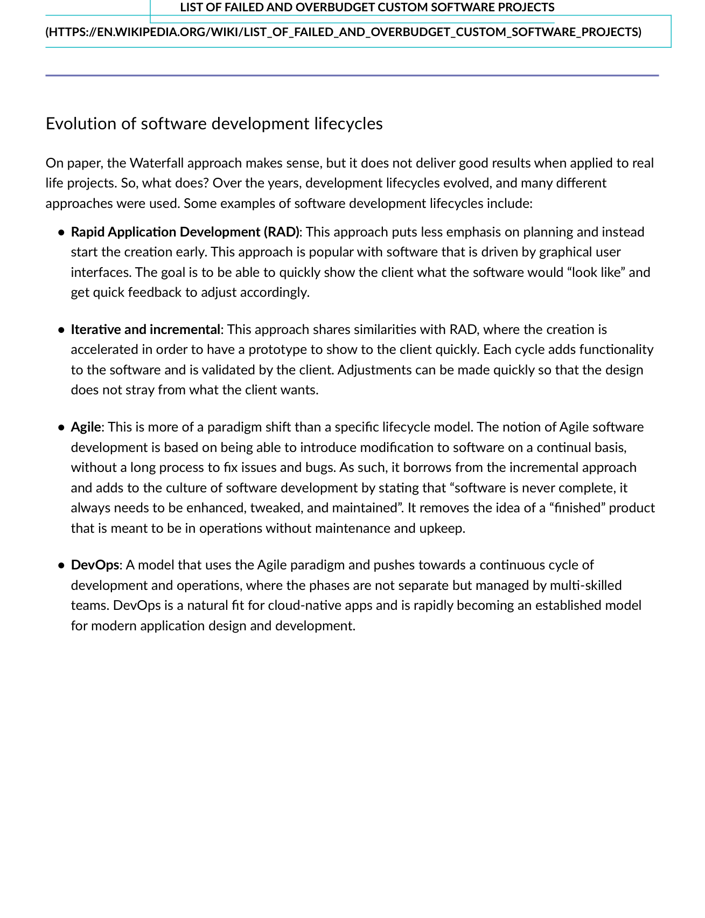
Fig 8.6 — SDLC evolution: Waterfall → RAD → Iterative/Incremental → Agile → DevOps. Each model addressing limitations of previous.

Model | Key Characteristics
Waterfall | 6-phase linear (Requirements→Analysis→Design→Coding→Testing→Deployment). Rigid, cannot go back. Good for rigour, bad for flexibility.
RAD | Rapid prototyping. Less planning, quick client demo, fast feedback. GUI-driven.
Iterative/Incremental | Build in cycles, adding functionality each iteration. Client validates each cycle.
Agile | Software is never 'finished' — always evolving. Continuous delivery, embrace change.
DevOps | Agile + operations combined. Multi-skilled teams. Continuous development and operations cycle. Natural fit for cloud-native.

8.5 CI/CD Pipeline
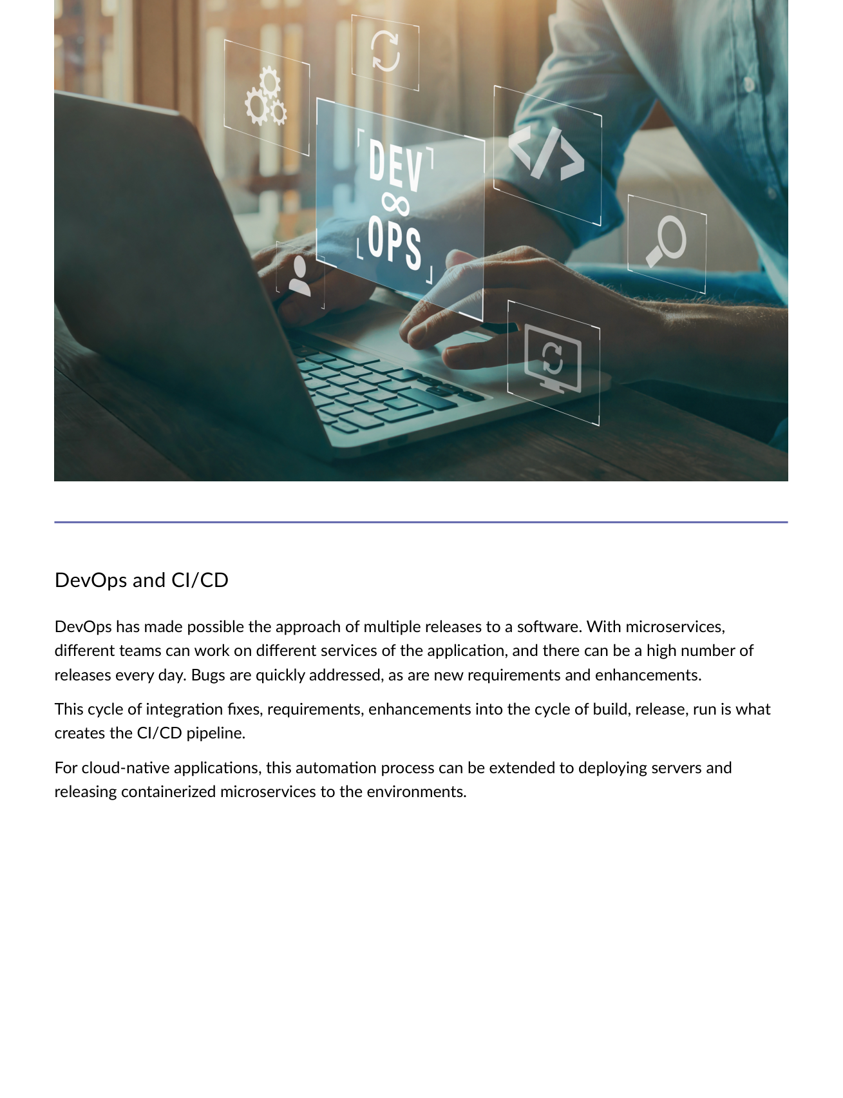
Fig 8.7 — DevOps enables multiple daily releases. Different teams work on different microservices. CI/CD cycle: fixes → enhancements → build → release → run.
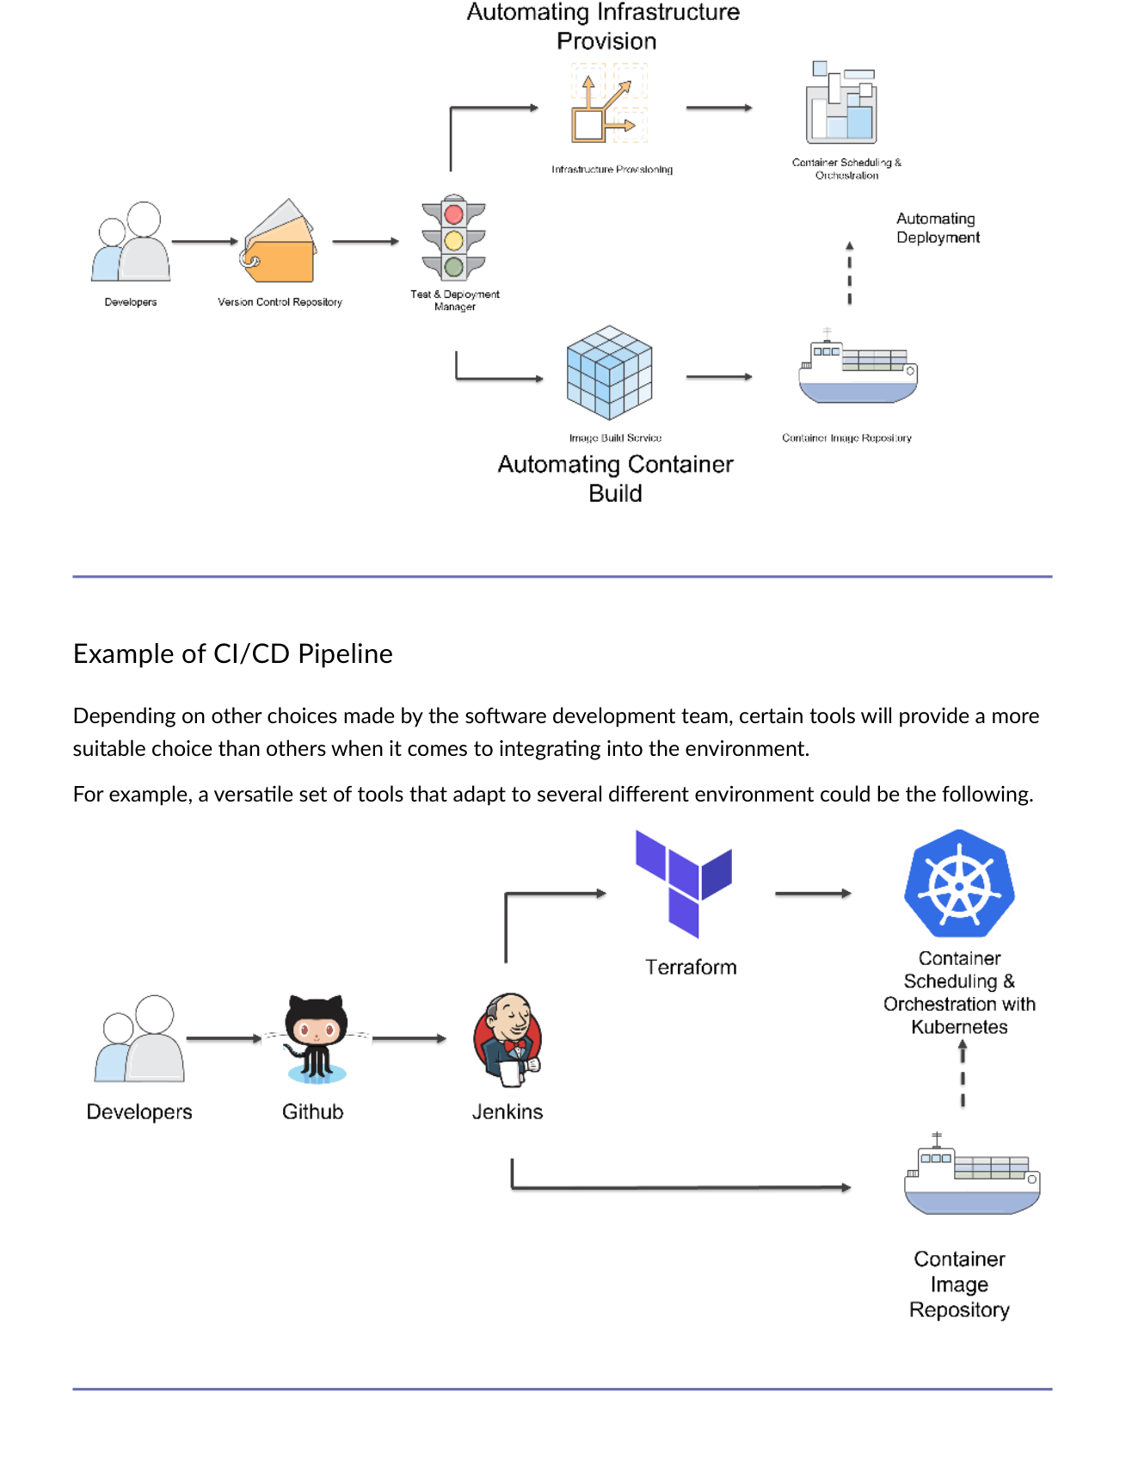
Fig 8.8 — Example CI/CD pipeline: Source Code Repo → CI Build Tool → Container Registry → CD Tool → Target Environment.
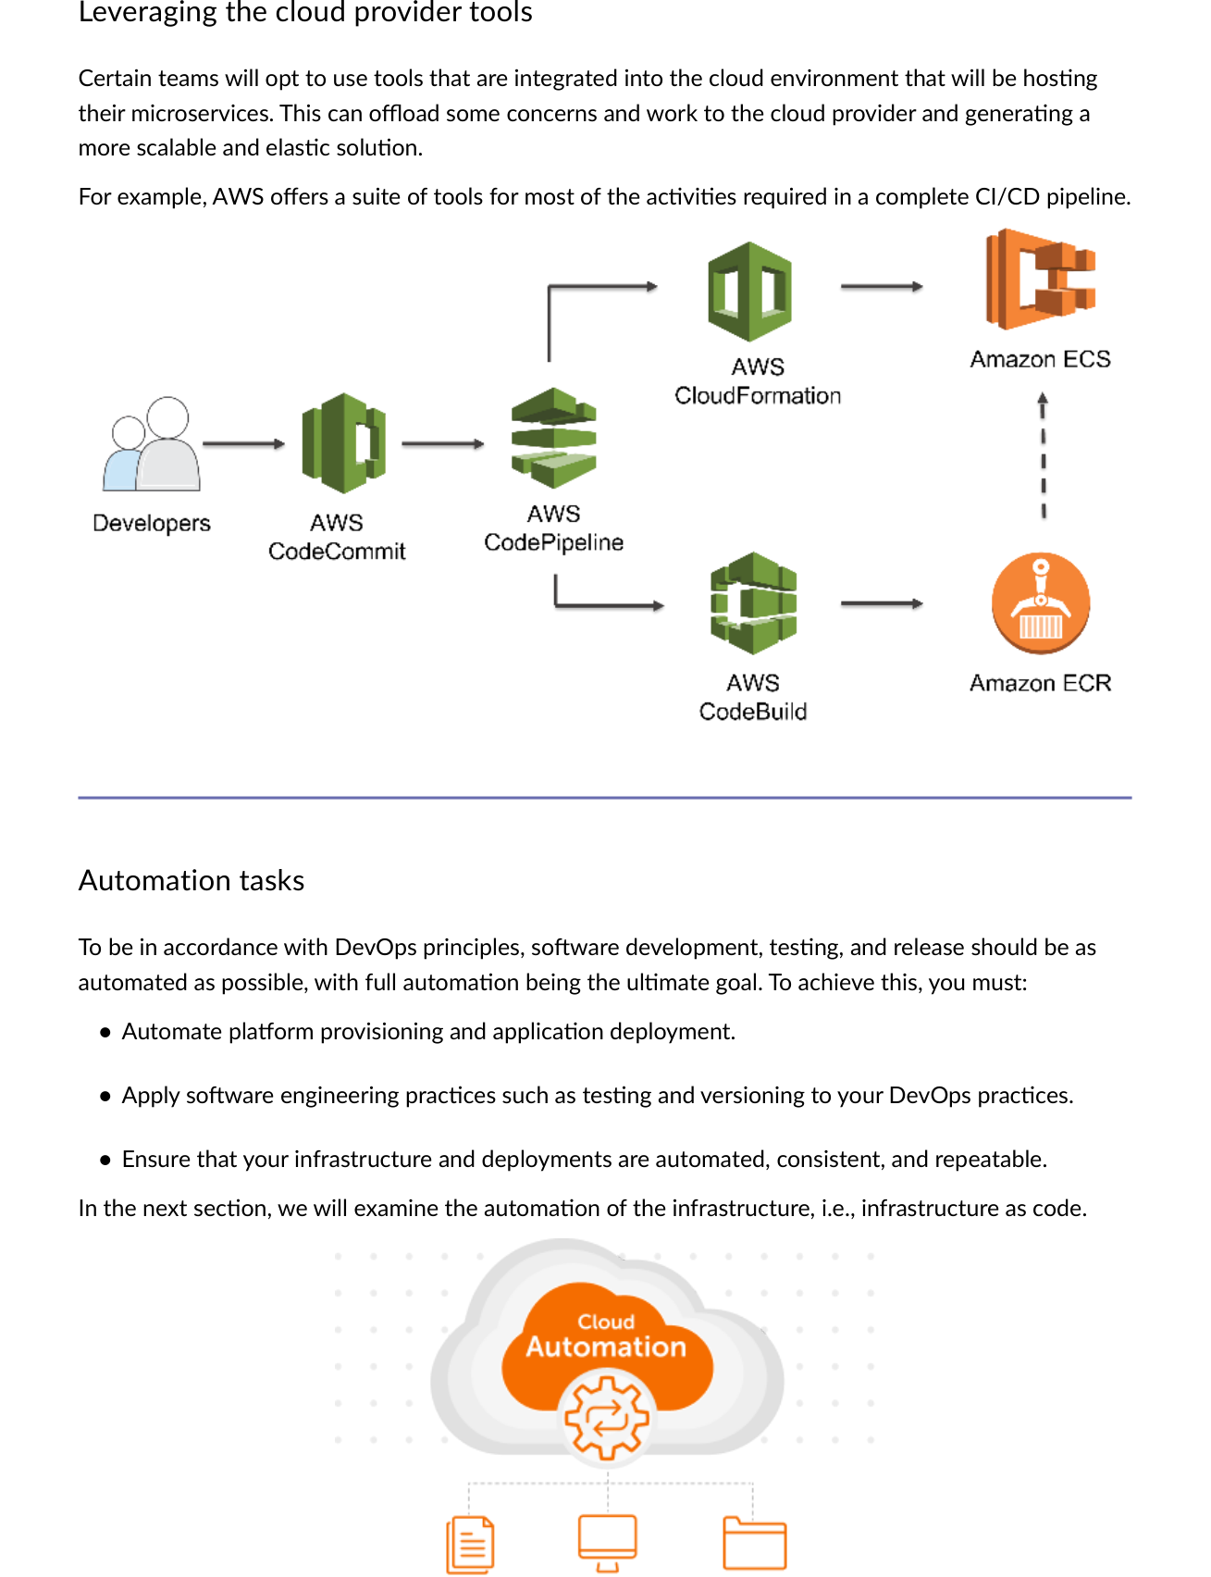
Fig 8.9 — Cloud provider CI/CD tools: AWS offers CodeCommit, CodeBuild, ECR, CodeDeploy, ECS/EKS for complete pipeline.

8.6 Automating the Container Build Process
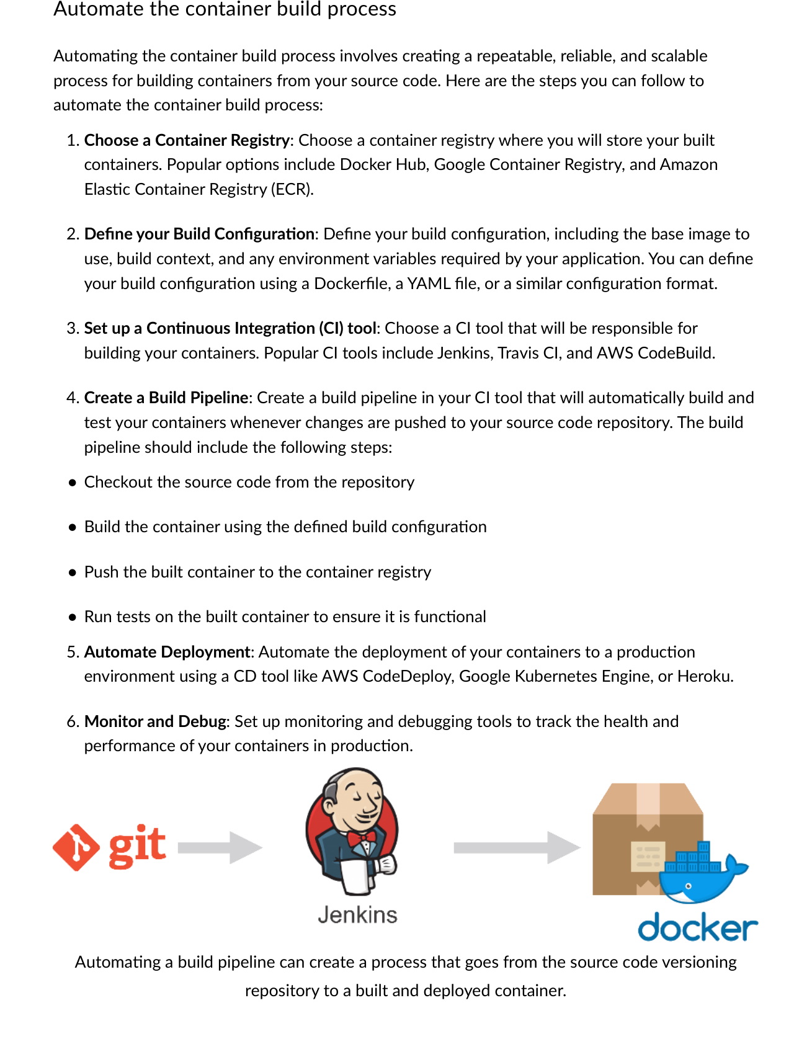
Fig 8.10 — Automate container build: Choose Registry → Define Build Config (Dockerfile) → Set up CI tool → Create Build Pipeline → Automate Deployment → Monitor.
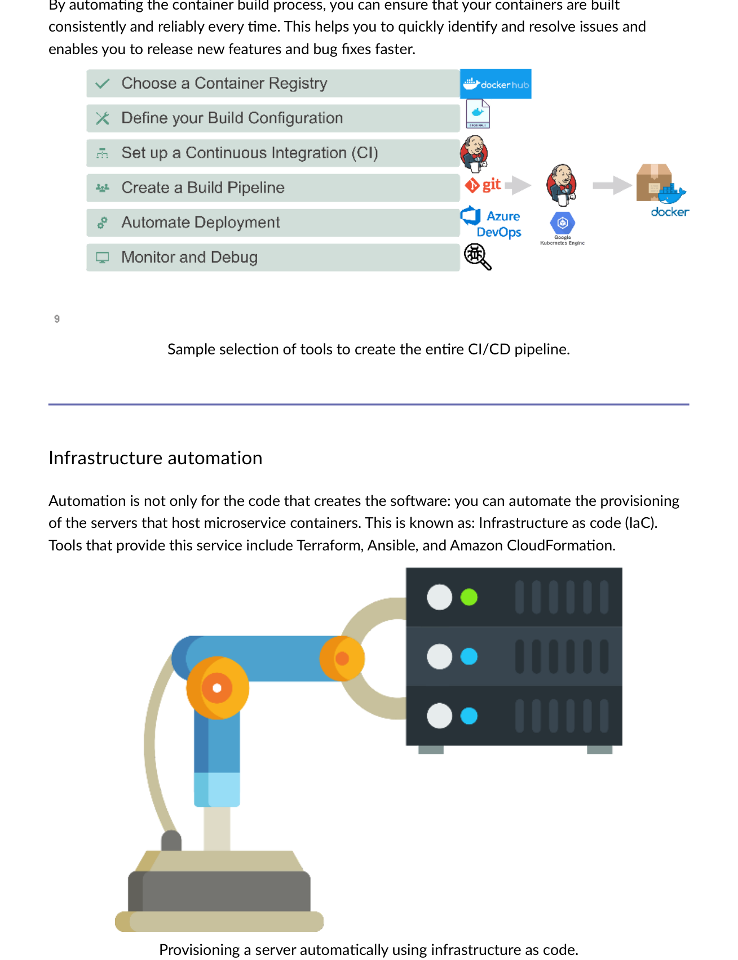
Fig 8.11 — Sample CI/CD tool selection: Git → Jenkins/CircleCI → Docker → DockerHub/ECR/ACR → Kubernetes/ECS.
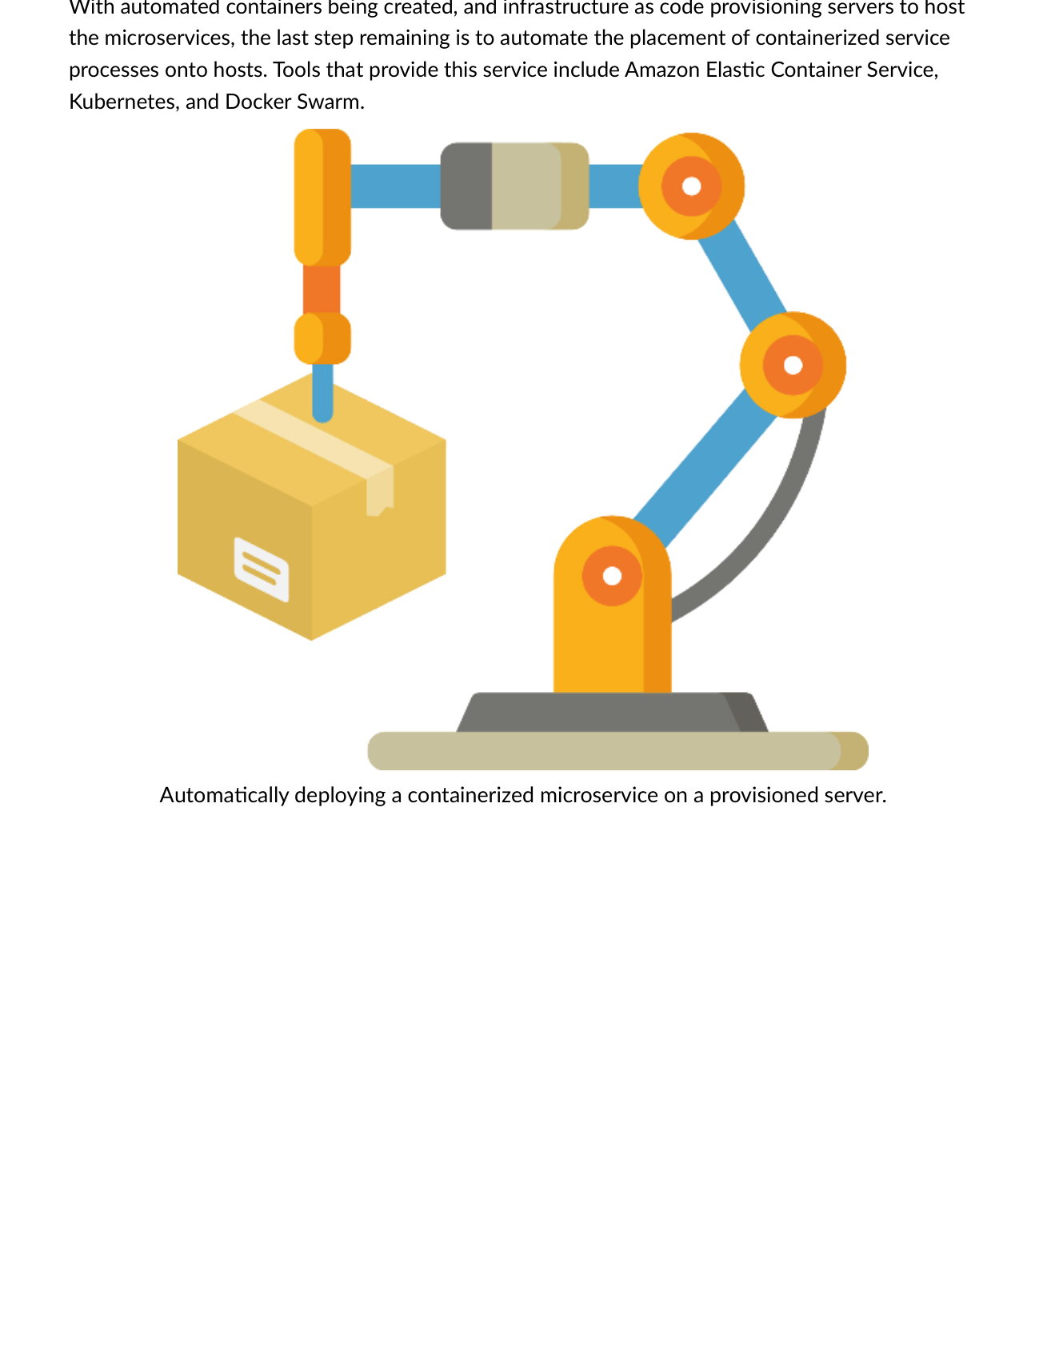
Fig 8.12 — Final automation step: place containerized services on provisioned servers using Amazon ECS, Kubernetes, or Docker Swarm.

Three Automation Layers — Complete Pipeline
Layer | Tools | Purpose
1. Container Build Automation | Jenkins, CircleCI, GitHub Actions, CodeBuild | Build and push container image to registry on every commit.
2. Infrastructure Automation (IaC) | Terraform, Ansible, ARM, CloudFormation | Provision servers/VMs/networks to host containers.
3. Container Placement Automation | Kubernetes, Amazon ECS, Docker Swarm | Place containers on provisioned hosts automatically.
💡 Career Tip
The DevOps/cloud-native trifecta every employer looks for: IaC + CI/CD + Container Orchestration. Being able to explain how all three connect from code commit to running container is a core cloud engineering interview skill.

QUIZ — 30 Essential Questions | CST8915 Cloud-Native

Cover the answer, attempt each question, then reveal. 🟢 Easy 🟠 Medium 🔴 Hard

Q1 [Easy] What is the CNCF official definition focus of cloud-native?
✅ Technologies empowering organizations to build scalable apps in modern environments (public/private/hybrid clouds) using containers, microservices, immutable infrastructure, and declarative APIs. Enables loosely coupled, resilient, manageable, observable systems.

Q2 [Easy] Name all 6 pillars of cloud-native.
✅ 1.The Cloud (PaaS/managed services) 2.Modern Design (12-Factor) 3.Microservices 4.Containerization 5.Backing Services 6.Automation

Q3 [Medium] Explain Pets vs. Cattle analogy.
✅ Pets=traditional servers: named, cared for, scaled up, missed if down. Cattle=cloud servers: numbered identically, scaled out, disposable, auto-replaced if failed. Cloud-native uses Cattle with immutable infrastructure.

Q4 [Easy] Netflix/Uber/WeChat deployment facts?
✅ Netflix: 600+ services, 100 deployments/day. Uber: 1,000+ services, thousands/week. WeChat: 3,000+ services, 1,000/day.

Q5 [Medium] What 5 factors make an app a good cloud-native candidate?
✅ Needs constant feature evolution, requires high release velocity, individual features release without full redeployment, teams with different tech stacks, components must scale independently.

Q6 [Medium] What is the 'Fear Cycle' in a monolithic application?
✅ As monolith grows too complex, administrators fear making changes (unintended side effects). New features become expensive. Each release requires full redeployment. Eventually no one understands the full application.

Q7 [Easy] Name the 4 technologies cloud-native computing combines.
✅ 1.DevOps (agile dev + CI/CD) 2.API-based communication 3.Microservices 4.Containers

Q8 [Medium] What is Factor 3 (Configurations) and why is it important?
✅ Config externalized from code and stored in environment variables. Same container deployed to all environments; config differs per environment. Prevents credentials in source code, makes environments interchangeable.

Q9 [Medium] Explain Factor 5: Build, Release, Run.
✅ Strict separation: Build (code+deps → binary artifact) → Release (artifact+config → immutable release with unique ID) → Run (execute in target environment). Releases are immutable — any change must create a new release.

Q10 [Medium] What does Factor 8 (Concurrency) say about scaling?
✅ Scale OUT horizontally across multiple identical processes — NOT scale up a single large instance. Develop the app to be concurrent so scaling out in cloud environments is seamless.

Q11 [Hard] What are the 3 additional factors beyond the original 12?
✅ API First (make everything a service), Telemetry (include monitoring/health data collection), Authentication/Authorization (implement identity and RBAC from the start).

Q12 [Medium] What are the 4 microservices principles?
✅ 1.Componentization (each service is a 12-factor mini-app) 2.Product Focused (products not projects) 3.Decentralization (no central bus) 4.Automation (IaC, CI/CD, container placement).

Q13 [Medium] What are the 4 challenges of microservices?
✅ 1.Communication (direct HTTP vs. decoupled messaging) 2.Resiliency (what when a service is unavailable) 3.Distributed Data (cross-service queries/transactions) 4.Secrets (securely managing credentials in distributed arch).

Q14 [Hard] What is the danger of throwaway microservices?
✅ Unmaintained microservices can corrupt data, breach service integrity, and jeopardize the entire application. ALL microservices MUST be maintained and kept in running order.

Q15 [Medium] What are the 4 application environment components to package?
✅ 1.Runtime Engine (JRE, Python interpreter) 2.Code (compiled or scripted) 3.Dependencies (libraries, packages) 4.Configuration (declarative metadata defining app needs).

Q16 [Easy] Key difference between VMs and containers?
✅ VMs virtualize hardware — each VM has full guest OS (gigabytes, minutes to start). Containers virtualize OS — share host kernel (megabytes, seconds to start). Containers truly portable; VMs portable limited by guest OS.

Q17 [Easy] What does a Dockerfile do?
✅ Defines how to build a container image — specifies base image, layers in dependencies, includes app code and config. Enables portable deployment independent of host environment.

Q18 [Hard] 3 limitations of VM virtualization that containers solve?
✅ 1.Each VM has separate full OS image — adds overhead (containers share host kernel). 2.Portability not guaranteed — app depends on guest OS (containers truly portable). 3.Resources not optimally shared — containers use only what they need.

Q19 [Medium] What are the 8 orchestration tasks?
✅ Scheduling, Affinity/Anti-affinity, Health Monitoring, Failover, Scaling, Networking, Service Discovery, Rolling Upgrades with auto rollback.

Q20 [Easy] What is a Kubernetes Pod?
✅ Smallest deployable object in K8s. Represents single app instance. Wraps one or more containers with shared storage/network. CANNOT run containers directly in K8s — must be wrapped in a pod.

Q21 [Hard] Name the 5 Control Plane services and 3 Node services.
✅ Control Plane: API Server, etcd (Backing Store), Scheduler, Controller Manager, Cloud Controller Manager. Node: Kubelet, Kube-proxy, Container Runtime.

Q22 [Easy] Give the formal definition of a backing service.
✅ A backing service is any service the app consumes OVER THE NETWORK as part of its normal operation.

Q23 [Hard] Factor 4 on local vs. third-party backing services?
✅ 12-Factor app makes NO distinction between local and third-party services — both are attached resources via URL. Swap local MySQL for Amazon RDS without changing code — only config handle changes.

Q24 [Medium] What are the 7 benefits of DBaaS?
✅ Cost savings, Scalability (up/down), Simpler management, Rapid development, Data security (enterprise-grade), Reduced risk (SLA), Software quality (pre-selected options).

Q25 [Easy] What does IaC stand for and what is 'idempotent'?
✅ Infrastructure as Code — defining infrastructure using code and version control. Idempotent: run same IaC script repeatedly without side effects — only updated resources affected each time.

Q26 [Hard] What are the 5 automated deployment stages?
✅ 1.Developer builds feature (inner loop). 2.Push to code repo. 3.CI pipeline: auto build/test/package into artifact. 4.CD pipeline: artifact+config → immutable release → deploy. 5.Released feature runs in target environment.

Q27 [Medium] Compare Waterfall and DevOps SDLC models.
✅ Waterfall: linear 6-phase, each phase complete before next, rigid. DevOps: Agile+operations combined, multi-skilled teams, continuous delivery, multiple daily releases, natural fit for cloud-native microservices.

Q28 [Hard] What are the 3 automation layers in the complete cloud-native pipeline?
✅ 1.Container Build Automation (CI: builds/pushes container image). 2.Infrastructure Automation/IaC (Terraform/Ansible: provisions servers). 3.Container Placement Automation (Kubernetes/ECS/Docker Swarm: places containers on hosts).

Q29 [Hard] How does containerization embody Factor 2 (Dependencies)?
✅ Containers isolate and package all their own dependencies — never rely on host. Deployments carry all deps with them. Container image includes runtime, code, deps, and config as single portable artifact.

Q30 [Hard] Summarize the relationship between the 6 cloud-native pillars.
✅ Cloud (PaaS infra) enables Modern Design (12-Factor) structuring Microservices (independent services) packaged as Containers (portable) consuming Backing Services (databases/queues/caches via URLs) — all delivered through Automation (IaC + CI/CD + orchestration).

KEY TERMS GLOSSARY | CST8915 Full-Stack Cloud-Native

Term | Definition | Term | Definition
Cloud-Native | Build apps exploiting cloud advantages: microservices, containers, orchestration, backing services, automation. | CNCF | Cloud Native Computing Foundation — 400+ members. Hosts K8s, Prometheus, Envoy.
Immutable Infra | Servers never modified after deployment — destroyed and replaced when changes needed. | Pets vs Cattle | Pets=named/cared-for servers. Cattle=disposable/identical/auto-replaced instances.
12-Factor App | Methodology for building portable, scalable SaaS apps via 12 principles. | Codebase (F1) | One repo per microservice; same code to all environments (QA/Staging/Prod).
Dependencies (F2) | Explicitly declare/isolate all deps — NEVER rely on the host. | Config (F3) | Store config in env vars, not code. Same container, different config per env.
Backing Svc (F4) | Attached resources via URL. Local = third-party. Only config changes, not code. | Build/Release/Run (F5) | Strict separation. Each release immutable with unique ID. Support rollback.
Processes (F6) | Stateless processes. Externalize state to backing services. | Port Binding (F7) | Each microservice on own port. Network-level isolation.
Concurrency (F8) | Scale OUT via identical processes — not scale UP one large instance. | Disposability (F9) | Fast startup, graceful shutdown. Instances disposable.
Dev/Prod Parity (F10) | Keep all environments as similar as possible. Containers help. | Logging (F11) | Logs as event streams → aggregator → Azure Monitor/Splunk → archival.
Admin Processes (F12) | Admin tasks as one-off processes via independent tools. | API First | Design everything as service API from day one.
Microservices | Small independent services via well-defined APIs — each owns its data store. | Monolithic App | Single unified software app — all components in one large application.
Container | Package with all elements to run in any environment — virtualizes the OS. | Container Image | Binary package: app code + dependencies + runtime. Blueprint for a container.
Docker | De facto standard container engine. docker build → push → run. | Dockerfile | Instructions for building a container image (FROM, COPY, RUN, CMD).
Container Registry | Stores/distributes container images. Docker Hub, ECR, ACR. | Hypervisor | Software creating/running VMs — sits between hardware and VMs.
Virtual Machine | Digital computer with own OS, binaries, libraries. Gigabytes, minutes to start. | Kubernetes | Open-source container orchestration — de facto cloud-native standard.
Pod | Smallest K8s unit — wraps containers with shared storage/network. | Node | Worker machine running pods (VM or physical).
Control Plane | API Server + etcd + Scheduler + Controller Manager — manages cluster. | kubectl | Kubernetes CLI — sends commands to cluster control plane.
etcd | Distributed key-value store — K8s backing store for all cluster state. | YAML | Human-readable config language for K8s manifests.
Rolling Upgrade | Zero-downtime update — gradually replaces old pods with new ones. | Backing Service | Any service consumed over the network as part of normal operation.
DBaaS | Database as a Service — fully managed DB consumed via URL/API. | NoSQL | Not-only SQL — database for unstructured/semi-structured data (MongoDB, DynamoDB).
Hard Coding | Setting info within app code — inflexible, requires code change to modify. | Attached Resource | Backing service bound via URL in config — interchangeable without code changes.
IaC | Infrastructure as Code — provisioning infra via version-controlled code. | Terraform | HashiCorp cloud-agnostic declarative IaC. terraform apply.
CI/CD | Continuous Integration + Continuous Delivery/Deployment — automated delivery pipeline. | CI | Auto build and test on every commit — catch integration issues early.
CD | Auto deploy after CI passes — enable frequent reliable releases. | DevOps | Culture combining dev + ops for faster, reliable software delivery.
Agile | Iterative dev embracing continuous change. Software is never 'finished'. | Waterfall | Linear 6-phase SDLC — each phase complete before next. Cannot go back.
Idempotent | Running same operation repeatedly produces same result — no side effects. | Immutable Release | Release that cannot be changed — any update requires creating a new release.
Inner Loop | Local dev cycle: code → run → debug before pushing to repo. | Containerd | Container backend extracted from Docker — standard container runtime.
gRPC | High-performance RPC framework by Google for inter-service communication. | AMQP | Advanced Message Queuing Protocol — async messaging between microservices.
Redis | In-memory data store used as cache, database, and message broker. | Service Discovery | Mechanism enabling containers/services to locate each other on the network.

INTERVIEW PREP | Cloud-Native Developer / Cloud Architect

Technical Questions

[Technical] What is cloud-native and how does it differ from traditional cloud hosting?
💬 Cloud-native is designing apps to FULLY EXPLOIT cloud advantages — not just moving existing apps to the cloud. Traditional cloud hosting (lift-and-shift) moves apps to IaaS VMs without changing architecture. Cloud-native uses microservices, containers, orchestration, backing services, and automation to build loosely coupled, scalable, resilient, observable systems designed FOR the cloud, not just deployed ON it.

[Technical] Explain the Twelve-Factor App and its significance.
💬 12 principles for cloud-native SaaS apps: one codebase/service (F1), explicit dependencies (F2), config in environment (F3), backing services as attached resources via URL (F4), strict Build/Release/Run separation (F5), stateless processes (F6), port binding (F7), horizontal scaling (F8), disposable instances (F9), Dev/Prod parity (F10), logs as event streams (F11), admin tasks as one-off processes (F12). Significance: vendor-neutral blueprint for apps that deploy and scale rapidly on any cloud.

[Technical] How do containers differ from VMs? When would you use each?
💬 VMs virtualize hardware — each VM has full guest OS (gigabytes, minutes to start). Containers virtualize OS — share host kernel (megabytes, seconds). Use VMs for full OS control, custom kernels, complete isolation, legacy apps. Use containers for fast deployment, horizontal scalability, microservices, Dev/Prod environment parity. In practice, containers often run ON VMs in cloud (e.g., AKS worker nodes are VMs running K8s pods).

[Technical] What is Kubernetes and what problems does it solve?
💬 Open-source container orchestration — de facto standard. Solves managing many containers at scale: automatic scheduling (placing containers on nodes), health monitoring (auto-restarting failed containers), auto-scaling (adding/removing instances on demand), service discovery (containers finding each other by name), rolling upgrades (zero-downtime deployments), networking overlay. Without K8s, managing hundreds of containers across many hosts requires manual intervention — K8s automates all of this declaratively via YAML manifests.

[Technical] What is IaC and why is it essential for cloud-native?
💬 IaC defines and provisions infrastructure (networks, VMs, load balancers) using version-controlled code instead of manual processes. Idempotent — running the same script multiple times produces the same result. Tools: Terraform (cloud-agnostic), Ansible, Azure ARM/Bicep, AWS CloudFormation. Essential for cloud-native because: (1) repeatable/consistent environments eliminating 'works on my machine', (2) foundation of CI/CD pipelines, (3) version-controls infrastructure alongside application code, (4) supports immutable infrastructure where servers are replaced via automation.

[Technical] What is a backing service and how does the 12-Factor App treat them?
💬 Any service consumed over the network as part of normal operation — databases, queues, caches, file storage. 12-Factor treats ALL as attached resources: accessed via URL, defined in config (not hardcoded), interchangeable without code changes. Local MySQL = Amazon RDS — swap by changing only config. Cloud-native apps prefer managed backing services: provider handles performance, security, monitoring, maintenance.

Scenario Questions

[Scenario] Designing a new e-commerce platform — how would you apply cloud-native principles?
💬 Break monolith into microservices: Product, Cart, Payment, Order, User, Notification — each independently deployable. Each follows 12-Factor: own repo, explicit dependencies, config in env vars, databases as backing services via URL. Containerize with Docker. Use AKS for orchestration — auto-scaling during peaks, rolling upgrades with zero downtime. Backing services: Azure SQL for orders, Redis for cart caching, Azure Service Bus for async notifications. CI/CD via Azure DevOps: commit → build → push to ACR → deploy to AKS. IaC via Terraform for all Azure resources.

[Scenario] A monolithic application is failing at scale. How do you migrate to cloud-native?
💬 Multi-phase — not a big-bang replacement. Phase 1: Lift-and-shift monolith to IaaS VMs — stop the bleeding. Phase 2: Strangler Fig Pattern — identify highest-traffic capabilities and extract them as microservices first (e.g., user auth, product catalog). Phase 3: Containerize each extracted service, deploy to Kubernetes. Phase 4: Replace backing services with managed cloud services (SQL Server → Azure SQL, file server → Azure Files). Phase 5: Build CI/CD pipeline per service — each team owns full lifecycle. Apply 12-Factor principles to every new microservice extracted.

[Scenario] How would you design a zero-downtime deployment for a microservice?
💬 Use Kubernetes rolling updates. Ensure microservice follows Factor 9 (Disposability) — fast startup, graceful shutdown. Configure readiness probes (K8s only routes traffic to fully-started pods). Configure liveness probes (K8s auto-restarts unhealthy pods). Set rolling update strategy: maxUnavailable:0 (no pod removed until new one ready), maxSurge:1 (add one extra pod at a time). Always at least one healthy instance serving traffic. Make update backward-compatible with current DB schema. If new version has issues, rollback is one kubectl command.

Behavioural Questions

[Behavioural] Why is Pets vs. Cattle important for cloud-native infrastructure?
💬 Captures a fundamental infrastructure mindset shift. Pets = invest in specific machines, name them, fix them when broken → fragility. Cattle = treat infrastructure as disposable and identical — when one fails, don't fix it, destroy it and auto-spin a new identical one. Enables true horizontal scaling, immutable infrastructure, and zero-downtime recovery. Practical implication: NEVER SSH into production to fix a server (that's treating it as a Pet). Instead, fix the IaC/Dockerfile/config and let automation replace the instance.

[Behavioural] Explain the relationship between microservices and the Twelve-Factor App.
💬 Complementary but separate: 12-Factor is the methodology for DESIGNING a microservice; microservices is the ARCHITECTURAL STYLE for composing an application. Each microservice should itself be a 12-Factor app — own codebase (F1), own dependencies (F2), config in environment (F3), communicates with other services as backing services via URL (F4), separate build/release/run stages (F5), stateless process (F6), own port (F7), scales horizontally (F8), disposable (F9). When every microservice follows 12-Factor, you get a cloud-native application that is portable, scalable, and maintainable.

Quick-Fire 30-Second Answers
Question | 30-Second Answer
What is cloud-native? | Designing apps to fully exploit cloud: microservices, containers, orchestration, backing services, automation.
What is a microservice? | Small independently deployable service with own codebase, data store, and API — one business capability.
What is Docker? | De facto standard container engine. Packages apps with all dependencies. docker build → push → run.
What is Kubernetes? | Open-source container orchestration. Manages scheduling, scaling, health, service discovery, rolling upgrades.
What is IaC? | Infrastructure as Code — defining infra using version-controlled code. Idempotent and repeatable.
What is CI/CD? | CI: auto build/test on every commit. CD: auto deploy after CI passes. Enables multiple daily releases.
What is a backing service? | Any service consumed over the network as part of normal operation — DB, queue, cache, file storage via URL.
12-Factor in one sentence? | Methodology for building portable, scalable SaaS apps: one codebase, config in env, backing services as attached resources, stateless processes, horizontal scaling, disposable instances.
What is a Kubernetes Pod? | Smallest K8s deployable unit — wraps containers with shared storage/network. Cannot run containers directly in K8s.
What is the Pets vs. Cattle analogy? | Pets=named/cared-for traditional servers. Cattle=identical/disposable/auto-replaced cloud instances.
What is DevOps? | Culture combining dev + ops. Multi-skilled teams, shared responsibility, CI/CD, continuous delivery.
What is immutable infrastructure? | Infrastructure never modified after deployment. Changes = destroy old + provision new. Consistency + reliability.

