AMS Help (1.1.8-1)

(Auditory Modelling System)

Lowel P. O'Mard

Centre for the Neural Basis of Hearing
Department of Psychology
University of Essex
Colchester
Essex, UK
CO4 3SQ

Introduction
The auditory model simulator (AMS) allows users to design, run and evaluate auditory models. It is backed up by the extensive collection of published and new models supplied by the development system for auditory modelling (DSAM), formerly known as LUTEar. At the time of writing, AMS is available for PC (Windows(tm) 95/98 NT) and UNIX platforms. A Macintosh(tm) will also eventually be available.

Installation
An automatic installation package is available for installing AMS on PC's. This can be easily installed by clicking on the package executable file downloaded onto your computer. The package is available from the WWW site and can be downloaded as a single file of about 2.5M, or two compressed archives that can be unpacked onto two floppy disks.

Getting started with AMS
Once AMS has been installed you can start running simulations immediately. AMS is configured on installation to run the default AIM model (how other models can be configured and run is described below). When the program is started the simulation manager window will appear as shown in the diagram below.

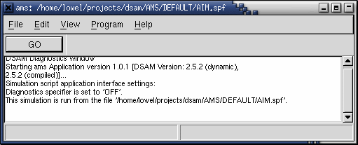
Figure 1 AMS simulation manager window.
This window allows you to run the simulation by pressing the "Go" button. The menu options allow you to

- Examine and change the simulation parameters,
- Change how the simulation is run, and
- List the current simulation parameters.

Program diagnostics are listed to the diagnostics section of the Simulation Manager window (where you can see the words "DSAM Diagnostics Window"). This window can be resized as required.

Running the Simulation
Pressing the "GO" button runs the default simulation. When the simulation is run additional windows will appear, as shown in the following screen shot:

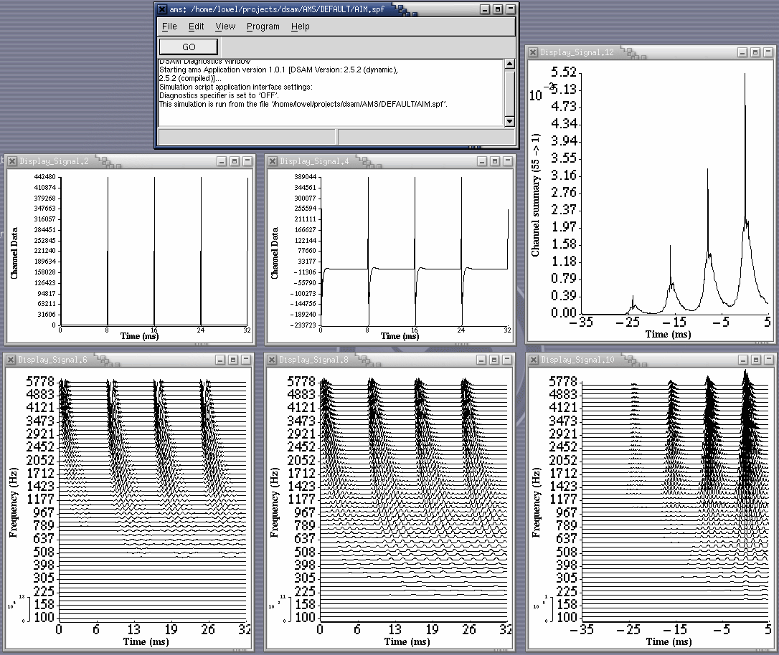
Figure 2 AMS run.

Changing Simulation Parameters
Once you have run the default simulation you can experiment with changing the simulation parameters. To gain access to the simulation parameters select the Simulation parameter option from the Edit menu. The simulation window will then appear as in the figure below:

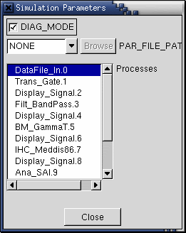
Figure 3 Simulation Parameter window

The bottom section of this window shows the process elements or modules in the simulation (as defined in the simulation script which is described later). The simulation starts with a DataFile_In process and ends with a Display_Signal process. You may examine and change any of the module parameters by clicking the mouse on one of the process names. For example, by clicking on the BM_GammaT process name the following parameter window is opened:

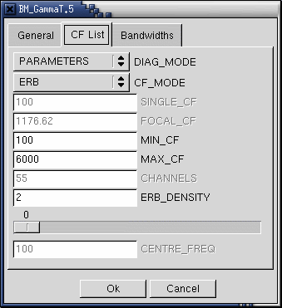
Figure 4 The parameter window for the BM_GammaT simulation process
You may change any of the module parameter values by using the standard window controls, e.g. by entering text into the appropriate. An abbreviation for each parameter is given to the left of each of the parameter controls. If you position the mouse over a parameter control and leave it there, a fuller description of the parameter will appear. You may press 'GO' after changing a parameter without closing the parameter window.

You can find further information, and example outputs for all of the process modules in the DSAM help manual.

Turning modules On and Off
You can turn of process modules from the simulation parameter window shown in Figure 3 Simulation Parameter window. Double clicking over the process module does this. When a process module is turned off, an "@" symbol appears to the left of the process name in the simulation parameter window. Turning off a process module means that the simulation will run without executing that process. This is useful when designing simulations, or for including many model-options in a single simulation script or just to see what happens. When a simulation is saved as a simulation parameter file (as described below) the state of the process modules: whether they are enabled or disabled, will also be saved.

Saving Changed Parameters to File
When you have changed a simulation and arranged the displays on your screen, you can save the state of the simulation as a Simulation Parameter File (SPF). This is an ASCII text file which contains a description of the simulation (in the form of a simulation script) and a list of all of the simulation process parameter values. The simulation can be read into AMS to return to using the simulation. This is also a good way for people to exchange simulations as such files can be sent via e-mail.

Segment Processing (Animated displays)
It is possible to see animated sequence of the process stages displayed in an AMS simulation. Processing a simulation in segmented sections of the stimulus makes this possible. The default AIM model simulation with which AMS is installed is initially configured to process one segment only of a data file. You can change the number of simulation runs, "NUM_RUNS" from the Edit->Main Parameters window (see Figure 5 Main Parameters Window) to a value higher than one. For each segment processed the displays will give a graphical display of the process data. The size of each segment is defined by the stimulus. In the case of the default AIM model, this is defined by the duration of the segment read from the data file. The speed at which this is done will of course vary according to how much processing is done (e.g. how many signal channels) and of course the power of your computer.

A special case occurs when reading stimuli from sound data files in segment processing mode. The number of segments to read from the stimulus is automatically calculated. This calculation takes place when the "NUM_RUNS" parameter (from the Edit->Main Parameters window, see Figure 5 Main Parameters Window) is set to, "-1" (a negative value). In this case the "NUM_RUNS" parameter will be set to the number of segments as determined by dividing the total duration of the signal by the segment duration. The segment duration is defined as the "DURATION" parameter for the DataFile_In.

AMS Menus
This section of the help document describes the options available from the AMS simulation manager window. This is the window that appears when the program is first started (see Figure 1 AMS simulation manager window.) If any of the menu options appear shaded, this means that the particular option has been disabled, e.g. if a valid simulation script has not yet been loaded.

File menu

File->Load parameter file (*.spf)…
This menu option opens a file browser to select a simulation parameter file (see section: The file browser window). Simulation parameter files can also be selected using the "Main Parameters" window from the "Edit" menu. Using this option from the "File" menu offers more direct access (fewer mouse operations).

File->Load script file (*.spf)…
This menu option opens a file browser to select a simulation script (see section: The file browser window). Simulation script files can also be selected using the "Main Parameters" window from the "Edit" menu. Using this option from the "File" menu offers more direct access (fewer mouse operations).

File->Save Simulation Pars.
This option allows you to save the current state of a simulation to a simulation parameter file (*.spf). Any parameter changes you have made while using the AMS program will be saved in the file. A file browser dialog window is opened (see Figure 6 File browser window). You may then specify the file to which the simulation parameter file should be saved. The simulation parameter file is a text file which can then be read when you wish to run the AMS program in the same state as you had previously saved in the file. (see section: Simulation parameter files). It is also a useful record of the state of a simulation, e.g. it can be listed and saved as a hard copy.

File->Quit
This option closes down the AMS program. This can also be done by process the key sequence "Ctrl-q".

Edit menu

Edit->Simulation parameters
Selecting this option will open a simulation parameter window. The window lists the names of all the processes in a simulation (as defined by the simulation script). By clicking the mouse on a process name, a window opens giving you access to the parameters for that process. You may open as many of the process parameter windows as you wish. You may keep the process parameter windows open when you execute the simulation; there is no need to close them before pressing "Go".

You can close process parameter windows by pressing the Ok or Cancel button. Pressing the Cancel button will close the parameter window ignoring any changes you might have made. You will notice that some changes in parameter windows will cause the Cancel button to be disabled. This means that a change has been made which cannot be ignored. The Cancel button will also be disabled if the simulation is run with the respective parameter window, or windows, open. This is because the changes will have been applied to the simulation. The ability to use the Cancel button will be restored if the window is closed then re-opened.

The top parameter area of the simulation parameter window shows the simulation diagnostic mode. This defines whether the diagnostics for the simulation are ON, OFF or if they are to be sent to a specified file. When the diagnostics are ON then the messages appear in the diagnostics panel of the simulation manager window (see Figure 1 AMS simulation manager window.)

You close the simulation parameter window by pressing the Close button at the bottom of the window. The simulation parameter window will close, along with all of its process module parameter windows.

This window can remain open while running the simulation.

Edit->Main parameters

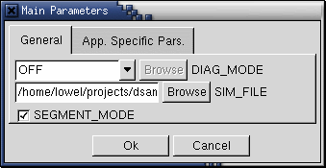
Figure 5 Main Parameters Window

This option allows you to change the main AMS program parameters. This window may be used to set the main diagnostics mode, load an alternative simulation script, specifiy the simulation parameter file to be read, set the segmented processing mode, set the file-locking mode or set the number of repeat runs (segment frames). Selecting the "App. Specific Pars" tab accesses the latter two parameters from the window.

Table 1 Application Parameters
Diagnostics mode | This parameter allows the user to decide whether or not to output diagnostics.  SCREEN: this value will send diagnostics to the simulation manager window's diagnostic panel. This can be scrolled up or down.  OFF: in this case no diagnostics will be output.  The last option in this control, set to "no_file" by default, allows a file to be selected to which the diagnostic information will be sent. The file name is specified by pressing the Browse button along side the control.
Simulation file | Using this parameter, different simulation scripts (*.sim) or simulation parameter file (*.spf) can be selected. The file path to the simulation file can be typed in directly, or by pressing the Browse button a file can be selected using the file browser window (see section: The file browser window). The successful selection of a simulation file will enable the simulation parameters option of the Edit menu.  NB. The default parameter files for a simulation will be read from the same file path as for the simulation script file.
Segmented processing mode | This parameter can be either ON or OFF. Segmented processing allows a simulation to be executed using signal segments that are smaller than the length of the signal. The simulation process is applied separately to each successive segment of the input signal, maintaining the continuity of the process state between each segment. A useful use of segmented processing is to observe the progressive changing of simulation processes as animated displays.
File locking Mode | This parameter can be either ON or OFF. When this parameter is enabled a lock file, ".ams_LCK" is created while the simulation is being process. It is deleted once the simulation run comes to an end. This is intended to be used when AMS is being run by another program, thus allowing the external program to know when AMS has finished processing its data.
Repeat runs/No. Segments | This is an integer value that defines the number of times a simulation script is run. In segmented processing mode it defines the number of segments processed. For example if the simulation script is set up to read data from a file in 32 ms segments, then setting this value to 4 will make the AMS program process 4 x 32 ms = 128 ms of the input signal.

View menu

View->Simulation parameters
This option prints the current simulation parameters in the diagnostics panel of the simulation manager window.

Program menu

Program->Execute
This menu option runs the simulation script. It has the same effect as pressing the 'GO' button.

Other AMS Windows

The file browser window
The file browser dialog window is opened when saving a reading files. Clicking the pointer (mouse) in the Directories and Files windows allows you to select the required file. The format of the file browser window may vary depending upon the platform on which AMS is being used. Simulation script files (*.sim) or simulation parameter files may be browsed by selecting the display extension.

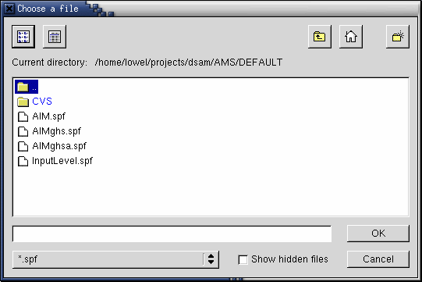
Figure 6 File browser window

The signal display window

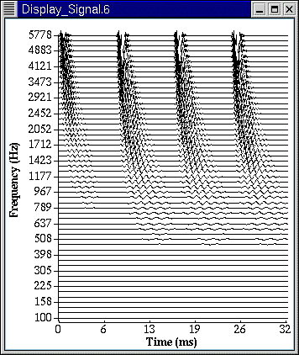
Figure 7 Signal display window

Using the DSAM/Help documentation

Advanced use of AMS

Parameter setting precedence on initialisation
When you run a simulation using AMS, the parameters used by the program and the simulation parameters will already have been set by variety of methods. These methods are summarised in the following diagram:

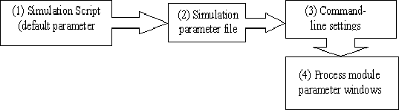
Figure 8 Precedence for parameter setting

Once the Simulation Manager window has appeared, AMS will have read the simulation script defined in the main parameters file 'AIM.par'. If this file does not exist, then a default set of main parameters will be chosen. The name of the file used to initialise the program can be changed from the command line (see "Command-line parameters and options"). On installation AMS is set up to read the main parameters for running the default AIM model.

Once the simulation script has been initialised, its parameters will then be set using the simulation parameter file (*.spf) if one has been specified. This is a text file containing simulation and program parameter values that can be saved from the AMS program (simulation manager window menus) or created manually using a text editor (see section: Simulation parameter files). The settings from the simulation parameter file will override the parameters with which the simulation was initialised using the simulation script.

If the AMS program is started from the command line, then the command-line settings will override any previously set parameters.

After the AMS program initialises, the user can then change the main parameters and the simulation parameters using the respective dialog windows.

Command-line parameters and options
When used on a UNIX(tm) or PC system, the AMS program can be run from the command line. This is also possible using Macintosh system, i.e. when calling AMS from another program. There are various reasons why you might want to do this. For instance, you may need to call AMS from within another program, such as Matlab(tm) or from a shell script. Server mode is particularly useful for this purpose, and is described below in section: Server mode. The AMS program allows you to change the operating parameters from the command line. You can change the main parameters for the program, and you can also change the simulation process parameters.

The AMS program is called using the following syntax: "ams [options] [parameter1 value1 parameter2 value 2 ….]".

The available options are described below. The optional parameter/value pairs are simulation process parameter names, followed by the required values. The syntax for these setting pairs is described below.

Command-line options
The available options for the ams program can be listed by issuing the command: "ams -h"

Table 2 AMS command-line options
Option | Arguments | Description
-h | none | This prints the available options and the command-line syntax for the AMS program.
-l | <list> | This option allows you to produce lists from the simulation script. The list options are:  parameters - this list option will produce a list of all of the parameters for a simulation script, followed by the main parameter values. The list is produced in the general format "parameter.module.step value description. These information can then be used to set the simulation process parameters from the command line.  cfinfo - this list option will produce a list of the centre frequency information for the first basilar membrane process module found in the simulation script.
-P | <file name> | The main parameters for the AMS program will be read from <file name> file.
-r | <x> | The number of repeat runs (segment frames) is set to the integer value <x>.. This main program parameter is described in section: Edit->Main parameters)
-s | <file name> | This option sets the simulation file to <file name>. This main program parameter is described in section: Edit->Main parameters). A simulation parameter file can be created using the "-l" command-line option.
-V | none | This option prints the current AMS program version.
-S | none | This option instructs the AMS program to run in server mode. The server mode is described in section: Server mode.
-I | <x> | When using the server mode option the server ID is set to the integer <x>. The server mode is described in section: Server mode.

Examples

A small section of the output produced by the command "ams -l parameters", using the default AIM settings, is shown below.:

##--------------- DataFile_In [0] ---------------##
FILENAME.DataFile_In.0 cegc_br.raw Stimulus file name.
WORDSIZE.DataFile_In.0 2 Default word size (1,2 or 4 bytes)
ENDIAN_MODE.DataFile_In.0 0 big- or little-endian: 0, 1 or 2.
CHANNELS.DataFile_In.0 1 No. Channels for raw binary and ASCII
NORM_MODE.DataFile_In.0 0 Normalisation factor (0 or -ve: automatic).
SAMPLERATE.DataFile_In.0 20000 Default sample rate: (Hz).
DURATION.DataFile_In.0 0.032 Duration of read signal: -ve = unlimited (s)
STARTTIME.DataFile_In.0 0 Start time (offset) for signal (s).
GAIN.DataFile_In.0 137 Relative signal gain (dB).
##--------------- Trans_Gate [1] ---------------##
POS_MODE.Trans_Gate.1 RELATIVE Position mode ('absolute' or 'relative')
OP_MODE.Trans_Gate.1 RAMP Operation mode ('ramp' or 'damp')
TYPE_MODE.Trans_Gate.1 SINE 'linear', 'sine', 'raised_cos', 'exp_decay'
OFFSET.Trans_Gate.1 0 Time offset (s)
DURATION.Trans_Gate.1 0.0001 Ramp (s)
SLOPE.Trans_Gate.1 0.004 Slope parameter or half-life .
##--------------- PreEm_BandPass [2] ---------------##
ORDER.PreEm_BandPass.2 2 Filter order.
ATTENUATION.PreEm_BandPass.2 0 Pre-attenuation for filter (dB).
LOWER_FREQ.PreEm_BandPass.2 450 Lower, 3 dB down cut-off frequency (Hz).
UPPER_FREQ.PreEm_BandPass.2 8500 Upper, 3 dB down cut-off frequency (Hz).
(The rest of the listing has been truncated).

Note that some of the descriptions have been shortened so that they fit on this page.

The listing shows only the parameters for the first three process modules in the simulation script. Note that the parameters list for each process module starts with a comment line. The comment line contains the name of the process module, and the step number in the simulation script. Each of the lines has the order parameter name, value, description. This file can be used to find the parameter names to use when setting parameters from the command line.

Command-line Parameter/Value pairs
It is possible to run and set the parameters of a simulation from the command line. This is done using the syntax shown at the start of this section (Command-line parameters and options).

The parameter name syntax is:

<parameter name>.<process name>.<label>

This is the same format that is produce by the "ams -l parameters" command or as stored in simulation parameter files. The process name and the label can also be found from the simulation parameter window (see Figure 3 Simulation Parameter window).

An example of setting a parameter from the command line is "ams duration.DataFile_In.0 0.011". Assuming that the program is set to the default installation settings (using the AIM simulation script) the command will produce the following figures, which you can compare with Figure 2.

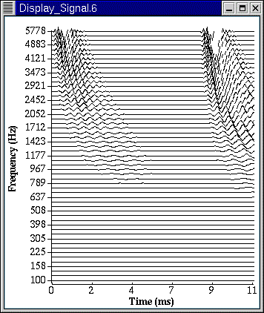
Figure 9 DSAM Display (6) window with segment duration 11 ms

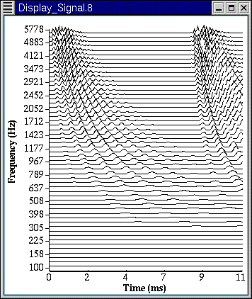
Figure 10 DSAM Display (8) window with segment duration 11 ms

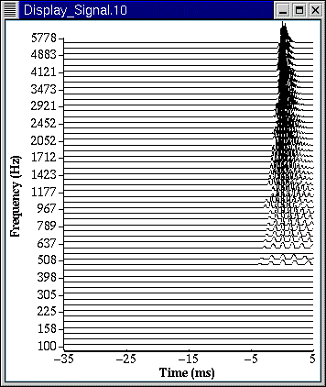
Figure 11 DSAM Display (10) window with segment duration 11 ms. Note that the time axis for this SAI display is independent of the segment duration.

You can see that the time for the first two displays (Figure 9 and Figure 10) now run from 0 to 11 ms instead of 0 to 32 ms. The display in Figure 11 is special and has its time range set by the Stabilised Auditory Image process module - see the DSAM Help document for further information.

Abbreviations can be used when setting parameters from the command line, e.g. the following example could be repeated using the command "ams dur.Data.0 0.011". Only the process label can not be abbreviated.

You may also reduce the number of fields included in the parameter name: "ams dur.Data 0.011" and "ams dur 0.011" will both work. Note that in the latter case, the value of the first parameter in the simulation starting with "dur" will be changed. The rule is that you increase the number of fields used to identify a parameter as the opportunity for ambiguities increases. For example, in the default AIM simulation script, there are three uses of the "Display_Signal" process module, so the full number of fields must be employed to ensure that the correct display parameter is set. In this case you may still abbreviate both the parameter name and the module name.

Note that any parameters set on the command line will override settings in a simulation parameter file, if one is specified.

Server mode

Introduction
The server mode for AMS was introduced so that it could be run without requiring any user intervention at all, i.e. pressing the "GO" button. This means that the AMS program can be completely controlled by other programs, such as MATLAB(tm), shell scripts or batch-files. On multi-user systems, different AMS servers can be used.

Server mode can only be started using the command-line syntax as described in section: Command-line parameters and options, using the "-S" option, i.e. the command "ams -S" will start AMS in server mode with all the defaults as defined by the current main program and simulation parameters.

When AMS server mode is started, the current simulation will be run once. Controls are then sent to the AMS program using command lines that include the "-S" option. Using the example given in section "Command-line parameters and options":

- The command "ams -S" starts an instance of AMS in server mode.
- The command "ams -S duration 0.011" would instruct the AMS program to re-run the simulation, after setting the DataFile_In process module's duration parameter to 11 ms.
- The command "ams -S -r 10" would change the number of segments of the stimulus read to 10 segments (repeats).

Using multiple servers
More than one instance of AMS can be started in server mode. In addition to the "-S" option the "-I <x>" option must also be given, where "<x>" is the given identity number for the server:

- The command "ams -S -I 5" starts an instance of AMS in server mode, with identity, "5".
- The command "ams -S -I 5 duration 0.011" would instruct the AMS server with identity "5", to re-run the simulation, after setting the DataFile_In process module's duration parameter to 11 ms.

Using pipes
It is possible to use pipes with AMS on UNIX and PC systems. This may be done by using a special file name for the DataFile_In/DataFile_Out process modules parameter. Instead of using a usual file name, such as "cegc_br.raw", using the filename "-.raw". This indicates to the DataFile_In/DataFile_Out modules that the file is to be read from or output to the standard input or output respectively. The extension indicates which format is to be read or output. The AMS program can then be used in a pipe command, e.g.

- cat cegc_br.raw | ams_ng > output.txt

Note that the "ams_ng" program is used rather than "ams". This is the AMS program compiled without the Graphical User Interface support (GUI). It is supplied with all installations of AMS. It is best to use this form of the program when calling AMS from other programs, when the GUI support or displays are not required.

Also note that the diagnostics mode of the AMS program should be set to OFF otherwise these diagnostic messages can cause the reading of binary files by subsequent commands in pipes to fail.

Simulation parameter files

Description
When the "Save Simulation pars." is selected from the File menu (File->Save Simulation Pars) the current state of the simulation being run is saved to a plain text file. This file has been called a simulation parameter file (SPF) because it contains all of the information required to define a particular simulation. This information includes the positioning of any display windows, which is a useful facility as you can return to a particular desktop configuration just by saving a SPF.

SPF's contain the simulation script, followed by the parameter settings for each of the process modules on successive lines. An example of a SPF is given below. The middle section of the file is missing for display purposes. It has been formatted using a table though the actual saved file is plain text.

Table 3 Simulation parameter file (AIM.spf)
##--------------- Simulation script ----------------------##
ON Diagnostics mode ('off' or 'on').

begin {
DataFile_In < waveDflt.par
Trans_Gate < gateDflt.par
Display_Signal < WAVEdflt.par
Filt_BandPass < midearDflt.par
Display_Signal < WAVEdflt.par
BM_GammaT < gtfDflt.par
Display_Signal < BMMdflt.par
IHC_Meddis86 < medDflt.par
Display_Signal < NAPdflt.par
Ana_SAI < stiDflt.par
Display_Signal < SAIdflt.par
Util_ReduceChannels < reduceDflt.par
Display_Signal < sumSAIdflt.par
}
##--------------- DataFile_In [0] ---------------##
FILENAME.DataFile_In.0 | "cegc_br.raw" | Stimulus file name.
WORDSIZE.DataFile_In.0 | 2 | Default word size for sound data (1,2 or 4 bytes)
ENDIAN_MODE.DataFile_In.0 | 0 | Default (for format), big- or little-endian: 0, 1 or 2.
CHANNELS.DataFile_In.0 | 1 | No. of Channels: for raw binary and ASCII files.)
NORM_MODE.DataFile_In.0 | 0 | Normalisation factor for writing (0 or -ve: automatic).
SAMPLERATE.DataFile_In.0 | 20000 | Default sample rate: for raw binary and ASCII files (Hz).
DURATION.DataFile_In.0 | 0.032 | Duration of read signal: -ve = unlimited (s)
STARTTIME.DataFile_In.0 | 0 | Start time (offset) for signal (s).
GAIN.DataFile_In.0 | 137 | Relative signal gain (dB).
##--------------- Trans_Gate [1] ---------------##
POS_MODE.Trans_Gate.1 | "RELATIVE" | Position mode ('absolute' or 'relative')
OP_MODE.Trans_Gate.1 | "RAMP" | Operation mode ('ramp' or 'damp')
TYPE_MODE.Trans_Gate.1 | "SINE" | Type mode ('linear', 'sine', 'raised_cos' or 'exp_decay')
OFFSET.Trans_Gate.1 | 0 | Time offset (s)
DURATION.Trans_Gate.1 | 0.0001 | Ramp duration - negative assumes the end of the signal (s)
SLOPE.Trans_Gate.1 | 0.004 | Slope parameter or half-life (in 'decay_par' mode only)
********** lines missing ***********
##--------------- Util_ReduceChannels [11] ---------------##
MODE.Util_ReduceChannels.11 | "AVERAGE" | Mode - 'average' or simple 'sum'.
NUM_CHANNELS.Util_ReduceChannels.11 | 1 | Number of channels signal is to be averaged to.
##--------------- Display_Signal [12] ---------------##
AUTO_SCALING.Display_Signal.12 | ON | Automatic scaling ('on' or 'off').
CHANNEL_STEP.Display_Signal.12 | 1 | Channel stepping mode.
MAGNIFICATION.Display_Signal.12 | 1 | Signal magnification.
MAXY.Display_Signal.12 | 0.034799 | Maximum Y value (for manual scaling).
MINY.Display_Signal.12 | 0 | Minimum Y Value (for manual scaling).
NUMGREYSCALES.Display_Signal.12 | 10 | Number of grey scales (raster mode).
WIDTH.Display_Signal.12 | -1 | Displayed signal width (seconds or x units).
X_RESOLUTION.Display_Signal.12 | 0.01 | Resolution of X scale (1 - low, fractions are higher).
NORMALISATION.Display_Signal.12 | "BOTTOM" | Y normalisation mode ('bottom' or 'middle').
X_DEC_PLACES.Display_Signal.12 | 0 | X axis scale decimal places.
X_TICKS.Display_Signal.12 | 5 | X axis tick marks.
Y_AXIS_MODE.Display_Signal.12 | "LINEAR_SCALE" | Y axis mode ('channel' (No.) or 'scale').
Y_DEC_PLACES.Display_Signal.12 | 2 | Y axis scale decimal places.
Y_TICKS.Display_Signal.12 | 15 | Y axis tick marks.
FRAMEDELAY.Display_Signal.12 | 0 | Delay between display frames (s)
MODE.Display_Signal.12 | "LINE" | Display mode ('off', 'line' or 'raster').
SUMMARYDISPLAY.Display_Signal.12 | OFF | Summary display mode ('on' or 'off').
TOPMARGIN.Display_Signal.12 | 5 | Top margin for display (percent of display height).
WIN_HEIGHT.Display_Signal.12 | 392 | Display frame height (pixel units).
WIN_TITLE.Display_Signal.12 | "Display_Signal.12" | Display window title.
WIN_WIDTH.Display_Signal.12 | 342 | Display frame width (pixel units).
WIN_X_POS.Display_Signal.12 | 837 | Display frame X position (pixel units).
WIN_Y_POS.Display_Signal.12 | 90 | Display frame Y position (pixel units).
<<>> Simulation parameter file divider.
DIAG_MODE.AMS.0 | "SCREEN" | Diagnostics mode specifier ('off', 'screen' or <filename>).
SIM_FILE.AMS.0 | "AIM.sim" | Simulation file.
SEGMENT_MODE.AMS.0 | ON | Segmented or frame-base processing mode ('on' or 'off').
FILELOCKING_MODE.AMS.0 | OFF | File locking mode ('on' or 'off').
NUM_RUNS.AMS.0 | 1 | Number of repeat runs, or segments/frames.

A comment line precedes the parameters for each process in the simulation script. The comment (text on a line after a '#' character) contains the name of the process module and the process step number in the simulation script. The process parameter lines are in three sections: the parameter specification, the parameter value and the parameter description.

The parameter specification uses the full format as described above in the section "Command-line Parameter/Value pairs" above; the parameter name, the module name and the process step number are given.

If the parameter value is a string, then it is enclosed in speech marks. These are not really necessary unless the string contains white space.

The description is only to provide additional information about a parameter.

The line with the "<<>>" characters at the beginning is important in a SPF. It tells the program that the simulation parameter lines have ended, and that the following lines are the program parameter lines.

Using Simulation Parameter Files

SPF's can be read directly into the AMS program to define a simulation. If this is done, then it will replace any simulation that was previously being run by the program.

The SPF file can be edited directly, by hand or using another program, before reading it into AMS as it is a plain text file. You can add as many comment lines as you wish, or even change parameters. (It is usually better to change parameters from AMS as illegal values will be checked.) The formatting required is quite loosely defined. The process module parameter settings must begin on a new line, and the simulation script should be correctly set out, as described in the DSAM help documentation.

Because they are plain text files, SPF's can be e-mailed to colleagues thus simulation processes can be shared and compared.

It is possible to create new simulations by creating a simulation parameter file from scratch. However, it is usually simpler to use a simulation script, which reads the process parameters from different files. A SPF file can then be created by reading the simulation script into AMS, then saving the simulation as an SPF.

Input Signal Level

Introducing Potential Level Problems
When using AMS, it is sometimes necessary to ensure that the input stimulus to a simulation is of the correct level. This issue is of particular concern to those using binary sound format files as input to AMS, and is especially important when level-depend process modules such as the IHC_Meddis86 hair cell model are used. The hair cell model only responds at the spontaneous rate unless the input it receives is above the threshold intensity. (See the rate-intensity curves for the IHC_Meddis86 process module in the DSAM Help document).

Raw binary files will usually have been normalised to allow the maximum dynamic range to be stored using the specified word size. Such a file read into AMS using the DataFile_In process module and used without being scaled will be interpreted as a very low dB SPL intensity. Unless the normalisation value that was used is known then the signal read from the data file will need to be appropriately scaled before it can produce a response from the hair cell model. The signal can be scaled using the "gain" parameter of the DataFile_In process module.

A Simple Method to Set a Useable Gain
For some uses, the exact setting of the input level is not required: the important thing is to produce a useable response from the respective simulation. To this end a simple simulation has been included with this installation, it can be loaded into AMS using the "InputLevel.spf" SPF file, which can be found in the installation's "DEFAULT" directory.

The "InputLevel.spf" simulation reads in a specified data file and displays the signal. A 57 dB SPL pure tone used as input will fill the display window, with peaks at 20024 μPa and troughs at -20024 μPa. The user can set the file read by this simulation, and the gain changed until the signal displayed fills the screen in a similar way. The intensity may not be exactly 57 dB SPL because the intensity calculation is only accurate for pure tones.

The name of the file read by the simulation can be set by selecting the simulation parameter window (see section Edit->Simulation parameters), then selecting the DataFile_In process module parameter window, as shown in Figure 12 below.

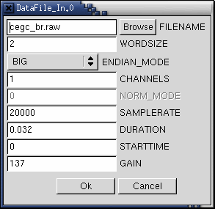
Figure 12 DataFile_In Parameter Window

The required file name can then be typed in or selected by pressing the "Browse" button.

Leaving the DataFile_In parameter window open, run the simulation (press the "Go" button). The signal will be displayed as shown in Figure 13 below for a pure tone.

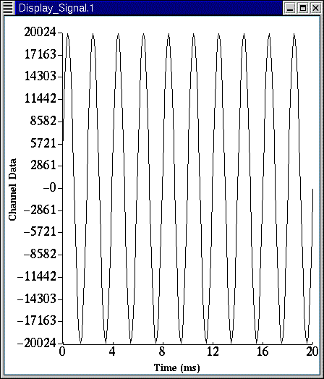
Figure 13 Level Display Window

Now change the "Gain" parameter in the DataFile_In parameter window and re-run the simulation. Continue to do this until the signal fills the display in a similar way to the pure tone. As a guide, a two-word (16 bit) binary file will require a gain of around 120 dB.

Please note that AIFF files written using AMS or another DSAM application do not require scaling in this way, as the normalisation information is stored with the file, i.e. if the "PTone57dBSPL.aif" is selected, it will be displayed as shown in Figure 13 without zero gain being applied. This file can also be found in the installation's "DEFAULT" directory.

