AMS Tutorials (2.4)

(Auditory Modelling System)

Ray Meddis
Lowel P. O'Mard

Centre for the Neural Basis of Hearing
Department of Psychology
University of Essex
Colchester
Essex, UK
CO4 3SQ

First steps with Auditory Modelling system (AMS)
This tutorial describes AMS and how to use it. It is divided into two sections:
- a formal description of AMS (sections to )
- worked examples using auditory models(sections to )

The tutorial assumes that
- AMS has already been installed.
- You currently have a folder at the top level C:\DSAM containing all relevant folders and resources.
If you have located the DSAM folder elsewhere, you will need to take care when interpreting path names in what follows.

The tutorial materials are all found in C:\DSAM\AMS\tutorials. Copy this folder to your normal workspace. Do not work inside the DSAM workspace.

You may find it helpful to create a shortcut to AMS.exe and place it on your desktop. You will find it in C:\DSAM\AMS. The phrase 'launch AMS' can then be interpreted as 'double click on the AMS shortcut'.

Getting started
Launch AMS by double-clicking on the desktop icon 'Shortcut to AMS.exe'.

The program should now display a window with a blue title bar containing pull-down menus and a 'GO' button. We call this window the 'AMS window'. You can resize the AMS window by dragging on the corners in the usual way. The current simulation is named in the title bar of the AMS window.

Do not click on 'GO'. If you do, AMS will run the program that was most recently loaded (or a default program set by the installer). This could give you a long wait or other complications.

Load the model
- In the AMS window, select the 'File' pull-down menu and select 'Load script file (*.sim)'
- Navigate to the Tutorial folder. (You should have your own copy in your workspace).
- In the Autocorrelation folder, select the acf.sim file and click on 'Open'.

AMS will now load the acf.sim file. Nothing will happen until you click on GO.

This operation should be trouble free if you have been given the correct files. However, if there are problems (such as missing files or incorrectly prepared .par files), these will be reported immediately in the AMS window.

Go!
- Click on 'GO'

Your screen should fill with display windows showing the results of the various stages of the model computations. A detailed description of these will be given in section 5.

Your screen should look something like this.
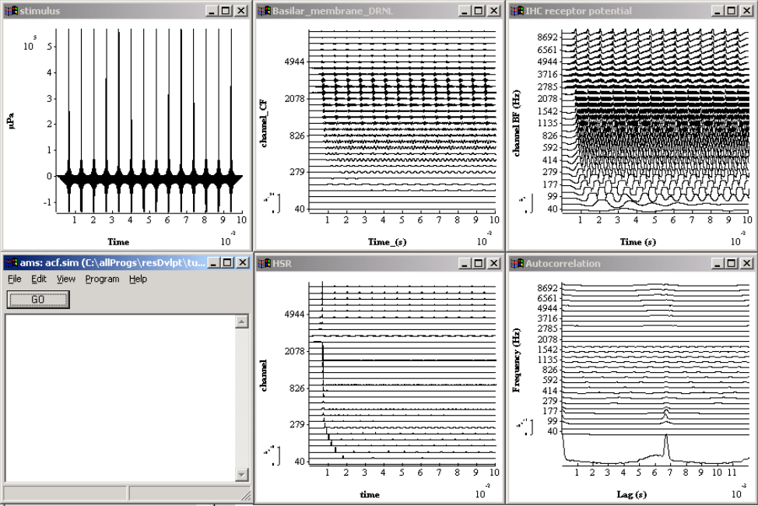
Figure 1. Sample screen display for acf.sim

Stop!
If a program is taking too long, select the AMS window and type CTRL/c. It might work! PCs are getting better at interrupting programs but are still not perfect.

If this does not work, kill the program by invoking the windows 'Task Manager' and 'ending' the AMS process. You can find the Task Manager by right-clicking on the taskbar (normally the bar at the bottom of the screen).

If the program locks up (nobody is perfect!), you should use the Task Manager to kill it.

Quit.
If the AMS window is open but the program is not running, you can quit the program using the File menu; select File->Quit from the AMS window.

Re-launching AMS
When you next launch AMS, it should start with the model most-recently loaded. This assumes that you quit your last session in an orderly way (by selecting 'Quit' from the File menu.

Trouble shooting.
Nothing should go wrong at this stage. If there are problems at this stage, repeat the whole installation process from the beginning.

If that does not work, email lowel@essex.ac.uk or email rmeddis@essex.ac.uk.

Simple things that can go wrong.
- AMS may be looking at a different simulation file from the one expected. To be absolutely sure, load the file explicitly using File->Load Script file (*.sim). This is particularly a problem if you have been using .spf files. These can look very similar to the corresponding .sim file. If you change a .sim file and it has no effect, this probably means that you are running the .spf file!

- .par file has some comments that do not have comment marks (#). If these are missing, AMS will try to read the comments and become confused.

- Case sensitivity sometimes arises, for example with stimulus file names. Mostly, however, AMS is not case sensitive.

- A file required by AMS might be in use by another application. Close the application or otherwise release the file.

About AMS

A shared resource
A note on the philosophy of AMS may well be appropriate here. The DSAM (Development System for Auditory Modelling) and the AMS application are all part of an auditory community-wide project. While it is hosted by the CNBH (Centre for Neural Basis of Hearing), DSAM has been designed as a platform for common use. Anyone can contribute modules to the core routine library as long as they are willing to adopt the conventions of DSAM code. A software tool is available that generates the basic code for routines. A separate tutorial will soon be available for users who wish to incorporate C-code routines into the DSAM system. Alternatively, users can make suggestions for modules that might be included or directions that might be explored. Indeed, active users have suggested all of the modules presently in use.

Organic nature
DSAM is growing continuously and consists of a fixed library of tried and tested routines with a minority of routines that are still in development. Some routines are very stable, a minority are still being debated and moulded to suit the needs of users. At any given time, both a stable and a BETA version of the system are available. The stable is relatively problem free and is supported by the manual. The beta version includes the latest improvements and extensions with no guarantee that they have been thoroughly tested; BETA versions will have undergone functional testing, however it is never possible to know the behaviour of the system in every foreign situation.

This software is distributed in the hope that it will be useful, but WITHOUT ANY WARRANTY; without even the implied warranty of MERCHANTABILITY or FITNESS FOR A PARTICULAR PURPOSE.

Please bear the above in mind. We are not a commercial concern, though effort is made to present as professional a package as possible. This software is a shared effort. If you are having difficulty, get in touch and we shall try to help. If you have a comment or suggestion, let us have it. If we can use it, we shall.

Documentation is a nightmare for us. Not only is it time-consuming to produce, it is also rapidly out-dated by the continual developments that are taking place. The authors are also scientists and science has first priority, so the documentation is always lagging behind. The very best way to find out about DSAM and to learn its subtle ways is to visit Essex University and spend a day or two with us. You will be made very welcome. This is how most serious users got started.

Levels of user
Low level. Originally, all users were C-savvy programmers who borrowed or cannibalised C-code from the core-routines library.

High level. For some purposes, complete models have been prepared for end-users who did not wish to become involved in the detailed process of constructing models. Discuss your requirements with us, if you fall into this category.

Flexible modellers. Currently, our emphasis is on providing a system that allows users to build up models from fixed but flexible building blocks. This is AMS (the Auditory Modelling System). The rest of this document is aimed at flexible modellers. . Many different models can be produced. The flexible modeller can combine an AMS model with MATLAB or UNIX programming.

Free to University users
University researchers engaged on purely scientific studies can download and use this software freely. They are also welcome to consult the authors for help when required.

The software is not free to commercial users or users engaged on commercial contracts. We expect such users to contact us to discuss their requirements and any applicable charges.

Understanding AMS files (.sim, .par and .spf)
AMS is an application that allows the user to build auditory models using a simple scripting language. The script that defines a model is contained in a text file called a simulation file or a '.sim' file. The simulation file specifies a list of modules and specifies the order in which they are to be run.

Each module name may be accompanied by the name of a parameter or '.par' file. Parameter files are text files that specify the value of the parameters used in the accompanying module. If no parameter file is specified, AMS will supply default parameters. Parameters can also be set and changed while AMS is running. Parameter files merely specify the parameter values at start-up.

Parameter and simulation files are created and modified using the text editor of your choice.

There is another kind of file called a 'simulation parameter file (or '.spf' file). AMS itself normally creates this file. It is a text file that can be edited in a text editor. It is a complete description of a simulation in a single file. It incorporates both simulation and parameter file specifications.

Examples of many simulation and parameter files can be found in the folders that accompany these tutorial notes.

Overview and example of .sim and .par files
Here is a simple but complete and viable simulation file. It requests AMS to generate a click and show it in a display window.

# generateClick.sim
begin {
# Stimulus generation
Stim_Click < stimClick1.par
Display_Signal
}

The important part lies between the left and right curly brackets. It consists of the names of two process modules; Stim_Click and Display_Signal. A parameter file is specified for the click generation module; stimClick1.par.

# Stim_Click < stimClick1.par

TIME 0.001 Time for the delta-function click (s).
AMPLITUDE 40 Amplitude (uPa).
DURATION 0.01 Duration (s).
DT 1e-05 Sampling interval, dt (s).

This parameter file requests a 40 μPa click after 1 msec in a total stimulus whose duration is 10 msec. The sample rate of the model is 100 kHz and the width of the click is a single sample (10 μsec).

The .sim file

Simulation file structure
This section gives a formal statement of the structure of a simulation file. You can skip this on first reading but it may prove useful later as a source of reference.

The simulation file is made up of a series of separate lines:
- Continuation across successive lines is not permitted.
- Blank lines are ignored.
- Lines in the file beginning with a '#' symbol are ignored by DSAM. These lines are used for comments.
- Anything occurring after the final curly bracket is ignored.

Header.
Scripts can begin with optional header information consisting of two parameters. The parameter name is the first item on each (optional) line, for example:

Diag_mode on Diagnostics mode - \off\ or \on\
Par_file_path_mode relative Parameter file path mode - \relative\ or \absolute\

Diagnostics mode: on/off. . This instructs AMS whether or not to show run-time diagnostics in the AMS window. There are two possible values: 'off' and 'on'. This default setting is 'off'.

Parameter file path mode: relative/absolute. Parameter file paths are either relative to the folder containing the .sim file location or absolute. The default setting is 'relative'.

If a line is not added for either parameter, then the respective default settings will be used.

Process statements.
All process statements must lie inside the curly brackets of a begin { } sequence. Everything after the curly brackets is ignored.

Each line within the curly brackets must obey the following syntax

<switch> <label%> process name <path indicators> <parameter file name>

Switch.
An '@' can be used to switch off a module. This module can be enabled at run time, if required, using the edit\ simulation parameters window. To enable the module, open this window and find the module name in the list. It should have a'@' character beside it. Remove the '@' sign by double-clicking on the module name. It may be necessary to single click first (to open the parameter window) and then double click on the module name, this is a bug in the system.)

Labels
Labels are useful when a line will be referenced from elsewhere; for example in a path indicator or from a MATLAB program.
- Labels are optional.
- All labels consist of an ASCII string terminated with a '%'.
- The string may not contain a space.

Process names.
A list of process names can be found in the manual (help files) accessed from the AMS window: Help-> DSAM Help->Process modules reference library.

A process can, itself be a simulation (Util_SimScript). If this happens, the named simulation file is run at this point.

Path indicators
These define the source of the input to the process and the destination of the output.

The syntax of a path indicator is:
(input list -> output list)

- Path indicators follow immediately after the process name
- Path indicators are optional. If none is given, defaults are used
  - The default input to a process comes from the preceding process.
  - The output goes by default to the following process.
- The input list and the output list consist exclusively of labels defined elsewhere in the script. The % label indicator is omitted inside a list.
- If a line contains a path indicator, it must also have a label

For example:
acc% accumulate (a, b -> c, d)

This shows that the accumulate process will take its input from the two processes labelled a and b. The output will go to processes labelled c and d. The output will not go to the following process.

Parameter file names
These are preceded by a '<' character. Parameter files are optional. If they are not present, AMS supplies default parameters. The default parameters can be found in the manual (help files).

- The parameter file name is, in fact, the address of the parameter file.

- If the Parameter file path mode is set to 'absolute', this will be taken to represent the full file path.

- If the Parameter file path mode is set to 'relative', this will be taken to represent the file path starting with the location of the simulation file.

Repeat loops
A repeat loop can be placed anywhere within a begin {...} group.

repeat N {
......
}

A group of process statements inside the curly brackets of a repeat loop will be computed N times, where N must be a positive integer.

Some process modules accumulate results (for example, ANA-histogram) inside a repeat loop unless actively reset. To reset a module use the reset command. For example

repeat 20 {
...
reset myHist
myHist% Ana_Histogram <myHistogram.par
}

Editing .sim files
Changes can be made to .sim and .par files using a text editor. When a change is made (and the new text saved), it is necessary to reload the files into AMS because AMS cannot see that you have edited the files.
- Reload using the AMS window File menu 'File->Reload simulation file'.

Parameter files
The .par files contain parameters that are used by their calling process.

Each process requires its own unique set of parameters. A list of parameters can be found in the manual (help files) associated with its respective process. A list of process names and their parameters can be found in the manual (help files) in Help\ DSAM Help\ Process modules reference library.

Parameter files are optional. If no file is specified, the default parameters will be used. If a parameter file contains less than the full set of parameters, the missing parameters will be assigned default values. The values associated with the parameters in the manual are the default values.

A parameter file consists of a list of parameter name\value pairs; one pair per line.
- The parameter name is the first item on each line
- The parameter value is the second item on each line
- All subsequent material on the line will be ignored.
- Blank lines are ignored.
- All characters following the comment character '#' character will be ignored.

Changing parameters
Permanent changes. Change parameters by editing .par files using a text editor. When a change is made (and the new text saved), it is necessary to reload the files into AMS because AMS cannot see that you have edited the files.
- Reload using the AMS window File menu 'File->Reload simulation file'.

Temporary changes. Parameters can also be changed temporarily while AMS is open by using the parameter windows.
- Select 'Edit->Simulation parameters' from the AMS pull-down menus. This will open another window listing all the processes. Select a process by clicking on its name.
- When the parameter window for a given process is open, you can select and change any visible parameter. These changes will remain in force until the end of the session when they will be forgotten unless they are saved in a .spf file.
- It is not necessary to close the parameter window before running the program again. Just click on 'GO'.
- Parameters affecting displays can be changed in the same way. However, they can also be changed by right-clicking on the display and selecting 'preferences'. If you change the parameters in this way, you must close the parameter window before attempting any other action. The display will be changed without the need to rerun the program

.spf files
A simulation parameter file (.spf file) describes the complete model and all its parameters in a single file.

Its advantages include
- Compact and easily transportable.
- Gives a complete specification of the model including the process sequence and all parameters.
- It shows full process names including its label.

Its disadvantages include
- It is not easy to add new process modules to a model described by a .spf file.

Creating .spf files
- Run AMS
- Load the model of choice using the .sim file
- Select the option 'Save simulation pars' from the AMS window File menu.
- Name it. The file name must have the file extension '.spf'.
- Save it.

The .spf file is a text file that can be inspected using any text editor.

AMS is able to run the model using this file alone. To run a model using a .spf file, use the 'File' pull-down menu on the AMS window and select 'Load parameter file'. In some circumstances, this is the preferred mode of operation (only one file needed). It is particularly useful when you wish to share a model with a colleague who has no desire to manage or to delve into a whole collection of separate files.

After making temporary changes to parameters using the parameter windows in AMS, you may wish to preserve the changes. The best way is to immediately save the simulation parameters as an .spf file with its own name. You still have the original parameters in the .sim and .par files. These are unaffected by saving an .spf file.

Warning! If you save an .spf file, AMS will assume that this is now your current file and will store this assumption when you quit. When launching AMS at a later date, the system will automatically load the last file in use. If you saved a .spf file, AMS will automatically reload the .spf file. If you really want the original .sim file, you must reload it explicitly. This can be a trap for the unwary. If you find that changes to your .par files are not having any effect, this may be because the system is reading your most recent .spf file.

Example of simulation specification file
This ,spf file is based on the example given in 3.1.1.

##--------------- Simulation script ----------------------##
DIAG_MODE ON Diagnostics operation mode PAR_FILE_PATH_MODE "RELATIVE" Parameter file path mode

begin {
Stim_Click < stimClick1.par
Display_Signal
}

##----- Stim_Click.0 (stimClick1.par) -----##
TIME.Stim_Click.0 0.001 Time for the delta-function click AMPLITUDE.Stim_Click.0 40 Amplitude (uPa).
DURATION.Stim_Click.0 0.01 Duration (s).
DT.Stim_Click.0 1e-005 Sampling interval, dt (s).

##----- Display_Signal.1 (not_set) -----##
MAGNIFICATION.Display_Signal.1 1 Signal magnification.
NORMALISATION.Display_Signal.1 "MIDDLE" CHANNEL_STEP.Display_Signal.1 1 Channel stepping mode.
NUMGREYSCALES.Display_Signal.1 10 Number of grey scales.
X_RESOLUTION.Display_Signal.1 0.01 Resolution of X scale WIDTH.Display_Signal.1 -1 Displayed signal width Y_AXIS_TITLE.Display_Signal.1 "" Y-axis title.
Y_AXIS_MODE.Display_Signal.1 "CHANNEL" Y-axis mode AUTO_SCALING.Display_Signal.1 ON Automatic scaling ('on' or 'off').
AUTO_Y_SCALE.Display_Signal.1 ON Automatic y-axis scale MAXY.Display_Signal.1 0 Maximum Y value MINY.Display_Signal.1 0 Minimum Y Value Y_NUMBER_FORMAT.Display_Signal.1 "y" Y axis scale number Y_DEC_PLACES.Display_Signal.1 0 Y axis scale decimal places.
Y_TICKS.Display_Signal.1 15 Y axis tick marks.
Y_INSET_SCALE.Display_Signal.1 ON Y inset scale mode X_AXIS_TITLE.Display_Signal.1 "" X axis title.
AUTO_X_SCALE.Display_Signal.1 ON Autoscale option for x-axis X_NUMBER_FORMAT.Display_Signal.1 "xe-3" X axis scale number X_DEC_PLACES.Display_Signal.1 0 X axis scale decimal places.
X_TICKS.Display_Signal.1 6 X axis tick marks.
X_OFFSET.Display_Signal.1 0 X offset for display in zoom mode X_EXTENT.Display_Signal.1 -1 X extent for display in zoom mode WIN_TITLE.Display_Signal.1 "Display_Signal.1" Display window title.
MODE.Display_Signal.1 "LINE" Display mode SUMMARYDISPLAY.Display_Signal.1 OFF Summary display mode FRAMEDELAY.Display_Signal.1 0 Delay between display frames (s)
TOPMARGIN.Display_Signal.1 5 Top margin for display WIN_HEIGHT.Display_Signal.1 500 Display frame height WIN_WIDTH.Display_Signal.1 440 Display frame width (pixel units).
WIN_X_POS.Display_Signal.1 0 Display frame X position WIN_Y_POS.Display_Signal.1 0 Display frame Y position

<<>> Simulation parameter file divider.

DIAG_MODE.ams.0 "OFF" Diagnostics mode specifier SIM_FILE.ams.0 "C:\Program Files\DSAM\AMS\resDvlpt\tutorials \generateStimulus\generateClick.sim" Simulation file.
SEGMENT_MODE.ams.0 ON Segmented or frame-base processing # Sub-parameter list:
FILELOCKING_MODE.ams.0 OFF File locking mode ('on' or 'off').
NUM_RUNS.ams.0 1 Number of repeat runs

Running a simulation
The files described above are located in a folder
'Tutorials\GenerateStimulus'

You can run this program in the following way
- Launch AMS. The AMS window will appear on the screen.
- Select from the pulldown menus- File -> Load script file (*.sim)...
- Open file 'generateClick.sim'
- Click on 'GO'
- You should then see the display screen below.

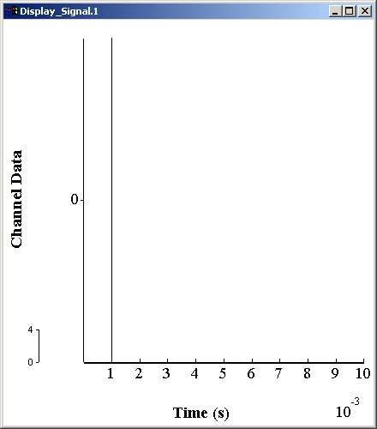
You can change the parameters while AMS is running. In the followiing example we shall change the time of occurrence of the click from 1 to 5 msec.

1. Select from the pulldown menus- File -> edit\ simulation parameters. You should see a display like this

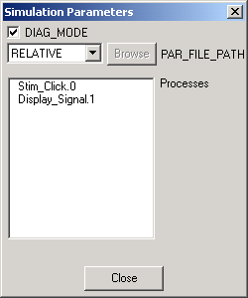

2. Click on the process Stim_Click. This should produce a display like this

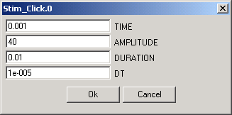

3. Change the click time (TIME) from .001 to .005.
- Click on 'GO' in the AMS window. The click in the display should move to the later time.

File input/output in AMS
AMS uses the processes DataFile_In and DataFile_Out to handles files.

AMS assumes that the numerical values in a file are micro Pascals (μPa). An appropriate GAIN needs to be set to convert the file values to numbers that makes sense to AMS. See below for advice.

The sample rate for evaluating the model is taken from the sample rate of the sound file when this is specified in the header file. Typical values for recording sounds (8 kHz to 44.1 kHz) are normally too slow for modeling purposes. Too slow a sample rate will cause a crash when evaluating filter modules if the filter-cutoffs are more than half the sample rate. Also, modules that create pulses (e.g. Util_BINOM) may try to produce pulses narrower than the epoch duration. These problems are reported only when the modules are evaluated and this can be confusing as the link with file-reading module is not obvious. Samples should either be recorded at a suitable sample rate (say, >50 kHz) or the data should be up-sampled in AMS before any filtering takes place. See below for advice.

File types
The file types that can be used are identified by their file extension
- .DAT ASCII files produced by and readable by a text editor. Values are successive values of a waveform. For binaural signals, pairs of values are used.
- .WAV signal files using the .wav format and having values between +1 and –1. MATLAB is a useful source of .wav files
- .AIF signal files using the AIFF format. These files preserve the absolute value of the signal. Unfortunately, MATLAB does not create or read this type of file. (A ReadAIFF.m MATLAB is part of the AMS installation. It can be found in the C:\DSAM\AMS\Matlab directory with its supporting files. The directory can be added to your matlab path.)
- .raw binary files.

Parameters
The parameter files for DataFile_In and DataFile_Out have the same format. There are nine parameters. Not all are required all of the time. For example, when using DataFile_Out it is possible to omit the parameter file altogether (if you are happy with the default file name output.dat)

FILENAME Make sure that the filename extension is included. This must be one of the above types. (default 'output.dat'). AMS assumes that the file to be read is in the same folder as the .sim (or .spf) file. If it is somewhere else, the full filepath must be specified.

GAIN This gain will be applied to the values read in; (default 0). Setting the gain can be tricky and is described in more detail below.

STARTTIME To ignore the initial part of the signal, use this parameter to specify how much to ignore; (default 0).

DURATION Specifies how much of the signal is to be used. A value of –1 indicates that the signal is to be used to its end; (default –1). DURATION has a special meaning in SEGMENT mode (section 4.5 below).

SAMPLERATE For .dat and .raw, this value should be set; (default 8000).

The sample rate is used as the sample rate of subsequent modeling processes.

If the file contains its own sample rate (e.g. .wav and .aif), this parameter is ignored. This can cause problems because ideal modeling sample rates are often very high (100 kHz) compared to audio modeling rates. Make sure that the sample rate of the file is high enough. If the sample rate is too low, the following error message will be shown: ‘the sampling interval dt = 0.1 ms is too low for the filter specification’. One solution to this problem is to upsample the file in AMS. The .sim file should begin like this

DataFile_In <dataFile.par
Util_reduceDT <reduceDT.par

N.B. The .par file reduceDT.par contains only one parameter

DENOMINATOR 4

This will increases the sampling rate by a factor of 4.

CHANNELS Distinguishes monaural (value 1) from binaural (value 2). Default is 1.This parameter is ignored when using .wav and .aif files;.

WORDSIZE Number of words to be used for each point in the waveform; (default 2). Used only for binary files.

ENDIAN_MODE Values are BIG, BIG_UNSIGNED, LITTLE, LITTLE_UNSIGNED and DEFAULT. This parameter is used when transferring files from computers with different operating systems (e.g. Mac to IBM PC). If a file cannot be read using the default, try all the others in turn and hope for the best!

NORM_MODE Applies a correction factor. Used only for binary files.

AMS output files can be used for reinput to AMS. If the aim is to stage the AMS analysis by producing an output file to be used for restarting the process at a later date, a .aif file type should be used as this preserves all aspects of the signal used by AMS.

File input
Any of the above file types can be used for reading in a new signal that has been produced using other software such as audio capture software or user programs.

Text or ASCII files

When signals at input using text or ASCII files, you should observe the following rules:

- It must have the file extension ‘.dat’
- Make sure that this is a genuine text file (not a word-processed file)
- The signal values are a column of figures one value wide.
- SAMPLERATE must be set in the .par file (AMS cannot guess this)
- Specify DURATION (AMS will not work this out for you)

Gain setting
This can be a major headache for beginners, so listen up.

AMS assumes that all stimulus input files are given in micro Pascals (μPa). If they are not in this form, then the GAIN parameter can be used to set matters aright. Most auditory filter systems are nonlinear in nature and the nonlinearity is applied differently at different levels. It is important that the level of the signal is specified correctly.

Gain setting for WAV files
WAV is a common file format use by much audio capture software. All .wav files are compressed to have values within the limits of +1 to –1. A .wav file contains no information as to the original amplitude of the signal. The user must specify a GAIN function that will restore a signal to its original intensity. After restoration, the waveform will be specified in μPa. Choosing an appropriate GAIN function can be tricky.

When AMS reads a .wav file, it reads the values as if they were between +0.5 and -0.5 μPa . There are complex historical reasons for this. If you forget this (and think that the AMS sees the input as between +/- 1 μPa) your level will be reduced by 6 dB.

To specify the GAIN you need to specify the peak amplitude in μPa. If you do not know the peak value, you cannot specify the GAIN. If you do, we can attempt the necessary calculations. Table 1 may be helpful.

peak level dB | Peak  mPa | AMS  GAIN
0 | 28 | 35
20 | 283 | 55
40 | 2828 | 75
60 | 28284 | 95
80 | 282843 | 115
100 | 2828427 | 135
Table 1 GAIN to be applied to a .wav file to achieve specified peak amplitudes. This table assumes that the peak value in the .wav file is +1. Note that the peak value dB will normally be greater than the rms value in dB SPL.
As a rule of thumb, a GAIN of around 95 dB to achieve an rms level between 50 and 60 dB SPL.

If you are creating your own .wav files using MATLAB, make sure that the data are normalized before using the wavwrite function.

Example 1
Our first example is very simple but illustrates the principles.

Create a .wav file using a pure tone (sinusoid). The wav file will have a peak value of 1. We wish to convert this to a pure tone stimulus at 0 dB SPL.

Solution: A 0 dB SPL pure tone has an rms of 20 microPascals and a peak value of approximately 28 microPascals (you just have to know that). To convert our .wav file peak of +1 to 28 we need to apply a scalar of 28. This is equivalent to a gain of

20*log10(28/0.5) = 35 dB.

Remember that AMS sees the .wav file as numbers in the range +0.5 to -0.5 (see above).

Set the GAIN parameter in the DataFile_In process to 35.

Example 2
Well, actually, I wanted 56 dB SPL.

Solution: add 56 to 35 to get the desired GAIN of 91 dB.

Example 3
I don't care about the peak value. I want to set an overall rms value for my wav file (dBrmsDesired).

Solution: Measure the rms value of the .wav file (dBrmsMyFile).

Remember that AMS sees the .wav file as numbers in the range +0.5 to -0.5 (see above).

Your required GAIN is

GAIN= dBrmsDesired – dBrmsMyFile

Example 4
How do I get AMS to measure my rms value? Not all .wav files are properly normalized – especially those created by user programs in MATLAB(!).

Use the module Ana_Intensity. Create a .sim file like this:

# intensity.sim

begin {
DataFile_In < fileIn.par
DisplaySignal
Ana_Intensity
DataFile_Out
}

and a .par file (called fileIn.par) like this

# DataFile_In < fileIn.par

FILENAME myfile.wav

This program will display the whole wav file and compute its level (rms, re 0 dB SPL).

The level will appear in a file called ‘output.dat’ in the current directory. Both the left and right channels are assessed. Only one value is given for monaural signals.

Time (s) 0 1
0.00000e+000 -39.3021 -39.3021

In this case the signal would require a GAIN of 39.3 dB to restore it to a 0 dB SPL signal and a GAIN of 89.3 to restore it to a 50 dB SPL signal.

This useful little program can be found in the Tutorials\MeasureIntensity folder.

Sample rate
SAMPLERATE is a parameter of the dataFile_In module. However, if the file specifies its own sample rate (e.g. .wav or .aif files), the parameter will be ignored SAMPLERATE will be ignored and the actual file sample rate will be used. If the sample rate is not specified in the file header (e.g. .dat and .raw), AMS will use the value specified by SAMPLERATE.

When using .wav or .aif files, the sample rate for evaluating the model is taken from the sample rate specified in the header of the sound file. However, typical values for recording sounds (8 kHz to 44.1 kHz) are normally too slow for modeling purposes. If the sample rate is to low, an error will occur at some later point in the model computation; for example, when evaluating filter modules if the filter-cutoffs are more than half the sample rate. Also, modules that create pulses (e.g. Util_BINOM) may try to produce pulses narrower than the epoch duration and computation will be halted. These problems are reported only when the module is evaluated and this can be confusing because the problem occurs in a later module but the remedy lies in the first (DataFile_In) module.

Sound files should be recorded at a suitable sample rate (say, >50 kHz). If this is not possible or the file already exists, the solution is to upsample the file.This can be done in AMS before any filtering takes place using the Util_reduceDT module. If the sample rate is too slow for modeling purposes, the file can be up-sampled to increase the sample rate. Add the Util_reduceDT module immediately after the dataFile_In module

fileIn% dataFile_In < fileIn.par
Util_reduceDT < reduceDT.par

Util_reduceDT has only one parameter (DENOMINATOR) which is the number of samples required to replace a single sample. A complete par file might look like this

DENOMINATOR 4

This would give a four times increase in sample rate. Upsampling is smoothed to minimise artefacts.

File use in SEGMENT mode
In SEGMENT mode AMS analyses equal-length sections of the input file one at a time. The parameter DURATION specifies the length of each segment. The analysis is repeated for each segment of the input file. When a dataFile_Out module is encountered, the current signal is appended to the output file.

SEGMENT MODE and NUM_RUNS are specified at run time using the AMS window pull-down menus Edit\Main parameters and the General and Specific tabs respectively.

If NUM_RUNS is set to -1, AMS will compute the number of segments for you and reset NUM_RUNS to the appropriate value when you click on ‘GO’.

Example
Compute the rms level of the signal over 5 msec segments for the first 5 segments using the intensity.sim program given in section 4.3.2 above.

Load intensity.sim
Set DURATION to .005
Set SEGMENT mode ON
Set NUM_RUNS to 5
GO

AMS now computes the intensity of the first five 5-ms segments of the signal. The output file looks like this

Time (s) 0 1
0.00000e+000 -52.0259 -52.0259
1.00000e+000 -36.2996 -36.2996
2.00000e+000 -52.0259 -52.0259
3.00000e+000 -36.2996 -36.2996
4.00000e+000 -52.0259 -52.0259

Trouble shooting
This section is a cumulative record of error messages that have foxed some users in the past and what to do about them.

If you cannot solve your problem on the basis of the advice given below, you should do the following:

Save your model as an .spf file. Send the file to either Ray Meddis (rmeddis@essex.ac.uk) or Lowel O’Mard (lowel@essex.ac.uk) for a diagnosis.

If your model reads in a data file, you should send that as well.

Do not send .sim files unless absolutely necessary. If you do send a .sim file, you must also send all the .par files referred to in the .sim file. .spf files are better because they contain additional information needed to identify some of the less obvious problems that occur from time to time.

If your problem is linked to a MATLAB call (and only occurs in the context of its MATLAB usage), please also send the MATLAB code with clear specification of the line number where the error is occurring. There is a separate trouble shooting section for MATLAB problems in the section ‘Using AMS with MATLAB’.

the sampling interval dt = 0.1 ms is too low for the filter specification

This message occurs when the sampling rate is too low. Some modules especially filters, require minimum sampling rates or the filters become unstable. The solution is to increase the model sample rate. This is normally done in the stimulus generation module.

The problem most often arises when stimulus input is through file input or input from a MATLAB runDSAMsim call. The sample rate of the model is assumed to be the sample rate of the file. If this is a normal audio file, the sample rate is almost certainly to be too low for modeling purposes.

Solution 1: supply a file with a higher sampling rate.
Solution 2:upsample the file in AMS using the module Util_reduceDT immediately after reading in the file. This utility has only one parameter (DENOMINATOR) which should be set to some value (say, 4) that will multiply the sample rate.

Execute Utility Datum: could not execute process ‘0’
This error message will occur if an attempt is made to read past the end of an input signal. This can occur if the DataFile_In "duration" parameter is not set correctly.

Solution 1:: Try setting the "duration" parameter to the default "-1" value, which will read the entire signal.

Solution 2: The error message may mean that you are trying to run AMS in SEGMENT mode inappropriately.

1. Launch AMS and load your .spf or .sim file

2. select Edit\ Main Parameters

3. choose the tab 'App. Specific Pars'. You should set the NUM_RUNS parametr to 1.

4. now click on 'GO' in the main AMS window. All will be well.

Gammatone filterbank
This model can be found in the folder Tutorials\AuditoryPeriphery. The original version of this folder can be found in DSAM\AMS\ Tutorials\AuditoryPeriphery. If you have not already done so, copy this folder into your regular workspace. Please do not work in the AMS workspace.

Launch AMS and load 'filterbankGammatone.sim'. Hit 'GO'. You should see the displays shown in Figure 2

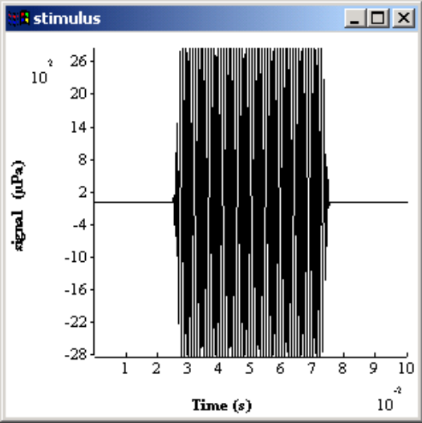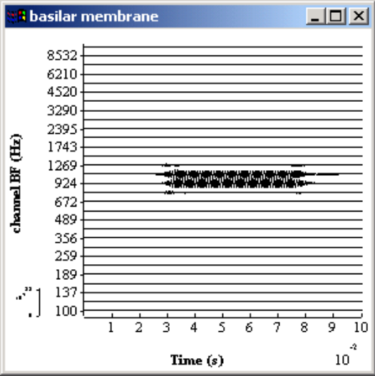
Figure 2 Output from filterbankGammatone.sim.

The stimulus display shows a 50-msec, 40-dB SPL, 1-kHz signal, shaped by a 2.5-msec raised cosine onset and offset ramp. The basilar membrane window shows the response of a gammatone filterbank consisting of 30 filters with BFs between 100 and 10000 Hz equally spaced on a ERB scale. The bandwidths of the filters are based on a proposal by Moore and Glasberg ( ??).

Simulation file.

# filterbankGammatone.sim

begin {

# generate stimulus
stim_pureTone_2 < stimTone.par

# Ramps
Trans_Gate < rampUp.par
Trans_Gate < rampDown.par
Display_Signal < displaySignal.par

# Outer-/middler-ear filter model.
Filt_MultiBPass < filtMultiBandpassGP.par

#convert to stapes velocity
Util_mathOp < mathOPstapes.par

# Basilar membrane filter model.
BM_gammaT < BM_gammatone.par
Display_Signal < displayBM.par
DataFile_out

}

The sequence of operations in the simulation file is
- Generation of the stimulus (stim_pureTone_2)
- Application of onset and offset ramps (Trans_Gate).
- Outer\middle ear is simulated using two parallel bandpass filters (Filt_MultiBPass) and a scalar (Util_mathOp)
- Computation of the gammatone filterbank (BM_gamma_T )
- Writing the result to a file (DataFile_out).

A more detailed account of each stage is given along with the individual parameter files below.

processes and parameters

Stimulus generation
The parameter file stimTone.par reads as follows:

# stim_pureTone_2 < stimTone.par

frequency 1000 #Hz
intensity 40 #dB SPL
duration .05 #seconds
dt .00001 #100 kHz
begin_silence .025 #seconds
end_silence .025 #seconds

The first line is a comment. It is good practice to paste the calling line from the .sim file as the first line of the parameter file. This shows the name of the .par file in a printout and offers a reminder of the name of the calling process. This practice can be a great help to a third party advising on any problems you may be experiencing.

duration is the duration of the pure tone. Silences are additional to the tone. The total duration is 0.1 s.

dt sets the sample rate for the whole model, including all succeeding processes. dt will be checked by AMS to make sure that it is small enough to satisfy the requirements of all filters that appear later in the simulation script.

Ramp on/off
Two parameter files; one for ramping up and one for ramping down.

# Trans_Gate < rampUp.par

op_mode ramp
pos_mode relative
duration 2.5e-3

# Trans_Gate < rampDown.par

op_mode damp
pos_mode relative
duration 2.5e-3

Trans_gate is a process that transforms the stimulus by applying a gating function. It takes a number of parameters but only three key parameters are shown here. The other parameters are supplied by default.

op_mode specifies whether the ramp is up (ramp) or down (damp).

pos_mode specifies whether the ramp is applied at the beginning of the signal (absolute) or at the onset of the tone (relative).

duration specifies the length of the ramp.

Tip: Ramps must be included when using internally generated signals (except clicks). A warning will be issued if no ramps are set.

Display signal

# Display_Signal < displaySignal.par

WIN_TITLE stimulus

win_height 300
win_width 300
win_x_pos 0
win_y_pos 0

y_axis_mode linear
y_axis_title "signal (µPa)"

Display_signal is a very complex function that takes many parameters. Only a few are required for this display, however.

win_title allows the user to specify text in the (blue) band at the top of the display. If the text requires spaces, it should be given inside double quotes.

win_height, win_width are specifications in pixel units of the height and width of the display windows.

win_x_pos, win_y_pos specify the location (in pixel units) of the top left hand corner of the display relative to the screen. (0, 0) specifies the top left of the screen.

In general, the location and size of the display will vary with different screen sizes and different resolutions.

y_axis_mode defines the meaning of the numbers alongside the y_axis. channel defines the numbers as representing the best frequency (BF) of the individual channels. linear defines the numbers as representing the numerical value of the function, as in a normal graph. The signal has only one channel, so linear is the appropriate choice.

y_axis_title specifies the text to be written alongside the y axis. The x_axis_title is not given because the default value for this is 'time', and that is appropriate for this display.

Outer/middle ear filter
The outer and middle ear attenuate high and low frequency sounds. Here we have chosen to simulate a guinea pig outer/middle ear function using two parallel bandpass filter following Sumner et al. (2003).

# Filt_MultiBPass < filtMultiBandpassGP.par

NUM_FILTERS 2

CASCADE 0:2
ATTENUATION 0:0
LOWER_FREQ 0:4000
UPPER_FREQ 0:25000

CASCADE 1:3
ATTENUATION 1:0
LOWER_FREQ 1:700
UPPER_FREQ 1:30000

The parameter num_filters specifies the number of filters. Each filter must be fully described in terms of its parameters. The notation i:param specifies the parameter for the i^{th} filter. Filter numbers are sequenced 0,1.. N-1.

Each filter is composed of a cascade of first-order filters where the 3-dB down points of the first-order filters are specified by the parameters low_freq and upper_freq. The parameter cascade specifies the number of cascaded filters.

A cascade of 3 filters, for example, is similar to but not the same thing as a third order filter. A filter consisting of a cascade of three first-order filters has high and low frequency skirts with the same slope as a third order filter but the upper and lower cut-offs will be narrower than those specified in the parameters. In this case the low_freq and upper_freq parameters specify the 9-dB down points of the filter.

attenuation is the reduction in level between the input and output at BF. It is specified in dB.

Conversion to stapes velocity

AMS uses realistic physical units whenever possible. The input signal is in micro Pascals. The next stage requires that the pressure representation be changed to stapes velocity. The outer/middle ear is linear in operation. Therefore, this can be achieved by applying a scalar using Util_Mathop. The scalar used is 1.4e-10 following the suggestion of Sumner et al (2003).

# Util_mathOp < mathOPstapes.par
operator scale
operand 1.4e-10

Gammatone filter
The BM_gammaT process computes the gammatone filter output at a number of different BFs. It is a process with many parameters. A small number of key parameters are shown in the parameter file.

# BM_gammaT < BM_gammatone.par

channels 20
min_cf 100
max_cf 10000
cascade 4
cf_mode human
b_mode erb

channels specifies the number of channels to be used. channels must be a positive integer greater than 1 (see 8.1.2.1 below for example of single channel operation).

min_cf and max_cf specify the range of CFs to be used.

cascade indicates the number of cascaded first-order gammatone filters that are used to make a single filter. The greater the cascade value, the steeper the slope of the filter skirts.

cf_mode refers to the method of spacing the channel CFs. When set to 'HUMAN, the BFs are equally spaced on a Greenwood scale based on the dimensions of the human basilar membrane.

B_MODE specifies the method for computing bandwidths. ERB is based on the formula suggested by Moore and Glasberg
If a single filter is required, set the cf_mode to 'single' and use the parameter single_cf to set its CF.

BM display

# Display_Signal < displayBM.par

win_title "basilar membrane"

win_height 300
win_width 300
win_x_pos 300
win_y_pos 0

y_axis_mode channel
y_axis_title "channel BF (Hz)"

Only new parameters will be explained here. For an explanation of other parameters, see 6.2.3.

y_axis_mode is set to 'channel' to request that channel CFs be identified along the y-axis. A scale is shown in the bottom left-hand corner of the display to help interpret the positive and negative deflections of the individual functions. This scale can be small and may be necessary to maximise the display to read this clearly.

File output
The process DataFile_Out automatically writes the result to a file called, by default, 'output.dat'.

In this case, the output file consists of a matrix with 30 columns (1 for each channel) and 10000 rows (1 for each time sample). In addition, the first column indicates the time of each row and the first row indicates the CF of each channel.

Tabs separate the columns. This makes the files suitable for reading directly into Excel and other spreadsheets.

Tip: If you want to give your output file a different name, use a parameter file with a single parameter:

FILENAME myfileName.dat

It is important to use .dat as the file ending if you want to look at the file in a text editor.

Things to do

Switch off diagnostics
When you are happy that the model is running satisfactorily, switch off the diagnostics by adding a line to the top of the .sim file.

Diag_mode off Diagnostics mode ("off" or "on").

Change the BF range
- Run the filterbankGammatone model
- Select Edit\ Simulation parameters.. from the AMS window pull down menus
- Click once on BM_gammaT.6 in the Simulation Parameters window.
- Change MIN_CF and MAX_CF to new values (say 500 and 3000)
- Click on GO (no need to close the parameter window).

Nonlinear filterbank
This model can be found in the folder Tutorials\AuditoryPeriphery. The original version of this folder can be found in DSAM\AMS\|Tutorials\AuditoryPeriphery. If you have not already done so, copy this folder into your regular workspace. Please do not work in the AMS workspace.

Gammatone filters are linear in the sense that their properties do not change with signal level. However, the auditory periphery is known to be nonlinear. As the signal level increases, the bandwidth of the filter increases and the frequency that elicits the biggest response (the best frequency, or BF) shifts. To meet the requirements of nonlinearity we need a nonlinear filterbank. The method adopted here is the dual resonance nonlinear (DRNL) filter, described in detail elsewhere: Meddis et al, (2001) and Lopez-Poveda and Meddis R (2001a).

The .sim file below contains a new model that is exactly the same as that given in filterbankGammatone.sim above except for two changes.

- The line

@ BM_gammaT < BM_gammatone.par

now contains a '@' character. This disables the BM_gammaT process but leaves it in the model so that it can be enabled at run time. This will allow comparisons to be made with the nonlinear filterbank.

- A new basilar process has been introduced to implement the nonlinear filters

BM_DRNL < BM_drnlGP.par

Simulation file

# filterbankDRNL.sim

begin {

# generate stimulus
stim_pureTone_2 < stimTone.par

# Ramps
Trans_Gate < rampUp.par
Trans_Gate < rampDown.par
Display_Signal < displaySignal.par

# Outer-/middler-ear filter model.
Filt_MultiBPass < filtMultiBandpassGP.par

#convert to stapes velocity
Util_mathOp < mathOpStapes.par

# Basilar membrane filter model.
@ BM_gammaT < BM_gammatone.par
BM_DRNL < BM_drnlGP.par
Display_Signal < displayBM.par
DataFile_out

}

DRNL parameter file
The parameter file for the DRNL filter is complex but necessarily so. Normally, this need not concern most users because standard sets of parameters are becoming available for animal and human applications. Default parameters will also be useful while setting up models. This means that you can omit the parameter file altogether. However, you will normally need to use a tailored .par file for publishable studies.

The .par file shown below is based on the filterbank proposed for the guinea pig by Sumner et al. (2003). The parameters are based directly on table I in that paper. Their table is reproduced below the .par file for comparison purposes.

The nonlinear system consists of two separate pathways, a linear and a nonlinear pathway. Parameters are given separately for each pathway and tagged as NL or NONLIN for the nonlinear path and LIN or LINEAR for the linear path.

Many key parameters vary as a function of CF. By default these parameters are specified as a logarithmic function of CF

log(param)= p(0) + p(1)log(CF)

For example, in the case of the bandwidths of the filters in the nonlinear path, p(0) and p(1) are set to 0.8 and 0.58 using

NONLINBWIDTH_PARAMETER 0:0.8
NONLINBWIDTH_PARAMETER 1:0.58

At 1 kHz, the nonlinear bandwidth can be computed:

NLBW= 10^ (0.8 + 0.58 log10(1000)) = 347 Hz

With nonlinear filters, the distinction between BF (best frequency) and CF (centre frequency) becomes important. We try to use the term CF to refer to a parameter of a component filter while BF refers to the frequency that yields the greatest response at the output of the system as a whole. For example, BF changes with level (it is an emergent property) while CF (the description of a passive component) does not change. Notice that, in the DRNL model, the CF of the nonlinear path is not normally the same as that for the linear path.

When computing model parameters, CF is normally taken to be the CF of the filters in the nonlinear path. CF_MODE controls the spacing of the CFs. When it is set to 'GUINEA_PIG', the CFs are equally spaced along a Greenwood (1990) scale whose parameters are based on guinea pig measurements.

# BM_DRNL < BMdrnlGP.par

# nonlinear path
NL_GT_CASCADE 3 Nonlinear gammatone filter cascade.
NL_LP_CASCADE 4 Nonlinear low-pass filter cascade.

NONLINBWIDTH_PARAMETER 0:0.8
NONLINBWIDTH_PARAMETER 1:0.58

COMPRSCALEA_PARAMETER 0:1.87
COMPRSCALEA_PARAMETER 1:0.45

COMPRSCALEB_PARAMETER 0:-5.65
COMPRSCALEB_PARAMETER 1:0.875

COMP_N_EXPON 0.1 Compression exponent, n (units).
L_GT_CASCADE 3 Linear gammatone filter cascade.
L_LP_CASCADE 4 Linear low-pass filter cascade.

# linear path
LINCF_PARAMETER 0:0.339
LINCF_PARAMETER 1:0.895

LINBWIDTH_PARAMETER 0:1.3
LINBWIDTH_PARAMETER 1:0.57

LINSCALEG_PARAMETER 0:5.68
LINSCALEG_PARAMETER 1:-0.97

# CF List Parameters:-
DIAG_MODE PARAMETERS
CF_MODE GUINEA_PIG
MIN_CF 300 Minimum centre frequency (Hz).
MAX_CF 15000 Maximum centre frequency (Hz).
CHANNELS 20 No. of centre frequencies.

Table 2 Basilar membrane filtering (DRNL) parameters taken from sumner et al ( ) Table I..
Parameters that are fixed across all BFs
Compression exponent, v (dB/dB) | 0.1
Gammatone cascade of non-linear path | 3
Low-pass filter cascade of non-linear path | 4
Center frequency of non-linear path, CF_{NL} | Set equal to BF
Low-pass cut off of non-linear path, LP_{NL}, | Set equal to BF
Gammatone cascade of linear path | 3
Low-pass filter cascade of linear path | 4
Low-pass cut-off of linear path, LP_{lin} | Set equal to CF_{lin}
Parameters that vary with BF:  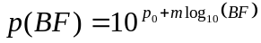 | Filter-bank coefficients |  | Single filter at 6kHz BF (in Figure 4B). Filterbank values shown in brackets.
 | p₀ | m
Bandwidth (Hz) of non-linear path, BW_{NL} (Hz). | 0.8 | 0.58 | 980 (unchanged)
Compression parameter, a | 1.87 | 0.45 | 251 (3716)
Compression parameter, b | -5.65 | 0.875 | 4.52x10⁻³ (unchanged)
Center Frequency of linear path, CF_{lin} (Hz). | 0.339 | 0.895 | 2961 (5253)
Bandwidth of linear path, BW_{lin} (Hz). | 1.3 | 0.53 | 634 (2006)
Linear path gain, G_{lin}. | 5.68 | -0.97 | 103 (unchanged)

Model output
The output should look like Figure 3.

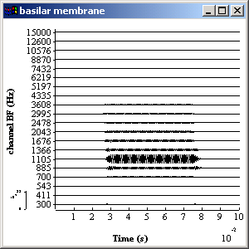
Figure 3 DRNL output

Things to do

Compare the output of the DRNL with the gammatone filter.
- Select Edit\ Simulation parameters from the AMS window pull-down menus
- Double click on BM_drnl.7 to disable the nonlinear computations. A '@' character should appear beside the process name. It may be necessary to single-click to open the window and then double-click to disable the process.
- Double-click on BM_gammaT.6, to enable the gammatone filter. The '@' character should disappear.
- Make sure that only one of the two filters is enabled and then click on 'GO'.

Differences should be small at low signal levels but greater at high signal levels.

Tip: A problem with this method is that the display is set to autoscale. After running the program check the inset scale at the bottom left of the display. You may need to maximize the display to read this well.

Auditory nerve
This model can be found in the folder Tutorials\AuditoryPeriphery. The original version of this folder can be found in DSAM\AMS\Tutorials\AuditoryPeriphery. If you have not already done so, copy this folder into your regular workspace. Please do not work in the AMS workspace.

This section extends the model to include a simulation of a stream of spikes in a single auditory nerve fiber.

Single auditory nerve fiber

Simulation file

# auditoryNerve.sim

begin {

# generate stimulus
stim_pureTone_2 < stimTone.par

# Ramps
Trans_Gate < rampUp.par
Trans_Gate < rampDown.par
Display_Signal < displaySignal.par

# Outer-/middler-ear filter model.
Filt_MultiBPass < filtMultiBandpassGP.par

#convert to stapes velocity
Util_mathOp < mathOpStapes.par

# Basilar membrane filter model.
BM_DRNL < BM_drnlGP1.par
Display_Signal < displayBM.par

# IHC receptor potential
IHCRP_Shamma3StateVelIn < IHCRP_VelIn_GP.par
Display_Signal < displayRP.par

#IHC synaptic response
IHC_Meddis2000 < IHChsr2000spike.par

# apply a refractory period
AN_SG_Meddis02 < ANrefractory.par
Display_Signal < displaySynapse.par

DataFile_Out

}

The first part of the auditoryNerve.sim file is the same as that for the DRNL filterbank. Only one change has been made; the DRNL filter has been changed to show only one auditory nerve fiber. This makes the demonstration more like a real physiological experiment.

The new processes in the .sim file are concerned with the response of the
- Inner hair cell (IHC)
- IHC/auditory nerve (AN) synapse
- Spike activity of the auditory nerve.
The output should look like Figure 4.

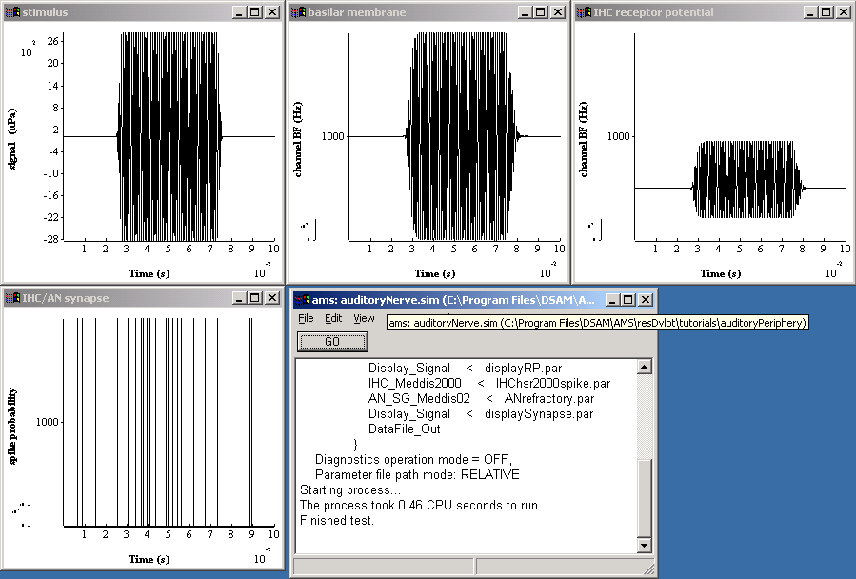
Figure 4 Auditory nerve model

Processes and parameters

Filterbank

# BM_DRNL < BMdrnlGP1.par

(.......as in previous section)

CF_MODE SINGLE
SINGLE_CF 1000

This .par file is the same as BMdrnlGP.par with the number of channels set to single and its CF specified to be 1000 Hz. Any number of channels could have been used but a single channel is more appropriate for the examples that follow.

Receptor potential

# IHCRP_Shamma3StateVelIn < IHCRP_VelIn_GP.par

# Sumner, C, Lopez-Poveda, E.A., O'Mard, L.P. and Ray Meddis,
# "A revised model of the inner-hair cell and auditory nerve complex"

E_T 0.1 Endocochlear potential, Et (V).
E_K -70.45E-3 Reversal potential, Ek (V).
G0 1.97e-09 Resting conductance, G0 (S).
G_K 1.8e-08 Potassium conductance, Gk (S = Siemens).
RP_CORRECTION 0.04 Reversal potential correction, Rp/(Rt+Rp).
G_MAXC 8e-09 Maximum mechanical conductance, Gmax (S).
S0 85e-9 Sensitivity constant, S0 (/m).
U0 7e-9 Offset constant, U0 (m).
S1 5e-7 Sensitivity constant, S1 (/m).
U1 7e-9 Offset constant, U1 (m).
C_TOTAL 6e-12 Total capacitance, C = Ca + Cb (F).
T_C 2.13e-3 Cilia/BM time constant (s).
GAIN_C 16 Cilia/BM coupling gain, C (dB).

This module computes the IHC receptor potential on the basis of BM velocity.

These parameters are based on Sumner et al. (2002a). This parameter file can be omitted for casual work. The default values will work well for most purposes. Nevertheless, publishable work should use an explicit parameter file that can be quickly checked against other published sources.

Tip: Most of these parameters should not need changing. However, GAIN_C may be usefully changed in some circumstances. It represents the coupling gain between the basilar membrane and the IHC. Adjusting the gain can be used to adjust the threshold of the subsequent auditory nerve fiber.

Display receptor potential

# Display_Signal < displayRP.par

WIN_TITLE "IHC receptor potential"

WIN_HEIGHT 300
WIN_WIDTH 300
WIN_X_POS 600
WIN_Y_POS 0

Y_AXIS_MODE LINEAR
Y_AXIS_TITLE "receptor potential (mV"
AUTO_Y_SCALE OFF
MINY -60E-3
MAXY -20E-3

The auto_y_scale is set to OFF because we know that the receptor potential only exists within a limited voltage range. Accordingly, MINY and MAXY have been set to –60 mV and –20 mV respectively.

IHC synapse

# IHC_Meddis2000 < IHChsr2000spike.par

# Sumner, C, Lopez-Poveda, E.A., O'Mard, L.P. and Ray Meddis,
# "A revised model of the inner-hair cell and auditory nerve complex
# Table II

OP_MODE SPIKE Output mode: 'spike' or probability, 'prob'
DIAG_MODE OFF Diagnostic mode:('off', 'screen' or <file name>).
RAN_SEED 0 Random number seed (0 for different each run).

PERM_Z 2e+32 Transmitter release permeability, Z (unitless gain)
REV_POT_ECA 0.066 Calcium reversal potential, E_Ca (Volts).
BETA_CA 400 Calcium Boltzmann function parameter, beta.
GAMMA_CA 130 Calcium Boltzmann function parameter, gamma.
TAU_M 1e-4 Calcium current time constant (s).
TAU_CA 1e-4 Calcium diffusion (accumulation) time constant (s).

REPLENISH_Y 10 Replenishment rate (units per second).
LOSS_L 2580 Loss rate (units per second).
REPROCESS_X 66.3 Reprocessing rate (units per second).
RECOVERY_R 6580 Recovery rate (units per second).

POWER_CA 3 Calcium transmitter release exponent (power).

# These parameters used to set fiber type
GMAX_CA 8E-9 Maximum calcium conductance (Siemens).
CONC_THRESH_CA 4.48e-11 Calcium threshold Concentration.
MAX_FREE_POOL_M 10 Max. no. of transmitter packets in free pool (integer).

A recommended .par file is given even though the default values will give a reasonable result. When publishing results using a model of this kind it is important to specify these parameters. The values given here have been taken from Sumner et al (2002a) table II

OP_MODE is an important parameter. When set to 'SPIKE' the output signifies a stochastic transmitter release event. The model assumes that a single release event is enough to generate a post-synaptic spike in the auditory nerve fiber if it is not already in a refractory state. The output is, therefore, binary. A release event lasts for only one sample period.

Tip: An alternative is to set the OP_MODE parameter to 'PROB'. In this case the output is a continuous function between 0 and 1 representing the probability of observing the onset of a spike during that sample period. This gives a smoother representation of the IHC response.

Auditory nerve refractory effects

# AN_SG_Meddis02 < ANrefractory.par

RAN_SEED 0
PULSE_DURATION -1
MAGNITUDE 1
REFRAC_PERIOD 0.75E-3
RECOVERY_TAU .6E-3

This process computes the refractory state of one or more nerve fibres. A release event triggers an action potential in the AN fiber if it is not in a refractory state. The process introduces an absolute refractory state for a period of 0.75 msec (REFRAC_PERIOD) following an action potential. It then enters a relative refractory state in which the probability of a successful conversion of a release event into an action potential is governed by an exponential recovery process. The time constant of this process is defined by RECOVERY_TAU.

The output from this process is a stream of pulses whose height and width are defined by PULSE_MAGNITUDE and PULSE_DURATION respectively. If PULSE_DURATION is set to –1, the width of the pulse will be set automatically to DT.

If RAN_SEED is set to a negative integer, the random number process used to make the stochastic decisions, will be the same on each run. If it is set to zero, it will be different for each run.

Tip: This process requires an input consisting of a random binary process (transmitter release events). The IHC synapse process parameter OP_MODE must therefore be set to deliver SPIKE events. Probabilities are not appropriate as input.

Generating a post stimulus time histogram (PSTH)
A PSTH can be computed using the REPEAT function. All processes within the REPEAT curly brackets are repeated a number of times (specified after the REPEAT command. The number of repeats must be set in the .sim file. It cannot be changed at run time.

Processes up to the generation of the receptor potential are deterministic. Repeating these processes would not serve any purpose, as they would give the same result each time. The REPEAT block, therefore, begins with the IHC synapse, the first stochastic process.

Simulation file
This .sim file produces a PSTH based on 200 presentations of a pure tone stimulus to a single auditory nerve fiber. It is the same as the auditoryNerve.sim file except for two new processes at the end.

# ANpsth.sim

begin {

# generate stimulus
stim_pureTone_2 < stimTone.par

# Ramps
Trans_Gate < rampUp.par
Trans_Gate < rampDown.par
Display_Signal < displaySignal.par

# Outer-/middler-ear filter model.
Filt_MultiBPass < filtMultiBandpassGP.par

#convert to stapes velocity
Util_mathOp < mathOPstapes.par

# Basilar membrane filter model.
BM_DRNL < BM_drnlGP1.par
Display_Signal < displayBM.par

# IHC receptor potential
IHCRP_Shamma3StateVelIn < IHCRP_VelIn_GP.par
Display_Signal < displayRP.par

repeat 200 {

#IHC synaptic response
IHC_Meddis2000 < IHChsr2000spike.par

# apply a refractory period
AN_SG_Meddis02 < ANrefractory.par
Display_Signal < displaySynapse.par

Ana_histogram < histogramPSTH.par
Display_Signal < displayPSTH.par

}

DataFile_Out
}

When run, the output should look like Figure 5.

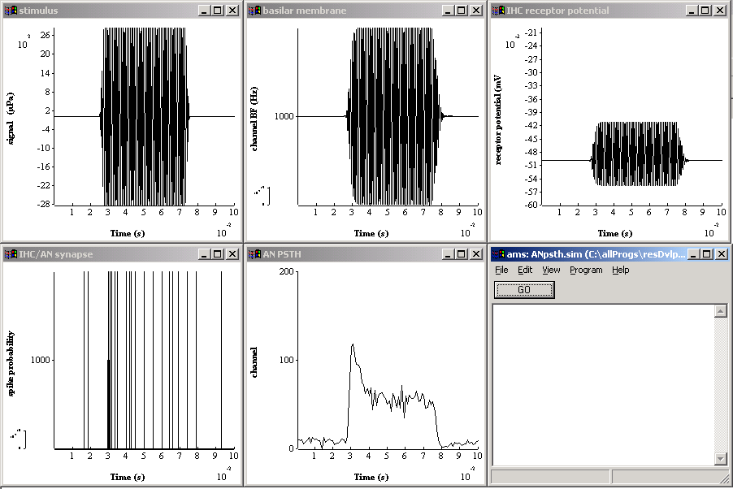
Figure 5 PSTH computed using the auditory nerve model.

Create a PSTH
The histogram process can be used to bin and count events. It is an accumulating process. Every time it is activated it adds the new results to the old results.

# Ana_histogram < histogram1.par

DETECT_MODE SPIKE
BIN_WIDTH 1E-3
THRESHOLD 0.5

Ana_Histogram accumulates results across all the repeat trials.

DETECT_MODE when set to SPIKE an event occurs whenever the input function rises above the THRESHOLD value. The time of the event is the time of the positive-going zero-crossing.

BIN_WIDTH defines the width of the bin. If not set, the default is DT and this is normally too small for most purposes.

THRESHOLD The input from the AN_SG_Meddis02 process is in the form of narrow pulses with a height of 1 unit. By setting the THRESHOLD to 0.5, all events will be detected as they pass form zero to one.

Display the PSTH

# Display_Signal < displayPSTH.par

WIN_TITLE "AN PSTH"

WIN_HEIGHT 300
WIN_WIDTH 300
WIN_X_POS 300
WIN_Y_POS 300

Y_AXIS_MODE LINEAR
Y_AXIS_TITLE "spike count"
AUTO_Y_SCALE off
MINY 0
MAXY 200
Y_NUMBER_FORMAT Ye0
Y_TICKS 3

The display has been created using a fixed y-axis with a maximum of 200 (spikes). This will guarantee that the PSTH will grow (before your very eyes) with each REPEAT loop.

Y_NUMBER_FORMAT defines the format of the numbers in the y-axis. Ye0 keeps the numbers simple.

Y_TICKS specifies the number of numbers along the y-scale.

Things to do

Try different signal levels and notice how the PSTH changes.

- Load and run the program
- Edit\simulation parameters
- select stim_pureTone_2 and open parameter window
- change INTENSITY
- GO

Generate a Period histogram

ANpsth.sim can be adapted to produce a period histogram (rather than a PSTH) by changing the histogram parameter file

# ANperiodHistogram.sim

begin {

# generate stimulus
stim_pureTone_2 < stimTone.par

# Ramps
Trans_Gate < rampUp.par
Trans_Gate < rampDown.par
Display_Signal < displaySignal.par

# Outer-/middler-ear filter model.
Filt_MultiBPass < filtMultiBandpassGP.par

#convert to stapes velocity
Util_mathOp < mathOPstapes.par

# Basilar membrane filter model.
BM_DRNL < BM_drnlGP1.par
Display_Signal < displayBM.par

# IHC receptor potential
IHCRP_Shamma3StateVelIn < IHCRP_VelIn_GP.par
Display_Signal < displayRP.par

repeat 200 {

#IHC synaptic response
IHC_Meddis2000 < IHChsr2000spike.par

# apply a refractory period
AN_SG_Meddis02 < ANrefractory.par
Display_Signal < displayFiberResponse.par

Ana_histogram < histogramPH.par
Display_Signal < displayPH.par

}
DataFile_Out

}
The results should look like this

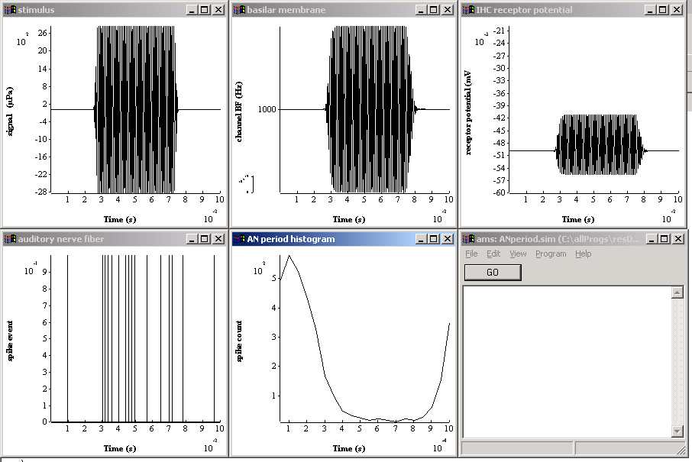
Figure 6 Periodhsitogram based on a single auditory nerve fiber, 200 repeats

period histogram
# Ana_histogram < histogramPH.par

BIN_WIDTH 50E-6 # 20 bins for 1 kHz period

DETECT_MODE SPIKE
THRESHOLD 0.5

TYPE_MODE PH
PERIOD 0.001
OFFSET 0.0025
OFFSET 0.0025

TYPE_MODE is defined as PH for period histogram (use PSTH for post stimulus time histogram)

PERIOD specifies the period of the signal. The stimulus is a 1-kHz tone and it period is 0.001s.

BIN_WIDTH is now 50 microseconds. This will create 20 bins in a single 1 msec cycle.

OFFSET specifies the duration of the initial section of the stimulus that is to be ignored (the silent period).

Tip: The binwidth must be carefully calculated to give an exact number of bins

Display period histogram

# Display_Signal < displayPH.par

WIN_TITLE "AN period histogram"

WIN_HEIGHT 300
WIN_WIDTH 300
WIN_X_POS 300
WIN_Y_POS 300

Y_AXIS_MODE LINEAR
Y_AXIS_TITLE "spike count"
AUTO_Y_SCALE on

The AUTO_SCALE has been switched on for this example.

Things to do
Try changing the frequency of the stimulus. Note that you will need to change the period and the binwidth in the histogram module.

The 'Loudness' model
This model can be found in the folder Tutorials\Loudness. The original version of this folder can be found in DSAM\AMS\Tutorials\Loudness. If you have not already done so, copy this folder into your regular workspace. Please do not work in the AMS workspace.

General introduction
The model is based on the idea that the loudness of a stimulus might be related to the sum total of auditory nerve activity in response to that stimulus. The model consists mainly of a sequence of computations representing different stages in physiological signal processing between the acoustic stimulus and the auditory nerve (AN) response. Two types of fibers are represented (LSR, HSR) . The model finishes by summing all AN spike activity (across channels) and applying a 'temporal window function'. Finally, the model creates an output file, 'output.dat' that contains the output from the temporal window as a function of time. The research question is whether or not the output from the model can predict the loudness property of stimuli.

For an approachable overview of the topic of loudness I recommend Plack and Carlyon (1995). Their coverage suggests lots of experiments that can be tried with the model.

To run the model, launch 'AMS'. Consult section 2.5 on help with getting started. The output of the model should look something like this. The temporal sequence of screens goes from left to right from top to bottom.

The use of the model here is not an endorsement of the theory but an opportunity to test the theory,

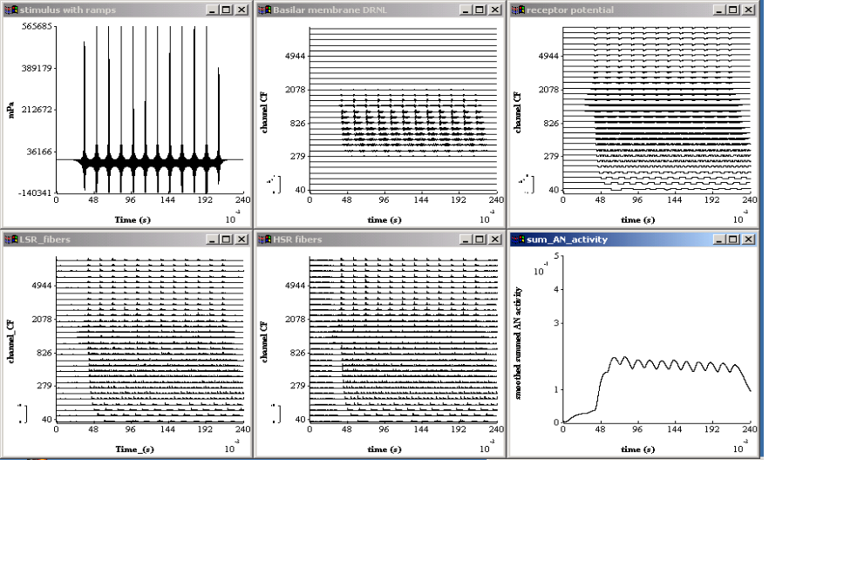

The loudness simulation file
The model is specified by a .sim file (loudness.sim) that should be present in your tutorials\loudness folder:

Simulation files are discussed in general in section 3.1 above.

#loudness.sim

diag_mode on Diagnostics mode ("off" or "on").

begin {

# stimulus generation
Stim_Harmonic < stimHarmonic.par

# apply ramps to signal
Trans_Gate < rampUp.par
Trans_Gate < rampDown.par
Util_PadSignal < padSignal.par
Display_Signal < displayStimulus.par

# outer/middle ear simulation
Filt_MultiBPass < filtIIRMoore.par

# convert to stapes velocity
Util_mathOp < mathOPstapes.par

# nonlinear DRNL filterbank
BM_DRNL < BM_DRNLHuman.par
Display_Signal < displayBM.par

# receptor potential
z% IHCRP_Shamma3StateVelIn (->a,b,d) < IHCRP_VelIn_GP.par
a% Display_Signal (z->) < displayRP.par

# IHC synaptic response and spike generation in three fiber types
# LSR
b% IHC_Meddis2000 (z->) < IHC_Meddis2000LSR.par
An_SG_Binomial < binomialLSR.par
b1% Display_Signal (->x) < displayLSR.par

# HSR
d% IHC_Meddis2000 (z->) < IHC_Meddis2000HSR.par
An_SG_Binomial < binomialHSR.par
d1% Display_Signal (->x) < displayHSR.par

# combine LSR, MSR and HSR fiber outputs
x% Util_Accumulate (b1, d1->)

# add across channels
Util_ReduceChannels < reduceChannels.par

# apply temporal window
Filt_MultiBPass < filtMBtemporalWindow.par
Display_Signal < displaySumAN.par

# write results to a data file
DataFile_out < dataFileOut.par
}

Processes and parameter files

Stimulus generation
# Stim_Harmonic < stimHarmonic.par

FUND_FREQ 64 Fundamental frequency (Hz).
INTENSITY 60 Intensity (dB SPL).
DURATION 0.2 Duration (s).
DT 2e-05 Sampling interval, dt (s).

LOW_HARMONIC 1 Lowest harmonic number.
HIGH_HARMONIC 20 Highest harmonic number.

PHASE_MODE COSINE

This process generates a harmonic stimulus. The .par file can be used to define
- the fundamental frequency
- the first and last harmonic number
- the intensity and duration of the signal.
- the phase relationships among the harmonics

The process can be used to create even more complex harmonic stimuli. See the manual.

Signal level is specified as dB SPL per component. The signal is represented as instantaneous pressure in micro Pascals.

Sample rate. DT, the stimulus sampling interval, is a very important parameter. This not only defines the sample rate for generating the stimulus but also defines the sample rate for all the model computations. This value must be set with care. A useful value is 2e-5s (equivalent to 50-kHz sample rate). For definitive computations, DT should be even shorter.

Large values of DT (lower sampling rates) may give rise to false results. AMS may even complain if the value is so large as to be predictably problematic. For example some IIR filters become unstable if the sample rate is too low. On the other hand, very small values of DT (e.g. 1e-6s) may result in long computation times with very little improvement in the quality of the result. If two values of dt give almost identical results, use the larger value and enjoy shorter computation times.

Stimulus ramps
Trans_Gate < rampUp.par
Trans_Gate < rampDown.par
See 6.2.2

PadSignal
This process adds silence to the beginning and end of the stimulus. It is important to do this for the 'Loudness' model because it integrates information over time. This integration needs a period of silence before and after the end of the stimulus proper to allow the integrator to stabilise.

# Util_PadSignal < padSignal.par

BEGIN_DURATION 0.02 initial silence to be added
END_DURATION 0.02 final silence to be added

Display signal
Display_Signal < displayStimulus.par

Display_Signal < displayStimulus.par

See section 6.2.3.

Human outer/middle ear
The outer middle ear (pre-emphasis) filter is a set of four parallel IIR bandpass filters. The overall effect of the outer/middle ear was calculated by combining the
outer ear transfer function as published in Moore et al. (1997) Fig. 2 with
the middle ear function published as figure 3 of the same paper. The
overall filter was published in Glasberg and Moore (2002).

# Filt_MultiBPass < filtIIRMoore.par

NUM_FILTERS 4

CASCADE 0:2
ATTENUATION 0:-12
LOWER_FREQ 0:100
UPPER_FREQ 0:1300

CASCADE 1:2
ATTENUATION 1:1.5
LOWER_FREQ 1:350
UPPER_FREQ 1:6500

CASCADE 2:2
ATTENUATION 2:5
LOWER_FREQ 3:1800
UPPER_FREQ 3:5200

CASCADE 3:2
ATTENUATION 3:-11
LOWER_FREQ 3:7500
UPPER_FREQ 3:14000

The parameter num_filters specifies the number of filters. Each filter must be fully described in terms of its parameters. The notation i:param specifies the parameter for the i^{th} filter. Filter numbers are sequenced 0,1.. N-1.

Each filter is composed of a cascade of first-order filters where the 3-dB down points of the first-order filters are specified by the parameters low_freq and upper_freq. The parameter cascade specifies the number of cascaded filters.

A cascade of 3 filters, for example, is similar to but not the same thing as a third order filter. A filter consisting of a cascade of three first-order filters has high and low frequency skirts with the same slope as a third order filter but the upper and lower cut-offs will be narrower than those specified in the parameters. In this case the low_freq and upper_freq parameters specify the 9-dB down points of the filter.

attenuation is the reduction in level between the input and output at BF. It is specified in dB.

The resulting filter is shown in Figure 7.

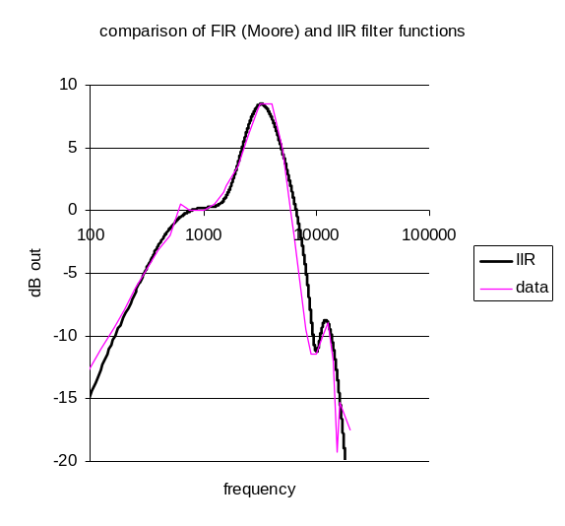
Figure 7 Comparison of multiBandPass approximation with original human data.

stapes motion
The next stage requires that we simulate the conversion of the input signal from sound pressure (μPa) to stapes motion (m/s). This is a linear conversion requiring nothing more than the application of a scalar.

# Util_mathOp < mathOpStapes.par
# converts microPascals to stapes velocity (m/s)

OPERATOR SCALE
OPERAND 3E-10

The scalar we have used is 3e-10. This was chosen to give an output of 1e-8 m/s for a 1 kHz signal at 0 dB SPL (Lopez-Poveda and Meddis, 2001).

BM_DRNL < BM_DRNLHuman.par
This process simulates the nonlinear response of the basilar membrane at a number of points along the length of the cochlea. It accepts stapes motion as input and returns basilar membrane (BM) velocity at 40 different points with characteristic frequency (CF) varying between 40 Hz and 10 kHz and spaced according to Greenwood's function for the distribution of CFs along the BM.

The rationale of the DRNL filter is explained elsewhere, Meddis et al. (2001). The particular coefficients used for the filters are taken from Lopez-Poveda and Meddis (2001). These have been optimized for human listeners. Expect these filter coefficients to change as new data is obtained and better fits are established.

This is a filterbank with many filters. The filter parameters for any given filter depend on the CF of that filter. They are computed in DSAM using a log regression equations fit to psycho-acoustic data. The regression equations look like this

log(parameter)= a + b log(CF)

where a and b need to be specified for each parameter. Unless you are specifically interested in the nuances of DRNL filtering, we advise that these parameters are not changed. These parameters are liable to change in the light of new data and new methods of estimating the parameters. If you want the latest set of parameters, contact Ray Meddis.

However, users may want to specify the number of filters and the range of their CFs. This can be done at the bottom of the file.

# BM_DRNL < BMdrnlGP.par

# Parameters are based on
# Lopez-Poveda, E.A., and Ray Meddis.
#"A human non-linear cochlear filterbank"
# JASA 110, 3107-3118, (2001)

#nonlinear path
NL_GT_CASCADE 3 Nonlinear gammatone filter cascade.
NL_LP_CASCADE 3 Nonlinear low-pass filter cascade.

NONLINBWIDTH_PARAMETER 0:-0.032
NONLINBWIDTH_PARAMETER 1:0.774

COMPRSCALEA_PARAMETER 0:1.4
COMPRSCALEA_PARAMETER 1:0.82

COMPRSCALEB_PARAMETER 0:1.62
COMPRSCALEB_PARAMETER 1:-0.82

COMP_N_EXPON 0.25 Compression exponent, n (units).

L_GT_CASCADE 3 Linear gammatone filter cascade.
L_LP_CASCADE 4 Linear low-pass filter cascade.

#linear path
LINCF_PARAMETER 0:-0.068
LINCF_PARAMETER 1:1.02

LINBWIDTH_PARAMETER 0:0.037
LINBWIDTH_PARAMETER 1:0.79

LINSCALEG_PARAMETER 0:4.2
LINSCALEG_PARAMETER 1:-0.48

#BF List Parameters:-
CF_MODE HUMAN
MIN_CF 40 Minimum centre frequency (Hz).
MAX_CF 10000 Maximum centre frequency (Hz).
CHANNELS 10 No. of centre frequencies.

Display BM
see section 6.2.7.

Receptor potential
See section 8.1.2.2 for a general description of this process.

In this example the output of the receptor potential process is used three times; as an input to the LSR and HSR fiber computations and also to the display process. To signal this, the three destinations are indicated in the parentheses.

z% IHCRP_Shamma3StateVelIn (->a,b,d) < IHCRP_VelIn_GP.par

Display Receptor potential
See section 8.1.2.3.

IHC synapse; LSR fibers
See section 8.1.2.4 for a general description of this process.

In this example the input comes from the receptor potential process labelled z%.

b% IHC_Meddis2000 (z->) < IHC_Meddis2000LSR.par

This process generates a stream of probabilities that reflect the likelihood that an action potential will occur in an auditory nerve fiber. The parameters that define this as a low spontaneous rate synapse can be found at the end of the .par file.

# IHC_Meddis2000 < IHC_Meddis2000HSR.par

# Sumner, et al (2002); Table II

OP_MODE PROB Output mode: 'spike' or probability, 'prob'
DIAG_MODE OFF Diagnostic mode:('off', 'screen' or <file name>).
RAN_SEED 0 Random number seed (0 for different each run).

PERM_Z 2e+32 Transmitter release permeability, Z (unitless gain)
REV_POT_ECA 0.066 Calcium reversal potential, E_Ca (Volts).
BETA_CA 400 Calcium Boltzmann function parameter, beta.
GAMMA_CA 130 Calcium Boltzmann function parameter, gamma.
TAU_M 1e-4 Calcium current time constant (s).
TAU_CA 1e-4 Calcium diffusion (accumulation) time constant (s).

REPLENISH_Y 10 Replenishment rate (units per second).
LOSS_L 2580 Loss rate (units per second).
REPROCESS_X 66.3 Reprocessing rate (units per second).
RECOVERY_R 6580 Recovery rate (units per second).

POWER_CA 3 Calcium transmitter release exponent (power).

# These parameters used to set fiber type
# based on HSR (1) in Sumner table II
GMAX_CA 8E-9 Maximum calcium conductance (Siemens).
CONC_THRESH_CA 4.48e-11 Calcium threshold Concentration.
MAX_FREE_POOL_M 10 Max. no. of transmitter packets in free pool

Auditory nerve spike generation; LSR fibers
# An_SG_Binomial < binomialLSR.par

NUM_FIBRES 36 Number of fibres.
RAN_SEED 0 Random number seed (0 for different seed for each run).
PULSE_DURATION 2e-05 Pulse duration (s).
MAGNITUDE 1 Pulse magnitude (arbitrary units).
REFRAC_PERIOD 0.00075 Refractory period (s).

This process takes spike probabilities from the synapse process and converts them to spike activity in a specified number of fibers. Spikes take the form of pulses whose height and width can be specified as parameters. For this particular example, the height and duration are arbitrary, so long as both HSR and LSR pulses are the same. 36 LSR fibers are used compared to 64 HSR fibers. This preserves the ratio of HSR/LSR fibers found in (Relkin, Hear. Res., 1991, 215-222). The output is the sum of all the pulses.

The method for computing the spike events is based on a rapid approximation using the binomial distribution (see Pearson). Refractory effects are simulated (somewhat imprecisely) using a formula to be found in Meddis?.

Display spike activity
There are two displays displayHSR.par and displayLSR.par.. Autoscale is switched off and all three displays are set to have the same y-scale so that comparisons can be made between displays.

# Display_Signal < displayLSR.par

WIN_TITLE "LSR_fibers"

WIN_HEIGHT 300
WIN_WIDTH 300
WIN_X_POS 0
WIN_Y_POS 300

Y_AXIS_TITLE "channel BF"
Y_AXIS_MODE CHANNEL
AUTO_Y_SCALE OFF
MAXY 10
MINY 0

X_AXIS_TITLE Time_(s)

Note that the output from the display process is directed toward the accumulate process below labeled x%.

b1% Display_Signal (->x) < displayLSR.par

HSR fibers
# HSR
d% IHC_Meddis2000 (z->) < IHC_Meddis2000HSR.par
An_SG_Binomial < binomialLSR.par
d1% Display_Signal (->x) < displayHSR.par

see LSR fibers above

Util_Accumulate
The two sets of fibers are now combined using this process. Util_Accumulate simply sums both of the input signals; b1 and d1. The output of this process is a single multi-channel representation.

x% Util_Accumulate (b1, d1->)

This process needs no parameter file.

Util_ReduceChannels < reduceChannels.par
This process adds together the activity in all of the channels, which is across BF channels.

It can be configured to combine channels together in different ways such as across two or three equal sets but on this occasion only one grand total is required.

We have a choice of whether to sum the channels or average them. Summing the channels is more in the spirit of the loudness model. However, averaging has the advantage of keeping the 'loudness' estimate roughly invariant when the number of channels is changed. This means that we can turn the auto-scale off in the subsequent display.

# Util_ReduceChannels < reduceChannels.par

MODE AVERAGE Mode - 'average' or simple 'sum'.
NUM_CHANNELS 1 (resulting number of channels)

Filt_MultiBPass < filtMBtemporalWindow.par
The temporal window is implemented here using a third-order bandpass filter with a very zero Hz lower cut-off frequency and a 40 Hz upper cutoff frequency. The parameters have been chosen to make the filter similar in operation to the temporal widow specified in Plack et al. (?) Here is the impulse response of the filter.

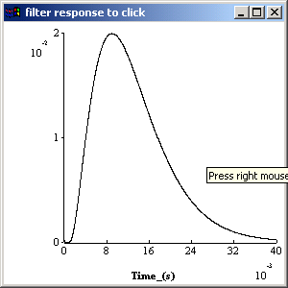

# Filt_MultiBPass < filtMBtemporalWindow.par

NUM_FILTERS 1 No. of parallel band pass filters.
CASCADE 0:3
ATTENUATION 0:0
LOWER_FREQ 0:0
UPPER_FREQ 0:40

Display_Signal < displaySumAN.par
The autoscale has been set to off. This makes it easier to see changes in "loudness" when the stimulus is changed.

'linear' has been chosen for the y-axis mode because we want to know the actual level of the output rather than the channel number.

# Display_Signal < displaySumAN.par

WIN_TITLE "sum AN activity: loudness?"

WIN_HEIGHT 300
WIN_WIDTH 300
WIN_X_POS 600
WIN_Y_POS 300

Y_AXIS_TITLE "smoothed summed AN activity"
Y_AXIS_MODE LINEAR
AUTO_Y_SCALE OFF
MAXY 0.5
MINY 0

X_AXIS_TITLE "time (s)"

DataFile_out < dataFileOut.par
The summed auditory nerve activity shown in the display is written to an ASCII .dat file. The first value in each row is the time.

Time (s) 0
0.00000e+000 0
2.00000e-005 0
4.00000e-005 0
6.00000e-005 0
8.00000e-005 0

-- --
-- --

2.80000e-004 0
3.00000e-004 0
3.20000e-004 0
3.40000e-004 0.0859397
3.60000e-004 0.171963
3.80000e-004 0.42995
4.00000e-004 0.602249
4.20000e-004 0.774716
4.40000e-004 0.775472
4.60000e-004 0.77623

The file name is specified as a '.dat' file. this guarantees that the output will be in printable form.

# DataFile_out < dataFileOut.par

FILENAME output.dat

Things to do

Stimulus intensity
Increase the intensity of the sound and monitor the effect on the loudness estimate in the final display. Does it agree with your intuition?

Effect of phase on loudness
The stimulus is a harmonic complex with each component in cosine phase. Does the phase affect the loudness estimate? The data that inspired the model came from Gockel et al. They found that cosine phase stimuli were louder than random phase stimuli.

Autocorrelation
This model can be found in the folder Tutorials\Autocorrelation. The original version of this folder can be found in DSAM\AMS\Tutorials\Autocorrelation. If you have not already done so, copy this folder into your regular workspace. Please do not work in the AMS workspace.

Model implementation (.sim and .par files)

.sim file

The autocorrelation model is broadly similar to the model presented in the original JASA articles: Meddis and Hewit (1991 a, b), Meddis and O'Mard(1997)

There is, however, one important difference. It has been updated to include the latest nonlinear peripheral model and the latest hair cell model from the Essex stable. There is no reason to persist with the original linear models now that we have useful nonlinear models.

The model has a number of stages

- Stimulus Input; A harmonic complex.
- Auditory periphery: The output from the periphery is a stream of probabilities of action potentials in fibers of the AN.
- Autocorrelation. A separate autocorrelation is computed at each stimulus frequency.
- Summary ACFs are computed by adding vertically all the rows in the ACF matrix (i.e. across all BF channels).
- Write to file

#ACF.sim

begin {

# Stimulus generation
stim% Stim_Harmonic < stimHarmonic.par

#apply ramps to signal
Trans_Gate < rampUp.par
Trans_Gate < rampDown.par
Display_Signal < displayStimulus.par

#outer/middle ear simulation
Filt_MultiBPass < filtMultiBandpass.par

#convert to stapes velocity
filt_LowPass < filtScaleToStapes.par

#nonlinear DRNL filterbank
BM_DRNL < BM_DRNLHuman.par
Display_Signal < displayBM.par

#receptor potential
Filt_MultiBPass < filtStereocilia.par
IHCRP_Shamma < IHCreceptorPotential.par
Display_Signal < displayReceptorPotential.par

# HSR
IHC_Meddis2000 < IHC_Meddis2000HSR.par
Display_Signal < displayHSR.par

Ana_Acf < acf.par
Display_Signal < displayACF.par

Util_ReduceChannels <reduceChannels.par

#write results to a data file
DataFile_out < dataFileOut.par
}

Example
When the model is run, the screen should look something like this.
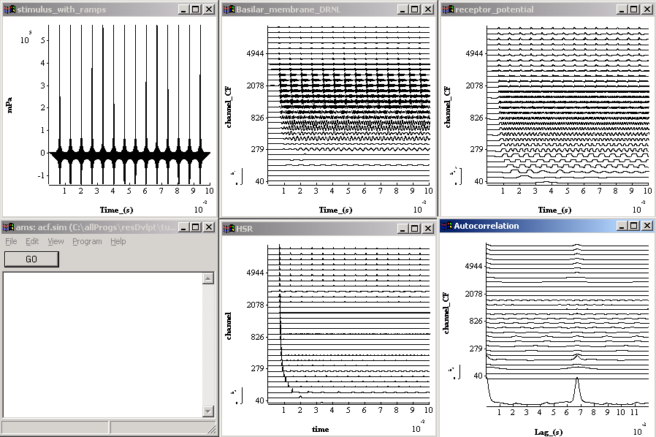

Figure 8 Autocorrelation model

Generate harmonic stimulus
# Stim_Harmonic < stimHarmonic.par

LOW_HARMONIC 1 Lowest harmonic number.
HIGH_HARMONIC 20 Highest harmonic number.
PHASE_MODE COSINE

FUND_FREQ 150 Fundamental frequency (Hz).
INTENSITY 60 Intensity (dB SPL).
DURATION 0.1 Duration (s).
DT 2e-05 Sampling interval, dt (s).

Stim_Harmonic is capable of generating a wide range of harmonic stimuli. Here it creates a harmonic complex. The output is in microPascals.

DT is the sampling period

Auditory periphery
This is described fully in sections 9.3.2 to 9.3.10.

#apply ramps to signal
Trans_Gate < rampUp.par
Trans_Gate < rampDown.par
Display_Signal < displayStimulus.par

#outer/middle ear simulation
Filt_MultiBPass < filtMultiBandpass.par

#convert to stapes velocity
filt_LowPass < filtScaleToStapes.par

#nonlinear DRNL filterbank
BM_DRNL < BM_DRNLHuman.par
Display_Signal < displayBM.par

#receptor potential
Filt_MultiBPass < filtStereocilia.par
IHCRP_Shamma < IHCreceptorPotential.par
Display_Signal < displayReceptorPotential.par

# HSR
IHC_Meddis2000 < IHC_Meddis2000HSR.par
Display_Signal < displayHSR.par

Autocorrelation
This module performs a within-channel running autocorrelation function and displays the final state of the function at the end of the signal.

# Ana_Acf < acf.par

TIME_CONST 0.0025 Time constant, tw (s).
MAX_LAG 0.012 Maximum autocorrelation lag, tau (s).

TIME_CONST specifies the time constant of the running autocorrelation function.
MAX_LAG specifies the longest period to be computed.

Display_Signal < displayACF.par
We want to see the summary autocorrelation coefficient (SACF) as well as the individual ACFs. This can be achieved by setting the subsequent display module parameter 'summary_display' to 'ON'. Note that this is a display facility only. The SACF is not passed to the next module. The output from Ana_Acf is the matrix of autocorrelation function (channel x lag).

It is also important to label the x-axis correctly ('Lag') to avoid confusion.

# Display_Signal < displayACF.par

Y_AXIS_MODE CHANNEL Y-axis mode ('channel' (No.) or 'scale').
AUTO_Y_SCALE ON Automatic y-axis scale ('on' or 'off').

X_AXIS_TITLE "Lag (s)"

WIN_TITLE Autocorrelation Display window title.
SUMMARYDISPLAY ON Summary display mode ('on' or 'off').

WIN_HEIGHT 300 Display frame height (pixel units).
WIN_WIDTH 300 Display frame width (pixel units).
WIN_X_POS 600 Display frame X position (pixel units).
WIN_Y_POS 300 Display frame Y position (pixel units).

Computing the SACF
This module performs a summation (or averaging) across channels of the signal. The user specifies how many output signals he wants. If two are selected, the top half of the signals are combined to produce the first output signal and the bottom half used to produce the second output signal.

# Util_ReduceChannels < reduceChannels.par

MODE AVERAGE Mode - 'average' or 'sum'.
NUM_CHANNELS 1 (resulting number of channels)

Writing the results to file
The result of the preceding module is written to an output file. The default is 'output.dat'.

The output has the following format

Time (s) 0
2.00000e-005 0.000820702
4.00000e-005 0.000817631
6.00000e-005 0.000803369
8.00000e-005 0.000778897
1.00000e-004 0.000745795
1.20000e-004 0.000706055
1.40000e-004 0.000661867
1.60000e-004 0.000615415
1.80000e-004 0.000568703
- - -

Binaural pitch extraction
This model can be found in the folder tutorials\binauralPitch. The original version of this folder can be found in DSAM\AMS\tutorials\ binauralPitch. If you have not already done so, copy this folder into your regular workspace. Please do not work in the AMS workspace.

This is a complex example. It is included to show how to handle binaural models. It also illustrates some fancy connections between modules.

When all harmonics of a fundamental frequency are presented to both ears (a diotic pitch stimulus), the percept has a pitch at a frequency close to the spacing of the harmonics. However, a binaural pitch stimulus consisting of a series of consecutive harmonics organised so that the even numbered harmonics are presented to one ear and odd numbered harmonics presented to the other ear (a dichotic pitch stimulus) also produces a pitch percept at the fundamental frequency (Houtsma and Goldstein, 1972). If pitch is processed monaurally, one might argue that the dichotic pitch stimulus should have a pitch at twice the frequency of the monaural stimulus. The fact that it does not has been used to argue that pitch is processed centrally, that is after the combination of left and right ear inputs.

However, this leaves us with two possibilities. The first is that raw stimulus information is combined and then pitch is extracted. The second is that periodicity information is extracted separately from each ear and that information is combined later to give the pitch percept.

We need to decide between two hypotheses:
- Early cross-over hypothesis: Left and right signals are combined before periodicity processing takes place
- Late cross-over hypothesis: Periodicity is processed separately in each ear and the results shared

To make specific predictions about the outcome of such experiments, we need to develop suitable computational models. The models to be described below are developments of monaural autocorrelation models.

Model outline
The 'binauralPitch' folder contains two models of binaural pitch extraction 'early-crossover' and 'late-crossover' (see Figure 9). Both models work on the basis that all auditory processes are duplicated on the left and the right sides. There is sharing of information of the results of these processes between the left and the right systems. The two models differ in terms of the level at which the information is shared (before or after periodicity analysis).
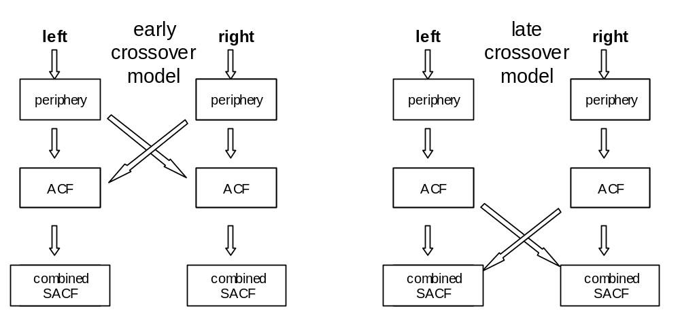
Figure 9 Comparison of the structure of the early-crossover and late-crossover models.

In the early-crossover version, the input from the left and right auditory nerve (AN) is combined before the autocorrelation analysis is performed.

In the late-crossover version, a separate autocorrelation analysis is performed on the left and right input from the auditory nerve. The results of these two autocorrelation analyses are then combined across the left/right divide.

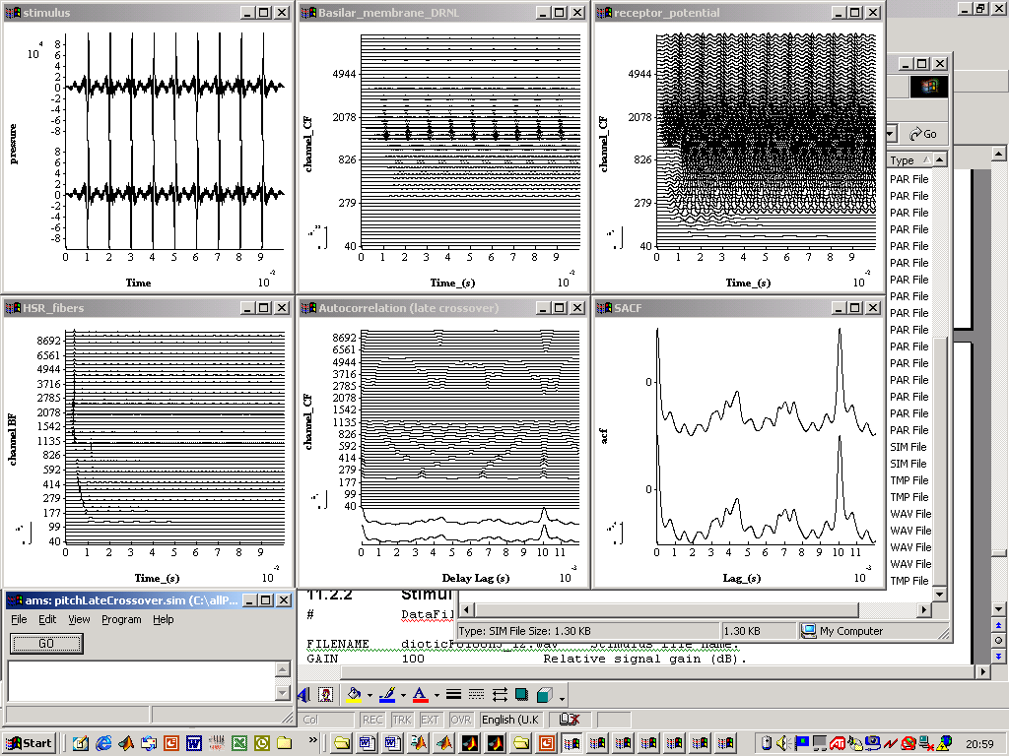
Figure 10 Output from early cross-over model for the diotic pitch stimulus (all harmonics to both ears (dioticF0100H3_12.wav).

The models are binaural and require a binaural input signal. Signal processing is separate for the left and right auditory nerves for both early-crossover and late-crossover models. In the displays, the left and right channels are interleaved so that corresponding channels can be compared.

Both models have the same three processing stages
- periphery (see sections 9.3.2 to 9.3.10)
- autocorrelation
- cross-ear combined summary autocorrelation (SACF)

Processing of binaural signals requires no special programming. DSAM\AMS automatically detects and processes binaural signals appropriately. For a binaural signal, each channel occupies two adjacent lines (left and right) in each display.

Early-crossover model

.sim file
#pitchEarlyCrossover.sim

# Simulation accepts a binaural input
# combines the AN spike probability input from both ears
# performs an acf on the combined input.

begin {

# Stimulus generation
DataFile_In < dataFileIn.par

#apply ramps to signal
Trans_Gate < rampUp.par
Trans_Gate < rampDown.par
Display_Signal < displayStimulus.par

# outer/middle ear simulation
Filt_MultiBPass < filtIIRMoore.par

# convert to stapes velocity
Util_mathOp < mathOPstapes.par

# nonlinear DRNL filterbank
BM_DRNL < BM_DRNLHuman.par
Display_Signal < displayBM.par

# receptor potential
IHCRP_Shamma3StateVelIn < IHCRP_VelIn_GP.par
Display_Signal < displayReceptorPotential.par

# HSR auditory nerve synapse
ihcrp% IHC_Meddis2000 (->swap, acc, dispHR) < IHC_Meddis2000HSR.par
dispHR% Display_Signal (ihcrp->) < displayHSR.par

#create left right mirror image
swap% Util_swapLR (ihcrp->acc)

#average left/right ihc probabilities together
acc% Util_Accumulate (ihcrp, swap-> )

#autocorrelate
Ana_Acf < acf.par
Display_Signal < displayACFearly.par

#create summary acf by collapsing across channels
a% Util_ReduceChannels < UtRedChans.par
Display_Signal < displayACFearly.par
#write results to a data file
DataFile_out < dataFileOut.par
}

Stimulus input
# DataFile_In < dataFileIn.par

FILENAME dioticF0100H3_12.wav Stimulus file name.
GAIN 100 Relative signal gain (dB).

The input file is a binaural .wav file. The file must be binaural or an error will be generated. The binauralPitch folder contains a number of .wav files, both dichotic and diotic harmonic stimuli. For example, dioticF0100H3_12.wav is a diotic stimulus with F0=100 Hz and harmonics 3 to 12.

The .wav files were generated using MATLAB programs also given in the binauralPitch folder; dioticHarmonicStimulus.m and dichoticHarmonicStimulus.m

The GAIN has been set to 100. This yields signal peak of 74 dB SPL. Of course, the effect of the gain depends upon the values in the .wav file. However, if the peak value in the .wav file is 1, a GAIN of 100 dB will yield a peak at 74 dB SPL.

The peripheral model
This includes all modules between the outer/middle ear simulation (Filt_MultiBPass) and the generation of AN spike probabilities (IHC_Meddis2000). See sections 9.3.2 to 9.3.10 for a complete description.

Crossover
#create left right mirror image
swap% Util_swapLR (ihcrp->acc)

#average left/right ihc probabilities together
acc% Util_Accumulate (ihcrp, swap-> )

The combination of information of left and right AN activity takes place using the swap module (Util_swap). This module takes a copy of the binaural AN response and swaps left with right to create a mirror image. Util_Accumulate then adds the original AN response to the mirror image to create a binaural combination of the left and right AN response. This might be represented algebraically,

AN response = [AN_left, AN_right]
swapped response = [AN_right, AN_left]
combination = AN response+ swapped response
=[AN_left +AN_right, AN_right+AN_left]

Note that the left and right are now the same.

The Util_Accumulate module adds together two or more inputs. The inputs are defined in the path indicator (ihcrp, swap-> )These indicators refer to row labels (e.g. ihcrp % and acc%). These labels are then used to define 'connectors' that are shown in parentheses. For example
- (-> swap, acc) means 'take the output of this module and send it to the two modules labelled swap% and acc%'.
- (ihcrp, swap->) means
  - use as input to this module the output from the modules labelled ihrcp% and swap%

Autocorrelation and SACF
The process Util_Acf performs the autocorrelation. A separate ACF is computed for each channel. The left and right channels are interleaved in the display.

The summary ACF is computed using the Util_ReduceChannels module. This adds across channels to produce a single channel, the SACF.

See section 10.1.5 and 10.1.7 for more information

Late-crossover model

.sim file
The late-crossover model is similar to the early-crossover model in most respects. However, the sharing of information between left and right takes place after the computation of the ACFs.

# pitchLateCrossover.sim

# simulation accepts a binaural input
# computes an acf for each ear independently
# and then averages the two acfs.

begin {

# Stimulus generation
DataFile_In < dataFileIn.par

# apply ramps to signal
Trans_Gate < rampUp.par
Trans_Gate < rampDown.par
Display_Signal < displayStimulus.par

# outer/middle ear simulation
Filt_MultiBPass < filtIIRMoore.par

# convert to stapes velocity
Util_mathOp < mathOPstapes.par

# nonlinear DRNL filterbank
BM_DRNL < BM_DRNLHuman.par
Display_Signal < displayBM.par

# receptor potential
IHCRP_Shamma3StateVelIn < IHCRP_VelIn_GP.par
Display_Signal < displayReceptorPotential.par
# HSR
IHC_Meddis2000 < IHC_Meddis2000HSR.par
Display_Signal < displayHSR.par

# autocorrelate
Ana_Acf < acf.par
Display_Signal < displayACFlate.par

# create summary acf
redch% Util_ReduceChannels (->swap, acc) < UtRedChans.par

# create left right mirror image
swap% util_swapLR (redch->acc)

# add left/right acfs together
acc% Util_Accumulate (redch, swap-> )
Display_Signal < displayACF2.par

#write results to a data file
DataFile_out < dataFileOut.par
}

This model is the same as the early crossover model up to the point where the autocorrelation is performed. In this model the autocorrelation is performed separately on the left and right channels before the left and right channels are combined.

Example
The two models can now be tested with diotic and dichotic stimuli:
Diotic
- Both left and right channels have 10 harmonics of a 100-Hz fundamental starting with the 3rd harmonic. (dioticF0100H3_12.wav)
Dichotic
- The left channel consists of 5 odd-numbered harmonics of a 100 Hz fundamental starting with the 3rd harmonic.
- The right channel consists of 5 even numbered harmonics of a 100 Hz fundamental starting with the 4th. (dichoticF0100H3_12.wav).

Diotic stimulus. Figure 11 shows the response of the early cross-over model to the diotic stimulus. The combined SACF shows a substantial peak at a lag of 10 msec. This pattern would normally be associated with a percept of a 100-Hz pitch
Figure 11. Early-crossover model with dichotic stimulus (see text)

Figure 12 shows the screen display for both the late-crossover model for exactly the same stimulus. The output is the same as Figure 11. Both early and late crossover models predict a pitch percept of 100 Hz.

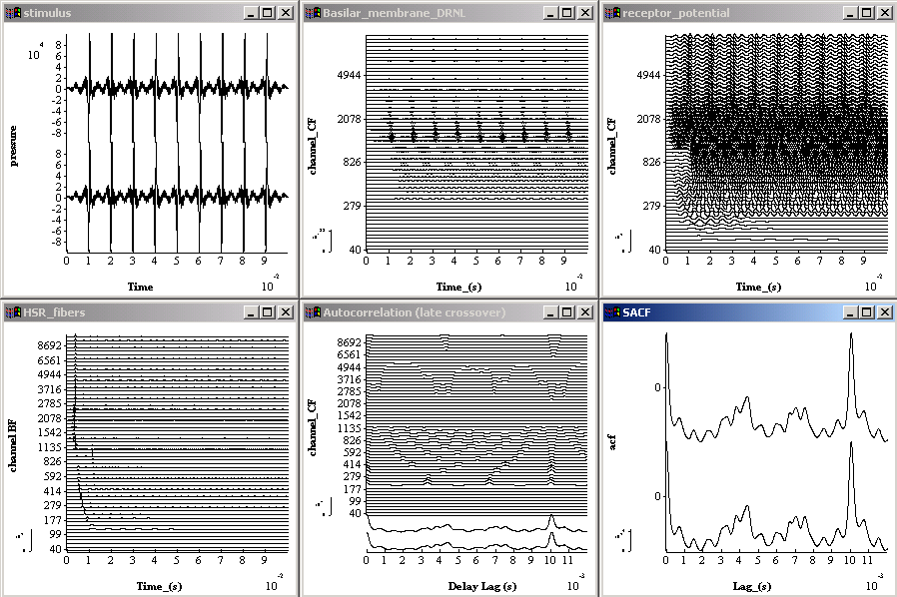

Figure 12. Late-crossover model with dichotic stimulus (see text)

Dichotic stimulus. Figure 13 shows the response of the early cross-over model to the dichotic stimulus. The combined SACF shows a substantial peak at a lag of 10 msec. This pattern would normally be associated with a percept of a 100-Hz pitch, that is no change from the diotic condition.

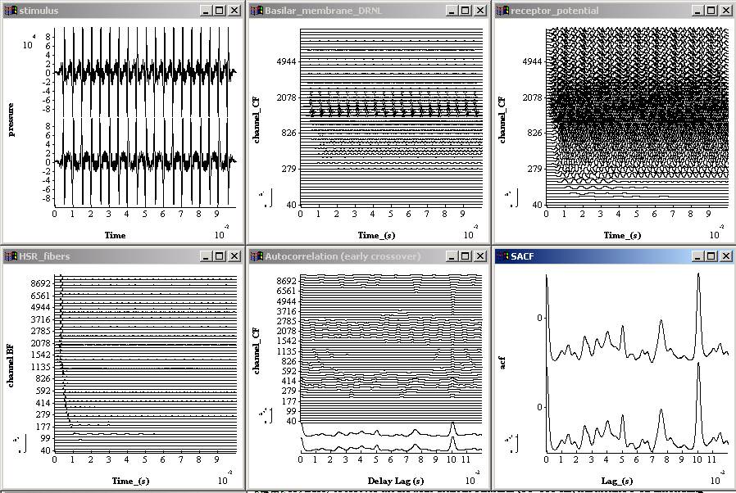
Figure 13. Early-crossover model with dichotic stimulus (F0=100 Hz, harmonics 3-12 alternating between ears).
Figure 14 shows the late cross-over model's prediction for the diotic stimulus. It is the same as the early cross-over model. Both models predict that both diotic and dichotic stimuli will give rise to a 100 Hz pitch percept.

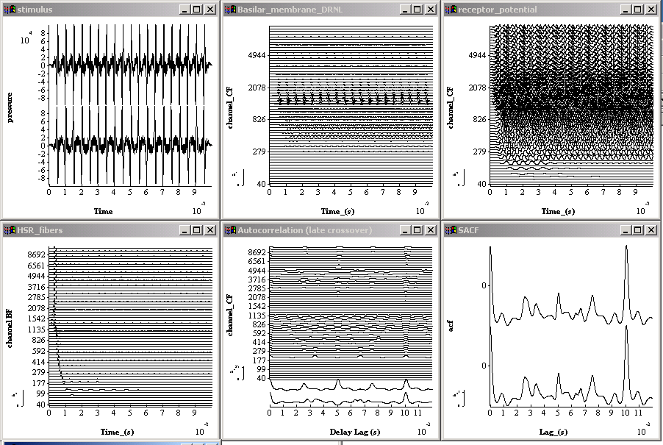
Figure 14. Late-crossover model with dichotic stimulus (F0=100 Hz, harmonics 3-12 alternating between ears).

Discussion
Both models (early and late crossover models) predict that both stimuli (dichotic and diotic) will be perceived as having a 100-Hz pitch. The fact that diotic and dichotic stimuli both give the same pitch cannot, therefore, be used to support the conclusion that the pitch detection mechanism occurs after combination of binaural information, Houtsma and Goldstein (1972).

At first sight the result looks trivial; after all why do we need to explain a null result? However, close examination of the autocorrelation figures shows that it is more complex than can be easily intuited. Figure 15 shows that the analysis gives different summary SACFs for all four conditions. We might expect this because the diotic and dichotic stimuli are very different. It is not surprising that the early crossover model gives a similar pitch prediction for both stimuli. This is because the AN effects of the separated harmonics are brought together before the autocorrelation process.

However, in the late crossover model, one might expect that 200-Hz periodicities would be more prominent for the dichotic stimulus. This is certainly true for the left SACF (upper trace, even harmonics) where a clear peak can be seen at 5-msec lag. However, (and here is the surprise), the lower trace (odd harmonics) shows a dip at 5 msec. When these two traces are combined to give the final pitch percept, the 5-msec peak and trough cancel leaving the main peak firmly at 10 msec with a resulting prediction of 100-Hz pitch percept.

diotic (same to both ears) dichotic

early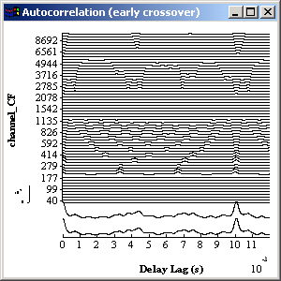 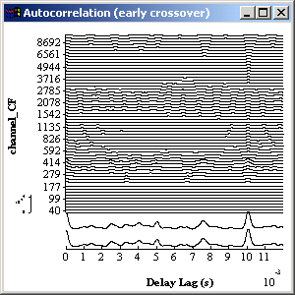

late 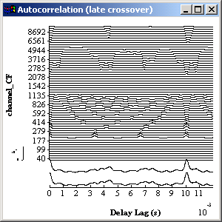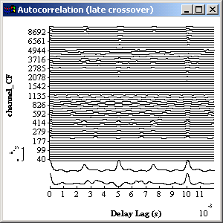

Figure 15 Comparison of the autocorrelation functions for diotic and dichotic stimuli presented to the early and late crossover models.

Precedence
This model can be found in the folder Tutorials\Precedence. The original version of this folder can be found in DSAM\AMS\Tutorials\ This model can be found in the folder Tutorials\Precedence. If you wish to change the program, copy this folder into your regular workspace. Please, do not make changes in the AMS workspace.

Model implementation (.sim and .par files)

.sim file
The precedence model is based as closely as possible on the precedence model of Hartung and Trahiotis (2001). In their model, they show that many effects associated with the title ‘precedence effect’ can be explained in terms of the activity of the auditory periphery (i.e. do not require neural processes such as inhibition).

Precedence concerns the phenomenon where the ITD of the first of a pair of binaural clicks determines the location of the clicks. In other words, the second pair of clicks is largely ignored. It is taken into account but is given a much lower weighting in the decision-making process.

This model is slightly different from the published version.. It has been updated to include the latest nonlinear peripheral model and the latest hair cell model from the Essex stable. There is no reason to persist with the original linear models now that we have useful nonlinear models. It does, however, raise the question of whether it still works with a nonlinear periphery.

There is another, less important difference. Hartung and Trahiotis did not use a running cross correlation but integrated across the whole 30 msec waveform. This simplifies the modelling process by avoiding some difficult decisions. In this implementation, however, we have used a 50-msec stimulus period starting with a 20 msec silence. The result is then integrated with a time constant of 15 msec.

The model has a number of stages

- Stimulus Input; A pair of binaural clicks.
- Auditory periphery: This section uses the same auditory periphery as described in the Loudness tutorial. The output from the periphery is a stream of probabilities of action potentials in fibers of the AN.
- Cross-correlation. A separate cross-correlation (CCF) is computed at each stimulus frequency.
- Summary CCFs are computed by adding vertically all the rows in the CCF matrix (i.e. across all BF channels).
- Write to file

#precedence.sim

off Diagnostics mode ("off" or "on").
relative Parameter file path mode - \relative\ or \absolute\

begin {

# Stimulus generation
# left clicks
L1% stim_click (->Lacc) <click_L1.par
L2% stim_click (->Lacc) <click_L2.par
Lacc% Util_accumulate (L1, L2->bin)

# right clicks
R1% stim_click (->Racc) <click_R1.par
R2% stim_click (->Racc) <click_R2.par
Racc% Util_accumulate (R1, R2->bin)

#combine left and right clicks into binaural stimulus
bin% Util_createBinaural (Lacc, Racc->)

# allow screen control of level
Util_mathOp < mathOpClickLevel.par
Display_Signal < displayStimulus.par

#outer/middle ear simulation
Filt_MultiBPass < filtIIRMoore.par

#convert to stapes velocity
Util_mathOp < mathOpstapes.par

#nonlinear DRNL filterbank
BM_DRNL < BM_DRNLHuman.par
Display_Signal < displayBM.par

#receptor potential
IHCRP_Shamma3StateVelIn < IHCRP_VelIn_GP.par
Display_Signal < displayReceptorPotential.par

# HSR spike probability
IHC_Meddis2000 < IHC_Meddis2000HSR.par
Display_Signal < displaySpikeProb.par

# cross correlate
Ana_ccf < ccf.par
Display_Signal < displayCCF.par

#create summary acf
Util_ReduceChannels < UtRedChans.par
Display_Signal < displayCCFsummary.par

#write results to a data file
DataFile_out
}

Example
When the model is run, the screen should look something like this.
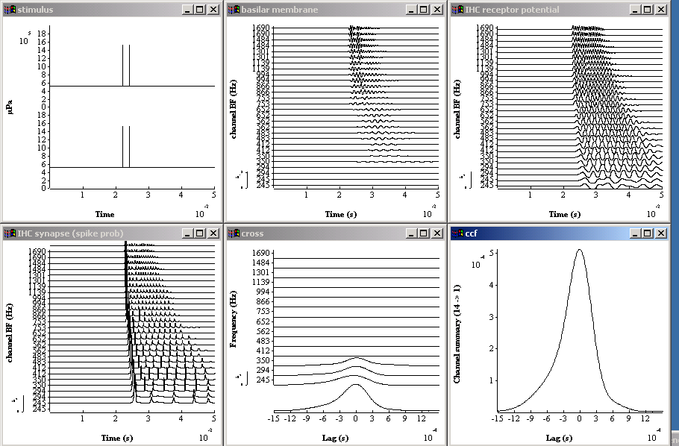

Figure 16 Precedence model

Generate click stimuli
We have four clicks; two on the left (L1, L2) and two on the right (R1, R2). We compute them all separately so that we can have individual control over their timing. The current set up creates a pair of clicks 2 msec apart with 0-msec ITD. The image should be central (last display in Fig. 17) .

Each click parameter file looks like this.

# stim_click <click_L1.par

TIME 22e-3
AMPLITUDE 1e6
DURATION 50e-3
DT 1e-5

TIME is when the click occurs (after 22 msec).
AMPLITUDE is the peak pressure in microPascals. These clicks are as wide as the sampling interval (DT). Note that many psychophysical experiments have wider clicks.
DURATION is the duration of the total stimulus including silence.
DT is the sampling period

First we create the two clicks on the left and then add them together

Lacc% Util_accumulate (L1, L2->bin)

Util_accumulate requires no parameter file. It just adds all its inputs together. The inputs are specified in the brackets (L1, L2 -> bin) that also specify that the output goes to the module labelled ‘bin%’.

Then we create the two clicks on the right and then add them together

Racc% Util_accumulate (R1, R2->bin)

Create Binaural stimulus

Combine the left and right stimulus into a binaural signal

bin% Util_createBinaural (Lacc, Racc->)

Util_createBinaural requires two inputs labelled Lacc and Racc to form the left and right components of the binaural signal.

The overall level of the stimuli can be controlled by a scalar applied by mathOp

Util_mathOp < mathOpClickLevel.par

The scalar is set to 1, so does not influence anything but is there for the user should he wish to explore very low or high signal levels without having to reset each click level independently.

Auditory periphery
This is the same as that used in the Loudness model and is described fully in sections 9.3.5 to 9.3.14.

Filt_MultiBPass < filtIIRMoore.par

#convert to stapes velocity
Util_mathOp < mathOpstapes.par

#nonlinear DRNL filterbank
BM_DRNL < BM_DRNLHuman.par
Display_Signal < displayBM.par

#receptor potential
IHCRP_Shamma3StateVelIn < IHCRP_VelIn_GP.par
Display_Signal < displayReceptorPotential.par

# HSR spike probability
IHC_Meddis2000 < IHC_Meddis2000HSR.par
Display_Signal < displaySpikeProb.par

Note: The BM_DRNLHuman.par file has been adjusted to use the same range of 14 best frequencies (224.7 to 1690 Hz) as used by Hartung and Trahiotis.

Cross correlation
This module performs a within-channel running cross correlation function and displays the final state of the function at the end of the signal.

Ana_ccf < ccf.par

OFFSET 48e-3
TIME_CONST 1e30
MAX_LAG 1.5e-3

OFFSET specifies the time at which the running cross correlation is to be displayed. The OFFSET must be shorter than the duration of the stimulus. As a rule of thumb, OFFSET+MAX_LAG <= DURATION.
(DURATION is specified in the click parameter files).

TIME_CONST specifies the time constant of a running cross-correlation function. Here we have set the time constant to a very large number (1e30). This is effectively an infinite time constant.

MAX_LAG specifies the longest ITD to be computed (H&T used +/- 1.5 msec).

Display_Signal < displayCCF.par
We want to see the summary cross correlation coefficient (SCCF) as well as the individual CCFs. This can be achieved by setting the subsequent display module parameter 'summary_display' to 'ON'. Note that this is a display facility only. The SACF is not passed to the next module. The output from Ana_ccf is the matrix of cross correlation functions (channel x lag).

It is also important to label the x-axis correctly ('Lag') to avoid confusion.

# Display_Signal < displayCCF.par

Y_AXIS_MODE CHANNEL Y-axis mode ('channel' (No.) or 'scale').

AUTO_Y_SCALE ON Automatic y-axis scale ('on' or 'off').

X_AXIS_TITLE "Lag (s)"

WIN_TITLE cross correlation Display window title.
SUMMARYDISPLAY ON Summary display mode ('on' or 'off').

WIN_HEIGHT 300 Display frame height (pixel units).
WIN_WIDTH 300 Display frame width (pixel units).
WIN_X_POS 300 Display frame X position (pixel units).
WIN_Y_POS 300 Display frame Y position (pixel units).

Computing the SCCF
This module performs a summation (or averaging) across channels of the signal. The user specifies how many output signals he wants. If two are selected, the top half of the signals are combined to produce the first output signal and the bottom half used to produce the second output signal. We want only one.

# Util_ReduceChannels < UtRedChans.par

MODE SUM Mode 'average' or simple 'sum'.
NUM_CHANNELS 1 Number of resulting channels.

Writing the results to file
The result of the preceding module is written to an output file. The default is 'output.dat'.

The output has the following format

Delay period (s) 0
-1.50000e-003 2.27253e-006
-1.49000e-003 2.39382e-006
-1.48000e-003 2.52502e-006
-1.47000e-003 2.66667e-006
-1.46000e-003 2.8193e-006
-1.45000e-003 2.98337e-006
.............

Fun things to do

Move to the left using the first click
Advance the time of the first left click (L1) by, say, 300 microSec. The CCF peak should move to the left.

Move to the left using the second click
Restore the time of the L1 and now advance the time of L2 by the same amount, say, 300 microSec. The peak should move to left of centre but by a smaller margin than observed when L1 was moved

Do some real modelling
Hartung and Trahiotis (2001) show a number of results using their implementation of the model (using linear filters and the old 86 hair cell model). You could try to replicate their results using the lates nonlinear model.

.

Bibliography

Hartung, K. and Trahiotis, C. (2001) “peripheral auditory processing and investigations of the ‘precedence effect’ which utilize successive transient stimuli”, J Acoust Soc Am, 110, 1505-1513.
Glasberg, B. R., and Moore, B. C. J. (2002). "A model of loudness
applicable to time-varying sounds," J. Audio Eng. Soc. 50, 331-342.
Moore BCJ, Glasberg BR, Baer T. (1997). “A model for the prediction of thresholds, loudness, and partial loudness,” J Audio Eng Soc 45 (4): 224-240.
Greenwood Donald D. (1990) "A cochlear frequency-position function for several species 29 years later", J Acoust Soc Am, 87, 6, Cochlear Mechanics.
Lopez-Poveda E.A., and Meddis R. (2001a). "A human nonlinear cochlear filterbank," J. Acoust. Soc. Am. 110, 3107-3118.
Meddis, R. and O'Mard, (1997) "A unitary theory of pitch perception," Journal of the Acoustical Society of America. 102, 1811-1820.
Meddis, R., O'Mard, L.P., and Lopez-Poveda, E.A. (2001). "A computational algorithm for computing nonlinear auditory frequency selectivity," J. Acoust. Soc. Am. 109, 2852-2861.
Moore, B. C. J., Glasberg, B. R., and Baer, T. (1997). "A model for the
prediction of thresholds, loudness and partial loudness," J. Audio Eng.
Soc. 45, 224-240.
Moore, B.C.J. and Glasberg, B.R. (1987) "Formulae describing frequency selectivity in the perception of loudness, pitch and time," in Frequency Selectivity in Hearing, edited by B.C.J.Moore (Academic, London)
Plack , C.P. and Carlyon,R.P. (1995) 'Loudness perception and Intensity coding' in Hearing, ed. B.C.J.Moore (Academic, New York).
Relkin,E.M. and Doucet,J.R. (1991) Hearing Research, 55, 215-222.
Sumner, C., Lopez-Poveda, E.A., O'Mard, L.P. and Meddis, R. (2002). 'Adaptation in a revised inner-hair cell model,' submitted to Journal of Acoustical Society of America. (accepted subject to revision).
Sumner, C., O'Mard, L.P., Lopez-Poveda, E.A., and Meddis, R. (2003). 'A non-linear filter-bank model of the guinea-pig cochlea,', submitted to Journal of Acoustical Society of America (accepted subject to revision).
Sumner, C.J., O'Mard, L.P., Lopez-Poveda, E.A., and Meddis, R. (2002a). "A revised model of the inner-hair cell and auditory nerve complex," Journal of the Acoustical Society of America, 111, 2189-2199.

Houtsma, A.J.M. And Goldstein, J.L. (1972) "The central origin of the pitch of complex tones: evidence from musical interval recognition,", J Acoust Soc Am, 51, 520-529

In fact, Sumner recommends a cascade of two filters but parallel filters appear to give a better fit to the animal data.
While three types are commonly quoted, some research suggest that some animals have only two distinct types; Relkin,E.M. and Doucet,J.R. (1991). Two makes for an easier model, but the .sim file could be easily extended to include three if required.

