**Week 5 Fox Demo Notes**

**My dear students, let us do this class exercise together !**

**What are we going to do ?**

* Create a local repository in your lab machine or system.
* Add web project resources index.html, style.css to local repository.
* Create a remote GitHub repository using your GitHub personal account.
* Configure your local repository to work with remote GitHub repository.
* Push your local repository contents to remote repository and synchronize it.
* Learn to use Visual Studio Code to perform web development and version control
  + Code changes and save them
  + Commit changes to local repository
  + Push and pull to synchronize remote and local repositories.

**Task 1 Create a local repository and add web project to local repository**

Open a command window. Change directory to C:\

**cd C:\**

Create a project, say fox-project

C:\>**mkdir fox-project**

Change directory to **fox-project**

C:\>**cd fox-project**

Create and edit a file index.html and save it, using Notepad editor.

**notepad index.html**

add some html content, <h1> welcome to fox project </h1> and then save it.

Initialize a new git repository. Use the command git init

C:\fox-project>**git init**

Add all resources in the current directory using git add command

C:\fox-project>**git add .**

Commit the changes with a message “created fox-project”

C:\fox-project>**git commit -m "created fox-project"**

Check the git status and git log

C:\my-project>**git status**

C:\my-project>**git log**

**Task 2 Create a remote GitHub repository using your GitHub personal account.**

Open a browser, go to <https://github.com/>

Sign in to your personal account.

Let us create a new GitHub repository **fox-project**

Click on **Repositories -🡪 New**

Enter the following values for this repository.

**Repository name: fox-project**

**Description (optional): fox demo repository**

**Type of Repository: Public**

Click on **Create repository**

**Task 3. Configure your local repository to work with remote GitHub repository. Push your local repository contents to remote repository and synchronize the repositories.**

Go back to the command window you were using for the local repo in task1. Continue to work in this command window directory.

You must add the remote repository to your local repository configuration.

Your local repository branch is Master, the GitHub repository branch is main. So before you push your content from local to remote, select the branch as main on the remote repository.

And then use the git push command. Type the following commands one by one.

**git remote add origin https://github.com/saravanankuppusamy/fox-project.git**

**git branch -M main**

**git push -u origin main**

Open a browser, go to GitHub repository, and verify the contents.

**Edit the contents of index.html in GitHub repository and Commit the changes**.

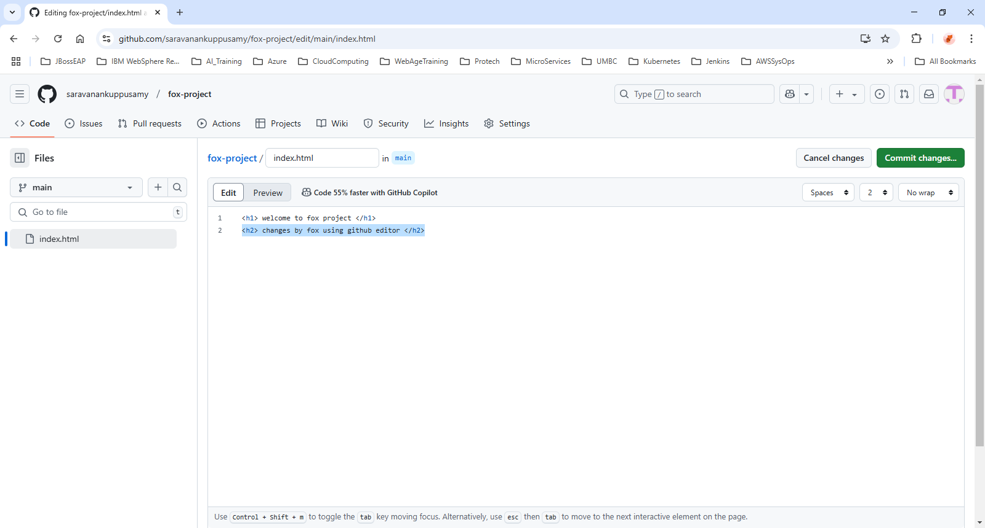

How to get this updated file into the local repository?

Go to Command window, use the command git pull

C:\fox-project>**git pull**

**A successful pull operation would display the following messages.**

C:\fox-project>git pull

remote: Enumerating objects: 5, done.

remote: Counting objects: 100% (5/5), done.

remote: Compressing objects: 100% (2/2), done.

remote: Total 3 (delta 0), reused 0 (delta 0), pack-reused 0 (from 0)

Unpacking objects: 100% (3/3), 970 bytes | 37.00 KiB/s, done.

From https://github.com/saravanankuppusamy/fox-project

f7403eb..1819be3 main -> origin/main

Updating f7403eb..1819be3

Fast-forward

index.html | 3 ++-

1 file changed, 2 insertions(+), 1 deletion(-)

**Task 4: Learn to use Visual Studio Code to perform web development and use version control**

Open the visual studio code. Open the project: fox-project

Click on **File 🡪 Open Folder 🡪 C:\fox-project**

In the project let us create a new file: **style.css** and add some code.

In the VS Code, Click on **Source Control (Ctrl + Shift + G)**

Enter a commit message**: added style.css**

Click on **Commit.**

A screenshot of a Visual Studio Code Source control Graphical user interface.
You can enter commit message and click on Commit.

After Commit, Click on **Sync Changes.**

A screenshot of a Visual Studio Code Source control graphical user interface displaying the button Sync changes.
The push on this button will synchronize the changes to remote repository.

**Make changes in the GitHub repository using GitHub editor. How can you synchronize with local repository?**

**Task 5 Let us create a new project in Visual Studio Code, add resources to the project, initialize a local repository and then push repo contents to remote GitHub Repository.**

Open the Visual Studio Code.

Click on **File -🡪 New Window.**

In the new window, let us click on **Explorer (Ctrl + Shift + E)**

To create a new Folder, click on **File 🡪 Add folder to Workspace.**

Let us add new folder **my-demo.**

Create index.html and style.css in this folder my-demo.

Click on Source Control (**Ctrl + Shift + G**), click on the button **Initialize Repository**.

Select the folder **my-demo** that contains index.html and style.css.

A screenshot of Visual Studio Code displaying Source Control user interface.
There is a button Initialize Repository. when you click on it, it will highlight the repo folder to choose.

Add a commit message and click on the **Commit** Button.

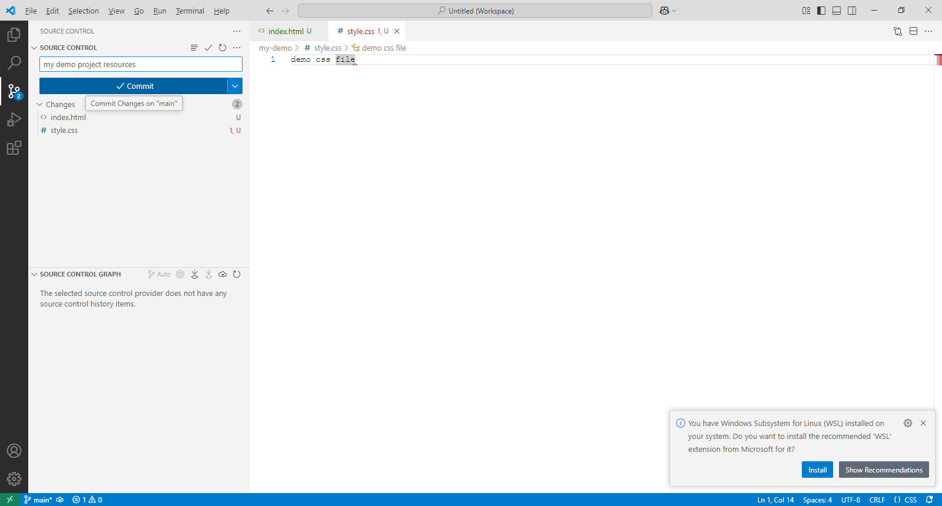

**Can you Publish the local repository to GitHub remote repository ? How ?**

**See Fox demo.**