Use Dewesoft TEDS Editor

Manufacturer: Unknown (109)

Model Number 1-A-1

Serial Number IP Last Class

Use template

MID#106 Dewesoft Sensor Properties

Manufacturer: 5bit ALPS ELEC

Model Number: 5bit IOT SMART MDL

Serial Number: 5bit MAC ADDRESS 10 Characters

0 1 2 3 4 5 6 7 8 9 A B C D E F

O L Q W S R T Y U I A B C D E F

User Data: A: Accuracy (if available)

User Data: S: Sensitivity (if available)

Save as ALPS-XXXX.tedsxml

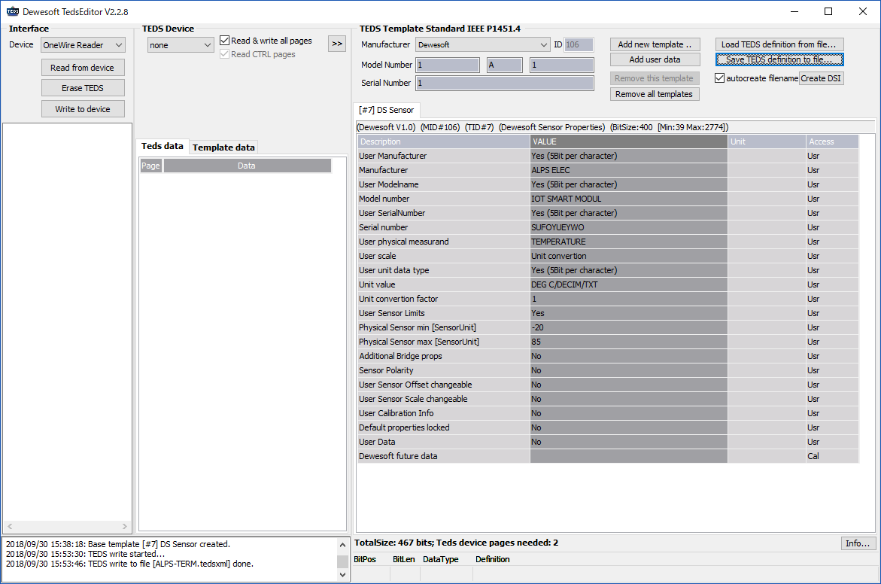

Create XML file

