****

Understanding Cellular Automata and Developing an Artefact to Replicate the Lotka-Volterra Predator-Prey Interaction Model

Thomas O. Weston

Towards the Degree of

BSc (Hons) Computing

at the University of Worcester

# Abstract

Simulations are essential to gaining a greater understanding of the world we live in. They allow us to test things from within an environment that we have complete control over, something that is rarely possible within real-life environments. Ecological systems, such as the interactions between predators and prey, can be very difficult to track and examine in the real world, not to mention expensive and time consuming. There is also the risk that human interference may disturb the natural balance and prevent systems from operating correctly.

It is for this reason that research and study into alternative methods of ecological modelling is so important. This dissertation is presented in two major parts: a literature review that surmises the current understanding of the cellular automata and the Lotka-Volterra models, and a first-hand development journal of an artefact that examines the suitability of the two being used in conjunction.

# Acknowledgements

In many ways this dissertation serves as the summative work of my time studying at the University of Worcester, employing the skills I have gained to explore and investigate a new field of study and discover what I can contribute to it.

I would like to thank my project supervisor Dr Colin Price for supporting and guiding me in the development of this project.

Table of Contents

[Abstract 2](#_Toc8522686)

[Acknowledgements 3](#_Toc8522687)

[1 Introduction 6](#_Toc8522688)

[1.1 Background 6](#_Toc8522689)

[1.2 Aims 6](#_Toc8522690)

[1.3 Objectives 6](#_Toc8522691)

[2 Review of Literature 7](#_Toc8522692)

[2.1 Cellular Automata 7](#_Toc8522693)

[2.1.1 History 7](#_Toc8522694)

[2.1.2 Definition 8](#_Toc8522695)

[2.1.3 Cellular Automata as Applied to Natural Systems 10](#_Toc8522696)

[2.2 Predator-Prey Interaction Models 10](#_Toc8522697)

[2.2.1 Population Cycles 10](#_Toc8522698)

[2.2.2 Lotka-Volterra Model 10](#_Toc8522699)

[3 Methodology 13](#_Toc8522700)

[3.1 Software Development Environment 13](#_Toc8522701)

[3.1.1 Processing 13](#_Toc8522702)

[3.1.2 GNU Octave 13](#_Toc8522703)

[3.2 Design Specification 13](#_Toc8522704)

[3.2.1 Assumptions 14](#_Toc8522705)

[3.2.2 Variables 14](#_Toc8522706)

[4 Development 15](#_Toc8522707)

[4.1 Version 1 15](#_Toc8522708)

[4.1.1 Rules 15](#_Toc8522709)

[4.1.2 Analysis 16](#_Toc8522710)

[4.2 Version 2 17](#_Toc8522711)

[4.2.1 Changes from Version 1 17](#_Toc8522712)

[4.2.2 Analysis 17](#_Toc8522713)

[4.3 Version 3 19](#_Toc8522714)

[4.3.1 Changes from Version 2 19](#_Toc8522715)

[4.3.2 Analysis 20](#_Toc8522716)

[4.4 Version 4 – Final Artefact 21](#_Toc8522717)

[4.4.1 Changes from Version 3 21](#_Toc8522718)

[4.4.2 Rules 21](#_Toc8522719)

[5 Results 23](#_Toc8522720)

[5.1 How Results were Gathered 23](#_Toc8522721)

[5.2 Fixed Parameters 23](#_Toc8522722)

[5.3 Average Population Results 23](#_Toc8522723)

[5.4 Validation 23](#_Toc8522724)

[5.5 Verification 24](#_Toc8522725)

[5.6 Parameter Testing 25](#_Toc8522726)

[5.6.1 Predator Catch Rate 25](#_Toc8522727)

[5.6.2 Deterministic vs Stochastic 26](#_Toc8522728)

[5.6.3 Size of Environment 27](#_Toc8522729)

[6 Reflection 28](#_Toc8522730)

[6.1 What was achieved 28](#_Toc8522731)

[6.2 What could have been improved upon 28](#_Toc8522732)

[7 Conclusion 29](#_Toc8522733)

[7.1 Summary 29](#_Toc8522734)

[7.2 Contributions 30](#_Toc8522735)

[7.3 Directions for Future Study 30](#_Toc8522736)

[8 References 31](#_Toc8522737)

[9 Project Proposal Form 33](#_Toc8522738)

[10 Grading Matrix 37](#_Toc8522739)

# Introduction

## Background

To study cellular automata is fascinating because it examines the world from a bottom-up approach. It does not concern itself with the bigger picture, but instead is focused on simple and set rules from which emergent behaviours and complex systems can emanate. In a sense, to examine cellular automata is to examine the nature of complexity itself.

This dissertation will be examining cellular automata as applied to the Lotka-Volterra predator-prey interaction model, as it exhibits logical ties that will become evident. Extensive research has been conducted into the field of cellular automata and predator-prey interaction models in order to establish a sufficient knowledge base for this project to proceed upon. The results and findings of this research shall be detailed in the literature review section of this dissertation. Key pieces of literature from prominent figures in this area, such as Stephen Wolfram, will also be reviewed, identifying the key contributions these works have added to the currently accepted knowledge at the time of writing.

A cellular automaton artefact has been constructed to further aid in achieving the aims and objectives of this dissertation. This artefact and the original data it has produced, have been subjected to tests and analysis to establish what it can add to the current understanding of cellular automata.

## Aims

The aim is to create a cellular automata artefact (hereby referred to as ‘the artefact’) that will simulate the interactions between predator and prey entities. The development of this artefact will serve as a thorough and in-depth exploration into creating a cellular automaton that emulates the Lotka-Volterra model.

1. This will be limited to a two-species system in which one species will predate the other.
2. Movement will be restricted to a Moore neighbourhood.
3. In order to obtain meaningful results, the field will be at least 50 x 50 cells in size.

## Objectives

The objective is to successfully gather and analyse the original data it produces, as well as comparing it to other work already conducted in the field.

1. The artefact will be designed and developed in adherence to the cellular automata and Lotka-Volterra predator-prey interaction models.
2. Use the research of relevant sources and information to aid in the production of the artefact.
3. Investigate how different initial variables and states affect the artefact.
4. Validate against a theoretical model and verify against a peer’s model.
5. Identify any weaknesses or limitations and highlight how improvements could be made.

# Review of Literature

A literature review has been carried out to establish a sufficient knowledge base for this project to proceed upon. The purpose of this review is to explain what was found in the research of cellular automata and predator-prey interaction models. It serves as the foundation that the project is built upon and will give you the required knowledge to understand the impact this artefact will have.

To effectively design and develop this artefact, an appropriate understanding into the origins, major advancements and key contributors must first be examined. To explore this vast field, a range of literature has been selected.

Before we examine the cellular automata model we must first look at what a model is within the context of a simulation. Clarke (2014) defines models as “simplifications of real-world systems” and goes on to claim how they can be used to test the way real-world systems might react to changes in their state and function. This can be useful for scenarios in which testing on the real-world system would be unacceptable or unrealistic. For example, closing the London Underground to test how the buses handle the increase in traffic, would likely result in chaos, whereas a simulation could emulate this scenario without any consequences.

However, models are only useful if they are based on knowledge and understanding of already established real-world systems and can reasonably fall in line with what is already understood to be true. Therefore, it is important that the correct simulation model is selected for simulating natural systems.

Cellular automata has been described as an “individual-based modelling approach” in ecology, due to the fact that they simulate systems from the bottom-up (Clarke, 2014). This means that they simulate each individual entity then gather results based on summative behaviours and patterns seen in the collective. They focus on the low-level interactions between autonomous entities and are generally much easier to program, making them some of the simplest frameworks for demonstrating complex systems behaviours.

Cellular automata models can also exhibit emergent behaviours. Emergence is a phenomenon commonly seen in natural systems, where it is:

“Said to exist in a system when new and unpredicted patterns or global-level structures arise as a direct result of local-level procedures” (Clarke, 2014).

## Cellular Automata

### History

The first person to introduce the concept of cellular automata to the world was Hungarian-American mathematician, John Von Neumann (Wolfram, 2002). At the time, he was trying to develop an abstract model of self-reproduction in biology. The cellular automaton he constructed in 1952-3, consisted of 29 possible states for each cell and complicated rulesets, that aimed to emulate the workings of various components of a computer and other mechanical devices (Wolfram, 2002).

This automaton was:

“A two-dimensional infinite array of uniform cells, where each cell is connected to its four orthogonal neighbors” (Sarkar, 2000).

Its “four orthogonal neighbors” in this case were its neighbouring cells to its immediate north, south, east and west. This would come to be known as the Von Neumann neighbourhood set (Sarkar, 2000).

In 1970, British mathematician John Conway would employ the cellular automata model in his now-famous ‘Game of Life’ (Bays, 2010). His original intention was to design a simple set of rules to study the macroscopic behaviour of a population (Sarkar, 2000). The design philosophy behind the ruleset was that growth or decay of the population should not be easily predictable. This population was represented by a two-dimensional infinite array of cells which all had a Moore neighbourhood (figure 4), where each cell could only be one of two states, 1 or 0. The rules for John Conway’s ‘Game of Life’ would dictate whether each individual cell would survive, give birth or die on each new cycle (Sigmund, 2017). These simple rules are capable of creating some very interesting results, such as the ‘Gosper Glider Gun’, which was the first known finite pattern that exhibited unlimited growth (Soto, 2017).

The ‘Game of Life’ proved to be a great showcase of cellular automata and the increase in interest led to it being seen as a legitimate simulation model for complex systems.

Despite this, interest in cellular automata had begun to fade by the end of the 1970s. It was eventually revitalised in 1983 when Stephen Wolfram published his first paper on cellular automata, simply titled ‘Cellular Automata’ (Human, 2014).

He went on to publish several papers on the topic, many of which have defined the current understanding of cellular automata. Much of his work will be heavily referenced and examined in this paper.

### Definition

Stephen Wolfram (1983) defines cellular automata as “simple mathematical idealizations of natural systems”. He states that it can be thought of as a number of entities that start with an initial value and evolve in discrete time steps according to deterministic rules, that specify the value of each entity in accordance to the value of neighbouring entities (Wolfram, 1983). Breaking this down, we can look at cellular automata as a series of properties a model must have, these are:

* A grid of cells which can each assume a finite number of states.
* A neighbourhood over which a change operator applies.
* A set of initial conditions.
* One or more rules which change the state of a cell based on the properties or states of its neighbouring cells.

The simplest possible cellular automata would be a one-dimensional array of cells. Time would be discrete and on each new cycle (or generation) the cells next state would be determined by its current state and that of its immediate neighbours to its left and right.

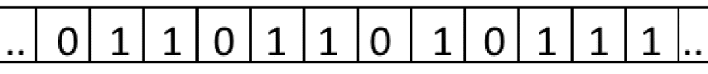

Figure 1. Cell Array

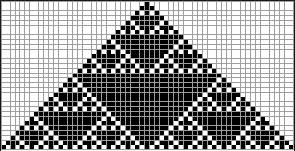In this simple cellular automaton, each cell would abide by the same ruleset. As the cellular automata is automatous and does not require external input, the range of possible behaviours is dictated by its initial state at *t =* 0and then proceeds deterministically under the effect of its ruleset applied at each new cycle (Shiffman, 2012).

Figure 2. Rule 182 from The Elementary cellular automaton by Stephen Wolfram (Weisstein, no date)

This paper will be focusing on two-dimensional cellular automaton, where instead of just having a one-dimensional array of cells, it has a two-dimensional matrix of cells. Instead of just looking at its neighbouring cells to its left and right, it will have a defined neighbourhood of bordering cells which can be defined in a few ways. The two most common neighbourhood definitions are the Von Neumann type (Von Neumann & Burks, 1966) and the Moore type which can be seen in figure 3 and figure 4 (Schiff, 2011).

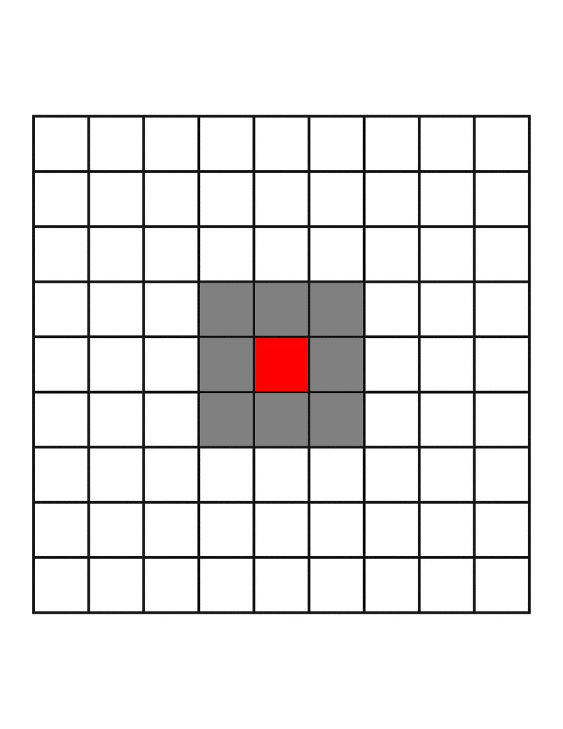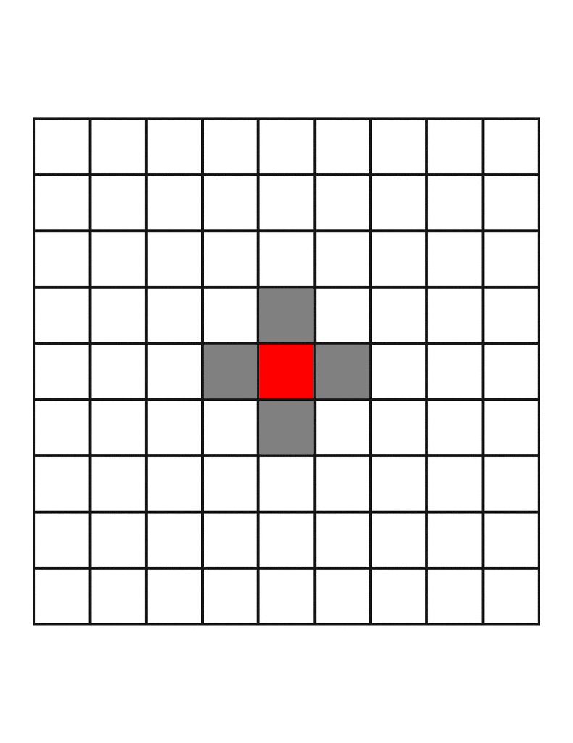

Figure 4. Moore neighbourhood

Figure 3. Von Neumann neighbourhood

### Cellular Automata as Applied to Natural Systems

Wolfram (1983) found that the mechanisms present in cellular automata are closer to that of natural systems than those found in conventional computation and theorises that:

“Many natural systems could be simulated more efficiently by cellular automata than by conventional computers.”

He goes on to explore this link further in his 1984 journal article ‘Cellular Automata as Models of Complexity’ (Wolfram, 1984). He notes that natural systems can show a great diversity of complex patterns and structures, and that cellular automata might be the correct approach to modelling them. He goes on to highlight the fact that cellular automata consists of many simple, identical components, that together are capable of complex behaviours. This can also be found in nature, where systems can exhibit complex behaviours despite its fundamental component parts being very simple.

Wolfram (1984) states that much is known about the nature of the individual components, but little is known about the mechanisms of how they work together to create the overall complexity observed. He theorises that cellular automata could help us to better understand how some of the systems in nature operate.

## Predator-Prey Interaction Models

Predator-prey interaction models aim to simulate an exploitative relationship between two species, where individuals of one species benefit by feeding on and directly harming other individuals. A predation interaction involves the predator killing and consuming the prey (Olson, 2014).

Within any natural system where one species predates another, there will be predator-prey interactions.

### Population Cycles

Population cycles occur when the size of a population varies in accordance to some form of observable pattern.

Population size is determined by a number of different variables, such as birth rates, death rates, immigration rates and emigration rates from the environment. Berryman (2002) identifies that “cycles in animal populations reflect the response of birth and death rates to an external physical factor that is itself cyclic”.

### Lotka-Volterra Model

One of the first models to examine the interaction between predators and prey, was proposed by American biophysicist, Alfred Lotka and Italian mathematician Vito Volterra (Stolaf, no date).

Lotka (1925) and Volterra (1926) both demonstrate that “cyclic dynamics are inherent in simple predator-prey models”. This led them to the hypothesis that “regular cycles can result from interactions between predator and prey populations” (Lotka, 1925). Lotka and Volterra both “derived the same equations and conclusions that the interaction would give rise to periodic oscillations in the two populations” (Kingsland, 1995).

The Lotka-Volterra model comprises of a pair of differential equations that describes predator-prey interactions in their simplest possible case (one predator species, one prey species) (Renshaw, 1993).

The Lotka-Volterra model presents population change as a function of predator-prey interactions. This model makes a number of assumptions (Lotka, 1925):

* The prey population will grow exponentially in the absence of predators. It is assumed that prey have a limitless supply of food and do not suffer from any other variables which may kill them (disease, accidents, other predators etc).
* The predator population will die in the absence of prey. It is assumed they will have no other forms of sustenance to sustain the population.
* The predators are capable of consuming an infinite number of prey. It is assumed their hunger can never be sated.
* There are no environmental factors that affect either predator or prey and the environment does not change to favour one species or the other.

Lotka-Volterra is an exponential model which assumes unlimited growth. The principle of unlimited growth can be attributed back to Thomas Malthus’ work, “An Essay on the Principle of Population” (1999), in which he claims that a population of size *N* will grow unbounded by a growth constant of *r*. This means it assumes that in the absence of predators, the prey population will increase at an exponential rate. This will cause the population of prey to change according to the following equation (Lotka, 1925):

Where:

* *N* is the number of prey.
* *t* represents time.
* *r* is the per capita rate of increase.

The prey’s rate of growth is affected with the introduction of a predator to the system. Prey will decrease based on the consumption rate of the predator. The predator first has to locate and capture its prey before it can consume it, so this variable also needs to be considered (Olson, 2014).

Where:

* *a* represents capture efficiency.
* *N* is still the number of prey.
* *P* is the number of predators.

Lotka (1925) states that the model for prey can be expressed by the following equation:

If no prey are present in the system, then the predators will starve and the population will decrease exponentially. However, with the presence of prey we can assume that prey will be consumed and new predators will be produced. *aNP* can also be used to represent the number of prey being consumed by predators (Olson, 2014). However, the consumed prey will still need to be converted into new predators. This can be expressed as the following equation:

Where:

* b represents the predators conversion efficiency.

As Volterra (1928) confirms, the final model for predators can be expressed as:

Where:

* *m* represents the predators mortality rate.

Putting this all together, Lotka (1925) and Volterra (1926) devised the coupled differential equations:

Prey:

Predators:

# Methodology

Section 2.1.1 and 2.1.2 looked at the history and definition of cellular automata. What was not explained however, is the varying properties and purposes of cellular automata.

In this section, the design and underlying logic behind the artefact will be examined. This will serve as an introduction to the artefact and how it operates, whilst also lending greater context to the development process presented in the following section.

The cellular automata modelling approach was chosen for its simplicity, which will make it a perfect fit for the straightforward Lotka-Volterra ecological model.

## Software Development Environment

### Processing

Processing is a free open-source software suite and programming language, primarily designed as a learning environment for graphic design students. It was created in 2001 by Ben Fry and Casey Reas (Fry and Reas, no date).

It was chosen because it is easy to deploy code and see immediate visual results. Within the context of this project, this meant that it was very easy to see visual representations of the cellular automata entities and examine their interactions qualitatively.

It also has the added functionality of writing data to text files that can be read by other software.

The entire code portion of the project has been developed in Processing.

### GNU Octave

GNU Octave is a high-level language for solving mathematical computations and equations. It is manipulated using a CLI (command line interface) (Eaton, no date).

Commands and scripts can be written using the MATLAB programming language.

For the purpose of data analysis, we will be generating Octave scripts dynamically using Processing then using the CLI to generate different visual representations of the data to examine.

Octave was chosen for its simplicity in turning raw data into visual diagrams, rather than using something like Fortran which would likely take more time to set up with no real benefit to the project.

## Design Specification

* The environment is a two-dimensional array of cells modelled against the progression of time.
* Time is expressed as ‘generations’ which represent a discrete step in time.
* In each new generation, the state of every cell in the environment is updated according to a set of rules.
* Each cell is square in shape.
* Each cell has a Moore neighbourhood consisting of its immediate cell neighbours.
* Each cell can have one of three states: empty (white), prey (blue) and predator (red).
* Just like Conway’s ‘Game of Life’, once started, the simulation will require no further user interaction.

### Assumptions

A number of assumptions need to be made about the system for the data it returns to be valid. These are listed below:

* All predators are identical to one another, there are no differences between individuals.
* All prey are identical to one another, there are no differences between individuals.
* Prey can only die to predation, there are no other forms of death for them.
* Predators can only die of starvation, there are no other forms of death for them.
* It is assumed that prey have an unlimited supply of food and do not suffer from any other variables which may kill them (disease, accidents, other predators etc). This means that the prey population should grow exponentially in the absence of predators and fill up all available space. This falls in line with the Lotka-Volterra model.
* The predator and prey exist in a vacuum, no other entities are present in this system.
* Every cycle is the same and executes the same set of rules. Time-related cycles such as day/night do not exist.

### Variables

The purpose of this section is to take note of the variables and how they can be changed from within the artefact. An investigation will take place into the implications of these changes. The variables are:

* int div() - Divides the cell grid, can be altered to change the size of the board.
* All the following variables are set by a user prompt before runtime:
  + int op1 – How many generations the simulation will run for.
  + int gridFill – The percentage of the grid that will be filled on initialisation.
  + float catchRate – The percentage chance that a predator will successfully catch a prey.
  + String distType – A flag for the type of distribution method that is being used, can be either deterministic or stochastic.

# Development

This section presents each major version of the artefact. It will show the changes made in each version in order to more accurately model the theoretical Lotka-Volterra model. Explaining the development process in this way will lend a greater understanding to the final artefact.

## Version 1

Version 1 represents the first attempt made at creating a cellular automaton from the ground-up. The aim of this version was to attempt to replicate the results found in the Lotka-Volterra interaction model using as simple of a ruleset as possible. The codebase would also go on to serve as a foundation that each subsequent version would proceed upon.

The automatons exist within a non-toroidal environment in which the boundaries are fixed and cannot be breached. This could potentially reflect a gated and controlled environment, such as a pen or enclosure. This potentially means that prey can no longer evade predators when they reach the boundaries of the environment.

The method, predPreyPicker(), is called at initialisation and determines the initial numbers of predators and prey spawned on the first cycle. This can be manipulated to change the initial ratio of predator vs prey. This method employs a stochastic Monte Carlo approach, as while the initial starting state of the cell is picked randomly, there is a set percentage chance of each state being picked (Rubinstein and Kroese, 2016).

### Rules

In this section we will outline and examine the rules used by the cellular automaton and justify their inclusion.

#### Prey



* If prey has a predator in its neighbourhood, it is eaten and turned into a predator itself.
* If prey have more than 3 prey in their neighbourhood, it dies, as if from overpopulation.
* Otherwise, do nothing.

#### Predators



* If predator has more than 3 predators in its neighbourhood, it dies, as if from overpopulation.
* If it does not have any prey in its neighbourhood to eat, it dies from starvation.
* Otherwise, do nothing.

#### Space



* If there are any predators, do not create a new prey.
* Then, if there are any prey in the neighbourhood, breed a new prey.

### rabbit wolf graphAnalysis

Figure 7. Visual Representation of the Lotka-Volterra Interaction Model (Predator-Prey Interaction, no date)

Figure 6. Octave Results for Ver 1

Figure 5. Ver 1 Processing output

Looking at the outputted results in figure 6, we can see that this initial version of the artefact has already obtained oscillation. This pattern stays consistent indefinitely, showing that the model is stable and neither predator nor prey will go extinct. This can be validated against the theoretical Lotka-Volterra model shown in figure 7.

However, when oscillation begins after around 30 generation cycles, the predators have a consistently higher population. This does not line up with the model that we are validating against and is one of the issues that will be addressed in subsequent versions to improve the validity of the artefact.

## Version 2

### Changes from Version 1

* The following changes were made to the rules:

#### Predator & Prey

* Both prey and predator no longer succumb to the ‘overpopulation’ rule, as this did not fall in line with the assumptions made by the Lotka-Volterra model; that prey should only die from predation and predators should only die from starvation.

#### Space

* If no predators or prey, remain blank.
* If any prey, breed a new prey.

### Analysis

Only a very small number of runs of this simulation result in a stable system. Most runs result with the predators chasing all of the prey to the borders of the environment, where they have no form of escape and are all predated. This could be alleviated in a future version by either, A: making the environment toroidal so that they can continue to run when they get to the edge of the environment, B: giving the prey some form of detection and evasion or C: giving the predators a limit to their hunger so they will not hunt the prey to extinction.

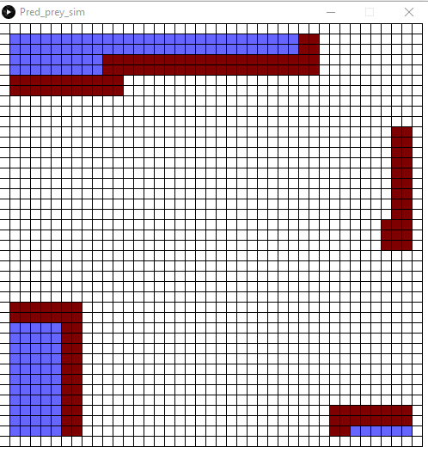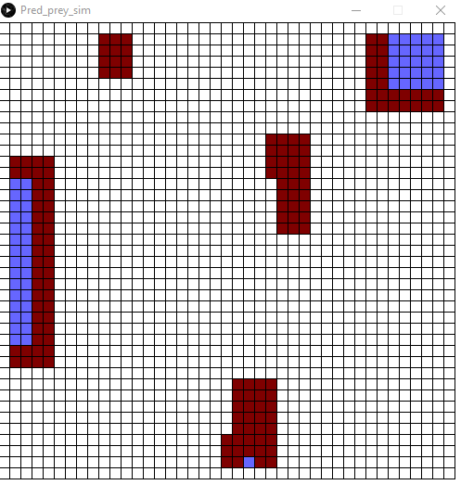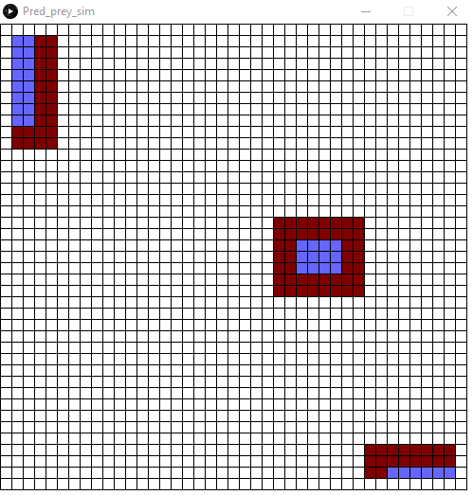

Figure 8. Processing outputs for unstable runs of Ver 2

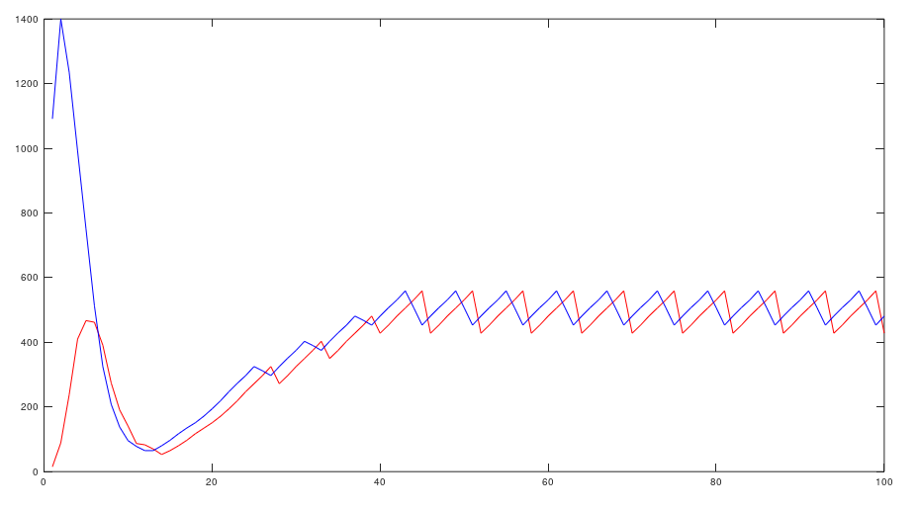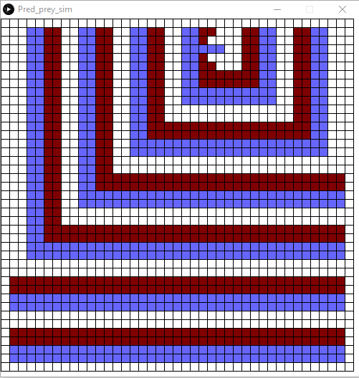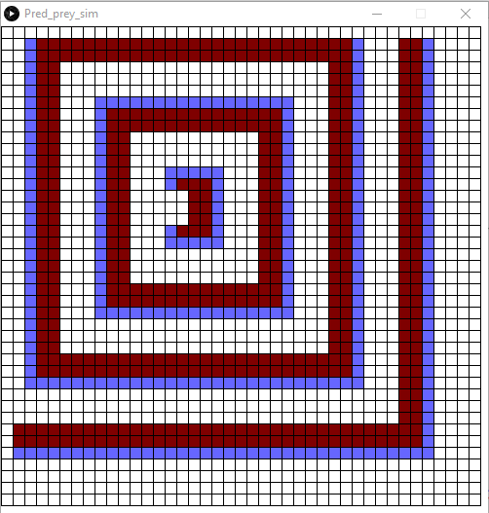What is interesting however, is that some runs do result in a stable system. These create a visual pattern where a group of a few predators chase a group of prey around a small area. The prey breed and these are chased to the boundaries by the predators. These runs produce results much closer to the Lotka-Volterra model (figure 7), which can be seen in figure 10.

Figure 10. Octave Results for Ver 2

Figure 9. Processing outputs for stable runs of Ver 2

Figure 10 is getting closer to the Lotka-Volterra pattern. Similar to version 1, it obtains oscillation after 30 generations and retains this pattern infinitely, showing that system stability has been achieved. The prey curve also leads the predator curve, as it should.

However, there is still room for improvement. In figure 10, the population of predator and prey are too close, and the oscillations are not as extreme as they should be.

## Version 3

### Changes from Version 2

* The way predators eat prey and breed new predators has been changed. Instead of prey simply changing into predators when they share a neighbourhood with one, they now change to an empty space which the predator then fills with another predator automaton.
* Added the ‘overpopulation’ rule back to predators to serve until a better solution is found for allowing the prey to escape the predators.
* Made the environment toroidal so that it loops around on itself. This more closely emulates a real-life predator-prey scenario, as they are unlikely to exist within the confined enclosure seen in previous versions.
* The following changes were made to the rules:

#### Prey



* If prey has a predator in its neighbourhood, it is eaten and turned into an empty space.

#### Predators



* If predator has more than two predators in its neighbourhood, it dies, as if from overpopulation.

#### Space



* If there are two or more predators and at least one prey, breed a new predator.
* Otherwise, if there are at least two prey in the neighbourhood, breed a new prey.

### Analysis

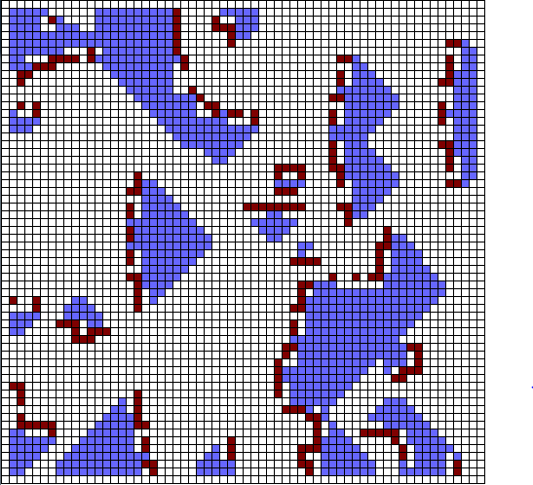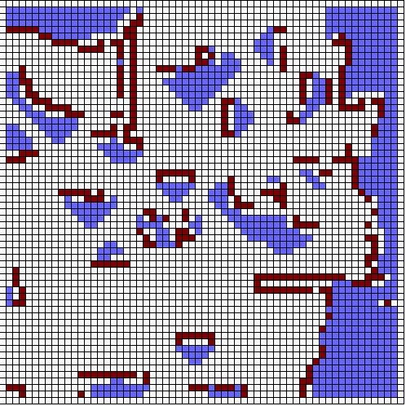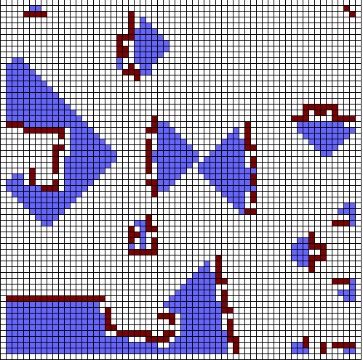Looking at the visual representation of the automatons, we can see some new patterns emerging. The predators now chase the prey in formations that somewhat resemble herding behaviours found in nature.

Figure 11. Processing outputs for Ver 3



Figure 12. Octave Results for Ver 3

Predator population somewhat correlates to prey population, but not to the same degree as previous versions.

Prey population is now consistently higher than predators, aligning with the Lotka-Volterra model.

Growth and decay is slower and must be observed over a longer period of time for a distinguishable pattern to emerge. Hence why figure 12 is mapped over 500 generation cycles.

## Version 4 – Final Artefact

Figure 13. Processing outputs for Ver 4

### Changes from Version 3

* Added a stochastic Monte Carlo picker method to determine the probability that a predator successfully catches its prey. This works in the same way as the method that picks the cells’ initial states. It represents the *a* in *aNP* as described in Section 2.2.2.
* This facilitated the removal of the ‘overpopulation’ rule as it provided a way for prey to escape the predators.
* Predator and prey now start at the same initial population.
* The user is now prompted to set a number of variables before runtime. These are:
  + How many generations it should run for.
  + What percentage of the board should be filled.
  + What the predator catch rate percentage should be.
  + Whether the system should employ a deterministic or stochastic approach to initial distribution.
* These allow the artefact to be easier for other users to experiment with, without having to manually alter the code.

### Rules

#### Prey



* If prey has a predator in its neighbourhood, it is hunted and calls a function that will calculate whether it survives the hunt or not.
* Otherwise, do nothing.

#### Predators



* If predator has a prey in its neighbourhood, it moves, as it will attempt to hunt it.
* If it does not have any prey in its neighbourhood to eat, it dies from starvation.
* Otherwise, do nothing.

#### Space



* Breed new predator if there are at least two predator and one prey.
* Else, if there are least two prey, breed a prey.
* Otherwise, remain blank.

# Results

## How Results were Gathered

Data was gathered and recorded by Processing during runtime of the final artefact (version 4). This data was then interpreted and converted into information using GNU Octave. More information is available about this software in Section 3.1 of the Methodology.

## Fixed Parameters

* The cell array is a 50 x 50 grid (2500 cells).
* Predators and prey occupy all available cells to a 1:1 ratio in a pre-set deterministic distribution.
* Predators have a 33% chance to successfully catch prey.
* The simulation will run for 300 generations.
* Predators and prey both start at the same population size (250 cells/10%).

## Average Population Results

|  |  |  |  |  |  |  |  |  |
| --- | --- | --- | --- | --- | --- | --- | --- | --- |
| Run | 1 | 2 | 3 | 4 | 5 | Mean | Standard Deviation | CV |
| Prey (Mean) | 545.3  (21.8%) | 548.5  (21.4%) | 550.7  (22%) | 545.5  (21.8%) | 550.1  (22%) | 548  (21.9%) | 2.2577865266672 | 0.0046061860445888 |
| Predators  (Mean) | 432.1  (17.2%) | 429.9  (17.1%) | 429.4  (17.176) | 432.1  (17.2%) | 434  (17.3) | 431.5  (17.2%) | 1.6697305171794 | 0.004326339444402 |

Table 1. Deviation of Generation 300 population numbers over 5 runs

## rabbit wolf graphValidation

Figure 14. Ver 4 Octave output

Figure 15. Lotka-Volterra Theoretical model

Figure 14 presents the most accurate representation of the Lotka-Volterra model produced by this artefact, compared to the hypothetical example seen in figure 15.

The starting configuration of cells has been altered. Predators and prey now occupy all available cells to a 1:1 ratio on initial spawn. As we can observe in figure 14, this causes a period of high volatility in predator and prey numbers at the start of the simulation. This is then followed by a steep rise and the highest peak in population numbers before oscillation begins.

This final version has achieved this by combining all qualities found in previous versions and by fixing areas which did not match up with the theoretical model. These are:

* Prey population is typically higher than the predator population.
* The system is stable.
* The system exhibits oscillation.
* The prey curve leads the predator curve.
* The predator population tracks the peaks of the prey population.

Comparing figure 14 to figure 15, it can be seen that both portray a cyclical relationship between predator *(P)* and prey population numbers *(N).* As *P* increases, so does their consumption rate (described in 2.2.2 as *aNP*). This decreases *N* which in turn decreases *P* and *aNP*. As *aNP* decreases, *N* is able to recover and begins to increase, allowing *P* to increase and causing the cycle to begin anew.

## Verification

I have verified the artefact against Human’s ‘Simple Model’ (2014), which shares many similarities. I have used the same starting configuration of cells and the same parameters (grid size, initial population size and distribution and number of runs), to ensure the comparison is fair. These parameters can be seen in Section 6.2.

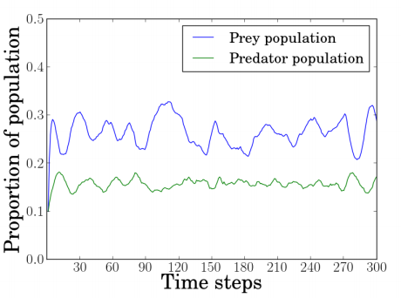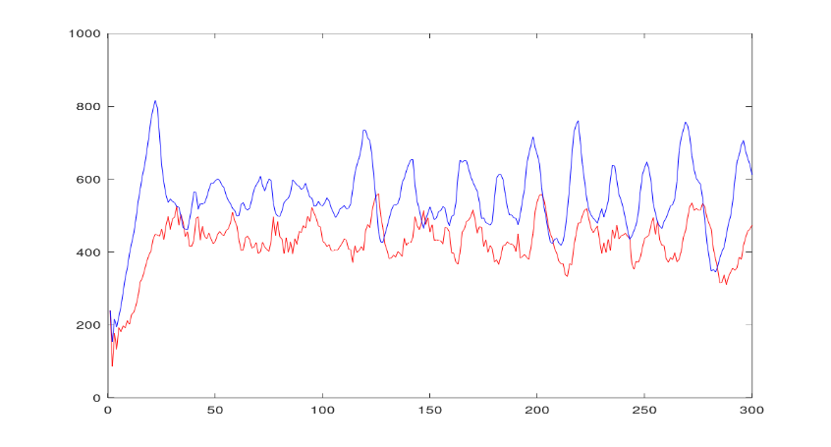

Figure 17. Results from Human's (2014) ‘Simple Model’

Figure 16. Results from Version 4, plotting predator (red) and prey (blue) population sizes over 300 generations

Comparing the results plotted in figures 16 and 17, a number of similarities and differences can be observed.

Similarities:

* Both models exhibit oscillating population cycles similar to those seen in the Lotka-Volterra interaction model.
* In both models the prey curve leads the predator curve, as also shown in Lotka-Volterra model.
* Both systems are stable.

Differences:

* The Oscillations in figure 16 are more extreme and frequent. This is because the deviation from the population mean average is larger in the artefact.
* Figure 17’s predator population size is much lower on average compared to figure 16’s. This doesn’t align with the Lotka-Volterra model where predator populations are much closer to the preys.
* Both systems are stable, but when examining his own model, Human (2014) states “it may also be concluded that, for coexistence to occur, parameters favouring predators need to be used as they have a much greater risk of extinction”. This is not true of the artefact, where even predators with only a 10% chance of successfully catching prey will eventually build up their numbers and create a Lotka-Volterra like cycle. This is evidenced in Section 5.6.1.

It can be concluded that the artefact produced (represented in figure 16) is more accurate to the Lotka-Volterra model than the one Human (2014) presents in his ‘Simple Model’.

## Parameter Testing

In order to analyse the simulation correctly, it is important to experiment with the variables and investigate the effect this has on the simulation as a whole.

|  |  |
| --- | --- |
| Predator Catch Rate % | Generation |
| 0% | N/A – Predator is wiped out |
| 10% | 206 |
| 20% | 68 |
| 30% | 36 |
| 40% | 30 |
| 50% | 27 |
| 60% | 26 |
| 70% | 24 |
| 80% | 25 |
| 90% | 25 |
| 100% | 25 – Prey is wiped out |

### Predator Catch Rate

Table 2. Results for the predator catch rate investigation

Figure 18. Number of generations taken for predator population to exceed prey mapped against catch rate %

Figure 18 shows the number of generations required for the predator population to catch up and exceed that of the prey population. Once this happens, the oscillating pattern of the Lotka-Volterra model can be observed.

Altering the predator’s catch rate percentage has a quantifiable effect on the amount of generations it takes for this to be achieved. As the predators catch % rate is increased, it has a negative effect on the number of generations required to achieve oscillation. 10% catch rate takes 206 generations, but this decreases until it stabilises at 25 generations needed.

0% and 100% catch rates both result in extremely unstable systems. 0% results in the all predators being wiped out and 100% results in all prey being wiped out.

Table 2 contains the numerical data for figure 18.

### Deterministic vs Stochastic

Deterministic

|  |  |  |  |  |  |  |  |  |
| --- | --- | --- | --- | --- | --- | --- | --- | --- |
| Run | 1 | 2 | 3 | 4 | 5 | Mean | Standard Deviation | CV |
| Prey (Mean) | 545.3  (21.8%) | 548.5  (21.4%) | 550.7  (22%) | 545.5  (21.8%) | 550.1  (22%) | 548  (21.9%) | 2.257786 | 0.004606186044588 |
| Predators  (Mean) | 432.1  (17.2%) | 429.9  (17.1%) | 429.4  (17.17) | 432.1  (17.2%) | 434  (17.3) | 431.5  (17.2%) | 1.669730 | 0.004326339444402 |

Table 3. Deterministic Results

|  |  |  |  |  |  |  |  |  |
| --- | --- | --- | --- | --- | --- | --- | --- | --- |
| Run | 1 | 2 | 3 | 4 | 5 | Mean | Standard Deviation | CV |
| Prey (Mean) | 557.1  (22.2%) | 544.7  (21.7%) | 555.7  (22.2%) | 549.8  (21.9%) | 545.4 (21.8%) | 547  (21.9%) | 4.850687 | 0.0103841769116 |
| Predators  (Mean) | 432.8  (17.3%) | 436.1  (17.4%) | 432.1  (17.2%) | 427.8  (17.1%) | 430  (17.2%) | 435.5  (17.4%) | 2.900239 | 0.0073477696687 |

Stochastic

Table 4. Stochastic Results

An investigation was done into the effect that the initial distributions of predators and prey would have on their average population sizes. The deterministic environment had predators and prey distributed one after another, until all cells on the board were filled. While the stochastic environment randomly distributed the predators and prey around the environment. Both environments began with equal numbers of predator and prey (1152). The results of this investigation can be seen in tables 3 and 4.

Both tables exhibit very similar population numbers for both predators and prey. However, the chaotic nature of the stochastic simulation lead to a higher standard deviation of results. This is due to the fact that the random initial distribution meant there was a wider range of populations during the earlier generations. After these stabilised and an oscillating population cycle appeared, numbers were virtually identical to those seen in the deterministic system.

But overall, the mean average population sizes for both predators and prey were very similar between the two different systems. This indicates that the model presented in the artefact is very stable and changing the initial distributions did very little to disrupt it.

### Size of Environment

Figure 19. average % of available cells occupied by predators and prey mapped against the size of the environment.

Red = Predator

Blue = Prey

Figure 19 shows the effect the size of the environment has on the percentage of the environment both predator and prey occupy.

As evidenced in both figure 19 and table 5, the percentage of available space both predators and prey occupy, grows at the same rate, in tandem with the size of the environment. It could be theorised that this percentage would continue to grow in even bigger environments and could benefit from further investigation in future studies.

Table 5. Data used for figure 19

Red = Predator

Blue = Prey

|  |  |  |  |  |  |  |  |  |  |
| --- | --- | --- | --- | --- | --- | --- | --- | --- | --- |
| Size of environment (cells) | 100 (10x10) | 400 (20x20) | 900 (30x30) | 1600 (40x40) | 2500  (50x50) | 3600  (60x60) | 4900  (70x70) | 6400  (80x80) | 8100  (90x90) |
| Predator | 14.88  (14.88%) | 60.57  (15.14%) | 136.28  (15.14%) | 278.99  (17.43%) | 430.49  (17.21%) | 663.83  (18.43%) | 880.37  (17.96%) | 1197.5  (18.71%) | 1744.6  (21.53%) |
| Prey | 16.90  (16.9%) | 78.47  (19.61%) | 200.45  (22.27%) | 370.98  (23.18%) | 565.06  (22.6%) | 879.45  (24.42%) | 1180.8  (24.09) | 1625.8  (25.4%) | 2395.7  (29.57%) |

# Reflection

## What was achieved

* In accordance with the aims, a cellular automata artefact designed to simulate the interactions between predator and prey entities was created.
* As per the objectives, I have successfully gathered and analysed the original data it produced, as well as compared it to other work already conducted in the field.
* Each major iteration of its development cycle was documented and analysed within this paper.
* A thorough investigation into an unknown field of study which allowed me to write a literature review. This skill will help me in future projects by allowing me to understand current and established knowledge within an area before I contribute to it.
* Following on from my showcase and feedback from my supervisor, I was able to identify that the original scope of my project was too large and would likely lead to a poor outcome. I adapted my proposed project to narrow its scope from looking at the applications of both cellular automata and agent-based models to natural systems, to just looking at cellular automata applications to the Lotka-Volterra interaction model. This is evidenced in the differences between the project proposal found in Section 9 and the aims and objectives of the finalised paper. This gave my project greater focus and made it easier to proceed.

## What could have been improved upon

* Due to the initial scope of the project being too wide, progression was stilted and slow until the projects focus was changed in January following feedback from the project showcase. If it was identified earlier in my project’s development that the scope was too large, it would have allowed me more time to realign my aims and objectives.
* A greater examination and analysis of existing cellular automatons may have allowed me to avoid many of the pitfalls I fell into during development.
* My ability to identify and analyse relevant sources was improved through the writing of my literature review, but prior research skills would have increased the range of sources used. Subsequent literature reviews will be stronger with the skills I have gained in this area.

# Conclusion

This dissertation has served as an investigative study into the suitability of cellular automata in modelling the Lotka-Volterra predator-prey model. On this front it has been a success, the artefact I have created follows all assumptions made by Lotka and Volterra (Sections 2.2.2 and 3.2.1). Through a number of versions, I have developed my artefact to follow the differential equations explained in Section 2.2.2 as closely as possible. This was followed by an analysis presented in Sections 4.4 and 5 that shows a number of close connections and similarities between the artefact and the model it is emulating. In the artefact that I have created the prey population is typically higher than the predator population, the system is stable, the system exhibits oscillation, the prey curve leads the predator curve and the predator population tracks the peaks of the prey population. These are all features also found in the Lotka-Volterra model, making the artefact I have produced a very accurate representation of it.

I can therefore conclude that the cellular automata model is a suitable platform for simulating predator-prey interactions using the Lotka-Volterra model.

## Summary

In section 1 the scope of the project was established, with the aims and objectives being laid out.

Section 2 involved an in-depth literature review examining a range of publicised works concerning both cellular automata and predator-prey interactions. This was done in fulfilment of objective 2 “to use the research of relevant sources and information to aid in the production of the artefact”. A brief history of cellular automata and its origins was given, lending context to the field. A clear and concise definition was given and its application to natural systems was examined using the works of Wolfram as credence. Predator-prey interaction models and population cycles were also described before the Lotka-Volterra model was examined in detail. Again, this involved looking at the history before defining it and walking through the process of how it operates.

In section 3 the development environment was defined, providing insight into how the artefact was created. Section 3.2 covered the specifications of the design of the artefact, including any assumptions that would need to be made and variables that could be altered.

Section 4 concerned itself on the development process of the project. It provided a thorough and in-depth analysis of each major iteration of the artefact and the changes that were made between each version. It showed how the artefact was designed and developed “in adherence to the cellular automata and Lotka-Volterra predator-prey interaction models” (objective 1). This culminated in the analysis of the final version of the artefact, version 4 in section 4.4.

Section 5 contained the results gathered from the artefact, as well as verifying and validating the model, covering objective 4 “validate against a theoretical model and verify against a peer’s model”. A number of investigations were then conducted in section 5.6 to test different aspects of the system. This satisfied objective 3, “investigate how different initial variables and states affects the artefact”.

In section 6 a personal reflection was conducted to ascertain what was achieved with this project and what could have been improved upon with the benefit of hindsight. This section fulfils objective 5 “identify any weaknesses or limitations and highlight how improvements could be made”.

The aim, “to create a cellular automata artefact that will simulate the interactions between predator and prey entities”, has been fully satisfied, as evidenced through the completion of the artefact’s development.

## Contributions

Section 4 provides insight into the development process of creating a cellular automaton. Supervisor Dr Colin Price stated that I “progressively refine [my] models and make a critical analysis” throughout this section. Being able to see how the artefact gradually came to fruition, may prove to be a valuable resource to anyone looking to create their own cellular automaton.

The artefact has been hosted on GitHub and is open source, making it available for anyone to download and develop as they wish. This will prove useful as during my research, many cellular automatons were found that exhibited behaviours seen in the Lotka-Volterra model, but none specifically sought to emulate it as closely as the artefact presented here does.

## Directions for Future Study

If this dissertation has inspired you to delve deeper into the field of cellular automata, there are a number of recommendations I can make for projects that may yield interesting results:

* Increasing the size of the environment further may continue to grow the percentage of occupied space and would benefit from further investigation.
* Create a cellular automata system in which a second predator entity is introduced, either at initialisation or during runtime. What effect does this have on the indigenous predator and prey populations?
* A critical analysis of different natural interactions and their suitability to the cellular automata modelling approach.

# References

Bays, C. (2010) ‘Introduction to Cellular Automata and Conway's Game of Life’, in Adamatzky, A. (ed.) *Game of Life Cellular Automata*. London: Springer, p. 1.

Berryman, A. (2002) ‘Population Cycles: Causes and Analysis’, in Berryman, A. (ed.) *Population Cycles: The Case for Trophic Interactions.* New York: Oxford University Press, pp. 3-4.

Clarke, K. (2014) ‘Cellular Automata and Agent-Based Models’, in Fischer, M. and Nijkamp, P. (eds.) *Handbook of Regional Science*. Berlin: Springer, pp. 1218-1231.

Eaton, J. (no date) *About*. Available at: https://www.gnu.org/software/octave/about.html (Accessed: 27 March 2019).

Fry, B. and Reas, C. (no date) *Overview.* Available at: https://processing.org/overview/ (Accessed: 27 March 2019).

Human, D. (2014) *Modelling predator-prey interactions with cellular automata.* Undergraduate. Stellenbosch University.

Kingsland, S. (1995) *Modeling Nature*. 2nd edn. Chicago: University of Chicago Press, pp. 109-110.

Lotka, A. (1925) ‘Elements of Physical Biology’, *Nature*, 116(2917).

Malthus, T. (1999) *An Essay on the Principle of Population*. 2nd edn. New York: Oxford University Press.

Olson, J. (2014) *Predation Part 3: Exploitation & Population Cycles.* Available at: <https://www.youtube.com/watch?v=bgsZy2HAZVM> (Accessed: 20 March 2019).

*Predator-Prey Interaction* (no date). Available at: http://www2.nau.edu/lrm22/lessons/predator\_prey/predator\_prey.html (Accessed: 11 April 2019).

Renshaw, E. (1993) *Modelling biological populations in space and time*. Cambridge: Cambridge University Press, p. 167.

Rubinstein, R. and Kroese, D. (2016) *Simulation and the Monte Carlo Method*. 3rd edn. New Jersey: John Wiley & Sons, pp. 50-61.

Sarkar, P. (2000) ‘A Brief History of Cellular Automata’, *ACM Computing Surveys*, 32(1), pp. 82-83.

Schiff, J. (2011) *Cellular Automata: A Discrete View of the World*. New Jersey: John Wiley & Sons, pp. 89-91.

Shiffman, D. (2012) *The Nature of Code*. Lexington: Daniel Shiffman, pp. 323-353.

Sigmund, K. (2017) *Games of life - explorations in ecology, evolution and behavior*. 2nd edn. New York: Courier Dover Publications, p. 10.

Soto, J. (2017) *Minimal Glider-Gun in a 2D Cellular Automaton*. Zacatecas: Universidad Autonoma de Zacatecas, pp. 1-3.

Stolaf. (no date). *Lotka-Volterra Predator-Prey Model*. Available at: https://www.stolaf.edu/people/mckelvey/envision.dir/lotka-volt.html (Accessed 4 Apr. 2019).

Volterra, V. (1926) ‘Fluctuations in the Abundance of a Species considered Mathematically’, *Nature*, 118(2972), pp. 558-560.

Volterra, V. (1928) ‘Variations and fluctuations of the number of individuals in animal species living together’, *Journal du Conseil*, 3(1), pp. 3–51.

Von Neumann, J. and Burks, A. (1966) *Theory of self-reproducing automata*, New York: University of Illinois press.

Weisstein, E. (no date) *Elementary Cellular Automaton*. Available at: http://mathworld.wolfram.com/ElementaryCellularAutomaton.html (Accessed: 22 February 2019).

Wolfram, S. (1983) ‘Cellular Automata’. *Los Alamos Science*, 9, pp. 2-21.

Wolfram, S. (1984) ‘Cellular automata as models of complexity’, *Nature*, 311(5985), pp. 419-424.

Wolfram, S. (2002) *A New Kind of Science*. Illinois: Wolfram Media, p. 876.

# Project Proposal Form

|  |  |  |  |
| --- | --- | --- | --- |
| **A STUDENT DETAILS (to be completed by the student)** | | | |
| **Name:** | Thomas Weston | | |
| **University email:** | [west1\_15@uni.worc.ac.uk](mailto:west1_15@uni.worc.ac.uk) | | |
| **Student Number:** | 15013956 | **Module code:** | COMP3001 |
| **Completion Date:** | 15.00  Thursday 2nd May 2019 | **Pathway:** | Computing |
| **Part time / Full time:** | Full time | **Year started course:** | 2015 |
| **Single/Major/Joint Honours:** | Single | **If joint/major, other subject:** |  |

|  |  |
| --- | --- |
| **B PROJECT DETAILS (to be completed by the student from milestone 1)** | |
| **Supervisor:** | Dr Colin B. Price |
| **Project Title:** | Endangered Species: Simulating their future |
| **Project Aims:**  **(***A broad statement of the expected outcome)* | * To create an application that will accurately simulate endangered species and their environment. The data it produces can be used by wildlife agencies to aid conservation efforts. * To successfully gather and analyse the original data it produces. As well as thorough testing of the performance of the application. * The application will be designed and developed in adherence to an Agent-based model. * The application will be made from the ground-up using Java and Object-Oriented Design. It shall adhere to the SOLID principles. * I shall be creating a GUI to provide a visual representation of the data. * The conditions and scope of the simulation can be manipulated by users. * The application will be planned and designed using the appropriate methods, such as ER diagrams and Test-Driven Development. * To use the research of relevant sources and information to aid in the production of my application. |
| **DETAILS OF PROPOSED PROJECT (to be completed by the Student**) | |
| **Research Question:** | What are the advantages and disadvantages of employing an agent-based model as opposed to a cellular automata model when simulating species population dynamics |
| **Type of Project:** | Design-Build-Test (DBT) |
| **Proposed Primary Research** | The primary data I will be gathering will be acquired through the use of my artefact. This data will be objective.  Processing has the ability to render interactive data visualisations and I will take advantage of this. |
| **Proposed Secondary Research** | I will gather secondary research from several sources. There have been many articles and studies published on the use and effectiveness of different modelling techniques on the simulation of species in their environment. For my secondary research I will be examining:   * Books * Journal Articles * Websites * Reports * Dissertations * Presentations/ Lectures * Computer Programs/ Software |
| **SMART Project Objectives** | |
| * Complete Gantt chart (needs to be done first) * Complete initial search for secondary research sources to be used in literature review * Complete reading * Complete ethical approval form and receive approval from project supervisor * Design and implement my artefact, culminating in a prototype * Prototype:   + S: Complete First Prototype   + M: Have a working proof of concept that can be exhibited at the project showcase   + A: I have the necessary hardware resources, I need to build up a knowledge base on simulation modelling through my research and the employ it through a practical understanding of the Processing application.   + R: Will gain feedback from industry reps, academic staff and fellow students. Can use this feedback to reflect and improve on project   + T: Before the 10th of January 2019, as this is when the project showcase is being held * Complete artefact * Undergo critical analysis on my artefact and examine how well it addresses my specification set out at the start * Test and gather primary research data on my artefact * Analyse The results and come to a conclusion using both primary and secondary research data | |

|  |  |
| --- | --- |
| **Requirements (A list of resources you will need such as software, hardware, data sources etc.)** | |
| * Processing – Free and open-source software sketchbook built on Java. * Lynda.com – Provided by the university, has a course called “Processing: Interactive Data Visualisation” that will help me to translate the data I gather into useable information. * Book: Processing: A Programming Handbook for Visual Designers and Artists. * Book: Make: Getting Started with Processing, Second Edition. * Access to the internet for online data sources. * Access to the Hive library for physical academic resources. * Knowledge and expertise from personal academic mentor and project supervisor. | |
| **Agreed Word Count** | Max 9000 words |

# Grading Matrix

|  |  |
| --- | --- |
| 2D_black_72dpi | Grading Matrix Template  This matrix captures the assessment criteria for the **Design-Build-Test** Computing Project Assessment. |

|  |  |  |  |  |  |  |  |  |  |  |  |  |
| --- | --- | --- | --- | --- | --- | --- | --- | --- | --- | --- | --- | --- |
| **Student Name: Thomas Weston** | | | | **Student Number: 15013956** | | | | **Academic Year:**  2018/2019 | | | **Module Code:**  COMP300x | |
| **Assessment Criteria**   1. Demonstrate a critical understanding of a significant computing issue aligned with the degree pathway [LO1]. 2. Provide a comprehensive critical review of relevant and contemporary literature [LO2]. 3. Design and construct an appropriate software or hardware computing artefact[LO3]. 4. Gather and analyse original data [LO4]. 5. Provide an accurate and critical evaluation of project outcomes against the stated objectives [LO5]. 6. Provide a personal assessment of the project contribution to addressing a significant computing problem and a reflection on your management of the project [LO6]. | | | | | | | | | | | **Assignment Description:**  Project Report + Artefact | |
| **Assignment Weighting:**  100% | |
| **Module Title:**  Computing Project | |
| **Assessment Criteria** | | | | | | | | | | | | |
|  | **Demonstrate a critical understanding of a significant computing issue aligned with the degree pathway** | | **Provide a comprehensive critical review of relevant and contemporary literature** | | **Design and construct an appropriate software or hardware computing artefact informed by primary research (requirements elicitation) and/or secondary research and/or critical literature review** | | **Gather and analyse primary data, either using the artefact, and/or regarding the design (requirements elicitation) and/or performance (user testing) of the artefact** | | **Provide an accurate and critical evaluation of the artefact against the stated design objectives or requirements specification** | | | **Provide a personal assessment of the project contribution to addressing a significant computing problem and a reflection on your management of the project** |
| The sort of stuff that should be included (These lists are NOT exhaustive) | **Why am I doing this project? Why is it useful? What problem is it solving? How does it link to my specialist pathway and/or employment aspirations? Research question(s)** | | **Literature review; citations; reference list; what other work has been done in this area? (Do authors agree with each other?) How does my proposed work link in with this? Best practice** | | **Planning, including Gantt chart; methodology; Project aims; Project objectives; strategy; justification of strategy; design documentation (wireframes, DFDs, ERDs, etc.); commentary on the design and construction process; limitations** | | **Data acquisition; justification of data gathering technique(s); data description; data analysis; conclusions based on data; limitations of data gathering techniques, data gathered and conclusions reached** | | **Does the project achieve its aims and meet its objectives? What is/are the answer(s) to the research question(s)? Do the findings agree with previous work? Limitations, how might they be overcome in the absence of resourcing restrictions? Suggestions for further work** | | | **What did the project achieve? What did I learn from doing this project, from my supervisor/ other students/the showcase/…? What went well? Why? What didn’t work? Why? How might it be done even better next time? Deviations from planning** |
| Approximate weighting (%) | **20** | | **20** | | **20** | | **20** | | **10** | | | **10** |
| A | 1. An original research question is formulated independently and without ambiguity and is clearly linked to the investigation of a significant computing problem area.  2. A persuasive demonstration of the nature and significance of the problem is presented articulately.  3. Recognition of potential contribution to the broader context and theory of the subject discipline (degree pathway) is evident. | | 1. A comprehensive and thorough literature review is presented which includes relevant principles, concepts and research performed in the area of the study.  2. The literature review is systematic, articulate and ordered in a clear and coherent fashion. Clear and correctly formatted referencing is used throughout.  3. A full range of contemporary and relevant sources is used. Sources largely consist of high quality and reliable sources such as peer reviewed academic articles.  4. The literature review demonstrates an ability to synthesise available evidence and to evaluate conflicting interpretations to reach a critical, independent, resolution. | | 1. A complete and precise system requirements specification is formulated from an articulate synthesis of a full range of functional and non-functional requirements.  2. A significant and high quality artefact has been created.  3. A systematic and coherent approach to designing an artefact to address a specification is documented.  4. The development process of an original artefact has been clearly and thoroughly documented.  5. A systematic and coherent justification for the design of the system has been provided. This will include a critical and persuasive argument demonstrating the value of formulating a detailed system requirements specification in the context of the proposed design.  6. Challenges for the design and implementation of the artefact are acknowledged and addressed. | | 1. Primary data is gathered systematically.  2. The findings are clearly described and subject to close critical analysis. The analytical method used is clearly demonstrated to be appropriate.  3. A coherent interpretation based on a synthesis of a range of results leads to a reasoned and well-articulated critical conclusion.  4. Specific limitations of the data gathering and analytic approach are acknowledged and addressed. | | 1. An articulate and critical evaluation of the artefact is undertaken independently and with full consideration of the specification.  2. The evaluation is clearly presented within the context of the research objectives, with clear outcomes demonstrated for each objective.  3. A detailed and thorough critical reflection on the effectiveness of the artefact in addressing the project objectives is clearly demonstrated.  4. Limitations of the design-build-test process and the final artefact are acknowledged and addressed through critical reflection.  5. A clear and insightful account of how future work might improve or build upon this process and product is provided. | | | 1. An articulate and persuasive argument for the nature and value of the contribution of the project outcomes is made in the context of related literature and theory.  2. An assessment of the management and planning of the project is present in the form of a critical analysis of the initial project plan with the actual project life cycle.  3. An informed and honest personal reflection of progress on the project overall with key challenges identified and potential improvements outlined. |
| B | 1. A research question is formulated without ambiguity and is clearly linked to the investigation of a significant computing problem area.  2. A clear demonstration of the nature and significance of the problem is presented effectively.  3. Recognition of potential contribution to the subject discipline (chosen degree pathway) is evident. | | 1. A comprehensive literature review is presented which includes relevant principles, concepts and research performed in the area of the study.  2. The literature review is well structured and presented in a clear and coherent fashion. Clear and correctly formatted referencing is used.  3. A range of contemporary and relevant sources is used. Sources largely consist of high quality and reliable sources such as peer reviewed academic articles.  4. The literature review demonstrates an ability to synthesise available evidence to reach a critical resolution. | | 1. A system requirements specification is formulated coherently. A range of functional and non-functional requirements is defined  2. A significant artefact has been created.  3. The design of the artefact to address a specification is clearly documented.  4. The development process of an original artefact has been documented fully.  5. A critical justification for the design of the system has been provided.  6. Some challenges and limitations of the design and implementation of the artefact are acknowledged and addressed. | | 1. Primary data is gathered.  2. The findings are clearly described and subject to close analysis. The analytical method used is demonstrated to be appropriate.  3. A coherent interpretation of the findings leads to a reasoned critical conclusion.  4. Some limitations of the data gathering and/or analytic approach are acknowledged. | | 1. A systematic evaluation of the artefact is undertaken with full consideration of the specification.  2. The evaluation is presented within the context of the research objectives, with clear outcomes demonstrated for each objective.  3. A critical reflection on the effectiveness of the artefact in addressing the project objectives is clearly demonstrated.  4. Some limitations of the design-build-test process and the final artefact are acknowledged and addressed through reflection.  5. Some account of how future work might improve or build upon this process and product is provided. | | | 1. A coherent argument for the nature and value of the contribution of the project outcomes is made.  2. An assessment of the management and planning of the project is present in the form of a critical comparison of the initial project plan with the actual project life cycle.  3. An informed and honest personal reflection of progress on the project overall with some key challenges identified. |
| C | 1. A research question is formulated and is clearly linked to the investigation of a significant computing problem area.  2. A clear demonstration of the nature and significance of the problem is presented appropriately.  3. Relevance to the subject discipline (chosen degree pathway) is strongly evident. | | 1. A literature review is presented which covers a range of relevant topics.  2. The literature review is presented in a clear and coherent fashion. Format of referencing is used correctly is most cases.  3. A range of relevant sources is used including peer reviewed academic articles.  4. The literature review demonstrates an ability to collate a variety of theories or opinion and present an informed argument. | | 1. A system requirements specification is clearly defined and includes some functional and non-functional requirements.  2. A functional artefact has been created.  3. The design of the artefact to address a specification is evident.  4. Documentation of the development process of an artefact is evident but may be lacking some details.  5. Some justification for the design of the system has been provided.  6. No assessment of limitations of the process. | | 1. Primary data is gathered.  2. The solution or findings are described and subject to analysis.  3. An interpretation of the findings leads to a reasoned conclusion.  4. An attempt to state some limitations of the data gathering and/or analytic approach | | 1. A comprehensive evaluation of the artefact is undertaken with consideration of the specification and research objectives.  2. A conclusion is reached regarding the evaluation that addresses most requirements.  3. Some reflection on the system specification, design and development process is evident.  4. Some key challenges and limitations are identified and discussed.  5. No indication of how the work may be developed. | | | 1. An argument for the nature and value of the contribution of the project outcomes is made.  2. An assessment of the management and planning of the project is present in the form of a systematic comparison of the initial project plan with the actual project life cycle.  3. An informed and honest personal reflection of progress is discussed. |
| D | 1. A research question is formulated and is aligned with a computing problem.  2. A demonstration of the nature of the problem is presented.  3. Relevance to the subject discipline (chosen degree pathway) is evident. | | 1,3. A literature review is presented which includes some relevant sources.  2. Some attempt to format references correctly is evident.  4. The literature review demonstrates an ability to collate and present a variety of theories or opinions evident from within the related literature. | | 1. An attempt to formulate a requirements specification is evident but may not be complete.  2. A limited but functional artefact has been created.  3. Some attempt to design the artefact with consideration of the specification is evident.  4. Some documentation of the development process of an artefact is evident but may be incomplete.  5,6. No justification for the design or consideration of the limitations of the process. | | 1. Some primary data is gathered.  2. An attempt to describe and analyse the primary data is demonstrated.  3. An interpretation of the findings leads to a conclusion.  4. No attempt to consider limitations of the data gathering and analysis | | 1. An evaluation of the artefact is undertaken with some consideration of the specification and research objectives.  2. A conclusion is reached regarding the evaluation that addresses some requirements.  3. An attempt to reflect on the system specification, design and development process is evident but may be lacking in detail.  4. No consideration of limitations of the design-build-test process or the resulting artefact  5. No indication of how the work may be developed. | | | 1. An attempt to define the contribution of the project is evident.  2. A coherent description of the management and planning of the project is present.  3. A reflection of progress is discussed. |
| Narrow Fail (E) | 1,2,3. A problem area is defined but a specific research questions is lacking. | | 1,2,3. A literature review is presented which includes a restricted range of sources.  4. The literature review demonstrates a limited ability to collate and present a variety of theories or opinions evident from within the related literature. Recapitulation of original sources may contain factual errors. | | 1. Limited attempt to formulate a requirements specification.  2. An attempt to create an artefact is evident but it may not be fully functional.  3. Limited attempt to design the artefact with consideration of the specification is evident.  4. Documentation of the development process is largely incomplete.  5,6. No justification for the design or consideration of the limitations of the process. | | 1. Limited primary data is gathered.  2. Limited and unsubstantiated attempt to describe and analyse the primary data is evident.  3. A conclusion based on the analysis of primary data is evident.  4. No attempt to consider limitations of the data gathering and analysis | | 1,2,3. An attempt to evaluate the artefact is evident but may be incomplete or lacking consideration of the specification and research objectives.  4. No consideration of limitations of the design-build-test process or the resulting artefact  5. No indication of how the work may be developed. | | | 1. There is limited attempt to define the contribution of the project.  2. A description of the management and planning of the project is present.  3. No reflection of personal progress. |
| Clear Fail  (F-G) | 1,2,3. A problem area is not clearly defined. | | 1,2,3,4. No literature review is evident or it lacks sufficient sources of appropriate quality. | | 1. No attempt to formulate a requirements specification.  2,3,4,5,6. No attempt to design and/or implement an artefact is evident. | | 1,2. No attempt to gather and/or describe primary data is evident.  3,4. No conclusion based on the analysis of primary data is provided. | | 1,2,3. No evaluation of the artefact is evident.  4,5. No attempt to assess limitations or potential for development. | | | 1. There is no attempt to define the contribution of the project.  2. No description of the management and planning of the project is present.  3. No personal reflection. |
| **Ethics Procedures**  Although not part of the explicitly assessed work in a Computing Project, students are expected to engage with the University’s ethics approval process.  Failure to do so constitutes academic misconduct, and carries various penalties.   |  |  | | --- | --- | | **Ethics Process:** Supervisors please insert a tick (✓) in the coloured box next to the appropriate description of the student’s ethics engagement.  If you place a tick in any of the red boxes, the grade for the project should be entered as ‘SM’ (Suspected Misconduct), and the Academic Integrity Tutor should be informed. | | | Ethics process completed, and project approved. All changes (e.g. modified questionnaires) also approved. |  | | Ethics process **partly completed**, low-risk project (not involving human participants) |  | | Ethics process **partly completed**, high-risk project (human participants) |  | | No engagement with ethics process, low-risk project (not involving human participants) |  | | No engagement with ethics process, high-risk project (human participants) |  | | If the ethics process was only **partly completed**, please indicate the extent of the student’s engagement: what was done, and what more should have been done.   * what was done * what more should have been done | | | | | | | | | | | | | | |
| **Overall Comments:** | | | | | | | | | | | | |
| **Recommendation for future assignments:** | | | | | | | | | | | | |
| **Employability & Engagement:** | | | | | | | | | | | | |
| **Agreed Assignment Grade:** | | **First Marker:** | | | | **Second Marker*:*** | | | | **Third Marker:**  *if required* | | |

**RESULTS ARE PROVISIONAL UNTIL AGREED BY THE BOARD OF EXAMINERS**