Automatic Registration Tool Proposal

Gage Peterson, Weston Dransfield, Palmer Cluff, Page Wiberg

1. Executive Summary

*Figure 1. www.dreamstime.com*

The confusing graduation planning process causes students to stay more semesters than intended. This costs BYU-Idaho additional money and decreases the number of students who can attend school (See Section 3 – Problem Statement).

The purpose of this proposal is to simplify class registration by generating schedules for students based on their Graduation Planner by building onto the existing sytem (See Section 4 - Objectives).

Total project length will be nine months (See Section 5 – Schedule).

*Months 1-3*

* Visual Design
* Software Design
* Begin development

*Months 3-6*

- Finish development

*Months 6-9*

- Beta and security testing

- Bug fixes

Total project cost is $54,108. This includes equipment costs and employee wages at $8.35 an hour. The expected return on investment is three months from the completion of the project (See Section 6 – Budget).

The team will include a project manager and four developers familiar with the programming languages and techniques required for this project. Team members will include: Gage Peterson, Weston Dransfield, Palmer Cluff, and Page Wiberg (See Section 7 – Personnel and Qualifications).

Equipment includes existing servers for testing and development and computers already available to developers working for BYU-Idaho (See section 8 – Facilities ).

1. Introduction
   1. **Purpose of proposal**
      1. *Problem statement*

The current graduation planning process is confusing. This confusion causes students to not enroll in the correct courses and stay more semesters than intended. This increases BYU-Idaho’s total expenses.

* + 1. *Objectives*

Simplify registration by generating suggested schedules based on the Graduation Planner. This will help students graduate within four years thus saving BYU-Idaho, and students, money. See *Figure 2.*

*Figure 2. Created by Weston Dransfield*

* 1. **Relevance to Audience**
     1. *Office of Student Records and Registration*

Simplifies registration process by generating valid schedules that will minimize the number of students with registration problems. It will also help predict how many classes are needed each semester, as well as save employee labor in this department.

* + 1. *Students*

This project will provide students with a hassle-free method of registration that will be simplified to picking from the schedules generated by the proposed system. Students with more complex schedules can customize a generated schedule to their needs and preferences.

* 1. **Credibility of Performing Organization**

Students implementing this proposal are software developers who have worked on multiple programing teams in the past (See Section 7). Team members will be made up of current BYU-Idaho students. This provides them with unique insights for how a refined registration process would function.

* 1. **Proposal Organization**
     1. *Sections and Contents*

**1. Executive Summary** - Summary of entire proposal.

**2. Introduction** - Purpose, relevance, credibility, and proposal organization.

**3. Problem Statement** - Explanation of problem.

**4. Objectives** - Specific project outcomes.

**5. Plan** - Detailed plan to achieve.

**6. Budget** - Specific project costs.

**7. Personnel and Qualifications** - Names, positions of personnel.

**8. Facilities and Equipment** - Specialized equipment.

# Problem Statement

*Figure 3. http://becuo.com/confused-person-computer*

 An alarming number of students at Brigham Young University-Idaho fail to sign up for the correct sequence of classes required to graduate in eight semesters. Beginning students often fail to complete classes that are required for upper-division classes. Some classes required for specific majors are only offered once a year. If a student fails to take these classes, it will delay graduating. This costs BYU-Idaho as well as students additional money and lowers the number of students who can attend BYU-Idaho.

# Objectives

Provide auto-generating schedules based on the student's graduation plan. When students use the online registration tool they will be presented with several automatically generated schedules.

Students will be able to choose one schedule for the their next semester. If further customization of the schedule is required, students can optionally customize the schedule.

# Plan

* 1. **Timeframe**

Project will be completed in a nine-month period (See *Table 1 and Figure 4*).

* + 1. *Months 1-3*
* Visual Design: create mockups of graphical user interface and design styles.
* Software Design: plan the structure of the applications using UML diagrams and other planning tools.
* Begin development: stub out main components of the software and begin implementation.
  + 1. *Months 3-6*
* Finish development: finish code implementation and have project ready for the testing and bug fixing stage.
  + 1. *Months 6-9*
* Beta and security testing: run thorough testing to find any bugs or problems that may arise.
* Bug fixes: fix bugs and implement any needed additional features.

*Figure 4. Created by Team*

*Table 1. Created by Weston Dransfield.*

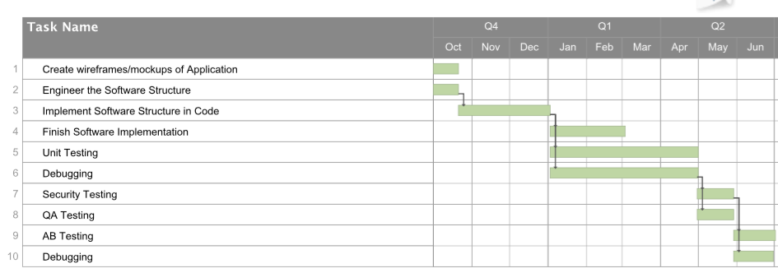

* 1. **Progress Reports**

The team project manager will be responsible for compiling and submitting all reports to the Office of Student Records and Registration using individual reports provided by team members.

* + 1. *Weekly reports will include:*
* What was accomplished during the week
* Significant problems encountered that will impact the project
* Status of pending problems from previous reports
* Weekly Expenditures
* What is planned for the upcoming week
  + 1. *Monthly reports will include:*
* Percentage of project completed
* Major milestones in the project
* Actual cost compared to expected cost

# Budget

* 1. **Budget Breakdown**

*Table 2. Created by Team*

|  |  |
| --- | --- |
| **Team Salaries** | **Cost** |
| Project Manager | $ 6,012 *(20 hours/week at $8.35/hour)* |
| Developer 1 | $ 12,024 *(40 hours/week at $8.35/hour)* |
| Developer 2 | $ 12,024 *(40 hours/week at $8.35/hour)* |
| Developer 3 | $ 12,024 *(40 hours/week at $8.35/hour*) |
| Developer 4 | $ 12,024 *(40 hours/week at $8.35/hour)* |
| **Total** | **$ 54,108** |

Computers are already available to BYU-I developers and software is free.

* 1. **Return on Investment**

Currently BYU-Idaho subsidizes student tuition costing the university thousands of dollars per student per semester. By decreasing the number of semesters it takes for a student to graduate the average total cost to the university for each student’s education will decrease. It is expected that BYU-Idaho will save enough money as a result of this project in two semesters to cover the entire cost of the project.

# Personnel and Qualifications

* 1. **Page Wiberg**
* Experience with the C++ programming language
* First hand experience with current class registration tools
  1. **Gage Peterson**
* Experience in web development using JavaScript, Node.js, PHP, HTML5, CSS3, and Java.
* Other development done in C++, Go, and Prolog.
  1. **Palmer Cluff**
* Experience with standard programming languages, primarily C++.
* Experience with web development using CSS and JavaScript
  1. **Weston Dransfield**
* Experience in back/front end web development on many BYU-Idaho web pages in HTML5, CSS3, JavaScript, and C#.
* Experience in many programming languages including C++, Java, and C#.

# Facilities and Equipment

* 1. **Needed**

- A workspace for designing and creating the software will be needed.

- Servers for testing and production will be needed.

* 1. **Availability of equipment**

- All the software can be found online for free.

- Servers already hosting registration will be used.