Homework 1 - Computer Vision
Point Processing | Spatial & Frequency-Domain Filtering | Wiener Restoration

Overview
This report covers the three problems of Homework 1: (A) Point Processing and Histogram-Based Image Enhancement, (B) Spatial- and Frequency-Domain Filtering, and (C) Wiener Filter. All required image-processing operations are implemented from scratch (no built-in function that directly performs the operation). Allowed built-ins are numpy (basic array operations), PIL (image loading), numpy.fft (FFT/IFFT, used in Parts B and C), and matplotlib (visualization). All intermediate computations use floating-point (float64).
Each experiment reports the figures, quantitative results, and a brief interpretation that explains why the observed result occurs.
Document status: Part A is complete below. Parts B and C are outlined as placeholders and will be added.

Part A. Point Processing and Histogram-Based Image Enhancement
Input: a color RGB image (point_processing_input_rgb.png, 512x512). Point processing maps each pixel independently; histogram-based methods redistribute the brightness distribution to improve contrast. All enhancement is applied to the luminance Y only, so hue/saturation are preserved.
Parameters
- RGB->YUV matrix: given (BT.601-style); inverse transform uses its matrix inverse
- Histogram: 8-bit, levels L = 256
- Contrast stretching: 2nd / 98th percentiles as r_min, r_max
- Gamma: gamma = 0.5, 1.0, 2.0 (c = 1)
- AHE / CLAHE tiles: 8x8; CLAHE clip = 0.01, 0.05 (fraction of tile pixel count)
- Bit-plane: reconstruct from the 4 most significant planes (bit 4..7)
Code is submitted as partA_point_processing.py; every figure in this section is produced by that script into output/.

A-1. RGB -> YUV Conversion
The given matrix is applied directly to separate luminance Y from chrominance U, V. Since R,G,B in [0,255] and the first row sums to 1, Y lies in [0,255] (luminance). U and V are color differences and can be negative, so they are kept as floats without clipping or 8-bit casting.
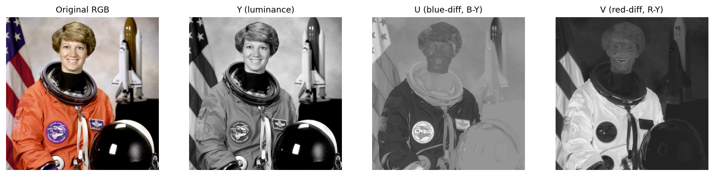
Figure A1. Original RGB and the Y, U, V components.
Quantitative results
Y range = [0.00, 255.00], U range = [-58.34, 41.36], V range = [-14.72, 93.85]
corr(U, B-Y) = 1.000, corr(V, R-Y) = 1.000
Interpretation (why the result occurs)
- Y (luminance): the weighted sum reflecting human brightness sensitivity (G has the largest weight, 0.587). It carries most of the structure and edges.
- U is proportional to (B-Y) and V to (R-Y): the blue-minus-luma and red-minus-luma color differences. The measured correlations are 1.000, confirming exact proportionality to B-Y and R-Y.
- Reading the U/V images: blue regions (the star field of the flag, blue parts of the suit) appear bright in U, and red regions (the red stripes, red parts of the suit) appear bright in V. imshow auto-scales min..max to black..white, so a blue pixel (large positive B-Y) becomes white in U.
- Why this matters: separating brightness (Y) from color (U,V) lets us enhance contrast on Y alone while preserving color - the core strategy of Part A.

A-2. Histogram Computation
Y is quantized to 8-bit (r_k in {0,...,255}) and counted per level directly: h(r_k) = n_k, with normalized histogram p(r_k) = n_k / MN.
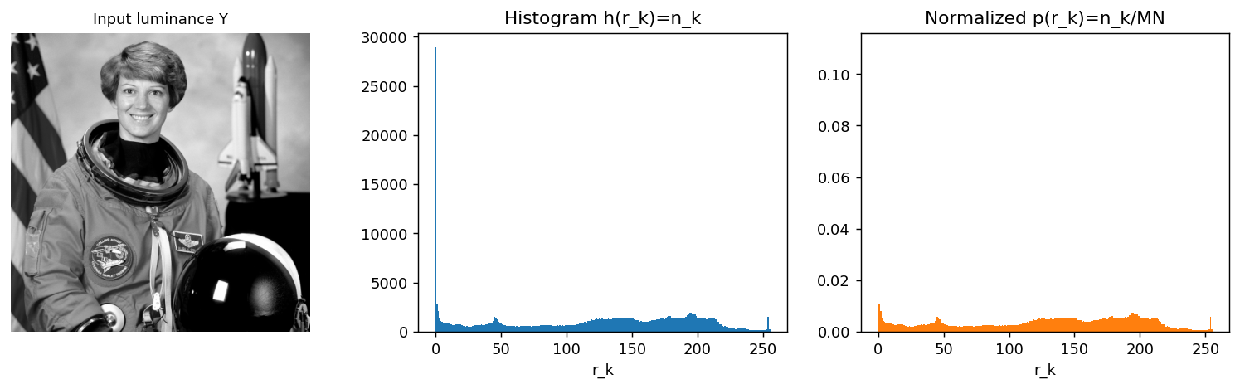
Figure A2. Input Y, histogram, and normalized histogram.
Quantitative results
sum(h) = 262144 ( = M*N ), sum(p) = 1.0000
Interpretation (why the result occurs)
- in the loop, k is the intensity r_k and np.sum(q==k) is the pixel count n_k.
- the normalized histogram has the same shape as the raw one because normalization divides every bar by the same constant MN; only the y-axis scale changes (counts vs. probability, sum = 1). A distribution concentrated in a narrow band means low contrast.

A-3. Histogram Equalization (HE)
The CDF, CDF(r_k) = sum_{j<=k} p(r_j), is used as the transform: s_k = (L-1)*CDF(r_k). This globally spreads the distribution toward uniform, increasing contrast. The equalized Y is recombined with the original U, V and converted back to RGB.
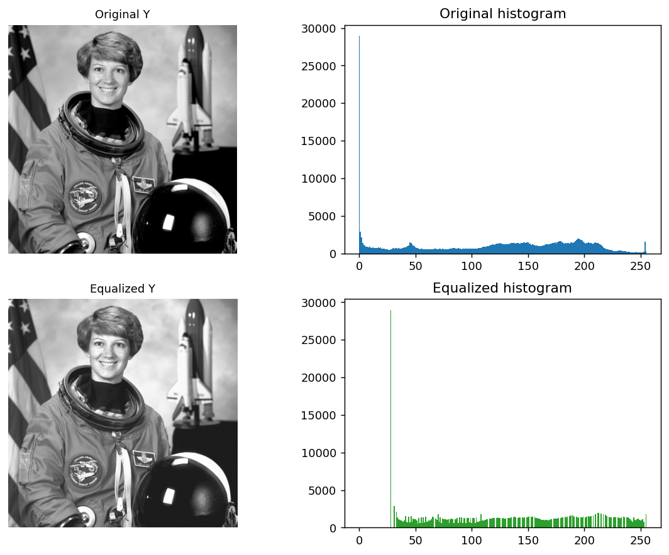
Figure A3-1. Original/equalized Y and their histograms.
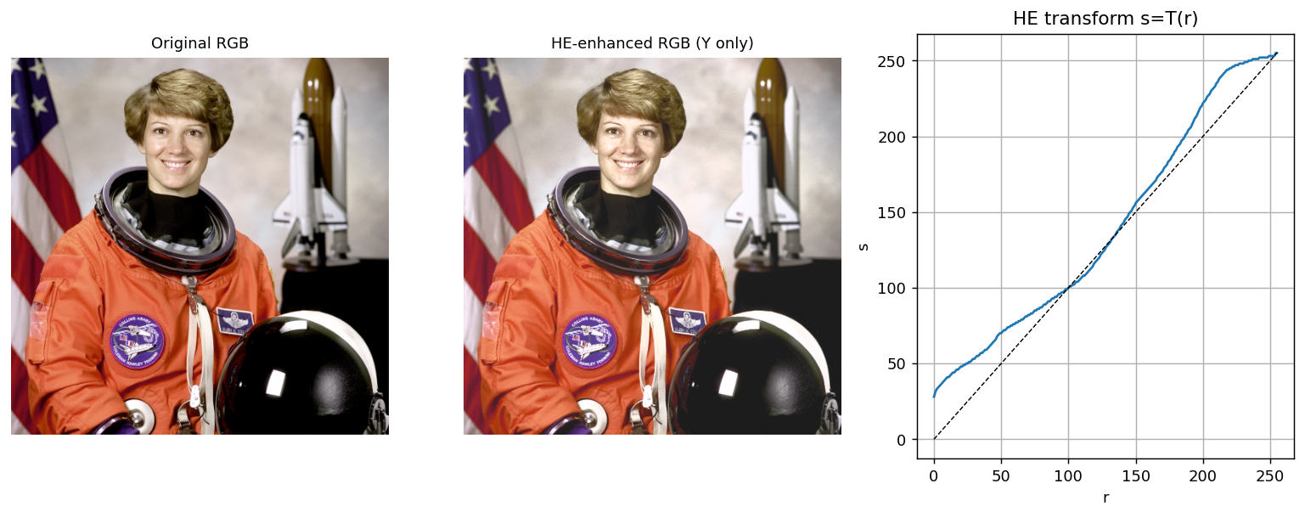
Figure A3-2. Original vs. HE RGB, and the transform s=T(r) (the curve is auxiliary, not a required item).
Quantitative results
Y mean 115.4 -> 129.5, std 75.1 -> 71.4
Interpretation (why the result occurs)
- the transform slope is dT/dr = (L-1)*p(r): where the histogram is dense (large p), the slope is steep and those intensities are spread apart, increasing contrast there.
- the equalized histogram becomes comb-like for two reasons: dense regions skip output levels (empty-level gaps), while sparse regions - whose CDF rises slowly - round several inputs to the same output (many-to-one merging).
- the mean rises (115.4 -> 129.5), so the image brightens overall. However, with a large pure-dark region present, the black background is lifted to mid-gray; mid-tone detail contrast increases while contrast within the dark region may decrease (a limitation of global HE).

A-4. Contrast Stretching
A piecewise-linear transform maps [r_min, r_max] linearly onto [0, L-1]. r_min, r_max are the 2nd/98th percentiles (robust to outliers).
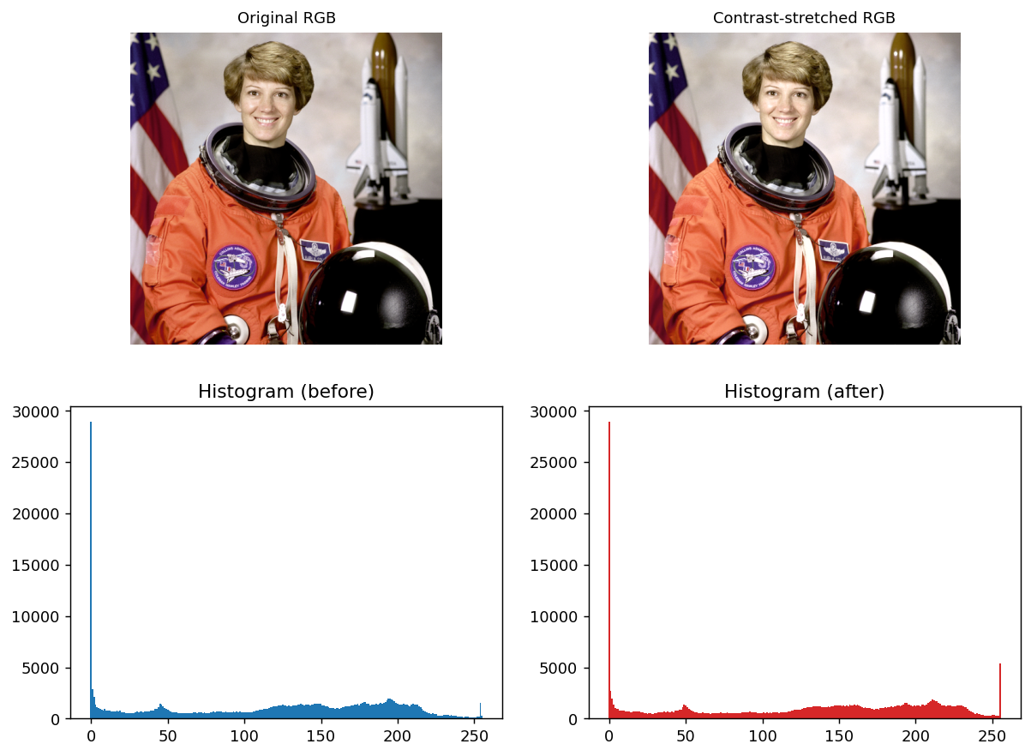
Figure A4. Original/stretched RGB and before/after histograms.
Quantitative results
r_min(2%) = 0.0, r_max(98%) = 235.0, gain = (L-1)/(r_max-r_min) = 1.085
Interpretation (why the result occurs)
- this image already spans nearly the full range (gain ~= 1.09), so the before/after difference is small. Stretching is most effective on low-dynamic-range (hazy) images.
- stretching vs. HE: stretching keeps the distribution shape and only widens the dynamic range linearly, whereas HE is a nonlinear CDF-based re-distribution. In short, 'widen the range' vs. 'flatten the distribution'.

A-5. Gamma Correction (power-law)
s = 255*(r/255)^gamma. In the general form s = c*r^gamma, c = 1 means no extra scaling. gamma = 0.5, 1.0, 2.0 are compared.
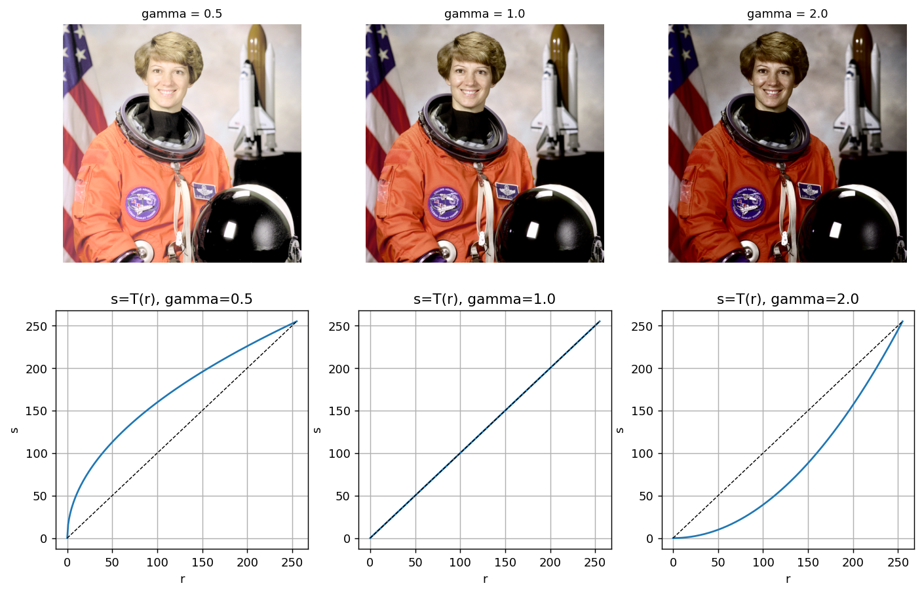
Figure A5. Result images and transform curves for each gamma.
Interpretation (why the result occurs)
- gamma < 1 (0.5): brightens and expands the dark tones. The slope gamma*r^(gamma-1) tends to infinity as r->0, so dark values are pulled apart (higher contrast), revealing shadow detail; the bright region is compressed.
- gamma = 1: identity transform (unchanged).
- gamma > 1 (2.0): darkens. Here the slope tends to 0 as r->0, so dark tones are compressed (shadows crushed) while bright tones expand.

A-6. Adaptive Histogram Equalization (AHE)
The image is divided into 8x8 tiles and HE is applied independently in each tile (no interpolation).
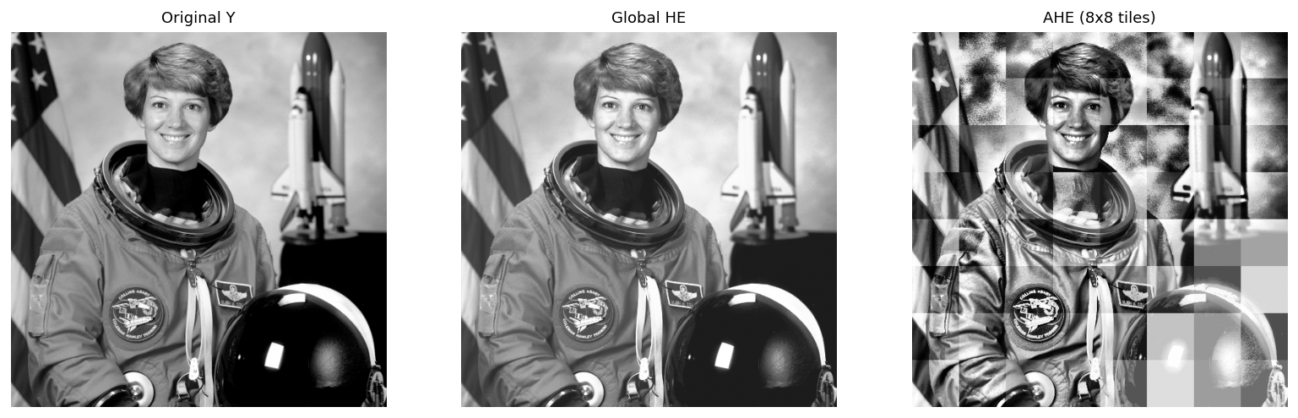
Figure A6. Original Y / global HE / AHE.
Interpretation (why the result occurs)
- using a local CDF per tile improves local contrast far more than global HE.
- noise amplification: in nearly uniform tiles (e.g., dark background, smooth parts of the suit) the narrow brightness range is force-stretched to 0..255, so faint noise shows up as blotches. Tile-boundary discontinuities also cause blocking artifacts - both addressed by CLAHE.

A-7. CLAHE (Contrast Limited AHE)
Each tile histogram is clipped at a clip limit, the excess is redistributed uniformly, a local CDF forms the mapping, and bilinear interpolation between tile centers removes boundary artifacts. clip = 0.01 and 0.05 are compared.
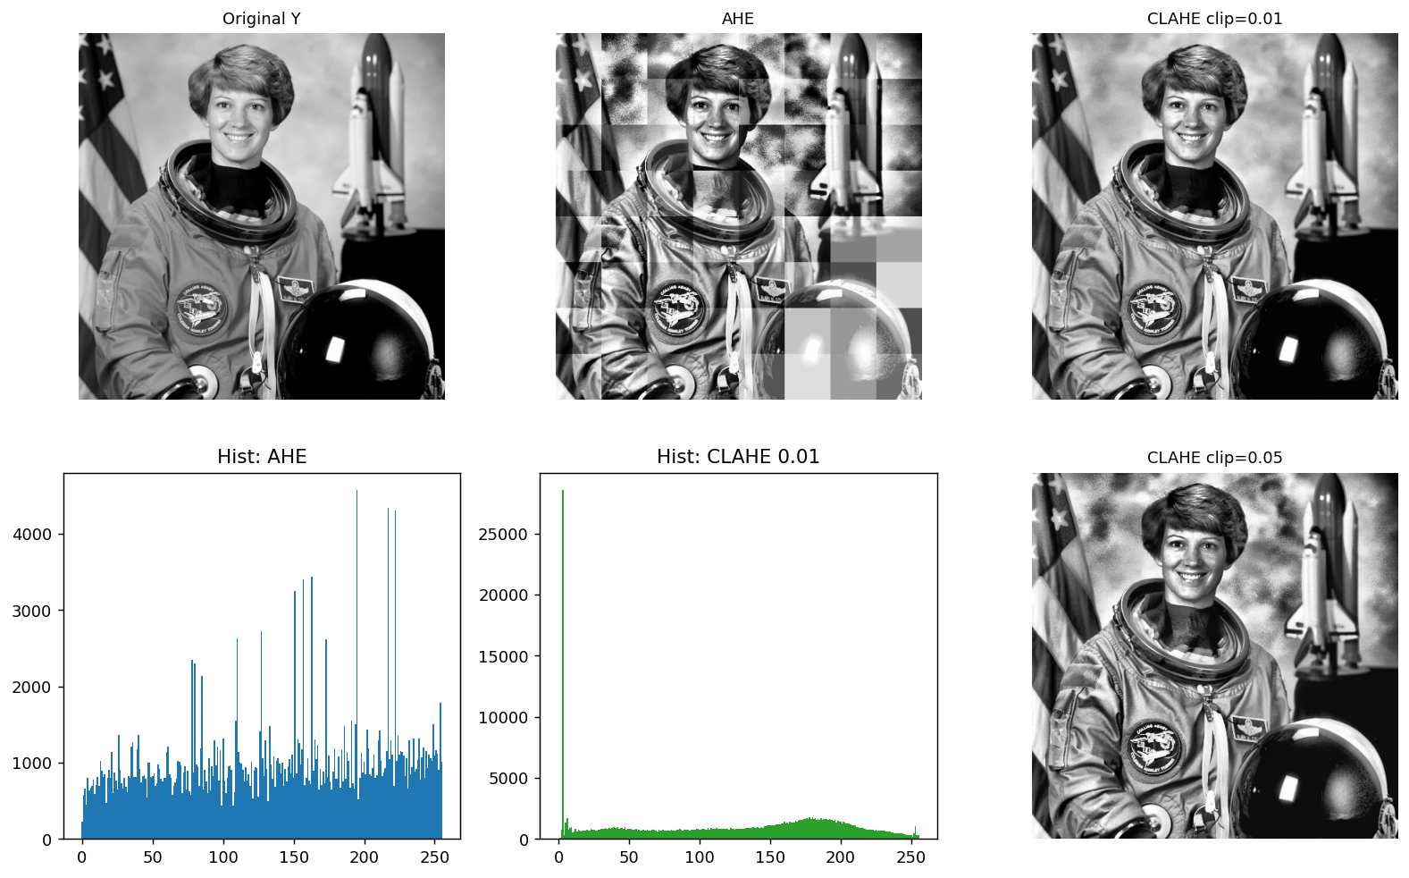
Figure A7. Original / AHE / CLAHE with histograms.
Quantitative results
Tile size 64x64 = 4096, clip=0.01 -> clip_count = 40
Darkest tile (7, 5): 3559 pixels with Y=0 (87%)
Input 0 -> output: AHE (no clip) 222 | CLAHE clip=0.01 3 | clip=0.05 14
Interpretation / Discussion
- Why CLAHE amplifies less noise: in AHE a tile's narrow brightness range makes the CDF steep (runaway contrast gain), amplifying noise. Clipping caps those peaks, bounding the slope.
- What clip acts on: clip is applied to the tile INPUT histogram (exactly as the assignment states). That histogram is the material for building the mapping (LUT); it is not a cap on the bars of the OUTPUT image histogram.
- Why the near-0 spike persists: the 3559 pixels with value 0 all map to a single output value (point mapping), so they pile into one output bin regardless of clipping. Clipping only moves where they land (AHE 0->222 vs. CLAHE 0->3); it cannot reduce the count. The near-0 spike therefore reflects a genuinely large dark region, not noise.
- Clip limit too small / too large: too small ~= original (peaks fully clipped -> near-uniform histogram -> linear CDF -> near-identity mapping, little enhancement); too large ~= AHE (peaks pass -> steep CDF -> over-contrast and background-noise amplification).

A-8. Bit-Plane Slicing
Y(x,y) = sum_k b_k * 2^k is decomposed into 8 bit planes. The image is reconstructed from the 4 most significant planes (bit 4..7) and compared with the original.
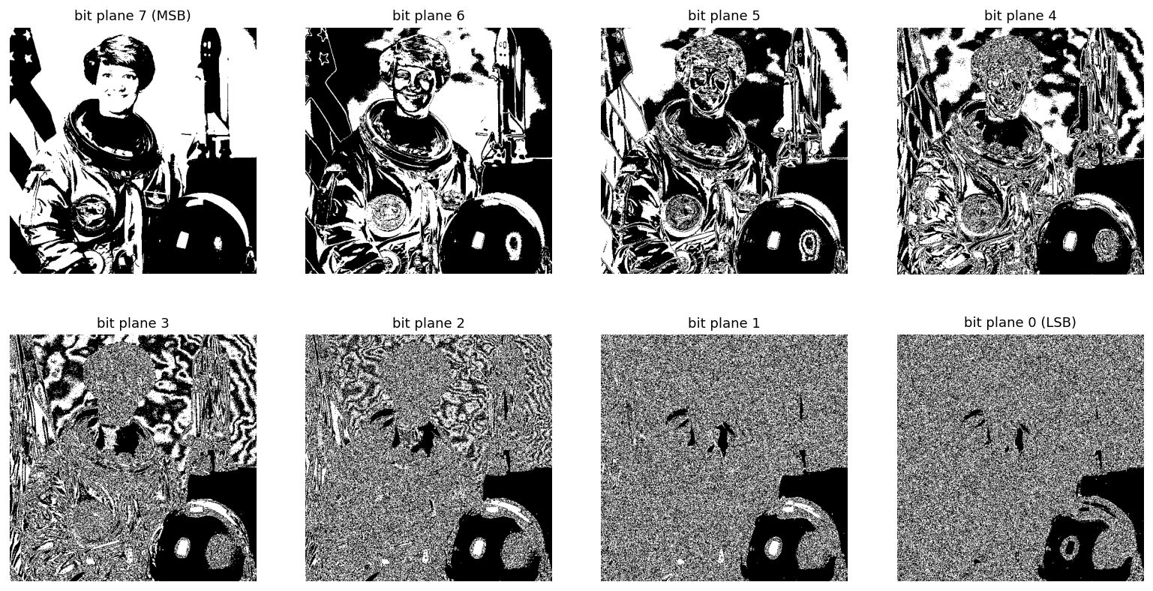
Figure A8-1. Eight bit planes (top-left MSB -> bottom-right LSB).
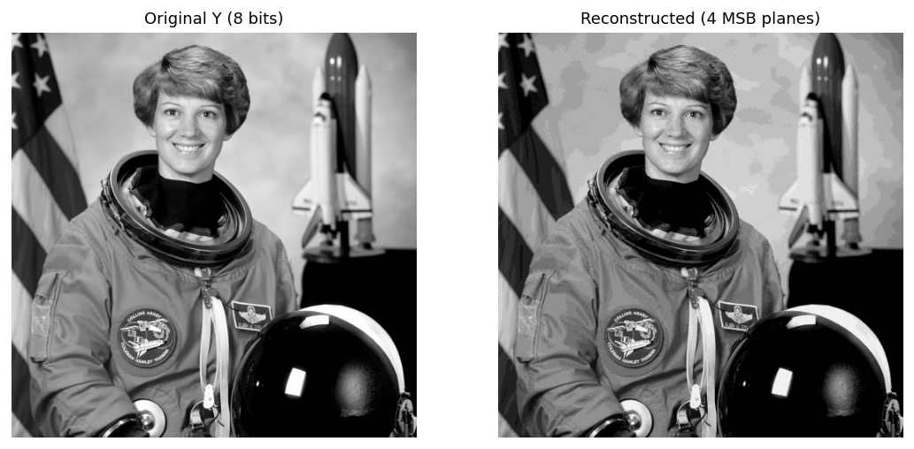
Figure A8-2. Original vs. 4-MSB reconstruction.
Quantitative results
4-MSB reconstruction: MSE = 67.19, PSNR = 29.86 dB
Interpretation (why the result occurs)
- high-order planes (bit 7/6/5) carry large brightness changes - most of the visual structure/outline. Low-order planes (bit 1/0) have tiny weight and resemble fine texture/noise.
- two reasons the 4 MSB are the most important: (1) their weights 16+32+64+128 = 240 are about 94% of the max value 255; (2) the reconstruction PSNR ~= 29.9 dB and is visually almost identical. Dropping the low bits causes faint false contours in smooth gradients.

A-9. Comparison and Discussion
The result image and histogram of each method are placed inside the table for a direct comparison of contrast improvement and noise.
Method | Result image | Scope | Contrast gain | Noise sensitivity | Histogram | Complexity | Typical use
Contrast stretching |  | Global | Low (linear dynamic-range widening; shape kept) | Uniform gain across range (linear), gain=(L-1)/(r_max-r_min) - usually small | 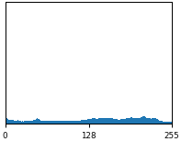 | O(MN) | Low-dynamic-range (hazy) images, preprocessing
Histogram equalization |  | Global | High (distribution flattening) | Selective amplification in dense bands (nonlinear) - stronger than uniform stretching | 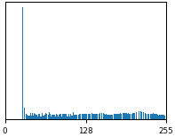 | O(MN+L) | Images with globally low contrast
AHE | 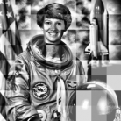 | Local | Very high (local) | High - narrow tile ranges stretched -> noise amplification + blocking | 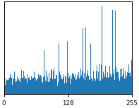 | Depends on tile count/size | Images where local contrast matters
CLAHE | 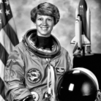 | Local | High (controlled by clip) | Low - clip caps the slope + interpolation removes blocking | 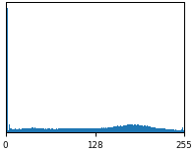 | AHE + clipping/interpolation -> depends on implementation/params | Medical, low-light; practical standard
Gamma correction |  | Global (point) | Tone-curve reshaping (brightness remap) | Low - monotonic point map adds no new noise (can emphasize existing noise for large gamma) | 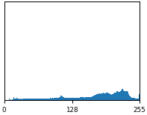 | O(MN) | Display gamma / exposure correction

Summary
Global methods (stretching, HE, gamma) are fast and simple but limited in local contrast; local methods (AHE, CLAHE) are strong on local contrast but cost more and are noisier. CLAHE balances the two extremes via the clip limit and interpolation, and is the practical standard.

Part B. Spatial- and Frequency-Domain Filtering
Input: a grayscale image. Each filter (3x3 blur, 3x3 sharpen) is applied in both the spatial domain (direct convolution) and the frequency domain (FFT multiply with zero-padding for linear convolution), and the two are compared via MSE / PSNR / SSIM. Also covered: frequency-response analysis, impulse-response verification, and Gaussian-based unsharp masking.
(To be completed.)

Part C. Wiener Filter
Input: a grayscale image degraded by a 15x15 Gaussian PSF (sigma=2.5) plus zero-mean Gaussian noise (RMS = 0.03). A Wiener filter F_hat = conj(H)/(|H|^2 + K) * G is designed from scratch and swept over K, with MSE / PSNR / SSIM reported in a table.
(To be completed.)

