**North Westwood Neighborhood Council**

**Budget Committee and General Board Joint Meeting**

**November 4, 2020 from 4:00 to 5:30pm**

**Zoom Meeting Online or By Telephone**

**Dial (669) 900-6833 to Join the Meeting**

**Then Enter This Webinar ID: 749 455 7845 and Press #**

**AGENDA**

(Parenthetical Times Are Just Estimates: Items May be Taken out-of-order without objection)

**VIRTUAL MEETING TELECONFERENCING NUMBER FOR**

**PUBLIC PARTICIPATION**

In conformity with the Governor’s Executive Order N-29-20 (MARCH 17, 2020) and due to concerns over COVID-19, the North Westwood Neighborhood Council meeting will be conducted entirely telephonically.

Every person wishing to address the Neighborhood Council must dial (669) 900-6833, and enter 915 9923 9424 and then press # to join the meeting. Instructions on how to sign up for public comment will be given to listeners at the start of the meeting

**Public Speakers**

The public is requested to dial *9, when prompted by the presiding officer, to address the Board on any agenda item before the Board takes an action on an item. The Council shall provide an opportunity for the public to address the Council on each agenda item before or during the Council’s consideration of the item. A member of the public wishing to speak on only one agenda item that is eligible for public comment shall be given an opportunity to speak for up to one minute when that item is considered by Council, or, at the discretion of the Presiding Officer, before consideration of the item.

Members of the public wishing to speak on more than one agenda item at a single meeting shall combine and present their comments addressing the agenda items at or near the beginning of the meeting during a segment called “Multiple Agenda Item Comment.” A member of the public speaking on more than one agenda item shall be allowed to speak for up to one minute per item up to a total of three minutes per meeting. This will be the only opportunity to speak, other than during General Public Comment, for those members of the public who have submitted speaker cards on more than one agenda item. Comments from the public on other matters, not appearing on the agenda but within the Board’s subject matter jurisdiction, will be heard during the General Public Comment period and shall be limited to 2 minutes.

**Americans with Disabilities Act**

As covered under Title II of the Americans with Disabilities Act, the City of Los Angeles does not discriminate on the basis of disability and, upon request, will provide reasonable accommodationto ensure equal access to its programs, services and activities. Sign language interpreters, assisted listening devices, or other auxiliary aids and/or services may be provided upon request. To ensure availability of services, please make your request 3 business days prior to the meeting you wish to attend by contacting Michael Skiles at northwestwoodcouncil@gmail.com.

**Public Access of Records**

In compliance with Government Code section 54957.5, non-exempt writings that are distributed to a majority or all of the board in advance of a meeting may be viewed at 1424 Westwood Blvd, at our website, http://northwestwoodneighborhoodcouncil.org or at the scheduled meeting. In addition, if you would like a copy of any record related to an item on the agenda, please contact northwestwoodcouncil@gmail.com

**North Westwood Neighborhood Council**

**Budget Committee and General Board Joint Meeting**

**November 2, 2020 from 4:00 to 5:30pm**

**In attendance: Noreen Ahmed, Joey Russel, Ernesto Arciniega**

**MINUTES**

* Call to order at 4:09pm
* No public comment

1. Discussion and possible recommendation of an amended 2020-2021 Administrative Packet and Budget.

* Joey spoke with Shauna - we need to pass a new budget; she recommended each month to extend the monthly expenditure. Second, the elections committee paid for translation services previously. Third reason, the CHHC townhall expenses for social media outreach.
* Joey added all three expenses to the budget, getting the funds from the general NPGs.
* $200 (MailChimp - monthly/weekly newsletter); $200 (translation for farsi), $100 + $900 (social media outreach for Budget Town Hall). Total of $1,400 (All of this is part of General and Operational Expenditures)
* MOTION: Joey moves that the the Budget Committee recommends that NWWNC approves an amended budget as follows: $16,549.78 for General and Operational Expenditures, $40,738.06 for Neighborhood Purpose Grants, and $2,000 for Community Improvement Projects for a grand total of $59,287.84 for the NWWNC 2020-2021 fiscal year budget.

-Ernesto seconded the motion

-Discussion - Ernesto asked if those are the only minor changes in the budget, Joey agrees.

-3 Ayes, 0 Nays, No abs. Motion passes

1. Discussion and possible recommendation on the Budget Town Hall Event Approval Form/event proposal, and in particular the funding components.

* NWWNC Budget Town Hall - CHHC met with Joey, Noreen, Nuha among others to approve an event, proposing with the city administrative office, to send Jacob Wexler. to do a presentation on how the city budget works, how the community can get involved, and an overview of the budget, and a panel of local groups, students, and other groups, to discuss how people can get involved as stakeholders, budget timeline, transparency, values, opportunities, and how to get involved to shape the budget. Contact person will be Andrew Lewis. NWWNC is the main sponsor. It will happen in January of 2021.
* Budget for the event:
* 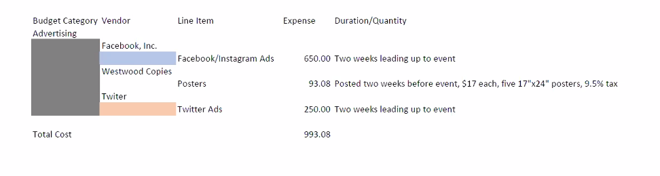

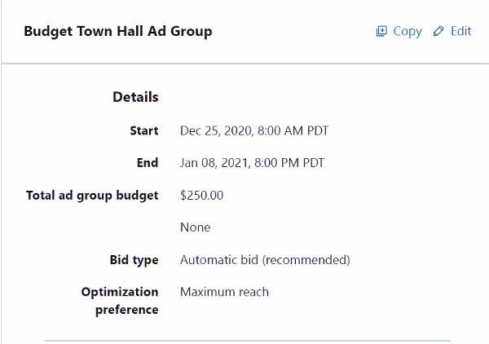

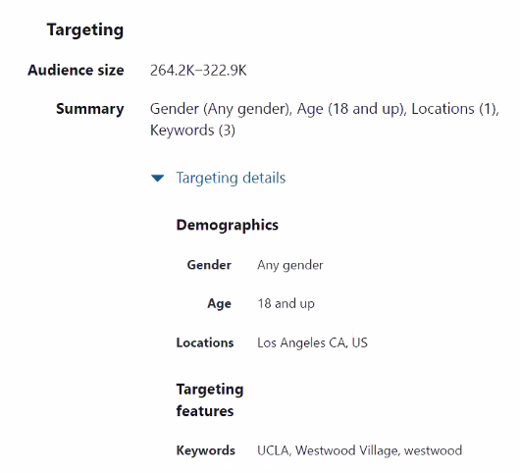

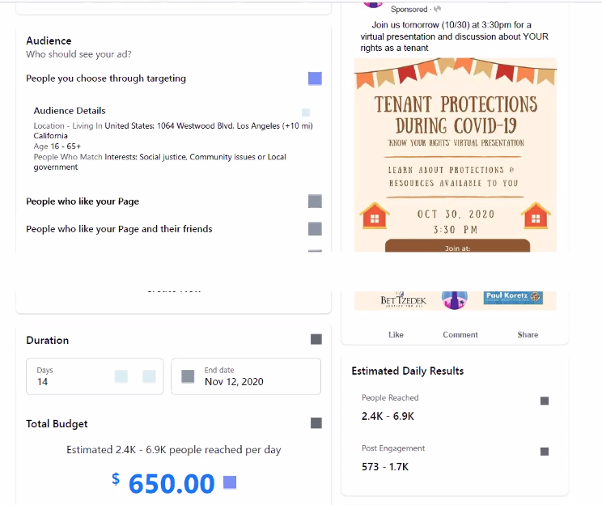

MOTION: Joey moves that the BC inform the NWWNC that it believes the Budget Town Hall event meets all the requirements for the City of Los Angeles for an event to be approved.

-Noreen seconds

-No discussion

-Vote: 3 AYES, 0 NAYS, 0 ABS.

1. Discussion on recruiting new applications for NPGs from the NWWNC and possible recommendations for organizations to reach out to.

-Joey: We need people to apply for NPGs. We need 3-4 people. We have a budget of a little under $12,000.

-Ernesto: there are many organizations in need of funding, particularly student organizations at UCLA. We should reach out to them as well.

-Joey: we should look for orgs related to food insecurity as well.   
-Joey: we should get a list of orgs and reach out.

-Noreen: maybe UCSA EVP’s can help with the outreach.

1. Update on encumbered funds and discussion and possible recommendation on which may be important to look into spending soon to avoid losing money to budget rollover.

* Joey: the board needs to get in contact with NPG recipients to check in. Joey will encourage the outreach committee to spend their encumbered funds.

1. Discussion on encumbered NPGs and how to proceed with communicating with these organizations regarding the NPG funds, including the West-Cal Academy, Friends of the Westwood Library, and Far Out Fest NPGs.

* Joey: reach out to NPG’s

Friends of the Westwood Library they said they want to change the fund purpose, allowed by city as last resort.

We need to reach out to friends of the Westwood Library, and Far Out Fest NPGs.

1. Discussion and possible recommendation to the full board that it begin spending its budget, due to the amount of money remaining to be spent.

* We have almost 60,000 dls that we haven’t used, and we have like 6-7 meetings.

1. Discussion and possible recommendation on budget committee administrative procedure, policies, best practices and division of work between members moving forward.

* Joey: we need to increase the number of budget committee members, and get people ready for the training and to be a treasurer.

1. Adjournment 5:11pm.