How Can Universities Enroll More Student Veterans?

Wesley Wilson

Political Analysis GOVT 650

Isa Haskologlu, Ph.D.

2023-09-30

## Introduction

Annually, approximately 200,000 service members transition from the U.S. military to civilian life. This military-to-civilian transition holds particular significance for policy makers tasked with ensuring the seamless reintegration of service members into civilian society. The primary policy instrument employed by the Federal Government to assist service members in this process is the provision of educational benefits through programs like the G.I. Bill. Simultaneously, many colleges and universities nationwide have voluntarily developed comprehensive initiatives aimed at both enhancing student diversity and accessing federal funding facilitated by the G.I. Bill. These initiatives encompass various measures, such as increasing financial aid for student veterans, establishing dedicated student veteran support center, or implementing liberal transfer credit policies recognizing military training as academic credit; however, little is known as to whether these initiatives lead to increases in student veteran enrollment. Drawing upon data sourced from the U.S. Department of Veterans’ Affairs’ G.I. Bill comparison tool, this paper seeks to examine the causal relationship between student support and the enrollment of student veterans.

## Research Question

### Do universities that offer more services or financial support to student veterans enroll more student veterans?

## Literature Review

The history of student veterans in higher education begins with the passing of the 1944 Servicemen’s Readjustment Act of 1994—known today as the G.I. Bill. Indicative of its name, the original G.I. Bill was designed principally to assist the soon-to-be millions of World War II veterans returning home the opportunity to re-acclimate to civilian life by providing funding to pursue higher education, unemployment insurance, and housing loans (National Archives 2021). The policy impacts of the G.I. Bill have been extensively researched and documented. The G.I. Bill caused a surge in student veteran enrollment and heavily increased collegiate access across America’s colleges (Bound and Turner 2002). In total, roughly half of America’s WWII veterans— nearly 8 million service members — would use the G.I. Bill for re-training or continued education (Cate et al. 2017, pp 8). With a total cost of roughly $14.5 billion, the G.I. Bill provided no shortage of financial benefits to colleges and, as an administrator at the Veterans Administration put it, the bill “helped raise the education level of an entire generation” (NYT 1956).

Student veterans’ relationship with institutions of higher learning has not always been positive. While the original G.I. passed unanimously in the House and Senate, many University presidents were staunchly opposed to the Bill. President Conant of Harvard University warned that colleges would also admit students with lower academic capabilities in their efforts to attract WWII veterans, thereby undermining academic rigor (Olson 1973, pp 604). Some presidents were concerned about accommodating married students with families on campus (Olson 1973, pp 603); others took a bold stance. For example, the President of the University of Chicago, Robert Maynard, was famously quoted, “Colleges and Universities will find themselves covered into educational hobo jungles” (Hindley 2014). The inflammtory rhetoric towards veterans on campus would eventually disipate and become more welcoming. In 1948, shortly after his initial criticism, President Conant of Harvard praises Harvard’s WWII veterans as being, “the best in Harvard’s history” (SVAC 2022, pp 26).

The original G.I. Bill was sunsetted in 1956. Since its discontinuance, Congress has enacted numerous versions of the education benefit —from the Korean War G.I. Bill, to the Montgomery G.I. Bill, to the present-day Post-9/11 G.I. Bill[1]. In terms of benefits, the Post-9/11 G.I. Bill differs substantially from previous generations by providing up to 36 months in education benefits, paying an annual tuition maximum of $27,120 to the school, and providing the student with housing and book stipends Veterans Benefits Administration (2023). Colleges whose tuition rates exceed the annual $27,000 tuition maximum—such as private universities—can elect to participate in the Yellow Ribbon Program (YRP). The YRP is a voluntary agreement between the VA and a University to help pay the tuition that exceeds the Post-9/11 G.I. Bill annual maximum. Under the YRP, colleges decide the maximum amount in tuition they will contribute per student, and the VA matches their contribution dollar-for-dollar (VBA Education Service 2020).

The Veterans Benefits Administration spends roughly $10.7 billion under the Post-9/11 G.I. Bill to provide education benefits to nearly 700,000 beneficiaries (CBO 2019). Today, VA education benefits account for nearly 20% of the federal government’s higher education spending (Pew 2019). As VA education spending has steadily increased, colleges have become increasingly interested in enrolling more student veterans to not only access federal dollars, but also diversify their student body. The Post-9/11 cohort of student veterans is the most diverse in US history. Student veterans today are more likely to be students of color (Holian, Adam, and Hunt-White 2020), first-generation college students (Schmeling and Maury 2019), and be Pell Grant recipients (NASFAA 2022) (a metric often used to measure socio-economic status).

The shared interests of Universities, policymakers, advocacy groups, and think-tanks have led to a growing body of literature dedicated to understanding the enrollment patterns and barriers of student veterans. In 2015, the Institute for Veterans and Military Families (IVMF) published research findings where the top barriers cited by student veterans in accessing higher education were lack of financial aid, expired G.I. Bill benefits, family obligations, and wellness issues (C., Maury, and Fay 2015). In analyzing student veterans’ enrollment decisions, location, college reputation, support, and affordability appear to be critical factors (Hill 2016). Other researchers have focused more heavily on understanding classroom experiences and campus services’ impact on enrollment. A 2019 study found that student veterans who had positive relationships with their faculty members were less likely to drop out than those who did not (Fernandez et al. 2019); while a 2014 study highlighted the importance of social integration and relationships (Olsen, Badger, and McCuddy 2014).

With a better understanding of student veterans’ needs, universities have developed robust support strategies, including increased financial aid like Yellow Ribbon scholarships and campus-service initiatives. For instance, the American Council on Education’s student veteran toolkit promotes veteran-friendly institutions by providing designated student lounges, central points of contact, veteran-specific orientations, and student veteran clubs (ACE 2018, pp5). In 2012, President Obama introduced the Principles of Excellence Program (POE) via Executive Order 13607, encouraging universities to adhere to guidelines for transparent information, ethical marketing, and aiding veterans in their transition to civilian life (National Archives 2012). Unfortunately, the causal impact of these voluntary initiatives on student veteran enrollment is largely unknown.

## Hypotheses

I have formulated several preliminary hypotheses based on a literature review and a general exploratory analysis of the data. First, given that student veterans commonly cite a lack of financial aid as a critical barrier to accessing higher education, I hypothesize that colleges offering more financial aid will enroll a greater number of student veterans. I believe that a variable quantifying financial aid offered to student veterans will be the most robust predictor for estimating student veteran enrollment. Second, I expect that colleges providing more student support services will also enroll more student veterans. These support services encompass various aspects, such as designating a student veteran point of contact, committing to adopting the Department of Education’s “8 Keys to Veteran Success,” becoming a signatory of the Principles of Excellence, or hosting a recognized student veteran group on campus. However, I anticipate that not all the student support variables will have statistically significant relationships with student veteran enrollment. Third, I anticipate that colleges located in areas with a high density of veterans living nearby will enroll more student veterans due to their close proximity to a rich market of prospective students. Finally, I hypothesize that institutional reputation is important to student veterans when selecting a college. Therefore, I expect that general outcome metrics of a college, such as graduation rates, post-graduation salaries, or retention rates, will exhibit statistically significant relationships with student veteran enrollment.

## About the Data

The data used for this analysis originates from two sources—the U.S. Census’ 2017-2021 5-year American Community Survey (ACS) and the U.S. Department of Veterans’ Affairs’ (VA) G.I. Bill Comparison Tool. The five-year ACS surveys populations with at least 20,000 residents and includes information about veterans. Specifically, the data used for this analysis was retrieved from the Census’ open data application programming interface (API) and provides the number of veterans identified in the 2017 ACS by zip code. I include the Census data as a control variable because colleges located in areas with a high population of veterans may be more likely to have higher student veteran enrollment. The original census data included the number of veterans for 33,774 zip codes.

The G.I. Bill Comparison Tool is a software application developed by the VA to assist student veterans and military-connected students find and research colleges. This tool consolidates institution-level data from various VA databases, the Department of Education’s (DOE) College Scorecard database, and DOE’s Integrated Postsecondary Education Data System (IPEDS). Once combined, the data includes crucial variables, such as the number of G.I. Bill beneficiaries enrolled, the amount offered in Yellow Ribbon Program Scholarships, whether the college has a designated point of contact for veterans, and whether it provides academic credit for military training, among others. These data are presented through the user-friendly interface of the G.I. Bill Comparison Tool. The data from the G.I. Bill Comparison Tool is publicly accessible via the tool’s website, which I accessed directly in September 2023. Since Universities often comprise several colleges with unique facility codes, the original G.I. Bill tool data included the descriptive characteristics for 17,922 colleges.

I merge census data with the G.I. Bill tool data based on zip codes. My main goal is to explore the connection between colleges’ voluntary efforts to attract and support student veterans. Since the Post-9/11 G.I. Bill fully covers public university tuition, it’s hard to determine if public institutions offer additional financial aid voluntarily. So, I focus on private colleges with tuition costs exceeding the Post-9/11 G.I. Bill limit. I then select variables for modeling student enrollment and support. Additionally, I incorporate control variables such as university size (measured by total undergraduates), annual tuition, institution-wide metrics, and the local census data reflecting the number of veterans in the surrounding community. The final data set used for analysis included institution-level characteristics of 932 colleges.

## Methodology

I employ a multivariate regression model to explore the relationship between student support and student-veteran enrollment. Initially, I visualize the distribution of the continuous variables. Given the variation in college sizes and tuition rates, these numeric variables exhibit wide ranges and significant skewness. To address this, I normalize the data by applying a logarithmic transformation to all numeric variables. This transformation fosters a more suitable and interpretable basis for comparison. To identify the most suitable model, I employ stepwise regression and select the model that minimizes the Akaike Information Criterion (AIC) value and retains only pertinent variables. The selected student support variables included the college’s average Yellow Ribbon scholarships per student, post-graduation salary, and various indicators such as membership in the principles of excellence program, a signed MOU with the Department of Defense, provision of Academic Credit for Military Training, and the presence of a recognized student veteran group on campus. The control variables encompassed the college’s undergraduate enrollment, annual tuition, post-graduation salary, and the number of veterans in the local community.

To ensure the absence of multicollinearity, I assess the correlation between independent variables and calculate each variable’s variance inflation factor (VIF). These evaluations reveal no substantial evidence of multicollinearity[2]. I identify outliers by standardizing the model’s residuals and define outliers as observations with standardized residuals exceeding three. The outliers correspond to colleges with low student-veteran enrollment (less than three students). However, given their apparent natural occurrence, I do not remove remove any outliers from the model data. Given that all numeric variables underwent logarithmic transformations, the final model shows the elasticity of student veteran enrollment, given the support offered by the university.

## Results

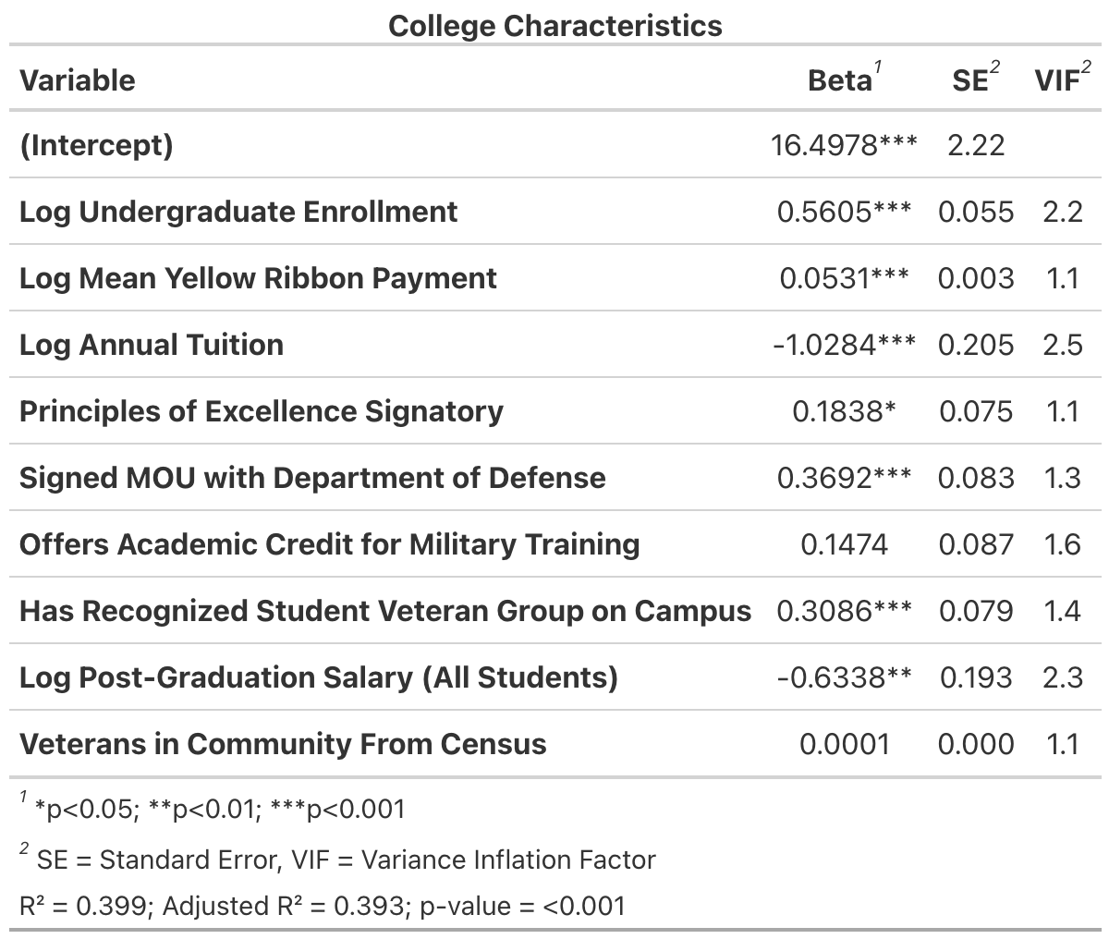

In the process of stepwise model selection, several variables were eliminated from the model. Notably, the “basic allowance for housing” variable, along with most of the outcome metric variables, was deemed unsuitable for predicting student veteran enrollment and thus removed. Additionally, various support indicator variables, such as whether the college had a designated point-of-contact and membership in the “eight keys to success” program, dropped from the final model. What’s particularly intriguing is that the indicator variable signifying college membership in the Yellow Ribbon Program was discarded from the model, while the mean Yellow Ribbon Payment remained as a statistically significant variable. This suggests that the amount awarded in Yellow Ribbon scholarships may carry more weight in predicting student veteran enrollment than simply being designated as a Yellow Ribbon school.

The most significant predictor of student veteran enrollment is tuition cost. As tuition increases, student veteran enrollment tends to decrease. To be precise, a one-percent tuition increase corresponds to a one-percent decrease in student veteran enrollment. Surprisingly, the second most significant predictor is post-graduation salaries. It seems that colleges with higher post-graduation salaries enroll statistically significantly fewer veterans. The third most influential predictor is undergraduate enrollment, and it appears that student veterans are more likely to enroll in larger private universities. Based on these findings, one could reasonably infer that student veterans tend to avoid smaller, “elite” universities in favor of more moderately priced, smaller institutions. These patterns could be attributed to cultural factors, as student veterans are often more likely to be first-generation students from modest backgrounds.

All remaining student support indicator variables have statistically significant, positive relationships with student veteran enrollment. On average, colleges that have a tuition assistance MOU with the Department of Defense generally enroll .37% more G.I. Bill students that those that do not; this might suggest that if student veterans can begin their degree in the service using tuition assistance, they might be more likely to continue their education pursuits at the same institution using their G.I. Bill. On average, colleges that have a recognized student veteran on campus enroll and are signed members of the principles of excellence enroll .31% and .18% more student veterans than those that do not respectively.

All remaining student support indicators show statistically significant and positive relationships with student veteran enrollment. On average, colleges with a tuition assistance MOU with the Department of Defense enroll 0.37% more G.I. Bill students than those without. This suggests that student veterans may be more likely to continue their education at the same institution using their G.I. Bill benefits after beginning with tuition assistance. Additionally, colleges with a recognized student veteran on campus and signed members of the principles of excellence enroll 0.31% and 0.18% more student veterans, respectively, compared to those without these features. Interestingly, providing academic credit for military training seems to yield the smallest increase in student enrollment as colleges that adopt these policies enroll only 0.18% more student veterans compared to those that do not[3].

## Discussion

These findings suggest that certain initiatives targeting student veterans lead to measurable changes in student veteran enrollment. However, it is important to note that the final model appears to account for approximately 40% of the variation in student veteran enrollment. This implies that other unobserved factors, such as a college offering specific programs or evening and part-time learning options, are likely influencing student veteran enrollment as well. Nevertheless, these findings offer valuable insights that can guide colleges in developing data-driven strategies to enhance student veteran enrollment on their respective campuses.

To elaborate further, a college starting from scratch that adopts a Memorandum of Understanding (MOU) with the Department of Defense (DoD), provides maximum Yellow Ribbon Program Scholarships, and actively encourages the formation of a student veteran group on campus could potentially increase their student veteran enrollment by 5%. Depending on the size of the institution, such an increase could have significant implications. For the fixed features, such as the negative relationship between student veteran enrollment and metrics like the college’s post-graduation salaries, annual tuition, and university size, colleges can consider designing tailored marketing campaigns and assisting prospective student veterans better understand their benefits. These campaigns can aim to educate and motivate prospective student veterans to apply to colleges that they may have previously perceived as out of their reach.

## References

ACE. 2018. “Toolkit for Veteran Friendly Institutions.” [American Council on Education. 2018. Toolkit for Veteran Friendly Institutions. Accessed 23 May 2022](https://American Council on Education. 2018. Toolkit for Veteran Friendly Institutions. Accessed 23 May 2022).

Bound, John, and Sarah Turner. 2002. “Going to War and Going to College: Did World War II and the g.i. Bill Increase Educational Attainment for Returning Veterans?” *Journal of Labor Economics* 20(4): 784–815. <https://www.jstor.org/stable/10.1086/342012>.

C., Zoli, R. Maury, and D. Fay. 2015. “Missing Perspectives: Servicemembers’ Transition From Service To Civilian Life - Data-Driven Research To Enact The Promise Of The Post-9/11 Gi Bill.”

Cate, C. A., J. S. Lyon, J. Schmeling, and B. Y. Bogue. 2017. *National Veteran Education Success Tracker: A Report on the Academic Success of Student Veterans Using the Post-9/11 GI Bill*. <https://studentveterans.org/wp-content/uploads/2020/08/NVEST-Report_FINAL.pdf>.

CBO. 2019. “The Post-9/11 GI Bill: Beneficiaries, Choices, and Cost.” *Congresssional Budget Office*.

Fernandez, Frank, Dan Merson, Hyun Kyoung Ro, and Susan Rankin. 2019. “Do Classroom Interactions Relate to Considerations of Institutional Departure Among Student Veterans and Service Members?” *Innovative Higher Education* 44(3): 233–45. <https://doi.org/10.1007/s10755-019-9460-8>.

Hill, Reginia. 2016. “Factors Affecting College Choice and Transfer: A Study of the Decision-Making Process of Student Veterans.” *Educational Foundations & Leadership Theses & Dissertations*. <https://digitalcommons.odu.edu/efl_etds/9>.

Hindley, Meredith. 2014. “How the GI Bill Became Law in Spite of Some Veterans’ Groups.” <https://www.neh.gov/humanities/2014/julyaugust/feature/how-the-gi-bill-became-law-in-spite-some-veterans-groups>.

Holian, Laura, Tara Adam, and Tracy Hunt-White. 2020. “A Profile of Military Students Who Received Federal Veterans’ Education Benefits in 201516.”

NASFAA. 2022. “Issue Brief: Doubling the Maximum Pell Grant.” <https://www.nasfaa.org/issue_brief_double_pell>.

National Archives. 2012. “Executive Order – Establishing Principles of Excellence for Educational Institutions Serving Service Members, Veterans, Spouses, and Other Family Members.” <https://obamawhitehouse.archives.gov/the-press-office/2012/04/27/executive-order-establishing-principles-excellence-educational-instituti>.

———. 2021. “Servicemen’s Readjustment Act (1944).” <https://www.archives.gov/milestone-documents/servicemens-readjustment-act>.

NYT. 1956. “G.i. SCHOOL LAW ENDS WEDNESDAY.” *New York Times*. <https://www.nytimes.com/1956/07/22/archives/gi-school-law-ends-wednesday-7800000-veterans-trained-in-world-war.html>.

Olsen, Timothy, Karen Badger, and Michael D. McCuddy. 2014. “Understanding the student veterans’ college experience: an exploratory study.” *U.S. Army Medical Department Journal*: 101–8.

Olson, Keith W. 1973. “The g. I. Bill and Higher Education: Success and Surprise.” *American Quarterly* 25(5): 596–610. <https://www.jstor.org/stable/2711698>.

Pew. 2019. “Two Decades of Change in Federal and State Higher Education Funding.” <https://pew.org/2M7okiZ>.

Rep. Roe, David P. [R-TN-1. 2017. “H.R.3218 - 115th Congress (2017-2018): Harry W. Colmery Veterans Educational Assistance Act of 2017.” <https://www.congress.gov/bill/115th-congress/house-bill/3218>.

Schmeling, J., and R Maury. 2019. *Student Veterans: A Valuable Asset to Higher Education*. <https://ivmf.syracuse.edu/student-veterans-a-valuable-asset-to-higher-education/#:~:text=Conclusion,their%20loyalty%20and%20generous%20contributions.>

SVAC. 2022. “Testimony of Student Veterans of America Before the Committes on Veterans’ Affairs.” <https://www.veterans.senate.gov/services/files/8B5159C0-EB86-4C8F-BB8F-45653BD9F048>.

VBA Education Service, GI. 2020. “VBA: Yellow Ribbon Program Fact Sheet.” <https://benefits.va.gov/BENEFITS/factsheets/education/Post-911_Yellow_Ribbon.pdf>.

Veterans Benefits Administration. 2023. “Post-9/11 GI Bill (Chapter 33) Rates.” <https://www.va.gov/education/benefit-rates/post-9-11-gi-bill-rates/>.

1. In 2017, Congress passed the Harry W. Colmery Veterans Education Assistance Act, or Forever G.I. Bill (Rep. Roe 2017). The bill revised the Post-9/11 G.I. Bill by removing time restrictions for program use and expanding benefits; however, the terms Forever G.I. Bill and Post-9/11 G.I. Bill are used interchangeably.
2. The independent variables with the highest correlation (+.56) were average Yellow Ribbon Payment and Annual Tuition.
3. While not shown in the table, the coefficient on academic transfer credit is statistically significant at the .10 level.