PART 1

Write javascript validation code to ensure all the fields in question.html are answer. Use alert box.

Use Question-Part1.html

Examples:

1.)

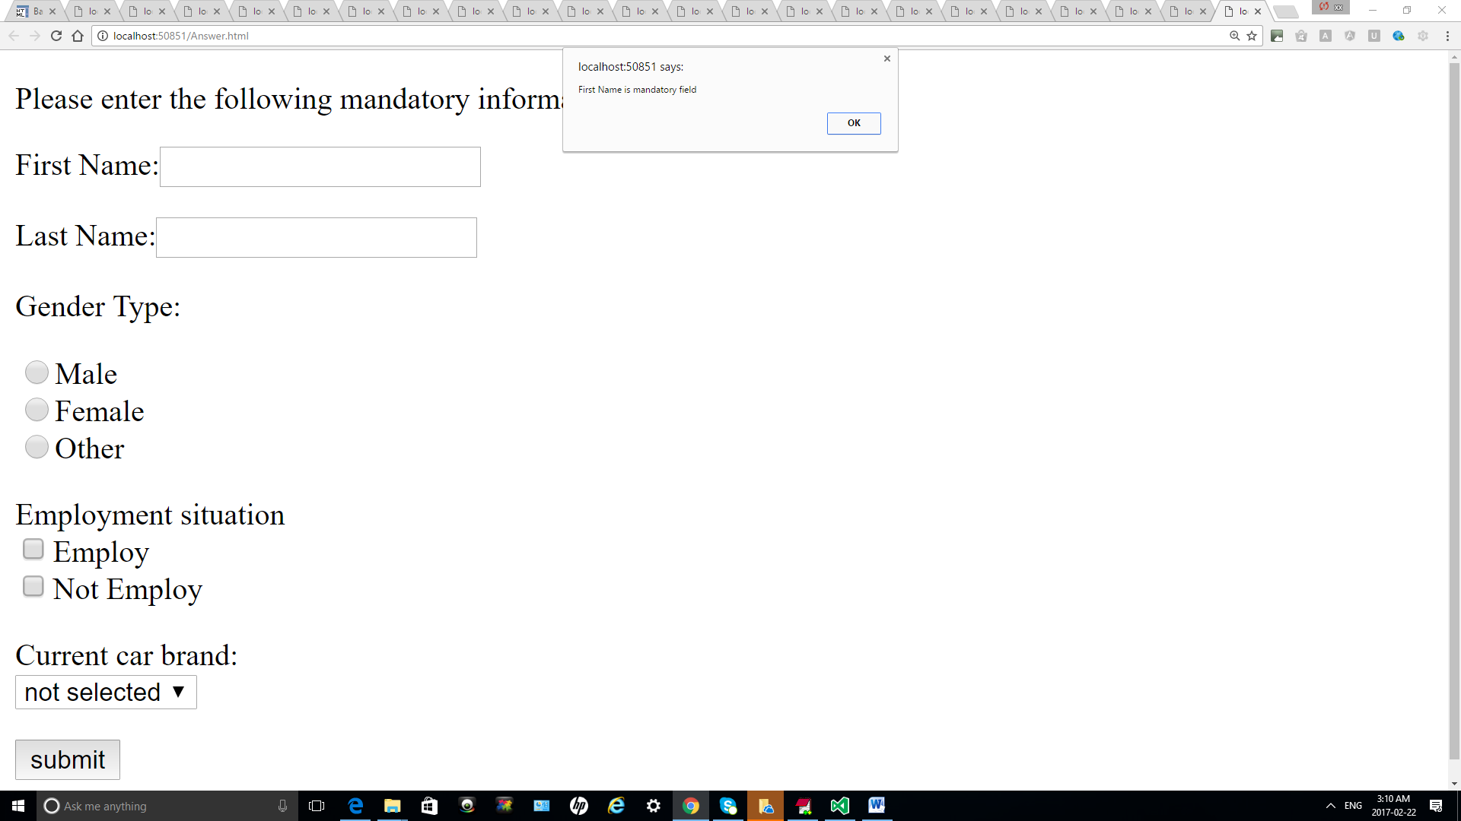

2.)

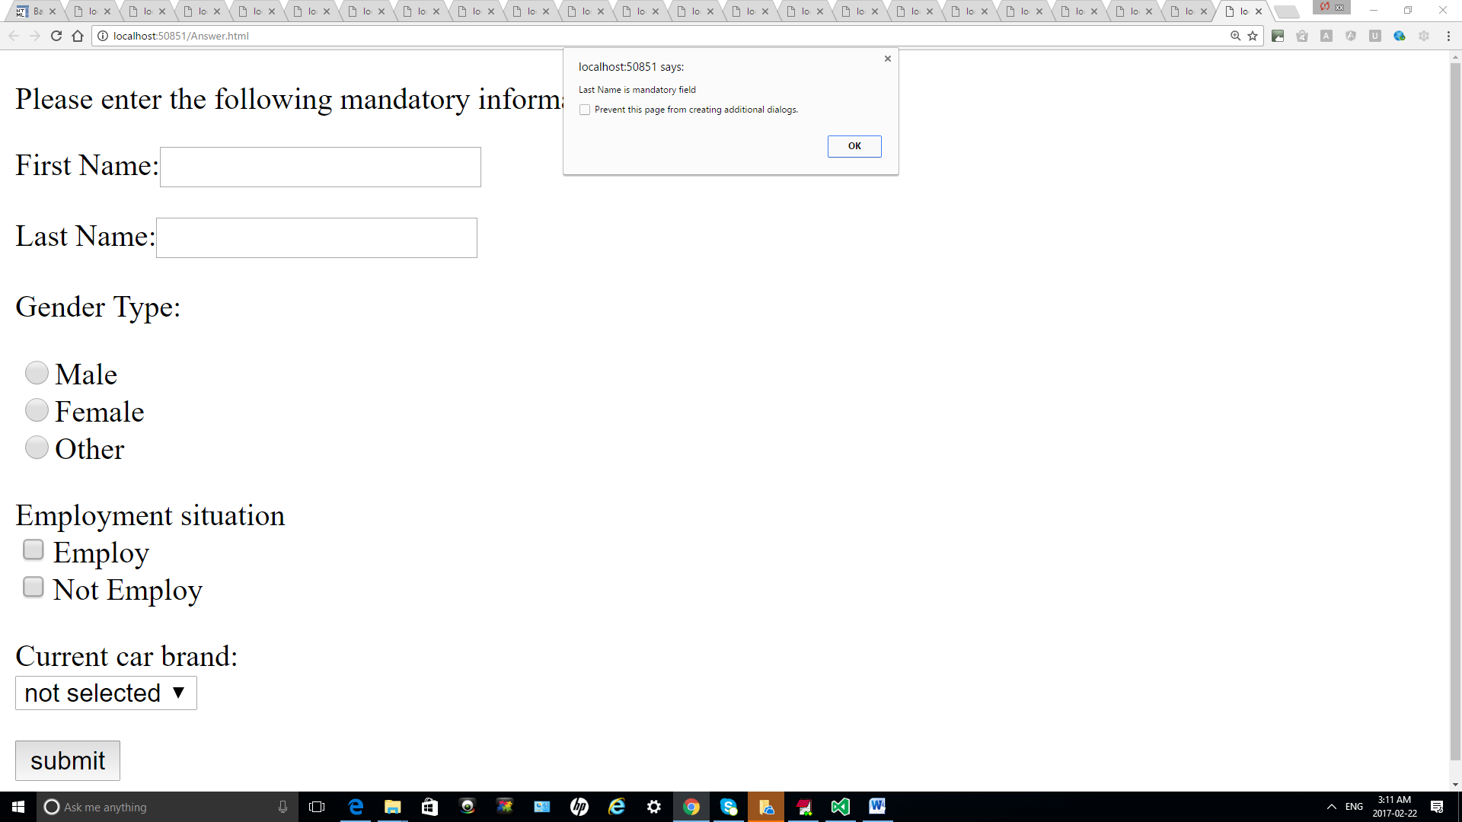

3.)

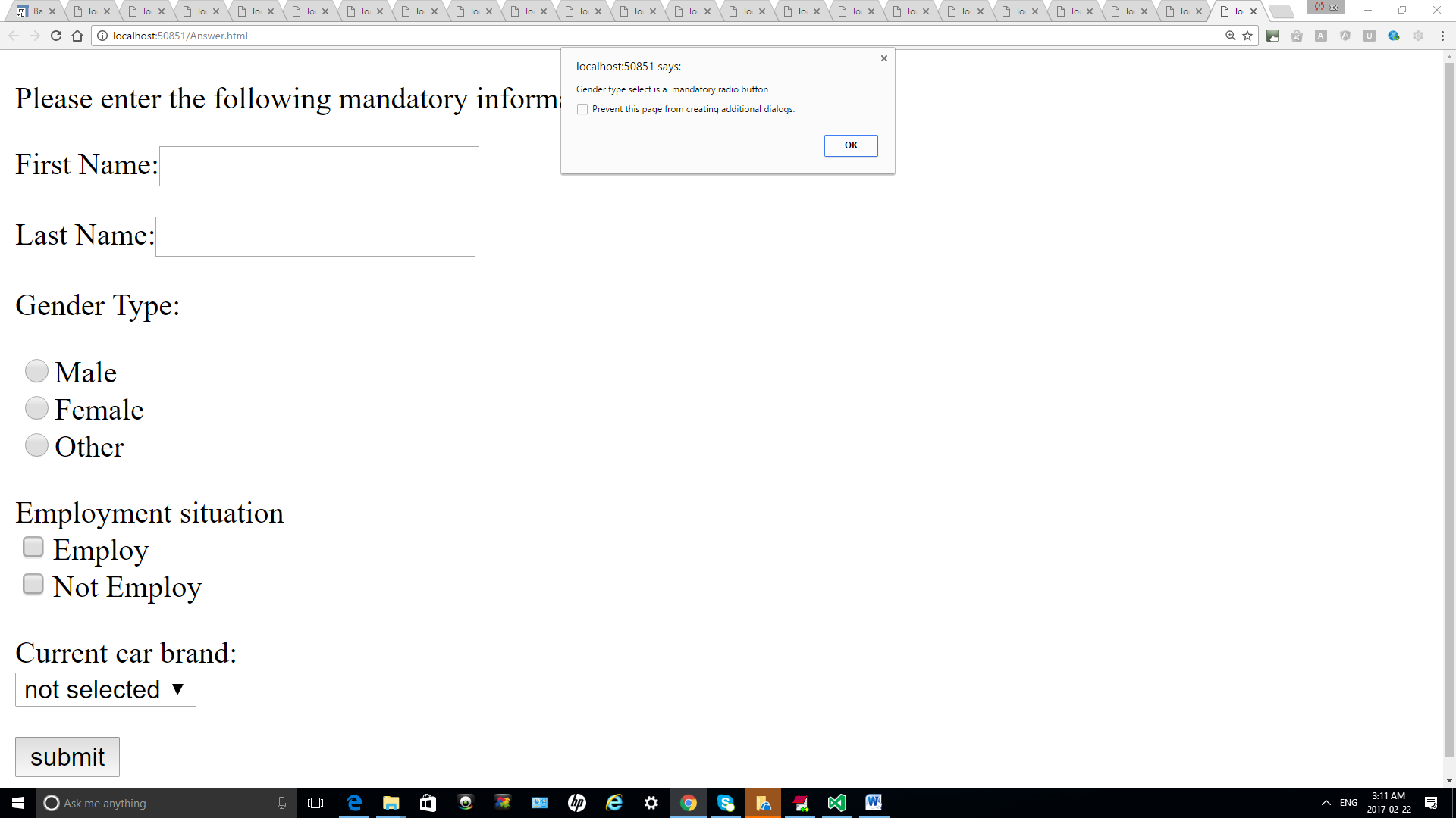

4.)

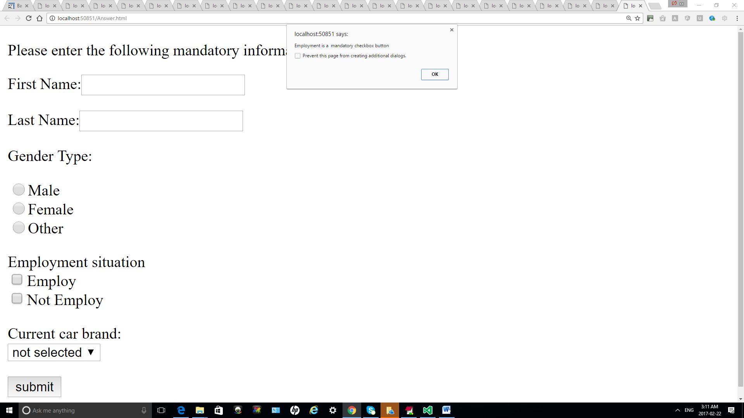

5.)

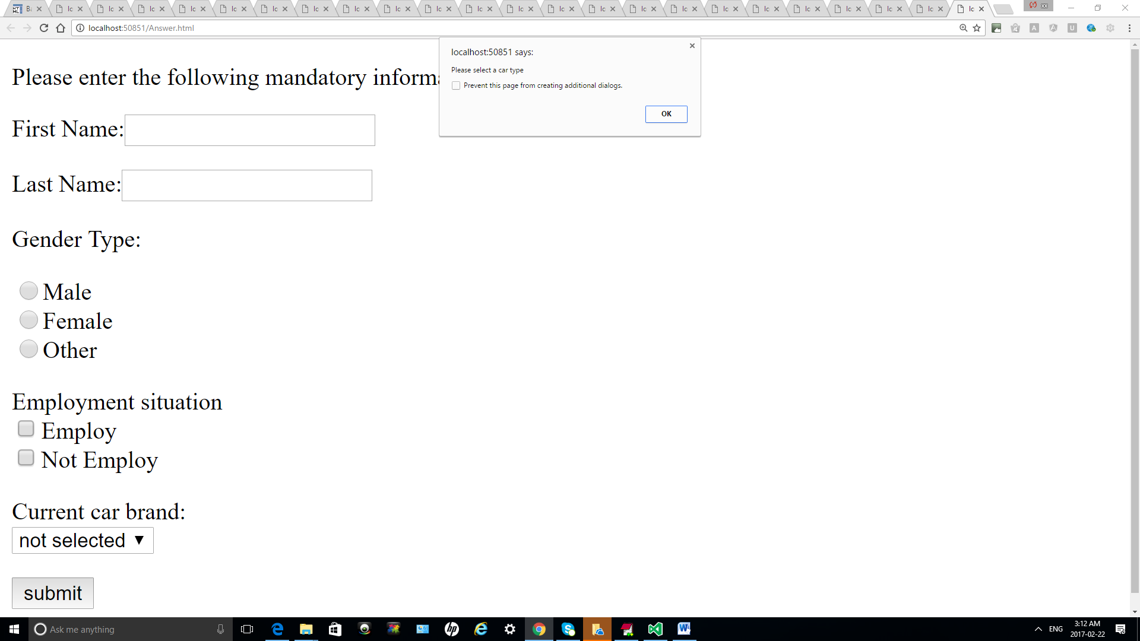

PART 2:

Write javascript validation code to ensure all the fields in question.html are answer.

Use Question-Part2.html

Examples:

