Congestion Control Using NBP

Introduction
- Organization Profile
- System Specification
    - Software specification
    - Hardware specification
    - Software description
- Problem Definition
    - Existing system
    - Proposed system
- Project Description
- Data flow diagram
- Entity Relationship Diagram
- Source code
- Sample screen layouts
- Testing
- Implementation
- Conclusion
- Biblography

1. Introduction

The Internet’s excellent scalability and robustness result in part from the end-to-end nature of Internet congestion control. End-to-end congestion control algorithms alone, however, are unable to prevent the congestion collapse and unfairness created by applications that are unresponsive to network congestion.

To address these maladies, we propose and investigate a novel congestion-avoidance mechanism called Congestion Free Router (CFR). CFR entails the exchange of feedback between routers at the borders of a network in order to detect and restrict unresponsive traffic flows before they enter the network, thereby preventing congestion within the network.

The Internet’s excellent scalability and robustness result in part from the end-to-end nature of Internet congestion control. End-to-end congestion control algorithms alone, however, are unable to prevent the congestion collapse and unfairness created by applications that are unresponsive to network congestion. To address these maladies, we propose and investigate a novel congestion-avoidance mechanism called Congestion Free Router (CFR).

CFR entails the exchange of feedback between routers at the borders of a network in order to detect and restrict unresponsive traffic flows before they enter the network, thereby preventing congestion within the network.

The fundamental philosophy behind the Internet is expressed by the scalability argument: no protocol, mechanism, or service should be introduced into the Internet if it does not scale well. A key corollary to the scalability argument is the end-to-end argument: to maintain scalability, algorithmic complexity should be pushed to the edges of the network whenever possible.

Perhaps the best example of the Internet philosophy is TCP congestion control, which is implemented primarily through algorithms operating at end systems. Unfortunately, TCP congestion control also illustrates some of the shortcomings of the end-to-end argument.

2. Organization Profile
Company Profile
In this world of increasing globalization, Stupros moves forward to meet the challenges of the future through the development of R & D projects in various domains. R & D project sector attracts the most prominent thinkers and practitioners in a range of fields that impinge on development. The global presence and reach attained by Stupros are not only substantiated by its presence, but also in terms of the training students in R & D project development.
Over the decade, Stupros, a Subsidiary of Spiro Technologies & consultant Pvt. Ltd provides a wide range of R & D project development training. Our uniqueness lies in the exclusive R & D project development. Accordingly, we created a setting that is enabling, dynamic and inspiring for the increase of solutions to global problems by R & D project development. Developing appropriate, responsible, innovative and practical solutions to students, by assisting in R & D project development. All our research is stranded in the need to provide an industry based training for students.

About team
Our team consists of more than 300 enthusiastic experts, drawn from a range of disciplines and experience, supported by infrastructure and facilities, which are world class and distinctively state-of-the-art. The strength of the organization lies in not only identifying and articulating intellectual challenges across a number of disciplines of knowledge but also in mounting research, training and demonstration projects leading to development of specific problem-based advanced technologies. The organization growth has been evolutionary, driven by a vision of the future and ingrained in challenges frightening today. The organization continues to grow in size, spread and intensity of work undertaken. Our experts are involved in a wide range of R & D project development training to student wishing to undertake professional development, or just wanting to learn about a new subject or area of study.
Technologies
We provide training in following domain for R & D project development:
Networking
Grid Computing
Data Mining
Image Processing,
Neural Network
Multimedia
Embedded systems
Power systems, Power electronics
Control systems, communication
Bio Informatics
Web Technologies
Grid Computing
About R & D
Research and development Training makes students to understand new concepts, understand the strength and far reaching potential of your conception. It helps student to understand and prepare for the future of your technology.
Vision
Our vision doesn't begin and end with the execution of R & D projects. The main intension is to provide world-class training to the students in R & D project development by sharing our knowledge and expertise to create value is our ultimate goal.

3. System Specification
3.1 Software Requirements Specifications
  - Java1.4 or More

  - Swings

  - Windows 98

3.2 Hardware Requirements Specifications
- Hard disk: 40 GB
- RAM: 128mb
- Processor: Pentium 4
- Monitor: 15” color monitor
- Floppy drive: 1.44 MB
- Mouse: HCL
- CD Drive: LG 52X
- Printer: Laser

  - Software Description

Windows : Windows 9 xs is the popularly used Operating System that handles many tasks like managing resource allocation, hence reducing the traffic density, utilizing the memory in an efficient manner
Java : Java was conceived by James Gosling, Patrick Naughton, Chris Wrath, Ed Frank, and Mike Sheridan at Sun Micro system. It is an platform independent programming language that extends it’s features wide over the network.Java2 version introduces an new component called “Swing” – is a set of classes that provides more powerful & flexible components than are possible with AWT.
- It’s a light weight package, as they are not implemented by platform-specific code.
-related classes are contained in javax.swing and its sub packages, such as javax.swing.tree.
-components explained in the Swing have more capabilities than those of AWT
The Java Language

What Is Java?
Java is two things: a programming language and a platform.

The Java Programming Language
Java is a high-level programming language that is all of the following:
Simple
- Object-oriented
- Distributed
- Interpreted
- Robust
- Secure
- Architecture-neutral
- Portable
- High-performance
- Multithreaded
- Dynamic

Java is also unusual in that each Java program is both compiled and interpreted. With a compiler, you translate a Java program into an intermediate language called Java byte codes--the platform-independent codes interpreted by the Java interpreter. With an interpreter, each Java byte code instruction is parsed and run on the computer. Compilation happens just once; interpretation occurs each time the program is executed. This figure illustrates how this works.
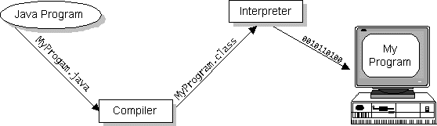

Java byte codes can be considered as the machine code instructions for the Java Virtual Machine (Java VM). Every Java interpreter, whether it's a Java development tool or a Web browser that can run Java applets, is an implementation of the Java VM. The Java VM can also be implemented in hardware.
Java byte codes help make "write once, run anywhere" possible. The Java program can be compiled into byte codes on any platform that has a Java compiler. The byte codes can then be run on any implementation of the Java VM. For example, the same Java program can run on Windows NT, Solaris, and Macintosh.

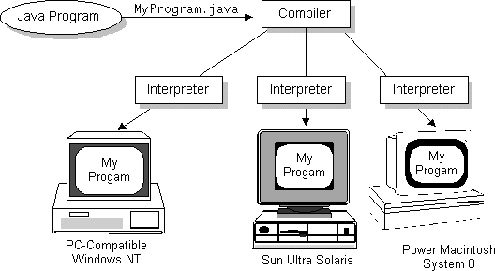

The Java Platform
A platform is the hardware or software environment in which a program runs. The Java platform differs from most other platforms in that it's a software-only platform that runs on top of other, hardware-based platforms. Most other platforms are described as a combination of hardware and operating system.
The Java platform has two components:
- The Java Virtual Machine (Java VM)
- The Java Application Programming Interface (Java API)
The Java API is a large collection of ready-made software components that provide many useful capabilities, such as graphical user interface (GUI) widgets. The Java API is grouped into libraries (packages) of related components.

The following figure depicts a Java program, such as an application or applet, that's running on the Java platform. As the figure shows, the Java API and Virtual Machine insulates the Java program from hardware dependencies.
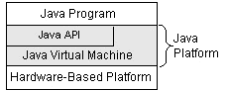

As a platform-independent environment, Java can be a bit slower than native code. However, smart compilers, well-tuned interpreters, and just-in-time byte code compilers can bring Java's performance close to that of native code without threatening portability.

What Can Java Do?
Probably the most well-known Java programs are Java applets. An applet is a Java program that adheres to certain conventions that allow it to run within a Java-enabled browser.
However, Java is not just for writing cute, entertaining applets for the World Wide Web ("Web"). Java is a general-purpose, high-level programming language and a powerful software platform. Using the generous Java API, we can write many types of programs.
The most common types of programs are probably applets and applications, where a Java application is a standalone program that runs directly on the Java platform.
How does the Java API support all of these kinds of programs? With packages of software components that provide a wide range of functionality. The core API is the API included in every full implementation of the Java platform. The core API gives you the following features:
- The Essentials: Objects, strings, threads, numbers, input and output, data structures, system properties, date and time, and so on.
- Applets: The set of conventions used by Java applets.
- Networking: URLs, TCP and UDP sockets, and IP addresses.
- Internationalization: Help for writing programs that can be localized for users worldwide. Programs can automatically adapt to specific locales and be displayed in the appropriate language.
- Security: Both low-level and high-level, including electronic signatures, public/private key management, access control, and certificates.
- Software components: Known as JavaBeans, can plug into existing component architectures such as Microsoft's OLE/COM/Active-X architecture, OpenDoc, and Netscape's Live Connect.
- Object serialization: Allows lightweight persistence and communication via Remote Method Invocation (RMI).
- Java Database Connectivity (JDBC): Provides uniform access to a wide range of relational databases.
Java not only has a core API, but also standard extensions. The standard extensions define APIs for 3D, servers, collaboration, telephony, speech, animation, and more.

How Will Java Change My Life?
Java is likely to make your programs better and requires less effort than other languages. We believe that Java will help you do the following:
- Get started quickly: Although Java is a powerful object-oriented language, it's easy to learn, especially for programmers already familiar with C or C++.
- Write less code: Comparisons of program metrics (class counts, method counts, and so on) suggest that a program written in Java can be four times smaller than the same program in C++.
- Write better code: The Java language encourages good coding practices, and its garbage collection helps you avoid memory leaks. Java's object orientation, its JavaBeans component architecture, and its wide-ranging, easily extendible API let you reuse other people's tested code and introduce fewer bugs.
- Develop programs faster: Your development time may be as much as twice as fast versus writing the same program in C++. Why? You write fewer lines of code with Java and Java is a simpler programming language than C++.
- Avoid platform dependencies with 100% Pure Java: You can keep your program portable by following the purity tips mentioned throughout this book and avoiding the use of libraries written in other languages.
- Write once, run anywhere: Because 100% Pure Java programs are compiled into machine-independent byte codes, they run consistently on any Java platform.
Distribute software more easily: You can upgrade applets easily from a central server. Applets take advantage of the Java feature of allowing new classes to be loaded "on the fly," without recompiling the entire program.
We explore the java.net package, which provides support for networking. Its creators have called Java “programming for the Internet.” These networking classes encapsulate the “socket” paradigm pioneered in the Berkeley Software Distribution (BSD) from the University of California at Berkeley.

1. NETWORKING BASICS

Ken Thompson and Dennis Ritchie developed UNIX in concert with the C language at Bell Telephone Laboratories, Murray Hill, New Jersey, in 1969. In 1978, Bill Joy was leading a project at Cal Berkeley to add many new features to UNIX, such as virtual memory and full-screen display capabilities. By early 1984, just as Bill was leaving to found Sun Microsystems, he shipped 4.2BSD, commonly known as Berkeley UNIX.

4.2BSD came with a fast file system, reliable signals, interprocess communication, and, most important, networking. The networking support first found in 4.2 eventually became the de facto standard for the Internet. Berkeley’s implementation of TCP/IP remains the primary standard for communications with the Internet. The socket paradigm for interprocess and network communication has also been widely adopted outside of Berkeley.

1.1 SOCKET OVERVIEW

A network socket is a lot like an electrical socket. Various plugs around the network have a standard way of delivering their payload. Anything that understands the standard protocol can “plug in” to the socket and communicate.

Internet protocol (IP) is a low-level routing protocol that breaks data into small packets and sends them to an address across a network, which does not guarantee to deliver said packets to the destination.

Transmission Control Protocol (TCP) is a higher-level protocol that manages to reliably transmit data. A third protocol, User Datagram Protocol (UDP), sits next to TCP and can be used directly to support fast, connectionless, unreliable transport of packets.

1.2 CLIENT/SERVER

A server is anything that has some resource that can be shared. There are compute servers, which provide computing power; print servers, which manage a collection of printers; disk servers, which provide networked disk space; and web servers, which store web pages. A client is simply any other entity that wants to gain access to a particular server.

In Berkeley sockets, the notion of a socket allows as single computer to serve many different clients at once, as well as serving many different types of information. This feat is managed by the introduction of a port, which is a numbered socket on a particular machine. A server process is said to “listen” to a port until a client connects to it. A server is allowed to accept multiple clients connected to the same port number, although each session is unique. To mange multiple client connections, a server process must be multithreaded or have some other means of multiplexing the simultaneous I/O.

1.3 RESERVED SOCKETS

Once connected, a higher-level protocol ensues, which is dependent on which port you are using. TCP/IP reserves the lower, 1,024 ports for specific protocols. Port number 21 is for FTP, 23 is for Telnet, 25 is for e-mail, 79 is for finger, 80 is for HTTP, 119 is for Netnews-and the list goes on. It is up to each protocol to determine how a client should interact with the port.

2. JAVA AND THE NET

Java supports TCP/IP both by extending the already established stream I/O interface. Java supports both the TCP and UDP protocol families. TCP is used for reliable stream-based I/O across the network. UDP supports a simpler, hence faster, point-to-point datagram-oriented model.

3. InetAddress CLASS

The InetAddress class is used to encapsulate both the numerical IP address and the domain name for that address. We interact with this class by using the name of an IP host, which is more convenient and understandable than its IP address. The InetAddress class hides the number inside. As of Java 2, version 1.4, InetAddress can handle both IPv4 and IPv6 addresses.

3.1 FACTORY METHODS

The InetAddress class has no visible constructors. To create an InetAddress object, we use one of the available factory methods. Factory methods are merely a convention whereby static methods in a class return an instance of that class. This is done in lieu of overloading a constructor with various parameter lists when having unique method names makes the results much clearer.

Three commonly used InetAddress factory methods are shown here.

static InetAddress getLocalHost( )
throws UnknownHostException

static InetAddress getByName(String hostName)
throws UnknowsHostException

static InetAddress[ ] getAllByName(String hostName)
throws UnknownHostException

The getLocalHost ( ) method simply returns the InetAddress object that represents the local host. The getByName ( ) method returns an InetAddress for a host name passed to it. If these methods are unable to resolve the host name, they throw an UnknownHostException.

On the internet, it is common for a single name to be used to represent several machines. In the world of web servers, this is one way to provide some degree of scaling. The getAllByName ( ) factory method returns an array of InetAddresses that represent all of the addresses that a particular name resolves to. It will also throw an UnknownHostException if it can’t resolve the name to at least one address. Java 2, version 1.4 also includes the factory method getByAddress( ), which takes an IP address and returns an InetAddress object. Either an IPv4 or an IPv6 address can be used.

3.2 INSTANCE METHODS

The InetAddress class also has several other methods, which can be used on the objects returned by the methods just discussed. Here are some of the most commonly used.

Boolean equals (Object other) Returns true if this object has the same Internet address as other.

Byte [ ] getAddress( ) Returns a byte array that represents the object’s Internet address in network byte order.

String getHostAddress( ) Returns a string that represents the host address associated with the InetAddress object.

String getHostName( ) Returns a string that represents the host name associated with the InetAddress object.

boolean isMulticastAddress( ) Returns true if this Internet address is a multicast address. Otherwise, it returns false.

String toString( ) Returns a string that lists the host name and the IP address for conveneince.

Internet addresses are looked up in a series of hierarchically cached servers. That means that your local computer might know a particular name-to-IP-address mapping autocratically, such as for itself and nearby servers. For other names, it may ask a local DNS server for IP address information. If that server doesn’t have a particular address, it can go to a remote site and ask for it. This can continue all the way up to the root server, called InterNIC (internic.net).

4. TCP/IP CLIENT SOCKETS

TCP/IP sockets are used to implement reliable, bidirectional, persistent, point-to-point, stream-based connections between hosts on the Internet. A socket can be used to connect Java’s I/O system to other programs that may reside either on the local machine or on any other machine on the Internet.
There are two kinds of TCP sockets in Java. One is for servers, and the other is for clients. The ServerSocket class is designed to be a “listener,” which waits for clients to connect before doing anything. The Socket class is designed to connect to server sockets and initiate protocol exchanges.

The creation of a Socket object implicitly establishes a connection between the client and server. There are no methods or constructors that explicitly expose the details of establishing that connection. Here are two constructors used to create client sockets:

Socket(String hostName, int port) Creates a socket connecting the local host to the named host and port; can throw an UnknownHostException or anIOException.

Socket(InetAddress ipAddress, int port) Creates a socket using a preexisting InetAddress object and a port; can throw an IOException.

A socket can be examined at any time for the address and port information associated with it, by use of the following methods:

InetAddress getInetAddress( ) Returns the InetAddress associated with the Socket object.

int getPort( ) Returns the remote port to which this Socket object is connected.

int getLocalPort( ) Returns the local port to which this Socket object is connected.

Once the Socket object has been created, it can also be examined to gain access to the input and output streams associated with it. Each of these methods can throw an IOException if the sockets have been invalidated by a loss of connection on the Net.

InputStream getInputStream( ) Returns the InputStream associated with the invoking socket.
OutputStream getOutputStream( ) Returns the OutputStream associated with the invoking socket.

5. TCP/IP SERVER SOCKETS

Java has a different socket class that must be used for creating server applications. The ServerSocket class is used to create servers that listen for either local or remote client programs to connect to them on published ports. ServerSockets are quite different form normal Sockets.

When we create a ServerSocket, it will register itself with the system as having an interest in client connections. The constructors for ServerSocket reflect the port number that we wish to accept connection on and, optionally, how long we want the queue for said port to be. The queue length tells the system how many client connection it can leave pending before it should simply refuse connections. The default is 50. The constructors might throw an IOException under adverse conditions. Here are the constructors:

ServerSocket(int port) Creates server socket on the specified port with a queue length of 50.

Serversocket(int port, int maxQueue) Creates a server socket on the specified port with a maximum queue length of maxQueue.

ServerSocket(int port, int maxQueue,
InetAddress localAddress) Creates a server socket on the specified port with a maximum queue length of maxQueue. On a multihomed host, localAddress specifies the IP address to which this socket binds.

ServerSocket has a method called accept( ), which is a blocking call that will wait for a client to initiate communications, and then return with a normal Socket that is then used for communication with the client.

6. URL

The Web is a loose collection of higher-level protocols and file formats, all unified in a web browser. One of the most important aspects of the Web is that Tim Berners-Lee devised a scaleable way to locate all of the resources of the Net. The Uniform Resource Locator (URL) is used to name anything and everything reliably.

The URL provides a reasonably intelligible form to uniquely identify or address information on the Internet. URLs are ubiquitous; every browser uses them to identify information on the Web. Within Java’s network class library, the URL class provides a simple, concise API to access information across the Internet using URLs.

6.1 FORMAT

Two examples of URLs are http;//www.osborne.com/ and http:// www.osborne.com:80/index.htm.

A URL specification is based on four components. The first is the protocol to use, separated from the rest of the locator by a colon (:). Common protocols are http, ftp, gopher, and file, although these days almost everything is being done via HTTP. The second component is the host name or IP address of the host to use; this is delimited on the left by double slashes (/ /) and on the right by a slash (/) or optionally a colon (:) and on the right by a slash (/). The fourth part is the actual file path. Most HTTP servers will append a file named index.html or index.htm to URLs that refer directly to a directory resource.

Java’s URL class has several constructors, and each can throw a
MalformedURLException. One commonly used form specifies the URL with a string that is identical to what is displayed in a browser:

URL(String urlSpecifier)

The next two forms of the constructor breaks up the URL into its component parts:

URL(String protocolName, String hostName, int port, String path)
URL(String protocolName, String hostName, String path)

Another frequently used constructor uses an existing URL as a reference context and then create a new URL from that context.

URL(URL urlObj, String urlSpecifier)

The following method returns a URLConnection object associated with the invoking URL object. it may throw an IOException.

URLConnection openConnection( )
It returns a URLConnection object associated with the invoking URL object. it may throw an IOException.

7. URLConnection

URLConnection is a general-purpose class for accessing the attributes of a remote resource. Once a connection to a remote server is made,we can use URLConnection to inspect the properties of the remote object before actually transporting it locally. These attributes are exposed by the HTTP protocol specification and, as such, only make sense for URL objects that are using the HTTP protocol.

4. Problem Definition
- Existing system
As a result of its strict adherence to end-to-end congestion control, the current Internet suffers from two maladies:
Congestion collapse from undelivered packets, and unfair allocations of bandwidth between competing traffic flows.

The first malady — congestion collapse from undelivered packets — arises when packets that are dropped before reaching their ultimate continually consume bandwidth
destinations.
The second malady—unfair bandwidth allocation to competing network flows—arises in the Internet for a variety of reasons, one of which is the existence of applications that do not respond properly to congestion. Adaptive applications (e.g., TCP-based applications) that respond to congestion by rapidly reducing their transmission rates are likely to receive unfairly small bandwidth allocations when competing with unresponsive applications. The Internet protocols themselves can also introduce unfairness. The TCP algorithm, for instance, inherently causes each TCP flow to receive a bandwidth that is inversely proportional to its round-trip time [6]. Hence, TCP connections with short round-trip times may receive unfairly large allocations of network bandwidth when compared to connections with longer round-trip times.

The impact of emerging streaming media traffic on traditional data traffic is of growing concern in the Internet community. Streaming media traffic is unresponsive to the congestion in a network, and it can aggravate congestion collapse and unfair bandwidth allocation.

- Proposed system

To address the maladies of congestion collapse we introduce and investigate a novel Internet traffic control protocol called Congestion Free Router (CFR). The basic principle of CFR is to compare, at the borders of a network, the rates at which packets from each application flow are entering and leaving the network. If a flow’s packets are entering the network faster than they are leaving it, then the network is likely buffering or, worse yet, discarding the flow’s packets. In other words, the network is receiving more packets than it is capable of handling. CFR prevents this scenario by “patrolling” the network’s borders, ensuring that each flow’s packets do not enter the network at a rate greater than they are able to leave the network. This patrolling prevents congestion collapse from undelivered packets, because unresponsive flow’s otherwise undeliverable
packets never enter the network in the first place.
Although CFR is capable of preventing congestion collapse and improving the fairness of bandwidth allocations, these improvements do not come for free. CFR solves these problems at the expense of some additional network complexity, since routers at the border of the network are expected to monitor and control the rates of individual flows in CFR. CFR also introduces added communication overhead, since in order for an edge outer to know the rate at which its packets are leaving the network, it must exchange feedback with other edge routers. Unlike some existing approaches trying to solve congestion collapse, however, CFR’s added complexity is isolated to edge routers; routers within the core of the network do not participate in the prevention of congestion collapse. Moreover, end systems operate in total ignorance of the fact that CFR is implemented in the network, so no changes to transport protocols are necessary at end systems.

5. Project Description
PROJECT MODULES

The various modules in the protocol are as follows:

Module 1: -

SOURCE MODULE.
Module 2: -
INROUTER ROUTER MODULE.
Module 3: -
ROUTER MODULE.
Module 4: -
OUTROUTER ROUTER MODULE.
Module 5: -
DESTINATION MODULE.

SOURCE MODULE:-
The task of this Module is to send the packet to the InRouter router.

INROUTER ROUTER MODULE:-
An edge router operating on a flow passing into a network is called an InRouter router. CFR prevents congestion collapse through a combination of per-flow rate monitoring at OutRouter routers and per-flow rate control at InRouter routers. Rate control allows an InRouter router to police the rate at which each flow’s packets enter the network. InRouter Router contains a flow classifier, per-flow traffic shapers (e.g., leaky buckets), a feedback controller, and a rate controller

ROUTER MODULE:-
The task of this Module is to accept the packet from the InRouter router and send it to the OutRouter router.

OUTROUTER ROUTER MODULE:-
An edge router operating on a flow passing out of a network is called an OutRouter router. CFR prevents congestion collapse through a combination of per-flow rate monitoring at OutRouter routers and per-flow rate control at InRouter routers. Rate monitoring allows an OutRouter router to determine how rapidly each flow’s packets are leaving the network. Rate monitored using a rate estimation algorithm such as the Time Sliding Window (TSW) algorithm. OutRouter Router contains a flow classifier, Rate monitor, and a feedback controller.

DESTINATION MODULE:-
The task of this Module is to accept the packet from the OutRouter router and stored in a file in the Destination machine.

Process Description:

Source module

- Sending data in the form of packet

        - Input data entities: Message to be transmitted from the source to the destination node in the form of packet with IP address for its identification.
        - Algorithm : not applicable
        - Output : formatted packet with the required information for communicating between the source & the destination node.

InRouter Module
Using rate control and leak bucket algorithm to rank the nodes in the network
    - Input data entities :which determine the rate of the packets
    - Algorithm : Leaky bucket
    - Output : All the nodes in the network assigned with a unique rank.

Router Module

- Input entities: receives data neighboring nodes
And transfer into another neighboring nodes.

- Algorithm: not applicable.

- Output :transfer packets to neighboring nodes

Out Module

- Using time sliding window and rate monitoring algorithm to rank the nodes in the network

  - Input data entities: which determine the rate of the
Packets flow in the network.

- Algorithm : time sliding window and rate monitoring

- Output : packets are sending to destination.

Destination:

Packets are received from the Neighboring nodes

Input data entities: message to be Received from the
Out router to the Destination node in
the form of packets with IP address.

Algorithm: not applicable

Output: formatted packets with the requirement
Information for communication between
Source and destination nodes.

PARAMETERS
Source Module:

Input Parameters:
- Source Machine Name is retrieved from the OS.
- User types destination Machine Name.
- Message is typed by User.

Output Parameters:
- Data Packets.

InRouter Module:

Input Parameters:
- Data Packets from Source Machine.
- Backward feedback from the Router.

Output Parameters:
- Data Packets.
- Forward feedback.

Router Module:
Input Parameters:
- Data Packets from InRouter Machine.
- Forward feedback from the Router or InRouter Router.
- Backward feedback from the Router or OutRouter Router.
- Hop count.
Output Parameters:
- Data Packets.
- Forward feedback.
- Incremented Hop count.
- Backward feedback.

OutRouter Module:

Input Parameters:
- Data Packets from Router.
- Forward feedback from the Router.

Output Parameters:
- Data Packets.
- Backward feedback.

Destination Module:
Message received from the OutRouter router will be stored in the corresponding folder as a text file depends upon the Source Machine Name.

6. Data flow diagram

A data flow oriented method is to provide a systematic approach for the description of the program structure. The representation of information flow is one element of requirement analysis. Information may be represented as a continuous flow that undergoes a series of transforms as it evolves from input to output. The Data Flow Diagram (DFD) is used as a graphical tool to depict information flow. Data Flow oriented design defines a number of different mappings that transforms information flow into program structure. The DFD is designed to aid communication.

Forward Forward

Feedback Feedback
Source
Source
Source
Destination

InRouter
Router

Router

OutRouter
Router

Destination
Destination
Backward
Feedback
Backward
Feedback

7. Entity Relationship Diagram

8.Source code
Source Module

import java.net.*;
import java.io.*;
import java.awt.*;
import java.awt.event.*;
import javax.swing.*;
import javax.swing.event.*;

class SouFrame implements ActionListener
{
static JButton jb1;
static JButton jb2;
static JLabel jl1,jl2;
static JTextField jtf;
static JTextArea jtf1;
static JScrollPane jsp;
static JFrame jf;
String dest_addr=" ";
String Msg=" ";
String conc=" ";
String fin=" ";
int st=0;
int end=48;
int len1=0;
Socket soc;
int split=0;
InetAddress in1=InetAddress.getLocalHost();

SouFrame() throws IOException
{
CreateFrame();
}

public void CreateFrame()
{
jf=new JFrame("Source");
Container cp=jf.getContentPane();
jl1=new JLabel("Destination Machine Name :");
jtf=new JTextField();
cp.setBackground(Color.pink);
jl2=new JLabel("Type the Message :");
jtf1=new JTextArea(10,10);
jb1=new JButton("SEND");
jb2=new JButton("CLEAR");
jsp=new JScrollPane(jtf1);
cp.setLayout(null);
cp.add(jl1);
cp.add(jtf);
cp.add(jl2);
cp.add(jsp);
cp.add(jb1);
jl1.setForeground(Color.blue);
jl2.setForeground(Color.blue);
jb1.setBorder(BorderFactory.createEtchedBorder(Color.yellow,Color.red));
jtf.setBorder(BorderFactory.createEtchedBorder(Color.black,Color.black));
jsp.setBorder(BorderFactory.createEtchedBorder(Color.black,Color.black));
jb1.addActionListener(this);
cp.add(jb2);
jb2.setBorder(BorderFactory.createEtchedBorder(Color.yellow,Color.red));
jb2.addActionListener(this);
jl1.setBounds(5,50,195,25);
jtf.setBounds(165,50,200,25);
jl2.setBounds(5,100,195,25);
jsp.setBounds(165,100,200,200);
jb1.setBounds(150,325,75,25);
jb2.setBounds(250,325,75,25);
jf.setVisible(true);
jf.setBounds(100,100,400,400);
jf.validate();
jf.setDefaultCloseOperation(JFrame.EXIT_ON_CLOSE);
}

public void actionPerformed(ActionEvent e)
{
if(e.getSource()==jb1)
{
try
{
SendPacket();
}
catch(IOException e1)
{
JOptionPane.showMessageDialog((Component) null,"InRouter Machine is Not Ready To Data Transfer","Click OK",JOptionPane.ERROR_MESSAGE);
}
}
else
{
jtf.setText("");
jtf1.setText("");
}
}

public void SendPacket() throws IOException
{
try
{
dest_addr=jtf.getText();
Msg=jtf1.getText();
if(((dest_addr.trim()).length())>0)
{
if(((Msg.trim()).length())>0)
{
System.out.println("**********************"+jtf.getText()+"****************");
soc=new Socket("192.168.0.6",7788);
OutputStream out = soc.getOutputStream();
st=0;
end=48;
conc=dest_addr+"`"+in1.getHostName()+"`";
byte buffer[]=Msg.getBytes();
int len=buffer.length;
len1=len;
if(len<=48)
{
fin=conc+Msg+"\n"+"null";
byte buffer1[]=fin.getBytes();
out.write(buffer1);
}
else
{
fin=conc+Msg.substring(st,end)+"\n";
byte buffer2[]=fin.getBytes();
out.write(buffer2);
Thread.sleep(1000);
while(len1>48)
{
len1-=48;
if(len1<=48)
{
fin=conc+Msg.substring(end,len)+"\n"+"null";
byte buffer3[]=fin.getBytes();
out.write(buffer3);
Thread.sleep(1000);
}
else
{
split=end+48;
fin=conc+Msg.substring(end,split)+"\n";
end=split;
byte buffer5[]=fin.getBytes();
out.write(buffer5);
Thread.sleep(1000);
}
}
}
}
else
{
JOptionPane.showMessageDialog((Component) null,"There Is No Message To Send","Click OK",JOptionPane.INFORMATION_MESSAGE);
}
}
else
{
JOptionPane.showMessageDialog((Component) null,"Destination Machine Name is Missing","Click OK",JOptionPane.INFORMATION_MESSAGE);
}
}
catch(UnknownHostException e)
{
JOptionPane.showMessageDialog((Component) null,"Check the InRouter Machine Name","Click OK",JOptionPane.INFORMATION_MESSAGE);
}
catch(InterruptedException e1)
{
}
}
}

class CFRSource
{
public static void main(String args[])throws IOException
{
SouFrame sf=new SouFrame();
}
}

InRouter Module

import javax.swing.*;
import java.net.*;
import java.io.*;
import java.awt.*;
import java.util.Vector;
import javax.swing.UIManager;

class In_Frame //implements Runnable
{
JFrame Ing_fra;
Container cp1;
int tot;
static JTextArea Ing_data=new JTextArea();
JTextField InTxt;
static JTextField OutTxt=new JTextField();
JLabel InPac,OutPac;
String instring="";
static int length=0;
static int length1=0;
static String s="";
static String s1="";
static int I=0;
String fin="";
static String dest="";
static String sou="";
boolean sta=true;
static int inp=0,outp=0;
JScrollPane jsp;
BufferedReader in1;
OutputStream out;
int readcnt=0;
static String text;
String egg="";
static String text1;
static Vector msg=new Vector();
static Vector len=new Vector();
static Vector des=new Vector();
static Vector sour=new Vector();
char chstr[]=new char[512];
long l;
Send sen=new Send(this);
String inf="com.sun.java.swing.plaf.windows.WindowsLookAndFeel";

In_Frame()
{
}

public void dis_ing_fra()
{
Ing_fra=new JFrame("In Router");
cp1=Ing_fra.getContentPane();
cp1.setLayout(null);
InPac=new JLabel("INCOMING PACKETS :");
OutPac=new JLabel("OUTGOING PACKETS :");
InTxt=new JTextField();
InTxt.setText("0");
OutTxt.setText("0");
InPac.setForeground(Color.blue);
OutPac.setForeground(Color.blue);
Ing_data.setEditable(false);
InTxt.setEditable(false);
OutTxt.setEditable(false);
Ing_data.setBorder(BorderFactory.createEtchedBorder(Color.black,Color.black));
InTxt.setBorder(BorderFactory.createEtchedBorder(Color.black,Color.black));
OutTxt.setBorder(BorderFactory.createEtchedBorder(Color.black,Color.black));
jsp=new JScrollPane(Ing_data);
cp1.add(jsp);
cp1.add(InPac);
cp1.add(InTxt);
cp1.add(OutPac);
cp1.add(OutTxt);
jsp.setBounds(5,5,470,400);
InPac.setBounds(5,425,130,25);
InTxt.setBounds(125,425,75,25);
OutPac.setBounds(250,425,150,25);
OutTxt.setBounds(375,425,75,25);
Ing_fra.setBounds(5,5,500,500);
Ing_fra.setDefaultCloseOperation(JFrame.EXIT_ON_CLOSE);
try
{
UIManager.setLookAndFeel(inf);
SwingUtilities.updateComponentTreeUI(Ing_fra);
}
catch(Exception e)
{
e.printStackTrace();
}
Ing_fra.setVisible(true);
}

public void dis_ing_data()
{
try
{
ServerSocket ss=new ServerSocket(7788);
while(true)
{
System.out.println("waiting");
Socket soc=ss.accept();
System.out.println("Connected");
sta=true;
while(sta)
{
in1= new BufferedReader(new InputStreamReader(soc.getInputStream())); out=soc.getOutputStream();
display();
}
}
}
catch(IOException e)
{
e.printStackTrace();
}
}

public void add()
{
text+="Source :"+sou+"\nMessage :"+s.trim()+"\nDestination :"+dest+"\n";
Ing_data.setText(text);
}

public void incoming(int in)
{
InTxt.setText(in+"");
}

public void outgoing(int out)
{
OutTxt.setText(out+"");
}
public void display()
{
try
{
while(true)
{
readcnt=in1.read(chstr);
if(readcnt <=0)
{
continue;
}
else
{
break;
}
}
instring =new String(chstr, 0, readcnt);
msg.add(instring);
I++;
if(!instring.endsWith("null"))
{
length=instring.length();
length1=0;
len.add(length+"");

for(int l=0;l<length;l++)
{
if((instring.charAt(l))=='`')
{
dest=instring.substring(0,l);
des.add(dest);
s1=instring.substring(l+1,length);
l=length+1;
length1=s1.length();
}
}
for(int l=0;l<length1;l++)
{
if((s1.charAt(l))=='`')
{
sou=s1.substring(0,l);
sour.add(sou);
s=s1.substring(l+1,length1);
l=length1+1;
}
}
add();
inp++;
incoming(inp);
}
else
{
sta=false;
length=instring.length()-4;
length1=0;
len.add(length+"");
for(int l=0;l<length;l++)
{
if((instring.charAt(l))=='`')
{
dest=instring.substring(0,l);
des.add(dest);
s1=instring.substring(l+1,length);
l=length+1;
length1=s1.length();
}
}
for(int l=0;l<length1;l++)
{
if((s1.charAt(l))=='`')
{
sou=s1.substring(0,l);
sour.add(sou);
s=s1.substring(l+1,length1);
l=length1+1;
}

}
add();
inp++;
incoming(inp);
}
}
catch(IOException e)
{
e.printStackTrace();
}
}
}

class A extends Thread
{
In_Frame i;
A(In_Frame obj1)
{
i=obj1;
java.util.Timer t=new java.util.Timer();
if((i.msg.size())>0)
{
t.schedule(i.sen,10000);
}
else
{
t.schedule(i.sen,10000,30000);
}
try
{
Thread.sleep(1000);
}
catch(InterruptedException e)
{
e.printStackTrace();
}
}
}

class B extends Thread
{
In_Frame i1;
B(In_Frame obj1)
{
i1=obj1;
try
{
Leaky l=new Leaky(i1);
java.util.Timer t1=new java.util.Timer();
t1.schedule(l,10000,1000);
}
catch(Exception e){}
}
}

class InRouter
{
public static void main(String args[])
{
try
{
In_Frame obj=new In_Frame();
obj.dis_ing_fra();
//Fin f=new Fin();
A a=new A(obj);
Back b=new Back(obj);
RateControl rc=new RateControl(obj);
obj.dis_ing_data();
}
catch(Exception e){}
}
}

9.Sample screen layouts

Source
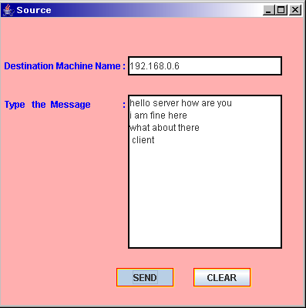

InRouter
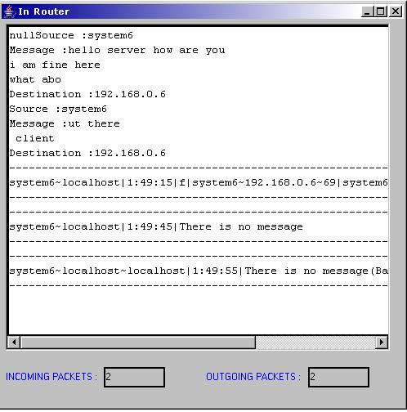

Router

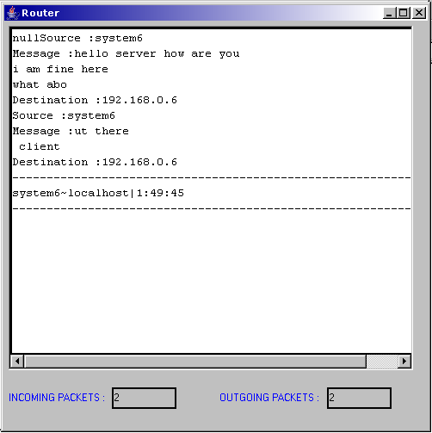

OutRouter

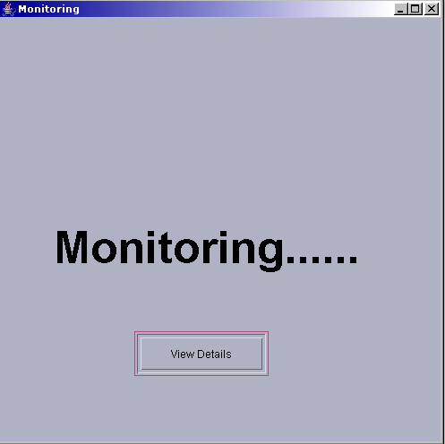

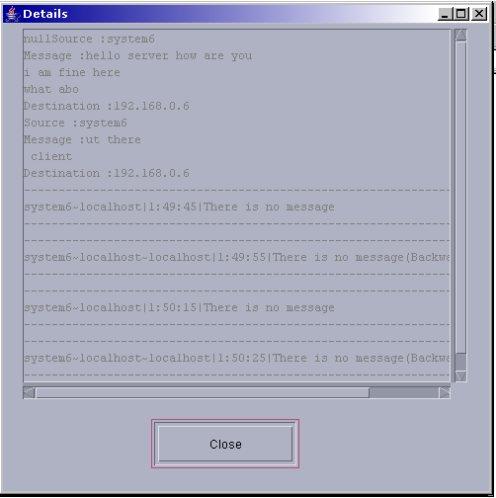

Destination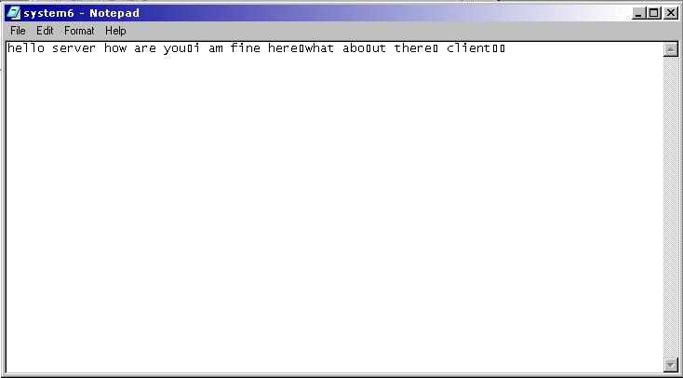

10.Testing

UNIT TESTING:
Software testing is critical element of software quality assurance and represents ultimate review of specification, design and coding. Test case design focuses on a set of technique for the creation of test cases that meet overall testing objectives. Planning and testing of a programming system involve formulating a set of test cases, which are similar to the real data that the system is intended to manipulate. Test castes consist of input specifications, a description of the system functions exercised by the input and a statement of the extended output. Through testing involves producing cases to ensure that the program responds, as expected, to both valid and invalid inputs, that the program perform to specification and that it does not corrupt other programs or data in the system.
In principle, testing of a program must be extensive. Every statement in the program should be exercised and every possible path combination through the program should be executed at least once. Thus, it is necessary to select a subset of the possible test cases and conjecture that this subset will adequately test the program.
INTEGRATION TESTING:
It involves the testing of the order in which the different modules are combined to produce the functioning whole. Integration testing generally throws light on the order of arrangement of units, modules, systems, subsystems and the entire product.
The proposed system, “ the client server architecture “ inherits a bottom-up integration strategy in which all the subsystem and the modules involved in it are independently tested and integrated to from the entire system, which is then tested as a whole.
For the testing of this system it was required that the software be tested for performing its basic functions that are as follows: -
Start the server first and then client, then there is no error.Start the server and client, and then stop the server and a send a message from client. The error is no server connection.Start client first, then the error is client is not connected to the server.

VALIDATION TESTING:
Validation testing is used to validate the correct user name and password and card number and pin number and if person gives the invalid username and password, at that time the card validation does not execute.

PERFORMANCE TESTING:
Performance testing determines the amount of execution thime spent in various parts of the unit, program throughput, response time and device utilization by the program unit.

11.Implementation

Related work

The maladies of congestion collapse from undelivered packets and of unfair bandwidth allocations have not gone unrecognized. Some have argued that there are social incentives for multimedia applications to be friendly to the network, since an application would not want to be held responsible for throughput degradation in the Internet. Nevertheless, unresponsive UDP flows are becoming disturbingly frequent in the Internet, and they are an example that the Internet cannot rely solely on social incentives to control congestion or to operate fairly.

Some have argued that congestion collapse and unfairness can be mitigated through the use of improved packet scheduling or queue management mechanisms in network routers. For instance, per-flow packet scheduling mechanisms such as WFQ attempt to offer fair allocations of bandwidth to flows contending for the same link.

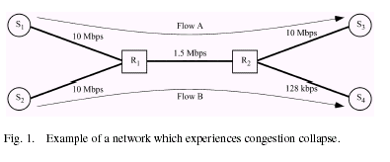

For illustration, consider the example shown in Fig. 1. In this example, two unresponsive flows (flow A and flow B) compete for bandwidth in a network containing two bottleneck links (- and -) arbitrated by a fair queuing mechanism at routers and, at the first bottleneck link (-), fair queuing at router ensures that each flow receives half of the link’s available bandwidth (750 kb/s). On the second bottleneck link (-), much of the traffic from flow B is discarded due to the link’s limited capacity (128 kb/s). Hence, flow-A achieves a throughput of 750 kb/s, and flow B achieves a throughput of 128 kb/s.

Clearly, congestion collapse has occurred, because flow B’s packets, which are ultimately discarded on the second bottleneck link (-), limit the throughput of flow A across the first bottleneck link (-). An allocation of bandwidth is said to be globally max-min fair if, at every link, all active flows not bottlenecked at another link are allocated a maximum, equal share of the link’s remaining bandwidth [22]. A globally max-min fair allocation of bandwidth for the example shown in Fig. 1 would have been 1.372 Mb/s for flow A and 128 kb/s for flow B.

DETAILS OF THE PROJECT

CFR is a network layer congestion-avoidance protocol that is aligned with the core-stateless approach. The core-stateless approach, which has recently received a great deal of research attention [18], [24], allows routers on the borders (or edges) of a network to perform flow classification and maintain per-flow state but does not allow routers at the core of the network to do so. Fig. 2 illustrates this architecture. As in other work on core-stateless approaches, we draw a further distinction between two types of edge routers. Depending on which flow it is operating on, an edge router may be viewed as an InRouter or an OutRouter router. An edge router operating on a flow passing into a

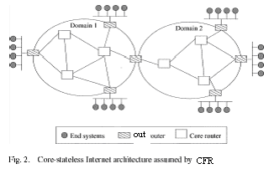
network is called an InRouter router, whereas an edge router operating on a flow passing out of a network is called an OutRouter router. Note that a flow may pass through more than one OutRouter (or InRouter) router if the end-to-end path crosses multiple networks.

CFR prevents congestion collapse through a combination of per-flow rate monitoring at OutRouter routers and per-flow rate control at InRouter routers. Rate monitoring allows an OutRouter router to determine how rapidly each flow’s packets are leaving the network, whereas rate control allows an InRouter router to police the rate at which each flow’s packets enter the network. Linking these two functions together are the feedback packets exchanged between InRouter and OutRouter routers; InRouter routers send OutRouter routers forward feedback packets to inform them about the flows that are being rate controlled, and OutRouter routers send InRouter routers backward feedback packets to inform them about the rates at which each flow’s packets are leaving the network. By matching the InRouter rate and OutRouter rate of each flow, CFR prevents congestion collapse within the network.

FLOWCHART ANALYSIS:

Leaky Bucket Algorithm
Rate Control Algorithm
Time Sliding Window Algorithm

Leaky Bucket Algoritham
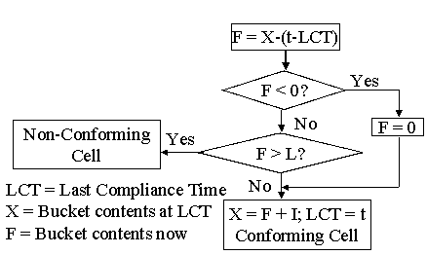

Rate control algorithm
If
CurrentRTT<e.baseRTT
On arrival of backward feedback packet p from OutRouter router e
Current RTT =Current Time -p.times tamp
Delta RTT=-Current RTT-
e.base RTT

e.base RTT=Current RTT

RTTs Elapsed= (Current Time-e.last FeedbackTime)/CurrentRTT
e.last FeedbackTime=Current Time

For each flow f listed in p
Rate Quantum=min (MSS/currentRTT, f.egreesRate/QF)
A
B
True
False

f.phase=
CONGESTION_
AVOIDANCE
If (deltaRTT*f.InRouterRate<MSS*e.hopcount)
f.InRouter Rate=f.InRouterRate*2^RTTsElapsed
If f.phase
= = CONGESTION_
AVOIDANCE

If (deltaRTT*f.InRouterRate<MSS*e.hopcount)
f.InRouterRate=f.InRouter Rate + rate Quantum*RTTsElapsed
f. InRouter Rate=
f.OutRouterRate-rateQuantum

NEXT
True
True
False
True
False
If f.phase
= = SLOW_START
B
A

Time sliding window algorithm
Arrival of the Forward
Feedback at the OutRouter Router

Start the timer
If Packets are arrived
Wait until the packet is forward

Current Packet is send
Wait until the Packet is arrived
Yes
No
Acknowledgement is backward to InRouter
If Packets are forwarded
Yes
No
If no Packet to Forwarded
Stop the timer
Yes
Forward the next packet
No

Working Aspects of the CFR

Mechanism:

- The architectural components, namely, the modified edge routers, which must be present in the network
- The feedback control algorithm, which determines how and when information is exchanged between edge route
- The rate control algorithm, which uses the information carried in feedback packets to regulate flow transmission rates and thereby prevent congestion collapse in the network.

A. Architectural Components
The only components of the network that require modification by CFR are edge routers; the input ports of OutRouter routers must be modified to perform per-flow monitoring of bit rates, and the output ports of InRouter routers must be modified to perform per-flow rate control. In addition, both the InRouter and the OutRouter routers must be modified to exchange and handle CFR feedback packets.

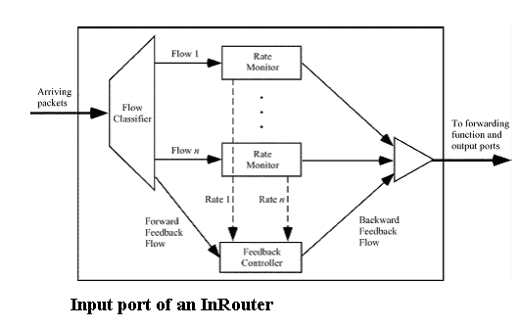

The input ports of OutRouter routers are enhanced in CFR. Fig. 3 illustrates the architecture of an OutRouter router’s input port. Data packets sent by InRouter routers arrive at the input port of the OutRouter router and are first classified by flow. Flow classification is performed by InRouter routers on every arriving packet based upon a flow classification policy.
An example flow classification policy is to examine the packet’s source and destination network addresses, and to aggregate all packets arriving on an InRouter router and destined to the same OutRouter router into the same CFR flow (i.e., a macro-flow). Other flow classification policies can be used, for instance, in the case of IPv6, flows may be classified by examining the packet header’s flow label, whereas in the case of IPv4, it could be done by examining the packet’s source and destination addresses and port numbers.
After classifying packets into flows, each flow’s bit rate is then rate monitored using a rate estimation algorithm such as the Time Sliding Window (TSW) algorithm. These rates are collected by a feedback controller, which returns them in backward feedback packets to an InRouter router whenever a forward feedback packet arrives from that InRouter router.

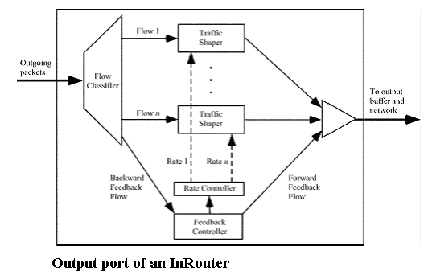

The output ports of InRouter routers are also enhanced in CFR. Each output port contains a flow classifier, per-flow traffic shapers (e.g., leaky buckets), a feedback controller, and a rate controller (see Fig. 4). The flow classifier classifies packets into flows, and the traffic shapers limit the rates at which packets from individual flows enter the network. The feedback controller receives backward feedback packets returning from OutRouter routers and passes their contents to the rate controller. It also generates forward feedback packets that are transmitted to the network’s OutRouter routers. To prevent congestion collapse, the rate controller adjusts traffic shaper parameters according to a TCP-like rate-control algorithm, and the rate-control algorithm used in CFR is described later in this section.

B. Feedback Control Algorithm
The feedback control algorithm in CFR determines how and when feedback packets are exchanged between edge routers. Feedback packets take the form of ICMP packets and are necessary in CFR for three reasons. First, forward feedback packets allow OutRouter routers to discover which InRouter routers are acting as sources for each of the flows they are monitoring. Second, backward feedback packets allow OutRouter routers to communicate per-flow bit rates to InRouter routers. Third, forward and backward feedback packets allow InRouter routers to detect incipient network congestion by monitoring edge-to-edge round-trip times.

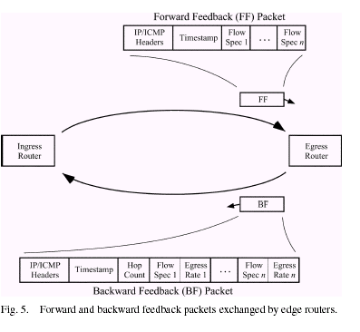

The contents of feedback packets are shown in Fig. 5.

Contained within the forward feedback packet generated at an InRouter router are a time stamp and a list of flow specifications for flows originating at the InRouter router. The time stamp field is used to calculate the round-trip time between two edge routers, and the list of flow specifications indicates to an OutRouter router the identities of active flows originating at the InRouter router.

A flow specification is a value uniquely identifying a flow, assigned by the InRouter router flow classifier. InRouter router adds a flow to its list of active flows whenever a packet from a new flow arrives; it removes a flow when the flow
becomes inactive. In the event that the network’s maximum transmission unit size is not sufficient to hold an entire list of flow specifications, multiple forward feedback packets are used.

When an OutRouter router receives a forward feedback packet, it immediately generates a backward feedback packet and returns it to the InRouter router. Contained within the backward feedback packet are the forward feedback packet’s original time stamp, a hop count, and a list of observed bit rates, called OutRouter rates, collected by the OutRouter router for each flow listed in the forward feedback packet.

The hop count, which is used by the InRouter router’s rate-control algorithm, indicates how many routers are in the path between the InRouter and the OutRouter router. The OutRouter router determines the hop count by examining the time-to-live (TTL) field of arriving forward feedback packets. When the backward feedback packet arrives at the InRouter router, its contents are passed to the InRouter router’s rate controller, which uses them to adjust the parameters of each flow’s traffic shaper.

In order to determine how often to generate forward feedback packets, an InRouter router keeps a byte transmission counter for each flow it monitors. Whenever a flow’s byte transmission counter exceeds a threshold, denoted CFR’s transmission counter threshold ( ), the InRouter router generates and transmits a forward feedback packet to the flow’s OutRouter router, and resets the byte transmission counters of all flows included in the feedback packet.

Using a byte transmission counter for each flow ensures that forward feedback packets are generated more frequently when flows transmit at higher rates, thereby allowing InRouter routers to respond more quickly to impending congestion collapse. To maintain a frequent flow of feedback between edge routers even when data transmission rates are low, InRouter routers also generate forward feedback packets
Whenever a time-out interval is exceeded.

C. Rate-Control Algorithm

The CFR rate-control algorithm regulates the rate at which each flow is allowed to enter the network. Its primary goal is to converge on a set of per-flow transmission rates (here in after called InRouter rates) that prevents congestion collapse due to undelivered packets. It also attempts to lead the network to a state of maximum link utilization and low router buffer occupancies, and it does this in a manner that is similar to TCP.

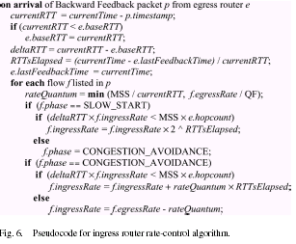

In the CFR rate-control algorithm, shown in Fig. 6, a flow may be in one of two phases, slow start or congestion avoidance, similar to the phases of TCP congestion control. The desirable stability characteristics of slow-start and congestion control algorithms have been proven in TCP congestion control, and CFR expects to benefit from their well-known stability features. In CFR, new flows entering the network start with the slow-start phase and proceed to the congestion-avoidance phase only after the flow has experienced incipient congestion.

The rate-control algorithm is invoked whenever a backward feedback packet arrives at an InRouter router. Recall that backward feedback packets contain a timestamp and a list of flows arriving at the OutRouter router from the InRouter router as well as the monitored OutRouter rates for each flow. Upon the arrival of a backward feedback packet, the algorithm calculates the current round-trip time (currentRTT in Fig. 6) between the edge routers and updates the base round-trip time (e.base RTT), if necessary.

The base round-trip time (e.base RTT) reflects the best-observed round-trip time between the two edge routers. The algorithm then calculates deltaRTT, which is the difference between the current round-trip time (currentRTT) and the base round-trip time (e.baseRTT). A deltaRTT value greater than zero indicates that packets are requiring a longer time to traverse the network than they once did, and this can only be due to the buffering of packets within the network.

Propagation delay
Queuing delay
Round-trip time
Source
Sink

CFR’s rate-control algorithm decides that a flow is experiencing incipient congestion whenever it estimates that the network has buffered the equivalent of more than one of the flow’s packets at each router hop. To do this, the algorithm first computes the product of the flow’s InRouter rate (f.InRouterRate) and deltaRTT (i.e., f.InRouterRate deltaRTT). This value provides an estimate of the amount of the flow’s data that is buffered somewhere in the network. If this amount (i.e., f.InRouterRate deltaRTT) is greater than the number of router hops between the InRouter and the OutRouter routers (e.hopcount) multiplied by the size of the largest possible packet (MSS) (i.e., MSS e.hopcount), then the flow is considered to be experiencing incipient congestion.

The rationale for determining incipient congestion in this manner is to maintain both high link utilization and low queuing delay. Ensuring there is always at least one packet buffered for transmission on a network link is the simplest way to achieve full utilization of the link, and deciding that congestion exists when more than one packet is buffered at the link keeps queuing delays low.

Therefore, CFR’s rate-control algorithm allows the “equivalent” of e.hopcount packets to be buffered in flow’s path before it reacts to congestion by monitoring deltaRTT.1 a similar approach is used in the DEC bit congestion-avoidance mechanism. Furthermore, the approach used by CFR’s rate control algorithm to detect congestion, by estimating whether the network has buffered the equivalent of more than one of the flow’s packets at each router hop, has the advantage that, when congestion occurs, flows with higher InRouter rates detect congestion first. This is because the condition f.InRouterRate deltaRTT MSS e.hopcount fails first for flows with a large InRouter rate, detecting that the path is congested due to InRouter flow.

When the rate-control algorithm determines that a flow is not experiencing congestion, it increases the flow’s InRouter rate. If the flow is in the slow-start phase, its InRouter rate is doubled for each round-trip time that has elapsed since the last backward feedback packet arrived (f.InRouter).

The estimated number of round-trip times since the last feedback packet arrived is denoted as RTTs Elapsed. Doubling the InRouter rate during slow start allows a new flow to rapidly capture available bandwidth when the network is underutilized. If, on the other hand, the flow is in the congestion-avoidance phase, then its InRouter rate is conservatively incremented by one rate Quantum value for each round trip that has elapsed since the last backward feedback packet arrived (f.InRouterrate rate Quantum RTTsElapsed). This is done to avoid the creation of congestion. The rate quantum is computed as the maximum segment size divided by the current round-trip time between the edge routers. This results in rate growth behavior that is similar to TCP in its congestion-avoidance phase.

Furthermore, the rate quantum is not allowed to exceed the flow’s current OutRouter rate divided by a constant quantum factor (QF). This guarantees that rate increments are not excessively large when the round-trip time is small. When the rate-control algorithm determines that a flow is experiencing incipient congestion, it reduces the flow’s InRouter rate.

If a flow is in the slow-start phase, it enters the congestion-avoidance phase. If a flow is already in the congestion-avoidance phase, its InRouter rate is reduced to the flow’s OutRouter rate decremented by a constant value. In other words, an observation of incipient congestion forces the InRouter router to send the flow’s packets into the network at a rate slightly lower than the rate at which they are leaving the network.

CFR’s rate-control algorithm is designed to have minimum impact on TCP flows. The rate at which CFR regulates each flow (f.InRouterRate) is primarily a function of the
round-trip time between the flow’s InRouter and OutRouter routers (currentRTT). In CFR, the initial InRouter rate for a new flow is set to be MSS/e.baseRTT, following TCP’s initial rate of one segment per round-trip time.

CFR’s currentRTT is always smaller than TCP’s end-to-end round-trip time (as the distance between InRouter and OutRouter routers, i.e., the currentRTT in CFR, is shorter than the end-to-end distance, i.e., TCP’s round-trip time). As a result, f.InRouterRate is normally larger than TCP’s transmission rate when the network is not congested, since the TCP transmission window increases at a rate slower than CFR’s f.InRouterRate increases. Therefore, CFR normally does not regulate TCP flows.

However, when congestion occurs, CFR reacts first by reducing f.InRouterRate and, therefore, reducing the rate at which TCP packets are allowed to enter the network. TCP eventually detects the congestion (either by losing packets or due to longer round-trip times) and then promptly reduces its transmission rate. From this time point on,
f.InRouterRate becomes greater than TCP’s transmission rate, and therefore, CFR’s congestion control does not regulate TCP sources until congestion happens again.

Leaky bucket Algorithm

The "leaky bucket" algorithm is key to defining the meaning of conformance.
The leaky bucket analogy refers to a bucket with a hole in the bottom that causes it to "leak" at a certain rate coresponding to a traffic cell rate parameter The "depth" of the bucket corresponds to a tolerance parameter Each cell arrival creates a "cup" of fluid flow "poured" into one or more buckets for use in conformance checking.
The Cell Loss Priority (CLP) bit in the ATM cell header determines which bucket(s) the cell arrival fluid pours into. In the algorithm, a cell counter represents the bucket. This counter is incremented by one for each incoming cell. The "leak rate" in the algorithm is the decrement rate which reduces the counter value by one at certain intervals. This rate is given by the cell rate under consideration
and is governed by the minimum distance between two consecutive cells. The bucket volume is analogous to the cell counter range, which is represented by the permissible time tolerance for the incoming cells. This value is determined through the traffic contract or is set by the network provider and is called CDVT (cell delay variation tolerance). If the counter exceeds a certain value, the cells are assumed not to conform to the contract. To counteract this, non-conforming cells can now either be tagged or dropped. The algorithm is called "dual leaky bucket" if several parameters are monitored at once, or "single leaky bucket" if only one parameter is monitored.
In the "Leaky Bucket" analogy the cells do not actually flow through the bucket; only the check for conformance to the contract does.

12.Conclusion

In this project, we have presented a novel congestion-avoidance mechanism for the Internet called CFR and an ECSFQ mechanism. Unlike existing Internet congestion control approaches, which rely solely on end-to-end control, CFR is able to prevent congestion collapse from undelivered packets. ECSFQ complements CFR by providing fair bandwidth allocations in a core-stateless fashion.

CFR ensures at the border of the network that each flow’s packets do not enter the network faster than they are able to leave it, while ECSFQ ensures, at the core of the network that flows transmitting at a rate lower than their fair share experience no congestion, i.e., low network queuing delay. This allows the transmission rate of all flows to converge to the network fair share. CFR requires no modifications to core routers nor to end systems.

Only edge routers are enhanced so that they can perform the requisite per-flow monitoring, per-flow rate-control and feedback exchange operations, while ECSFQ requires a simple core-stateless modification to core routers. Simulation results show that CFR successfully prevents congestion collapse from undelivered packets. They also show that, while CFR is unable to eliminate unfairness on its own, it is able to achieve approximate global max-min fairness for competing network flows when combined with ECSFQ, they approximate global max-min fairness in a completely core-stateless fashion.

13.Biblography

References

[1] S. Floyd and K. Fall, “Promoting the use of end-to-end congestion control
in the internet,” IEEE/ACM Trans. Networking, vol. 7, pp. 458–472,
Aug. 1999.

[2] J. Nagle, “Congestion control in IP/TCP Internet works,” Internet Engineering
Task Force, RFC 896, Jan. 1984.

[3] V. Jacobson, “Congestion avoidance and control,” ACM Comput. Commun. Rev., vol. 18, no. 4, pp. 314–329, Aug. 1988.

[4] (1999, Jan.) Real Broadcast Network White Paper. Real Networks, Inc. [Online]. Available: http://www.real.com/solutions/rbn/ whitepaper.html

[5] (1999, Jan.) Real Video Technical White Paper. Real Networks Inc. [Online]. Available: http://www.real.com/devzone/library/whitepapers/ overview.html

[6] A. Habib and B. Bhargava, “Unresponsive flow detection and control in differentiated services networks,” presented at the 13th IASTED Int. Conf. Parallel and Distributed Computing and Systems, Aug. 2001.

[10] A. Mustafa and M. Hassan, “End to end IP rate control,” in Recent Advances in Computing and Communications. New York: McGraw-Hill, Dec. 2000, pp. 279–282.

[11] A. Rangarajan and A. Acharya, “ERUF: Early regulation of unresponsive best-effort traffic,” presented at the Int. Conf. Networks and Protocols, Oct. 1999.

[12] S. Robinson, “Multimedia transmission drive net toward gridlock,” New York Times, Aug. 23, 1999.

[13] A. Demers, S.Keshav, and S. Shenker, “Analysis and simulation of a fair queuing algorithm,” in Proc. ACM SIGCOMM, Sept. 1989, pp. 1–12.

