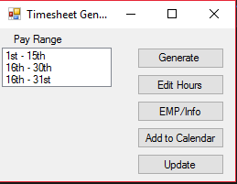

When running the program for the first time, you will want to edit your hours, and employee info, you can do so by either clicking “Edit Hours” or “EMP/Info”

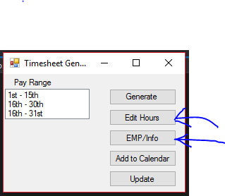

When you click the “Edit hours” option, you’re given a screen that will allow you to input your hours for certain days of the week. If you’re working a full 8 hour day, you can enter “8” in the box for total amount of hours, and it will fill in the rest of the boxes for you. 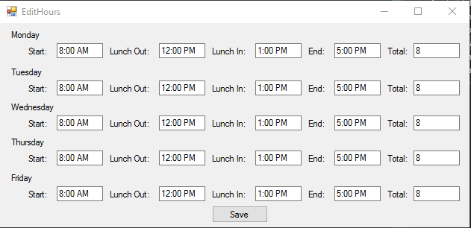

When you click on the “Emp/Info” button you are given a similar screen in which you can enter your employee info.

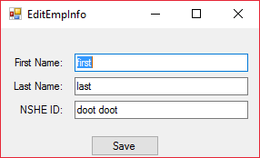

Before you are able to generate a timesheet, you will have to select a pay-range that you want the timesheet to be generated for. After selecting a pay-range, you can click generate.

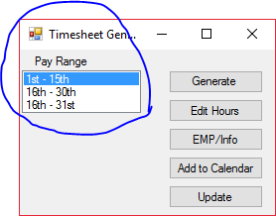

Enjoy your filled in timesheet!

