
SECTION
TWO

TABLE OF CONTENTS

SECTION 2: FINANCIAL DOCUMENTS

- CHARGEBACK ORDER
- COVER LETTER - PRE-OFFSET NOTICE FOR BALANCED BOOK ADJUSTMENT
- FIDUCIARY APPOINTMENT – J. Russell George, Inspector General
- FIDUCIARY APPOINTMENT – Timothy F. Geithner, Secretary of The Treasury
- FIDUCIARY APPOINTMENT – Douglas Schulman, Commissioner, IRS
- I.R.S. FORM 56 - J. Russell George, Inspector General
- I.R.S. FORM 56 – Timothy F. Geithner, Secretary of The Treasury
- I.R.S. FORM 56 - Douglas Schulman, Commissioner, IRS
- I.R.S. FORM 1040-V
- INTERNATIONAL BILL OF EXCHANGE
SECTION 2 – FINANCIAL DOCUMENTS
U.S. TREASURY
FILING & MAILING PROCEDURES

- NOTIFICATION TO U.S. TREASURY

SPECIAL NOTES

NOTE 1: SECTION 2 DOCUMENTS ARE NOT FILED AT YOUR LOCAL COURTHOUSE.
NOTE 2: EVERYTHING SENT TO US TREASURY IS MAILED VIA REGISTERED MAIL.
NOTE 3: EVERYTHING SENT TO US TREASURY IS PRINTED ON LASER PRINTER USING 32 lb. BOND PAPER.
NOTE 4: EVERYTHING SENT TO US TREASURY, EXCEPT BOND, ARE ORIGINAL/CERTIFIED COPIES ONLY.
NOTE 5: EVERY BOND SENT TO US TREASURY IS ORIGINAL ONLY.

- Gather the following documents:

Original/Certified Section 1 Documents printed on 32 lb. Cotton Bond Paper
Original/Certified Section 2 Documents printed on 32 lb. Cotton Bond Paper
Original/Certified Birth Certificate
Original/Certified Birth Certificate Bond printed on 32 lb. Cotton Bond Paper using a LASER printer, not an Ink Jet printer.

- Use LARGE Birth Certificate Stamp “Accepted for Value” at a 45 degree angle on the reverse side of Birth Certificate.

- Stamp “Accepted for Value” on the reverse side of IRS Form 1040-V.

- Address envelope to the following recipient:

Use Notary’s Return Address
TIMOTHY F. GEITHNER
SECRETARY OF THE TREASURY
DEPARTMENT OF THE TREASURY
1500 PENNSYLVANIA AVENUE N.W.
WASHINGTON, D.C. 20220

- Prepare for mailing of ORIGINAL or CERTIFIED COPIES PRINTED ON BOND PAPER using the following mailing instructions:

- Registered Mail with Return Receipt Signature Required USPO Form 3811
- $21.00 in postage stamps on the envelope. DO NOT ALLOW POSTAL EMPLOYEE TO PLACE A METERED STAMP ON YOUR PACKAGE. INFORM THEM YOU WANT STAMP POSTAGE ONLY.
- Declare a $21.00 value on mail receipt with USPO Form 3806
- DO NOT BUY INSURANCE
- DO NOT SEND OVERNIGHT MAIL
- Send package by Notary Presentment listing all documents by name, number (if applicable), and file number. This validates the contents of your mailed package
- On your envelope, use Notary’s Return Address
- Track your package via www.usps.com
- WAIT A MINIMUM OF 4 DAYS AFTER US TREASURY RECEIPT BEFORE BEGINNING TO NOTIFY THE OTHER 18 AGENCIES.
SECTION 2 – FINANCIAL DOCUMENTS

18 AGENCIES (NOT U.S. TREASURY)
FILING & MAILING PROCEDURES

- NOTIFICATION TO 18 AGENCIES

SPECIAL NOTES

- Has it been 4 plus days since the US TREASURY received your registered mail package?

NOTE 1: SECTION 2 DOCUMENTS ARE NOT FILED AT YOUR LOCAL COURTHOUSE.
NOTE 2: EVERYTHING MAILED TO 18 AGENCIES OTHER THAN US TREASURY IS SENT VIA CERTIFIED MAIL
NOTE 3: EVERYTHING SENT TO 18 AGENCIES OTHER THAN US TREASURY IS PRINTED ON REGULAR PRINT PAPER.
NOTE 4: EVERYTHING SENT TO 18 AGENCIES OTHER THAN US TREASURY ARE COPIES OF ORIGINAL DOCUMENTS.
NOTE 5: YOU WILL PROBABLY GET IT

- Gather the following documents and STAMP COPY ON EVERY PAGE BEING MAILED:

Copies of Certified Section 1 Documents (front and back) printed on regular print paper
Copies of Certified Section 2 Documents (front and back) printed on regular print paper
Copy of Certified Birth Certificate (front and back)
Copy of Certified Birth Certificate Bond (front and back) printed on regular print paper. Stamp “COPY” on the Birth Certificate Bond to eliminate potential counterfeiting.

- Address 18 envelopes to each of the 18 recipients found on “Agency Mailing List”

- Prepare for mailing of copies of all documents in Item 1 using the following mailing criteria:

- Certified Mail
- Send package by Notary Presentment listing all documents by name, number (if applicable), and file number. This validates the contents of your mailed package
- On your envelope, use Notary’s Return Address
- Metered Postage or Stamps
- Monitor & Track receipt of packages via www.usps.com
SECTION 2 – FINANCIAL DOCUMENTS

U.S. TREASURY
FILING & MAILING PROCEDURES

- PAYING A MORTGAGE OR BILL

SPECIAL NOTES

NOTE 1: SECTION 2 DOCUMENTS ARE NOT FILED AT YOUR LOCAL COURTHOUSE.
NOTE 2: EVERYTHING SENT TO US TREASURY IS MAILED VIA REGISTERED MAIL.
NOTE 3: EVERYTHING SENT TO US TREASURY IS PRINTED ON LASER PRINTER USING 32 lb. BOND PAPER.
NOTE 4: EVERYTHING SENT TO US TREASURY, EXCEPT BOND, ARE ORIGINAL/CERTIFIED COPIES ONLY.
NOTE 5: EVERY BOND SENT TO US TREASURY IS ORIGINAL ONLY.

- Gather the following documents:

- Original Certified Bonded Promissory Note printed on 32 lb. Cotton Bond Paper using a LASER printer, not an Ink Jet printer.
- Original Cover Sheet named PRE-OFFSET NOTICE FOR BALANCED BOOK ADJUSTMENT completed appropriately
- 1040V – Stamped “Accepted For Value” on back at 45 degree angle
- Original Bill/Statement that you are trying to make payment
- Copy of IRS Form 56 that was sent to Secretary of Treasury

- Address envelope to the following recipient:

Use Notary’s Return Address
INTERNAL REVENUE SERVICE
Att. Operations Mgr, Accts. Management 2
ANNA S. MEDLOCK
P.O. BOX 149338
AUSTIN, TX 787614-9338
TO WHOM YOU ARE MAKING PAYMENT
ADDRESS OF RECIPIENT
CITY, STATE ZIP OF RECIPIENT

CITY, STATE ZIP OF RECIPIENT

OR

- Prepare for mailing of ORIGINAL or CERTIFIED COPIES PRINTED ON BOND PAPER using the following mailing instructions:

- Registered Mail with Return Receipt Signature Required USPO Form 3811
- $21.00 in postage stamps on the envelope. DO NOT ALLOW POSTAL EMPLOYEE TO PLACE A METERED STAMP ON YOUR PACKAGE. INFORM THEM YOU WANT STAMP POSTAGE ONLY.
- Declare a $21.00 value on mail receipt with USPO Form 3806
- DO NOT BUY INSURANCE
- DO NOT SEND OVERNIGHT MAIL
- Send package by Notary Presentment listing all documents by name, number (if applicable), and file number. This validates the contents of your mailed package
- On your envelope, use Notary’s Return Address
- Track your package via www.usps.com
- WAIT A MINIMUM OF 4 DAYS AFTER US TREASURY RECEIPT BEFORE BEGINNING TO NOTIFY THE OTHER 18 AGENCIES.
TO: (UPPER CASE AGENCY ADDRESS located on mailing list)

FROM: John-Lee: Doe – Principal, Secured Party Creditor UCC File Number: (UCCFileNumber)
C/O 123 Main Street FOR: JOHN LEE DOE, DEBTOR
RealManCity, RealManState; near [RealManZipCode] RE: Account Number – (SS#NoDashes)
Non Domestic without the US Social Security Number – (SS#WithDashes)
Treasury Routing Number- (TreasuryAccount#)
DATE: DocumentFilingDate Liber Number(s) - (From Docs Filed at Courthouse)

PRE-OFFSET NOTICE FOR BALANCED BOOK ADJUSTMENT

Dear Gentlemen,

The enclosed Statute Staple Security instruments are rendered to you for the purpose of balanced book adjustment as legal tender to lower and reduce the UNITED STATES national debt. The undersigned understands the complexity of following this procedure. The “Code” is effectively in place to save and protect the monetary system of this country. If and when non-accreditation occurs, the economy and monetary system of the country will certainly collapse. That is the complexity and importance of honoring this procedure.

USC TITLE 12, CHAPTER 2 – NATIONAL BANKS - Authorizes the procedure. If you don’t understand this procedure please research the US Code, for clarity or seek competent legal counsel. You should understand that in Title 12 USC section 371b, 12 the Code defines “Exposure” to include all extensions of credit regardless of name and description. This procedure is intended for all of the people of the United States. Non accreditation will result in a serious error and injury against the Internal Revenue Service, and the Principal Secured Party Creditor. This will cause a miscalculation upon the Federal Reserve Accountant Balanced Book, and will require a filing of the proper IRS forms for collection of these funds. This adjustment may be completed by MR. TIMOTHY F. GEITHNER, Secretary of the US Treasury, who is my legally appointed fiduciary agent, or my designee as Fiduciary on the attached IRS Form 56. Documentation is enclosed.

As you are well aware, lawful money no longer exists in our economic system. This was replaced by Federal Reserve “Notes”, which is, in effect, a promissory note. This procedure to allow offset of debt is the proper legal remedy that has been provided for us to discharge debt, since the money was removed by the U. S. Corporate Government. This is a debt obligation of the United States. Please use this procedure to offset any bills that I present by balanced book adjustment, settlement in full, discharge of all presentments, and return all interest to the Principal. MR. TIMOTHY F. GEITHNER, or my designated Fiduciary Agent, is authorized to adjust, from this account, along with any reasonable and lawful interest, penalties, and extra fees, as needed, in order to satisfy this procedure. This may be ledgered against the Account Number indicated as best suits the needs of the US Treasury.

Sincerely,

_________________________________________________________________
John-Lee: Doe, Principal and Secured Party Creditor for JOHN LEE DOE, Debtor
CC: TIMOTHY F. GEITHNER - Secretary of the US Treasury - Washington, D.C.
FEDERAL RESERVE WINDOW - Washington, D.C.
UNITED STATES COURT of INTERNATIONAL TRADE - New York, New York
UNITED STATES SECURITIES and EXCHANGE COMMISSION - Washington, D.C.
US DEPARTMENT of COMMERCE – DEPT. of ASSISTANCE & LITIGATION - D.C.
US DEPARTMENT of COMMERCE – DAVID A. SAMPSON - Washington, D.C.
DEPARTMENT of ASSISTANCE and FINANCE LITIGATION - Washington, D.C.
SECRETARY, INTERNAL REVENUE SERVICE - Washington, D.C.
SOCIAL SECURITY ADMINISTRATION - Baltimore, Maryland
UNITED STATES SECURITIES and EXCHANGE COMMISSION - Atlanta, Georgia
U.S. DEPARTMENT of TRANSPORTATION – MARY E. PETERS - Washington, D.C.
U.S. DEPARTMENT of TRANSPORTATION - AGGECRGL- Washington, D.C.
JUAN CARLOS MENDEZ TORRES – INTERNAL REVENUE SERVICE - San Juan, Puerto Rico
DEPARTMENT OF THE TREASURY DATE: DocumentFilingDate
c/o TIMOTHY F GEITHNER
SECRETARY AND TRUSTEE OF THE US BANKRUPTCY
1500 PENNSYLVANIA AVE. NW
Washington, D. C. 20220

Registered Mail Article Number: (BCRegisteredMail#)

CHARGEBACK ORDER (UCC 3-104)
IN ACCORD WITH HJR-192 AND PUBLIC LAW 73-10
INSTRUCTIONS NOT SUBJECT TO NEGOTIABILITY

RE: CHARGEBACK ORDER

Dear TIMOTHY GEITHNER, SECRETARY IN CHARGE:

Enclosed are documents from the Undersigned’s Commercial Agreements, which are recorded in the Public Record. On any presentments to the DEPARTMENT OF THE TREASURY or INTERNAL REVENUE with receipts and other evidence that have been accepted for value all related endorsements front and back to include those in accord with UCC-3-419. The total amount of this CHARGEBACK enclosed is $100,000,000,000.00 (ONE HUNDRED BILLION US DOLLARS).

Please chargeback the undersigned’s account number, (SS#NoDashes), for the same value including interest, penalties, and fees necessary for securing, registration, and discharge of the public liability. As you know, this is a public debt obligation of the United States. This is an order to adjust the account, discharge the debt, and zero the account for all presentments that have been Accepted for Value and endorsed with a valid signature. These presentments will be delivered to you or to your Accounts Management office by United States mail by the Secured Party Creditor, undersigned below.

This Registered and Posted Account, # (SS#NoDashes) part of the undersigned’s tax estimate, is directed for use (priority) for the Republic (Article IV, Section IV of the original United States Constitution) in accord with public policy HJR-192, (discharge of the public debt).

MR. TIMOTHY F. GEITHNER, Secretary-in-charge and/or your Deputy-in-charge, are to take the undersigned’s acceptance (BA), this Article Seven receipt, in exchange for the tax exemption priority. This chargeback order, in accord with HJR-192, Public Law 73-10 is hereby presented for the receiver to the Federal Window, for settlement, by Electronic Funds Transfer (EFT), of any presentments tendered to you by the Undersigned Secured Party Creditor, which must be completed within the three (3) day Truth-in-Lending time (Regulation Z).

With This POSTED transaction, the CHARGEBACK charges documented by the enclosed forms, for use by the Republic, is complete. The International, United States Post Office Return Receipt Notice is accepted as acknowledgement from the Secretary of the Treasury without dishonor.

Until then, I am very truly,

_____________________________________________________
(John-Lee: Doe), Secured Party Bond # (B/C Bond #)
Account # (SS#NoDashes) Treasury Routing # – (TreasuryAccount#)
c/o 123 Main Street
(RealManCity, RealManState; Near [RealManZipCode]
Pre-Paid- Account
Priority-Exempt from Levy
Void where prohibited by law

CC: FED WINDOW
IRS COMMISSIONER
JUAN CARLOS MENDEZ TORRES – DEPARTMENTO DE HACIENDA
P.O. Box 9024140, San Juan, P.R. 00902-414

John-Lee: Doe Registered Mail Number BCRegisteredMail#
C/O 123 Main Street
RealManCity, RealManState; Near[RealManZipCode]
Non Domestic without the US
________________________________________________________________________

) In Admiralty
UNITED STATES OF AMERICA ) Account Number SS#WithDashes
INTERNAL REVENUE SERVICE )
Plaintiff )
) COMMERCIAL NOTICE
- ) APPOINTMENT OF
) FIDUCIARY CREDITOR AND
) DEBTOR
JOHN LEE DOE )
Respondent/Defendant )
___________________________________ )

John-Lee: Doe agent, lawful man, ) creditor, injured third party intervener ) NO hearing requested
_______________________________________________________________________

COMMERCIAL NOTICE APPOINTMENT OF FIDUCIARY DEBTOR AND CREDITOR

COMES NOW John-Lee: Doe, a Real Party in Interest, who is neutral in the public, who is unschooled in law, making a special visitation by absolute ministerial right to J. RUSSELL GEORGE, INSPECTOR GENERAL, DEPARTMENT OF THE TREASURY, and notices the DEPARTMENT OF THE TREASURY with enunciation of principles as stated in Haines v. Kerner, 404 U.S. 519, wherein the court has directed that those who are unschooled in law making pleadings and/or complaints shall have the court look to the substance of the pleadings rather than in the form, and hereby makes the following pleadings/notices in the above referenced matter without waiver of any defenses.

Appointment of Fiduciary

I, John-Lee: Doe, “Third Party Interest Intervener,” having terminated the previous fiduciary to the corporate entity (ens legis), a documented vessel under United States registry, otherwise described as JOHN LEE DOE, JOHN L DOE, JOHN DOE, or any alphabetical or numerical variation thereof, a.k.a. (Debtor), nunc pro tunc BirthDate C.E., said entity having as it’s trustee the Secretary of Transportation of the United States pursuant to and in accordance with [Title 46 App. U.S.C. § 1247] and there being no living sentient being responsible to accept service of process or other documents, and cannot appear in a court of the United States or act as a duly appointed transfer agent, and cannot achieve parity with real people. Therefore I, John-Lee: Doe, “Third Party Interest Intervener,” hereby nominate and do appoint J. Russell George a/k/a J. RUSSELL GEORGE, OFFICE OF THE INSPECTOR GENERAL OF THE DEPARTMENT OF THE TREASURY as being qualified to fulfill the position of “Fiduciary Creditor” and Fiduciary Debtor” for the corporate entity described above in all-capital-letter-assemblages, the same to be effective immediately as of the date set forth below, and shall continue until further notice or reappointment, substitution or cancellation, within the venue as ordained and established by the People of the Territory of RealManState, through their original Organic Constitutions of RealManState state.

Whereas, said fiduciary creditor’s responsibilities are to exercise scrupulous good faith and candor towards, and for the benefit and on behalf of John-Lee: Doe, “Third Party Interest Intervener,” the exclusive and limited purpose of accepting and receiving all liabilities, accepting and receiving all service of process and other documents, instruments, bonds or other important papers, to appear and discharge, settle and close all matters material to above referred (Debtor) in all-capital-letter-assemblages, the same shall be by order of John-Lee: Doe, “Third Party Interest Intervener” or other delegated appointee of John-Lee: Doe, “Third Party Interest Intervener,” including assignments for or on behalf of the principal (Debtor), JOHN LEE DOE, including any alphabetical or numerical variation thereof as described above, and to do all other acts requisite to faithfully execute said appointment, fully, faithfully, specially under this appointment.

Fiduciary Creditor, J. Russell George a/k/a J. RUSSELL GEORGE OFFICE OF THE INSPECTOR GENERAL OF THE DEPARTMENT OF THE TREASURY, is hereby authorized to use the private exemption of John-Lee: Doe, or the JOHN LEE DOE, SS#WithDashes, for the adjustment and set-off of all matters, with regards to the Internal Revenue Service account numbers SS#WithDashes, which have previously been Accepted For Value, and Returned for Settlement, Closure and discharge. J. Russell George a/k/a J. RUSSELL GEORGE, OFFICE OF THE INSPECTOR GENERAL OF THE DEPARTMENT OF THE TREASURY, is to issue the appropriate IRS 1099 forms and to be in compliance with all revenue requirements in this matter timely.

I, John-Lee: Doe, “Third Party Interest Intervener” asseverate that the facts enumerated herein are set forth in good faith with clean hands and that the same are true, correct, complete and not misleading, so certified without the United States.

________________ _______________________________________________
Right Thumb Print John-Lee: Doe
Third Party Interest Intervener,
DATE: ______________ Authorized Agent For:
JOHN LEE DOE, (ens legis)
C/O John-Lee: Doe
123 Main Street
RealManCity, RealManState; Near [RealManZipCode]
Non Domestic without the US

CERTIFICATE OF SERVICE

I HEREBY CERTIFY that I, (NotaryName), Notary, have inspected the contents of this package and it includes this Notice of Appointment of Fiduciary Debtor. The Undersigned or his Authorized Agent appeared before me on_____________________________ and provided (DriverLicenseState) Drivers License for proof of identity.

cc: J. RUSSELL GEORGE, INSPECTOR GENERAL, DEPARTMENT OF TREASURY

cc: TIMOTHY F. GEITHNER, SECRETARY, THE DEPARTMENT OF THE TREASURY

cc: DOUGLAS SCHULMAN, COMMISSIONER, INTERNAL REVENUE SERVICE

Enclosures:
1040V
Fiduciary Form 56

RESPECTFULLY SUBMITTED;

__________________________
John-Lee: Doe
123 Main Street
RealManCity, RealManState; Near [RealManZipcode]

Appointment Fiduciary Creditor and Debtor

John-Lee: Doe Registered Mail Number BCRegisteredMail#
C/O 123 Main Street
RealManCity, RealManState; Near[RealManZipCode]
Non Domestic without the US
________________________________________________________________________

) In Admiralty
UNITED STATES OF AMERICA ) Account Number SS#WithDashes
INTERNAL REVENUE SERVICE )
Plaintiff )
) COMMERCIAL NOTICE
- ) APPOINTMENT OF
) FIDUCIARY CREDITOR AND
) DEBTOR
JOHN LEE DOE )
Respondent/Defendant )
___________________________________ )

John-Lee: Doe agent, lawful man, ) creditor, injured third party intervener ) NO hearing requested
_______________________________________________________________________

COMMERCIAL NOTICE APPOINTMENT OF FIDUCIARY DEBTOR AND CREDITOR

COMES NOW John-Lee: Doe, a Real Party in Interest, who is neutral in the public, who is unschooled in law, making a special visitation by absolute ministerial right to MR. TIMOTHY F. GEITHNER, SECRETARY OF THE TREASURY, and notices the IRS with enunciation of principles as stated in Haines v. Kerner, 404 U.S. 519, wherein the court has directed that those who are unschooled in law making pleadings and/or complaints shall have the court look to the substance of the pleadings rather than in the form, and hereby makes the following pleadings/notices in the above referenced matter without waiver of any defenses.

Appointment of Fiduciary

I, John-Lee: Doe, “Third Party Interest Intervener,” having terminated the previous fiduciary to the corporate entity (ens legis), a documented vessel under United States registry, otherwise described JOHN LEE DOE, JOHN L DOE, JOHN DOE, or any alphabetical or numerical variation thereof, a.k.a. (Debtor), nunc pro tunc BirthDate C.E., said entity having as it’s trustee the Secretary of Transportation of the United States pursuant to and in accordance with [Title 46 App. U.S.C. § 1247] and there being no living sentient being responsible to accept service of process or other documents, and cannot appear in a court of the United States or act as a duly appointed transfer agent, and cannot achieve parity with real people. Therefore I, John-Lee: Doe, “Third Party Interest Intervener,” hereby nominate and do appoint MR. TIMOTHY F. GEITHNER a/k/a MR. TIMOTHY F. GEITHNER, INTERNAL REVENUE AGENT OF THE INTERNAL REVENUE SERVICE, DEPARTMENT OF THE TREASURY as being qualified to fulfill the position of “Fiduciary Creditor” and Fiduciary Debtor” for the corporate entity described above in all-capital-letter-assemblages, the same to be effective immediately as of the date set forth below, and shall continue until further notice or reappointment, substitution or cancellation, within the venue as ordained and established by the People of the Territory of RealManState, through their original Organic Constitutions of RealManState state.

Whereas, said fiduciary creditor’s responsibilities are to exercise scrupulous good faith and candor towards, and for the benefit and on behalf of John-Lee: Doe, “Third Party Interest Intervener,” the exclusive and limited purpose of accepting and receiving all liabilities, accepting and receiving all service of process and other documents, instruments, bonds or other important papers, to appear and discharge, settle and close all matters material to above referred (Debtor) in all-capital-letter-assemblages, the same shall be by order of John-Lee: Doe, “Third Party Interest Intervener” or other delegated appointee of John-Lee: Doe, “Third Party Interest Intervener,” including assignments for or on behalf of the principal (Debtor), JOHN LEE DOE, including any alphabetical or numerical variation thereof as described above, and to do all other acts requisite to faithfully execute said appointment, fully, faithfully, specially under this appointment.

Fiduciary Creditor, MR. TIMOTHY F. GEITHNER, a/k/a TIMOTHY F. GEITHNER, SECRETARY OF THE TREASURY, is hereby authorized to use the private exemption of John-Lee: Doe, or the JOHN LEE DOE, SS#WithDashes, for the adjustment and set-off of all matters, with regards to the Internal Revenue Service account numbers SS#WithDashes, which have previously been Accepted For Value, and Returned for Settlement, Closure and discharge. MR. TIMOTHY F. GEITHNER, a/k/a TIMOTHY F. GEITHNER, SECRETARY OF THE TREASURY, is to issue the appropriate IRS 1099 forms and to be in compliance with all revenue requirements in this matter timely.

I, John-Lee: Doe, “Third Party Interest Intervener” asseverate that the facts enumerated herein are set forth in good faith with clean hands and that the same are true, correct, complete and not misleading, so certified without the United States.

________________ _______________________________________________
Right Thumb Print John-Lee: Doe
Third Party Interest Intervener,
DATE: ______________ Authorized Agent For:
JOHN LEE DOE, (ens legis)
C/O John-Lee: Doe
123 Main Street
RealManCity, RealManState; Near [RealManZipCode]
Non Domestic without the US

CERTIFICATE OF SERVICE

I HEREBY CERTIFY that I, (NotaryName), Notary, have inspected the contents of this package and it includes this Notice of Appointment of Fiduciary Debtor. The Undersigned or his Authorized Agent appeared before me on_____________________________ and provided DriverLicenseState Drivers License for proof of identity.

cc: J. RUSSELL GEORGE, INSPECTOR GENERAL, DEPARTMENT OF TREASURY

cc: TIMOTHY F. GEITHNER, SECRETARY, THE DEPARTMENT OF THE TREASURY

cc: DOUGLAS SCHULMAN, COMMISSIONER, INTERNAL REVENUE SERVICE

Enclosures:
1040V
Fiduciary Form 56

RESPECTFULLY SUBMITTED;

__________________________
John-Lee: Doe
123 Main Street
RealManCity, RealManState; Near [RealManZipcode]

Appointment Fiduciary Creditor and Debtor

John-Lee: Doe Registered Mail Number BCRegisteredMail#
C/O 123 Main Street
RealManCity, RealManState; Near[RealManZipCode]
Non Domestic without the US
________________________________________________________________________

) In Admiralty
UNITED STATES OF AMERICA ) Account Number SS#WithDashes
INTERNAL REVENUE SERVICE )
Plaintiff )
) COMMERCIAL NOTICE
- ) APPOINTMENT OF
) FIDUCIARY CREDITOR AND
) DEBTOR
JOHN LEE DOE )
Respondent/Defendant )
___________________________________ )

John-Lee: Doe agent, lawful man, ) creditor, injured third party intervener ) NO hearing requested
_______________________________________________________________________

COMMERCIAL NOTICE APPOINTMENT OF FIDUCIARY DEBTOR AND CREDITOR

COMES NOW John-Lee: Doe, a Real Party in Interest, who is neutral in the public, who is unschooled in law, making a special visitation by absolute ministerial right to DOUGLAS SCHULMAN, OFFICE OF THE COMMISSIONER, INTERNAL REVENUE SERVICE, and notices the IRS with enunciation of principles as stated in Haines v. Kerner, 404 U.S. 519, wherein the court has directed that those who are unschooled in law making pleadings and/or complaints shall have the court look to the substance of the pleadings rather than in the form, and hereby makes the following pleadings/notices in the above referenced matter without waiver of any defenses.

Appointment of Fiduciary

I, John-Lee: Doe, “Third Party Interest Intervener,” having terminated the previous fiduciary to the corporate entity (ens legis), a documented vessel under United States registry, otherwise described as JOHN LEE DOE, JOHN L DOE, JOHN DOE, or any alphabetical or numerical variation thereof, a.k.a. (Debtor), nunc pro tunc BirthDate C.E., said entity having as it’s trustee the Secretary of Transportation of the United States pursuant to and in accordance with [Title 46 App. U.S.C. § 1247] and there being no living sentient being responsible to accept service of process or other documents, and cannot appear in a court of the United States or act as a duly appointed transfer agent, and cannot achieve parity with real people. Therefore I, John-Lee: Doe, “Third Party Interest Intervener,” hereby nominate and do appoint Douglas Schulman a/k/a DOUGLAS SCHULMAN, OFFICE OF THE COMMISSIONER, INTERNAL REVENUE SERVICE as being qualified to fulfill the position of “Fiduciary Creditor” and Fiduciary Debtor” for the corporate entity described above in all-capital-letter-assemblages, the same to be effective immediately as of the date set forth below, and shall continue until further notice or reappointment, substitution or cancellation, within the venue as ordained and established by the People of the Territory of RealManState, through their original Organic Constitutions of RealManState state.

Whereas, said fiduciary creditor’s responsibilities are to exercise scrupulous good faith and candor towards, and for the benefit and on behalf of John-Lee: Doe, “Third Party Interest Intervener,” the exclusive and limited purpose of accepting and receiving all liabilities, accepting and receiving all service of process and other documents, instruments, bonds or other important papers, to appear and discharge, settle and close all matters material to above referred (Debtor) in all-capital-letter-assemblages, the same shall be by order of John-Lee: Doe, “Third Party Interest Intervener” or other delegated appointee of John-Lee: Doe, “Third Party Interest Intervener,” including assignments for or on behalf of the principal (Debtor), JOHN LEE DOE, including any alphabetical or numerical variation thereof as described above, and to do all other acts requisite to faithfully execute said appointment, fully, faithfully, specially under this appointment.

Fiduciary Creditor, J. Russell George a/k/a J. RUSSELL GEORGE OFFICE OF THE INSPECTOR GENERAL OF THE DEPARTMENT OF THE TREASURY, is hereby authorized to use the private exemption of John-Lee: Doe, or the JOHN LEE DOE, SS#WithDashes, for the adjustment and set-off of all matters, with regards to the Internal Revenue Service account numbers SS#WithDashes, which have previously been Accepted For Value, and Returned for Settlement, Closure and discharge. Douglas Schulman a/k/a DOUGLAS SCHULMAN, OFFICE OF THE COMMISSIONER, INTERNAL REVENUE SERVICE, is to issue the appropriate IRS 1099 forms and to be in compliance with all revenue requirements in this matter timely.

I, John-Lee: Doe, “Third Party Interest Intervener” asseverate that the facts enumerated herein are set forth in good faith with clean hands and that the same are true, correct, complete and not misleading, so certified without the United States.

________________ _______________________________________________
Right Thumb Print John-Lee: Doe
Third Party Interest Intervener,
DATE: ______________ Authorized Agent For:
JOHN LEE DOE, (ens legis)
C/O John-Lee: Doe
123 Main Street
RealManCity, RealManState; Near [RealManZipCode]
Non Domestic without the US

CERTIFICATE OF SERVICE

I HEREBY CERTIFY that I, (NotaryName), Notary, have inspected the contents of this package and it includes this Notice of Appointment of Fiduciary Debtor. The Undersigned or his Authorized Agent appeared before me on_____________________________ and provided (DriverLicenseState) Drivers License for proof of identity.

cc: J. RUSSELL GEORGE, INSPECTOR GENERAL, DEPARTMENT OF TREASURY

cc: TIMOTHY F. GEITHNER, SECRETARY, THE DEPARTMENT OF THE TREASURY

cc: DOUGLAS SCHULMAN, COMMISSIONER, INTERNAL REVENUE SERVICE

Enclosures:
1040V
Fiduciary Form 56

RESPECTFULLY SUBMITTED;

__________________________
John-Lee: Doe
123 Main Street
RealManCity, RealManState; Near [RealManZipcode]

Appointment Fiduciary Creditor and Debtor

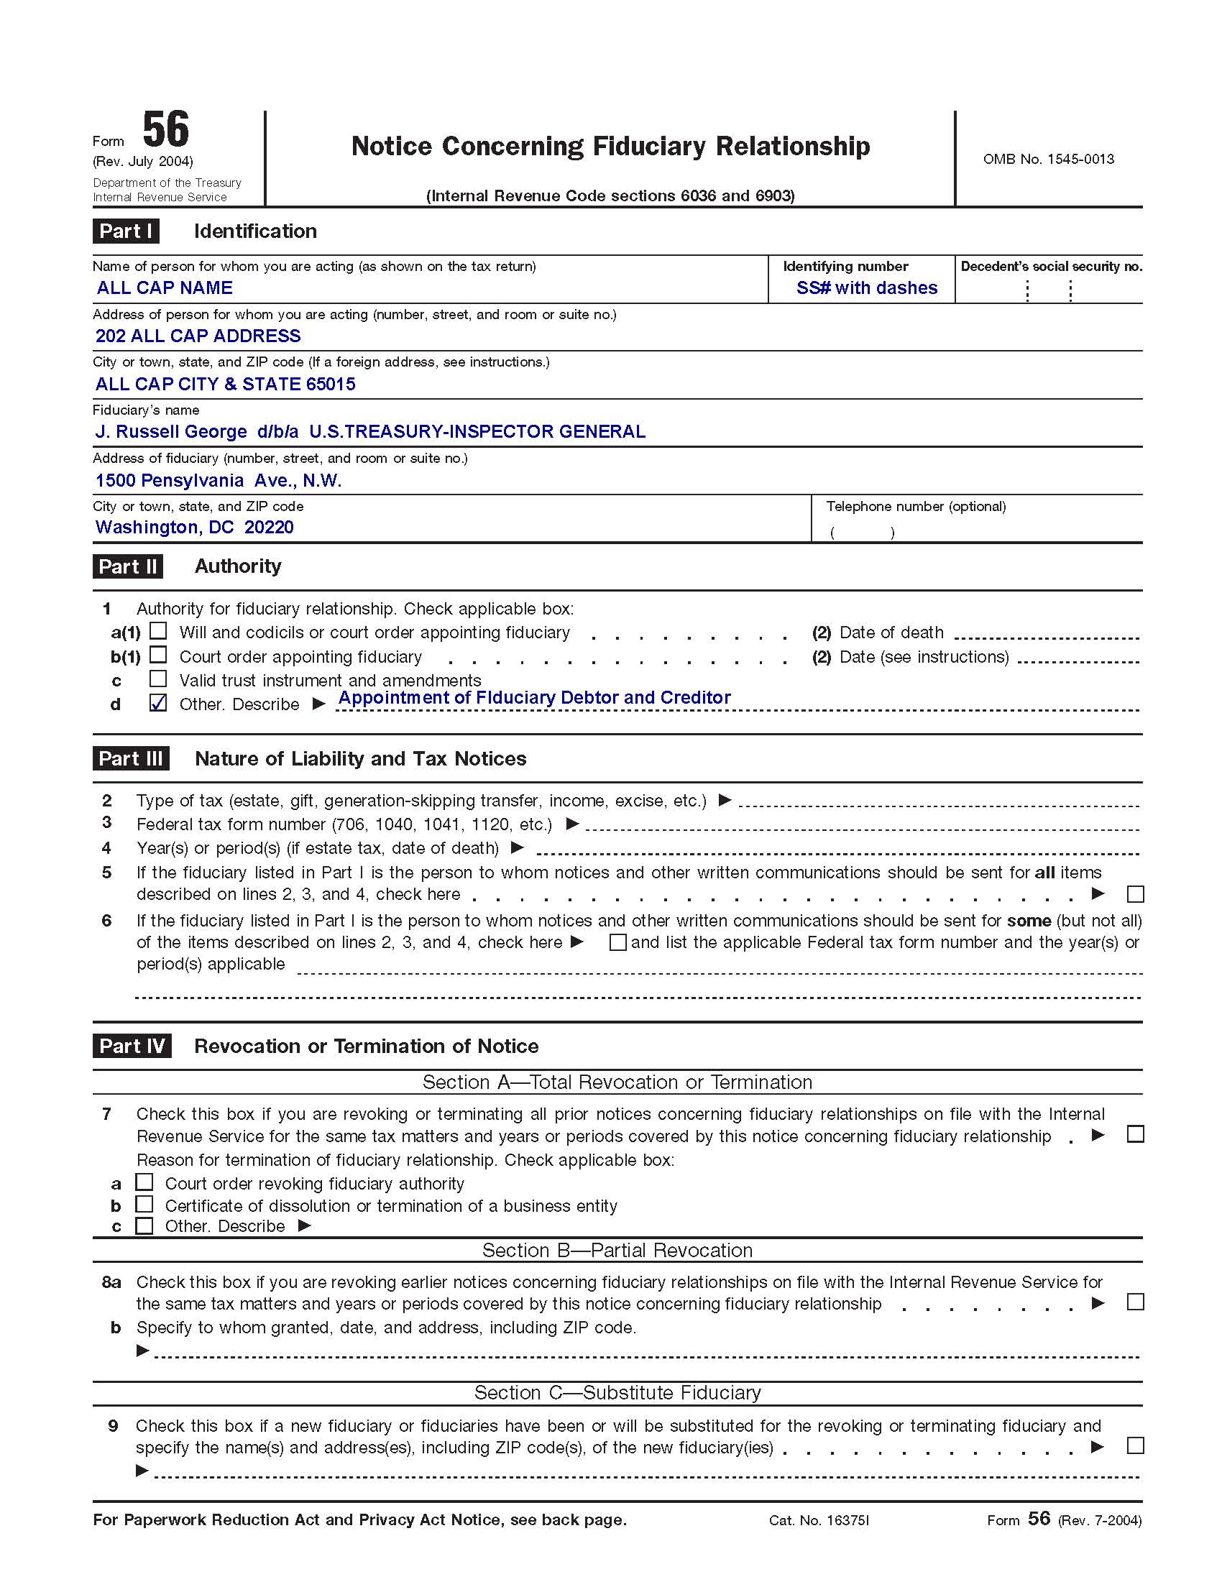

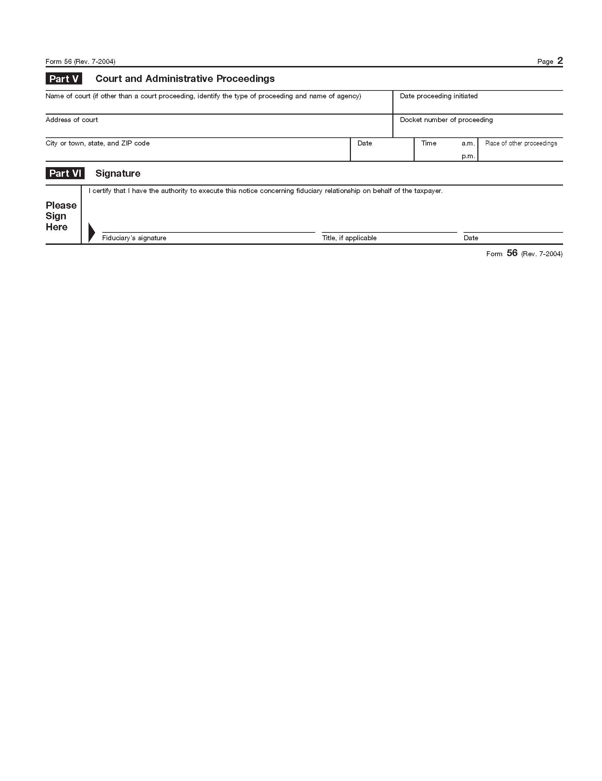
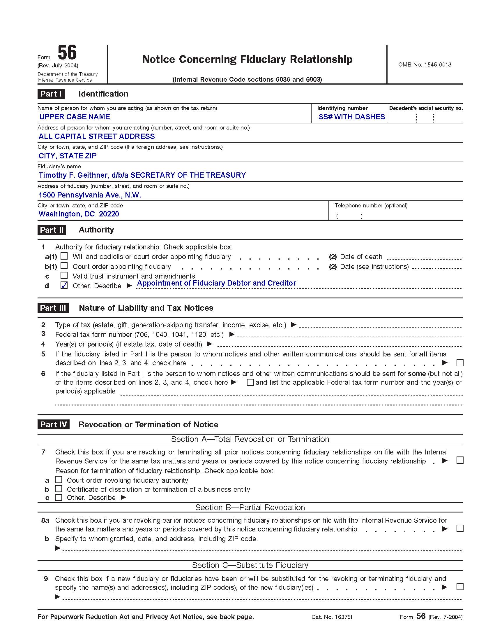

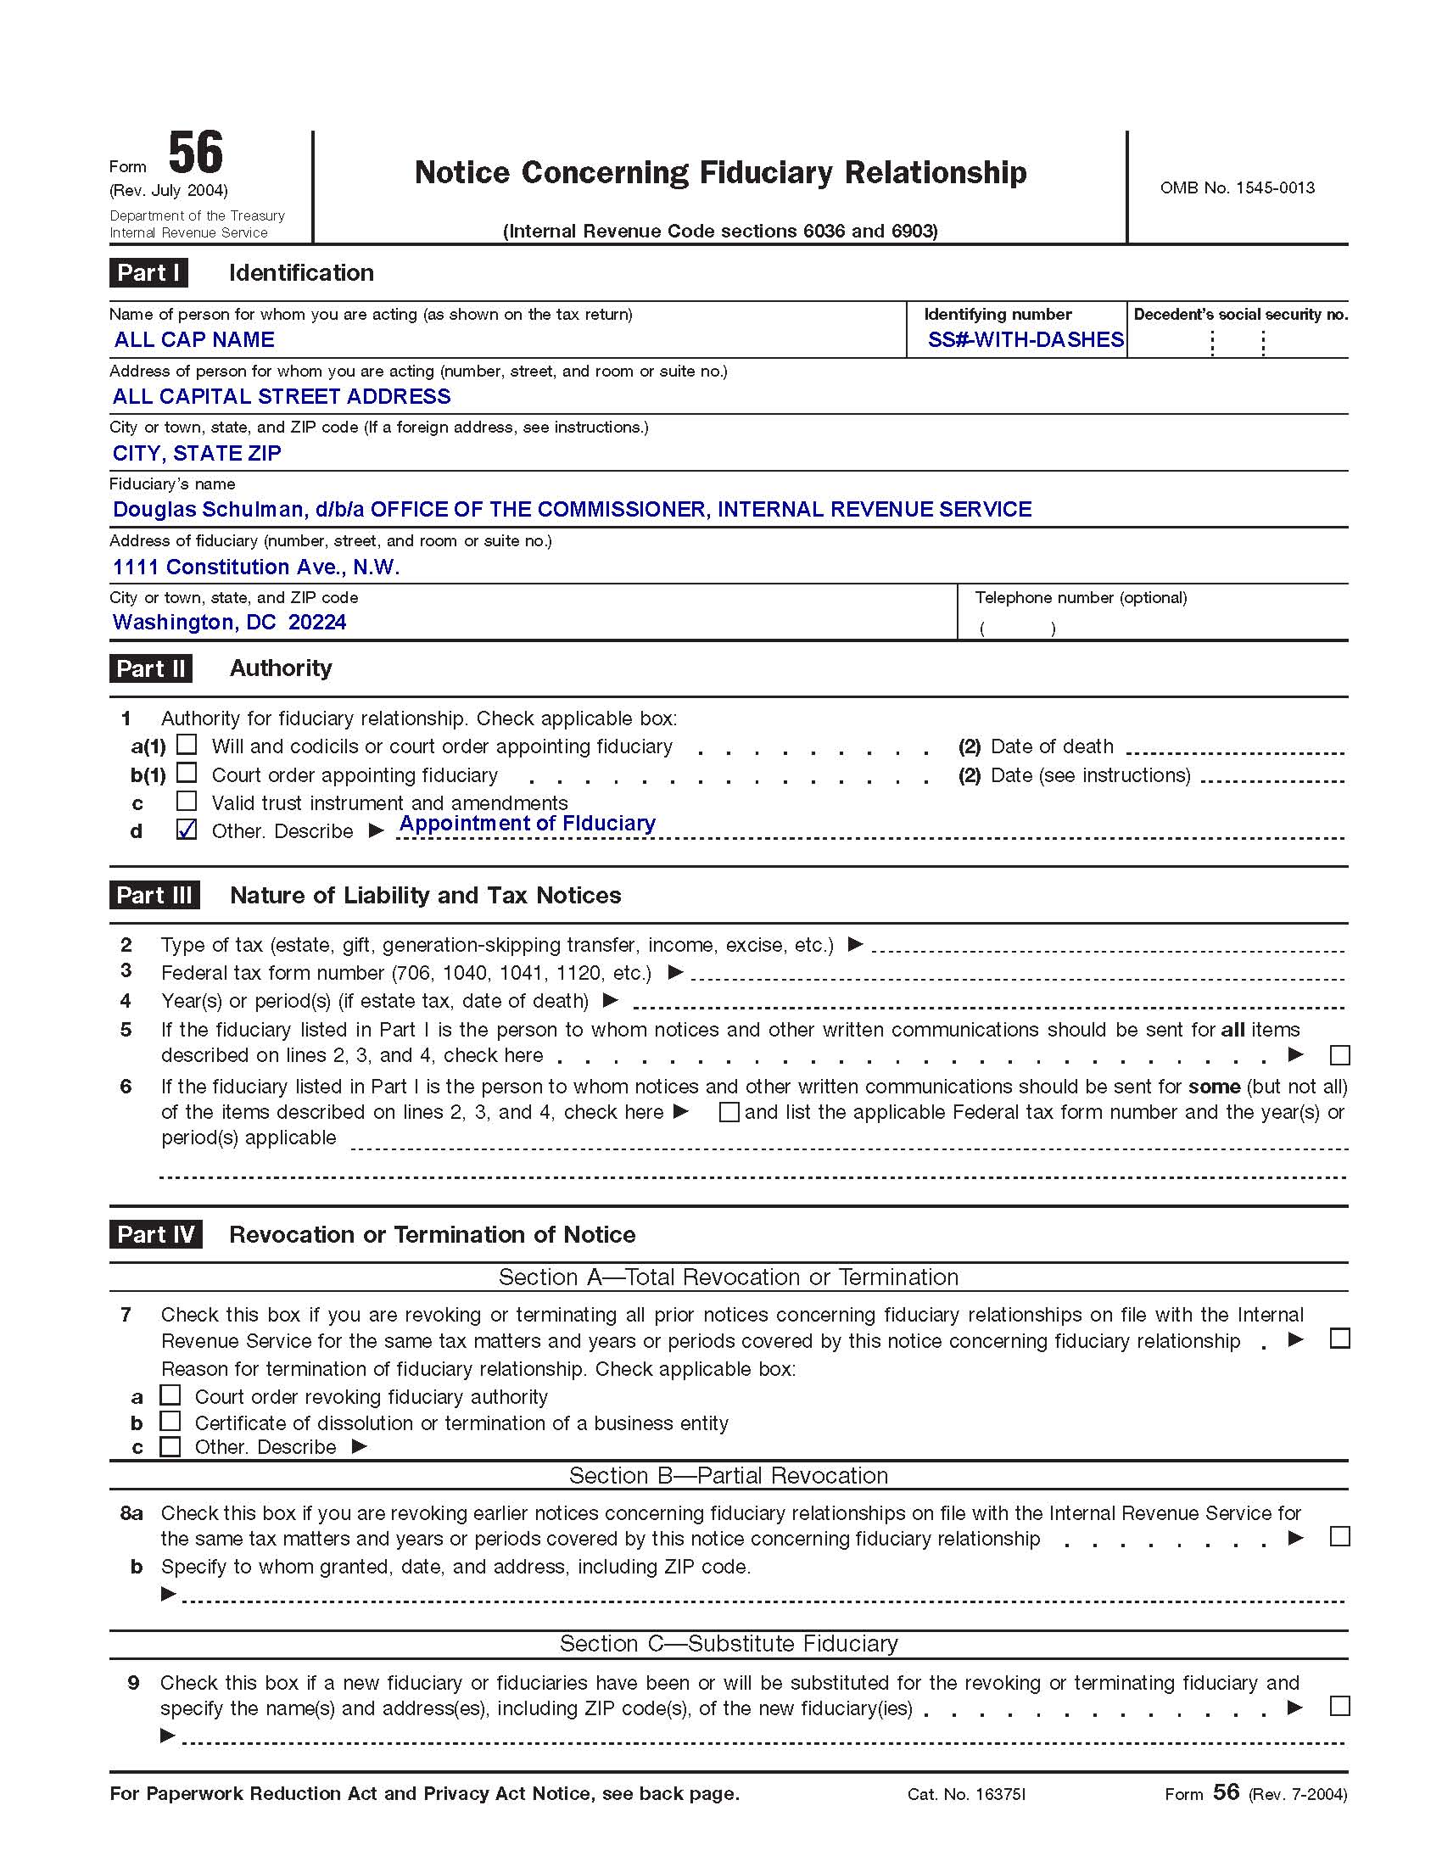

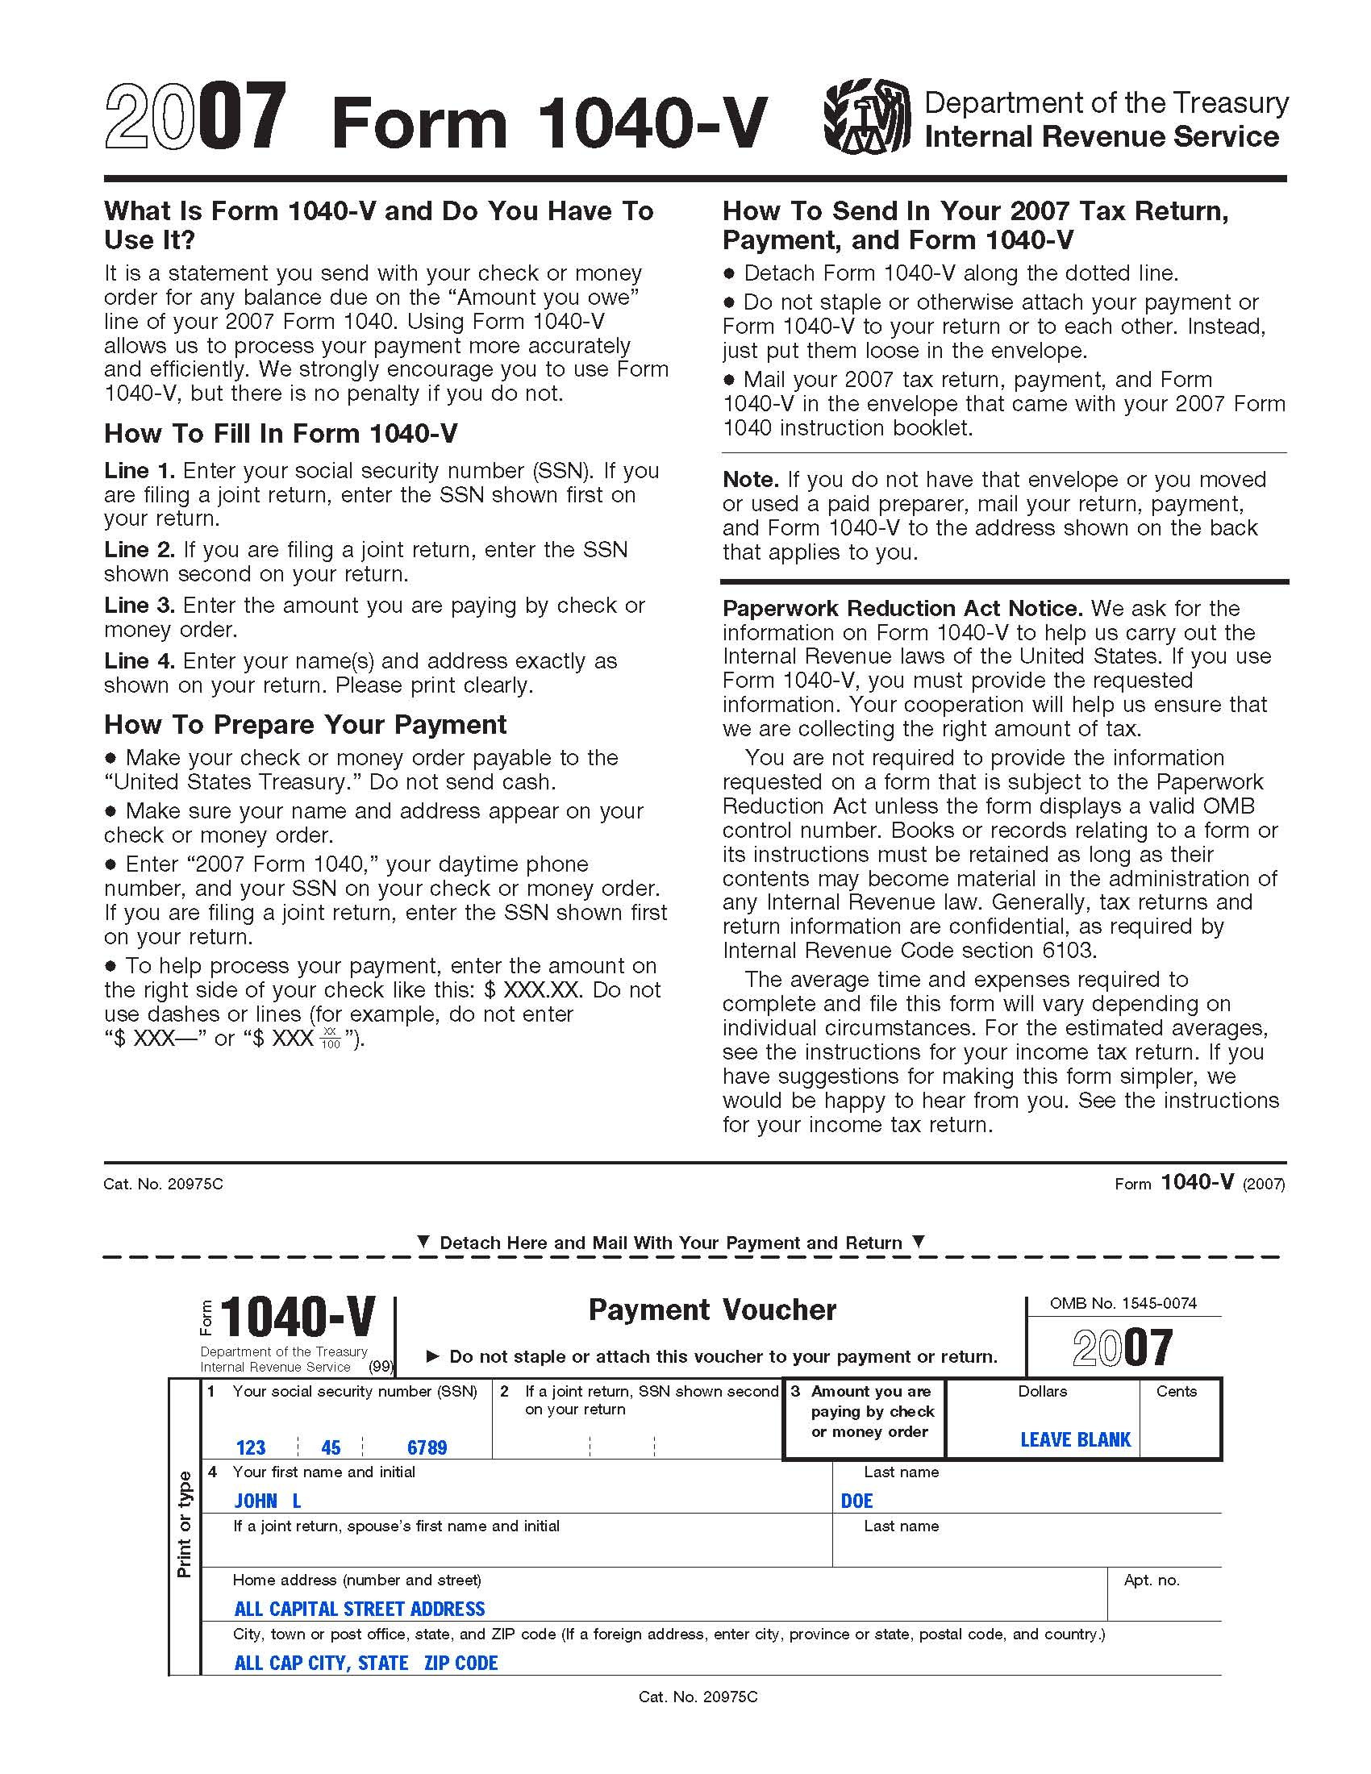

BOARD OF GOVERNORS Private Notice DocumentFilingDate
FEDERAL RESERVE BANK WINDOW Registered Mail # BCRegisteredMail#
WASHINGTON D.C.

NON-NEGOTIABLE INTERNATIONAL BILL OF EXCHANGE
IN ACCORDANCE WITH HOUSE JOINT RESOLUTION
ONE NINETY TWO HJR-192 C/P

RE: CHARGEBACK OF PERSONAL PRIVATE TREASURY ACCOUNTS

Dear MR. TIMOTHY F. GEITHNER or SECRETARY-IN-CHARGE of documents:

Please see enclosed (articles) from examination(s) of parties Private Commercial Agreements as an initial lien listed on enclosed (accounting sheets) receipts attached as collateral. The undersigned accepts for value all related endorsements, front and back, to include those in accord with UCC 3-419). The full amount of (Final payoff) NON-NEGOTIABLE CHARGEBACK accrued is One Hundred Billion Dollars ($100,000,000,000.00). Please “charge back” to my private Treasury Account # SS#NoDashes the same value, charging employees’ identification account # SS#WithDashes necessary fees securing registration in (prioritizing exchange of tax exemption discharging public liabilities) of all my personal possessions, and command memory of # SS#NoDashes charging the same to debtor’s order or your order. There is zero controversy by all individuals in association with Collateral Articles of General Accounting Practices.
- The Posted Registered Account BCRegisteredMail# fund, now part of my tax estate, directed (priority) use for the Republic (Article IV, Section 4 of the united States Constitution) in accordance with public policy HJR-192 (Discharge of Public Debt). MR. TIMOTHY F. GEITHNER Junior Secretary-in-charge and/or Deputy-in-charge are to take my acceptance (BA), this Article Seven Receipt, in exchange for tax exemption priority. This “NON-NEGOTIBLE INTERNATIONAL BILL OF EXCHANGE” according to HJR-192 as presented for receivership by the Federal Reserve (Bank) Window Accountant for final payoff, transferring same to undersigns private trust account number: SS#NoDashes as (EFT) three (3) days Truth-in-Lending time for settlement of retail agreements.
- With this posted transaction “Chargeback” charges documented by enclosed forms (Articles) for use by the Republic is complete. If you need further information or assistance with charging my private treasury account, please feel free to correspond.

Until then, I am sincerely,
___________________________________
LS: John-Lee: Doe
c/o 123 Main Street
RealManCity, RealManState; near [RealManZipCode]
Non Domestic without the US

Invoice Number: NameInitials - BirthMonth/BirthDay/YYYY

