偵測率

2024-11-20

=================================================  
package: Distance  
BBS: 2015~2023  
林業署: 2021~2024  
================================================

### BBS

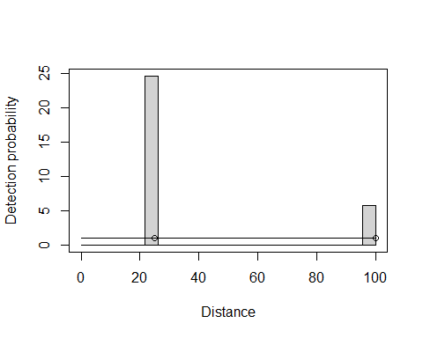

##   
## Distance sampling analysis object  
##   
## Summary for ds object  
## Number of observations : 536   
## Distance range : 0 - 100   
## AIC : 4958.151   
## Optimisation : mrds (nlminb)   
##   
## Detection function:  
## Half-normal key function   
##   
## Detection function parameters   
## Scale coefficient(s):   
## estimate se  
## (Intercept) 12.08518 1e+05  
##   
## Estimate SE CV  
## Average p 0.9999999 1.113407e-05 1.113407e-05  
## N in covered region 536.0000429 8.863047e-03 1.653553e-05  
## EDR 99.9999960 5.567033e-04 5.567033e-06

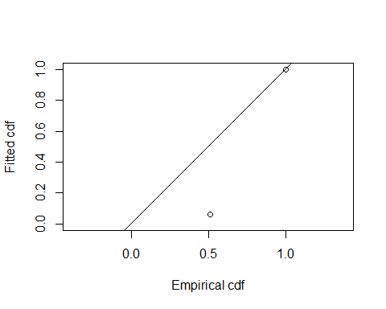

##   
## Goodness of fit results for ddf object  
##   
## Distance sampling Cramer-von Mises test (unweighted)  
## Test statistic = 37.0141 p-value = 0.06691

### 林業署

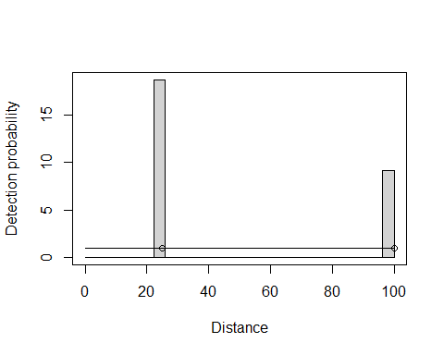

##   
## Distance sampling analysis object  
##   
## Summary for ds object  
## Number of observations : 715   
## Distance range : 0 - 100   
## AIC : 6258.842   
## Optimisation : mrds (nlminb)   
##   
## Detection function:  
## Half-normal key function   
##   
## Detection function parameters   
## Scale coefficient(s):   
## estimate se  
## (Intercept) 12.58305 16853.84  
##   
## Estimate SE CV  
## Average p 1 0.03874883 0.03874884  
## N in covered region 715 27.70541863 0.03874884  
## EDR 100 1.93744175 0.01937442

gof_ds(fit_F)

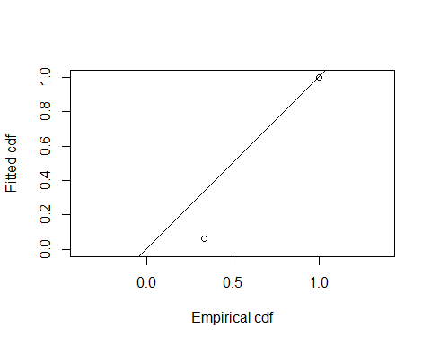

##   
## Goodness of fit results for ddf object  
##   
## Distance sampling Cramer-von Mises test (unweighted)  
## Test statistic = 75.1633 p-value = 0.145352

如果將棲地類型列入變數

* BBS

| Key function | Formula | C-vM p-value | $$\hat{P_{a}}$$ | se($\hat{P_{a}}$) | $Δ$ AIC |
| --- | --- | --- | --- | --- | --- |
| Half-normal | ~1 | 0.06691 | 0.9999999 | 0.0000111 | 0.000000 |
| Half-normal | ~1 + TypeName.1 | 0.06691 | 0.9999998 | 0.0156032 | 6.000001 |

* 林業署

| Key function | Formula | C-vM p-value | $$\hat{P_{a}}$$ | se($\hat{P_{a}}$) | $Δ$ AIC |
| --- | --- | --- | --- | --- | --- |
| Half-normal | ~1 | 0.145352 | 1.0000000 | 0.0387488 | 0.000000 |
| Half-normal | ~1 + TypeName.1 | 0.145352 | 0.9999992 | 0.0384996 | 6.000435 |

$\hat{P_{a}}$ is average detectability;  
se($\hat{P_{a}}$) is standard error. Models are sorted according to AIC.