獼猴資料合併分析(BBS&Forest)

2024-12-27

* 林保署資料：
  + 年：2021~2023
  + 範圍：海拔50m以上的森林內
* BBS資料：
  + 年：2021~2023
  + 範圍：海拔50m以上的森林內
* 變數：
  + 年：連續變數，林保署(2021~2023) & BBS(2021~2023)
  + 森林類型：類別變數，闊葉林、竹林、混淆林、針葉林
  + 海拔：連續變數，50m以上
  + 調查日：連續變數，3月1日到6月30日，即第60~182天
  + 地理分區：類別變數，北部、中部、南部、西南、花蓮、台東
  + 資料來源：類別變數，林保署(Forest) & BBS
* 應變數(y)：猴群數量(1 or 0)

建立估算model

m1 <- glm(Macaca_sur ~  
TypeName.1 + Year + Altitude + julian.D + Region2 + Data, family = poisson(link = “log”), data = df)

變數篩選

| (Intercept) | Altitude | Data | julian.D | Region2 | TypeName.1 | Year | df | logLik | AICc | delta | weight |
| --- | --- | --- | --- | --- | --- | --- | --- | --- | --- | --- | --- |
| numeric | numeric | factor | numeric | factor | factor | numeric | integer | numeric | numeric | numeric | model.weights |
| -4.2 |  | + |  | + | + |  | 10 | -3,293.9 | 6,607.7 | 0.00 | 0.41 |
| -4.1 |  | + | -0.001 | + | + |  | 11 | -3,293.2 | 6,608.4 | 0.70 | 0.29 |
| -4.2 | 0.000 | + |  | + | + |  | 11 | -3,293.8 | 6,609.6 | 1.90 | 0.16 |
| -12.5 |  | + |  | + | + | 0.004 | 11 | -3,293.9 | 6,609.7 | 1.99 | 0.15 |
| n: 4 | | | | | | | | | | | |

Analysis of Deviance Table

| term | statistic | df | p.value |
| --- | --- | --- | --- |
| TypeName.1 | 7.935 | 3 | 0.047 |
| Year | 0.011 | 1 | 0.915 |
| Altitude | 0.477 | 1 | 0.490 |
| julian.D | 1.681 | 1 | 0.195 |
| Region2 | 248.724 | 5 | 0.000 |
| Data | 19.996 | 1 | 0.000 |

Summary(m1)

|  | Estimate | Standard Error | z value | Pr(>|z|) |  |
| --- | --- | --- | --- | --- | --- |
| (Intercept) | -13.466 | 88.516 | -0.152 | 0.8791 |  |
| TypeName.1針葉林 | -0.149 | 0.213 | -0.699 | 0.4844 |  |
| TypeName.1混淆林 | 0.173 | 0.168 | 1.028 | 0.3039 |  |
| TypeName.1闊葉林 | 0.249 | 0.141 | 1.764 | 0.0777 | . |
| Year | 0.005 | 0.044 | 0.106 | 0.9154 |  |
| Altitude | 0.000 | 0.000 | 0.693 | 0.4880 |  |
| julian.D | -0.001 | 0.001 | -1.296 | 0.1951 |  |
| Region2Hualien | 0.711 | 0.134 | 5.294 | 0.0000 | *** |
| Region2North | -0.508 | 0.139 | -3.653 | 0.0003 | *** |
| Region2South | 0.686 | 0.133 | 5.143 | 0.0000 | *** |
| Region2Southwest | 0.943 | 0.129 | 7.291 | 0.0000 | *** |
| Region2Taitung | 1.144 | 0.123 | 9.285 | 0.0000 | *** |
| DataForest | 0.348 | 0.079 | 4.390 | 0.0000 | *** |
| *Signif. codes: 0 <= '***' < 0.001 < '**' < 0.01 < '*' < 0.05* | | | | | |
|  | | | | | |
| (Dispersion parameter for poisson family taken to be 1) | | | | | |
| Null deviance: 5340 on 23267 degrees of freedom | | | | | |
| Residual deviance: 5008 on 23255 degrees of freedom | | | | | |

設置一個dataframe - 欄位  
- 年：2021~2023  
- 森林類型：類別變數，闊葉林、竹林、混淆林、針葉林  
- 海拔：2001 m，海拔50m到3952m間的平均值  
- 調查日：121，即第60~182天的中間值  
- 地理分區：類別變數，北部、中部、南部、西南、花蓮、台東  
- 資料來源：類別變數，林保署(Forest) & BBS

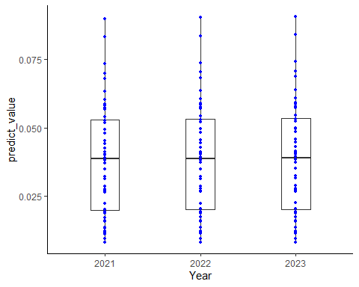

| Year | Mean_predict |
| --- | --- |
| 2021 | 0.0389 |
| 2022 | 0.0391 |
| 2023 | 0.0392 |