BBS Macaca Data Summary 2024
2025-12-15

資料統整

原始資料

調查日3/1~6/30間、包含非森林、包含50m以下
猴群數量
variable | Year | 宜蘭縣 | 臺北市 | 新北市 | 桃園市 | 苗栗縣 | 臺中市 | 南投縣 | 雲林縣 | 嘉義縣 | 臺南市 | 高雄市 | 屏東縣 | 花蓮縣 | 臺東縣 | Total
筆數 | 2015 | 6 |  |  |  | 1 | 6 | 6 | 8 | 1 |  | 2 | 3 | 13 | 2 | 48
筆數 | 2016 | 2 |  |  |  |  | 3 | 6 | 7 | 2 |  | 2 | 3 | 17 | 1 | 43
筆數 | 2017 |  |  |  |  |  | 2 | 5 | 7 | 1 |  | 4 | 6 | 5 | 2 | 32
筆數 | 2018 | 2 |  | 1 |  | 2 | 2 | 7 | 8 | 2 |  | 5 | 2 | 6 | 12 | 49
筆數 | 2019 | 1 |  |  | 1 | 2 | 3 | 11 | 7 | 1 | 1 | 2 | 1 | 13 | 16 | 59
筆數 | 2020 | 6 | 1 |  |  | 1 | 5 | 7 | 10 | 3 | 3 | 2 | 2 | 15 | 13 | 68
筆數 | 2021 |  | 1 | 3 |  | 2 | 6 | 8 | 10 | 7 | 1 | 5 | 5 | 11 | 11 | 70
筆數 | 2022 | 1 | 2 | 5 |  | 4 | 4 | 11 | 13 | 3 | 3 | 4 | 5 | 21 | 21 | 97
筆數 | 2023 | 3 | 4 | 4 |  | 7 | 6 | 10 | 11 | 7 |  | 13 | 3 | 13 | 8 | 89
筆數 | 2024 | 2 | 2 | 5 |  | 3 | 2 | 20 | 12 | 2 |  | 9 | 1 | 20 | 18 | 96
樣區數 | 2015 | 4 |  |  |  | 1 | 4 | 5 | 3 | 1 |  | 2 | 2 | 8 | 2 | 32
樣區數 | 2016 | 2 |  |  |  |  | 3 | 6 | 2 | 2 |  | 2 | 2 | 9 | 1 | 29
樣區數 | 2017 |  |  |  |  |  | 1 | 3 | 4 | 1 |  | 1 | 3 | 3 | 2 | 18
樣區數 | 2018 | 2 |  | 1 |  | 1 | 2 | 6 | 2 | 1 |  | 2 | 2 | 3 | 5 | 27
樣區數 | 2019 | 1 |  |  | 1 | 2 | 2 | 7 | 2 | 1 | 1 | 1 | 1 | 9 | 9 | 37
樣區數 | 2020 | 4 | 1 |  |  | 1 | 3 | 5 | 3 | 3 | 2 | 2 | 2 | 9 | 5 | 40
樣區數 | 2021 |  | 1 | 3 |  | 2 | 4 | 6 | 2 | 2 | 1 | 2 | 3 | 6 | 6 | 38
樣區數 | 2022 | 1 | 1 | 4 |  | 3 | 3 | 8 | 3 | 1 | 1 | 2 | 3 | 11 | 10 | 51
樣區數 | 2023 | 3 | 1 | 4 |  | 4 | 5 | 9 | 3 | 2 |  | 3 | 3 | 7 | 5 | 49
樣區數 | 2024 | 1 | 1 | 4 |  | 3 | 1 | 15 | 3 | 1 |  | 3 | 1 | 9 | 8 | 50
樣點數 | 2015 | 5 |  |  |  | 1 | 6 | 6 | 7 | 1 |  | 2 | 3 | 12 | 2 | 45
樣點數 | 2016 | 2 |  |  |  |  | 3 | 6 | 7 | 2 |  | 2 | 2 | 16 | 1 | 41
樣點數 | 2017 |  |  |  |  |  | 2 | 4 | 7 | 1 |  | 4 | 5 | 5 | 2 | 30
樣點數 | 2018 | 2 |  | 1 |  | 2 | 2 | 7 | 6 | 2 |  | 5 | 2 | 6 | 11 | 46
樣點數 | 2019 | 1 |  |  | 1 | 2 | 2 | 11 | 5 | 1 | 1 | 2 | 1 | 12 | 13 | 52
樣點數 | 2020 | 6 | 1 |  |  | 1 | 5 | 7 | 9 | 3 | 3 | 2 | 2 | 14 | 11 | 64
樣點數 | 2021 |  | 1 | 3 |  | 2 | 5 | 8 | 8 | 6 | 1 | 5 | 5 | 10 | 10 | 64
樣點數 | 2022 | 1 | 2 | 5 |  | 4 | 4 | 11 | 11 | 3 | 2 | 4 | 5 | 20 | 19 | 91
樣點數 | 2023 | 3 | 4 | 4 |  | 7 | 6 | 10 | 9 | 7 |  | 9 | 3 | 13 | 8 | 83
樣點數 | 2024 | 2 | 2 | 5 |  | 3 | 1 | 20 | 11 | 2 |  | 8 | 1 | 19 | 17 | 91

孤猴數量
variable | Year | 宜蘭縣 | 臺北市 | 新北市 | 桃園市 | 新竹縣 | 苗栗縣 | 臺中市 | 南投縣 | 雲林縣 | 嘉義縣 | 臺南市 | 高雄市 | 屏東縣 | 花蓮縣 | 臺東縣 | Total
筆數 | 2015 |  |  |  |  |  | 1 | 2 | 1 | 4 | 1 |  | 6 |  | 10 |  | 25
筆數 | 2016 | 1 |  |  |  |  |  |  | 1 |  |  |  | 5 | 3 | 3 | 1 | 14
筆數 | 2017 |  |  |  |  |  |  | 2 | 2 | 5 |  |  | 1 | 2 | 3 |  | 15
筆數 | 2018 |  |  |  |  |  |  | 3 | 3 | 2 | 2 |  |  | 1 | 5 | 4 | 20
筆數 | 2019 | 1 |  | 1 |  |  |  |  | 4 | 1 | 1 | 2 | 4 | 1 | 4 | 1 | 20
筆數 | 2020 | 1 |  |  |  | 1 |  | 6 | 5 | 1 | 4 | 1 | 7 | 3 | 3 | 3 | 35
筆數 | 2021 | 2 |  | 1 |  |  | 2 |  | 8 | 2 | 1 | 2 | 4 | 4 | 7 | 2 | 35
筆數 | 2022 | 2 |  | 3 |  |  |  |  | 10 | 2 |  | 3 | 4 | 3 | 7 | 5 | 39
筆數 | 2023 | 4 | 2 | 2 |  |  | 4 | 2 | 2 | 3 | 4 |  | 5 | 1 | 10 | 5 | 44
筆數 | 2024 | 3 |  | 3 | 1 |  | 4 |  | 5 | 2 | 3 |  | 1 | 6 | 9 | 4 | 41
樣區數 | 2015 |  |  |  |  |  | 1 | 2 | 1 | 2 | 1 |  | 2 |  | 6 |  | 15
樣區數 | 2016 | 1 |  |  |  |  |  |  | 1 |  |  |  | 3 | 2 | 3 | 1 | 11
樣區數 | 2017 |  |  |  |  |  |  | 2 | 2 | 2 |  |  | 1 | 1 | 3 |  | 11
樣區數 | 2018 |  |  |  |  |  |  | 3 | 3 | 2 | 1 |  |  | 1 | 4 | 4 | 18
樣區數 | 2019 | 1 |  | 1 |  |  |  |  | 3 | 1 | 1 | 1 | 4 | 1 | 3 | 1 | 17
樣區數 | 2020 | 1 |  |  |  | 1 |  | 2 | 5 | 1 | 3 | 1 | 4 | 2 | 2 | 2 | 24
樣區數 | 2021 | 2 |  | 1 |  |  | 2 |  | 7 | 2 | 1 | 1 | 3 | 3 | 5 | 2 | 29
樣區數 | 2022 | 2 |  | 2 |  |  |  |  | 9 | 2 |  | 1 | 2 | 3 | 4 | 3 | 28
樣區數 | 2023 | 3 | 2 | 2 |  |  | 4 | 2 | 2 | 3 | 2 |  | 4 | 1 | 7 | 3 | 35
樣區數 | 2024 | 3 |  | 2 | 1 |  | 2 |  | 5 | 2 | 2 |  | 1 | 2 | 7 | 4 | 31
樣點數 | 2015 |  |  |  |  |  | 1 | 2 | 1 | 4 | 1 |  | 6 |  | 8 |  | 23
樣點數 | 2016 | 1 |  |  |  |  |  |  | 1 |  |  |  | 4 | 3 | 3 | 1 | 13
樣點數 | 2017 |  |  |  |  |  |  | 2 | 2 | 5 |  |  | 1 | 2 | 3 |  | 15
樣點數 | 2018 |  |  |  |  |  |  | 3 | 3 | 2 | 2 |  |  | 1 | 5 | 4 | 20
樣點數 | 2019 | 1 |  | 1 |  |  |  |  | 3 | 1 | 1 | 1 | 4 | 1 | 4 | 1 | 18
樣點數 | 2020 | 1 |  |  |  | 1 |  | 4 | 5 | 1 | 4 | 1 | 7 | 3 | 3 | 3 | 33
樣點數 | 2021 | 2 |  | 1 |  |  | 2 |  | 8 | 2 | 1 | 2 | 4 | 4 | 7 | 2 | 35
樣點數 | 2022 | 2 |  | 3 |  |  |  |  | 10 | 2 |  | 3 | 3 | 3 | 7 | 5 | 38
樣點數 | 2023 | 4 | 2 | 2 |  |  | 4 | 2 | 2 | 3 | 4 |  | 5 | 1 | 10 | 5 | 44
樣點數 | 2024 | 3 |  | 3 | 1 |  | 4 |  | 5 | 2 | 3 |  | 1 | 6 | 9 | 4 | 41

分析用

調查日3/1~6/30間、“不”包含非森林、“不”包含50m以下
猴群數量
variable | Year | 宜蘭縣 | 臺北市 | 新北市 | 桃園市 | 苗栗縣 | 臺中市 | 南投縣 | 雲林縣 | 嘉義縣 | 臺南市 | 高雄市 | 屏東縣 | 花蓮縣 | 臺東縣 | Total
筆數 | 2015 | 5 |  |  |  | 1 | 6 | 6 | 8 |  |  | 2 | 3 | 12 | 2 | 45
筆數 | 2016 | 1 |  |  |  |  | 3 | 6 | 7 | 2 |  | 2 | 3 | 17 | 1 | 42
筆數 | 2017 |  |  |  |  |  |  | 5 | 7 | 1 |  | 4 | 5 | 5 | 2 | 29
筆數 | 2018 | 2 |  | 1 |  | 2 | 1 | 7 | 8 | 2 |  | 5 | 2 | 5 | 12 | 47
筆數 | 2019 |  |  |  | 1 | 2 | 3 | 11 | 7 | 1 | 1 | 2 | 1 | 12 | 15 | 56
筆數 | 2020 | 6 | 1 |  |  | 1 | 5 | 7 | 10 | 3 | 3 | 2 | 2 | 13 | 13 | 66
筆數 | 2021 |  | 1 | 3 |  | 2 | 5 | 7 | 10 | 7 | 1 | 3 | 5 | 11 | 11 | 66
筆數 | 2022 |  | 2 | 5 |  | 4 | 4 | 9 | 13 | 3 | 3 | 4 | 2 | 20 | 21 | 90
筆數 | 2023 | 3 | 4 | 4 |  | 7 | 5 | 10 | 11 | 7 |  | 12 | 2 | 13 | 8 | 86
筆數 | 2024 | 2 | 2 | 5 |  | 3 | 2 | 20 | 12 | 2 |  | 9 | 1 | 17 | 17 | 92
樣區數 | 2015 | 3 |  |  |  | 1 | 4 | 5 | 3 |  |  | 2 | 2 | 7 | 2 | 29
樣區數 | 2016 | 1 |  |  |  |  | 3 | 6 | 2 | 2 |  | 2 | 2 | 9 | 1 | 28
樣區數 | 2017 |  |  |  |  |  |  | 3 | 4 | 1 |  | 1 | 2 | 3 | 2 | 16
樣區數 | 2018 | 2 |  | 1 |  | 1 | 1 | 6 | 2 | 1 |  | 2 | 2 | 2 | 5 | 25
樣區數 | 2019 |  |  |  | 1 | 2 | 2 | 7 | 2 | 1 | 1 | 1 | 1 | 8 | 9 | 35
樣區數 | 2020 | 4 | 1 |  |  | 1 | 3 | 5 | 3 | 3 | 2 | 2 | 2 | 7 | 5 | 38
樣區數 | 2021 |  | 1 | 3 |  | 2 | 4 | 5 | 2 | 2 | 1 | 2 | 3 | 6 | 6 | 37
樣區數 | 2022 |  | 1 | 4 |  | 3 | 3 | 7 | 3 | 1 | 1 | 2 | 2 | 10 | 10 | 47
樣區數 | 2023 | 3 | 1 | 4 |  | 4 | 5 | 9 | 3 | 2 |  | 3 | 2 | 7 | 5 | 48
樣區數 | 2024 | 1 | 1 | 4 |  | 3 | 1 | 15 | 3 | 1 |  | 3 | 1 | 7 | 8 | 48
樣點數 | 2015 | 4 |  |  |  | 1 | 6 | 6 | 7 |  |  | 2 | 3 | 11 | 2 | 42
樣點數 | 2016 | 1 |  |  |  |  | 3 | 6 | 7 | 2 |  | 2 | 2 | 16 | 1 | 40
樣點數 | 2017 |  |  |  |  |  |  | 4 | 7 | 1 |  | 4 | 4 | 5 | 2 | 27
樣點數 | 2018 | 2 |  | 1 |  | 2 | 1 | 7 | 6 | 2 |  | 5 | 2 | 5 | 11 | 44
樣點數 | 2019 |  |  |  | 1 | 2 | 2 | 11 | 5 | 1 | 1 | 2 | 1 | 11 | 12 | 49
樣點數 | 2020 | 6 | 1 |  |  | 1 | 5 | 7 | 9 | 3 | 3 | 2 | 2 | 12 | 11 | 62
樣點數 | 2021 |  | 1 | 3 |  | 2 | 4 | 7 | 8 | 6 | 1 | 3 | 5 | 10 | 10 | 60
樣點數 | 2022 |  | 2 | 5 |  | 4 | 4 | 9 | 11 | 3 | 2 | 4 | 2 | 19 | 19 | 84
樣點數 | 2023 | 3 | 4 | 4 |  | 7 | 5 | 10 | 9 | 7 |  | 8 | 2 | 13 | 8 | 80
樣點數 | 2024 | 2 | 2 | 5 |  | 3 | 1 | 20 | 11 | 2 |  | 8 | 1 | 16 | 16 | 87

孤猴數量
variable | Year | 宜蘭縣 | 臺北市 | 新北市 | 桃園市 | 新竹縣 | 苗栗縣 | 臺中市 | 南投縣 | 雲林縣 | 嘉義縣 | 臺南市 | 高雄市 | 屏東縣 | 花蓮縣 | 臺東縣 | Total
筆數 | 2015 |  |  |  |  |  | 1 | 2 | 1 | 4 | 1 |  | 6 |  | 9 |  | 24
筆數 | 2016 | 1 |  |  |  |  |  |  | 1 |  |  |  | 5 | 2 | 2 |  | 11
筆數 | 2017 |  |  |  |  |  |  | 2 | 2 | 5 |  |  | 1 | 2 | 2 |  | 14
筆數 | 2018 |  |  |  |  |  |  | 3 | 2 | 2 | 2 |  |  | 1 | 4 | 4 | 18
筆數 | 2019 | 1 |  | 1 |  |  |  |  | 4 | 1 | 1 | 2 | 3 | 1 | 4 | 1 | 19
筆數 | 2020 | 1 |  |  |  | 1 |  | 6 | 5 | 1 | 4 | 1 | 6 | 3 | 1 | 3 | 32
筆數 | 2021 | 2 |  | 1 |  |  | 2 |  | 8 | 2 | 1 | 2 | 3 | 3 | 7 | 2 | 33
筆數 | 2022 | 1 |  | 2 |  |  |  |  | 9 | 2 |  | 3 | 4 | 3 | 6 | 5 | 35
筆數 | 2023 | 4 | 2 | 2 |  |  | 4 | 1 | 2 | 3 | 4 |  | 5 | 1 | 9 | 5 | 42
筆數 | 2024 | 3 |  | 2 | 1 |  | 4 |  | 5 | 1 | 3 |  | 1 | 6 | 9 | 4 | 39
樣區數 | 2015 |  |  |  |  |  | 1 | 2 | 1 | 2 | 1 |  | 2 |  | 5 |  | 14
樣區數 | 2016 | 1 |  |  |  |  |  |  | 1 |  |  |  | 3 | 1 | 2 |  | 8
樣區數 | 2017 |  |  |  |  |  |  | 2 | 2 | 2 |  |  | 1 | 1 | 2 |  | 10
樣區數 | 2018 |  |  |  |  |  |  | 3 | 2 | 2 | 1 |  |  | 1 | 3 | 4 | 16
樣區數 | 2019 | 1 |  | 1 |  |  |  |  | 3 | 1 | 1 | 1 | 3 | 1 | 3 | 1 | 16
樣區數 | 2020 | 1 |  |  |  | 1 |  | 2 | 5 | 1 | 3 | 1 | 3 | 2 | 1 | 2 | 22
樣區數 | 2021 | 2 |  | 1 |  |  | 2 |  | 7 | 2 | 1 | 1 | 2 | 2 | 5 | 2 | 27
樣區數 | 2022 | 1 |  | 2 |  |  |  |  | 8 | 2 |  | 1 | 2 | 3 | 3 | 3 | 25
樣區數 | 2023 | 3 | 2 | 2 |  |  | 4 | 1 | 2 | 3 | 2 |  | 4 | 1 | 6 | 3 | 33
樣區數 | 2024 | 3 |  | 1 | 1 |  | 2 |  | 5 | 1 | 2 |  | 1 | 2 | 7 | 4 | 29
樣點數 | 2015 |  |  |  |  |  | 1 | 2 | 1 | 4 | 1 |  | 6 |  | 7 |  | 22
樣點數 | 2016 | 1 |  |  |  |  |  |  | 1 |  |  |  | 4 | 2 | 2 |  | 10
樣點數 | 2017 |  |  |  |  |  |  | 2 | 2 | 5 |  |  | 1 | 2 | 2 |  | 14
樣點數 | 2018 |  |  |  |  |  |  | 3 | 2 | 2 | 2 |  |  | 1 | 4 | 4 | 18
樣點數 | 2019 | 1 |  | 1 |  |  |  |  | 3 | 1 | 1 | 1 | 3 | 1 | 4 | 1 | 17
樣點數 | 2020 | 1 |  |  |  | 1 |  | 4 | 5 | 1 | 4 | 1 | 6 | 3 | 1 | 3 | 30
樣點數 | 2021 | 2 |  | 1 |  |  | 2 |  | 8 | 2 | 1 | 2 | 3 | 3 | 7 | 2 | 33
樣點數 | 2022 | 1 |  | 2 |  |  |  |  | 9 | 2 |  | 3 | 3 | 3 | 6 | 5 | 34
樣點數 | 2023 | 4 | 2 | 2 |  |  | 4 | 1 | 2 | 3 | 4 |  | 5 | 1 | 9 | 5 | 42
樣點數 | 2024 | 3 |  | 2 | 1 |  | 4 |  | 5 | 1 | 3 |  | 1 | 6 | 9 | 4 | 39

2015 ~ 2024 年間，每年位在海拔50 m以上森林的調查樣點數、臺灣獼猴( Macaca cyclopis )的猴群數及相對密度
TypeName.1 | 樣點數 |  | 猴群數 |  | 相對密度
TypeName.1 | Mean | Se | Mean | Se | Mean | Se
2015 | 1503.5 | 36.5 | 22.5 | 0.5 | 0.0150 | 0.0000
2016 | 1422.0 | 63.0 | 21.0 | 4.0 | 0.0149 | 0.0035
2017 | 1327.0 | 30.0 | 14.5 | 2.5 | 0.0110 | 0.0021
2018 | 1474.5 | 57.5 | 23.5 | 3.5 | 0.0161 | 0.0030
2019 | 1388.0 | 35.0 | 28.0 | 4.0 | 0.0201 | 0.0024
2020 | 1583.0 | 37.0 | 33.0 | 2.0 | 0.0208 | 0.0008
2021 | 1490.5 | 195.5 | 33.0 | 1.0 | 0.0224 | 0.0023
2022 | 1758.0 | 60.0 | 45.0 | 1.0 | 0.0256 | 0.0014
2023 | 1854.0 | 84.0 | 43.0 | 12.0 | 0.0229 | 0.0054
2024 | 1897.0 | 54.0 | 46.0 | 8.0 | 0.0241 | 0.0035

2015 ~ 2024 年位在海拔50 m以上森林的調查樣點數、臺灣獼猴( Macaca cyclopis )的猴群數及相對密度
TypeName.1 | 樣點數 |  | 猴群數 |  | 相對密度
TypeName.1 | Mean | Se | Mean | Se | Mean | Se
North | 545.7 | 26.8 | 3.5 | 0.8 | 0.0059 | 0.0010
Center | 501.6 | 13.3 | 6.1 | 0.6 | 0.0120 | 0.0010
South | 145.1 | 7.3 | 3.5 | 0.4 | 0.0248 | 0.0028
Southwest | 142.2 | 2.8 | 6.4 | 0.7 | 0.0460 | 0.0049
Hualien | 154.1 | 2.8 | 6.2 | 0.8 | 0.0402 | 0.0048
Taitung | 81.2 | 5.1 | 5.1 | 0.8 | 0.0591 | 0.0087
TW | 1569.8 | 47.1 | 30.9 | 2.7 | 0.0193 | 0.0012

2015 ~ 2024年各森林類型內的調查樣點數、臺灣獼猴( Macaca cyclopis )的猴群數及相對密度
TypeName.1 | 樣點數 |  | 猴群數 |  | 相對密度
TypeName.1 | Mean | Se | Mean | Se | Mean | Se
Forest (EL>50m) | 1569.8 | 47.1 | 31.0 | 2.7 | 0.0193 | 0.0012
闊葉林 | 1082.0 | 35.7 | 21.2 | 2.1 | 0.0190 | 0.0014
針葉林 | 148.8 | 5.8 | 2.2 | 0.2 | 0.0153 | 0.0016
混淆林 | 166.0 | 3.4 | 4.0 | 0.5 | 0.0243 | 0.0033
竹林 | 172.9 | 4.7 | 3.5 | 0.5 | 0.0203 | 0.0031
Forest (EL<50m) | 202.6 | 8.4 | 0.6 | 0.2 | 0.0027 | 0.0008
非森林 | 1197.2 | 92.5 | 0.7 | 0.2 | 0.0005 | 0.0002
Total | 2809.4 | 213.2 | 29.3 | 3.2 | 0.0093 | 0.0009

年的相對密度
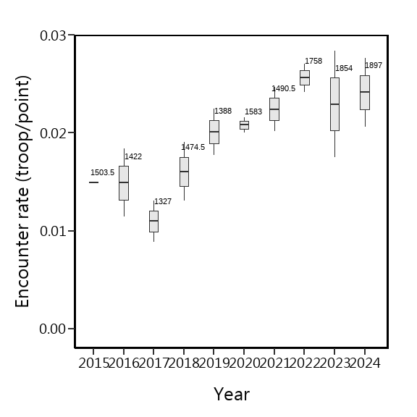

Region的相對密度
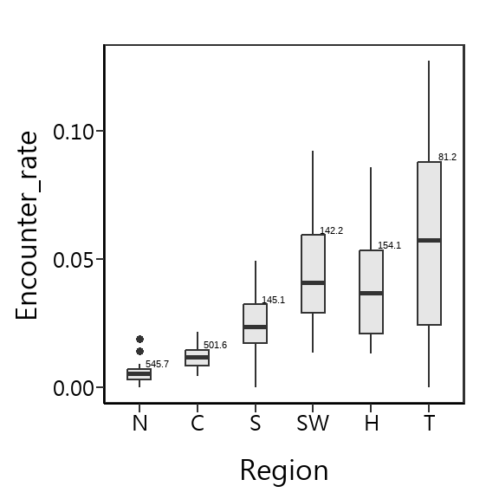

森林類型的相對密度
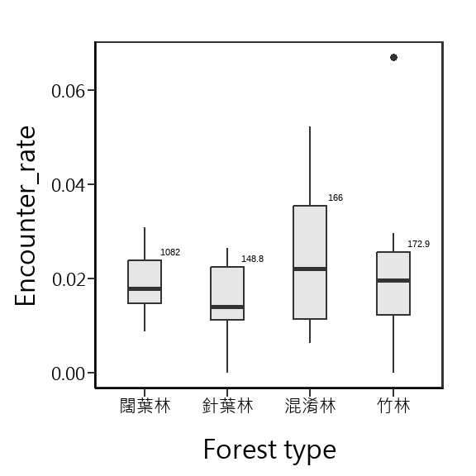

海拔的相對密度
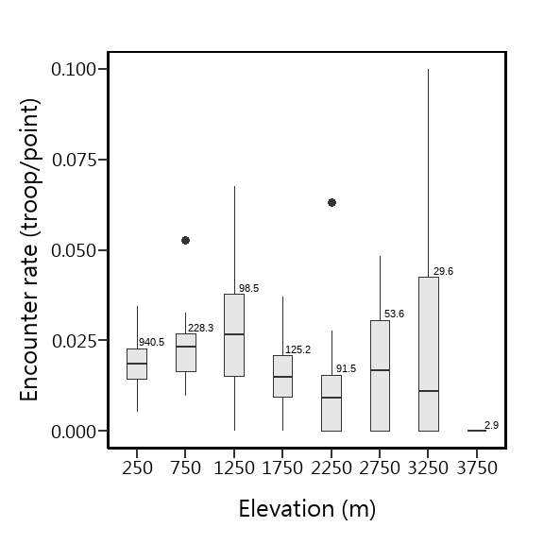

Julian Day的相對密度
Julian Day = 60，係指第60~74天，Julian Day = 75，係指第75~89天，以此類推，僅Julian Day = 180，係指第180~182天
