con <- dbConnect(RSQLite::SQLite(), dbname="D:/R/test/DB/P_BBS.db")
list_Point<-
dbReadTable(con, "list_Point") %>%
arrange(樣區編號, 獼猴樣區編號,as.numeric(樣點代號))
list_Site<-
dbReadTable(con, "list_Site")
table_point<-
dbReadTable(con, "table_point")
dbDisconnect(con)
M.data <- read_excel(here("./data/clean/for analysis_1524.xlsx"),
sheet=1) %>%
filter(analysis %in% "Y") %>%
mutate_at(c("Year", "Survey", "Point", "Macaca_sur",
"Month", "Day", "Distance"), as.numeric)%>%
st_as_sf(., coords = c("X_97", "Y_97"),crs=3826) %>%
st_join(., ecoregion3) %>%
st_drop_geometry() %>%
mutate(ZONE41 = as.character(ZONE41)) %>%
mutate(Region = case_when(
as.numeric(Altitude) <1000 & ZONE41 %in% "1" ~ "North",
as.numeric(Altitude) <1000 & ZONE41 %in% "2" ~ "East",
as.numeric(Altitude) <1000 & ZONE41 %in% "3" ~ "West",
as.numeric(Altitude) >= 1000 ~ "Mountain"
))%>%
right_join(list_Site[,c('SiteID', '樣區編號','獼猴樣區編號')], .,
by = c("樣區編號" = "Site_N"))

全島
Goodness of fit:
## Goodness of fit:
## Chi-square = 1956.70, df=2027, p=0.8658
## Likelihood Ratio = 1955.38, df=2027, p=0.8703
## AIC (up to a constant) = -2098.62
wald
Wald test for significance of covariates
Covariate | Wald_test | df | p
Region | 11.1279 | 9 | 0.2670
Wald test for significance of changes in slope
Changepoint | Wald_test | df | p
2021 | 1.640 | 4 | 0.802
2022 | 2.483 | 4 | 0.648
2023 | 5.483 | 4 | 0.241
Index
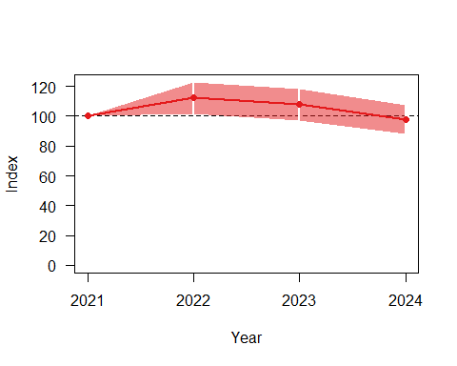
Overall
## from upto add se_add mul se_mul p meaning
## 2021 2024 -0.01063976 0.03105911 0.9894166 0.0307304 0.7645784 Uncertain
from | upto | add | se_add | mul | se_mul | p | meaning
2021 | 2024 | -0.011 | 0.031 | 0.989 | 0.031 | 0.765 | Uncertain
overall
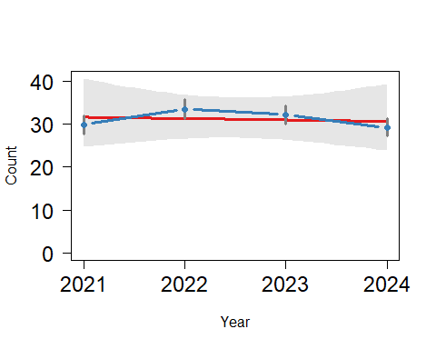

海拔50-250m
path <- "D:/R/SHP圖層"
ELE_50250 <- st_read(paste0(path,"/","0_自製/局部海拔/ELE_50~250.shp"), crs=3826) %>%
st_transform(crs=3826) %>%
mutate(ELE = "50-250")
## Reading layer `ELE_50~250' from data source
## `D:\R\SHP圖層\0_自製\局部海拔\ELE_50~250.shp' using driver `ESRI Shapefile'
## Simple feature collection with 1 feature and 1 field
## Geometry type: MULTIPOLYGON
## Dimension: XY
## Bounding box: xmin: 166832.6 ymin: 2423010 xmax: 351224.2 ymax: 2798677
## Projected CRS: TWD97 / TM2 zone 121
summary(ELE_50250)
## ELEV geometry ELE
## Min. :50 MULTIPOLYGON :1 Length:1
## 1st Qu.:50 epsg:3826 :0 Class :character
## Median :50 +proj=tmer...:0 Mode :character
## Mean :50
## 3rd Qu.:50
## Max. :50
ELE250_list_Point <-
list_Point %>%
filter(!is.na(X_97)) %>%
st_as_sf(., coords = c("X_97", "Y_97"), crs = 3826) %>%
st_join(.,ELE_50250) %>%
st_drop_geometry() %>%
filter(!is.na(ELE))
Goodness of fit:
## Goodness of fit:
## Chi-square = 506.26, df=545, p=0.8814
## Likelihood Ratio = 514.85, df=545, p=0.8186
## AIC (up to a constant) = -575.15
wald
Wald test for significance of covariates
Covariate | Wald_test | df | p
Region | 7.3973 | 6 | 0.2857
Wald test for significance of changes in slope
Changepoint | Wald_test | df | p
2021 | 1.342 | 3 | 0.719
2022 | 2.890 | 3 | 0.409
2023 | 6.186 | 3 | 0.103
Index
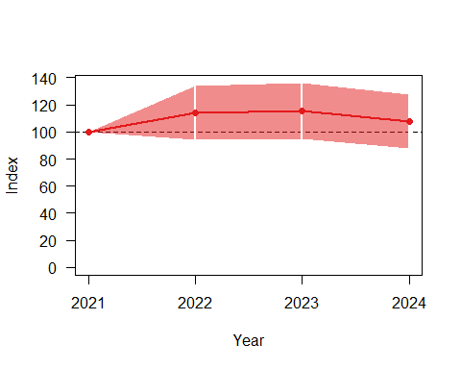
Overall
## from upto add se_add mul se_mul p meaning
## 2021 2024 0.02339424 0.0582532 1.02367 0.05963206 0.7268296 Uncertain
from | upto | add | se_add | mul | se_mul | p | meaning
2021 | 2024 | 0.023 | 0.058 | 1.024 | 0.060 | 0.727 | Uncertain
overall
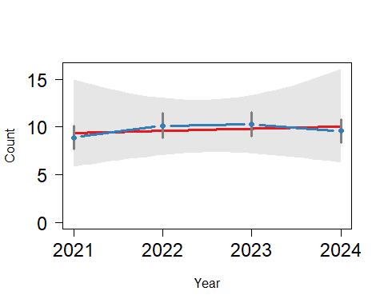

海拔50-500m
path <- "D:/R/SHP圖層"
ELE_50500 <- st_read(paste0(path,"/","0_自製/局部海拔/ELE_50~500.shp"), crs=3826) %>%
st_transform(crs=3826) %>%
mutate(ELE = "50-500")
## Reading layer `ELE_50~500' from data source
## `D:\R\SHP圖層\0_自製\局部海拔\ELE_50~500.shp' using driver `ESRI Shapefile'
## Simple feature collection with 1 feature and 1 field
## Geometry type: MULTIPOLYGON
## Dimension: XY
## Bounding box: xmin: 166832.6 ymin: 2423010 xmax: 351224.2 ymax: 2798677
## Projected CRS: TWD97 / TM2 zone 121
summary(ELE_50500)
## ELEV geometry ELE
## Min. :50 MULTIPOLYGON :1 Length:1
## 1st Qu.:50 epsg:3826 :0 Class :character
## Median :50 +proj=tmer...:0 Mode :character
## Mean :50
## 3rd Qu.:50
## Max. :50
ELE500_list_Point <-
list_Point %>%
filter(!is.na(X_97)) %>%
st_as_sf(., coords = c("X_97", "Y_97"), crs = 3826) %>%
st_join(.,ELE_50500) %>%
st_drop_geometry() %>%
filter(!is.na(ELE))
Goodness of fit:
## Goodness of fit:
## Chi-square = 996.97, df=1061, p=0.9199
## Likelihood Ratio = 1011.63, df=1061, p=0.8587
## AIC (up to a constant) = -1110.37
wald
Wald test for significance of covariates
Covariate | Wald_test | df | p
Region | 8.5820 | 6 | 0.1985
Wald test for significance of changes in slope
Changepoint | Wald_test | df | p
2021 | 2.385 | 3 | 0.496
2022 | 4.239 | 3 | 0.237
2023 | 8.035 | 3 | 0.045
Index
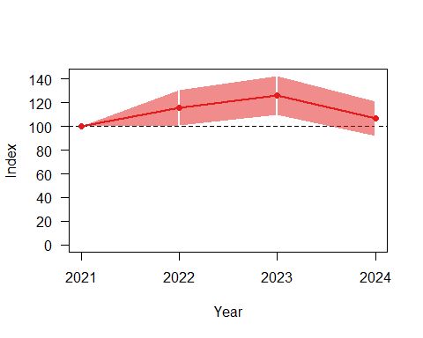
Overall
## from upto add se_add mul se_mul p meaning
## 2021 2024 0.02706592 0.0436136 1.027436 0.04481016 0.5981672 Uncertain
from | upto | add | se_add | mul | se_mul | p | meaning
2021 | 2024 | 0.027 | 0.044 | 1.027 | 0.045 | 0.598 | Uncertain
overall
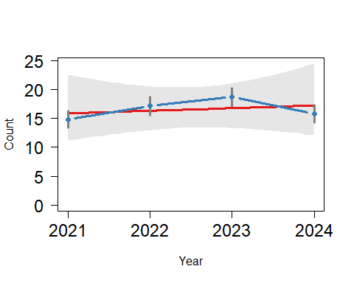

海拔50-1000m
path <- "D:/R/SHP圖層"
ELE_501000 <- st_read(paste0(path,"/","0_自製/局部海拔/ELE_50~1000.shp"), crs=3826) %>%
st_transform(crs=3826) %>%
mutate(ELE = "50-1000")
## Reading layer `ELE_50~1000' from data source
## `D:\R\SHP圖層\0_自製\局部海拔\ELE_50~1000.shp' using driver `ESRI Shapefile'
## Simple feature collection with 1 feature and 1 field
## Geometry type: MULTIPOLYGON
## Dimension: XY
## Bounding box: xmin: 166832.6 ymin: 2423010 xmax: 351224.2 ymax: 2798677
## Projected CRS: TWD97 / TM2 zone 121
summary(ELE_501000)
## ELEV geometry ELE
## Min. :50 MULTIPOLYGON :1 Length:1
## 1st Qu.:50 epsg:3826 :0 Class :character
## Median :50 +proj=tmer...:0 Mode :character
## Mean :50
## 3rd Qu.:50
## Max. :50
ELE1000_list_Point <-
list_Point %>%
filter(!is.na(X_97)) %>%
st_as_sf(., coords = c("X_97", "Y_97"), crs = 3826) %>%
st_join(.,ELE_501000) %>%
st_drop_geometry() %>%
filter(!is.na(ELE))
Goodness of fit:
## Goodness of fit:
## Chi-square = 1483.69, df=1550, p=0.8842
## Likelihood Ratio = 1490.59, df=1550, p=0.8574
## AIC (up to a constant) = -1609.41
wald
Wald test for significance of covariates
Covariate | Wald_test | df | p
Region | 8.3838 | 6 | 0.2113
Wald test for significance of changes in slope
Changepoint | Wald_test | df | p
2021 | 1.172 | 3 | 0.760
2022 | 1.287 | 3 | 0.732
2023 | 5.483 | 3 | 0.140
Index
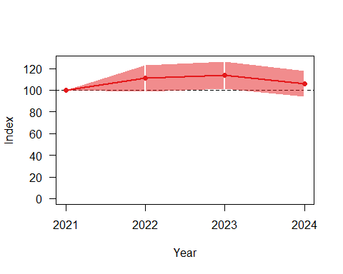
Overall
## from upto add se_add mul se_mul p meaning
## 2021 2024 0.01959842 0.03552305 1.019792 0.03622611 0.6365594 Uncertain
from | upto | add | se_add | mul | se_mul | p | meaning
2021 | 2024 | 0.020 | 0.036 | 1.020 | 0.036 | 0.637 | Uncertain
overall
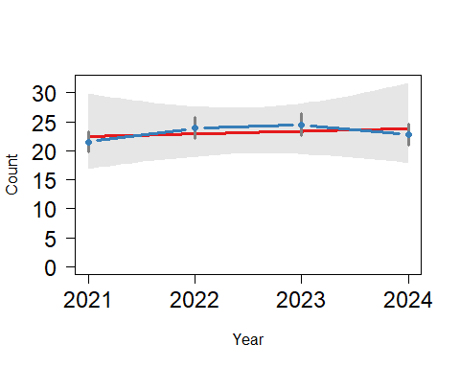

林班地
path <- "D:/R/SHP圖層"
Foresty_up50 <- st_read(paste0(path,"/","0_自製/海拔50公尺以的林班地/Foresty_up50.shp"), crs=3826) %>%
st_transform(crs=3826) %>%
mutate(range = "Foresty")
## Reading layer `Foresty_up50' from data source
## `D:\R\SHP圖層\0_自製\海拔50公尺以的林班地\Foresty_up50.shp'
## using driver `ESRI Shapefile'
## Simple feature collection with 1 feature and 1 field
## Geometry type: MULTIPOLYGON
## Dimension: XY
## Bounding box: xmin: 182507.4 ymin: 2423010 xmax: 351091.4 ymax: 2766881
## Projected CRS: TWD97 / TM2 zone 121
summary(Foresty_up50)
## ELEV geometry range
## Min. :50 MULTIPOLYGON :1 Length:1
## 1st Qu.:50 epsg:3826 :0 Class :character
## Median :50 +proj=tmer...:0 Mode :character
## Mean :50
## 3rd Qu.:50
## Max. :50
Foresty_up50_list_Point <-
list_Point %>%
filter(!is.na(X_97)) %>%
st_as_sf(., coords = c("X_97", "Y_97"), crs = 3826) %>%
st_join(.,Foresty_up50) %>%
st_drop_geometry() %>%
filter(!is.na(range))
Goodness of fit:
## Goodness of fit:
## Chi-square = 1032.58, df=1063, p=0.7427
## Likelihood Ratio = 1025.50, df=1063, p=0.7906
## AIC (up to a constant) = -1100.50
wald
Wald test for significance of covariates
Covariate | Wald_test | df | p
Region | 4.1207 | 9 | 0.9033
Wald test for significance of changes in slope
Changepoint | Wald_test | df | p
2021 | 5.157 | 4 | 0.272
2022 | 3.622 | 4 | 0.460
2023 | 1.362 | 4 | 0.851
Index
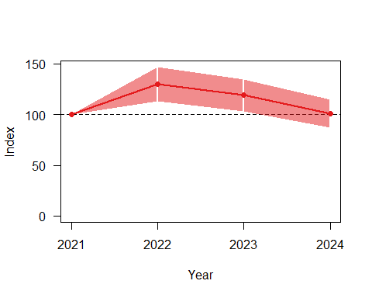
Overall
## from upto add se_add mul se_mul p meaning
## 2021 2024 -0.00556723 0.04290923 0.9944482 0.04267101 0.9086406 Uncertain
from | upto | add | se_add | mul | se_mul | p | meaning
2021 | 2024 | -0.006 | 0.043 | 0.994 | 0.043 | 0.909 | Uncertain
overall
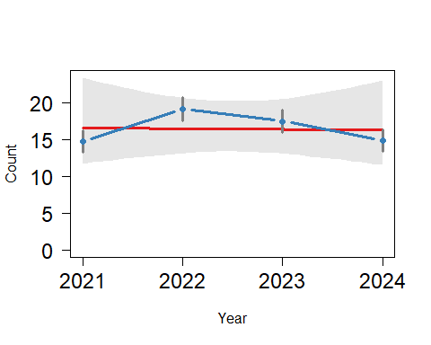

非林班地
path <- "D:/R/SHP圖層"
NotForesty_up50 <- st_read(paste0(path,"/","0_自製/海拔50公尺以的非林班地/NotForesty_up50.shp"), crs=3826) %>%
st_transform(crs=3826) %>%
mutate(range = "NotForesty")
## Reading layer `NotForesty_up50' from data source
## `D:\R\SHP圖層\0_自製\海拔50公尺以的非林班地\NotForesty_up50.shp'
## using driver `ESRI Shapefile'
## Simple feature collection with 1 feature and 1 field
## Geometry type: MULTIPOLYGON
## Dimension: XY
## Bounding box: xmin: 166832.6 ymin: 2423012 xmax: 351224.2 ymax: 2798677
## Projected CRS: TWD97 / TM2 zone 121
summary(NotForesty_up50)
## ELEV geometry range
## Min. :50 MULTIPOLYGON :1 Length:1
## 1st Qu.:50 epsg:3826 :0 Class :character
## Median :50 +proj=tmer...:0 Mode :character
## Mean :50
## 3rd Qu.:50
## Max. :50
NotForesty_up50_list_Point <-
list_Point %>%
filter(!is.na(X_97)) %>%
st_as_sf(., coords = c("X_97", "Y_97"), crs = 3826) %>%
st_join(.,Foresty_up50) %>%
st_drop_geometry() %>%
filter(is.na(range))
Goodness of fit:
## Goodness of fit:
## Chi-square = 922.05, df=952, p=0.7512
## Likelihood Ratio = 916.81, df=952, p=0.7885
## AIC (up to a constant) = -987.19
wald
Wald test for significance of covariates
Covariate | Wald_test | df | p
Region | 16.5613 | 9 | 0.0560
Wald test for significance of changes in slope
Changepoint | Wald_test | df | p
2021 | 1.874 | 4 | 0.759
2022 | 3.608 | 4 | 0.462
2023 | 8.338 | 4 | 0.080
Index
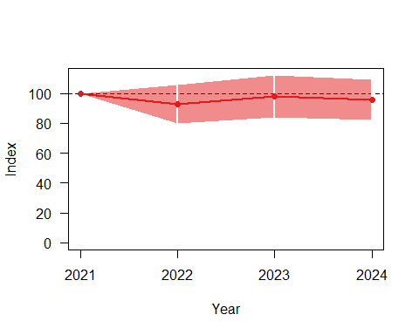
Overall
## from upto add se_add mul se_mul p meaning
## 2021 2024 -0.00786362 0.04549192 0.9921672 0.04513559 0.8786742 Uncertain
from | upto | add | se_add | mul | se_mul | p | meaning
2021 | 2024 | -0.008 | 0.045 | 0.992 | 0.045 | 0.879 | Uncertain
overall
