全島
Goodness of fit:
## Goodness of fit:
## Chi-square = 1956.70, df=2027, p=0.8658
## Likelihood Ratio = 1955.38, df=2027, p=0.8703
## AIC (up to a constant) = -2098.62
wald
Wald test for significance of changes in slope
Changepoint | Wald_test | df | p
2021 | 1.640 | 4 | 0.802
2022 | 2.483 | 4 | 0.648
2023 | 5.483 | 4 | 0.241
Index
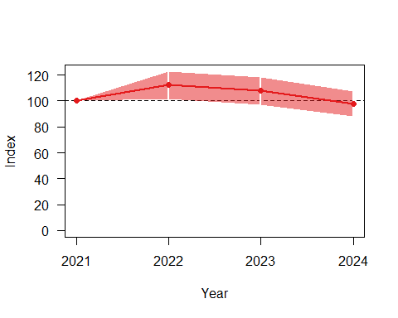
Overall
from | upto | add | se_add | mul | se_mul | p | meaning
2021 | 2024 | -0.011 | 0.031 | 0.989 | 0.031 | 0.765 | Uncertain

海拔50-250m
Goodness of fit:
## Goodness of fit:
## Chi-square = 506.26, df=545, p=0.8814
## Likelihood Ratio = 514.85, df=545, p=0.8186
## AIC (up to a constant) = -575.15
wald
Wald test for significance of changes in slope
Changepoint | Wald_test | df | p
2021 | 1.342 | 3 | 0.719
2022 | 2.890 | 3 | 0.409
2023 | 6.186 | 3 | 0.103
Index
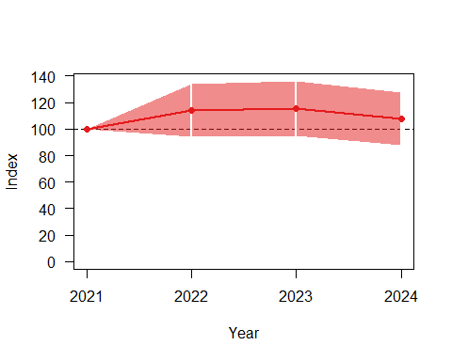
Overall
from | upto | add | se_add | mul | se_mul | p | meaning
2021 | 2024 | 0.023 | 0.058 | 1.024 | 0.060 | 0.727 | Uncertain

海拔50-500m
Goodness of fit:
## Goodness of fit:
## Chi-square = 996.97, df=1061, p=0.9199
## Likelihood Ratio = 1011.63, df=1061, p=0.8587
## AIC (up to a constant) = -1110.37
Wald test for significance of changes in slope
Changepoint | Wald_test | df | p
2021 | 2.385 | 3 | 0.496
2022 | 4.239 | 3 | 0.237
2023 | 8.035 | 3 | 0.045
Index
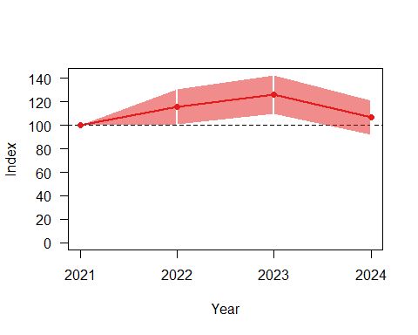
Overall
from | upto | add | se_add | mul | se_mul | p | meaning
2021 | 2024 | 0.027 | 0.044 | 1.027 | 0.045 | 0.598 | Uncertain

海拔50-1000m
Goodness of fit:
## Goodness of fit:
## Chi-square = 1483.69, df=1550, p=0.8842
## Likelihood Ratio = 1490.59, df=1550, p=0.8574
## AIC (up to a constant) = -1609.41
wald
Wald test for significance of changes in slope
Changepoint | Wald_test | df | p
2021 | 1.172 | 3 | 0.760
2022 | 1.287 | 3 | 0.732
2023 | 5.483 | 3 | 0.140
Index
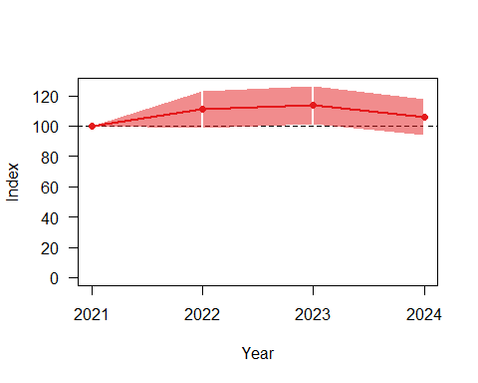
Overall
from | upto | add | se_add | mul | se_mul | p | meaning
2021 | 2024 | 0.020 | 0.036 | 1.020 | 0.036 | 0.637 | Uncertain

林班地
Goodness of fit:
## Goodness of fit:
## Chi-square = 1032.58, df=1063, p=0.7427
## Likelihood Ratio = 1025.50, df=1063, p=0.7906
## AIC (up to a constant) = -1100.50
wald
Wald test for significance of changes in slope
Changepoint | Wald_test | df | p
2021 | 5.157 | 4 | 0.272
2022 | 3.622 | 4 | 0.460
2023 | 1.362 | 4 | 0.851
Index
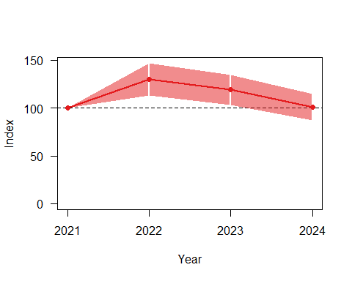
Overall
from | upto | add | se_add | mul | se_mul | p | meaning
2021 | 2024 | -0.006 | 0.043 | 0.994 | 0.043 | 0.909 | Uncertain

非林班地
Goodness of fit:
## Goodness of fit:
## Chi-square = 922.05, df=952, p=0.7512
## Likelihood Ratio = 916.81, df=952, p=0.7885
## AIC (up to a constant) = -987.19
wald
Wald test for significance of changes in slope
Changepoint | Wald_test | df | p
2021 | 1.874 | 4 | 0.759
2022 | 3.608 | 4 | 0.462
2023 | 8.338 | 4 | 0.080
Index
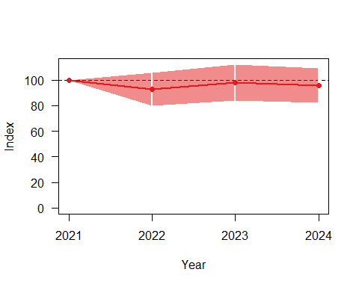
Overall
from | upto | add | se_add | mul | se_mul | p | meaning
2021 | 2024 | -0.008 | 0.045 | 0.992 | 0.045 | 0.879 | Uncertain

