猴群數估算
2026-04-27
con <- dbConnect(RSQLite::SQLite(), dbname="D:/R/test/DB/P_BBS.db")
list_Point<-
dbReadTable(con, "list_Point") %>%
arrange(樣區編號, 獼猴樣區編號,as.numeric(樣點代號))
list_Site<-
dbReadTable(con, "list_Site")
table_point<-
dbReadTable(con, "table_point")
dbDisconnect(con)
forest_town<- read_xlsx(
here("合併估算_20260424/鄉鎮內50m以上的森林面積.xlsx")) %>%
select(-perimeter) %>%
mutate(area = area/1000000) %>% #換成km2
setDT
se <- function(x){sd(x)/sqrt(length(x))}
per_Area <- (0.1*0.1*pi) #100m(=0.1km)半徑的單位原面積

BBS
相對密度(群/樣點)圖

林業署
相對密度(群/樣點)
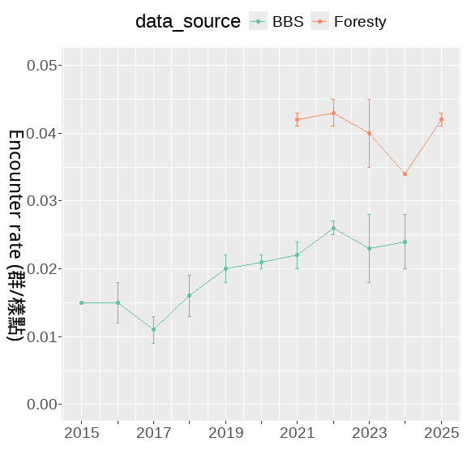
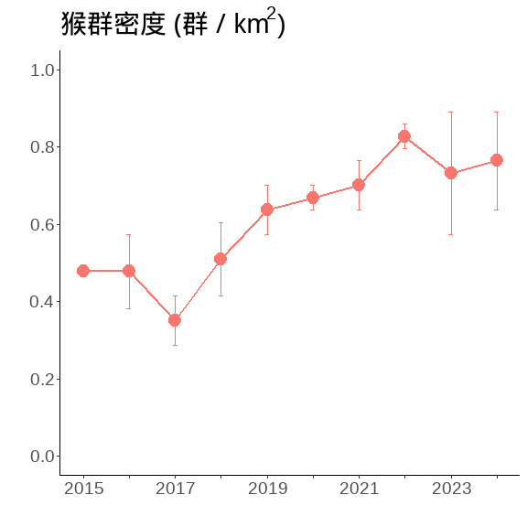
相對密度(群/樣點)
combine_bb_outout <-
E_year_F %>% mutate(data_source = "Foresty") %>%
bind_rows(E_year %>% mutate(data_source = "BBS"))
combine_bb_outout
## Year Mean_N SD_N Mean_m SD_m Mean_E SD_E data_source
## <num> <num> <num> <num> <num> <num> <num> <char>
## 1: 2021 2136.0 33.0 89.5 2.5 0.042 0.001 Foresty
## 2: 2022 2188.5 44.5 95.0 3.0 0.043 0.002 Foresty
## 3: 2023 2209.5 31.5 89.0 12.0 0.040 0.005 Foresty
## 4: 2024 2249.0 43.0 75.5 1.5 0.034 0.000 Foresty
## 5: 2025 2280.0 39.0 96.0 1.0 0.042 0.001 Foresty
## 6: 2015 1503.5 36.5 22.5 0.5 0.015 0.000 BBS
## 7: 2016 1422.0 63.0 21.0 4.0 0.015 0.003 BBS
## 8: 2017 1327.0 30.0 14.5 2.5 0.011 0.002 BBS
## 9: 2018 1474.5 57.5 23.5 3.5 0.016 0.003 BBS
## 10: 2019 1388.0 35.0 28.0 4.0 0.020 0.002 BBS
## 11: 2020 1583.0 37.0 33.0 2.0 0.021 0.001 BBS
## 12: 2021 1490.5 195.5 33.0 1.0 0.022 0.002 BBS
## 13: 2022 1758.0 60.0 45.0 1.0 0.026 0.001 BBS
## 14: 2023 1854.0 84.0 43.0 12.0 0.023 0.005 BBS
## 15: 2024 1897.0 54.0 46.0 8.0 0.024 0.004 BBS
#合併檢測————–
合併及擷取2021~2024的資料
combine_bb <-
bb_F %>%
select(SiteID,Year, 樣區編號,獼猴樣區編號, Point, Survey, Macaca_sur, Macaca_dist,AB) %>%
mutate(data_source = "Foresty") %>%
bind_rows(
bb %>%
select(SiteID,Year, 樣區編號,獼猴樣區編號, Point, Survey,
Macaca_sur, Macaca_dist,AB)%>%
mutate(data_source = "BBS") %>%
mutate(Point = Point %>% as.character()) %>%
anti_join(bb_F[, c('SiteID','Year')],
by = c('SiteID','Year'))
) %>%
filter(Year %in% c(2021:2024))
相對密度(群/樣點)
combine_bb%>%
setDT %>%
.[, .(N = length(Macaca_sur)
),
by = c('Year', 'Survey', 'data_source')] %>%
.[, .(
Mean_N = mean(N)%>% round(3)),
by = c('Year', 'data_source')] %>%
pivot_wider(id_cols = "Year",
names_from = "data_source",
values_from = "Mean_N")
## # A tibble: 4 × 3
## Year Foresty BBS
## <dbl> <dbl> <dbl>
## 1 2021 2136 1335
## 2 2022 2188. 1506
## 3 2023 2210. 1630.
## 4 2024 2249 1662
藍色數字為平均樣區數
combine_bb %>%
setDT %>%
.[, .(N = length(Macaca_sur),
m = sum(Macaca_sur, na.rm=T)
),
by = c('Year', 'Survey')] %>%
.[,E_km2 := m/N/per_Area] %>%
.[, Mean_N := mean(N), by = c('Year')] %>%
ggplot(., aes(x = as.character(Year), y = E_km2))+
geom_boxplot(width = 0.3, linewidth = 0.4, fill= gray(.9))+
stat_summary(fun = mean, geom = "text",
aes(label = round(Mean_N, 2)),
position = position_nudge(x = 0, y = 0.21),
# hjust = 0.3,
# vjust = -5,
color = "blue")+
scale_y_continuous(breaks = seq(0,1.5,0.5), limits = c(0,1.5))+
labs(x = "", y = expression(paste("猴群密度 (群 / km"^2,")")))+
theme(
panel.border = element_rect(linewidth = 1.5,fill = NA),
panel.grid = element_blank(),
panel.background = element_blank(),
axis.text = element_text(size = 20,colour = "black"),
axis.title = element_text(size = 18,colour = "black"),
axis.title.y = element_text(angle = 270,
vjust = -1, hjust = 0.5),
legend.position = "top"
)
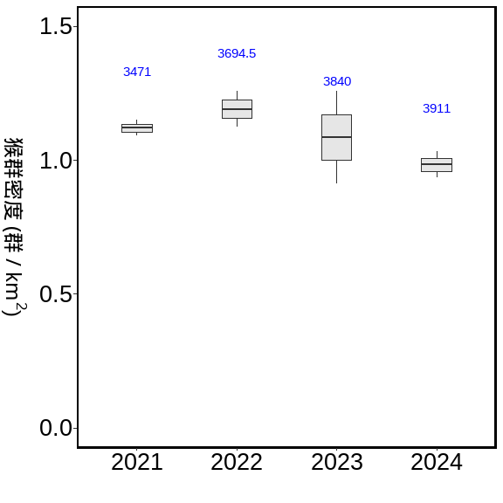
combine_bb %>%
setDT %>%
.[, .(N = length(Macaca_sur),
m = sum(Macaca_sur, na.rm=T)
),
by = c('Year', 'Survey', 'data_source')] %>%
.[,Encounter_rate := m/N] %>%
.[, Mean_N := mean(N), by = c('Year','data_source')] %>%
ggplot(., aes(x = as.character(Year), y = Encounter_rate))+
geom_boxplot( aes(fill= data_source))
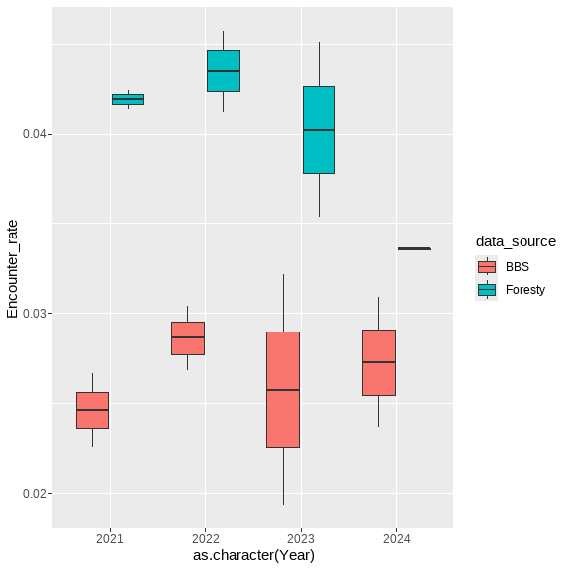
path <- "D:/R/SHP圖層"
town <- st_read(paste0(path,"/","鄉(鎮、市、區)界線(TWD97經緯度)1131028/TOWN_MOI_1131028.shp"), crs=4326) %>%
st_transform(crs=3826)
## Reading layer `TOWN_MOI_1131028' from data source
## `D:\R\SHP圖層\鄉(鎮、市、區)界線(TWD97經緯度)1131028\TOWN_MOI_1131028.shp'
## using driver `ESRI Shapefile'
## Simple feature collection with 368 features and 7 fields
## Geometry type: MULTIPOLYGON
## Dimension: XY
## Bounding box: xmin: 114.3593 ymin: 10.37135 xmax: 124.5612 ymax: 26.38528
## Geodetic CRS: WGS 84
summary(town)
## TOWNID TOWNCODE COUNTYNAME TOWNNAME
## Length:368 Length:368 Length:368 Length:368
## Class :character Class :character Class :character Class :character
## Mode :character Mode :character Mode :character Mode :character
## TOWNENG COUNTYID COUNTYCODE geometry
## Length:368 Length:368 Length:368 MULTIPOLYGON :368
## Class :character Class :character Class :character epsg:3826 : 0
## Mode :character Mode :character Mode :character +proj=tmer...: 0
town_list_Point <-
list_Point %>%
filter(!is.na(X_97)) %>%
st_as_sf(., coords = c("X_97", "Y_97"), crs = 3826) %>%
st_join(.,town) %>%
st_drop_geometry()
town_combine_bb <-
town_list_Point %>%
right_join(.,combine_bb,
by = c("樣區編號","獼猴樣區編號", "樣點代號"="Point"))
#2021~2024年的調查資料
summary__combine <-
town_combine_bb %>%
group_by( Year, Survey) %>%
summarise(N = PointID %>% unique() %>% length,
m = AB %>% sum,
E = m / N,
E_km2 = m / N/per_Area,
.groups = 'drop') %>%
group_by(Year) %>%
summarise(Mean_N = mean(N),
Se_N = se(N),
Mean_m = mean(m),
Se_m = se(m),
Mean_E = mean(E) ,
Se_E = se(E),
Mean_E_km2 = mean(E_km2) ,
Se_E_km2 = se(E_km2),
.groups = 'drop') %>%
mutate_at(c('Se_N','Se_m','Se_E','Mean_E',
'Mean_E_km2','Se_E_km2'), function(x)round(x,3)) %>%
mutate_at(c('Mean_N','Mean_m'), function(x)round(x,2))
調查資料的E
summary__combine %>%
flextable()
Year | Mean_N | Se_N | Mean_m | Se_m | Mean_E | Se_E | Mean_E_km2 | Se_E_km2
2,021 | 3,471.0 | 206.0 | 122.0 | 4.0 | 0.035 | 0.001 | 1.121 | 0.030
2,022 | 3,694.5 | 104.5 | 138.0 | 4.0 | 0.037 | 0.002 | 1.191 | 0.068
2,023 | 3,840.0 | 110.0 | 130.5 | 25.5 | 0.034 | 0.006 | 1.077 | 0.181
2,024 | 3,911.0 | 97.0 | 121.0 | 9.0 | 0.031 | 0.002 | 0.984 | 0.049
縣市
COUNT_combine_bb_outout <-
town_combine_bb %>%
group_by(COUNTYNAME) %>%
summarise(樣點數 = PointID %>% unique() %>% length,
筆數 = PointID %>% length,
'猴群數' = AB %>% sum )
summary_COUNT_combine <-
town_combine_bb %>%
group_by(COUNTYNAME, Year, Survey) %>%
summarise(N = PointID %>% unique() %>% length,
m = AB %>% sum,
E = m / N,
E_km2 = m / N/per_Area,
.groups = 'drop') %>%
group_by(COUNTYNAME) %>%
summarise(Mean_N = mean(N),
Se_N = se(N),
Mean_m = mean(m),
Se_m = se(m),
Mean_E = mean(E) ,
Se_E = se(E),
Mean_E_km2 = mean(E_km2) ,
Se_E_km2 = se(E_km2),
.groups = 'drop') %>%
mutate_at(c('Se_N','Se_m','Se_E','Mean_E',
'Mean_E_km2','Se_E_km2'), function(x)round(x,3)) %>%
mutate_at(c('Mean_N','Mean_m'), function(x)round(x,2)) %>%
arrange(-Mean_E)
調查資料的E
summary_COUNT_combine %>%
flextable()
COUNTYNAME | Mean_N | Se_N | Mean_m | Se_m | Mean_E | Se_E | Mean_E_km2 | Se_E_km2
雲林縣 | 57.62 | 3.047 | 6.38 | 0.754 | 0.111 | 0.012 | 3.546 | 0.388
臺東縣 | 375.38 | 3.595 | 30.62 | 2.853 | 0.082 | 0.008 | 2.604 | 0.251
屏東縣 | 175.12 | 2.539 | 10.62 | 0.596 | 0.061 | 0.004 | 1.938 | 0.123
嘉義縣 | 241.50 | 6.706 | 13.38 | 1.614 | 0.056 | 0.007 | 1.777 | 0.217
花蓮縣 | 402.12 | 5.456 | 19.38 | 1.133 | 0.048 | 0.003 | 1.533 | 0.087
高雄市 | 245.50 | 2.946 | 9.12 | 1.172 | 0.037 | 0.005 | 1.191 | 0.158
南投縣 | 551.50 | 19.300 | 13.88 | 0.895 | 0.025 | 0.001 | 0.797 | 0.034
宜蘭縣 | 230.12 | 4.779 | 5.50 | 0.802 | 0.024 | 0.003 | 0.752 | 0.099
臺中市 | 376.88 | 10.197 | 8.75 | 1.359 | 0.023 | 0.003 | 0.725 | 0.099
苗栗縣 | 178.25 | 7.685 | 3.00 | 0.535 | 0.017 | 0.002 | 0.526 | 0.080
新北市 | 324.00 | 16.272 | 3.62 | 0.778 | 0.011 | 0.002 | 0.356 | 0.072
臺南市 | 97.50 | 3.162 | 1.00 | 0.327 | 0.010 | 0.004 | 0.322 | 0.112
臺北市 | 119.25 | 11.426 | 1.12 | 0.295 | 0.009 | 0.002 | 0.278 | 0.074
桃園市 | 143.88 | 3.114 | 0.75 | 0.412 | 0.005 | 0.003 | 0.167 | 0.093
彰化縣 | 35.50 | 1.547 | 0.12 | 0.125 | 0.004 | 0.004 | 0.114 | 0.114
新竹縣 | 146.50 | 2.420 | 0.62 | 0.263 | 0.004 | 0.002 | 0.136 | 0.058
嘉義市 | 13.62 | 1.209 | 0.00 | 0.000 | 0.000 | 0.000 | 0.000 | 0.000
基隆市 | 5.00 | 0.000 | 0.00 | 0.000 | 0.000 | 0.000 | 0.000 | 0.000
新竹市 | 9.88 | 1.457 | 0.00 | 0.000 | 0.000 | 0.000 | 0.000 | 0.000
summary_COUNT_combine %>%
mutate(
COUNTYNAME = sapply(COUNTYNAME,
function(x) paste(str_split(x, "")[[1]], collapse = "\n")),
COUNTYNAME = reorder(COUNTYNAME, -Mean_E)) %>%
ggplot(data = ., aes(COUNTYNAME, Mean_E))+
geom_bar(aes(fill = -Mean_E), stat = "identity") +
labs(x = "",y ="Encounter_rate")+
scale_color_brewer(palette = "Set2")+
theme_classic()+
theme(
text = element_text(size = 18),
legend.position = "none")
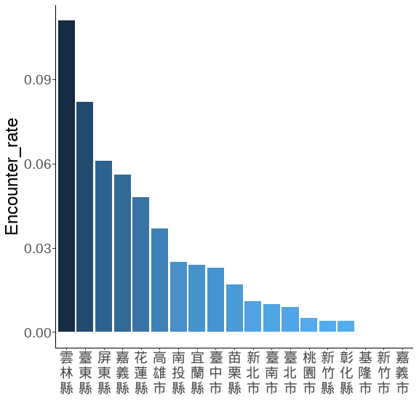
藍色數字為平均樣區數
n.name <- read_xlsx(here::here("./script/Analysis 2025 for Forestry/00.xlsx"))
COUNTY__sorted <- town_combine_bb %>%
group_by(COUNTYNAME, Year, Survey) %>%
summarise(N = PointID %>% unique() %>% length,
m = AB %>% sum,
.groups = 'drop') %>% setDT %>%
.[,Encounter_rate := m/N] %>%
.[, Mean_N := mean(N), by = c('COUNTYNAME')] %>%
.[, Mean_E := mean(Encounter_rate), by = c('COUNTYNAME')] %>%
arrange(desc(Mean_E)) %>% .$COUNTYNAME %>% unique()
town_nn <-
town_combine_bb %>%
group_by(COUNTYNAME, Year, Survey) %>%
summarise(N = PointID %>% unique() %>% length,
m = AB %>% sum,
.groups = 'drop') %>% setDT %>%
.[,Encounter_rate := m/N] %>%
.[, Mean_N := mean(N), by = c('COUNTYNAME')] %>%
.[, Mean_E := mean(Encounter_rate), by = c('COUNTYNAME')] %>%
arrange(desc(Mean_E))%>%
left_join(n.name, by = 'COUNTYNAME') %>% .$COUNTYNAME2 %>% unique() %>%
lapply(.,
function(x) paste(str_split(x, "")[[1]], collapse = "\n")) %>% unlist()
town_combine_bb %>%
group_by(COUNTYNAME, Year, Survey) %>%
summarise(N = PointID %>% unique() %>% length,
m = AB %>% sum,
.groups = 'drop') %>% setDT %>%
.[,E_km2 := m/N/per_Area] %>%
.[, Mean_N := mean(N), by = c('COUNTYNAME')] %>%
ggplot(., aes(x = COUNTYNAME, y = E_km2))+
geom_boxplot(width = 0.3, linewidth = 0.4, fill= gray(.9))+
stat_summary(fun = mean, geom = "text",
aes(label = round(Mean_N, 1)),
position = position_nudge(x = 0, y = 1.7),
angle = 270,
# hjust = -0.1,
# vjust = 0,
color = "blue")+
scale_x_discrete(limit = COUNTY__sorted , labels = town_nn)+
scale_y_continuous(breaks = seq(0,5,1), limits = c(0,5.3))+
labs(x = "", y = expression(paste("猴群密度 (群 / km"^2,")")))+
theme(
panel.border = element_rect(linewidth = 1.5,fill = NA),
panel.grid = element_blank(),
panel.background = element_blank(),
axis.text.x = element_text(size = 12,colour = "black", angle = 0),
axis.text.y = element_text(size = 18,colour = "black"),
axis.title = element_text(size = 18,colour = "black"),
axis.title.y = element_text(angle = 270,
vjust = -1, hjust = 0.5),
legend.position = "top"
)
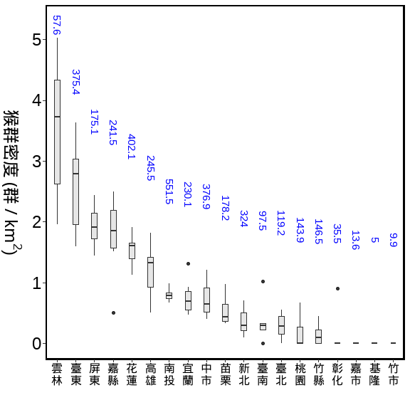
鄉鎮
town_combine_bb_outout <-
town_combine_bb %>%
group_by(COUNTYNAME,TOWNNAME, data_source) %>%
summarise(樣點數 = PointID %>% unique() %>% length,
筆數 = PointID %>% length,
'猴群數' = AB %>% sum,
.groups = 'drop' ) %>%
pivot_wider(., id_cols = c('COUNTYNAME','TOWNNAME'),
names_from = 'data_source',
values_from =c('樣點數', '筆數', '猴群數')) %>%
arrange(-`樣點數_BBS`)
town_combine_bb_outout%>%
flextable() %>%
colformat_double() %>%
separate_header() %>%
align(align = "center", part = "all") %>%
valign(valign = "center", part = "header") %>%
autofit()
COUNTYNAME | TOWNNAME | 樣點數 |  | 筆數 |  | 猴群數
 |  | BBS | Foresty | BBS | Foresty | BBS | Foresty
南投縣 | 仁愛鄉 | 115 | 59 | 729 | 420 | 10.0 | 5.0
南投縣 | 信義鄉 | 86 | 138 | 427 | 913 | 7.0 | 38.0
臺中市 | 和平區 | 71 | 254 | 466 | 1,929 | 14.0 | 48.0
新北市 | 新店區 | 50 | 17 | 288 | 123 | 8.0 | 1.0
臺北市 | 北投區 | 47 | 8 | 234 | 53 | 1.0 | 0.0
南投縣 | 鹿谷鄉 | 46 | 5 | 328 | 39 | 13.0 | 0.0
臺北市 | 士林區 | 42 |  | 261 |  | 8.0
新北市 | 三芝區 | 38 |  | 182 |  | 0.0
桃園市 | 復興區 | 38 | 63 | 169 | 412 | 0.0 | 6.0
嘉義縣 | 阿里山鄉 | 33 | 99 | 147 | 710 | 1.0 | 9.0
桃園市 | 龜山區 | 32 |  | 247 |  | 0.0
臺中市 | 霧峰區 | 31 |  | 140 |  | 1.0
臺東縣 | 卑南鄉 | 30 | 48 | 184 | 361 | 13.0 | 31.0
花蓮縣 | 秀林鄉 | 30 | 113 | 213 | 686 | 12.0 | 42.0
宜蘭縣 | 大同鄉 | 29 | 78 | 175 | 572 | 3.0 | 15.0
花蓮縣 | 卓溪鄉 | 28 | 33 | 224 | 182 | 22.0 | 3.0
南投縣 | 水里鄉 | 27 | 14 | 153 | 103 | 0.0 | 4.0
新北市 | 淡水區 | 27 |  | 146 |  | 0.0
新北市 | 石碇區 | 27 | 11 | 89 | 88 | 2.0 | 3.0
高雄市 | 桃源區 | 27 | 30 | 174 | 192 | 8.0 | 9.0
新北市 | 三峽區 | 26 | 42 | 132 | 293 | 2.0 | 0.0
臺北市 | 內湖區 | 26 |  | 127 |  | 0.0
雲林縣 | 林內鄉 | 24 | 12 | 163 | 92 | 25.0 | 5.0
南投縣 | 國姓鄉 | 23 | 33 | 171 | 243 | 7.0 | 5.0
苗栗縣 | 泰安鄉 | 23 | 62 | 123 | 484 | 5.0 | 4.0
南投縣 | 魚池鄉 | 22 | 1 | 176 | 8 | 4.0 | 1.0
新北市 | 烏來區 | 22 | 41 | 156 | 318 | 1.0 | 7.0
臺北市 | 文山區 | 22 |  | 132 |  | 0.0
新北市 | 汐止區 | 21 | 6 | 87 | 48 | 1.0 | 2.0
宜蘭縣 | 頭城鎮 | 19 | 3 | 85 | 18 | 1.0 | 0.0
花蓮縣 | 壽豐鄉 | 19 | 48 | 140 | 332 | 4.0 | 24.0
花蓮縣 | 瑞穗鄉 | 19 |  | 151 |  | 6.0
南投縣 | 中寮鄉 | 18 |  | 144 |  | 1.0
嘉義縣 | 番路鄉 | 17 | 40 | 72 | 293 | 8.0 | 31.0
桃園市 | 大溪區 | 17 |  | 118 |  | 0.0
苗栗縣 | 三義鄉 | 17 | 12 | 115 | 89 | 3.0 | 0.0
苗栗縣 | 頭屋鄉 | 17 | 2 | 134 | 16 | 6.0 | 0.0
高雄市 | 美濃區 | 17 | 18 | 54 | 132 | 0.0 | 15.0
嘉義市 | 東區 | 16 |  | 109 |  | 0.0
新竹縣 | 尖石鄉 | 16 | 70 | 65 | 540 | 0.0 | 2.0
花蓮縣 | 萬榮鄉 | 16 | 40 | 122 | 279 | 15.0 | 3.0
南投縣 | 草屯鎮 | 15 | 11 | 116 | 70 | 2.0 | 0.0
新北市 | 金山區 | 15 | 7 | 30 | 50 | 0.0 | 0.0
桃園市 | 龍潭區 | 15 |  | 57 |  | 0.0
臺中市 | 太平區 | 15 | 11 | 88 | 80 | 0.0 | 7.0
苗栗縣 | 獅潭鄉 | 15 | 4 | 96 | 32 | 0.0 | 0.0
屏東縣 | 內埔鄉 | 14 |  | 76 |  | 0.0
桃園市 | 蘆竹區 | 14 |  | 102 |  | 0.0
臺中市 | 東勢區 | 14 |  | 78 |  | 0.0
花蓮縣 | 光復鄉 | 14 | 12 | 104 | 93 | 0.0 | 2.0
高雄市 | 田寮區 | 14 | 4 | 98 | 31 | 0.0 | 0.0
南投縣 | 竹山鎮 | 13 | 17 | 86 | 123 | 0.0 | 14.0
嘉義縣 | 中埔鄉 | 13 |  | 20 |  | 0.0
新竹縣 | 關西鎮 | 13 |  | 98 |  | 0.0
臺東縣 | 海端鄉 | 13 | 45 | 87 | 355 | 4.0 | 14.0
南投縣 | 集集鎮 | 12 |  | 96 |  | 0.0
屏東縣 | 來義鄉 | 12 | 8 | 90 | 58 | 3.0 | 1.0
臺南市 | 東山區 | 12 |  | 78 |  | 4.0
臺中市 | 北屯區 | 11 | 6 | 76 | 48 | 0.0 | 0.0
臺北市 | 信義區 | 11 |  | 16 |  | 0.0
臺北市 | 南港區 | 11 |  | 82 |  | 0.0
花蓮縣 | 鳳林鎮 | 11 | 12 | 63 | 95 | 1.0 | 4.0
高雄市 | 茂林區 | 11 |  | 65 |  | 3.0
新北市 | 坪林區 | 10 | 20 | 80 | 153 | 1.0 | 1.0
新北市 | 平溪區 | 10 |  | 20 |  | 0.0
新北市 | 瑞芳區 | 10 |  | 80 |  | 0.0
新竹縣 | 五峰鄉 | 10 | 36 | 58 | 275 | 1.0 | 2.0
臺南市 | 新化區 | 10 |  | 10 |  | 0.0
臺南市 | 龍崎區 | 10 |  | 80 |  | 0.0
臺東縣 | 成功鎮 | 10 | 17 | 54 | 135 | 6.0 | 13.0
臺東縣 | 東河鄉 | 10 | 18 | 78 | 144 | 15.0 | 12.0
高雄市 | 旗山區 | 10 | 7 | 76 | 50 | 2.0 | 3.0
嘉義縣 | 竹崎鄉 | 9 | 11 | 72 | 86 | 1.0 | 2.0
屏東縣 | 恆春鎮 | 9 | 17 | 72 | 118 | 2.0 | 6.0
新竹縣 | 寶山鄉 | 9 |  | 72 |  | 0.0
臺南市 | 左鎮區 | 9 | 12 | 72 | 95 | 0.0 | 0.0
臺東縣 | 達仁鄉 | 9 | 48 | 72 | 370 | 4.0 | 28.0
雲林縣 | 斗六市 | 9 |  | 63 |  | 21.0
嘉義縣 | 大埔鄉 | 8 | 47 | 54 | 366 | 10.0 | 35.0
新竹市 | 東區 | 8 |  | 34 |  | 0.0
臺北市 | 中山區 | 8 |  | 40 |  | 0.0
臺南市 | 六甲區 | 8 | 11 | 64 | 82 | 0.0 | 0.0
臺東縣 | 大武鄉 | 8 | 5 | 64 | 26 | 4.0 | 6.0
臺東縣 | 金峰鄉 | 8 | 19 | 64 | 119 | 8.0 | 11.0
花蓮縣 | 玉里鎮 | 8 | 20 | 64 | 122 | 0.0 | 3.0
苗栗縣 | 公館鄉 | 8 | 1 | 64 | 7 | 0.0 | 0.0
南投縣 | 南投市 | 7 |  | 51 |  | 0.0
宜蘭縣 | 三星鄉 | 7 | 10 | 56 | 73 | 1.0 | 0.0
宜蘭縣 | 礁溪鄉 | 7 | 18 | 49 | 133 | 0.0 | 2.0
屏東縣 | 滿州鄉 | 7 | 26 | 46 | 176 | 3.0 | 4.0
彰化縣 | 花壇鄉 | 7 |  | 42 |  | 0.0
新北市 | 林口區 | 7 |  | 49 |  | 0.0
新竹縣 | 峨眉鄉 | 7 |  | 56 |  | 0.0
臺中市 | 新社區 | 7 |  | 24 |  | 0.0
高雄市 | 岡山區 | 7 |  | 56 |  | 0.0
高雄市 | 楠梓區 | 7 |  | 46 |  | 0.0
高雄市 | 鼓山區 | 7 | 6 | 28 | 27 | 14.0 | 8.0
彰化縣 | 彰化市 | 6 |  | 48 |  | 0.0
新北市 | 八里區 | 6 |  | 12 |  | 0.0
新北市 | 泰山區 | 6 |  | 24 |  | 0.0
新北市 | 萬里區 | 6 |  | 12 |  | 0.0
新竹市 | 香山區 | 6 |  | 45 |  | 0.0
苗栗縣 | 銅鑼鄉 | 6 |  | 39 |  | 0.0
雲林縣 | 古坑鄉 | 6 | 18 | 48 | 95 | 0.0 | 0.0
高雄市 | 大樹區 | 6 |  | 24 |  | 0.0
高雄市 | 杉林區 | 6 | 6 | 42 | 40 | 0.0 | 1.0
高雄市 | 鳥松區 | 6 |  | 48 |  | 0.0
宜蘭縣 | 員山鄉 | 5 | 17 | 40 | 121 | 0.0 | 1.0
屏東縣 | 獅子鄉 | 5 | 35 | 15 | 217 | 1.0 | 30.0
新北市 | 五股區 | 5 |  | 32 |  | 0.0
高雄市 | 仁武區 | 5 |  | 40 |  | 0.0
高雄市 | 小港區 | 5 |  | 40 |  | 0.0
屏東縣 | 琉球鄉 | 4 |  | 12 |  | 0.0
屏東縣 | 霧臺鄉 | 4 | 10 | 32 | 75 | 1.0 | 5.0
彰化縣 | 員林市 | 4 |  | 24 |  | 0.0
新北市 | 石門區 | 4 |  | 8 |  | 0.0
臺中市 | 大雅區 | 4 |  | 20 |  | 0.0
苗栗縣 | 大湖鄉 | 4 | 11 | 8 | 68 | 0.0 | 4.0
苗栗縣 | 頭份市 | 4 |  | 8 |  | 0.0
高雄市 | 內門區 | 4 | 5 | 28 | 40 | 0.0 | 0.0
嘉義縣 | 民雄鄉 | 3 |  | 21 |  | 0.0
基隆市 | 七堵區 | 3 |  | 24 |  | 0.0
彰化縣 | 大村鄉 | 3 |  | 18 |  | 0.0
新北市 | 土城區 | 3 |  | 12 |  | 0.0
新北市 | 樹林區 | 3 |  | 24 |  | 0.0
桃園市 | 八德區 | 3 |  | 21 |  | 0.0
桃園市 | 桃園區 | 3 |  | 19 |  | 0.0
臺中市 | 潭子區 | 3 |  | 20 |  | 0.0
臺北市 | 大安區 | 3 |  | 9 |  | 0.0
臺南市 | 山上區 | 3 |  | 24 |  | 0.0
苗栗縣 | 造橋鄉 | 3 |  | 9 |  | 0.0
南投縣 | 名間鄉 | 2 |  | 16 |  | 0.0
基隆市 | 安樂區 | 2 |  | 16 |  | 0.0
新北市 | 深坑區 | 2 |  | 8 |  | 0.0
臺中市 | 南屯區 | 2 |  | 8 |  | 0.0
臺中市 | 大肚區 | 2 |  | 8 |  | 0.0
臺中市 | 清水區 | 2 |  | 4 |  | 0.0
臺中市 | 烏日區 | 2 |  | 8 |  | 0.0
臺中市 | 西屯區 | 2 |  | 8 |  | 0.0
臺南市 | 白河區 | 2 |  | 4 |  | 0.0
臺東縣 | 延平鄉 | 2 | 34 | 16 | 265 | 1.0 | 24.0
花蓮縣 | 富里鄉 | 2 | 18 | 16 | 124 | 0.0 | 9.0
花蓮縣 | 花蓮市 | 2 |  | 16 |  | 0.0
高雄市 | 大社區 | 2 |  | 16 |  | 0.0
高雄市 | 左營區 | 2 |  | 14 |  | 0.0
屏東縣 | 新埤鄉 | 1 |  | 5 |  | 0.0
屏東縣 | 枋寮鄉 | 1 |  | 5 |  | 0.0
彰化縣 | 芬園鄉 | 1 |  | 8 |  | 0.0
新竹縣 | 竹東鎮 | 1 |  | 8 |  | 0.0
桃園市 | 觀音區 | 1 |  | 6 |  | 0.0
臺中市 | 沙鹿區 | 1 |  | 6 |  | 0.0
臺中市 | 豐原區 | 1 |  | 4 |  | 0.0
臺南市 | 玉井區 | 1 | 5 | 7 | 40 | 0.0 | 0.0
臺東縣 | 太麻里鄉 | 1 | 18 | 8 | 142 | 1.0 | 5.0
臺東縣 | 蘭嶼鄉 | 1 |  | 1 |  | 0.0
臺東縣 | 關山鎮 | 1 | 8 | 8 | 62 | 0.0 | 4.0
高雄市 | 大寮區 | 1 |  | 8 |  | 0.0
高雄市 | 林園區 | 1 |  | 8 |  | 0.0
高雄市 | 甲仙區 | 1 | 15 | 6 | 99 | 1.0 | 1.0
高雄市 | 阿蓮區 | 1 |  | 7 |  | 0.0
嘉義縣 | 梅山鄉 |  | 15 |  | 91 |  | 10.0
宜蘭縣 | 冬山鄉 |  | 8 |  | 58 |  | 3.0
宜蘭縣 | 南澳鄉 |  | 37 |  | 285 |  | 10.0
宜蘭縣 | 蘇澳鎮 |  | 23 |  | 176 |  | 8.0
屏東縣 | 三地門鄉 |  | 20 |  | 141 |  | 10.0
屏東縣 | 春日鄉 |  | 1 |  | 8 |  | 1.0
屏東縣 | 泰武鄉 |  | 6 |  | 46 |  | 2.0
屏東縣 | 牡丹鄉 |  | 18 |  | 139 |  | 8.0
屏東縣 | 瑪家鄉 |  | 6 |  | 48 |  | 7.0
屏東縣 | 高樹鄉 |  | 3 |  | 22 |  | 1.0
彰化縣 | 二水鄉 |  | 6 |  | 48 |  | 0.0
彰化縣 | 田中鎮 |  | 8 |  | 64 |  | 0.0
彰化縣 | 社頭鄉 |  | 4 |  | 32 |  | 1.0
新北市 | 雙溪區 |  | 7 |  | 48 |  | 0.0
臺南市 | 南化區 |  | 27 |  | 164 |  | 3.0
臺南市 | 楠西區 |  | 13 |  | 60 |  | 1.0
臺東縣 | 池上鄉 |  | 8 |  | 62 |  | 5.0
臺東縣 | 長濱鄉 |  | 27 |  | 216 |  | 29.0
臺東縣 | 鹿野鄉 |  | 14 |  | 110 |  | 7.0
花蓮縣 | 吉安鄉 |  | 7 |  | 56 |  | 1.0
花蓮縣 | 豐濱鄉 |  | 17 |  | 135 |  | 4.0
苗栗縣 | 卓蘭鎮 |  | 12 |  | 42 |  | 0.0
苗栗縣 | 南庄鄉 |  | 21 |  | 92 |  | 2.0
高雄市 | 六龜區 |  | 51 |  | 388 |  | 5.0
高雄市 | 燕巢區 |  | 5 |  | 39 |  | 0.0
高雄市 | 那瑪夏區 |  | 6 |  | 48 |  | 3.0
summary_TOWN_combine <-
town_combine_bb %>%
group_by(COUNTYNAME,TOWNNAME, Year, Survey) %>%
summarise(N = PointID %>% unique() %>% length,
m = AB %>% sum,
E = m / N,
E_km2 = m / N/per_Area ,
.groups = 'drop') %>%
group_by(COUNTYNAME,TOWNNAME) %>%
summarise(Mean_N = mean(N),
Se_N = se(N),
Mean_m = mean(m),
Se_m = se(m),
Mean_E = mean(E) ,
Se_E = se(E),
Mean_E_km2 = mean(E_km2) ,
Se_E_km2 = se(E_km2),
.groups = 'drop') %>%
mutate_at(c('Se_N','Se_m','Se_E','Mean_E',
'Mean_E_km2','Se_E_km2'), function(x)round(x,3)) %>%
mutate_at(c('Mean_N','Mean_m'), function(x)round(x,2))%>%
arrange(-Mean_E)
調查資料的E (前20名, 全部有186個鄉鎮)
summary_TOWN_combine%>%
arrange(-Mean_E) %>%
slice(1:20) %>%
flextable()
COUNTYNAME | TOWNNAME | Mean_N | Se_N | Mean_m | Se_m | Mean_E | Se_E | Mean_E_km2 | Se_E_km2
高雄市 | 鼓山區 | 6.88 | 0.639 | 2.75 | 0.559 | 0.384 | 0.057 | 12.215 | 1.829
雲林縣 | 斗六市 | 7.88 | 0.295 | 2.62 | 0.625 | 0.342 | 0.085 | 10.887 | 2.721
屏東縣 | 瑪家鄉 | 6.00 | 0.000 | 0.88 | 0.227 | 0.146 | 0.038 | 4.642 | 1.202
屏東縣 | 獅子鄉 | 29.00 | 0.866 | 3.88 | 0.549 | 0.134 | 0.019 | 4.264 | 0.616
臺東縣 | 長濱鄉 | 27.00 | 0.000 | 3.62 | 0.844 | 0.134 | 0.031 | 4.274 | 0.995
屏東縣 | 春日鄉 | 1.00 | 0.000 | 0.12 | 0.125 | 0.125 | 0.125 | 3.979 | 3.979
臺東縣 | 東河鄉 | 27.75 | 0.164 | 3.38 | 0.460 | 0.122 | 0.017 | 3.879 | 0.536
嘉義縣 | 梅山鄉 | 11.38 | 0.778 | 1.25 | 0.366 | 0.119 | 0.033 | 3.789 | 1.051
臺東縣 | 大武鄉 | 11.25 | 0.559 | 1.25 | 0.164 | 0.111 | 0.013 | 3.547 | 0.421
雲林縣 | 林內鄉 | 31.88 | 2.517 | 3.75 | 1.065 | 0.111 | 0.030 | 3.526 | 0.966
臺東縣 | 金峰鄉 | 22.88 | 1.315 | 2.38 | 0.375 | 0.108 | 0.019 | 3.445 | 0.590
嘉義縣 | 番路鄉 | 45.62 | 2.639 | 4.88 | 0.811 | 0.107 | 0.017 | 3.415 | 0.539
嘉義縣 | 大埔鄉 | 52.50 | 0.779 | 5.62 | 0.865 | 0.106 | 0.016 | 3.383 | 0.522
臺東縣 | 成功鎮 | 23.62 | 1.511 | 2.38 | 0.730 | 0.097 | 0.029 | 3.102 | 0.939
苗栗縣 | 大湖鄉 | 9.50 | 1.581 | 0.50 | 0.267 | 0.092 | 0.061 | 2.918 | 1.952
臺東縣 | 延平鄉 | 35.12 | 0.479 | 3.12 | 0.743 | 0.088 | 0.021 | 2.817 | 0.659
高雄市 | 茂林區 | 9.29 | 1.107 | 0.43 | 0.297 | 0.086 | 0.059 | 2.728 | 1.893
臺東縣 | 卑南鄉 | 68.12 | 2.083 | 5.50 | 0.945 | 0.083 | 0.015 | 2.632 | 0.492
臺東縣 | 池上鄉 | 7.75 | 0.164 | 0.62 | 0.263 | 0.083 | 0.036 | 2.629 | 1.157
高雄市 | 美濃區 | 23.25 | 0.901 | 1.88 | 0.350 | 0.080 | 0.014 | 2.551 | 0.457
town_combine_bb %>%
filter(str_detect(TOWNNAME, "大埔|番路|阿里山|古坑|林內")) %>%
group_by(COUNTYNAME,TOWNNAME, Year, Survey) %>%
summarise(N = PointID %>% unique() %>% length,
m = AB %>% sum,
E = m / N,
E_km2 = m / N/per_Area ,
.groups = 'drop') %>%
group_by(COUNTYNAME,TOWNNAME) %>%
summarise(N_Mean = mean(N),
N_Se = se(N),
N_range =paste0(min(N),"~", max(N)),
m_Mean = mean(m),
m_Se = se(m),
E_Mean = mean(E) ,
E_Se = se(E),
'E km2_Mean' = mean(E_km2) ,
'E km2_Se' = se(E_km2),
.groups = 'drop') %>%
mutate_at(c('N_Se','m_Se','E_Mean','E_Se',
'E km2_Mean','E km2_Se'), function(x)round(x,3)) %>%
mutate_at(c('N_Mean','m_Mean'), function(x)round(x,2))%>%
flextable() %>%
separate_header()
COUNTYNAME | TOWNNAME | N |  |  | m |  | E |  | E km2
 |  | Mean | Se | range | Mean | Se | Mean | Se | Mean | Se
嘉義縣 | 大埔鄉 | 52.50 | 0.779 | 49~55 | 5.62 | 0.865 | 0.106 | 0.016 | 3.383 | 0.522
嘉義縣 | 番路鄉 | 45.62 | 2.639 | 36~57 | 4.88 | 0.811 | 0.107 | 0.017 | 3.415 | 0.539
嘉義縣 | 阿里山鄉 | 107.12 | 3.833 | 88~121 | 1.25 | 0.250 | 0.011 | 0.002 | 0.365 | 0.068
雲林縣 | 古坑鄉 | 17.88 | 0.789 | 15~22 | 0.00 | 0.000 | 0.000 | 0.000 | 0.000 | 0.000
雲林縣 | 林內鄉 | 31.88 | 2.517 | 16~36 | 3.75 | 1.065 | 0.111 | 0.030 | 3.526 | 0.966
summary_TOWN_combine %>%
mutate(
TOWNNAME = sapply(TOWNNAME,
function(x) paste(str_split(x, "")[[1]], collapse = "\n")),
TOWNNAME = reorder(TOWNNAME, -Mean_E)) %>%
filter(Mean_E>0) %>%
slice_max(order_by = Mean_E, n = 20) %>%
ggplot(data = , aes(TOWNNAME, Mean_E))+
geom_bar(aes(fill = -Mean_E), stat = "identity") +
#geom_col(aes(fill = -Mean_E))+
labs(x = "",y ="Encounter_rate")+
scale_color_brewer(palette = "Set2")+
theme_classic()+
theme(text = element_text(size = 18),
legend.position = "none")
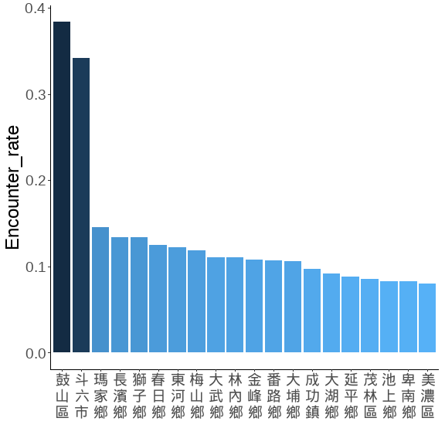
藍色數字為平均樣區數
TOWN__sorted <- town_combine_bb %>%
filter(str_detect(TOWNNAME, "大埔|番路|阿里山|古坑|林內")) %>%
group_by(TOWNNAME, Year, Survey) %>%
summarise(N = PointID %>% unique() %>% length,
m = AB %>% sum,
.groups = 'drop') %>% setDT %>%
.[,Encounter_rate := m/N] %>%
.[, .(Mean_N = mean(N),
Mean_E = mean(Encounter_rate)), by = c('TOWNNAME')] %>%
# slice_max(order_by = Mean_E, n = 50) %>%
arrange(desc(Mean_E)) %>% .$TOWNNAME %>% unique()
town_nn2 <-
lapply(TOWN__sorted,
function(x) paste(str_split(x, "")[[1]], collapse = "\n")) %>% unlist()
town_combine_bb %>%
filter(str_detect(TOWNNAME, "大埔|番路|阿里山|古坑|林內")) %>%
group_by(TOWNNAME, Year, Survey) %>%
summarise(N = PointID %>% unique() %>% length,
m = AB %>% sum,
.groups = 'drop') %>% setDT %>%
.[,E_km2 := m/N/per_Area] %>%
.[, Mean_N := mean(N), by = c('TOWNNAME')] %>%
ggplot(., aes(x = TOWNNAME, y = E_km2))+
geom_boxplot(width = 0.3, linewidth = 0.4, fill= gray(.9))+
stat_summary(fun = mean, geom = "text",
aes(label = round(Mean_N, 1)),
position = position_nudge(x = 0.1, y = 1.8),
angle=270,
color = "blue")+
scale_x_discrete(limit = TOWN__sorted , labels = town_nn2)+
# scale_y_continuous(breaks = seq(0,0.2,0.05), limits = c(0,0.2))+
labs(x = "", y = expression(paste("猴群密度 (群 / km"^2,")")))+
theme(
panel.border = element_rect(size = 1.5,fill = NA),
panel.grid = element_blank(),
panel.background = element_blank(),
axis.text.x = element_text(size = 18,colour = "black", angle = 0),
axis.text = element_text(size = 20,colour = "black"),
axis.title = element_text(size = 18,colour = "black"),
axis.title.y = element_text(angle = 270,
vjust = -1, hjust = 0.5),
legend.position = "top"
)
## Warning: The `size` argument of `element_rect()` is deprecated as of ggplot2 3.4.0.
## ℹ Please use the `linewidth` argument instead.
## This warning is displayed once every 8 hours.
## Call `lifecycle::last_lifecycle_warnings()` to see where this warning was
## generated.
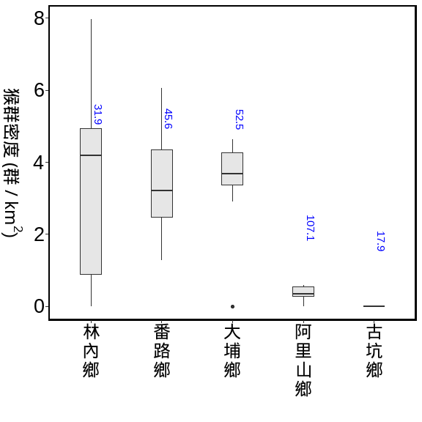

BBS與林業署的資料 (用1:1混和)

全島 vs 縣市 vs 鄉鎮
海拔50m以上的森林總面積=21028.14 (km²)
方法：bootstrap
重複抽樣：10,000次
單位面積的半徑: 100m
海拔50m以上的森林總面積=21028.14 (km²)
方法：bootstrap
重複抽樣：10,000次
單位面積的半徑: 100m
troop_M_all %>%
mutate('年' = as.character(Year)) %>%
mutate(
'相對密度_km2' = round(mm,3),
"相對密度_km2(95%CI)" = paste0(round(q_1,3), "~", round(q_3,3))
) %>%
mutate(
'群數' = round(M_troops),
"群數(95%CI)" = paste0(round(q1_troops), "~", round(q3_troops))
) %>%
mutate(
'隻數' = round(M_troops*25),
"隻數(95%CI)" = paste0(round(q1_troops*25), "~", round(q3_troops*25))
) %>%
select(年, `相對密度_km2`:`隻數(95%CI)`) %>%
flextable::flextable()
年 | 相對密度_km2 | 相對密度_km2(95%CI) | 群數 | 群數(95%CI) | 隻數 | 隻數(95%CI)
2021 | 1.119 | 0.981~1.261 | 23,524 | 20634~26515 | 588,111 | 515846~662886
2022 | 1.188 | 1.051~1.327 | 24,982 | 22103~27901 | 624,548 | 552580~697519
2023 | 1.083 | 0.953~1.214 | 22,764 | 20046~25536 | 569,104 | 501138~638407
2024 | 0.984 | 0.863~1.107 | 20,697 | 18141~23276 | 517,426 | 453533~581892
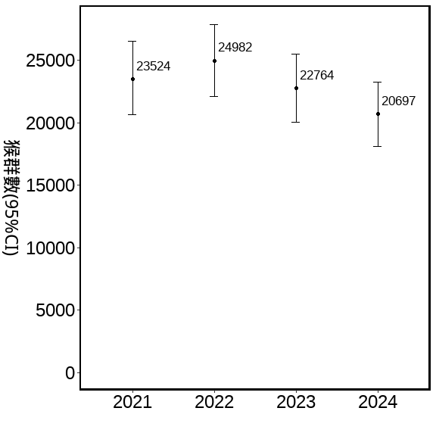
估計縣市猴群數 50m以上的森林，2021-2024的資料bootstraps
海拔50m以上的森林在各縣市面積 (km²)
方法：bootstrap
重複抽樣：10,000次
單位面積的半徑: 100m
per_Area <- (0.1*0.1*pi) #100m半徑的單位原面積
COUNTY_M_all <-
forest_town %>%
.[, .(area = sum(area)), by = 'COUNTYNAME'] %>%
left_join(bootstrap_AB_all_COUNTY, .,by = 'COUNTYNAME') %>% setDT %>%
.[ , 'M_troops' := (area)*mm] %>%
.[ , 'q1_troops' := (area)*q_1] %>%
.[ , 'q3_troops' := (area)*q_3] %>%
.[, 'log_troops':= log(M_troops)]%>%
.[ , 'COUNT' := M_troops*25]
用縣市的資料分別抽樣，再依各縣市50m以上的森林面積，去估算
COUNTYNAME | 相對密度_km2 | 相對密度_km2(95%CI) | 群數 | 群數(95%CI) | 隻數 | 隻數(95%CI)
臺東縣 | 2.596 | 2.29~92.785 | 7,320 | 6457~8221 | 182,999 | 161422~205514
花蓮縣 | 1.534 | 1.306~56.377 | 5,591 | 4761~6456 | 139,769 | 119019~161397
屏東縣 | 1.936 | 1.545~74.49 | 2,868 | 2289~3468 | 71,712 | 57237~86697
南投縣 | 0.801 | 0.657~30.09 | 2,376 | 1949~2806 | 59,407 | 48720~70148
高雄市 | 1.179 | 0.924~45.914 | 1,932 | 1513~2363 | 48,289 | 37834~59075
嘉義縣 | 1.762 | 1.433~66.603 | 1,321 | 1074~1568 | 33,013 | 26860~39209
宜蘭縣 | 0.761 | 0.553~31.37 | 1,243 | 904~1611 | 31,081 | 22611~40275
臺中市 | 0.738 | 0.57~28.901 | 815 | 629~1002 | 20,373 | 15729~25050
苗栗縣 | 0.535 | 0.335~24.158 | 643 | 402~912 | 16,081 | 10061~22806
新北市 | 0.356 | 0.233~15.636 | 528 | 346~729 | 13,210 | 8653~18217
雲林縣 | 3.530 | 2.624~140.663 | 341 | 253~427 | 8,526 | 6337~10672
臺南市 | 0.328 | 0.122~18.186 | 146 | 54~254 | 3,649 | 1362~6356
新竹縣 | 0.136 | 0.027~8.645 | 138 | 28~276 | 3,448 | 690~6898
桃園市 | 0.165 | 0.055~9.683 | 74 | 25~136 | 1,846 | 618~3397
臺北市 | 0.302 | 0.133~15.931 | 29 | 13~48 | 720 | 318~1194
彰化縣 | 0.111 | 0~10.703 | 8 | 0~25 | 209 | 0~633
基隆市 | 0.000 | 0~0 | 0 | 0~0 | 0 | 0~0
新竹市 | 0.000 | 0~0 | 0 | 0~0 | 0 | 0~0
嘉義市 | 0.000 | 0~0 | 0 | 0~0 | 0 | 0~0
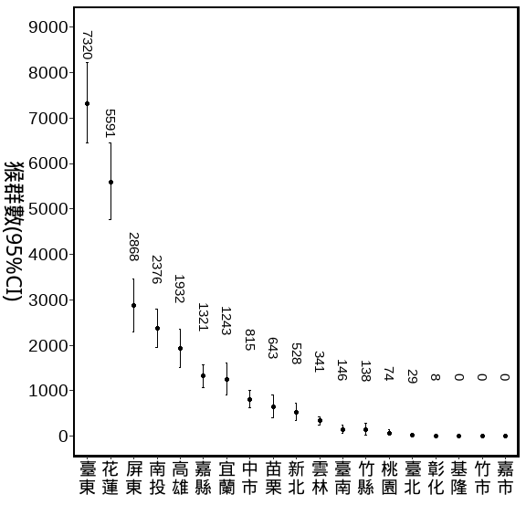
估計部分鄉鎮猴群數 50m以上的森林，2021-2024的資料bootstraps
大埔,番路,阿里山,古坑,林內
per_Area <- (0.1*0.1*pi) #100m半徑的單位原面積
TOWN_M_all <-
forest_town %>%
left_join(bootstrap_AB_all_TOWN, .,by = 'TOWNNAME') %>% setDT %>%
.[ , 'M_troops' := area*mm] %>%
.[ , 'q1_troops' := area*q_1] %>%
.[ , 'q3_troops' := area*q_3] %>%
.[, 'log_troops':= log(M_troops)]%>%
.[ , 'COUNT' := M_troops*25]
COUNTYNAME | TOWNNAME | 相對密度_km2 | 相對密度_km2(95%CI) | 群數 | 群數(95%CI) | 隻數 | 隻數(95%CI)
嘉義縣 | 大埔鄉 | 3.407 | 2.501~4.396 | 435 | 319~561 | 10,866 | 7977~14020
嘉義縣 | 番路鄉 | 3.404 | 2.442~4.448 | 213 | 152~278 | 5,313 | 3811~6942
嘉義縣 | 阿里山鄉 | 0.370 | 0.149~0.594 | 143 | 58~231 | 3,587 | 1441~5763
雲林縣 | 林內鄉 | 3.750 | 2.497~4.993 | 67 | 45~90 | 1,686 | 1123~2245
雲林縣 | 古坑鄉 | 0.000 | 0~0 | 0 | 0~0 | 0 | 0~0
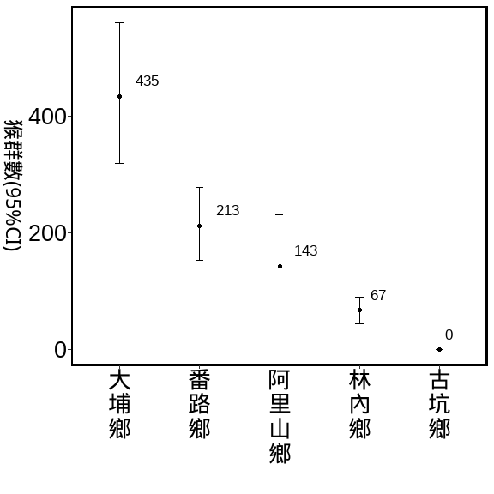

BBS與林業署的資料 (用1:1混和)

全島 vs 是否林班地
path <- "D:/R/SHP圖層"
Foresty_50 <- st_read(paste0(path,"/","0_自製/海拔50公尺以的林班地/Foresty_up50.shp"), crs=3826) %>%
st_transform(crs=3826) %>%
mutate(range = "Fotersty") %>%
dplyr::select(-ELEV)
## Reading layer `Foresty_up50' from data source
## `D:\R\SHP圖層\0_自製\海拔50公尺以的林班地\Foresty_up50.shp'
## using driver `ESRI Shapefile'
## Simple feature collection with 1 feature and 1 field
## Geometry type: MULTIPOLYGON
## Dimension: XY
## Bounding box: xmin: 182507.4 ymin: 2423010 xmax: 351091.4 ymax: 2766881
## Projected CRS: TWD97 / TM2 zone 121
summary(Foresty_50)
## range geometry
## Length:1 MULTIPOLYGON :1
## Class :character epsg:3826 :0
## Mode :character +proj=tmer...:0
Foresty_list_Point <-
list_Point %>%
filter(!is.na(X_97)) %>%
st_as_sf(., coords = c("X_97", "Y_97"), crs = 3826) %>%
st_join(.,Foresty_50) %>%
st_drop_geometry() %>%
mutate(range = ifelse(range %in% "Fotersty",
"林班地","非林班地"))
Foresty_combine_bb <-
Foresty_list_Point %>%
right_join(.,combine_bb,
by = c("樣區編號","獼猴樣區編號", "樣點代號"="Point"))
summary_Foresty_combine <-
Foresty_combine_bb %>%
group_by(range, Year, Survey) %>%
summarise(N = PointID %>% unique() %>% length,
m = AB %>% sum,
E = m / N,
E_km2 = m / N/per_Area,
.groups = 'drop') %>%
group_by(range, Year) %>%
summarise(Mean_N = mean(N),
Se_N = se(N),
Mean_m = mean(m),
Se_m = se(m),
Mean_E = mean(E) ,
Se_E = se(E),
Mean_E_km2 = mean(E_km2) ,
Se_E_km2 = se(E_km2),
.groups = 'drop') %>%
mutate_at(c('Se_N','Se_m','Se_E','Mean_E',
'Mean_E_km2','Se_E_km2'), function(x)round(x,3)) %>%
mutate_at(c('Mean_N','Mean_m'), function(x)round(x,2)) %>%
arrange(range, Year)
調查資料的E
summary_Foresty_combine %>%
flextable()%>%
autofit() %>%
align(align = "center", part = "all") %>%
set_table_properties(layout = "autofit") %>%
colformat_num(., big.mark="")
range | Year | Mean_N | Se_N | Mean_m | Se_m | Mean_E | Se_E | Mean_E_km2 | Se_E_km2
林班地 | 2021 | 1657.0 | 99.0 | 61.5 | 3.5 | 0.037 | 0.000 | 1.182 | 0.003
林班地 | 2022 | 1734.5 | 62.5 | 79.0 | 1.0 | 0.046 | 0.002 | 1.452 | 0.071
林班地 | 2023 | 1731.5 | 62.5 | 70.0 | 13.0 | 0.040 | 0.006 | 1.280 | 0.193
林班地 | 2024 | 1753.0 | 48.0 | 60.5 | 9.5 | 0.034 | 0.004 | 1.095 | 0.143
非林班地 | 2021 | 1814.0 | 107.0 | 60.5 | 0.5 | 0.033 | 0.002 | 1.065 | 0.054
非林班地 | 2022 | 1960.0 | 42.0 | 59.0 | 3.0 | 0.030 | 0.002 | 0.960 | 0.069
非林班地 | 2023 | 2108.5 | 47.5 | 60.5 | 12.5 | 0.029 | 0.005 | 0.910 | 0.168
非林班地 | 2024 | 2158.0 | 49.0 | 60.5 | 0.5 | 0.028 | 0.001 | 0.893 | 0.028
藍色數字為平均樣區數
Foresty__sorted <- Foresty_combine_bb %>%
group_by(range, Year, Survey) %>%
summarise(N = PointID %>% unique() %>% length,
m = AB %>% sum,
.groups = 'drop') %>% setDT %>%
.[,Encounter_rate := m/N] %>%
.[, Mean_N := mean(N), by = c('range')] %>%
.[, Mean_E := mean(Encounter_rate), by = c('range')] %>%
arrange(desc(Mean_E)) %>% .$range %>% unique()
range_nn <-
Foresty_combine_bb %>%
group_by(range, Year, Survey) %>%
summarise(N = PointID %>% unique() %>% length,
m = AB %>% sum,
.groups = 'drop') %>% setDT %>%
.[,Encounter_rate := m/N] %>%
.[,E_km2 := m/N/per_Area] %>%
group_by(range, Year) %>%
summarise(
Mean_N = mean(N),
Mean_E = mean(Encounter_rate),
Mean_E_km2 = quantile(E_km2,0.75)) %>%
arrange(desc(Mean_E))
## `summarise()` has grouped output by 'range'. You can override using the
## `.groups` argument.
Foresty_combine_bb %>%
group_by(range, Year, Survey) %>%
summarise(N = PointID %>% unique() %>% length,
m = AB %>% sum,
.groups = 'drop') %>% setDT %>%
.[,E_km2 := m/N/per_Area] %>%
.[, Mean_N := mean(N), by = c('range', "Year")] %>%
ggplot(., aes(x = as.character(Year), y = E_km2),group = range)+
geom_boxplot(aes(fill= range),width = 0.3, linewidth = 0.4)+
geom_text(data=range_nn,
aes(label = Mean_N, y = Mean_E_km2),
position = position_dodge(width = 0.75),
hjust = -0.4,vjust = -1,
size = 3,
angle = 0,
color = "blue")+
scale_y_continuous(breaks = seq(0,2,0.5), limits = c(0,2))+
labs(x = "", y = expression(paste("猴群密度 (群 / km"^2,")")))+
theme(
panel.border = element_rect(linewidth = 1.5,fill = NA),
panel.grid = element_blank(),
panel.background = element_blank(),
axis.text.x = element_text(size = 12,colour = "black", angle = 0),
axis.text.y = element_text(size = 18,colour = "black"),
axis.title = element_text(size = 18,colour = "black"),
axis.title.y = element_text(angle = 270,
vjust = -1, hjust = 0.5),
legend.position = "top"
)
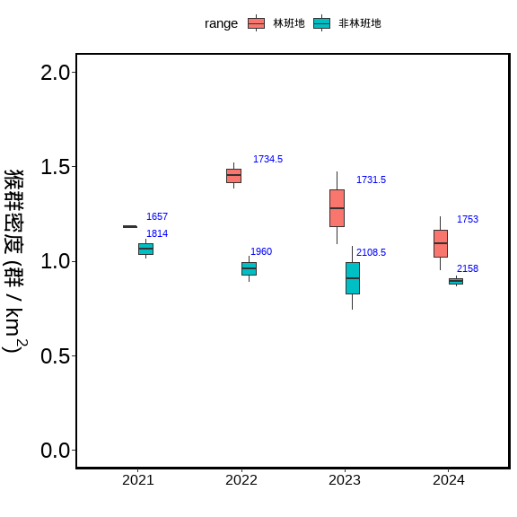

BBS與林業署的資料 (用1:1混和)

全島 vs 50-250m vs 50-500m vs 50-1000m
path <- "D:/R/SHP圖層"
ELE_50250 <- st_read(paste0(path,"/","0_自製/局部海拔/ELE_50~250.shp"), crs=3826) %>%
st_transform(crs=3826) %>%
mutate(ELE = "50-250")
## Reading layer `ELE_50~250' from data source
## `D:\R\SHP圖層\0_自製\局部海拔\ELE_50~250.shp' using driver `ESRI Shapefile'
## Simple feature collection with 1 feature and 1 field
## Geometry type: MULTIPOLYGON
## Dimension: XY
## Bounding box: xmin: 166832.6 ymin: 2423010 xmax: 351224.2 ymax: 2798677
## Projected CRS: TWD97 / TM2 zone 121
summary(ELE_50250)
## ELEV geometry ELE
## Min. :50 MULTIPOLYGON :1 Length:1
## 1st Qu.:50 epsg:3826 :0 Class :character
## Median :50 +proj=tmer...:0 Mode :character
## Mean :50
## 3rd Qu.:50
## Max. :50
ELE_50500 <- st_read(paste0(path,"/","0_自製/局部海拔/ELE_50~500.shp"), crs=3826) %>%
st_transform(crs=3826) %>%
mutate(ELE = "50-500")
## Reading layer `ELE_50~500' from data source
## `D:\R\SHP圖層\0_自製\局部海拔\ELE_50~500.shp' using driver `ESRI Shapefile'
## Simple feature collection with 1 feature and 1 field
## Geometry type: MULTIPOLYGON
## Dimension: XY
## Bounding box: xmin: 166832.6 ymin: 2423010 xmax: 351224.2 ymax: 2798677
## Projected CRS: TWD97 / TM2 zone 121
summary(ELE_50500)
## ELEV geometry ELE
## Min. :50 MULTIPOLYGON :1 Length:1
## 1st Qu.:50 epsg:3826 :0 Class :character
## Median :50 +proj=tmer...:0 Mode :character
## Mean :50
## 3rd Qu.:50
## Max. :50
ELE_501000 <- st_read(paste0(path,"/","0_自製/局部海拔/ELE_50~1000.shp"), crs=3826) %>%
st_transform(crs=3826) %>%
mutate(ELE = "50-1000")
## Reading layer `ELE_50~1000' from data source
## `D:\R\SHP圖層\0_自製\局部海拔\ELE_50~1000.shp' using driver `ESRI Shapefile'
## Simple feature collection with 1 feature and 1 field
## Geometry type: MULTIPOLYGON
## Dimension: XY
## Bounding box: xmin: 166832.6 ymin: 2423010 xmax: 351224.2 ymax: 2798677
## Projected CRS: TWD97 / TM2 zone 121
summary(ELE_501000)
## ELEV geometry ELE
## Min. :50 MULTIPOLYGON :1 Length:1
## 1st Qu.:50 epsg:3826 :0 Class :character
## Median :50 +proj=tmer...:0 Mode :character
## Mean :50
## 3rd Qu.:50
## Max. :50
ELE250_list_Point <-
list_Point %>%
filter(!is.na(X_97)) %>%
st_as_sf(., coords = c("X_97", "Y_97"), crs = 3826) %>%
st_join(.,ELE_50250) %>%
st_drop_geometry() %>%
filter(!is.na(ELE))
ELE250_combine_bb <-
ELE250_list_Point %>%
right_join(.,combine_bb,
by = c("樣區編號","獼猴樣區編號", "樣點代號"="Point")) %>%
filter(!is.na(ELE))
summary_ELE250_combine <-
ELE250_combine_bb %>%
group_by(ELE, Year, Survey) %>%
summarise(N = PointID %>% unique() %>% length,
m = AB %>% sum,
E = m / N,
E_km2 = m / N/per_Area,
.groups = 'drop') %>%
group_by(ELE, Year) %>%
summarise(Mean_N = mean(N),
Se_N = se(N),
Mean_m = mean(m),
Se_m = se(m),
Mean_E = mean(E) ,
Se_E = se(E),
Mean_E_km2 = mean(E_km2) ,
Se_E_km2 = se(E_km2),
.groups = 'drop') %>%
mutate_at(c('Se_N','Se_m','Se_E','Mean_E',
'Mean_E_km2','Se_E_km2'), function(x)round(x,3)) %>%
mutate_at(c('Mean_N','Mean_m'), function(x)round(x,2)) %>%
arrange(ELE, Year)
ELE500_list_Point <-
list_Point %>%
filter(!is.na(X_97)) %>%
st_as_sf(., coords = c("X_97", "Y_97"), crs = 3826) %>%
st_join(.,ELE_50500) %>%
st_drop_geometry() %>%
filter(!is.na(ELE))
ELE500_combine_bb <-
ELE500_list_Point %>%
right_join(.,combine_bb,
by = c("樣區編號","獼猴樣區編號", "樣點代號"="Point")) %>%
filter(!is.na(ELE))
summary_ELE500_combine <-
ELE500_combine_bb %>%
group_by(ELE, Year, Survey) %>%
summarise(N = PointID %>% unique() %>% length,
m = AB %>% sum,
E = m / N,
E_km2 = m / N/per_Area,
.groups = 'drop') %>%
group_by(ELE, Year) %>%
summarise(Mean_N = mean(N),
Se_N = se(N),
Mean_m = mean(m),
Se_m = se(m),
Mean_E = mean(E) ,
Se_E = se(E),
Mean_E_km2 = mean(E_km2) ,
Se_E_km2 = se(E_km2),
.groups = 'drop') %>%
mutate_at(c('Se_N','Se_m','Se_E','Mean_E',
'Mean_E_km2','Se_E_km2'), function(x)round(x,3)) %>%
mutate_at(c('Mean_N','Mean_m'), function(x)round(x,2)) %>%
arrange(ELE, Year)
ELE1000_list_Point <-
list_Point %>%
filter(!is.na(X_97)) %>%
st_as_sf(., coords = c("X_97", "Y_97"), crs = 3826) %>%
st_join(.,ELE_501000) %>%
st_drop_geometry() %>%
filter(!is.na(ELE))
ELE1000_combine_bb <-
ELE1000_list_Point %>%
right_join(.,combine_bb,
by = c("樣區編號","獼猴樣區編號", "樣點代號"="Point")) %>%
filter(!is.na(ELE))
summary_ELE1000_combine <-
ELE1000_combine_bb %>%
group_by(ELE, Year, Survey) %>%
summarise(N = PointID %>% unique() %>% length,
m = AB %>% sum,
E = m / N,
E_km2 = m / N/per_Area,
.groups = 'drop') %>%
group_by(ELE, Year) %>%
summarise(Mean_N = mean(N),
Se_N = se(N),
Mean_m = mean(m),
Se_m = se(m),
Mean_E = mean(E) ,
Se_E = se(E),
Mean_E_km2 = mean(E_km2) ,
Se_E_km2 = se(E_km2),
.groups = 'drop') %>%
mutate_at(c('Se_N','Se_m','Se_E','Mean_E',
'Mean_E_km2','Se_E_km2'), function(x)round(x,3)) %>%
mutate_at(c('Mean_N','Mean_m'), function(x)round(x,2)) %>%
arrange(ELE, Year)
調查資料的E
summary_ELE250_combine%>%
flextable()
ELE | Year | Mean_N | Se_N | Mean_m | Se_m | Mean_E | Se_E | Mean_E_km2 | Se_E_km2
50-250 | 2,021 | 1,068.5 | 38.5 | 35.5 | 0.5 | 0.033 | 0.002 | 1.059 | 0.053
50-250 | 2,022 | 1,112.5 | 21.5 | 41.5 | 5.5 | 0.037 | 0.006 | 1.191 | 0.180
50-250 | 2,023 | 1,222.5 | 18.5 | 41.5 | 8.5 | 0.034 | 0.006 | 1.077 | 0.205
50-250 | 2,024 | 1,173.5 | 38.5 | 40.0 | 3.0 | 0.034 | 0.004 | 1.089 | 0.117
summary_ELE500_combine%>%
flextable()
ELE | Year | Mean_N | Se_N | Mean_m | Se_m | Mean_E | Se_E | Mean_E_km2 | Se_E_km2
50-500 | 2,021 | 1,840.5 | 81.5 | 64.0 | 2.0 | 0.035 | 0.003 | 1.111 | 0.084
50-500 | 2,022 | 1,941.5 | 25.5 | 77.5 | 10.5 | 0.040 | 0.006 | 1.273 | 0.189
50-500 | 2,023 | 2,084.5 | 33.5 | 79.0 | 14.0 | 0.038 | 0.006 | 1.203 | 0.194
50-500 | 2,024 | 2,045.5 | 50.5 | 68.0 | 1.0 | 0.033 | 0.001 | 1.059 | 0.042
summary_ELE1000_combine%>%
flextable()
ELE | Year | Mean_N | Se_N | Mean_m | Se_m | Mean_E | Se_E | Mean_E_km2 | Se_E_km2
50-1000 | 2,021 | 2,531.0 | 101.0 | 94 | 1 | 0.037 | 0.001 | 1.184 | 0.035
50-1000 | 2,022 | 2,664.5 | 45.5 | 104 | 10 | 0.039 | 0.004 | 1.245 | 0.141
50-1000 | 2,023 | 2,810.5 | 42.5 | 104 | 16 | 0.037 | 0.005 | 1.175 | 0.163
50-1000 | 2,024 | 2,847.5 | 68.5 | 98 | 6 | 0.034 | 0.001 | 1.095 | 0.041
summary_ELE_combine <-
bind_rows(ELE250_combine_bb ,
ELE500_combine_bb ,
ELE1000_combine_bb
) %>%
group_by(ELE, Year, Survey) %>%
summarise(N = PointID %>% unique() %>% length,
m = AB %>% sum,
E = m / N,
E_km2 = m / N/per_Area,
.groups = 'drop') %>%
mutate(ELE = factor(ELE, levels = c("50-250", "50-500", "50-1000")))
ELE_nn <-
summary_ELE_combine %>%
group_by(ELE, Year) %>%
summarise(
Mean_N = mean(N),
Mean_E = mean(E),
Mean_E_km2 = max(E_km2))
## `summarise()` has grouped output by 'ELE'. You can override using the `.groups`
## argument.
ggplot(summary_ELE_combine, aes(x = as.character(Year), E_km2))+
geom_boxplot(aes(fill = ELE))+
geom_text(data=ELE_nn,
aes(label = Mean_N, y = Mean_E_km2+0.04, group = ELE),
position = position_dodge(width = 0.75),
hjust = 0.5,vjust = -0.05,
size = 2.8,
angle = 0,
color = "blue")+
scale_y_continuous(breaks = seq(0,2,0.5), limits = c(0,2))+
labs(x = "", y = expression(paste("猴群密度 (群 / km"^2,")")))+
theme(
panel.border = element_rect(linewidth = 1.5,fill = NA),
panel.grid = element_blank(),
panel.background = element_blank(),
axis.text.x = element_text(size = 12,colour = "black", angle = 0),
axis.text.y = element_text(size = 18,colour = "black"),
axis.title = element_text(size = 18,colour = "black"),
axis.title.y = element_text(angle = 270,
vjust = -1, hjust = 0.5),
legend.position = "top"
)
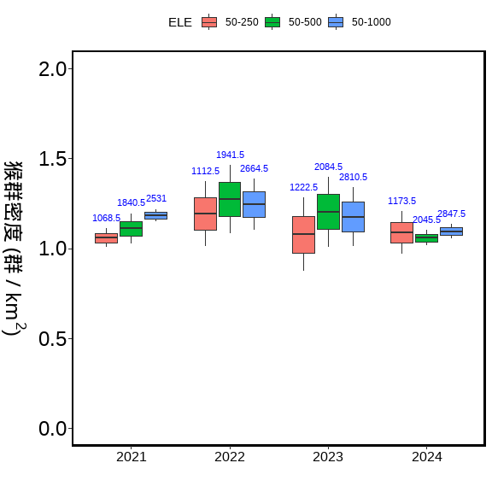

END

