全島猴群數
2026-09-02
con <- dbConnect(RSQLite::SQLite(), dbname="D:/R/test/DB/P_BBS.db")
list_Point<-
dbReadTable(con, "list_Point") %>%
arrange(樣區編號, 獼猴樣區編號,as.numeric(樣點代號))
list_Site<-
dbReadTable(con, "list_Site")
table_point<-
dbReadTable(con, "table_point")
dbDisconnect(con)
se <- function(x){sd(x)/sqrt(length(x))}
per_Area <- (0.1*0.1*pi) #100m(=0.1km)半徑的單位原面積

BBS

林業署

林業署 & BBS
#合併檢測————–
合併及擷取2021~2025的資料
2021-2025年本島各森林類型內的調查樣點數、臺灣獼猴( Macaca cyclopis )的猴群數及相對密度
NF | EL50 | Mean_N | Se_N | Mean_m | Se_m | Mean_E | Se_E
Forest | larger | 3,777.9 | 74.9 | 129.1 | 4.5 | 1.0895 | 0.1172
Forest | less | 251.4 | 9.0 | 2.1 | 0.5 | 0.2658 | 0.1855
Not_Forest | larger | 615.3 | 24.3 | 1.3 | 0.4 | 0.0691 | 0.0775
Not_Forest | less | 906.0 | 34.0 | 0.1 | 0.1 | 0.0033 | 0.0103
註：相對密度(群/km^2)。
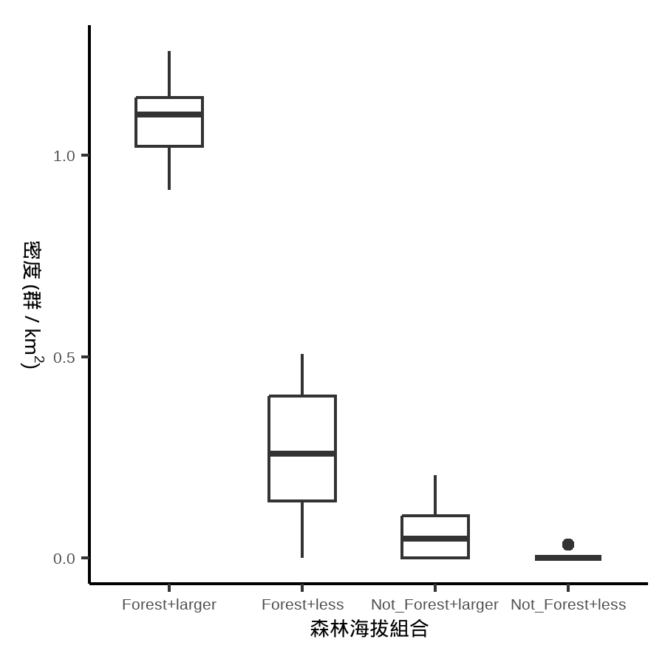
EL50 total
EL50 | Mean_N | Se_N | Mean_m | Se_m | Mean_E | Se_E
larger | 4,393.2 | 97.7 | 130.4 | 4.5 | 0.9472 | 0.1033
less | 1,157.4 | 42.4 | 2.2 | 0.5 | 0.0595 | 0.0403
註：相對密度(群/km^2)。
總total
Mean_N | Se_N | Mean_m | Se_m | Mean_E | Se_E
5,550.6 | 138.8 | 132.6 | 4.4 | 0.763 | 0.0827
註：相對密度(群/km^2)。
#bootstrap————————-
Forest & less50
bb_less50F<-
combine_bb %>%
mutate(EL50 = ifelse(Altitude < 50, "less", "larger")) %>%
mutate(NF = ifelse(TypeName.1 == "非森林", "Not_Forest", "Forest")) %>%
filter(EL50 %in% "less" & NF %in% "Forest") %>% setDT %>%
.[, A := ifelse(Macaca_dist %in% "A", Macaca_sur,0)] %>%
.[, AB := ifelse(Macaca_dist %in% c("A","B"), Macaca_sur,0)]
海拔50m以上的非森林總面積=508.27 (km²)
方法：bootstrap
重複抽樣：10,000次
單位面積的半徑: 100m
less50F_M_all <-
bootstrap_AB_bb_less50F %>%
setDT %>%
.[ , 'M_troops' := (508.27)*mm] %>%
.[ , 'q1_troops' := (508.27)*q_1] %>%
.[ , 'q3_troops' := (508.27)*q_3] %>%
.[, 'log_troops':= log(M_troops)]%>%
.[ , 'COUNT' := M_troops*25]
less50F_M_all %>%
mutate('類型' = "Forest_less50") %>%
mutate(
'相對密度_km2' = round(mm,3),
"相對密度_km2(95%CI)" = paste0(round(q_1,3), "~", round(q_3,3))
) %>%
mutate(
'群數' = round(M_troops),
"群數(95%CI)" = paste0(round(q1_troops), "~", round(q3_troops))
) %>%
mutate(
'隻數' = round(M_troops*25),
"隻數(95%CI)" = paste0(round(q1_troops*25), "~", round(q3_troops*25))
) %>%
select(類型, `相對密度_km2`:`隻數(95%CI)`) %>%
flextable::flextable()
類型 | 相對密度_km2 | 相對密度_km2(95%CI) | 群數 | 群數(95%CI) | 隻數 | 隻數(95%CI)
Forest_less50 | 0.265 | 0.152~0.38 | 135 | 77~193 | 3,369 | 1931~4827
Forest & EL>50
bb_larger50F<-
combine_bb %>%
mutate(EL50 = ifelse(Altitude < 50, "less", "larger")) %>%
mutate(NF = ifelse(TypeName.1 == "非森林", "Not_Forest", "Forest")) %>%
filter(EL50 %in% "larger" & NF %in% "Forest") %>% setDT %>%
.[, A := ifelse(Macaca_dist %in% "A", Macaca_sur,0)] %>%
.[, AB := ifelse(Macaca_dist %in% c("A","B"), Macaca_sur,0)]
海拔50m以上的非森林總面積=21028.14 (km²)
方法：bootstrap
重複抽樣：10,000次
單位面積的半徑: 100m
set.seed(4)
#重複抽樣10000次----
bootstrap_AB_bb_larger50F <-
bb_larger50F %>%
split(., .$EL50) %>%
lapply(., function(x){
replicate(10000, mean(sample(x$AB, replace = TRUE), na.rm = T))
})%>%
lapply(., function(x){
data.frame(
'q_1' = quantile(x/per_Area, probs = 0.025),
'mm' = mean(x/per_Area),
'q_3' = quantile(x/per_Area, probs = 0.975)
)
}) %>%
bind_rows(.id = 'larger50_Forest')
row.names(bootstrap_AB_bb_larger50F) <- NULL
larger50F_M_all <-
bootstrap_AB_bb_larger50F %>%
setDT %>%
.[ , 'M_troops' := (21028.14)*mm] %>%
.[ , 'q1_troops' := (21028.14)*q_1] %>%
.[ , 'q3_troops' := (21028.14)*q_3] %>%
.[, 'log_troops':= log(M_troops)]%>%
.[ , 'COUNT' := M_troops*25]
larger50F_M_all %>%
mutate('類型' = "Forest_larger50") %>%
mutate(
'相對密度_km2' = round(mm,3),
"相對密度_km2(95%CI)" = paste0(round(q_1,3), "~", round(q_3,3))
) %>%
mutate(
'群數' = round(M_troops),
"群數(95%CI)" = paste0(round(q1_troops), "~", round(q3_troops))
) %>%
mutate(
'隻數' = round(M_troops*25),
"隻數(95%CI)" = paste0(round(q1_troops*25), "~", round(q3_troops*25))
) %>%
select(類型, `相對密度_km2`:`隻數(95%CI)`) %>%
flextable::flextable()
類型 | 相對密度_km2 | 相對密度_km2(95%CI) | 群數 | 群數(95%CI) | 隻數 | 隻數(95%CI)
Forest_larger50 | 1.086 | 1.028~1.144 | 22,829 | 21615~24061 | 570,716 | 540381~601518
Forest & EL>0
bb_larger0F<-
combine_bb %>%
mutate(EL50 = ifelse(Altitude < 50, "less", "larger")) %>%
mutate(NF = ifelse(TypeName.1 == "非森林", "Not_Forest", "Forest")) %>%
filter( NF %in% "Forest") %>% setDT %>%
.[, A := ifelse(Macaca_dist %in% "A", Macaca_sur,0)] %>%
.[, AB := ifelse(Macaca_dist %in% c("A","B"), Macaca_sur,0)]
海拔0m以上的森林總面積=21,536.41 (km²)
方法：bootstrap
重複抽樣：10,000次
單位面積的半徑: 100m
larger0F_M_all <-
bootstrap_AB_bb_larger0F %>%
setDT %>%
.[ , 'M_troops' := (21536.41)*mm] %>%
.[ , 'q1_troops' := (21536.41)*q_1] %>%
.[ , 'q3_troops' := (21536.41)*q_3] %>%
.[, 'log_troops':= log(M_troops)]%>%
.[ , 'COUNT' := M_troops*25]
larger0F_M_all %>%
mutate('類型' = "Forest_larger0") %>%
mutate(
'相對密度_km2' = round(mm,3),
"相對密度_km2(95%CI)" = paste0(round(q_1,3), "~", round(q_3,3))
) %>%
mutate(
'群數' = round(M_troops),
"群數(95%CI)" = paste0(round(q1_troops), "~", round(q3_troops))
) %>%
mutate(
'隻數' = round(M_troops*25),
"隻數(95%CI)" = paste0(round(q1_troops*25), "~", round(q3_troops*25))
) %>%
select(類型, `相對密度_km2`:`隻數(95%CI)`) %>%
flextable::flextable()
類型 | 相對密度_km2 | 相對密度_km2(95%CI) | 群數 | 群數(95%CI) | 隻數 | 隻數(95%CI)
Forest_larger0 | 1.035 | 0.98~1.091 | 22,286 | 21097~23496 | 557,140 | 527419~587391

END

