猴群數估算
2026-07-30
con <- dbConnect(RSQLite::SQLite(), dbname="D:/R/test/DB/P_BBS.db")
list_Point<-
dbReadTable(con, "list_Point") %>%
arrange(樣區編號, 獼猴樣區編號,as.numeric(樣點代號))
list_Site<-
dbReadTable(con, "list_Site")
table_point<-
dbReadTable(con, "table_point")
dbDisconnect(con)
forest_town<- read_xlsx(
here("合併估算2021_2025/鄉鎮內50m以上的森林面積.xlsx")) %>%
select(-perimeter) %>%
mutate(area = area/1000000) %>% #換成km2
setDT
se <- function(x){sd(x)/sqrt(length(x))}
per_Area <- (0.1*0.1*pi) #100m(=0.1km)半徑的單位原面積

BBS
相對密度(群/樣點)圖

林業署
相對密度(群/樣點)
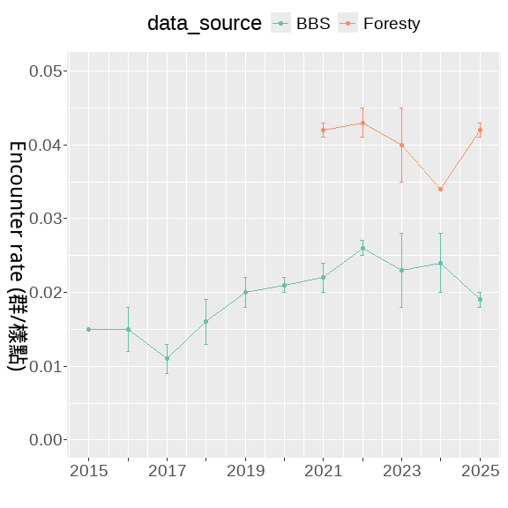
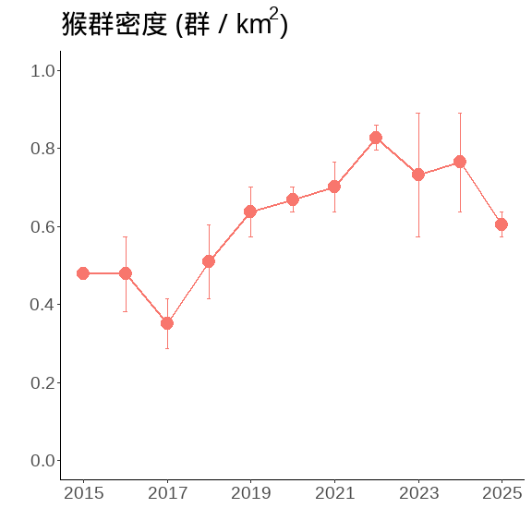
相對密度(群/樣點)
combine_bb_outout <-
E_year_F %>% mutate(data_source = "Foresty") %>%
bind_rows(E_year %>% mutate(data_source = "BBS"))
combine_bb_outout
## Year Mean_N SD_N Mean_m SD_m Mean_E SD_E data_source
## <num> <num> <num> <num> <num> <num> <num> <char>
## 1: 2021 2136.0 33.0 89.5 2.5 0.042 0.001 Foresty
## 2: 2022 2188.5 44.5 95.0 3.0 0.043 0.002 Foresty
## 3: 2023 2209.5 31.5 89.0 12.0 0.040 0.005 Foresty
## 4: 2024 2249.0 43.0 75.5 1.5 0.034 0.000 Foresty
## 5: 2025 2280.0 39.0 96.0 1.0 0.042 0.001 Foresty
## 6: 2015 1498.0 33.0 22.5 0.5 0.015 0.000 BBS
## 7: 2016 1419.0 62.0 21.0 4.0 0.015 0.003 BBS
## 8: 2017 1325.5 29.5 14.5 2.5 0.011 0.002 BBS
## 9: 2018 1468.5 58.5 23.5 3.5 0.016 0.003 BBS
## 10: 2019 1385.0 35.0 28.0 4.0 0.020 0.002 BBS
## 11: 2020 1581.0 36.0 33.0 2.0 0.021 0.001 BBS
## 12: 2021 1489.5 195.5 33.0 1.0 0.022 0.002 BBS
## 13: 2022 1750.5 55.5 45.0 1.0 0.026 0.001 BBS
## 14: 2023 1847.0 82.0 42.5 11.5 0.023 0.005 BBS
## 15: 2024 1894.5 53.5 46.0 8.0 0.024 0.004 BBS
## 16: 2025 2010.0 91.0 38.5 0.5 0.019 0.001 BBS
#合併檢測————–
合併及擷取2021~2025的資料
combine_bb <-
bb_F %>%
select(SiteID,Year, 樣區編號,獼猴樣區編號, Point, Survey, Macaca_sur, Macaca_dist,AB) %>%
mutate(data_source = "Foresty") %>%
bind_rows(
bb %>%
select(SiteID,Year, 樣區編號,獼猴樣區編號, Point, Survey,
Macaca_sur, Macaca_dist,AB)%>%
mutate(data_source = "BBS") %>%
mutate(Point = Point %>% as.character()) %>%
anti_join(bb_F[, c('SiteID','Year')],
by = c('SiteID','Year'))
) %>%
filter(Year %in% c(2021:2025))
相對密度(群/樣點)
combine_bb%>%
setDT %>%
.[, .(N = length(Macaca_sur)
),
by = c('Year', 'Survey', 'data_source')] %>%
.[, .(
Mean_N = mean(N)%>% round(3)),
by = c('Year', 'data_source')] %>%
pivot_wider(id_cols = "Year",
names_from = "data_source",
values_from = "Mean_N")
## # A tibble: 5 × 3
## Year Foresty BBS
## <dbl> <dbl> <dbl>
## 1 2021 2136 1334.
## 2 2022 2188. 1499
## 3 2023 2210. 1624.
## 4 2024 2249 1660.
## 5 2025 2280 1709
藍色數字為平均樣區數
combine_bb %>%
setDT %>%
.[, .(N = length(Macaca_sur),
m = sum(Macaca_sur, na.rm=T)
),
by = c('Year', 'Survey')] %>%
.[,E_km2 := m/N/per_Area] %>%
.[, Mean_N := mean(N), by = c('Year')] %>%
ggplot(., aes(x = as.character(Year), y = E_km2))+
geom_boxplot(width = 0.3, linewidth = 0.4, fill= gray(.9))+
stat_summary(fun = mean, geom = "text",
aes(label = round(Mean_N, 2)),
position = position_nudge(x = 0, y = 0.21),
# hjust = 0.3,
# vjust = -5,
color = "blue")+
scale_y_continuous(breaks = seq(0,1.5,0.5), limits = c(0,1.5))+
labs(x = "", y = expression(paste("猴群密度 (群 / km"^2,")")))+
theme(
panel.border = element_rect(linewidth = 1.5,fill = NA),
panel.grid = element_blank(),
panel.background = element_blank(),
axis.text = element_text(size = 20,colour = "black"),
axis.title = element_text(size = 18,colour = "black"),
axis.title.y = element_text(angle = 270,
vjust = -1, hjust = 0.5),
legend.position = "top"
)
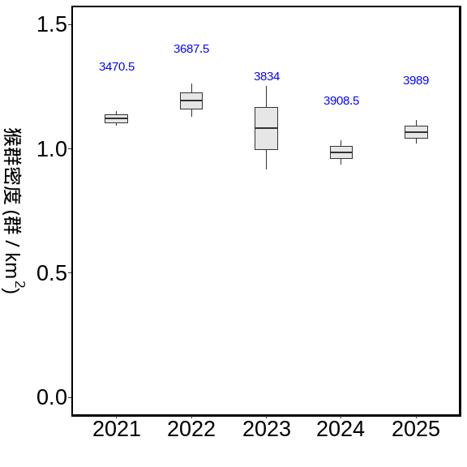
combine_bb %>%
setDT %>%
.[, .(N = length(Macaca_sur),
m = sum(Macaca_sur, na.rm=T)
),
by = c('Year', 'Survey', 'data_source')] %>%
.[,Encounter_rate := m/N] %>%
.[, Mean_N := mean(N), by = c('Year','data_source')] %>%
ggplot(., aes(x = as.character(Year), y = Encounter_rate))+
geom_boxplot( aes(fill= data_source))
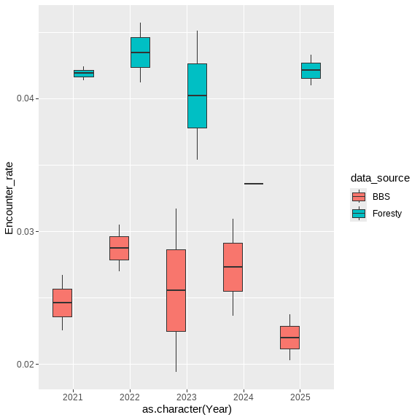
path <- "D:/R/SHP圖層"
town <- st_read(paste0(path,"/","鄉(鎮、市、區)界線(TWD97經緯度)1131028/TOWN_MOI_1131028.shp"), crs=4326) %>%
st_transform(crs=3826)
## Reading layer `TOWN_MOI_1131028' from data source
## `D:\R\SHP圖層\鄉(鎮、市、區)界線(TWD97經緯度)1131028\TOWN_MOI_1131028.shp'
## using driver `ESRI Shapefile'
## Simple feature collection with 368 features and 7 fields
## Geometry type: MULTIPOLYGON
## Dimension: XY
## Bounding box: xmin: 114.3593 ymin: 10.37135 xmax: 124.5612 ymax: 26.38528
## Geodetic CRS: WGS 84
summary(town)
## TOWNID TOWNCODE COUNTYNAME TOWNNAME
## Length:368 Length:368 Length:368 Length:368
## Class :character Class :character Class :character Class :character
## Mode :character Mode :character Mode :character Mode :character
## TOWNENG COUNTYID COUNTYCODE geometry
## Length:368 Length:368 Length:368 MULTIPOLYGON :368
## Class :character Class :character Class :character epsg:3826 : 0
## Mode :character Mode :character Mode :character +proj=tmer...: 0
town_list_Point <-
list_Point %>%
filter(!is.na(X_97)) %>%
st_as_sf(., coords = c("X_97", "Y_97"), crs = 3826) %>%
st_join(.,town) %>%
st_drop_geometry()
town_combine_bb <-
town_list_Point %>%
right_join(.,combine_bb,
by = c("樣區編號","獼猴樣區編號", "樣點代號"="Point"))
#2021~2025年的調查資料
summary__combine <-
town_combine_bb %>%
group_by( Year, Survey) %>%
summarise(N = PointID %>% unique() %>% length,
m = AB %>% sum,
E = m / N,
E_km2 = m / N/per_Area,
.groups = 'drop') %>%
group_by(Year) %>%
summarise(Mean_N = mean(N),
Se_N = se(N),
Mean_m = mean(m),
Se_m = se(m),
Mean_E = mean(E) ,
Se_E = se(E),
Mean_E_km2 = mean(E_km2) ,
Se_E_km2 = se(E_km2),
.groups = 'drop') %>%
mutate_at(c('Se_N','Se_m','Se_E','Mean_E',
'Mean_E_km2','Se_E_km2'), function(x)round(x,3)) %>%
mutate_at(c('Mean_N','Mean_m'), function(x)round(x,2))
調查資料的E
summary__combine %>%
flextable()
Year | Mean_N | Se_N | Mean_m | Se_m | Mean_E | Se_E | Mean_E_km2 | Se_E_km2
2,021 | 3,470.5 | 206.5 | 122.0 | 4.0 | 0.035 | 0.001 | 1.121 | 0.030
2,022 | 3,687.5 | 100.5 | 138.0 | 4.0 | 0.037 | 0.002 | 1.193 | 0.067
2,023 | 3,834.0 | 109.0 | 130.0 | 25.0 | 0.034 | 0.006 | 1.074 | 0.177
2,024 | 3,908.5 | 96.5 | 121.0 | 9.0 | 0.031 | 0.002 | 0.984 | 0.049
2,025 | 3,989.0 | 104.0 | 133.5 | 2.5 | 0.034 | 0.002 | 1.067 | 0.048
縣市
COUNT_combine_bb_outout <-
town_combine_bb %>%
group_by(COUNTYNAME) %>%
summarise(樣點數 = PointID %>% unique() %>% length,
筆數 = PointID %>% length,
'猴群數' = AB %>% sum )
summary_COUNT_combine <-
town_combine_bb %>%
group_by(COUNTYNAME, Year, Survey) %>%
summarise(N = PointID %>% unique() %>% length,
m = AB %>% sum,
E = m / N,
E_km2 = m / N/per_Area,
.groups = 'drop') %>%
group_by(COUNTYNAME) %>%
summarise(Mean_N = mean(N),
Se_N = se(N),
Mean_m = mean(m),
Se_m = se(m),
Mean_E = mean(E) ,
Se_E = se(E),
Mean_E_km2 = mean(E_km2) ,
Se_E_km2 = se(E_km2),
.groups = 'drop') %>%
mutate_at(c('Se_N','Se_m','Se_E','Mean_E',
'Mean_E_km2','Se_E_km2'), function(x)round(x,3)) %>%
mutate_at(c('Mean_N','Mean_m'), function(x)round(x,2)) %>%
arrange(-Mean_E)
調查資料的E
summary_COUNT_combine %>%
flextable()
COUNTYNAME | Mean_N | Se_N | Mean_m | Se_m | Mean_E | Se_E | Mean_E_km2 | Se_E_km2
雲林縣 | 58.4 | 2.837 | 5.6 | 0.872 | 0.096 | 0.015 | 3.061 | 0.476
臺東縣 | 376.5 | 2.949 | 31.2 | 2.342 | 0.083 | 0.006 | 2.643 | 0.205
屏東縣 | 176.1 | 2.302 | 11.2 | 0.611 | 0.064 | 0.004 | 2.027 | 0.113
嘉義縣 | 245.1 | 5.847 | 12.6 | 1.376 | 0.052 | 0.006 | 1.655 | 0.190
花蓮縣 | 406.8 | 5.765 | 20.4 | 1.147 | 0.050 | 0.003 | 1.593 | 0.080
高雄市 | 248.5 | 3.240 | 9.1 | 0.900 | 0.037 | 0.004 | 1.172 | 0.122
南投縣 | 553.3 | 15.584 | 14.7 | 0.895 | 0.026 | 0.001 | 0.842 | 0.040
宜蘭縣 | 231.9 | 4.051 | 5.5 | 0.820 | 0.024 | 0.003 | 0.750 | 0.106
臺中市 | 378.5 | 8.046 | 8.1 | 1.269 | 0.021 | 0.003 | 0.671 | 0.096
苗栗縣 | 181.9 | 6.684 | 3.1 | 0.433 | 0.017 | 0.002 | 0.535 | 0.065
臺南市 | 98.0 | 2.521 | 1.1 | 0.277 | 0.011 | 0.003 | 0.354 | 0.094
新北市 | 333.1 | 14.466 | 3.3 | 0.651 | 0.010 | 0.002 | 0.320 | 0.062
臺北市 | 131.5 | 12.168 | 1.2 | 0.249 | 0.009 | 0.002 | 0.275 | 0.059
彰化縣 | 34.2 | 1.497 | 0.2 | 0.133 | 0.006 | 0.004 | 0.201 | 0.135
新竹縣 | 147.5 | 2.088 | 0.9 | 0.314 | 0.006 | 0.002 | 0.194 | 0.068
桃園市 | 145.4 | 3.056 | 0.7 | 0.335 | 0.005 | 0.002 | 0.156 | 0.076
嘉義市 | 13.9 | 0.971 | 0.0 | 0.000 | 0.000 | 0.000 | 0.000 | 0.000
基隆市 | 7.0 | 1.333 | 0.0 | 0.000 | 0.000 | 0.000 | 0.000 | 0.000
新竹市 | 10.3 | 1.184 | 0.0 | 0.000 | 0.000 | 0.000 | 0.000 | 0.000
summary_COUNT_combine %>%
mutate(
COUNTYNAME = sapply(COUNTYNAME,
function(x) paste(str_split(x, "")[[1]], collapse = "\n")),
COUNTYNAME = reorder(COUNTYNAME, -Mean_E)) %>%
ggplot(data = ., aes(COUNTYNAME, Mean_E))+
geom_bar(aes(fill = -Mean_E), stat = "identity") +
labs(x = "",y ="Encounter_rate")+
scale_color_brewer(palette = "Set2")+
theme_classic()+
theme(
text = element_text(size = 18),
legend.position = "none")
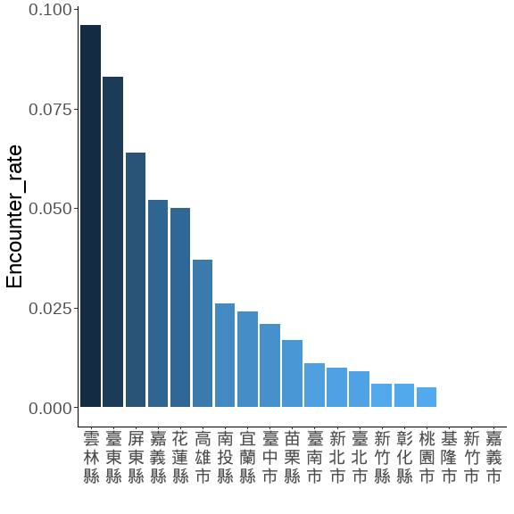
藍色數字為平均樣區數
n.name <- read_xlsx(here::here("./script/Analysis 2025 for Forestry/00.xlsx"))
COUNTY__sorted <- town_combine_bb %>%
group_by(COUNTYNAME, Year, Survey) %>%
summarise(N = PointID %>% unique() %>% length,
m = AB %>% sum,
.groups = 'drop') %>% setDT %>%
.[,Encounter_rate := m/N] %>%
.[, Mean_N := mean(N), by = c('COUNTYNAME')] %>%
.[, Mean_E := mean(Encounter_rate), by = c('COUNTYNAME')] %>%
arrange(desc(Mean_E)) %>% .$COUNTYNAME %>% unique()
town_nn <-
town_combine_bb %>%
group_by(COUNTYNAME, Year, Survey) %>%
summarise(N = PointID %>% unique() %>% length,
m = AB %>% sum,
.groups = 'drop') %>% setDT %>%
.[,Encounter_rate := m/N] %>%
.[, Mean_N := mean(N), by = c('COUNTYNAME')] %>%
.[, Mean_E := mean(Encounter_rate), by = c('COUNTYNAME')] %>%
arrange(desc(Mean_E))%>%
left_join(n.name, by = 'COUNTYNAME') %>% .$COUNTYNAME2 %>% unique() %>%
lapply(.,
function(x) paste(str_split(x, "")[[1]], collapse = "\n")) %>% unlist()
town_combine_bb %>%
group_by(COUNTYNAME, Year, Survey) %>%
summarise(N = PointID %>% unique() %>% length,
m = AB %>% sum,
.groups = 'drop') %>% setDT %>%
.[,E_km2 := m/N/per_Area] %>%
.[, Mean_N := mean(N), by = c('COUNTYNAME')] %>%
ggplot(., aes(x = COUNTYNAME, y = E_km2))+
geom_boxplot(width = 0.3, linewidth = 0.4, fill= gray(.9))+
stat_summary(fun = mean, geom = "text",
aes(label = round(Mean_N, 1)),
position = position_nudge(x = 0, y = 1.7),
angle = 270,
# hjust = -0.1,
# vjust = 0,
color = "blue")+
scale_x_discrete(limit = COUNTY__sorted , labels = town_nn)+
scale_y_continuous(breaks = seq(0,5,1), limits = c(0,5.3))+
labs(x = "", y = expression(paste("猴群密度 (群 / km"^2,")")))+
theme(
panel.border = element_rect(linewidth = 1.5,fill = NA),
panel.grid = element_blank(),
panel.background = element_blank(),
axis.text.x = element_text(size = 12,colour = "black", angle = 0),
axis.text.y = element_text(size = 18,colour = "black"),
axis.title = element_text(size = 18,colour = "black"),
axis.title.y = element_text(angle = 270,
vjust = -1, hjust = 0.5),
legend.position = "top"
)
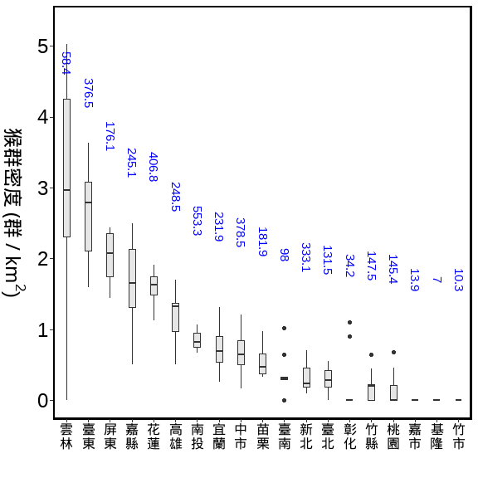
鄉鎮
town_combine_bb_outout <-
town_combine_bb %>%
group_by(COUNTYNAME,TOWNNAME, data_source) %>%
summarise(樣點數 = PointID %>% unique() %>% length,
筆數 = PointID %>% length,
'猴群數' = AB %>% sum,
.groups = 'drop' ) %>%
pivot_wider(., id_cols = c('COUNTYNAME','TOWNNAME'),
names_from = 'data_source',
values_from =c('樣點數', '筆數', '猴群數')) %>%
arrange(-`樣點數_BBS`)
town_combine_bb_outout%>%
flextable() %>%
colformat_double() %>%
separate_header() %>%
align(align = "center", part = "all") %>%
valign(valign = "center", part = "header") %>%
autofit()
COUNTYNAME | TOWNNAME | 樣點數 |  | 筆數 |  | 猴群數
 |  | BBS | Foresty | BBS | Foresty | BBS | Foresty
南投縣 | 仁愛鄉 | 118 | 60 | 908 | 531 | 11.0 | 19.0
南投縣 | 信義鄉 | 86 | 138 | 574 | 1,132 | 12.0 | 43.0
臺中市 | 和平區 | 71 | 254 | 597 | 2,417 | 16.0 | 57.0
臺北市 | 北投區 | 56 | 8 | 342 | 67 | 1.0 | 1.0
新北市 | 新店區 | 51 | 17 | 384 | 156 | 9.0 | 1.0
南投縣 | 鹿谷鄉 | 46 | 5 | 420 | 49 | 16.0 | 0.0
臺北市 | 士林區 | 44 |  | 347 |  | 10.0
新北市 | 三芝區 | 38 |  | 238 |  | 1.0
桃園市 | 復興區 | 38 | 63 | 215 | 520 | 0.0 | 7.0
嘉義縣 | 阿里山鄉 | 33 | 99 | 157 | 902 | 1.0 | 10.0
桃園市 | 龜山區 | 32 |  | 304 |  | 0.0
花蓮縣 | 卓溪鄉 | 32 | 33 | 284 | 238 | 26.0 | 6.0
臺中市 | 霧峰區 | 31 |  | 165 |  | 1.0
臺東縣 | 卑南鄉 | 30 | 50 | 238 | 457 | 18.0 | 38.0
花蓮縣 | 秀林鄉 | 30 | 113 | 234 | 880 | 12.0 | 56.0
宜蘭縣 | 大同鄉 | 29 | 78 | 233 | 702 | 5.0 | 16.0
南投縣 | 水里鄉 | 27 | 14 | 179 | 131 | 1.0 | 5.0
新北市 | 淡水區 | 27 |  | 200 |  | 0.0
新北市 | 石碇區 | 27 | 11 | 127 | 110 | 2.0 | 4.0
高雄市 | 桃源區 | 27 | 31 | 214 | 254 | 11.0 | 14.0
新北市 | 三峽區 | 26 | 42 | 160 | 375 | 2.0 | 0.0
臺北市 | 內湖區 | 26 |  | 178 |  | 0.0
嘉義縣 | 番路鄉 | 24 | 40 | 102 | 370 | 8.0 | 36.0
臺北市 | 文山區 | 24 |  | 180 |  | 0.0
雲林縣 | 林內鄉 | 24 | 12 | 192 | 116 | 29.0 | 5.0
南投縣 | 國姓鄉 | 23 | 33 | 214 | 307 | 8.0 | 8.0
苗栗縣 | 泰安鄉 | 23 | 62 | 161 | 607 | 5.0 | 7.0
南投縣 | 魚池鄉 | 22 | 1 | 220 | 10 | 5.0 | 1.0
新北市 | 烏來區 | 22 | 41 | 166 | 399 | 1.0 | 8.0
新北市 | 汐止區 | 21 | 6 | 129 | 60 | 1.0 | 2.0
宜蘭縣 | 頭城鎮 | 19 | 3 | 123 | 24 | 2.0 | 0.0
花蓮縣 | 壽豐鄉 | 19 | 48 | 178 | 426 | 5.0 | 32.0
花蓮縣 | 瑞穗鄉 | 19 |  | 187 |  | 6.0
南投縣 | 中寮鄉 | 18 |  | 180 |  | 1.0
新北市 | 金山區 | 17 | 7 | 57 | 64 | 0.0 | 0.0
桃園市 | 大溪區 | 17 |  | 152 |  | 0.0
苗栗縣 | 三義鄉 | 17 | 12 | 149 | 113 | 3.0 | 0.0
苗栗縣 | 頭屋鄉 | 17 | 2 | 168 | 20 | 6.0 | 0.0
高雄市 | 美濃區 | 17 | 18 | 64 | 166 | 0.0 | 17.0
嘉義市 | 東區 | 16 |  | 139 |  | 0.0
新竹縣 | 尖石鄉 | 16 | 70 | 95 | 674 | 0.0 | 2.0
花蓮縣 | 玉里鎮 | 16 | 20 | 88 | 149 | 3.0 | 5.0
花蓮縣 | 萬榮鄉 | 16 | 50 | 134 | 375 | 15.0 | 7.0
高雄市 | 鼓山區 | 16 | 6 | 57 | 27 | 16.0 | 8.0
南投縣 | 草屯鎮 | 15 | 11 | 141 | 89 | 3.0 | 0.0
桃園市 | 龍潭區 | 15 |  | 75 |  | 0.0
臺中市 | 太平區 | 15 | 11 | 112 | 100 | 0.0 | 7.0
苗栗縣 | 獅潭鄉 | 15 | 4 | 126 | 40 | 1.0 | 0.0
屏東縣 | 內埔鄉 | 14 |  | 86 |  | 0.0
桃園市 | 蘆竹區 | 14 |  | 130 |  | 0.0
臺中市 | 東勢區 | 14 |  | 96 |  | 0.0
花蓮縣 | 光復鄉 | 14 | 12 | 132 | 116 | 0.0 | 2.0
高雄市 | 田寮區 | 14 | 4 | 124 | 39 | 0.0 | 0.0
南投縣 | 竹山鎮 | 13 | 17 | 86 | 157 | 0.0 | 14.0
嘉義縣 | 中埔鄉 | 13 |  | 46 |  | 0.0
新竹縣 | 關西鎮 | 13 |  | 118 |  | 0.0
臺東縣 | 海端鄉 | 13 | 45 | 111 | 437 | 4.0 | 19.0
南投縣 | 集集鎮 | 12 |  | 120 |  | 0.0
屏東縣 | 來義鄉 | 12 | 8 | 114 | 73 | 5.0 | 1.0
臺南市 | 東山區 | 12 |  | 100 |  | 6.0
臺中市 | 北屯區 | 11 | 6 | 96 | 60 | 0.0 | 0.0
臺北市 | 信義區 | 11 |  | 26 |  | 0.0
臺北市 | 南港區 | 11 |  | 104 |  | 0.0
花蓮縣 | 鳳林鎮 | 11 | 12 | 85 | 119 | 2.0 | 8.0
雲林縣 | 古坑鄉 | 11 | 18 | 70 | 127 | 1.0 | 0.0
高雄市 | 茂林區 | 11 |  | 75 |  | 3.0
基隆市 | 暖暖區 | 10 |  | 20 |  | 0.0
新北市 | 坪林區 | 10 | 20 | 100 | 193 | 1.0 | 1.0
新北市 | 平溪區 | 10 |  | 20 |  | 0.0
新北市 | 瑞芳區 | 10 |  | 100 |  | 0.0
新竹縣 | 五峰鄉 | 10 | 36 | 78 | 340 | 1.0 | 6.0
臺南市 | 新化區 | 10 |  | 10 |  | 0.0
臺南市 | 龍崎區 | 10 |  | 100 |  | 0.0
臺東縣 | 成功鎮 | 10 | 17 | 74 | 167 | 9.0 | 17.0
臺東縣 | 東河鄉 | 10 | 18 | 98 | 178 | 21.0 | 15.0
苗栗縣 | 南庄鄉 | 10 | 21 | 10 | 116 | 0.0 | 2.0
高雄市 | 旗山區 | 10 | 7 | 96 | 64 | 4.0 | 3.0
嘉義縣 | 竹崎鄉 | 9 | 11 | 90 | 107 | 1.0 | 2.0
屏東縣 | 恆春鎮 | 9 | 17 | 90 | 152 | 2.0 | 9.0
新竹縣 | 寶山鄉 | 9 |  | 90 |  | 0.0
臺南市 | 左鎮區 | 9 | 12 | 82 | 119 | 0.0 | 0.0
臺東縣 | 達仁鄉 | 9 | 48 | 90 | 457 | 6.0 | 31.0
雲林縣 | 斗六市 | 9 |  | 79 |  | 21.0
嘉義縣 | 大埔鄉 | 8 | 47 | 70 | 459 | 10.0 | 44.0
新竹市 | 東區 | 8 |  | 46 |  | 0.0
臺北市 | 中山區 | 8 |  | 56 |  | 0.0
臺南市 | 六甲區 | 8 | 11 | 80 | 103 | 0.0 | 0.0
臺東縣 | 大武鄉 | 8 | 5 | 80 | 32 | 7.0 | 6.0
臺東縣 | 金峰鄉 | 8 | 19 | 80 | 154 | 10.0 | 16.0
花蓮縣 | 富里鄉 | 8 | 18 | 26 | 159 | 0.0 | 12.0
苗栗縣 | 公館鄉 | 8 | 1 | 80 | 9 | 0.0 | 2.0
南投縣 | 南投市 | 7 |  | 65 |  | 0.0
宜蘭縣 | 三星鄉 | 7 | 10 | 70 | 93 | 1.0 | 0.0
宜蘭縣 | 礁溪鄉 | 7 | 18 | 53 | 165 | 0.0 | 2.0
屏東縣 | 滿州鄉 | 7 | 26 | 56 | 224 | 4.0 | 7.0
彰化縣 | 花壇鄉 | 7 |  | 42 |  | 0.0
新北市 | 林口區 | 7 |  | 63 |  | 0.0
新竹縣 | 峨眉鄉 | 7 |  | 70 |  | 0.0
臺中市 | 新社區 | 7 |  | 34 |  | 0.0
高雄市 | 岡山區 | 7 |  | 70 |  | 0.0
高雄市 | 楠梓區 | 7 |  | 58 |  | 0.0
宜蘭縣 | 南澳鄉 | 6 | 41 | 12 | 358 | 0.0 | 14.0
彰化縣 | 彰化市 | 6 |  | 60 |  | 0.0
新北市 | 八里區 | 6 |  | 12 |  | 0.0
新北市 | 泰山區 | 6 |  | 36 |  | 0.0
新北市 | 萬里區 | 6 |  | 24 |  | 0.0
新竹市 | 香山區 | 6 |  | 57 |  | 0.0
苗栗縣 | 銅鑼鄉 | 6 |  | 51 |  | 0.0
高雄市 | 大樹區 | 6 |  | 36 |  | 0.0
高雄市 | 杉林區 | 6 | 6 | 48 | 51 | 0.0 | 2.0
高雄市 | 鳥松區 | 6 |  | 60 |  | 0.0
宜蘭縣 | 員山鄉 | 5 | 17 | 42 | 153 | 0.0 | 1.0
屏東縣 | 獅子鄉 | 5 | 35 | 25 | 275 | 4.0 | 37.0
新北市 | 五股區 | 5 |  | 36 |  | 0.0
高雄市 | 仁武區 | 5 |  | 50 |  | 0.0
高雄市 | 小港區 | 5 |  | 50 |  | 0.0
屏東縣 | 琉球鄉 | 4 |  | 20 |  | 0.0
屏東縣 | 霧臺鄉 | 4 | 10 | 40 | 86 | 1.0 | 5.0
彰化縣 | 員林市 | 4 |  | 32 |  | 0.0
新北市 | 石門區 | 4 |  | 12 |  | 0.0
桃園市 | 八德區 | 4 |  | 29 |  | 0.0
臺中市 | 大雅區 | 4 |  | 28 |  | 0.0
苗栗縣 | 大湖鄉 | 4 | 11 | 8 | 90 | 0.0 | 4.0
苗栗縣 | 頭份市 | 4 |  | 8 |  | 0.0
高雄市 | 內門區 | 4 | 5 | 36 | 50 | 0.0 | 0.0
嘉義縣 | 民雄鄉 | 3 |  | 27 |  | 0.0
基隆市 | 七堵區 | 3 |  | 30 |  | 0.0
彰化縣 | 大村鄉 | 3 |  | 18 |  | 0.0
新北市 | 土城區 | 3 |  | 12 |  | 0.0
新北市 | 樹林區 | 3 |  | 30 |  | 0.0
桃園市 | 桃園區 | 3 |  | 23 |  | 0.0
臺中市 | 潭子區 | 3 |  | 26 |  | 0.0
臺北市 | 大安區 | 3 |  | 15 |  | 0.0
臺南市 | 山上區 | 3 |  | 24 |  | 0.0
苗栗縣 | 造橋鄉 | 3 |  | 9 |  | 0.0
南投縣 | 名間鄉 | 2 |  | 20 |  | 0.0
基隆市 | 安樂區 | 2 |  | 20 |  | 0.0
新北市 | 深坑區 | 2 |  | 12 |  | 0.0
臺中市 | 南屯區 | 2 |  | 8 |  | 0.0
臺中市 | 大肚區 | 2 |  | 10 |  | 0.0
臺中市 | 清水區 | 2 |  | 4 |  | 0.0
臺中市 | 烏日區 | 2 |  | 8 |  | 0.0
臺中市 | 西屯區 | 2 |  | 12 |  | 0.0
臺南市 | 白河區 | 2 |  | 4 |  | 0.0
臺東縣 | 延平鄉 | 2 | 34 | 20 | 333 | 1.0 | 28.0
花蓮縣 | 花蓮市 | 2 |  | 20 |  | 0.0
高雄市 | 大社區 | 2 |  | 20 |  | 0.0
高雄市 | 左營區 | 2 |  | 18 |  | 0.0
屏東縣 | 新埤鄉 | 1 |  | 7 |  | 0.0
屏東縣 | 枋寮鄉 | 1 |  | 7 |  | 0.0
彰化縣 | 芬園鄉 | 1 |  | 10 |  | 0.0
新竹縣 | 竹東鎮 | 1 |  | 10 |  | 0.0
桃園市 | 觀音區 | 1 |  | 6 |  | 0.0
臺中市 | 沙鹿區 | 1 |  | 8 |  | 0.0
臺中市 | 豐原區 | 1 |  | 4 |  | 0.0
臺南市 | 玉井區 | 1 | 5 | 9 | 50 | 0.0 | 0.0
臺東縣 | 太麻里鄉 | 1 | 18 | 10 | 178 | 2.0 | 5.0
臺東縣 | 蘭嶼鄉 | 1 |  | 1 |  | 0.0
臺東縣 | 關山鎮 | 1 | 8 | 10 | 78 | 0.0 | 5.0
高雄市 | 大寮區 | 1 |  | 10 |  | 0.0
高雄市 | 林園區 | 1 |  | 10 |  | 0.0
高雄市 | 甲仙區 | 1 | 15 | 8 | 125 | 1.0 | 3.0
高雄市 | 阿蓮區 | 1 |  | 9 |  | 0.0
嘉義縣 | 梅山鄉 |  | 16 |  | 121 |  | 14.0
宜蘭縣 | 冬山鄉 |  | 8 |  | 71 |  | 3.0
宜蘭縣 | 蘇澳鎮 |  | 24 |  | 220 |  | 11.0
屏東縣 | 三地門鄉 |  | 20 |  | 176 |  | 10.0
屏東縣 | 春日鄉 |  | 1 |  | 10 |  | 1.0
屏東縣 | 泰武鄉 |  | 6 |  | 58 |  | 2.0
屏東縣 | 牡丹鄉 |  | 18 |  | 175 |  | 15.0
屏東縣 | 瑪家鄉 |  | 6 |  | 60 |  | 8.0
屏東縣 | 高樹鄉 |  | 3 |  | 27 |  | 1.0
彰化縣 | 二水鄉 |  | 6 |  | 60 |  | 1.0
彰化縣 | 田中鎮 |  | 8 |  | 80 |  | 0.0
彰化縣 | 社頭鄉 |  | 4 |  | 40 |  | 1.0
新北市 | 雙溪區 |  | 7 |  | 56 |  | 0.0
臺南市 | 南化區 |  | 27 |  | 213 |  | 3.0
臺南市 | 楠西區 |  | 13 |  | 86 |  | 2.0
臺東縣 | 池上鄉 |  | 8 |  | 78 |  | 5.0
臺東縣 | 長濱鄉 |  | 27 |  | 268 |  | 38.0
臺東縣 | 鹿野鄉 |  | 14 |  | 136 |  | 11.0
花蓮縣 | 吉安鄉 |  | 7 |  | 69 |  | 1.0
花蓮縣 | 豐濱鄉 |  | 17 |  | 169 |  | 6.0
苗栗縣 | 卓蘭鎮 |  | 12 |  | 54 |  | 1.0
高雄市 | 六龜區 |  | 51 |  | 487 |  | 6.0
高雄市 | 燕巢區 |  | 5 |  | 49 |  | 0.0
高雄市 | 那瑪夏區 |  | 6 |  | 60 |  | 3.0
summary_TOWN_combine <-
town_combine_bb %>%
group_by(COUNTYNAME,TOWNNAME, Year, Survey) %>%
summarise(N = PointID %>% unique() %>% length,
m = AB %>% sum,
E = m / N,
E_km2 = m / N/per_Area ,
.groups = 'drop') %>%
group_by(COUNTYNAME,TOWNNAME) %>%
summarise(Mean_N = mean(N),
Se_N = se(N),
Mean_m = mean(m),
Se_m = se(m),
Mean_E = mean(E) ,
Se_E = se(E),
Mean_E_km2 = mean(E_km2) ,
Se_E_km2 = se(E_km2),
.groups = 'drop') %>%
mutate_at(c('Se_N','Se_m','Se_E','Mean_E',
'Mean_E_km2','Se_E_km2'), function(x)round(x,3)) %>%
mutate_at(c('Mean_N','Mean_m'), function(x)round(x,2))%>%
arrange(-Mean_E)
調查資料的E (前20名, 全部有186個鄉鎮)
summary_TOWN_combine%>%
arrange(-Mean_E) %>%
slice(1:20) %>%
flextable()
COUNTYNAME | TOWNNAME | Mean_N | Se_N | Mean_m | Se_m | Mean_E | Se_E | Mean_E_km2 | Se_E_km2
高雄市 | 鼓山區 | 8.4 | 1.194 | 2.4 | 0.427 | 0.321 | 0.057 | 10.231 | 1.817
雲林縣 | 斗六市 | 7.9 | 0.233 | 2.1 | 0.605 | 0.274 | 0.081 | 8.709 | 2.591
臺東縣 | 長濱鄉 | 26.8 | 0.133 | 3.8 | 0.712 | 0.142 | 0.027 | 4.521 | 0.847
屏東縣 | 獅子鄉 | 30.0 | 0.955 | 4.1 | 0.482 | 0.137 | 0.016 | 4.348 | 0.509
屏東縣 | 瑪家鄉 | 6.0 | 0.000 | 0.8 | 0.200 | 0.133 | 0.033 | 4.244 | 1.061
臺東縣 | 東河鄉 | 27.6 | 0.221 | 3.6 | 0.452 | 0.131 | 0.017 | 4.179 | 0.552
嘉義縣 | 梅山鄉 | 12.1 | 0.781 | 1.4 | 0.306 | 0.122 | 0.026 | 3.880 | 0.831
臺東縣 | 大武鄉 | 11.2 | 0.442 | 1.3 | 0.153 | 0.116 | 0.013 | 3.706 | 0.410
臺東縣 | 金峰鄉 | 23.4 | 1.097 | 2.6 | 0.340 | 0.114 | 0.015 | 3.633 | 0.493
臺東縣 | 成功鎮 | 24.1 | 1.242 | 2.6 | 0.636 | 0.105 | 0.026 | 3.354 | 0.816
嘉義縣 | 大埔鄉 | 52.9 | 0.674 | 5.4 | 0.702 | 0.102 | 0.013 | 3.232 | 0.426
屏東縣 | 春日鄉 | 1.0 | 0.000 | 0.1 | 0.100 | 0.100 | 0.100 | 3.183 | 3.183
雲林縣 | 林內鄉 | 30.8 | 2.542 | 3.4 | 0.921 | 0.100 | 0.026 | 3.174 | 0.840
嘉義縣 | 番路鄉 | 47.2 | 2.332 | 4.4 | 0.718 | 0.095 | 0.016 | 3.030 | 0.498
屏東縣 | 牡丹鄉 | 17.5 | 0.342 | 1.5 | 0.428 | 0.083 | 0.024 | 2.653 | 0.757
臺東縣 | 卑南鄉 | 69.5 | 1.881 | 5.6 | 0.763 | 0.082 | 0.012 | 2.615 | 0.393
臺東縣 | 延平鄉 | 35.3 | 0.396 | 2.9 | 0.623 | 0.082 | 0.017 | 2.607 | 0.554
臺東縣 | 鹿野鄉 | 13.6 | 0.163 | 1.1 | 0.348 | 0.082 | 0.026 | 2.606 | 0.823
苗栗縣 | 大湖鄉 | 9.8 | 1.263 | 0.4 | 0.221 | 0.073 | 0.050 | 2.334 | 1.588
高雄市 | 美濃區 | 23.0 | 0.745 | 1.7 | 0.335 | 0.073 | 0.014 | 2.317 | 0.444
town_combine_bb %>%
filter(str_detect(TOWNNAME, "大埔|番路|阿里山|古坑|林內")) %>%
group_by(COUNTYNAME,TOWNNAME, Year, Survey) %>%
summarise(N = PointID %>% unique() %>% length,
m = AB %>% sum,
E = m / N,
E_km2 = m / N/per_Area ,
.groups = 'drop') %>%
group_by(COUNTYNAME,TOWNNAME) %>%
summarise(N_Mean = mean(N),
N_Se = se(N),
N_range =paste0(min(N),"~", max(N)),
m_Mean = mean(m),
m_Se = se(m),
E_Mean = mean(E) ,
E_Se = se(E),
'E km2_Mean' = mean(E_km2) ,
'E km2_Se' = se(E_km2),
.groups = 'drop') %>%
mutate_at(c('N_Se','m_Se','E_Mean','E_Se',
'E km2_Mean','E km2_Se'), function(x)round(x,3)) %>%
mutate_at(c('N_Mean','m_Mean'), function(x)round(x,2))%>%
flextable() %>%
separate_header()
COUNTYNAME | TOWNNAME | N |  |  | m |  | E |  | E km2
 |  | Mean | Se | range | Mean | Se | Mean | Se | Mean | Se
嘉義縣 | 大埔鄉 | 52.9 | 0.674 | 49~55 | 5.4 | 0.702 | 0.102 | 0.013 | 3.232 | 0.426
嘉義縣 | 番路鄉 | 47.2 | 2.332 | 36~57 | 4.4 | 0.718 | 0.095 | 0.016 | 3.030 | 0.498
嘉義縣 | 阿里山鄉 | 105.9 | 3.257 | 88~121 | 1.1 | 0.233 | 0.010 | 0.002 | 0.326 | 0.065
雲林縣 | 古坑鄉 | 19.7 | 1.367 | 15~27 | 0.1 | 0.100 | 0.004 | 0.004 | 0.118 | 0.118
雲林縣 | 林內鄉 | 30.8 | 2.542 | 16~36 | 3.4 | 0.921 | 0.100 | 0.026 | 3.174 | 0.840
summary_TOWN_combine %>%
mutate(
TOWNNAME = sapply(TOWNNAME,
function(x) paste(str_split(x, "")[[1]], collapse = "\n")),
TOWNNAME = reorder(TOWNNAME, -Mean_E)) %>%
filter(Mean_E>0) %>%
slice_max(order_by = Mean_E, n = 20) %>%
ggplot(data = , aes(TOWNNAME, Mean_E))+
geom_bar(aes(fill = -Mean_E), stat = "identity") +
#geom_col(aes(fill = -Mean_E))+
labs(x = "",y ="Encounter_rate")+
scale_color_brewer(palette = "Set2")+
theme_classic()+
theme(text = element_text(size = 18),
legend.position = "none")
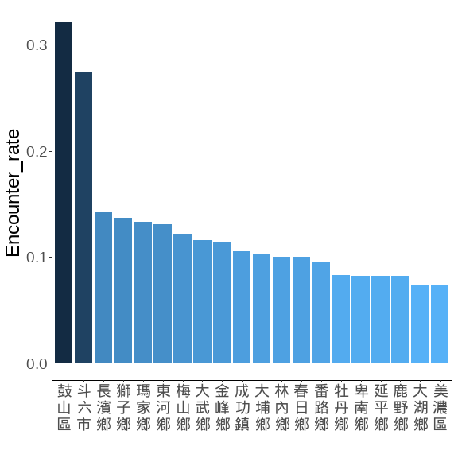
藍色數字為平均樣區數
TOWN__sorted <- town_combine_bb %>%
filter(str_detect(TOWNNAME, "大埔|番路|阿里山|古坑|林內")) %>%
group_by(TOWNNAME, Year, Survey) %>%
summarise(N = PointID %>% unique() %>% length,
m = AB %>% sum,
.groups = 'drop') %>% setDT %>%
.[,Encounter_rate := m/N] %>%
.[, .(Mean_N = mean(N),
Mean_E = mean(Encounter_rate)), by = c('TOWNNAME')] %>%
# slice_max(order_by = Mean_E, n = 50) %>%
arrange(desc(Mean_E)) %>% .$TOWNNAME %>% unique()
town_nn2 <-
lapply(TOWN__sorted,
function(x) paste(str_split(x, "")[[1]], collapse = "\n")) %>% unlist()
town_combine_bb %>%
filter(str_detect(TOWNNAME, "大埔|番路|阿里山|古坑|林內")) %>%
group_by(TOWNNAME, Year, Survey) %>%
summarise(N = PointID %>% unique() %>% length,
m = AB %>% sum,
.groups = 'drop') %>% setDT %>%
.[,E_km2 := m/N/per_Area] %>%
.[, Mean_N := mean(N), by = c('TOWNNAME')] %>%
ggplot(., aes(x = TOWNNAME, y = E_km2))+
geom_boxplot(width = 0.3, linewidth = 0.4, fill= gray(.9))+
stat_summary(fun = mean, geom = "text",
aes(label = round(Mean_N, 1)),
position = position_nudge(x = 0.1, y = 1.8),
angle=270,
color = "blue")+
scale_x_discrete(limit = TOWN__sorted , labels = town_nn2)+
# scale_y_continuous(breaks = seq(0,0.2,0.05), limits = c(0,0.2))+
labs(x = "", y = expression(paste("猴群密度 (群 / km"^2,")")))+
theme(
panel.border = element_rect(linewidth = 1.5,fill = NA),
panel.grid = element_blank(),
panel.background = element_blank(),
axis.text.x = element_text(size = 18,colour = "black", angle = 0),
axis.text = element_text(size = 20,colour = "black"),
axis.title = element_text(size = 18,colour = "black"),
axis.title.y = element_text(angle = 270,
vjust = -1, hjust = 0.5),
legend.position = "top"
)
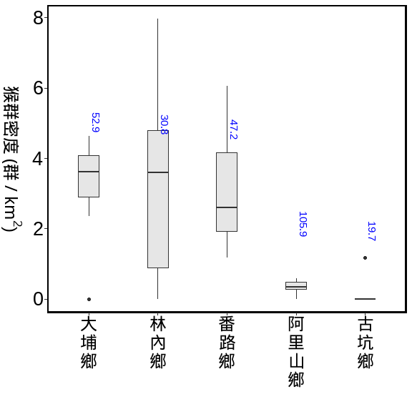

BBS與林業署的資料 (用1:1混和)

全島 vs 縣市 vs 鄉鎮
海拔50m以上的森林總面積=21028.14 (km²)
方法：bootstrap
重複抽樣：10,000次
單位面積的半徑: 100m
海拔50m以上的森林總面積=21028.14 (km²)
方法：bootstrap
重複抽樣：10,000次
單位面積的半徑: 100m
troop_M_all %>%
mutate('年' = as.character(Year)) %>%
mutate(
'相對密度_km2' = round(mm,3),
"相對密度_km2(95%CI)" = paste0(round(q_1,3), "~", round(q_3,3))
) %>%
mutate(
'群數' = round(M_troops),
"群數(95%CI)" = paste0(round(q1_troops), "~", round(q3_troops))
) %>%
mutate(
'隻數' = round(M_troops*25),
"隻數(95%CI)" = paste0(round(q1_troops*25), "~", round(q3_troops*25))
) %>%
select(年, `相對密度_km2`:`隻數(95%CI)`) %>%
flextable::flextable()
年 | 相對密度_km2 | 相對密度_km2(95%CI) | 群數 | 群數(95%CI) | 隻數 | 隻數(95%CI)
2021 | 1.119 | 0.981~1.257 | 23,533 | 20637~26423 | 588,335 | 515920~660571
2022 | 1.192 | 1.053~1.334 | 25,059 | 22145~28044 | 626,463 | 553629~701112
2023 | 1.079 | 0.955~1.208 | 22,686 | 20077~25402 | 567,159 | 501923~635041
2024 | 0.985 | 0.863~1.104 | 20,705 | 18153~23205 | 517,631 | 453823~580123
2025 | 1.066 | 0.942~1.193 | 22,410 | 19800~25086 | 560,258 | 495004~627145
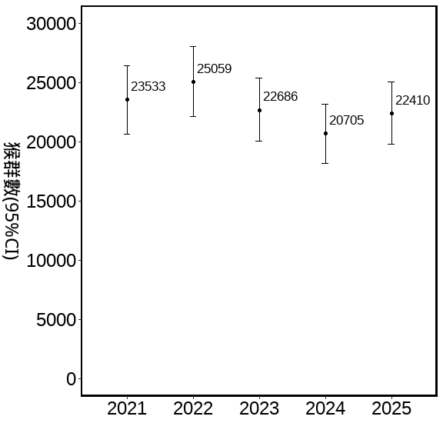
估計縣市猴群數 50m以上的森林，2021-2024的資料bootstraps
海拔50m以上的森林在各縣市面積 (km²)
方法：bootstrap
重複抽樣：10,000次
單位面積的半徑: 100m
per_Area <- (0.1*0.1*pi) #100m半徑的單位原面積
COUNTY_M_all <-
forest_town %>%
.[, .(area = sum(area)), by = 'COUNTYNAME'] %>%
left_join(bootstrap_AB_all_COUNTY, .,by = 'COUNTYNAME') %>% setDT %>%
.[ , 'M_troops' := (area)*mm] %>%
.[ , 'q1_troops' := (area)*q_1] %>%
.[ , 'q3_troops' := (area)*q_3] %>%
.[, 'log_troops':= log(M_troops)]%>%
.[ , 'COUNT' := M_troops*25]
用縣市的資料分別抽樣，再依各縣市50m以上的森林面積，去估算
COUNTYNAME | 相對密度_km2 | 相對密度_km2(95%CI) | 群數 | 群數(95%CI) | 隻數 | 隻數(95%CI)
臺東縣 | 2.639 | 2.359~93.113 | 7,443 | 6652~8250 | 186,083 | 166304~206241
花蓮縣 | 1.594 | 1.385~57.535 | 5,810 | 5048~6588 | 145,245 | 126208~164712
屏東縣 | 2.025 | 1.681~75.948 | 3,001 | 2491~3536 | 75,024 | 62277~88394
南投縣 | 0.845 | 0.713~31.314 | 2,509 | 2117~2920 | 62,722 | 52937~73002
高雄市 | 1.167 | 0.935~44.85 | 1,911 | 1532~2308 | 47,777 | 38296~57706
宜蘭縣 | 0.754 | 0.563~30.584 | 1,232 | 920~1571 | 30,806 | 22998~39266
嘉義縣 | 1.634 | 1.364~61.181 | 1,225 | 1022~1441 | 30,625 | 25553~36017
臺中市 | 0.681 | 0.538~26.501 | 751 | 594~919 | 18,775 | 14849~22970
苗栗縣 | 0.542 | 0.367~23.395 | 651 | 442~883 | 16,279 | 11043~22085
新北市 | 0.315 | 0.21~13.391 | 467 | 312~624 | 11,682 | 7796~15601
雲林縣 | 3.051 | 2.289~123.182 | 295 | 221~374 | 7,369 | 5529~9346
新竹縣 | 0.195 | 0.086~10.991 | 198 | 88~351 | 4,953 | 2192~8769
臺南市 | 0.357 | 0.162~18.61 | 159 | 72~260 | 3,974 | 1807~6504
桃園市 | 0.153 | 0.044~9.059 | 68 | 20~127 | 1,705 | 489~3178
臺北市 | 0.289 | 0.145~14.64 | 28 | 14~44 | 689 | 346~1097
彰化縣 | 0.184 | 0~14.813 | 14 | 0~35 | 345 | 0~875
基隆市 | 0.000 | 0~0 | 0 | 0~0 | 0 | 0~0
新竹市 | 0.000 | 0~0 | 0 | 0~0 | 0 | 0~0
嘉義市 | 0.000 | 0~0 | 0 | 0~0 | 0 | 0~0
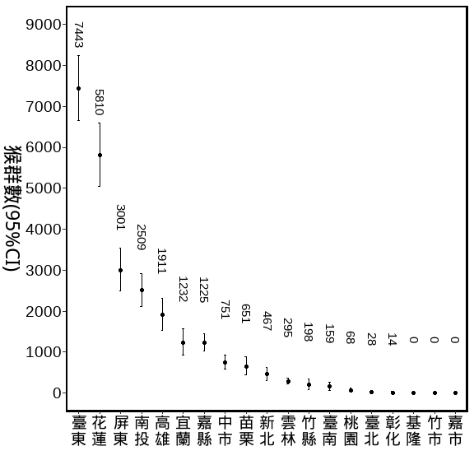
估計部分鄉鎮猴群數 50m以上的森林，2021-2025的資料bootstraps
大埔,番路,阿里山,古坑,林內
per_Area <- (0.1*0.1*pi) #100m半徑的單位原面積
TOWN_M_all <-
forest_town %>%
left_join(bootstrap_AB_all_TOWN, .,by = 'TOWNNAME') %>% setDT %>%
.[ , 'M_troops' := area*mm] %>%
.[ , 'q1_troops' := area*q_1] %>%
.[ , 'q3_troops' := area*q_3] %>%
.[, 'log_troops':= log(M_troops)]%>%
.[ , 'COUNT' := M_troops*25]
COUNTYNAME | TOWNNAME | 相對密度_km2 | 相對密度_km2(95%CI) | 群數 | 群數(95%CI) | 隻數 | 隻數(95%CI)
嘉義縣 | 大埔鄉 | 3.251 | 2.467~4.092 | 415 | 315~522 | 10,370 | 7868~13050
嘉義縣 | 番路鄉 | 2.963 | 2.158~3.844 | 185 | 135~240 | 4,624 | 3368~6000
嘉義縣 | 阿里山鄉 | 0.332 | 0.15~0.541 | 129 | 58~210 | 3,220 | 1457~5247
雲林縣 | 林內鄉 | 3.513 | 2.48~4.651 | 63 | 45~84 | 1,580 | 1115~2091
雲林縣 | 古坑鄉 | 0.159 | 0~0.485 | 10 | 0~32 | 260 | 0~794
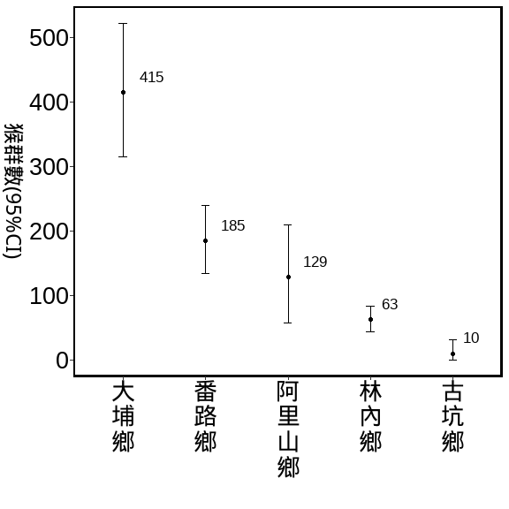

BBS與林業署的資料 (用1:1混和)

全島 vs 是否林班地
path <- "D:/R/SHP圖層"
Foresty_50 <- st_read(paste0(path,"/","0_自製/海拔50公尺以的林班地/Foresty_up50.shp"), crs=3826) %>%
st_transform(crs=3826) %>%
mutate(range = "Fotersty") %>%
dplyr::select(-ELEV)
## Reading layer `Foresty_up50' from data source
## `D:\R\SHP圖層\0_自製\海拔50公尺以的林班地\Foresty_up50.shp'
## using driver `ESRI Shapefile'
## Simple feature collection with 1 feature and 1 field
## Geometry type: MULTIPOLYGON
## Dimension: XY
## Bounding box: xmin: 182507.4 ymin: 2423010 xmax: 351091.4 ymax: 2766881
## Projected CRS: TWD97 / TM2 zone 121
summary(Foresty_50)
## range geometry
## Length:1 MULTIPOLYGON :1
## Class :character epsg:3826 :0
## Mode :character +proj=tmer...:0
Foresty_list_Point <-
list_Point %>%
filter(!is.na(X_97)) %>%
st_as_sf(., coords = c("X_97", "Y_97"), crs = 3826) %>%
st_join(.,Foresty_50) %>%
st_drop_geometry() %>%
mutate(range = ifelse(range %in% "Fotersty",
"林班地","非林班地"))
Foresty_combine_bb <-
Foresty_list_Point %>%
right_join(.,combine_bb,
by = c("樣區編號","獼猴樣區編號", "樣點代號"="Point"))
summary_Foresty_combine <-
Foresty_combine_bb %>%
group_by(range, Year, Survey) %>%
summarise(N = PointID %>% unique() %>% length,
m = AB %>% sum,
E = m / N,
E_km2 = m / N/per_Area,
.groups = 'drop') %>%
group_by(range, Year) %>%
summarise(Mean_N = mean(N),
Se_N = se(N),
Mean_m = mean(m),
Se_m = se(m),
Mean_E = mean(E) ,
Se_E = se(E),
Mean_E_km2 = mean(E_km2) ,
Se_E_km2 = se(E_km2),
.groups = 'drop') %>%
mutate_at(c('Se_N','Se_m','Se_E','Mean_E',
'Mean_E_km2','Se_E_km2'), function(x)round(x,3)) %>%
mutate_at(c('Mean_N','Mean_m'), function(x)round(x,2)) %>%
arrange(range, Year)
調查資料的E
summary_Foresty_combine %>%
flextable()%>%
autofit() %>%
align(align = "center", part = "all") %>%
set_table_properties(layout = "autofit") %>%
colformat_num(., big.mark="")
range | Year | Mean_N | Se_N | Mean_m | Se_m | Mean_E | Se_E | Mean_E_km2 | Se_E_km2
林班地 | 2021 | 1657.0 | 99.0 | 61.5 | 3.5 | 0.037 | 0.000 | 1.182 | 0.003
林班地 | 2022 | 1734.0 | 62.0 | 79.0 | 1.0 | 0.046 | 0.002 | 1.453 | 0.070
林班地 | 2023 | 1731.0 | 62.0 | 70.0 | 13.0 | 0.040 | 0.006 | 1.280 | 0.193
林班地 | 2024 | 1752.0 | 47.0 | 60.5 | 9.5 | 0.034 | 0.004 | 1.095 | 0.143
林班地 | 2025 | 1754.5 | 58.5 | 67.0 | 2.0 | 0.038 | 0.000 | 1.216 | 0.004
非林班地 | 2021 | 1813.5 | 107.5 | 60.5 | 0.5 | 0.033 | 0.002 | 1.065 | 0.054
非林班地 | 2022 | 1953.5 | 38.5 | 59.0 | 3.0 | 0.030 | 0.002 | 0.963 | 0.068
非林班地 | 2023 | 2103.0 | 47.0 | 60.0 | 12.0 | 0.028 | 0.005 | 0.905 | 0.161
非林班地 | 2024 | 2156.5 | 49.5 | 60.5 | 0.5 | 0.028 | 0.001 | 0.894 | 0.028
非林班地 | 2025 | 2234.5 | 45.5 | 66.5 | 4.5 | 0.030 | 0.003 | 0.949 | 0.083
藍色數字為平均樣區數
Foresty__sorted <- Foresty_combine_bb %>%
group_by(range, Year, Survey) %>%
summarise(N = PointID %>% unique() %>% length,
m = AB %>% sum,
.groups = 'drop') %>% setDT %>%
.[,Encounter_rate := m/N] %>%
.[, Mean_N := mean(N), by = c('range')] %>%
.[, Mean_E := mean(Encounter_rate), by = c('range')] %>%
arrange(desc(Mean_E)) %>% .$range %>% unique()
range_nn <-
Foresty_combine_bb %>%
group_by(range, Year, Survey) %>%
summarise(N = PointID %>% unique() %>% length,
m = AB %>% sum,
.groups = 'drop') %>% setDT %>%
.[,Encounter_rate := m/N] %>%
.[,E_km2 := m/N/per_Area] %>%
group_by(range, Year) %>%
summarise(
Mean_N = mean(N),
Mean_E = mean(Encounter_rate),
Mean_E_km2 = quantile(E_km2,0.75)) %>%
arrange(desc(Mean_E))
## `summarise()` has grouped output by 'range'. You can override using the
## `.groups` argument.
Foresty_combine_bb %>%
group_by(range, Year, Survey) %>%
summarise(N = PointID %>% unique() %>% length,
m = AB %>% sum,
.groups = 'drop') %>% setDT %>%
.[,E_km2 := m/N/per_Area] %>%
.[, Mean_N := mean(N), by = c('range', "Year")] %>%
ggplot(., aes(x = as.character(Year), y = E_km2),group = range)+
geom_boxplot(aes(fill= range),width = 0.3, linewidth = 0.4)+
geom_text(data=range_nn,
aes(label = Mean_N, y = Mean_E_km2),
position = position_dodge(width = 0.75),
hjust = -0.4,vjust = -1,
size = 3,
angle = 0,
color = "blue")+
scale_y_continuous(breaks = seq(0,2,0.5), limits = c(0,2))+
labs(x = "", y = expression(paste("猴群密度 (群 / km"^2,")")))+
theme(
panel.border = element_rect(linewidth = 1.5,fill = NA),
panel.grid = element_blank(),
panel.background = element_blank(),
axis.text.x = element_text(size = 12,colour = "black", angle = 0),
axis.text.y = element_text(size = 18,colour = "black"),
axis.title = element_text(size = 18,colour = "black"),
axis.title.y = element_text(angle = 270,
vjust = -1, hjust = 0.5),
legend.position = "top"
)
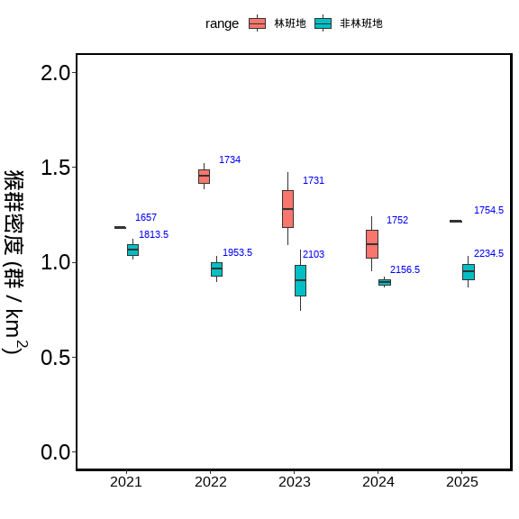

BBS與林業署的資料 (用1:1混和)

全島 vs 50-250m vs 50-500m vs 50-1000m
path <- "D:/R/SHP圖層"
ELE_50250 <- st_read(paste0(path,"/","0_自製/局部海拔/ELE_50~250.shp"), crs=3826) %>%
st_transform(crs=3826) %>%
mutate(ELE = "50-250")
## Reading layer `ELE_50~250' from data source
## `D:\R\SHP圖層\0_自製\局部海拔\ELE_50~250.shp' using driver `ESRI Shapefile'
## Simple feature collection with 1 feature and 1 field
## Geometry type: MULTIPOLYGON
## Dimension: XY
## Bounding box: xmin: 166832.6 ymin: 2423010 xmax: 351224.2 ymax: 2798677
## Projected CRS: TWD97 / TM2 zone 121
summary(ELE_50250)
## ELEV geometry ELE
## Min. :50 MULTIPOLYGON :1 Length:1
## 1st Qu.:50 epsg:3826 :0 Class :character
## Median :50 +proj=tmer...:0 Mode :character
## Mean :50
## 3rd Qu.:50
## Max. :50
ELE_50500 <- st_read(paste0(path,"/","0_自製/局部海拔/ELE_50~500.shp"), crs=3826) %>%
st_transform(crs=3826) %>%
mutate(ELE = "50-500")
## Reading layer `ELE_50~500' from data source
## `D:\R\SHP圖層\0_自製\局部海拔\ELE_50~500.shp' using driver `ESRI Shapefile'
## Simple feature collection with 1 feature and 1 field
## Geometry type: MULTIPOLYGON
## Dimension: XY
## Bounding box: xmin: 166832.6 ymin: 2423010 xmax: 351224.2 ymax: 2798677
## Projected CRS: TWD97 / TM2 zone 121
summary(ELE_50500)
## ELEV geometry ELE
## Min. :50 MULTIPOLYGON :1 Length:1
## 1st Qu.:50 epsg:3826 :0 Class :character
## Median :50 +proj=tmer...:0 Mode :character
## Mean :50
## 3rd Qu.:50
## Max. :50
ELE_501000 <- st_read(paste0(path,"/","0_自製/局部海拔/ELE_50~1000.shp"), crs=3826) %>%
st_transform(crs=3826) %>%
mutate(ELE = "50-1000")
## Reading layer `ELE_50~1000' from data source
## `D:\R\SHP圖層\0_自製\局部海拔\ELE_50~1000.shp' using driver `ESRI Shapefile'
## Simple feature collection with 1 feature and 1 field
## Geometry type: MULTIPOLYGON
## Dimension: XY
## Bounding box: xmin: 166832.6 ymin: 2423010 xmax: 351224.2 ymax: 2798677
## Projected CRS: TWD97 / TM2 zone 121
summary(ELE_501000)
## ELEV geometry ELE
## Min. :50 MULTIPOLYGON :1 Length:1
## 1st Qu.:50 epsg:3826 :0 Class :character
## Median :50 +proj=tmer...:0 Mode :character
## Mean :50
## 3rd Qu.:50
## Max. :50
ELE250_list_Point <-
list_Point %>%
filter(!is.na(X_97)) %>%
st_as_sf(., coords = c("X_97", "Y_97"), crs = 3826) %>%
st_join(.,ELE_50250) %>%
st_drop_geometry() %>%
filter(!is.na(ELE))
ELE250_combine_bb <-
ELE250_list_Point %>%
right_join(.,combine_bb,
by = c("樣區編號","獼猴樣區編號", "樣點代號"="Point")) %>%
filter(!is.na(ELE))
summary_ELE250_combine <-
ELE250_combine_bb %>%
group_by(ELE, Year, Survey) %>%
summarise(N = PointID %>% unique() %>% length,
m = AB %>% sum,
E = m / N,
E_km2 = m / N/per_Area,
.groups = 'drop') %>%
group_by(ELE, Year) %>%
summarise(Mean_N = mean(N),
Se_N = se(N),
Mean_m = mean(m),
Se_m = se(m),
Mean_E = mean(E) ,
Se_E = se(E),
Mean_E_km2 = mean(E_km2) ,
Se_E_km2 = se(E_km2),
.groups = 'drop') %>%
mutate_at(c('Se_N','Se_m','Se_E','Mean_E',
'Mean_E_km2','Se_E_km2'), function(x)round(x,3)) %>%
mutate_at(c('Mean_N','Mean_m'), function(x)round(x,2)) %>%
arrange(ELE, Year)
ELE500_list_Point <-
list_Point %>%
filter(!is.na(X_97)) %>%
st_as_sf(., coords = c("X_97", "Y_97"), crs = 3826) %>%
st_join(.,ELE_50500) %>%
st_drop_geometry() %>%
filter(!is.na(ELE))
ELE500_combine_bb <-
ELE500_list_Point %>%
right_join(.,combine_bb,
by = c("樣區編號","獼猴樣區編號", "樣點代號"="Point")) %>%
filter(!is.na(ELE))
summary_ELE500_combine <-
ELE500_combine_bb %>%
group_by(ELE, Year, Survey) %>%
summarise(N = PointID %>% unique() %>% length,
m = AB %>% sum,
E = m / N,
E_km2 = m / N/per_Area,
.groups = 'drop') %>%
group_by(ELE, Year) %>%
summarise(Mean_N = mean(N),
Se_N = se(N),
Mean_m = mean(m),
Se_m = se(m),
Mean_E = mean(E) ,
Se_E = se(E),
Mean_E_km2 = mean(E_km2) ,
Se_E_km2 = se(E_km2),
.groups = 'drop') %>%
mutate_at(c('Se_N','Se_m','Se_E','Mean_E',
'Mean_E_km2','Se_E_km2'), function(x)round(x,3)) %>%
mutate_at(c('Mean_N','Mean_m'), function(x)round(x,2)) %>%
arrange(ELE, Year)
ELE1000_list_Point <-
list_Point %>%
filter(!is.na(X_97)) %>%
st_as_sf(., coords = c("X_97", "Y_97"), crs = 3826) %>%
st_join(.,ELE_501000) %>%
st_drop_geometry() %>%
filter(!is.na(ELE))
ELE1000_combine_bb <-
ELE1000_list_Point %>%
right_join(.,combine_bb,
by = c("樣區編號","獼猴樣區編號", "樣點代號"="Point")) %>%
filter(!is.na(ELE))
summary_ELE1000_combine <-
ELE1000_combine_bb %>%
group_by(ELE, Year, Survey) %>%
summarise(N = PointID %>% unique() %>% length,
m = AB %>% sum,
E = m / N,
E_km2 = m / N/per_Area,
.groups = 'drop') %>%
group_by(ELE, Year) %>%
summarise(Mean_N = mean(N),
Se_N = se(N),
Mean_m = mean(m),
Se_m = se(m),
Mean_E = mean(E) ,
Se_E = se(E),
Mean_E_km2 = mean(E_km2) ,
Se_E_km2 = se(E_km2),
.groups = 'drop') %>%
mutate_at(c('Se_N','Se_m','Se_E','Mean_E',
'Mean_E_km2','Se_E_km2'), function(x)round(x,3)) %>%
mutate_at(c('Mean_N','Mean_m'), function(x)round(x,2)) %>%
arrange(ELE, Year)
調查資料的E
summary_ELE250_combine%>%
flextable()
ELE | Year | Mean_N | Se_N | Mean_m | Se_m | Mean_E | Se_E | Mean_E_km2 | Se_E_km2
50-250 | 2,021 | 1,068.0 | 39.0 | 35.5 | 0.5 | 0.033 | 0.002 | 1.060 | 0.054
50-250 | 2,022 | 1,109.0 | 20.0 | 41.5 | 5.5 | 0.038 | 0.006 | 1.194 | 0.179
50-250 | 2,023 | 1,216.5 | 17.5 | 41.0 | 8.0 | 0.034 | 0.006 | 1.070 | 0.194
50-250 | 2,024 | 1,172.5 | 39.5 | 40.0 | 3.0 | 0.034 | 0.004 | 1.090 | 0.118
50-250 | 2,025 | 1,238.5 | 21.5 | 48.0 | 3.0 | 0.039 | 0.003 | 1.235 | 0.099
summary_ELE500_combine%>%
flextable()
ELE | Year | Mean_N | Se_N | Mean_m | Se_m | Mean_E | Se_E | Mean_E_km2 | Se_E_km2
50-500 | 2,021 | 1,840.0 | 82.0 | 64.0 | 2.0 | 0.035 | 0.003 | 1.111 | 0.084
50-500 | 2,022 | 1,936.5 | 23.5 | 77.5 | 10.5 | 0.040 | 0.006 | 1.276 | 0.188
50-500 | 2,023 | 2,078.5 | 32.5 | 78.5 | 13.5 | 0.038 | 0.006 | 1.199 | 0.188
50-500 | 2,024 | 2,043.5 | 50.5 | 68.0 | 1.0 | 0.033 | 0.001 | 1.060 | 0.042
50-500 | 2,025 | 2,128.0 | 33.0 | 78.0 | 9.0 | 0.037 | 0.005 | 1.169 | 0.153
summary_ELE1000_combine%>%
flextable()
ELE | Year | Mean_N | Se_N | Mean_m | Se_m | Mean_E | Se_E | Mean_E_km2 | Se_E_km2
50-1000 | 2,021 | 2,530.5 | 101.5 | 94.0 | 1.0 | 0.037 | 0.001 | 1.184 | 0.035
50-1000 | 2,022 | 2,657.5 | 41.5 | 104.0 | 10.0 | 0.039 | 0.004 | 1.248 | 0.139
50-1000 | 2,023 | 2,804.5 | 41.5 | 103.5 | 15.5 | 0.037 | 0.005 | 1.172 | 0.159
50-1000 | 2,024 | 2,845.5 | 68.5 | 98.0 | 6.0 | 0.034 | 0.001 | 1.095 | 0.041
50-1000 | 2,025 | 2,935.0 | 46.0 | 104.0 | 3.0 | 0.035 | 0.002 | 1.129 | 0.050
summary_ELE_combine <-
bind_rows(ELE250_combine_bb ,
ELE500_combine_bb ,
ELE1000_combine_bb
) %>%
group_by(ELE, Year, Survey) %>%
summarise(N = PointID %>% unique() %>% length,
m = AB %>% sum,
E = m / N,
E_km2 = m / N/per_Area,
.groups = 'drop') %>%
mutate(ELE = factor(ELE, levels = c("50-250", "50-500", "50-1000")))
ELE_nn <-
summary_ELE_combine %>%
group_by(ELE, Year) %>%
summarise(
Mean_N = mean(N),
Mean_E = mean(E),
Mean_E_km2 = max(E_km2))
## `summarise()` has grouped output by 'ELE'. You can override using the `.groups`
## argument.
ggplot(summary_ELE_combine[summary_ELE_combine$ELE=="50-250",], aes(x = as.character(Year), E_km2))+
geom_boxplot(aes(fill = ELE))+
geom_text(data=ELE_nn[ELE_nn$ELE=="50-250",],
aes(label = Mean_N, y = Mean_E_km2+0.04, group = ELE),
position = position_dodge(width = 0.75),
hjust = 0.5,vjust = -0.05,
size = 2.8,
angle = 0,
color = "blue")+
scale_y_continuous(breaks = seq(0,2,0.5), limits = c(0,2))+
labs(x = "", y = expression(paste("猴群密度 (群 / km"^2,")")))+
theme(
panel.border = element_rect(linewidth = 1.5,fill = NA),
panel.grid = element_blank(),
panel.background = element_blank(),
axis.text.x = element_text(size = 12,colour = "black", angle = 0),
axis.text.y = element_text(size = 18,colour = "black"),
axis.title = element_text(size = 18,colour = "black"),
axis.title.y = element_text(angle = 270,
vjust = -1, hjust = 0.5),
legend.position = "top"
)
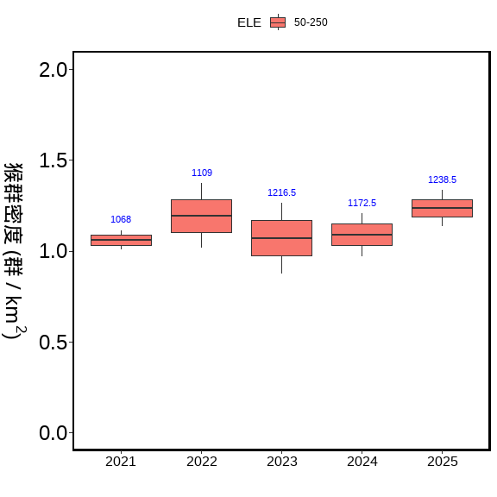
ggplot(summary_ELE_combine[summary_ELE_combine$ELE=="50-500",], aes(x = as.character(Year), E_km2))+
geom_boxplot(aes(fill = ELE))+
geom_text(data=ELE_nn[ELE_nn$ELE=="50-500",],
aes(label = Mean_N, y = Mean_E_km2+0.04, group = ELE),
position = position_dodge(width = 0.75),
hjust = 0.5,vjust = -0.05,
size = 2.8,
angle = 0,
color = "blue")+
scale_y_continuous(breaks = seq(0,2,0.5), limits = c(0,2))+
labs(x = "", y = expression(paste("猴群密度 (群 / km"^2,")")))+
theme(
panel.border = element_rect(linewidth = 1.5,fill = NA),
panel.grid = element_blank(),
panel.background = element_blank(),
axis.text.x = element_text(size = 12,colour = "black", angle = 0),
axis.text.y = element_text(size = 18,colour = "black"),
axis.title = element_text(size = 18,colour = "black"),
axis.title.y = element_text(angle = 270,
vjust = -1, hjust = 0.5),
legend.position = "top"
)
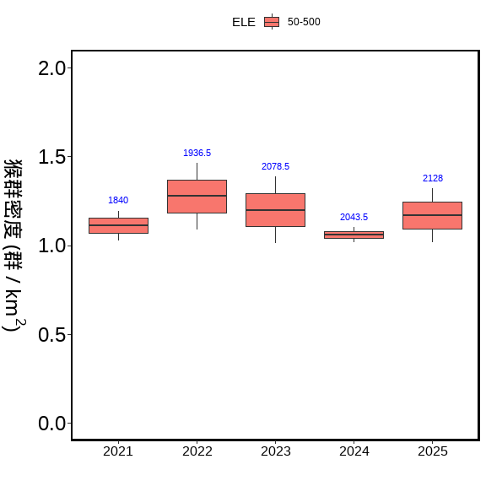
ggplot(summary_ELE_combine[summary_ELE_combine$ELE=="50-1000",], aes(x = as.character(Year), E_km2))+
geom_boxplot(aes(fill = ELE))+
geom_text(data=ELE_nn[ELE_nn$ELE=="50-1000",],
aes(label = Mean_N, y = Mean_E_km2+0.04, group = ELE),
position = position_dodge(width = 0.75),
hjust = 0.5,vjust = -0.05,
size = 2.8,
angle = 0,
color = "blue")+
scale_y_continuous(breaks = seq(0,2,0.5), limits = c(0,2))+
labs(x = "", y = expression(paste("猴群密度 (群 / km"^2,")")))+
theme(
panel.border = element_rect(linewidth = 1.5,fill = NA),
panel.grid = element_blank(),
panel.background = element_blank(),
axis.text.x = element_text(size = 12,colour = "black", angle = 0),
axis.text.y = element_text(size = 18,colour = "black"),
axis.title = element_text(size = 18,colour = "black"),
axis.title.y = element_text(angle = 270,
vjust = -1, hjust = 0.5),
legend.position = "top"
)
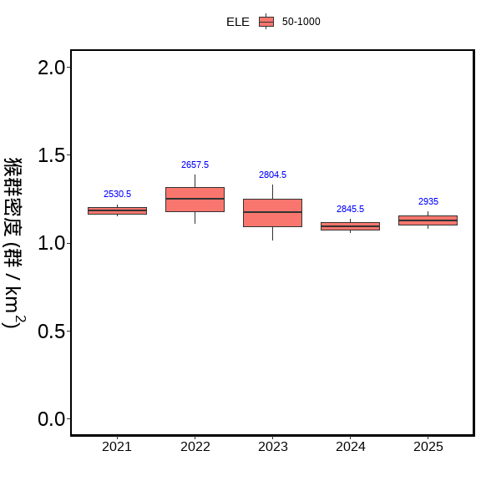

END

