BBS Macaca Data Summary 2025
2026-07-30

資料統整

原始資料

調查日3/1~6/30間、包含非森林、包含50m以下
猴群數量
variable | Year | 宜蘭縣 | 臺北市 | 新北市 | 桃園市 | 苗栗縣 | 臺中市 | 南投縣 | 雲林縣 | 嘉義縣 | 臺南市 | 高雄市 | 屏東縣 | 花蓮縣 | 臺東縣 | Total
筆數 | 2015 | 6 |  |  |  | 1 | 6 | 6 | 8 | 1 |  | 2 | 3 | 13 | 2 | 48
 | 2016 | 2 |  |  |  |  | 3 | 6 | 7 | 2 |  | 2 | 3 | 17 | 1 | 43
 | 2017 |  |  |  |  |  | 2 | 5 | 7 | 1 |  | 4 | 6 | 5 | 2 | 32
 | 2018 | 2 |  | 1 |  | 2 | 2 | 7 | 8 | 2 |  | 5 | 2 | 6 | 12 | 49
 | 2019 | 1 |  |  | 1 | 2 | 3 | 11 | 7 | 1 | 1 | 2 | 1 | 13 | 16 | 59
 | 2020 | 6 | 1 |  |  | 1 | 5 | 7 | 10 | 3 | 3 | 2 | 2 | 15 | 13 | 68
 | 2021 |  | 1 | 3 |  | 2 | 6 | 8 | 10 | 7 | 1 | 5 | 5 | 11 | 11 | 70
 | 2022 | 1 | 2 | 5 |  | 4 | 4 | 11 | 13 | 3 | 3 | 4 | 5 | 21 | 21 | 97
 | 2023 | 3 | 4 | 4 |  | 7 | 6 | 10 | 11 | 7 |  | 13 | 3 | 13 | 8 | 89
 | 2024 | 2 | 2 | 5 |  | 3 | 2 | 20 | 12 | 2 |  | 9 | 1 | 20 | 18 | 96
 | 2025 | 4 | 2 | 2 |  | 1 | 3 | 13 | 5 |  | 2 | 11 | 9 | 11 | 23 | 86
樣區數 | 2015 | 4 |  |  |  | 1 | 4 | 5 | 3 | 1 |  | 2 | 2 | 8 | 2 | 32
 | 2016 | 2 |  |  |  |  | 3 | 6 | 2 | 2 |  | 2 | 2 | 9 | 1 | 29
 | 2017 |  |  |  |  |  | 1 | 3 | 4 | 1 |  | 1 | 3 | 3 | 2 | 18
 | 2018 | 2 |  | 1 |  | 1 | 2 | 6 | 2 | 1 |  | 2 | 2 | 3 | 5 | 27
 | 2019 | 1 |  |  | 1 | 2 | 2 | 7 | 2 | 1 | 1 | 1 | 1 | 9 | 9 | 37
 | 2020 | 4 | 1 |  |  | 1 | 3 | 5 | 3 | 3 | 2 | 2 | 2 | 9 | 5 | 40
 | 2021 |  | 1 | 3 |  | 2 | 4 | 6 | 2 | 2 | 1 | 2 | 3 | 6 | 6 | 38
 | 2022 | 1 | 1 | 4 |  | 3 | 3 | 8 | 3 | 1 | 1 | 2 | 3 | 11 | 10 | 51
 | 2023 | 3 | 1 | 4 |  | 4 | 5 | 9 | 3 | 2 |  | 3 | 3 | 7 | 5 | 49
 | 2024 | 1 | 1 | 4 |  | 3 | 1 | 15 | 3 | 1 |  | 3 | 1 | 9 | 8 | 50
 | 2025 | 3 | 1 | 2 |  | 1 | 2 | 11 | 3 |  | 1 | 7 | 4 | 8 | 9 | 52
樣點數 | 2015 | 5 |  |  |  | 1 | 6 | 6 | 7 | 1 |  | 2 | 3 | 12 | 2 | 45
 | 2016 | 2 |  |  |  |  | 3 | 6 | 7 | 2 |  | 2 | 2 | 16 | 1 | 41
 | 2017 |  |  |  |  |  | 2 | 4 | 7 | 1 |  | 4 | 5 | 5 | 2 | 30
 | 2018 | 2 |  | 1 |  | 2 | 2 | 7 | 6 | 2 |  | 5 | 2 | 6 | 11 | 46
 | 2019 | 1 |  |  | 1 | 2 | 2 | 11 | 5 | 1 | 1 | 2 | 1 | 12 | 13 | 52
 | 2020 | 6 | 1 |  |  | 1 | 5 | 7 | 9 | 3 | 3 | 2 | 2 | 14 | 11 | 64
 | 2021 |  | 1 | 3 |  | 2 | 5 | 8 | 8 | 6 | 1 | 5 | 5 | 10 | 10 | 64
 | 2022 | 1 | 2 | 5 |  | 4 | 4 | 11 | 11 | 3 | 2 | 4 | 5 | 20 | 19 | 91
 | 2023 | 3 | 4 | 4 |  | 7 | 6 | 10 | 9 | 7 |  | 9 | 3 | 13 | 8 | 83
 | 2024 | 2 | 2 | 5 |  | 3 | 1 | 20 | 11 | 2 |  | 8 | 1 | 19 | 17 | 91
 | 2025 | 4 | 2 | 2 |  | 1 | 3 | 13 | 5 |  | 2 | 11 | 9 | 11 | 19 | 82

孤猴數量
variable | Year | 宜蘭縣 | 臺北市 | 新北市 | 桃園市 | 新竹縣 | 苗栗縣 | 臺中市 | 南投縣 | 雲林縣 | 嘉義縣 | 臺南市 | 高雄市 | 屏東縣 | 花蓮縣 | 臺東縣 | Total
筆數 | 2015 |  |  |  |  |  | 1 | 2 | 1 | 4 | 1 |  | 6 |  | 10 |  | 25
 | 2016 | 1 |  |  |  |  |  |  | 1 |  |  |  | 5 | 3 | 3 | 1 | 14
 | 2017 |  |  |  |  |  |  | 2 | 2 | 5 |  |  | 1 | 2 | 3 |  | 15
 | 2018 |  |  |  |  |  |  | 3 | 3 | 2 | 2 |  |  | 1 | 5 | 4 | 20
 | 2019 | 1 |  | 1 |  |  |  |  | 4 | 1 | 1 | 2 | 4 | 1 | 4 | 1 | 20
 | 2020 | 1 |  |  |  | 1 |  | 6 | 5 | 1 | 4 | 1 | 7 | 3 | 3 | 3 | 35
 | 2021 | 2 |  | 1 |  |  | 2 |  | 8 | 2 | 1 | 2 | 4 | 4 | 7 | 2 | 35
 | 2022 | 2 |  | 3 |  |  |  |  | 10 | 2 |  | 3 | 4 | 3 | 7 | 5 | 39
 | 2023 | 4 | 2 | 2 |  |  | 4 | 2 | 2 | 3 | 4 |  | 5 | 1 | 10 | 5 | 44
 | 2024 | 3 |  | 3 | 1 |  | 4 |  | 5 | 2 | 3 |  | 1 | 6 | 9 | 4 | 41
 | 2025 | 5 |  | 4 |  | 1 |  | 2 | 6 |  | 6 | 3 | 6 | 11 | 3 | 4 | 51
樣區數 | 2015 |  |  |  |  |  | 1 | 2 | 1 | 2 | 1 |  | 2 |  | 6 |  | 15
 | 2016 | 1 |  |  |  |  |  |  | 1 |  |  |  | 3 | 2 | 3 | 1 | 11
 | 2017 |  |  |  |  |  |  | 2 | 2 | 2 |  |  | 1 | 1 | 3 |  | 11
 | 2018 |  |  |  |  |  |  | 3 | 3 | 2 | 1 |  |  | 1 | 4 | 4 | 18
 | 2019 | 1 |  | 1 |  |  |  |  | 3 | 1 | 1 | 1 | 4 | 1 | 3 | 1 | 17
 | 2020 | 1 |  |  |  | 1 |  | 2 | 5 | 1 | 3 | 1 | 4 | 2 | 2 | 2 | 24
 | 2021 | 2 |  | 1 |  |  | 2 |  | 7 | 2 | 1 | 1 | 3 | 3 | 5 | 2 | 29
 | 2022 | 2 |  | 2 |  |  |  |  | 9 | 2 |  | 1 | 2 | 3 | 4 | 3 | 28
 | 2023 | 3 | 2 | 2 |  |  | 4 | 2 | 2 | 3 | 2 |  | 4 | 1 | 7 | 3 | 35
 | 2024 | 3 |  | 2 | 1 |  | 2 |  | 5 | 2 | 2 |  | 1 | 2 | 7 | 4 | 31
 | 2025 | 4 |  | 4 |  | 1 |  | 2 | 5 |  | 3 | 1 | 3 | 5 | 3 | 3 | 34
樣點數 | 2015 |  |  |  |  |  | 1 | 2 | 1 | 4 | 1 |  | 6 |  | 8 |  | 23
 | 2016 | 1 |  |  |  |  |  |  | 1 |  |  |  | 4 | 3 | 3 | 1 | 13
 | 2017 |  |  |  |  |  |  | 2 | 2 | 5 |  |  | 1 | 2 | 3 |  | 15
 | 2018 |  |  |  |  |  |  | 3 | 3 | 2 | 2 |  |  | 1 | 5 | 4 | 20
 | 2019 | 1 |  | 1 |  |  |  |  | 3 | 1 | 1 | 1 | 4 | 1 | 4 | 1 | 18
 | 2020 | 1 |  |  |  | 1 |  | 4 | 5 | 1 | 4 | 1 | 7 | 3 | 3 | 3 | 33
 | 2021 | 2 |  | 1 |  |  | 2 |  | 8 | 2 | 1 | 2 | 4 | 4 | 7 | 2 | 35
 | 2022 | 2 |  | 3 |  |  |  |  | 10 | 2 |  | 3 | 3 | 3 | 7 | 5 | 38
 | 2023 | 4 | 2 | 2 |  |  | 4 | 2 | 2 | 3 | 4 |  | 5 | 1 | 10 | 5 | 44
 | 2024 | 3 |  | 3 | 1 |  | 4 |  | 5 | 2 | 3 |  | 1 | 6 | 9 | 4 | 41
 | 2025 | 5 |  | 4 |  | 1 |  | 2 | 6 |  | 6 | 2 | 6 | 11 | 3 | 4 | 50

分析用

調查日3/1~6/30間、“不”包含非森林、“不”包含50m以下
猴群數量
variable | Year | 宜蘭縣 | 臺北市 | 新北市 | 桃園市 | 苗栗縣 | 臺中市 | 南投縣 | 雲林縣 | 嘉義縣 | 臺南市 | 高雄市 | 屏東縣 | 花蓮縣 | 臺東縣 | Total
筆數 | 2015 | 5 |  |  |  | 1 | 6 | 6 | 8 |  |  | 2 | 3 | 12 | 2 | 45
 | 2016 | 1 |  |  |  |  | 3 | 6 | 7 | 2 |  | 2 | 3 | 17 | 1 | 42
 | 2017 |  |  |  |  |  |  | 5 | 7 | 1 |  | 4 | 5 | 5 | 2 | 29
 | 2018 | 2 |  | 1 |  | 2 | 1 | 7 | 8 | 2 |  | 5 | 2 | 5 | 12 | 47
 | 2019 |  |  |  | 1 | 2 | 3 | 11 | 7 | 1 | 1 | 2 | 1 | 12 | 15 | 56
 | 2020 | 6 | 1 |  |  | 1 | 5 | 7 | 10 | 3 | 3 | 2 | 2 | 13 | 13 | 66
 | 2021 |  | 1 | 3 |  | 2 | 5 | 7 | 10 | 7 | 1 | 3 | 5 | 11 | 11 | 66
 | 2022 |  | 2 | 5 |  | 4 | 4 | 9 | 13 | 3 | 3 | 4 | 2 | 20 | 21 | 90
 | 2023 | 3 | 4 | 4 |  | 7 | 5 | 10 | 11 | 7 |  | 11 | 2 | 13 | 8 | 85
 | 2024 | 2 | 2 | 5 |  | 3 | 2 | 20 | 12 | 2 |  | 9 | 1 | 17 | 17 | 92
 | 2025 | 4 | 2 | 2 |  | 1 | 2 | 13 | 5 |  | 2 | 8 | 6 | 10 | 22 | 77
樣區數 | 2015 | 3 |  |  |  | 1 | 4 | 5 | 3 |  |  | 2 | 2 | 7 | 2 | 29
 | 2016 | 1 |  |  |  |  | 3 | 6 | 2 | 2 |  | 2 | 2 | 9 | 1 | 28
 | 2017 |  |  |  |  |  |  | 3 | 4 | 1 |  | 1 | 2 | 3 | 2 | 16
 | 2018 | 2 |  | 1 |  | 1 | 1 | 6 | 2 | 1 |  | 2 | 2 | 2 | 5 | 25
 | 2019 |  |  |  | 1 | 2 | 2 | 7 | 2 | 1 | 1 | 1 | 1 | 8 | 9 | 35
 | 2020 | 4 | 1 |  |  | 1 | 3 | 5 | 3 | 3 | 2 | 2 | 2 | 7 | 5 | 38
 | 2021 |  | 1 | 3 |  | 2 | 4 | 5 | 2 | 2 | 1 | 2 | 3 | 6 | 6 | 37
 | 2022 |  | 1 | 4 |  | 3 | 3 | 7 | 3 | 1 | 1 | 2 | 2 | 10 | 10 | 47
 | 2023 | 3 | 1 | 4 |  | 4 | 5 | 9 | 3 | 2 |  | 3 | 2 | 7 | 5 | 48
 | 2024 | 1 | 1 | 4 |  | 3 | 1 | 15 | 3 | 1 |  | 3 | 1 | 7 | 8 | 48
 | 2025 | 3 | 1 | 2 |  | 1 | 2 | 11 | 3 |  | 1 | 5 | 3 | 8 | 9 | 49
樣點數 | 2015 | 4 |  |  |  | 1 | 6 | 6 | 7 |  |  | 2 | 3 | 11 | 2 | 42
 | 2016 | 1 |  |  |  |  | 3 | 6 | 7 | 2 |  | 2 | 2 | 16 | 1 | 40
 | 2017 |  |  |  |  |  |  | 4 | 7 | 1 |  | 4 | 4 | 5 | 2 | 27
 | 2018 | 2 |  | 1 |  | 2 | 1 | 7 | 6 | 2 |  | 5 | 2 | 5 | 11 | 44
 | 2019 |  |  |  | 1 | 2 | 2 | 11 | 5 | 1 | 1 | 2 | 1 | 11 | 12 | 49
 | 2020 | 6 | 1 |  |  | 1 | 5 | 7 | 9 | 3 | 3 | 2 | 2 | 12 | 11 | 62
 | 2021 |  | 1 | 3 |  | 2 | 4 | 7 | 8 | 6 | 1 | 3 | 5 | 10 | 10 | 60
 | 2022 |  | 2 | 5 |  | 4 | 4 | 9 | 11 | 3 | 2 | 4 | 2 | 19 | 19 | 84
 | 2023 | 3 | 4 | 4 |  | 7 | 5 | 10 | 9 | 7 |  | 7 | 2 | 13 | 8 | 79
 | 2024 | 2 | 2 | 5 |  | 3 | 1 | 20 | 11 | 2 |  | 8 | 1 | 16 | 16 | 87
 | 2025 | 4 | 2 | 2 |  | 1 | 2 | 13 | 5 |  | 2 | 8 | 6 | 10 | 18 | 73

孤猴數量
variable | Year | 宜蘭縣 | 臺北市 | 新北市 | 桃園市 | 新竹縣 | 苗栗縣 | 臺中市 | 南投縣 | 雲林縣 | 嘉義縣 | 臺南市 | 高雄市 | 屏東縣 | 花蓮縣 | 臺東縣 | Total
筆數 | 2015 |  |  |  |  |  | 1 | 2 | 1 | 4 | 1 |  | 6 |  | 9 |  | 24
 | 2016 | 1 |  |  |  |  |  |  | 1 |  |  |  | 5 | 2 | 2 |  | 11
 | 2017 |  |  |  |  |  |  | 2 | 2 | 5 |  |  | 1 | 2 | 2 |  | 14
 | 2018 |  |  |  |  |  |  | 3 | 2 | 2 | 2 |  |  | 1 | 4 | 4 | 18
 | 2019 | 1 |  | 1 |  |  |  |  | 4 | 1 | 1 | 2 | 3 | 1 | 4 | 1 | 19
 | 2020 | 1 |  |  |  | 1 |  | 6 | 5 | 1 | 4 | 1 | 6 | 3 | 1 | 3 | 32
 | 2021 | 2 |  | 1 |  |  | 2 |  | 8 | 2 | 1 | 2 | 3 | 3 | 7 | 2 | 33
 | 2022 | 1 |  | 2 |  |  |  |  | 9 | 2 |  | 3 | 4 | 3 | 6 | 5 | 35
 | 2023 | 4 | 2 | 2 |  |  | 4 | 1 | 2 | 3 | 4 |  | 5 | 1 | 9 | 5 | 42
 | 2024 | 3 |  | 2 | 1 |  | 4 |  | 5 | 1 | 3 |  | 1 | 6 | 9 | 4 | 39
 | 2025 | 5 |  | 4 |  | 1 |  | 2 | 6 |  | 6 | 3 | 4 | 10 | 3 | 3 | 47
樣區數 | 2015 |  |  |  |  |  | 1 | 2 | 1 | 2 | 1 |  | 2 |  | 5 |  | 14
 | 2016 | 1 |  |  |  |  |  |  | 1 |  |  |  | 3 | 1 | 2 |  | 8
 | 2017 |  |  |  |  |  |  | 2 | 2 | 2 |  |  | 1 | 1 | 2 |  | 10
 | 2018 |  |  |  |  |  |  | 3 | 2 | 2 | 1 |  |  | 1 | 3 | 4 | 16
 | 2019 | 1 |  | 1 |  |  |  |  | 3 | 1 | 1 | 1 | 3 | 1 | 3 | 1 | 16
 | 2020 | 1 |  |  |  | 1 |  | 2 | 5 | 1 | 3 | 1 | 3 | 2 | 1 | 2 | 22
 | 2021 | 2 |  | 1 |  |  | 2 |  | 7 | 2 | 1 | 1 | 2 | 2 | 5 | 2 | 27
 | 2022 | 1 |  | 2 |  |  |  |  | 8 | 2 |  | 1 | 2 | 3 | 3 | 3 | 25
 | 2023 | 3 | 2 | 2 |  |  | 4 | 1 | 2 | 3 | 2 |  | 4 | 1 | 6 | 3 | 33
 | 2024 | 3 |  | 1 | 1 |  | 2 |  | 5 | 1 | 2 |  | 1 | 2 | 7 | 4 | 29
 | 2025 | 4 |  | 4 |  | 1 |  | 2 | 5 |  | 3 | 1 | 3 | 5 | 3 | 2 | 33
樣點數 | 2015 |  |  |  |  |  | 1 | 2 | 1 | 4 | 1 |  | 6 |  | 7 |  | 22
 | 2016 | 1 |  |  |  |  |  |  | 1 |  |  |  | 4 | 2 | 2 |  | 10
 | 2017 |  |  |  |  |  |  | 2 | 2 | 5 |  |  | 1 | 2 | 2 |  | 14
 | 2018 |  |  |  |  |  |  | 3 | 2 | 2 | 2 |  |  | 1 | 4 | 4 | 18
 | 2019 | 1 |  | 1 |  |  |  |  | 3 | 1 | 1 | 1 | 3 | 1 | 4 | 1 | 17
 | 2020 | 1 |  |  |  | 1 |  | 4 | 5 | 1 | 4 | 1 | 6 | 3 | 1 | 3 | 30
 | 2021 | 2 |  | 1 |  |  | 2 |  | 8 | 2 | 1 | 2 | 3 | 3 | 7 | 2 | 33
 | 2022 | 1 |  | 2 |  |  |  |  | 9 | 2 |  | 3 | 3 | 3 | 6 | 5 | 34
 | 2023 | 4 | 2 | 2 |  |  | 4 | 1 | 2 | 3 | 4 |  | 5 | 1 | 9 | 5 | 42
 | 2024 | 3 |  | 2 | 1 |  | 4 |  | 5 | 1 | 3 |  | 1 | 6 | 9 | 4 | 39
 | 2025 | 5 |  | 4 |  | 1 |  | 2 | 6 |  | 6 | 2 | 4 | 10 | 3 | 3 | 46

2015 ~ 2025 年間，每年位在海拔50 m以上森林的調查樣點數、臺灣獼猴( Macaca cyclopis )的猴群數及相對密度
TypeName.1 | 樣點數 |  | 猴群數 |  | 相對密度
 | Mean | Se | Mean | Se | Mean | Se
2015 | 1498.0 | 33.0 | 22.5 | 0.5 | 0.4781 | 0.0001
2016 | 1419.0 | 62.0 | 21.0 | 4.0 | 0.4759 | 0.1105
2017 | 1325.5 | 29.5 | 14.5 | 2.5 | 0.3497 | 0.0678
2018 | 1468.5 | 58.5 | 23.5 | 3.5 | 0.5132 | 0.0963
2019 | 1385.0 | 35.0 | 28.0 | 4.0 | 0.6416 | 0.0757
2020 | 1581.0 | 36.0 | 33.0 | 2.0 | 0.6638 | 0.0252
2021 | 1489.5 | 195.5 | 33.0 | 1.0 | 0.7147 | 0.0724
2022 | 1750.5 | 55.5 | 45.0 | 1.0 | 0.8197 | 0.0442
2023 | 1847.0 | 82.0 | 42.5 | 11.5 | 0.7251 | 0.1660
2024 | 1894.5 | 53.5 | 46.0 | 8.0 | 0.7697 | 0.1127
2025 | 2010.0 | 91.0 | 38.5 | 0.5 | 0.6113 | 0.0356
註：相對密度(群/km^2)。

2015 ~ 2025 年位在海拔50 m以上森林的調查樣點數、臺灣獼猴( Macaca cyclopis )的猴群數及相對密度
TypeName.1 | 樣點數 |  | 猴群數 |  | 相對密度
 | Mean | Se | Mean | Se | Mean | Se
North | 569.6 | 29.8 | 3.6 | 0.7 | 0.1857 | 0.0302
Center | 505.0 | 12.6 | 6.2 | 0.6 | 0.3871 | 0.0297
South | 149.1 | 7.3 | 3.8 | 0.4 | 0.8160 | 0.0803
Southwest | 142.9 | 2.8 | 6.2 | 0.7 | 1.3950 | 0.1530
Hualien | 155.6 | 2.9 | 6.1 | 0.7 | 1.2489 | 0.1397
Taitung | 84.0 | 5.0 | 5.6 | 0.8 | 1.9961 | 0.2714
TW | 1606.2 | 51.1 | 31.6 | 2.4 | 0.6148 | 0.0355
註：相對密度(群/km^2)。

2015 ~ 2025年各森林類型內的調查樣點數、臺灣獼猴( Macaca cyclopis )的猴群數及相對密度
TypeName.1 | 樣點數 |  | 猴群數 |  | 相對密度
 | Mean | Se | Mean | Se | Mean | Se
Forest (EL>50m) | 1606.2 | 51.1 | 31.6 | 2.4 | 0.6148 | 0.0355
闊葉林 | 1109.9 | 38.5 | 22.0 | 2.0 | 0.6117 | 0.0406
針葉林 | 152.1 | 6.0 | 2.2 | 0.2 | 0.4727 | 0.0495
混淆林 | 167.7 | 3.6 | 4.1 | 0.5 | 0.7745 | 0.0963
竹林 | 176.5 | 5.1 | 3.3 | 0.4 | 0.6161 | 0.0916
Forest (EL<50m) | 206.0 | 8.0 | 0.6 | 0.2 | 0.0961 | 0.0251
非森林 | 1237.3 | 89.1 | 0.9 | 0.2 | 0.0196 | 0.0053
Total | 2904.0 | 205.9 | 30.5 | 3.1 | 0.2998 | 0.0253
註：相對密度(群/km^2)。

年的相對密度
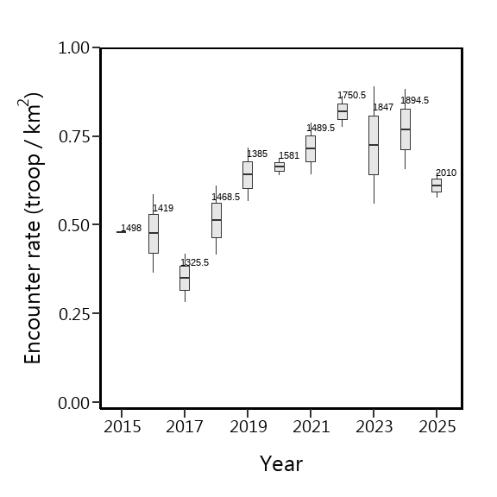

Region的相對密度
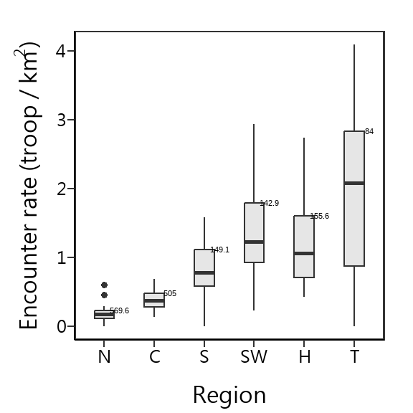

森林類型的相對密度
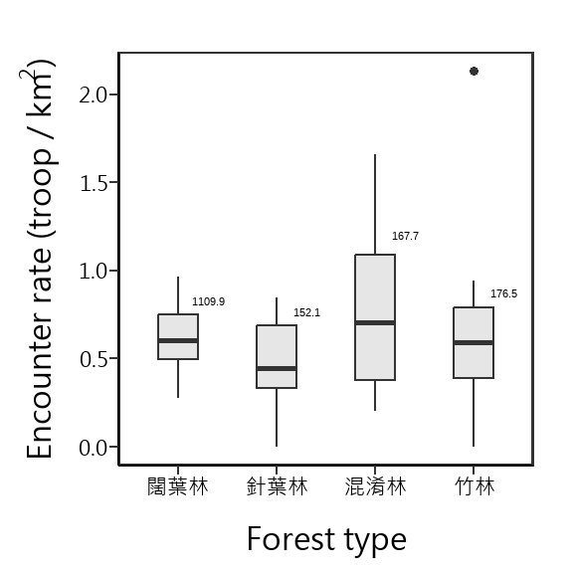

海拔的相對密度
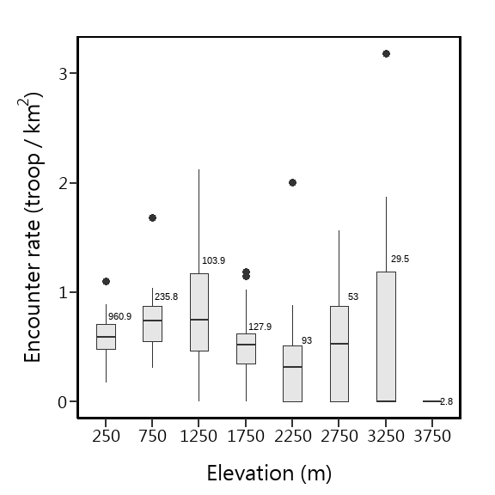

Julian Day的相對密度
Julian Day = 60，係指第60~74天，Julian Day = 75，係指第75~89天，以此類推，僅Julian Day = 180，係指第180~182天
