猴群數估算
2026-08-11
con <- dbConnect(RSQLite::SQLite(), dbname="D:/R/test/DB/P_BBS.db")
list_Point<-
dbReadTable(con, "list_Point") %>%
arrange(樣區編號, 獼猴樣區編號,as.numeric(樣點代號))
list_Site<-
dbReadTable(con, "list_Site")
table_point<-
dbReadTable(con, "table_point")
dbDisconnect(con)
forest_town<- read_xlsx(
here("合併估算2021_2025/鄉鎮內50m以上的森林面積.xlsx")) %>%
select(-perimeter) %>%
mutate(area = area/1000000) %>% #換成km2
setDT
forest_office<- read_xlsx(
here::here("./林務局年報2024/分署轄內50m以上的森林面積.xlsx")) %>%
select(-perimeter) %>%
mutate(area = area/1000000) #換成km2
se <- function(x){sd(x)/sqrt(length(x))}
per_Area <- (0.1*0.1*pi) #100m(=0.1km)半徑的單位原面積

BBS
相對密度(群/樣點)圖

林業署
相對密度(群/樣點)
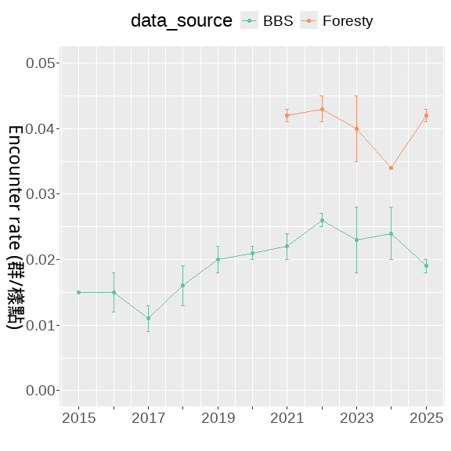
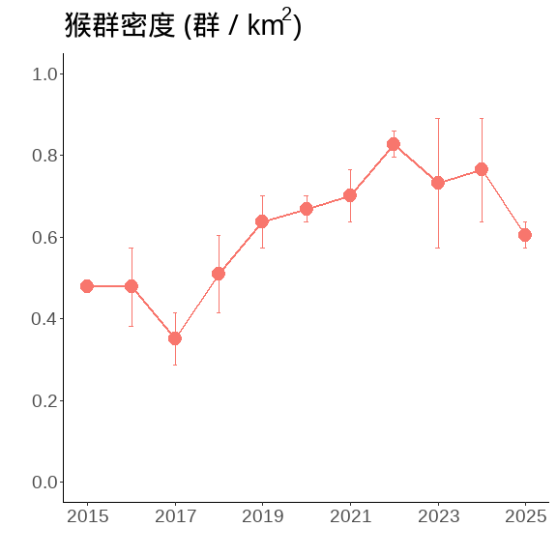
相對密度(群/樣點)
combine_bb_outout <-
E_year_F %>% mutate(data_source = "Foresty") %>%
bind_rows(E_year %>% mutate(data_source = "BBS"))
combine_bb_outout
## Year Mean_N SD_N Mean_m SD_m Mean_E SD_E data_source
## <num> <num> <num> <num> <num> <num> <num> <char>
## 1: 2021 2136.0 33.0 89.5 2.5 0.042 0.001 Foresty
## 2: 2022 2188.5 44.5 95.0 3.0 0.043 0.002 Foresty
## 3: 2023 2209.5 31.5 89.0 12.0 0.040 0.005 Foresty
## 4: 2024 2249.0 43.0 75.5 1.5 0.034 0.000 Foresty
## 5: 2025 2280.0 39.0 96.0 1.0 0.042 0.001 Foresty
## 6: 2015 1498.0 33.0 22.5 0.5 0.015 0.000 BBS
## 7: 2016 1419.0 62.0 21.0 4.0 0.015 0.003 BBS
## 8: 2017 1325.5 29.5 14.5 2.5 0.011 0.002 BBS
## 9: 2018 1468.5 58.5 23.5 3.5 0.016 0.003 BBS
## 10: 2019 1385.0 35.0 28.0 4.0 0.020 0.002 BBS
## 11: 2020 1581.0 36.0 33.0 2.0 0.021 0.001 BBS
## 12: 2021 1489.5 195.5 33.0 1.0 0.022 0.002 BBS
## 13: 2022 1750.5 55.5 45.0 1.0 0.026 0.001 BBS
## 14: 2023 1847.0 82.0 42.5 11.5 0.023 0.005 BBS
## 15: 2024 1894.5 53.5 46.0 8.0 0.024 0.004 BBS
## 16: 2025 2010.0 91.0 38.5 0.5 0.019 0.001 BBS

林業署 & BBS
#合併檢測————–
合併及擷取2021~2025的資料
combine_bb <-
bb_F %>%
select(SiteID,Year, 樣區編號,獼猴樣區編號, Point, Survey, Macaca_sur, Macaca_dist,AB) %>%
mutate(data_source = "Foresty") %>%
bind_rows(
bb %>%
select(SiteID,Year, 樣區編號,獼猴樣區編號, Point, Survey,
Macaca_sur, Macaca_dist,AB)%>%
mutate(data_source = "BBS") %>%
mutate(Point = Point %>% as.character()) %>%
anti_join(bb_F[, c('SiteID','Year')],
by = c('SiteID','Year'))
) %>%
filter(Year %in% c(2021:2025))
相對密度(群/樣點)
combine_bb%>%
setDT %>%
.[, .(N = length(Macaca_sur)
),
by = c('Year', 'Survey', 'data_source')] %>%
.[, .(
Mean_N = mean(N)%>% round(3)),
by = c('Year', 'data_source')] %>%
pivot_wider(id_cols = "Year",
names_from = "data_source",
values_from = "Mean_N")
## # A tibble: 5 × 3
## Year Foresty BBS
## <dbl> <dbl> <dbl>
## 1 2021 2136 1334.
## 2 2022 2188. 1499
## 3 2023 2210. 1624.
## 4 2024 2249 1660.
## 5 2025 2280 1709
藍色數字為平均樣區數
combine_bb %>%
setDT %>%
.[, .(N = length(Macaca_sur),
m = sum(Macaca_sur, na.rm=T)
),
by = c('Year', 'Survey')] %>%
.[,E_km2 := m/N/per_Area] %>%
.[, Mean_N := mean(N), by = c('Year')] %>%
ggplot(., aes(x = as.character(Year), y = E_km2))+
geom_boxplot(width = 0.3, linewidth = 0.4, fill= gray(.9))+
stat_summary(fun = mean, geom = "text",
aes(label = round(Mean_N, 2)),
position = position_nudge(x = 0, y = 0.21),
# hjust = 0.3,
# vjust = -5,
color = "blue")+
scale_y_continuous(breaks = seq(0,1.5,0.5), limits = c(0,1.5))+
labs(x = "", y = expression(paste("猴群密度 (群 / km"^2,")")))+
theme(
panel.border = element_rect(linewidth = 1.5,fill = NA),
panel.grid = element_blank(),
panel.background = element_blank(),
axis.text = element_text(size = 20,colour = "black"),
axis.title = element_text(size = 18,colour = "black"),
axis.title.y = element_text(angle = 270,
vjust = -1, hjust = 0.5),
legend.position = "top"
)
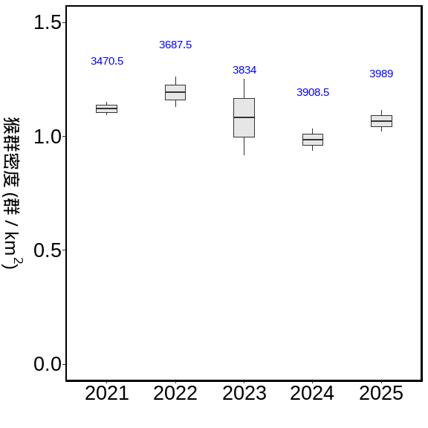
combine_bb %>%
setDT %>%
.[, .(N = length(Macaca_sur),
m = sum(Macaca_sur, na.rm=T)
),
by = c('Year', 'Survey', 'data_source')] %>%
.[,Encounter_rate := m/N] %>%
.[, Mean_N := mean(N), by = c('Year','data_source')] %>%
ggplot(., aes(x = as.character(Year), y = Encounter_rate))+
geom_boxplot( aes(fill= data_source))
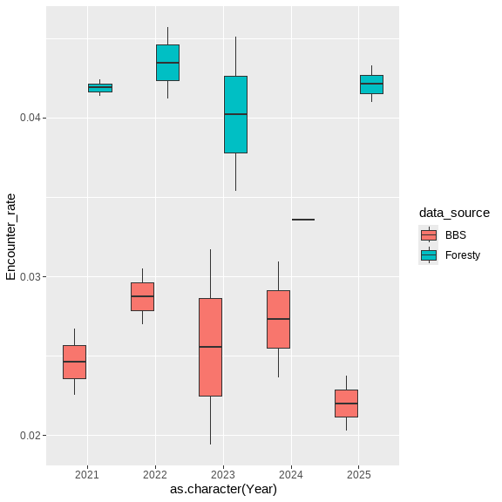
path <- "D:/R/SHP圖層"
town <- st_read(paste0(path,"/","鄉(鎮、市、區)界線(TWD97經緯度)1131028/TOWN_MOI_1131028.shp"), crs=4326) %>%
st_transform(crs=3826)
## Reading layer `TOWN_MOI_1131028' from data source
## `D:\R\SHP圖層\鄉(鎮、市、區)界線(TWD97經緯度)1131028\TOWN_MOI_1131028.shp'
## using driver `ESRI Shapefile'
## Simple feature collection with 368 features and 7 fields
## Geometry type: MULTIPOLYGON
## Dimension: XY
## Bounding box: xmin: 114.3593 ymin: 10.37135 xmax: 124.5612 ymax: 26.38528
## Geodetic CRS: WGS 84
summary(town)
## TOWNID TOWNCODE COUNTYNAME TOWNNAME
## Length:368 Length:368 Length:368 Length:368
## Class :character Class :character Class :character Class :character
## Mode :character Mode :character Mode :character Mode :character
## TOWNENG COUNTYID COUNTYCODE geometry
## Length:368 Length:368 Length:368 MULTIPOLYGON :368
## Class :character Class :character Class :character epsg:3826 : 0
## Mode :character Mode :character Mode :character +proj=tmer...: 0
town_list_Point <-
list_Point %>%
filter(!is.na(X_97)) %>%
st_as_sf(., coords = c("X_97", "Y_97"), crs = 3826) %>%
st_join(.,town) %>%
st_drop_geometry()
town_combine_bb <-
town_list_Point %>%
right_join(.,combine_bb,
by = c("樣區編號","獼猴樣區編號", "樣點代號"="Point"))
#2021~2025年的調查資料
summary__combine <-
town_combine_bb %>%
group_by( Year, Survey) %>%
summarise(N = PointID %>% unique() %>% length,
m = AB %>% sum,
E = m / N,
E_km2 = m / N/per_Area,
.groups = 'drop') %>%
group_by(Year) %>%
summarise(Mean_N = mean(N),
Se_N = se(N),
Mean_m = mean(m),
Se_m = se(m),
Mean_E = mean(E) ,
Se_E = se(E),
Mean_E_km2 = mean(E_km2) ,
Se_E_km2 = se(E_km2),
.groups = 'drop') %>%
mutate_at(c('Se_N','Se_m','Se_E','Mean_E',
'Mean_E_km2','Se_E_km2'), function(x)round(x,3)) %>%
mutate_at(c('Mean_N','Mean_m'), function(x)round(x,2))
調查資料的E
summary__combine %>%
flextable()
Year | Mean_N | Se_N | Mean_m | Se_m | Mean_E | Se_E | Mean_E_km2 | Se_E_km2
2,021 | 3,470.5 | 206.5 | 122.0 | 4.0 | 0.035 | 0.001 | 1.121 | 0.030
2,022 | 3,687.5 | 100.5 | 138.0 | 4.0 | 0.037 | 0.002 | 1.193 | 0.067
2,023 | 3,834.0 | 109.0 | 130.0 | 25.0 | 0.034 | 0.006 | 1.074 | 0.177
2,024 | 3,908.5 | 96.5 | 121.0 | 9.0 | 0.031 | 0.002 | 0.984 | 0.049
2,025 | 3,989.0 | 104.0 | 133.5 | 2.5 | 0.034 | 0.002 | 1.067 | 0.048
縣市
COUNT_combine_bb_outout <-
town_combine_bb %>%
group_by(COUNTYNAME) %>%
summarise(樣點數 = PointID %>% unique() %>% length,
筆數 = PointID %>% length,
'猴群數' = AB %>% sum )
summary_COUNT_combine <-
town_combine_bb %>%
group_by(COUNTYNAME, Year, Survey) %>%
summarise(N = PointID %>% unique() %>% length,
m = AB %>% sum,
E = m / N,
E_km2 = m / N/per_Area,
.groups = 'drop') %>%
group_by(COUNTYNAME) %>%
summarise(Mean_N = mean(N),
Se_N = se(N),
Mean_m = mean(m),
Se_m = se(m),
Mean_E = mean(E) ,
Se_E = se(E),
Mean_E_km2 = mean(E_km2) ,
Se_E_km2 = se(E_km2),
.groups = 'drop') %>%
mutate_at(c('Se_N','Se_m','Se_E','Mean_E',
'Mean_E_km2','Se_E_km2'), function(x)round(x,3)) %>%
mutate_at(c('Mean_N','Mean_m'), function(x)round(x,2)) %>%
arrange(-Mean_E)
調查資料的E
summary_COUNT_combine %>%
flextable()
COUNTYNAME | Mean_N | Se_N | Mean_m | Se_m | Mean_E | Se_E | Mean_E_km2 | Se_E_km2
雲林縣 | 58.4 | 2.837 | 5.6 | 0.872 | 0.096 | 0.015 | 3.061 | 0.476
臺東縣 | 376.5 | 2.949 | 31.2 | 2.342 | 0.083 | 0.006 | 2.643 | 0.205
屏東縣 | 176.1 | 2.302 | 11.2 | 0.611 | 0.064 | 0.004 | 2.027 | 0.113
嘉義縣 | 245.1 | 5.847 | 12.6 | 1.376 | 0.052 | 0.006 | 1.655 | 0.190
花蓮縣 | 406.8 | 5.765 | 20.4 | 1.147 | 0.050 | 0.003 | 1.593 | 0.080
高雄市 | 248.5 | 3.240 | 9.1 | 0.900 | 0.037 | 0.004 | 1.172 | 0.122
南投縣 | 553.3 | 15.584 | 14.7 | 0.895 | 0.026 | 0.001 | 0.842 | 0.040
宜蘭縣 | 231.9 | 4.051 | 5.5 | 0.820 | 0.024 | 0.003 | 0.750 | 0.106
臺中市 | 378.5 | 8.046 | 8.1 | 1.269 | 0.021 | 0.003 | 0.671 | 0.096
苗栗縣 | 181.9 | 6.684 | 3.1 | 0.433 | 0.017 | 0.002 | 0.535 | 0.065
臺南市 | 98.0 | 2.521 | 1.1 | 0.277 | 0.011 | 0.003 | 0.354 | 0.094
新北市 | 333.1 | 14.466 | 3.3 | 0.651 | 0.010 | 0.002 | 0.320 | 0.062
臺北市 | 131.5 | 12.168 | 1.2 | 0.249 | 0.009 | 0.002 | 0.275 | 0.059
彰化縣 | 34.2 | 1.497 | 0.2 | 0.133 | 0.006 | 0.004 | 0.201 | 0.135
新竹縣 | 147.5 | 2.088 | 0.9 | 0.314 | 0.006 | 0.002 | 0.194 | 0.068
桃園市 | 145.4 | 3.056 | 0.7 | 0.335 | 0.005 | 0.002 | 0.156 | 0.076
嘉義市 | 13.9 | 0.971 | 0.0 | 0.000 | 0.000 | 0.000 | 0.000 | 0.000
基隆市 | 7.0 | 1.333 | 0.0 | 0.000 | 0.000 | 0.000 | 0.000 | 0.000
新竹市 | 10.3 | 1.184 | 0.0 | 0.000 | 0.000 | 0.000 | 0.000 | 0.000
summary_COUNT_combine %>%
mutate(
COUNTYNAME = sapply(COUNTYNAME,
function(x) paste(str_split(x, "")[[1]], collapse = "\n")),
COUNTYNAME = reorder(COUNTYNAME, -Mean_E)) %>%
ggplot(data = ., aes(COUNTYNAME, Mean_E))+
geom_bar(aes(fill = -Mean_E), stat = "identity") +
labs(x = "",y ="Encounter_rate")+
scale_color_brewer(palette = "Set2")+
theme_classic()+
theme(
text = element_text(size = 18),
legend.position = "none")
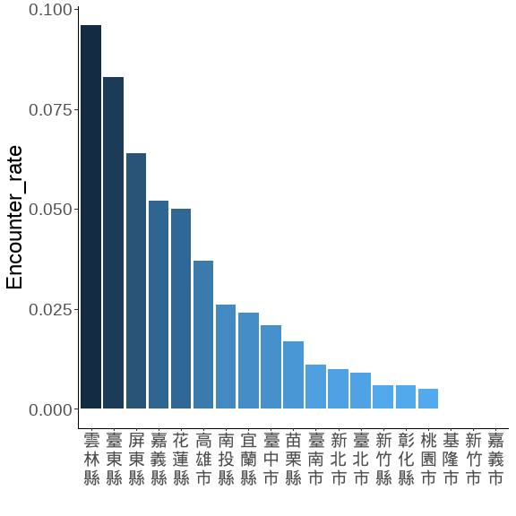
藍色數字為平均樣區數
n.name <- read_xlsx(here::here("./script/Analysis 2025 for Forestry/00.xlsx"))
COUNTY__sorted <- town_combine_bb %>%
group_by(COUNTYNAME, Year, Survey) %>%
summarise(N = PointID %>% unique() %>% length,
m = AB %>% sum,
.groups = 'drop') %>% setDT %>%
.[,Encounter_rate := m/N] %>%
.[, Mean_N := mean(N), by = c('COUNTYNAME')] %>%
.[, Mean_E := mean(Encounter_rate), by = c('COUNTYNAME')] %>%
arrange(desc(Mean_E)) %>% .$COUNTYNAME %>% unique()
town_nn <-
town_combine_bb %>%
group_by(COUNTYNAME, Year, Survey) %>%
summarise(N = PointID %>% unique() %>% length,
m = AB %>% sum,
.groups = 'drop') %>% setDT %>%
.[,Encounter_rate := m/N] %>%
.[, Mean_N := mean(N), by = c('COUNTYNAME')] %>%
.[, Mean_E := mean(Encounter_rate), by = c('COUNTYNAME')] %>%
arrange(desc(Mean_E))%>%
left_join(n.name, by = 'COUNTYNAME') %>% .$COUNTYNAME2 %>% unique() %>%
lapply(.,
function(x) paste(str_split(x, "")[[1]], collapse = "\n")) %>% unlist()
town_combine_bb %>%
group_by(COUNTYNAME, Year, Survey) %>%
summarise(N = PointID %>% unique() %>% length,
m = AB %>% sum,
.groups = 'drop') %>% setDT %>%
.[,E_km2 := m/N/per_Area] %>%
.[, Mean_N := mean(N), by = c('COUNTYNAME')] %>%
ggplot(., aes(x = COUNTYNAME, y = E_km2))+
geom_boxplot(width = 0.3, linewidth = 0.4, fill= gray(.9))+
stat_summary(fun = mean, geom = "text",
aes(label = round(Mean_N, 1)),
position = position_nudge(x = 0.25, y = 1.7),
angle = 270,
# hjust = -0.1,
# vjust = 0,
color = "blue")+
scale_x_discrete(limit = COUNTY__sorted , labels = town_nn)+
scale_y_continuous(breaks = seq(0,5,1), limits = c(0,5.3))+
labs(x = "", y = expression(paste("猴群密度 (群 / km"^2,")")))+
theme(
panel.border = element_rect(linewidth = 1.5,fill = NA),
panel.grid = element_blank(),
panel.background = element_blank(),
axis.text.x = element_text(size = 12,colour = "black", angle = 0),
axis.text.y = element_text(size = 18,colour = "black"),
axis.title = element_text(size = 18,colour = "black"),
axis.title.y = element_text(angle = 270,
vjust = -1, hjust = 0.5),
legend.position = "top"
)
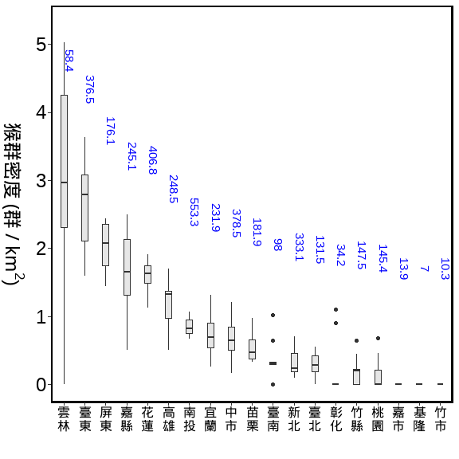
鄉鎮
調查資料的E (前20名, 全部有186個鄉鎮)
藍色數字為平均樣區數

BBS與林業署的資料 (用1:1混和)

全島 vs 縣市 vs 鄉鎮
海拔50m以上的森林總面積=21028.14 (km²)
方法：bootstrap
重複抽樣：10,000次
單位面積的半徑: 100m
海拔50m以上的森林總面積=21028.14 (km²)
方法：bootstrap
重複抽樣：10,000次
單位面積的半徑: 100m
troop_M_all %>%
mutate('年' = as.character(Year)) %>%
mutate(
'相對密度_km2' = round(mm,3),
"相對密度_km2(95%CI)" = paste0(round(q_1,3), "~", round(q_3,3))
) %>%
mutate(
'群數' = round(M_troops),
"群數(95%CI)" = paste0(round(q1_troops), "~", round(q3_troops))
) %>%
mutate(
'隻數' = round(M_troops*25),
"隻數(95%CI)" = paste0(round(q1_troops*25), "~", round(q3_troops*25))
) %>%
select(年, `相對密度_km2`:`隻數(95%CI)`) %>%
flextable::flextable()
年 | 相對密度_km2 | 相對密度_km2(95%CI) | 群數 | 群數(95%CI) | 隻數 | 隻數(95%CI)
2021 | 1.119 | 0.981~1.257 | 23,533 | 20637~26423 | 588,335 | 515920~660571
2022 | 1.192 | 1.053~1.334 | 25,059 | 22145~28044 | 626,463 | 553629~701112
2023 | 1.079 | 0.955~1.208 | 22,686 | 20077~25402 | 567,159 | 501923~635041
2024 | 0.985 | 0.863~1.104 | 20,705 | 18153~23205 | 517,631 | 453823~580123
2025 | 1.066 | 0.942~1.193 | 22,410 | 19800~25086 | 560,258 | 495004~627145
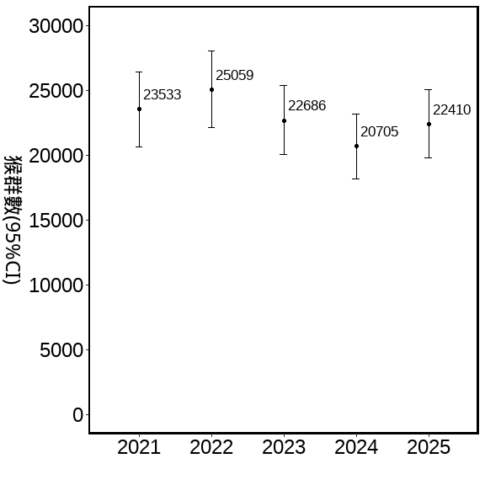
估計縣市猴群數 50m以上的森林，2021-2025的資料bootstraps
海拔50m以上的森林在各縣市面積 (km²)
方法：bootstrap
重複抽樣：10,000次
單位面積的半徑: 100m
per_Area <- (0.1*0.1*pi) #100m半徑的單位原面積
COUNTY_M_all <-
forest_town %>%
.[, .(area = sum(area)), by = 'COUNTYNAME'] %>%
left_join(bootstrap_AB_all_COUNTY, .,by = 'COUNTYNAME') %>% setDT %>%
.[ , 'M_troops' := (area)*mm] %>%
.[ , 'q1_troops' := (area)*q_1] %>%
.[ , 'q3_troops' := (area)*q_3] %>%
.[, 'log_troops':= log(M_troops)]%>%
.[ , 'COUNT' := M_troops*25]
用縣市的資料分別抽樣，再依各縣市50m以上的森林面積，去估算
COUNTYNAME | 相對密度_km2 | 相對密度_km2(95%CI) | 群數 | 群數(95%CI) | 隻數 | 隻數(95%CI)
臺東縣 | 2.639 | 2.359~93.113 | 7,443 | 6652~8250 | 186,083 | 166304~206241
花蓮縣 | 1.594 | 1.385~57.535 | 5,810 | 5048~6588 | 145,245 | 126208~164712
屏東縣 | 2.025 | 1.681~75.948 | 3,001 | 2491~3536 | 75,024 | 62277~88394
南投縣 | 0.845 | 0.713~31.314 | 2,509 | 2117~2920 | 62,722 | 52937~73002
高雄市 | 1.167 | 0.935~44.85 | 1,911 | 1532~2308 | 47,777 | 38296~57706
宜蘭縣 | 0.754 | 0.563~30.584 | 1,232 | 920~1571 | 30,806 | 22998~39266
嘉義縣 | 1.634 | 1.364~61.181 | 1,225 | 1022~1441 | 30,625 | 25553~36017
臺中市 | 0.681 | 0.538~26.501 | 751 | 594~919 | 18,775 | 14849~22970
苗栗縣 | 0.542 | 0.367~23.395 | 651 | 442~883 | 16,279 | 11043~22085
新北市 | 0.315 | 0.21~13.391 | 467 | 312~624 | 11,682 | 7796~15601
雲林縣 | 3.051 | 2.289~123.182 | 295 | 221~374 | 7,369 | 5529~9346
新竹縣 | 0.195 | 0.086~10.991 | 198 | 88~351 | 4,953 | 2192~8769
臺南市 | 0.357 | 0.162~18.61 | 159 | 72~260 | 3,974 | 1807~6504
桃園市 | 0.153 | 0.044~9.059 | 68 | 20~127 | 1,705 | 489~3178
臺北市 | 0.289 | 0.145~14.64 | 28 | 14~44 | 689 | 346~1097
彰化縣 | 0.184 | 0~14.813 | 14 | 0~35 | 345 | 0~875
基隆市 | 0.000 | 0~0 | 0 | 0~0 | 0 | 0~0
新竹市 | 0.000 | 0~0 | 0 | 0~0 | 0 | 0~0
嘉義市 | 0.000 | 0~0 | 0 | 0~0 | 0 | 0~0
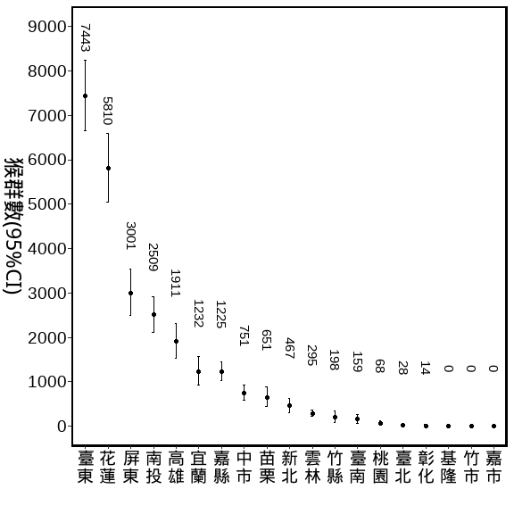
估計部分鄉鎮猴群數 50m以上的森林，2021-2025的資料bootstraps
大埔,番路,阿里山,古坑,林內
per_Area <- (0.1*0.1*pi) #100m半徑的單位原面積

BBS與林業署的資料 (用1:1混和)

全島 vs 是否林班地
path <- "D:/R/SHP圖層"
Foresty_50 <- st_read(paste0(path,"/","0_自製/海拔50公尺以的林班地/Foresty_up50.shp"), crs=3826) %>%
st_transform(crs=3826) %>%
mutate(range = "Fotersty") %>%
dplyr::select(-ELEV)
## Reading layer `Foresty_up50' from data source
## `D:\R\SHP圖層\0_自製\海拔50公尺以的林班地\Foresty_up50.shp'
## using driver `ESRI Shapefile'
## Simple feature collection with 1 feature and 1 field
## Geometry type: MULTIPOLYGON
## Dimension: XY
## Bounding box: xmin: 182507.4 ymin: 2423010 xmax: 351091.4 ymax: 2766881
## Projected CRS: TWD97 / TM2 zone 121
summary(Foresty_50)
## range geometry
## Length:1 MULTIPOLYGON :1
## Class :character epsg:3826 :0
## Mode :character +proj=tmer...:0
Foresty_list_Point <-
list_Point %>%
filter(!is.na(X_97)) %>%
st_as_sf(., coords = c("X_97", "Y_97"), crs = 3826) %>%
st_join(.,Foresty_50) %>%
st_drop_geometry() %>%
mutate(range = ifelse(range %in% "Fotersty",
"國有林班地","非國有林班地"))
Foresty_combine_bb <-
Foresty_list_Point %>%
right_join(.,combine_bb,
by = c("樣區編號","獼猴樣區編號", "樣點代號"="Point"))
summary_Foresty_combine <-
Foresty_combine_bb %>%
group_by(range, Year, Survey) %>%
summarise(N = PointID %>% unique() %>% length,
m = AB %>% sum,
E = m / N,
E_km2 = m / N/per_Area,
.groups = 'drop') %>%
group_by(range, Year) %>%
summarise(Mean_N = mean(N),
Se_N = se(N),
Mean_m = mean(m),
Se_m = se(m),
Mean_E = mean(E) ,
Se_E = se(E),
Mean_E_km2 = mean(E_km2) ,
Se_E_km2 = se(E_km2),
.groups = 'drop') %>%
mutate_at(c('Se_N','Se_m','Se_E','Mean_E',
'Mean_E_km2','Se_E_km2'), function(x)round(x,3)) %>%
mutate_at(c('Mean_N','Mean_m'), function(x)round(x,2)) %>%
arrange(range, Year)
調查資料的E
summary_Foresty_combine %>%
flextable()%>%
autofit() %>%
align(align = "center", part = "all") %>%
set_table_properties(layout = "autofit") %>%
colformat_num(., big.mark="")
range | Year | Mean_N | Se_N | Mean_m | Se_m | Mean_E | Se_E | Mean_E_km2 | Se_E_km2
國有林班地 | 2021 | 1657.0 | 99.0 | 61.5 | 3.5 | 0.037 | 0.000 | 1.182 | 0.003
國有林班地 | 2022 | 1734.0 | 62.0 | 79.0 | 1.0 | 0.046 | 0.002 | 1.453 | 0.070
國有林班地 | 2023 | 1731.0 | 62.0 | 70.0 | 13.0 | 0.040 | 0.006 | 1.280 | 0.193
國有林班地 | 2024 | 1752.0 | 47.0 | 60.5 | 9.5 | 0.034 | 0.004 | 1.095 | 0.143
國有林班地 | 2025 | 1754.5 | 58.5 | 67.0 | 2.0 | 0.038 | 0.000 | 1.216 | 0.004
非國有林班地 | 2021 | 1813.5 | 107.5 | 60.5 | 0.5 | 0.033 | 0.002 | 1.065 | 0.054
非國有林班地 | 2022 | 1953.5 | 38.5 | 59.0 | 3.0 | 0.030 | 0.002 | 0.963 | 0.068
非國有林班地 | 2023 | 2103.0 | 47.0 | 60.0 | 12.0 | 0.028 | 0.005 | 0.905 | 0.161
非國有林班地 | 2024 | 2156.5 | 49.5 | 60.5 | 0.5 | 0.028 | 0.001 | 0.894 | 0.028
非國有林班地 | 2025 | 2234.5 | 45.5 | 66.5 | 4.5 | 0.030 | 0.003 | 0.949 | 0.083
藍色數字為平均樣區數
Foresty__sorted <- Foresty_combine_bb %>%
group_by(range, Year, Survey) %>%
summarise(N = PointID %>% unique() %>% length,
m = AB %>% sum,
.groups = 'drop') %>% setDT %>%
.[,Encounter_rate := m/N] %>%
.[, Mean_N := mean(N), by = c('range')] %>%
.[, Mean_E := mean(Encounter_rate), by = c('range')] %>%
arrange(desc(Mean_E)) %>% .$range %>% unique()
range_nn <-
Foresty_combine_bb %>%
group_by(range, Year, Survey) %>%
summarise(N = PointID %>% unique() %>% length,
m = AB %>% sum,
.groups = 'drop') %>% setDT %>%
.[,Encounter_rate := m/N] %>%
.[,E_km2 := m/N/per_Area] %>%
group_by(range, Year) %>%
summarise(
Mean_N = mean(N),
Mean_E = mean(Encounter_rate),
Mean_E_km2 = quantile(E_km2,0.75),
.groups = 'drop') %>%
arrange(desc(Mean_E))
Foresty_combine_bb %>%
group_by(range, Year, Survey) %>%
summarise(N = PointID %>% unique() %>% length,
m = AB %>% sum,
.groups = 'drop') %>% setDT %>%
.[,E_km2 := m/N/per_Area] %>%
.[, Mean_N := mean(N), by = c('range', "Year")] %>%
ggplot(., aes(x = as.character(Year), y = E_km2),group = range)+
geom_boxplot(aes(fill= range),width = 0.3, linewidth = 0.4)+
geom_text(data=range_nn,
aes(label = Mean_N, y = Mean_E_km2),
position = position_dodge(width = 0.75),
hjust = -0.4,vjust = -1,
size = 3,
angle = 0,
color = "blue")+
scale_y_continuous(breaks = seq(0,2,0.5), limits = c(0,2))+
labs(x = "", y = expression(paste("猴群密度 (群 / km"^2,")")))+
theme(
panel.border = element_rect(linewidth = 1.5,fill = NA),
panel.grid = element_blank(),
panel.background = element_blank(),
axis.text.x = element_text(size = 12,colour = "black", angle = 0),
axis.text.y = element_text(size = 18,colour = "black"),
axis.title = element_text(size = 18,colour = "black"),
axis.title.y = element_text(angle = 270,
vjust = -1, hjust = 0.5),
legend.title = element_blank(),
legend.position = "top"
)
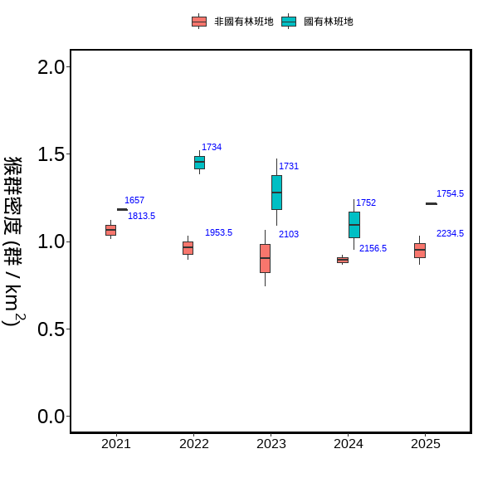

BBS與林業署的資料 (用1:1混和)

全島 vs 50-250m vs 50-500m vs 50-1000m
調查資料的E

Only林業署的資料

各分署
Office_F_bb_outout <-
bb_F %>%
group_by(Office) %>%
summarise(樣點數 = PointID %>% unique() %>% length,
筆數 = PointID %>% length,
'猴群數' = AB %>% sum )
summary_Office_F <-
bb_F %>%
group_by(Office, Year, Survey) %>%
summarise(N = paste0(獼猴樣區編號, "_", Point) %>% unique() %>% length,
m = AB %>% sum,
E = m / N,
E_km2 = m / N/per_Area,
.groups = 'drop') %>%
group_by(Office) %>%
summarise(Mean_N = mean(N),
Se_N = se(N),
Mean_m = mean(m),
Se_m = se(m),
Mean_E = mean(E) ,
Se_E = se(E),
Mean_E_km2 = mean(E_km2) ,
Se_E_km2 = se(E_km2),
.groups = 'drop') %>%
mutate_at(c('Se_N','Se_m','Se_E','Mean_E',
'Mean_E_km2','Se_E_km2'), function(x)round(x,3)) %>%
mutate_at(c('Mean_N','Mean_m'), function(x)round(x,2)) %>%
arrange(-Mean_E)
調查資料的E
summary_Office_F %>%
flextable()
Office | Mean_N | Se_N | Mean_m | Se_m | Mean_E | Se_E | Mean_E_km2 | Se_E_km2
臺東 | 300.3 | 1.832 | 23.9 | 1.941 | 0.080 | 0.006 | 2.531 | 0.201
屏東 | 256.8 | 2.843 | 14.7 | 0.423 | 0.057 | 0.002 | 1.825 | 0.059
嘉義 | 288.2 | 5.897 | 13.5 | 1.222 | 0.047 | 0.005 | 1.509 | 0.152
花蓮 | 255.2 | 6.403 | 12.1 | 1.370 | 0.047 | 0.005 | 1.502 | 0.153
南投 | 247.6 | 7.884 | 8.1 | 0.888 | 0.032 | 0.003 | 1.034 | 0.100
宜蘭 | 246.3 | 1.391 | 6.5 | 0.671 | 0.026 | 0.003 | 0.841 | 0.087
臺中 | 293.3 | 3.471 | 6.1 | 1.038 | 0.021 | 0.003 | 0.658 | 0.109
新竹 | 324.9 | 2.964 | 3.9 | 0.567 | 0.012 | 0.002 | 0.380 | 0.055
藍色數字為平均樣區數
Office__sorted <- bb_F %>%
group_by(Office, Year, Survey) %>%
summarise(N = paste0(獼猴樣區編號, "_", Point) %>% unique() %>% length,
m = AB %>% sum,
.groups = 'drop') %>% setDT %>%
.[,Encounter_rate := m/N] %>%
.[, Mean_N := mean(N), by = c('Office')] %>%
.[, Mean_E := mean(Encounter_rate), by = c('Office')] %>%
arrange(desc(Mean_E)) %>% .$Office %>% unique()
Office_nn <-
bb_F %>%
group_by(Office, Year, Survey) %>%
summarise(N = paste0(獼猴樣區編號, "_", Point) %>% unique() %>% length,
m = AB %>% sum,
.groups = 'drop') %>% setDT %>%
.[,Encounter_rate := m/N] %>%
.[, Mean_N := mean(N), by = c('Office')] %>%
.[, Mean_E := mean(Encounter_rate), by = c('Office')] %>%
arrange(desc(Mean_E))%>%
lapply(.,
function(x) paste(str_split(x, "")[[1]], collapse = "\n")) %>% unlist()
bb_F %>%
group_by(Office, Year, Survey) %>%
summarise(N = paste0(獼猴樣區編號, "_", Point) %>% unique() %>% length,
m = AB %>% sum,
.groups = 'drop') %>% setDT %>%
.[,E_km2 := m/N/per_Area] %>%
.[, Mean_N := mean(N), by = c('Office')] %>%
ggplot(., aes(x = Office, y = E_km2))+
geom_boxplot(width = 0.3, linewidth = 0.4, fill= gray(.9))+
stat_summary(fun = mean, geom = "text",
aes(label = round(Mean_N, 1)),
position = position_nudge(x = 0.2, y = 0.6),
angle = 270,
# hjust = -0.1,
# vjust = 0,
color = "blue")+
scale_x_discrete(limit = Office__sorted , labels = Office_nn)+
scale_y_continuous(breaks = seq(0,4,0.5), limits = c(0,3.5))+
labs(x = "", y = expression(paste("猴群密度 (群 / km"^2,")")))+
theme(
panel.border = element_rect(linewidth = 1.5,fill = NA),
panel.grid = element_blank(),
panel.background = element_blank(),
axis.text.x = element_text(size = 12,colour = "black", angle = 0),
axis.text.y = element_text(size = 18,colour = "black"),
axis.title = element_text(size = 18,colour = "black"),
axis.title.y = element_text(angle = 270,
vjust = -1, hjust = 0.5),
legend.position = "top"
)
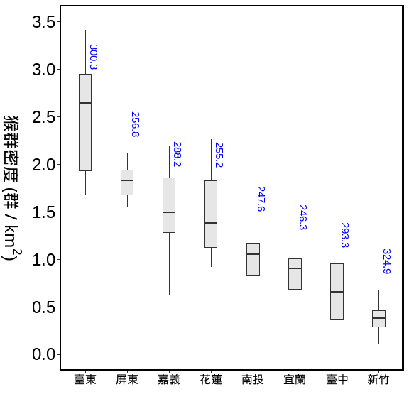
估計各分署猴群數 50m以上的森林，2021-2025的資料bootstraps
海拔50m以上的森林在各分署面積 (km²)
方法：bootstrap
重複抽樣：10,000次
單位面積的半徑: 100m
per_Area <- (0.1*0.1*pi) #100m半徑的單位原面積
Office_M_F <-
forest_office %>% setDT %>%
.[, .(area = sum(area)), by = 'Office'] %>%
left_join(bootstrap_AB_F_Office, .,by = 'Office') %>% setDT %>%
.[ , 'M_troops' := (area)*mm] %>%
.[ , 'q1_troops' := (area)*q_1] %>%
.[ , 'q3_troops' := (area)*q_3] %>%
.[, 'log_troops':= log(M_troops)]%>%
.[ , 'COUNT' := M_troops*25]
用分署的資料分別抽樣，再依各分署50m以上的森林面積，去估算
Office | 相對密度_km2 | 相對密度_km2(95%CI) | 群數 | 群數(95%CI) | 隻數 | 隻數(95%CI)
臺東 | 2.534 | 2.226~90.761 | 5,283 | 4641~5945 | 132,070 | 116018~148613
花蓮 | 1.509 | 1.247~56.378 | 4,424 | 3656~5191 | 110,601 | 91399~129787
屏東 | 1.824 | 1.537~67.469 | 3,027 | 2550~3517 | 75,683 | 63762~87930
南投 | 1.043 | 0.823~40.512 | 1,788 | 1411~2183 | 44,701 | 35278~54570
嘉義 | 1.490 | 1.248~55.547 | 1,627 | 1363~1906 | 40,682 | 34085~47658
宜蘭 | 0.837 | 0.646~33.321 | 1,386 | 1070~1734 | 34,662 | 26755~43343
臺中 | 0.661 | 0.51~26.254 | 807 | 622~1006 | 20,174 | 15560~25161
新竹 | 0.381 | 0.265~15.905 | 554 | 384~726 | 13,840 | 9606~18146
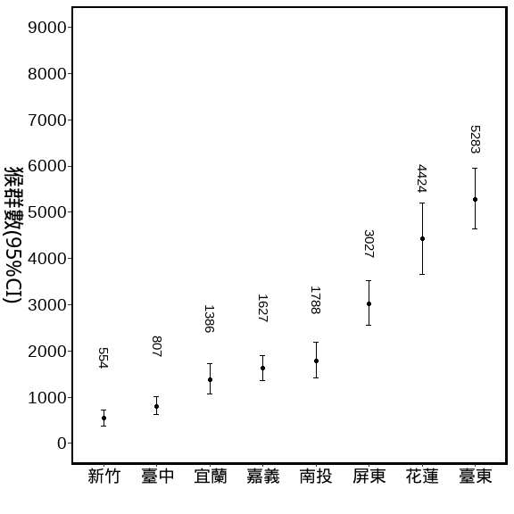

END

