表1. 2015 - 2019年各森林類型內的調查樣點數、猴群數及相對密度

Table1 Summary of sampling points and Taiwanese macaque troops in 2015-2019. (n = 10)

|  |  |  |  |
| --- | --- | --- | --- |
| Type of  forest | Count of  sample points  (mean ± se) | Count of  monkey troop  (mean ± se) | Relative density (troop/ points)  (mean ± se) |
| Forest | 1590.6 ± 25.7 | 22.8 ± 1.7 | 0.014 ± 0.001 |
| Broadleaf | 1099.8 ± 18.8 | 15.7 ± 1.2 | 0.014 ± 0.001 |
| Coniferous | 139.8 ± 4.3 | 1.1 ± 0.2 | 0.008 ± 0.001 |
| Bamboo | 186.9 ± 3.2 | 3.1 ± 0.8 | 0.017 ± 0.005 |
| Mixed | 164.1 ± 3.2 | 2.9 ± 0.6 | 0.018 ± 0.003 |
| Not forest | 1152.5 ± 13.7 | 0.7 ± 0.2 | - |
| Total | 2743.1 ± 34.0 | 23.5 ± 1.8 | - |

表2. 2015 - 2019年各地理分區內的調查樣點數、猴群數及相對密度

Table2 Summary of sampling points and Taiwanese macaque troops in the forest in 2015 -2019. (n = 10)

|  |  |  |  |
| --- | --- | --- | --- |
| Region* | Count of  sample points  (mean ± se) | Count of  monkey troop  (mean ± se) | Relative density  (troop/ points)  (mean ± se) |
| North | 563.3 ± 25.6 | 1.5 ± 0.5 | 0.003 ± 0.001 |
| Center | 475.6 ± 8.5 | 4.2 ± 0.5 | 0.009 ± 0.001 |
| Southwest | 174.6 ± 6.0 | 4.7 ± 0.6 | 0.028 ± 0.004 |
| South | 152.5 ± 4.7 | 3.1 ± 0.5 | 0.021 ± 0.004 |
| Hualien | 161.1 ± 2.9 | 6.3 ± 0.7 | 0.040 ± 0.005 |
| Taitung | 63.5 ± 3.2 | 3.0 ± 1.0 | 0.042 ± 0.014 |
| Total | 1590.6 ± 25.7 | 22.8 ± 1.7 | 0.014 ± 0.001 |

* North: include Taipei City, New Taipei City, Keelung City, Yilan County, Taoyuan City, Hsinchu County & Miaoli County; Center: include Taichung City, Changhua County & Nantou County; Southwest: Yunlin County, Chiayi City, Chiayi County & Tainan City; South: Kaohsiung City & Pingtung County; Hualien: Hualien County;

Taitung: Taitung County.

表3 以訊息理論研究法(AICc)對臺灣獼猴分布的影響因子進行模式選擇之結果

Table 3 Ranking of models of variables for the appearance of Taiwanese macaque troops based on the smallest AICc value (ΔAICc)

|  |  |  |  |  |  |  |  |  |  |  |
| --- | --- | --- | --- | --- | --- | --- | --- | --- | --- | --- |
| Intercept | Altitude | Julian Day | Region | Forest  Type | Year | df | logLik | AICc | ΔAICc | Akaike weight |
| -6.631 | 0.453 |  | + |  | 0.097 | 9 | -988.523 | 1995.1 | 0 | 0.261 |
| -6.629 | 0.413 | 0.098 | + |  | 0.096 | 10 | -987.769 | 1995.6 | 0.49 | 0.204 |
| -6.306 | 0.442 |  | + |  |  | 8 | -990.318 | 1996.6 | 1.59 | 0.118 |

+表示模式中包含此類別變數，數字則是代表該連續變數的係數，空白則表示模式不包含此變數。

表4 廣義線性混合模式(Generalized mixed linear models, GLMM)分析臺灣獼猴出現的影響因子的結果

Table4 Results of generalized mixed linear models(GLMM) ANOVA for the effects of the appearance of Taiwanese macaque.

|  |  |  |  |
| --- | --- | --- | --- |
| Parameter | χ2 | df | *p* value ( > χ2) |
| Altitude | 5.737 | 1 | 0.017 * |
| Year | 3.518 | 1 | 0.061 |
| Julian Day | 1.507 | 1 | 0.220 |
| Region | 42.832 | 5 | < 0.001 *** |

表5

Table5 Turkey

|  |  |  |  |  |  |
| --- | --- | --- | --- | --- | --- |
|  | Estimate | Std. Error | z value | *p* value(>|z|) |  |
| Southwest - Center | 0.689 | 0.559 | 1.232 | 0.817 |  |
| Hualien - Center | 1.941 | 0.519 | 3.737 | 0.002 | ** |
| Taitung - Center | 2.934 | 0.708 | 4.146 | < 0.001 | *** |
| North - Center | -0.726 | 0.500 | -1.452 | 0.689 |  |
| South - Center | 0.877 | 0.596 | 1.471 | 0.677 |  |
| Hualien - Southwest | 1.252 | 0.585 | 2.139 | 0.262 |  |
| Taitung - Southwest | 2.245 | 0.761 | 2.951 | 0.036 | * |
| North - Southwest | -1.415 | 0.567 | -2.494 | 0.123 |  |
| South - Southwest | 0.189 | 0.647 | 0.292 | 1.000 |  |
| Taitung - Hualien | 0.993 | 0.709 | 1.401 | 0.721 |  |
| North - Hualien | -2.667 | 0.521 | -5.121 | < 0.001 | *** |
| South - Hualien | -1.063 | 0.605 | -1.757 | 0.487 |  |
| North - Taitung | -3.660 | 0.710 | -5.155 | < 0.001 | *** |
| South - Taitung | -2.056 | 0.773 | -2.661 | 0.081 |  |
| South - North | 1.604 | 0.590 | 2.717 | 0.070 |  |

表?. 2015 - 2019年各年內的調查樣點數、猴群數及相對密度

Table? Summary of sampling points and Taiwanese macaque troops in the forest in 2015 -2019. (n = 2)

|  |  |  |  |
| --- | --- | --- | --- |
| Year | Count of  sample points  (mean ± se) | Count of  monkey troop  (mean ± se) | Relative density  (troop/ points)  (mean ± se) |
| 2015 | 22.0 ± 1.0 | 1678.0 ± 39.0 | 0.0131 ± 0.0009 |
| 2016 | 18.5 ± 4.5 | 1631.5 ± 74.5 | 0.0115 ± 0.0033 |
| 2017 | 17.5 ± 2.5 | 1506.0 ± 20.0 | 0.0116 ± 0.0018 |
| 2018 | 29.0 ± 2.0 | 1605.0 ± 65.0 | 0.0181 ± 0.0020 |
| 2019 | 27.0 ± 3.0 | 1532.5 ± 34.5 | 0.0176 ± 0.0016 |

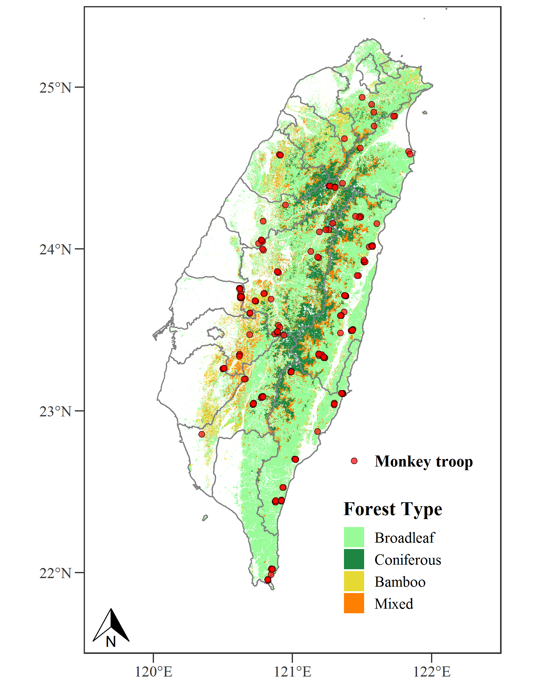

圖1 2015-2019年臺灣獼猴分布圖

Fig.1 Taiwan Macaque Distribution Map in 2015-2019



圖2 2015-2019年不同海拔的臺灣獼猴相對密度

Fig.2 Encounter rate of Taiwanese macaques at different altitudes from 2015 to 2019



圖3 2015-2019年臺灣獼猴平均相對密度的年間變化。(誤差線為標準誤)

Fig.3 Annual encounter rate of Taiwanese macaques in 2015 - 2019