表1. 2015 - 2019年各森林類型內的調查樣點數、猴群數及相對密度

Table1 Summary of sampling points and Taiwanese macaque troops in 2015-2019. (n = 10)

|  |  |  |  |  |
| --- | --- | --- | --- | --- |
| Forest type | Count of  sample points  (mean ± se) | Count of  monkey troop  (mean ± se) | Relative density  (troop/ points)  (mean ± se) | Density  (troop/ km2)  (mean ± se) |
| Forest (EL ≥ 50) | 1415.0 ± 23.1 | 22.2 ± 1.6 | 0.016 ± 0.001 | 0.500 ± 0.037 |
| Broadleaf | 1098.2 ± 21.1 | 15.5 ± 1.3 | 0.018 ± 0.002 | 0.571 ± 0.070 |
| Coniferous | 138.1 ± 4.1 | 1.0 ± 0.2 | 0.007 ± 0.001 | 0.237 ± 0.042 |
| Bamboo | 164.0 ± 3.3 | 2.9 ± 0.5 | 0.018 ± 0.003 | 0.569 ± 0.101 |
| Mixed | 186.9 ± 4.1 | 3.1 ± 0.8 | 0.020 ± 0.005 | 0.645 ± 0.175 |
| Forest (EL < 50) | 172.2 ± 5.8 | 0.3 ± 0.1 | 0.002 ± 0.001 | 0.055 ± 0.025 |
| Not forest | 1150.9 ± 13.0 | 0.7 ± 0.2 | 0.001 ± 0 | - |
| Total | 2738.1 ± 33.2 | 23.2 ± 1.8 | - | - |

EL: Elevation

表2. 2015 - 2019年各地理分區內的調查樣點數、猴群數及相對密度

Table2 Summary of sampling points and Taiwanese macaque troops in the forest in 2015 -2019. (n = 10)

|  |  |  |  |  |
| --- | --- | --- | --- | --- |
| Region* | Count of  sample points  (mean ± se) | Count of  monkey troop  (mean ± se) | Relative density  (troop/ points)  (mean ± se) | Density  (troop/ km2)  (mean ± se) |
| North | 480.4 ± 21.9 | 1.3 ± 0.4 | 0.003 ± 0.001 | 0.083 ± 0.028 |
| Center | 455.7 ± 8.9 | 4.0 ± 0.6 | 0.009 ± 0.001 | 0.277 ± 0.037 |
| Southwest | 150.1 ± 5.4 | 4.6 ± 0.6 | 0.032 ± 0.005 | 1.007 ± 0.146 |
| South | 116.4 ± 3.1 | 3.0 ± 0.4 | 0.027 ± 0.004 | 0.844 ± 0.132 |
| Hualien | 148.9 ± 3.2 | 6.3 ± 0.7 | 0.043 ± 0.005 | 1.363 ± 0.172 |
| Taitung | 63.5 ± 3.2 | 3.0 ± 1.0 | 0.042 ± 0.013 | 1.327 ± 0.410 |
| Total | 1415 ± 24.2 | 22.2 ± 1.7 | 0.016 ± 0.001 | 0.500 ± 0.039 |

* North: include Taipei City, New Taipei City, Keelung City, Yilan County, Taoyuan City, Hsinchu County & Miaoli County; Center: include Taichung City, Changhua County & Nantou County; Southwest: Yunlin County, Chiayi City, Chiayi County & Tainan City; South: Kaohsiung City & Pingtung County; Hualien: Hualien County;

Taitung: Taitung County.

表?. 2015 - 2019年各年內的調查樣點數、猴群數及相對密度

Table? Summary of sampling points and Taiwanese macaque troops in the forest in 2015 -2019. (n = 2)

|  |  |  |  |
| --- | --- | --- | --- |
| Year | Count of  sample points  (mean ± se) | Count of  monkey troop  (mean ± se) | Relative density  (troop/ points)  (mean ± se) |
| 2015 | 1500.5 ± 36.5 | 21.5 ± 0.5 | 0.014 ± 0.001 |
| 2016 | 1424.0 ± 63.0 | 18.0 ± 4.0 | 0.013 ± 0.003 |
| 2017 | 1332.0 ± 30.0 | 16.0 ± 1.0 | 0.012 ± 0.001 |
| 2018 | 1453.5 ± 62.5 | 29.0 ± 2.0 | 0.020 ± 0.002 |
| 2019 | 1365.0 ± 31.0 | 26.5 ± 2.5 | 0.019 ± 0.001 |

表3臺灣獼猴分布的影響因子進行模式選擇之結果

Table 3 Summary of model selection by generalized linear mixed-effects model (GLMM) used to model the effect of variables.

|  |  |  |  |  |  |  |  |  |  |  |
| --- | --- | --- | --- | --- | --- | --- | --- | --- | --- | --- |
| Intercept | Altitude | Julian Day | Region | Forest  Type | Year | df | Log-likelihood | AICc | ΔAICc | Akaike weight |
| -6.404 | 0.342 |  | + |  | 0.0995 | 9 | -950.791 | 1919.6 | 0.00 | 0.239 |
| -6.402 | 0.310 | 0.076 | + |  | 0.0988 | 10 | -950.351 | 1920.7 | 1.12 | 0.136 |
| -6.073 | 0.331 |  | + |  |  | 8 | -952.644 | 1921.3 | 1.70 | 0.102 |
| -6.169 |  |  | + |  | 0.0963 | 8 | -952.775 | 1921.6 | 1.96 | 0.090 |

Summary of model selection by generalized linear mixed-effects model (GLMM) used to model the effect of habitat type on number of Taiwanese macaque detected with altitude, julian day, region, forest type and year as covariates and site as a random variable (only models with ΔAICc score of < 2 are shown).

表4

Table4 Turkey

|  |  |  |  |  |  |
| --- | --- | --- | --- | --- | --- |
|  | Estimate | Std. Error | z value | *p* value(>|z|) |  |
| Southwest - Center | 0.740 | 0.567 | 1.304 | 0.779 |  |
| Hualien - Center | 1.915 | 0.510 | 3.757 | 0.002 | ** |
| Taitung - Center | 2.719 | 0.682 | 3.988 | < 0.001 | *** |
| North - Center | -0.894 | 0.508 | -1.761 | 0.485 |  |
| South - Center | 0.992 | 0.609 | 1.629 | 0.573 |  |
| Hualien - Southwest | 1.175 | 0.596 | 1.971 | 0.353 |  |
| Taitung - Southwest | 1.979 | 0.751 | 2.634 | 0.087 |  |
| North - Southwest | -1.634 | 0.595 | -2.748 | 0.064 |  |
| South - Southwest | 0.252 | 0.678 | 0.371 | 0.999 |  |
| Taitung - Hualien | 0.804 | 0.683 | 1.178 | 0.844 |  |
| North - Hualien | -2.809 | 0.533 | -5.269 | < 0.001 | *** |
| South - Hualien | -0.923 | 0.623 | -1.483 | 0.670 |  |
| North - Taitung | -3.613 | 0.702 | -5.150 | < 0.001 | *** |
| South - Taitung | -1.727 | 0.769 | -2.246 | 0.212 |  |
| South - North | 1.885 | 0.624 | 3.023 | 0.029 | * |

表5 2015-2019年臺灣獼猴族群變化轉折點之統計檢定結果

Table5

|  |  |  |  |
| --- | --- | --- | --- |
| Change point | Wald test | df | *p* value |
| 2017 | 22.073 | 8 | 0.005 |
| 2018 | 16.356 | 8 | 0.038 |

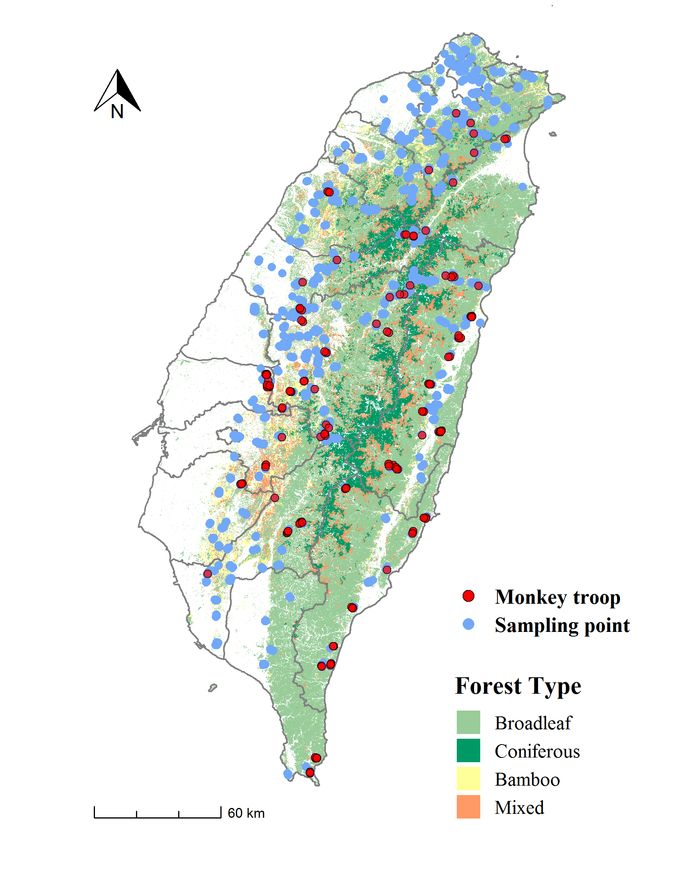

圖1 2015-2019年位於海拔50m以上的樣點及猴群分布圖

Fig.1 Taiwan Macaque Distribution Map in 2015-2019



圖2 2015-2019年不同海拔的臺灣獼猴相對密度

Fig.2 Encounter rate of Taiwanese macaques at different altitudes from 2015 to 2019

🡨only闊葉林



圖3 2015-2019年臺灣獼猴平均相對密度的年間變化。(誤差線為標準誤)

Fig.3 Annual encounter rate of Taiwanese macaques in 2015 - 2019